**Photo Editing**

Photo editing means an act of altering an image in very simple terminology. These images can be digital photographs, illustrations, prints, or photographs on film). Some types of editing, such as airbrushing, are done by hand and others are done using photo editing programs.

**Photo editing is also knows as**

• Image editing

• Image/photo manipulation

• Photoshopping

• Image/photo enhancement etc

**Photo-editing software**

Photo-editing software’s are software programs used to manipulate and enhance images.  
 Cost and features are the main factors when choosing photo editing software  
Some photo-editing software programs:

* Adobe Photoshop
* Corel Draw
* Microsoft Paint
* Inkscape
* Capture One
* Fotor
* Snappa
* PicMonkey
* Pixlr editor
* Canva
* GIMP
* PhotoPlus
* Paint.NET

Some photo-editing mobile apps:

* PicsArt
* Snapseed
* Edior De Fotos
* Photo Director
* Adobe Lightroom
* PicShot
* Polarr
* InstaSquare
* Enlight Photofox
* Picsa

**Types of photo editing  
1) Simple photo-editing may include**

♦ **Noise reduction**: Noise is the occurrence of color dots or specks where there should

be none. It is accomplished by reducing the pixel size to make the picture smooth.

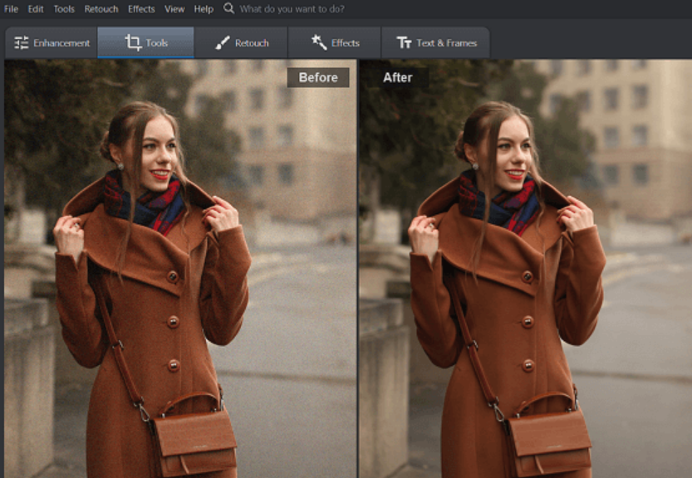

♦ **White balance**: Is used to change color of the light in the image.

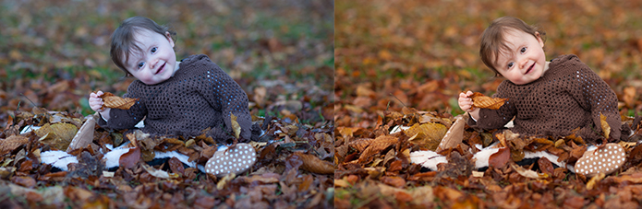

♦ **Contrast:** Higher contrast makes an image more punchy(darker), while lower contrast makes

it flatter(smooth) in color.

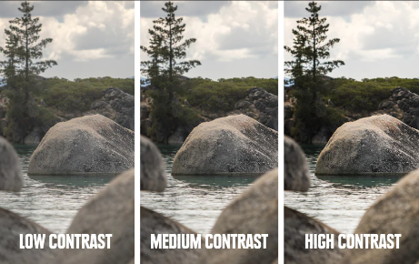

♦ **Exposure Adjustment:** The brightness of the image is adjusted.

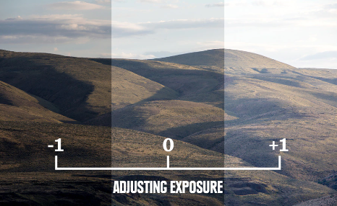

♦ **Color adjustments:** Is defined as the change the color of an item or element in the

photo. It may be background color or the component of main object.

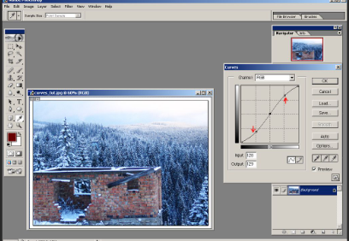

♦ **Image Resizing:** Image Resize is performed to adjust the dimensions of the image.

Image dimensions are the length and width of your image, measured in pixels. For

example, when you apply for a job, the recruiter ask to upload an image of 40x60 mm

etc.

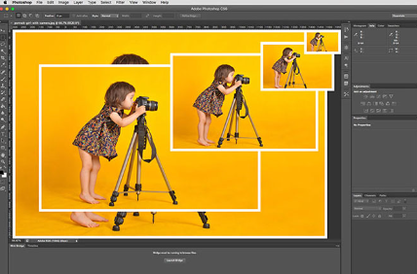

♦ **Image cropping:** Cropping makes the image to be in proper size or to remove

unwanted parts. Crop feature allows to drag a rectangular shape around an area in the

image to cut off the sides.

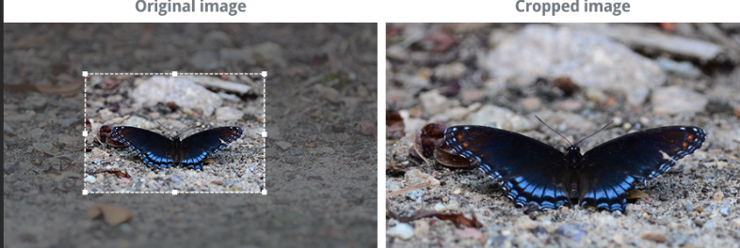

♦ **Background removal:** It is used to remove or alter the background from the image to

isolate the subject like white background etc.

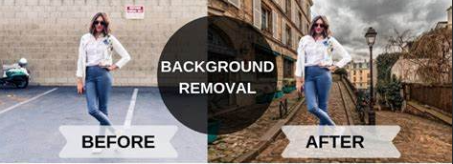

**2. Complex & advanced Photo Editing include:**

♦ **Portrait corrections:** Used to fix the complexion of people or objects in images.

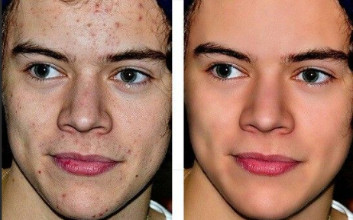

♦ **Special effects:** Can be anything from animation to adding weather conditions like

cloudy, fog or snow etc etc.

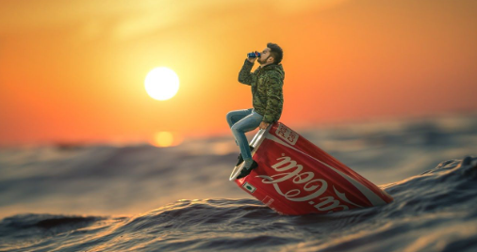

♦ **Clipping paths:** It is used extract a subject or element from an image. It may be a

person or object also.

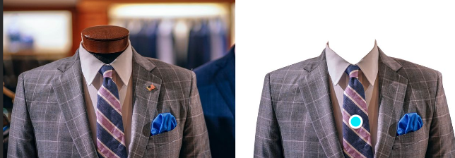

♦ **Adjusting text and visuals:** We may add text and visuals or manipulate the existing

one even remove them.

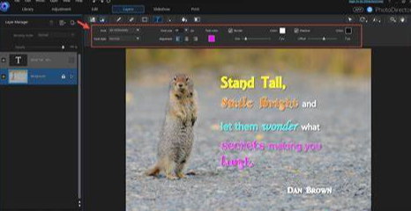

♦ **Photo stitching:** Technique is used to put two or more images together seamlessly to

make it look like they were shot that way

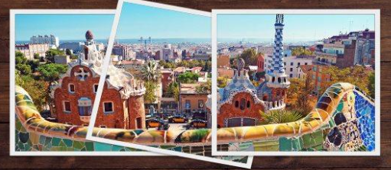

♦ **Drop and reflection shadow:** It is used create or adjust shadows

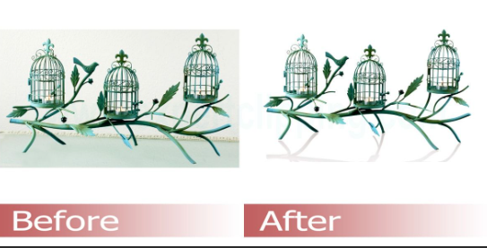

**3. Pixel level editing and parametric image editing**

♦ **Pixel level editing:** Pixel level editing means if an image is altered at the pixel level.

♦ **Parametric image editing:** In Parametric image editing(PIE )

**Photo editing Tools and Shortcuts:**

**Transform Tools: Ctrl+T  
Selection Tools:  
a)Marquee Tools: Ctrl+M  
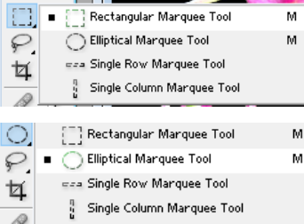**

**any part of graphic that is not included in another hot zone is called Rectangle.(out does type)**

**Win 10 brightness slider is a brightness tool**

**Improves the quality of image without distorting in Filters**

