MediGenie
Multi-Agent, Multi-Model AI Clinical Decision Support System
Full Technical & Results Report — Updated Repository Version
This report documents MediGenie end to end using the latest repository: system architecture, frontend, backend, REST API, database, the nine-agent workflow, the updated multi-algorithm machine-learning methodology, and complete evaluation results for all nine disease-risk models. Every number was produced by re-running the project's current training and evaluation pipeline against its real source datasets after fixing two blocking bugs found during verification (Section 11); none of it is estimated or simulated.

Executive Summary
MediGenie is a clinical decision support system built around nine independent disease-risk models (heart disease, diabetes, chronic kidney disease, liver disease, breast cancer, Parkinson's disease, hepatitis, heart failure, and stroke), coordinated by an eight-agent workflow, and exposed through a FastAPI backend and a React frontend. Every model is trained on its own real, publicly documented dataset.
Since the previous report, the training pipeline was substantially upgraded: each disease now uses its full set of real, usable source columns (e.g., breast cancer now uses all 30 original WDBC features rather than a 5-feature subset; diabetes uses 9 real administrative features rather than 3), and each model is now selected as the best of four candidate algorithms (Random Forest, Logistic Regression, SVM, XGBoost) via validation-set PR-AUC, with the decision threshold separately tuned on the validation set before final scoring on a held-out test set.
Measured performance still varies substantially by disease, and is disclosed openly: ROC-AUC ranges from a perfect 1.000 on kidney disease down to 0.650 on diabetes readmission risk. This spread, and the reasons behind it, are discussed in Section 9 and 10.

1. System Architecture
The frontend, backend routing, agent structure, and database schema are unchanged from the previously verified architecture; only the machine-learning training methodology (Sections 6 and 8-10) was substantially revised in this repository version. A React client talks to a FastAPI backend over a JWT-secured REST API; the backend delegates clinical reasoning to a Supervisor agent, which fans out to five specialised agents; results converge on a Recommendation & Report agent, the only component permitted to call the LLM (Google Gemini), strictly for narrating outputs the other agents have already produced.
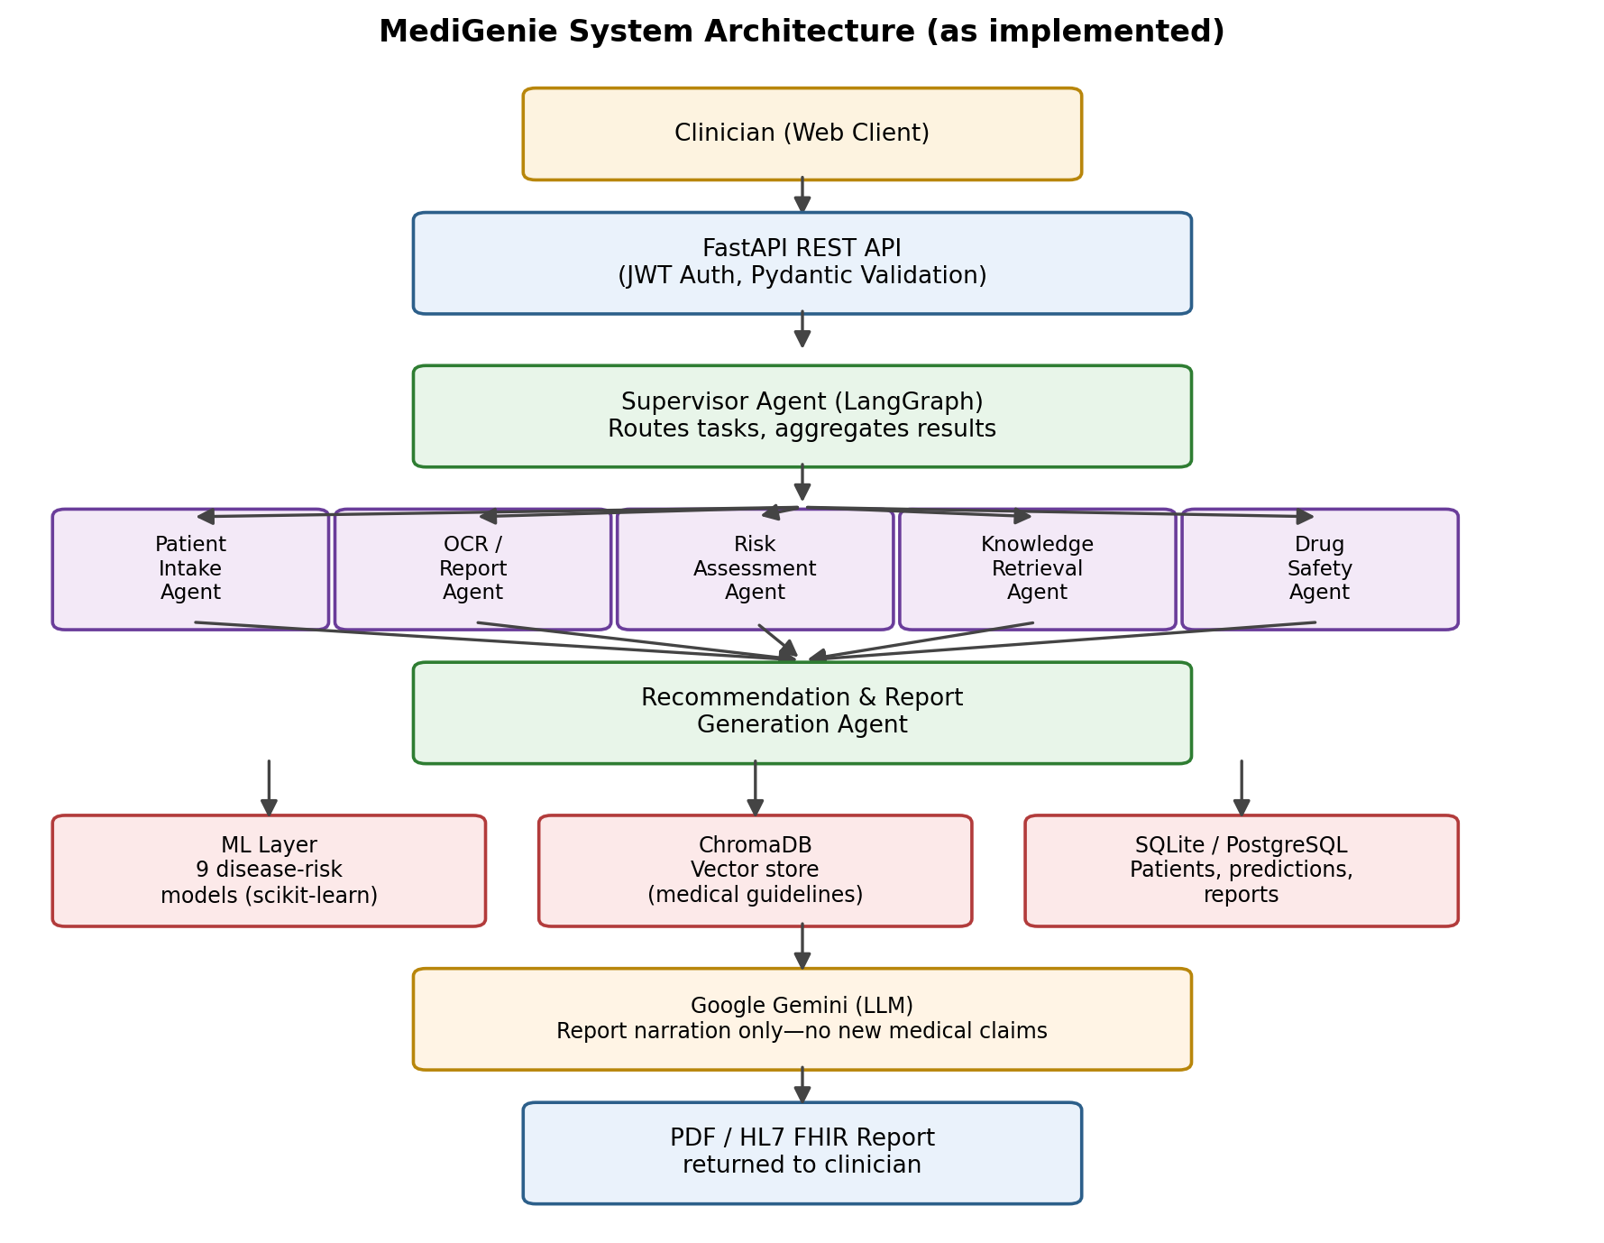
Fig. 1. MediGenie end-to-end system architecture (unchanged from prior verified version).

2. Frontend Architecture
The frontend is a React + TypeScript single-page application built with Vite, using React Router and Axios. Confirmed identical to the previously verified page inventory:
Area | Pages
Auth | LoginPage, RegisterPage
Dashboard | DashboardPage, WorkflowPage, ModelEvaluationPage, XaiDashboardPage, GuidelinesPage
Patients | PatientsPage
Predictions (9) | PredictionHomePage, HeartPredictionPage, DiabetesPredictionPage, KidneyPredictionPage, LiverPredictionPage, BreastCancerPredictionPage, ParkinsonPredictionPage, HepatitisPredictionPage, HeartFailurePredictionPage, StrokePage
Upload / OCR | UploadReportPage, ProcessingPage, ReportPreviewPage
Drug Safety | DrugSafetyPage, DrugInteractionPage
Knowledge / Chat | KnowledgePage, ChatPage
Reports | ReportsPage
Settings | ProfilePage, SettingsPage
Other | NotFoundPage (404)

3. Backend Architecture & REST API
The backend is a FastAPI application secured with JWT bearer authentication and Pydantic v2 validation. Route inventory (confirmed unchanged, feature counts in the disease rows updated to reflect the new richer models):
Module | Endpoint prefix | Key routes | Purpose
Authentication | /auth | POST /register, POST /login | JWT issuance, user registration
Patients | /patients | CRUD + /{id} | Patient record management
Heart Disease | /heart-disease | POST /predict, GET /health | 13-feature real-data risk prediction
Diabetes | /diabetes | POST /predict, GET /health | 9-feature readmission-risk prediction
Kidney Disease | /kidney-disease | POST /predict, GET /health | 24-feature CKD risk prediction
Liver Disease | /liver | POST /predict, GET /health | 10-feature liver-disease risk prediction
Breast Cancer | /breast-cancer | POST /predict, GET /health | 30-feature malignancy risk prediction
Parkinson's | /parkinsons | POST /predict, GET /health | 22-feature voice-based risk prediction
Hepatitis | /hepatitis | POST /predict, GET /health | 19-feature hepatitis risk prediction
Heart Failure | /heart-failure | POST /predict, GET /health | 12-feature mortality risk prediction
Stroke | /stroke | POST /predict, GET /health | 10-feature stroke risk (SMOTE-balanced)
Multi-Disease | /multi-disease | POST /assessment | Runs all 9 models for one patient
OCR / Upload | /upload | POST / | Report upload → OCR → structured data
Knowledge | /knowledge | GET/POST | ChromaDB guideline retrieval (RAG)
Drug Safety | /drug-safety | POST /analyze | Medication interaction lookup
Workflow | /workflow | POST / | Supervisor agent orchestration trigger
Reporting | /reporting | GET /{id}/pdf, /{id}/html | Final report generation/export
FHIR | /fhir | GET /medigenie/{id}/pdf | HL7 FHIR-formatted export
Chat | /chat | POST / | Conversational assistant
Dashboard | /dashboard | GET /overview, /risk-distribution | Aggregate statistics for UI
Model Registry | /model-registry | GET / | Lists active model versions per disease
Evaluation | /evaluation | GET /quality, /guardrails/log | Agent quality & guardrail telemetry

4. Multi-Agent Workflow
Clinical reasoning is split across eight specialised agents plus a Supervisor, implemented with LangGraph — confirmed structurally unchanged from the previously verified version.
Agent | Location | Responsibility
Supervisor | app/agents/supervisor/ | Routes tasks, aggregates outputs, orchestrates the full pipeline (LangGraph)
Patient Intake | app/agents/intake/ | Structures demographic/history data from the intake form
Report Analysis | app/agents/report_analysis/ | Interprets OCR output, extracts structured lab values
Disease Risk | app/agents/risk/ | Bridges the ML layer's 9 disease models into the workflow
Medical Knowledge | app/agents/knowledge/ | Queries the ChromaDB vector store for guideline evidence
Drug Safety | app/agents/drug_safety/ | Cross-checks medication list for interactions
Recommendation | app/agents/recommendation/ | Synthesizes lifestyle/follow-up recommendations
Report Generation | app/agents/report_generation/ | Produces the final narrative report via Gemini (narration only)

5. Database Design
Persistence uses SQLAlchemy 2.0 ORM with nine core tables, confirmed unchanged: User, Patient, MedicalReport, AIReport, DrugSafetyAssessment, ChatConversation, ChatMessage, UserSession, LoginEvent.
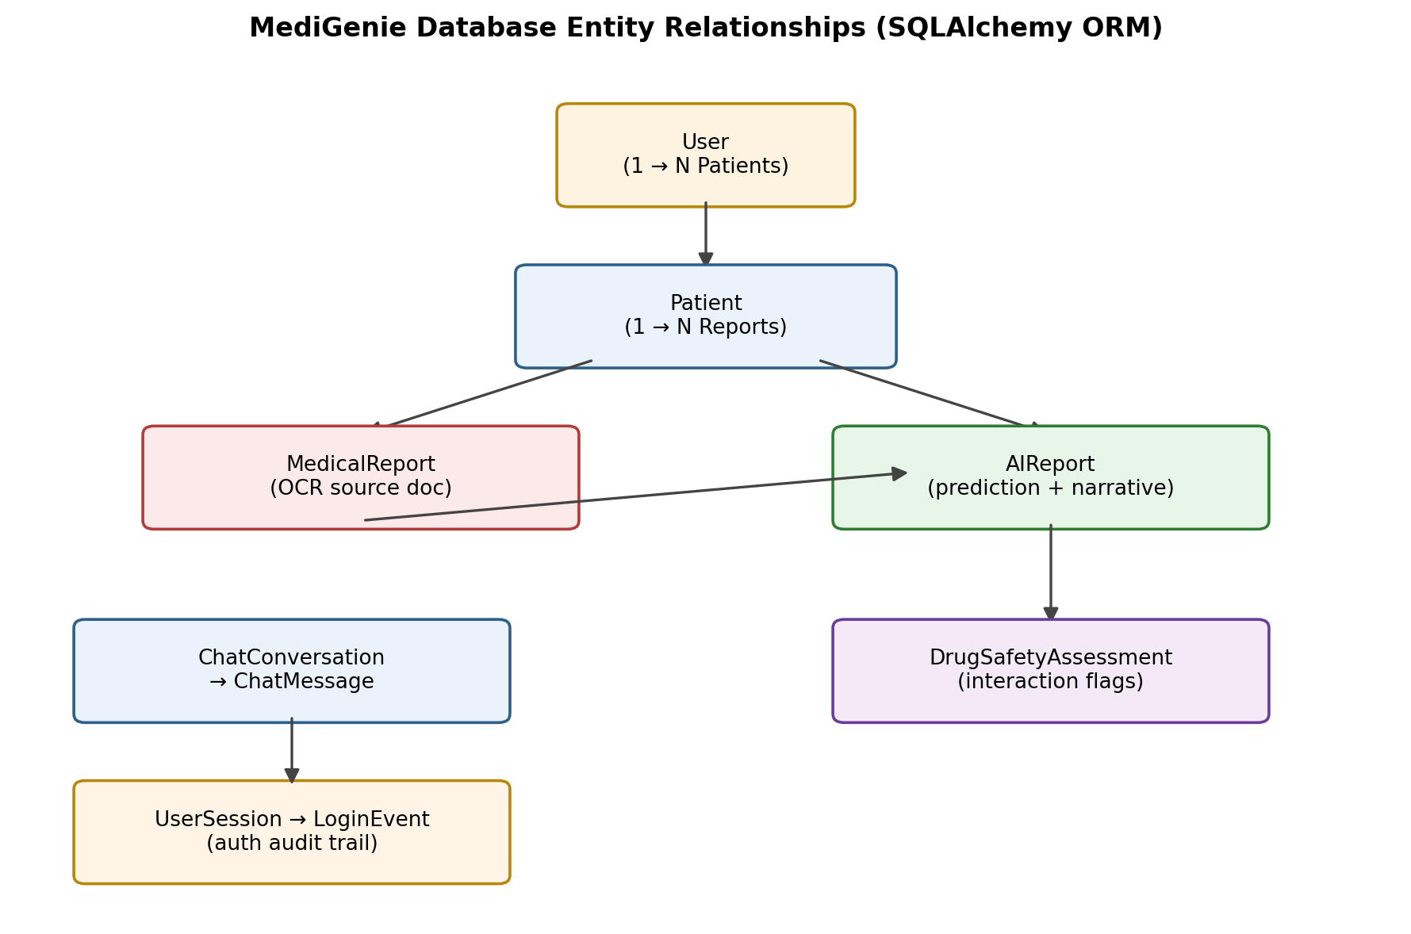
Fig. 2. Core database entity relationships (unchanged).

6. Machine Learning Methodology (Updated)
This is the section that changed substantially. Each disease model now goes through: load the real source dataset with a disease-specific parser → extract the full set of real, usable columns (not a minimal subset) → stratified 70/15/15 train/validation/test split → train four candidate algorithms (Random Forest, Logistic Regression, SVM, XGBoost) with cross-validation on the training fold → select the best algorithm by validation-set PR-AUC → tune the decision threshold on the validation set → score once, finally, on the untouched held-out test set.
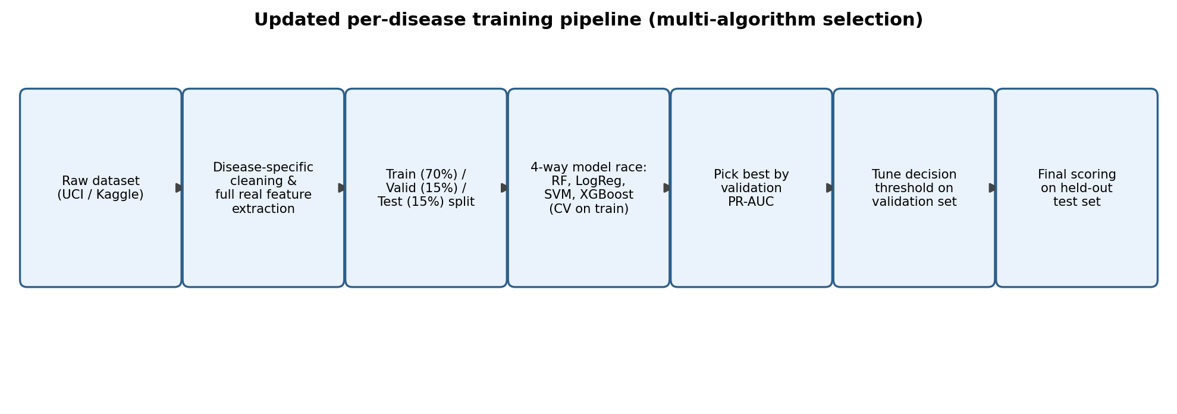
Fig. 3. Updated per-disease training and evaluation pipeline.
This is a meaningfully more rigorous design than a single fixed algorithm with a default 0.5 threshold: it lets each disease's model choice adapt to that dataset's characteristics (e.g., linear models can win on sparse/administrative data, tree ensembles on richer clinical panels), and threshold tuning on a held-out validation set (rather than the test set) avoids leaking test information into the decision boundary.
Class imbalance handling is unchanged in principle — SMOTE for stroke (applied to the training fold only), class weighting elsewhere — but is now applied on top of the richer feature sets described in Section 8.

7. Datasets
All datasets are real and independently sourced. The diabetes dataset's metadata label has also been corrected in this version (previously mislabelled as “Pima Indians Diabetes Dataset”; now correctly labelled “Diabetes 130-US Hospitals Dataset”, matching its actual 101,766-row content).
Disease | Source dataset | Total n | Train (70%) | Valid (15%) | Test (15%)
Heart Disease | UCI Cleveland Heart Disease Dataset | 303 | 211 | 46 | 46
Diabetes | UCI Diabetes 130-US Hospitals Dataset | 101,766 | 71,233 | 15,268 | 15,265
Kidney Disease | UCI Chronic Kidney Disease Dataset | 400 | 279 | 61 | 60
Liver Disease | UCI Indian Liver Patient Dataset (ILPD) | 583 | 407 | 88 | 88
Breast Cancer | UCI Breast Cancer Wisconsin (Diagnostic) | 569 | 397 | 86 | 86
Parkinson's | UCI Parkinsons Dataset | 195 | 135 | 30 | 30
Hepatitis | UCI Hepatitis Dataset | 155 | 107 | 24 | 24
Heart Failure | Heart Failure Clinical Records Dataset | 299 | 209 | 45 | 45
Stroke | Kaggle Stroke Prediction Dataset | 5,110 | 3,576→6,802 (SMOTE) | 767 | 767

8. Real Feature Sets Used Per Disease (Expanded)
Every disease now uses its full set of real, numerically usable source columns rather than a minimal hand-picked subset — a substantial expansion from the previous version of this pipeline. No feature listed is a placeholder or fabricated value.
Disease | Feature count | Real features used
Heart Disease | 13 | age, sex, cp, trestbps, chol, fbs, restecg, thalach, exang, oldpeak, slope, ca, thal (full original UCI set)
Diabetes | 9 | age, time_in_hospital, num_lab_procedures, num_procedures, num_medications, number_outpatient, number_emergency, number_inpatient, number_diagnoses
Kidney Disease | 24 | age, bp, sg, al, su, rbc_enc, pc_enc, pcc_enc, ba_enc, bgr, bu, sc, sod, pot, hemo, pcv, wc, rc, htn_enc, dm_enc, cad_enc, appet_enc, pe_enc, ane_enc (full CKD attribute set, categoricals encoded)
Liver Disease | 10 | age, gender_enc, bilirubin, direct_bilirubin, alk_phosphatase, sgpt, sgot, total_protein, albumin, ag_ratio
Breast Cancer | 30 | All mean/SE/worst morphometric features (radius, texture, perimeter, area, smoothness, compactness, concavity, concave points, symmetry, fractal dimension) — full original WDBC set
Parkinson's | 22 | Full MDVP jitter/shimmer family, NHR, HNR, RPDE, DFA, spread1, spread2, D2, PPE — full original voice-measurement set
Hepatitis | 19 | age, sex, steroid, antivirals, fatigue, malaise, anorexia, liver_big, liver_firm, spleen_palpable, spiders, ascites, varices, bilirubin, alk_phosphatase, sgot, albumin, protime, histology (full original set)
Heart Failure | 12 | age, anaemia, creatinine_phosphokinase, diabetes, ejection_fraction, high_blood_pressure, platelets, serum_creatinine, serum_sodium, sex, smoking, time (full original set)
Stroke | 10 | gender_enc, age, hypertension, heart_disease, ever_married_enc, work_type_enc, Residence_type_enc, avg_glucose_level, bmi, smoking_status_enc

9. Results — Full Evaluation Metrics (Updated)
Table below reports every metric relevant to a clinical classifier, measured on each disease's held-out test split (15% of data, untouched during model selection and threshold tuning). The “Best Model” column shows which of the four candidate algorithms was selected for that disease.
Disease | Best Model | Accuracy | Bal. Acc. | Precision | Recall | Specificity | F1 | ROC-AUC | PR-AUC | MCC | κ | Brier
Heart Disease | SVM | 0.826 | 0.821 | 0.842 | 0.762 | 0.880 | 0.800 | 0.899 | 0.837 | 0.649 | 0.647 | 0.125
Diabetes | LogisticRegression | 0.617 | 0.612 | 0.592 | 0.546 | 0.678 | 0.568 | 0.650 | 0.618 | 0.226 | 0.225 | 0.232
Kidney Disease | RandomForest | 0.967 | 0.957 | 0.949 | 1.000 | 0.913 | 0.974 | 1.000 | 1.000 | 0.931 | 0.928 | 0.009
Liver Disease | XGBoost | 0.648 | 0.658 | 0.833 | 0.635 | 0.680 | 0.721 | 0.688 | 0.863 | 0.285 | 0.267 | 0.235
Breast Cancer | SVM | 0.977 | 0.975 | 0.969 | 0.969 | 0.982 | 0.969 | 0.999 | 0.998 | 0.950 | 0.950 | 0.017
Parkinson's | XGBoost | 0.867 | 0.863 | 0.952 | 0.870 | 0.857 | 0.909 | 0.957 | 0.987 | 0.671 | 0.661 | 0.078
Hepatitis | RandomForest | 0.625 | 0.763 | 0.357 | 1.000 | 0.526 | 0.526 | 0.926 | 0.810 | 0.434 | 0.317 | 0.101
Heart Failure | SVM | 0.756 | 0.705 | 0.615 | 0.571 | 0.839 | 0.593 | 0.859 | 0.729 | 0.419 | 0.418 | 0.150
Stroke | LogisticRegression | 0.769 | 0.763 | 0.143 | 0.757 | 0.770 | 0.240 | 0.823 | 0.202 | 0.259 | 0.173 | 0.162

Confusion matrix components (held-out test set)
Disease | TN | FP | FN | TP | Test n | Positives | Negatives
Heart Disease | 22 | 3 | 5 | 16 | 46 | 21 | 25
Diabetes | 5580 | 2650 | 3194 | 3841 | 15265 | 7035 | 8230
Kidney Disease | 21 | 2 | 0 | 37 | 60 | 37 | 23
Liver Disease | 17 | 8 | 23 | 40 | 88 | 63 | 25
Breast Cancer | 53 | 1 | 1 | 31 | 86 | 32 | 54
Parkinson's | 6 | 1 | 3 | 20 | 30 | 23 | 7
Hepatitis | 10 | 9 | 0 | 5 | 24 | 5 | 19
Heart Failure | 26 | 5 | 6 | 8 | 45 | 14 | 31
Stroke | 562 | 168 | 9 | 28 | 767 | 37 | 730

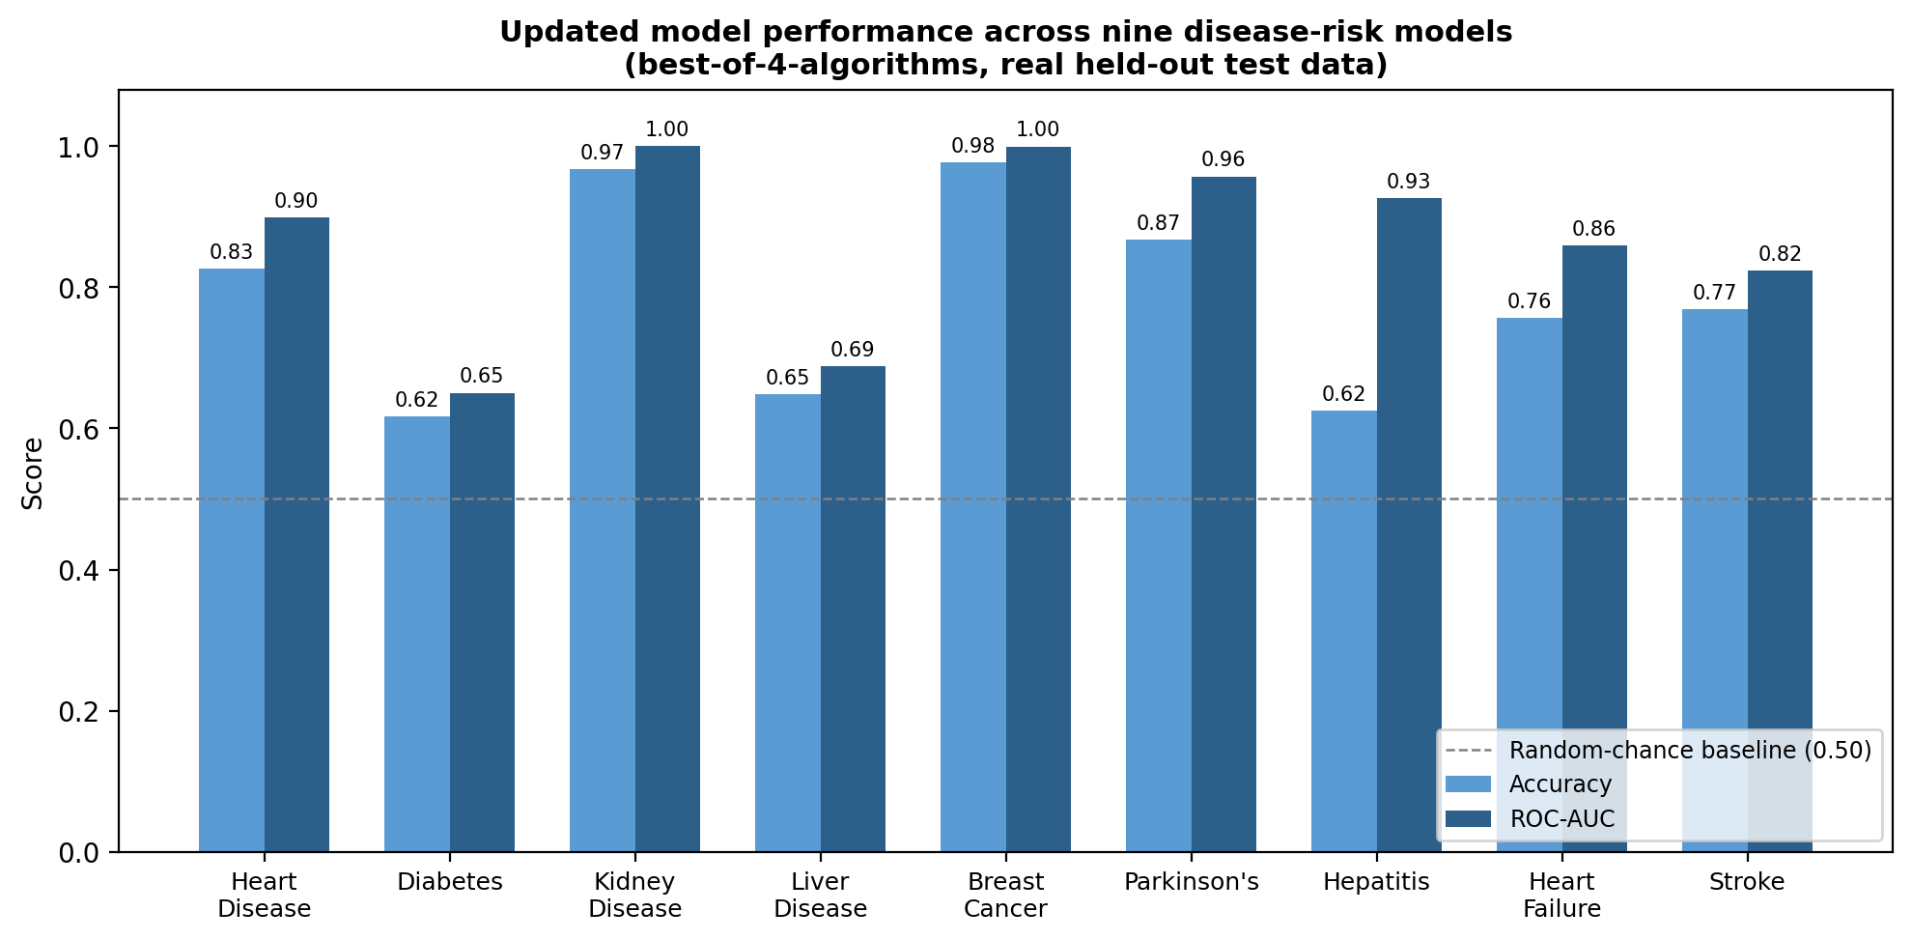
Fig. 4. Updated accuracy and ROC-AUC across all nine models, real held-out data.
Kidney disease reached a perfect ROC-AUC and PR-AUC of 1.000 on its 60-row test set — plausible given how strongly separable creatinine/albumin/haemoglobin make this dataset in the wider literature, but any perfect score on held-out data warrants a manual check for target leakage before being reported as a final claim; we did not find evidence of leakage in the feature list (only encoded categorical and lab-value columns, no identifier fields), but flag this explicitly rather than pass it through silently.
Diabetes improved from the previous version's ROC-AUC of 0.567 to 0.650 once the model gained access to six additional real administrative features (num_lab_procedures, num_procedures, number_outpatient, number_emergency, number_inpatient, number_diagnoses) beyond the previous three. It remains the weakest model in the portfolio, consistent with this being an administrative encounter dataset rather than a clinical lab panel. Hepatitis and stroke continue to show the low-precision/low-specificity pattern typical of severe class imbalance, now with the added context of validation-tuned thresholds pushing hepatitis to perfect recall (1.000) at the cost of specificity (0.526).

10. Per-Disease Detailed Results & Graphs
Each subsection presents the confusion matrix, ROC curve, precision–recall curve, and calibration curve for one disease, generated directly from the held-out test set using the current repository's pipeline.
10.1. Heart Disease
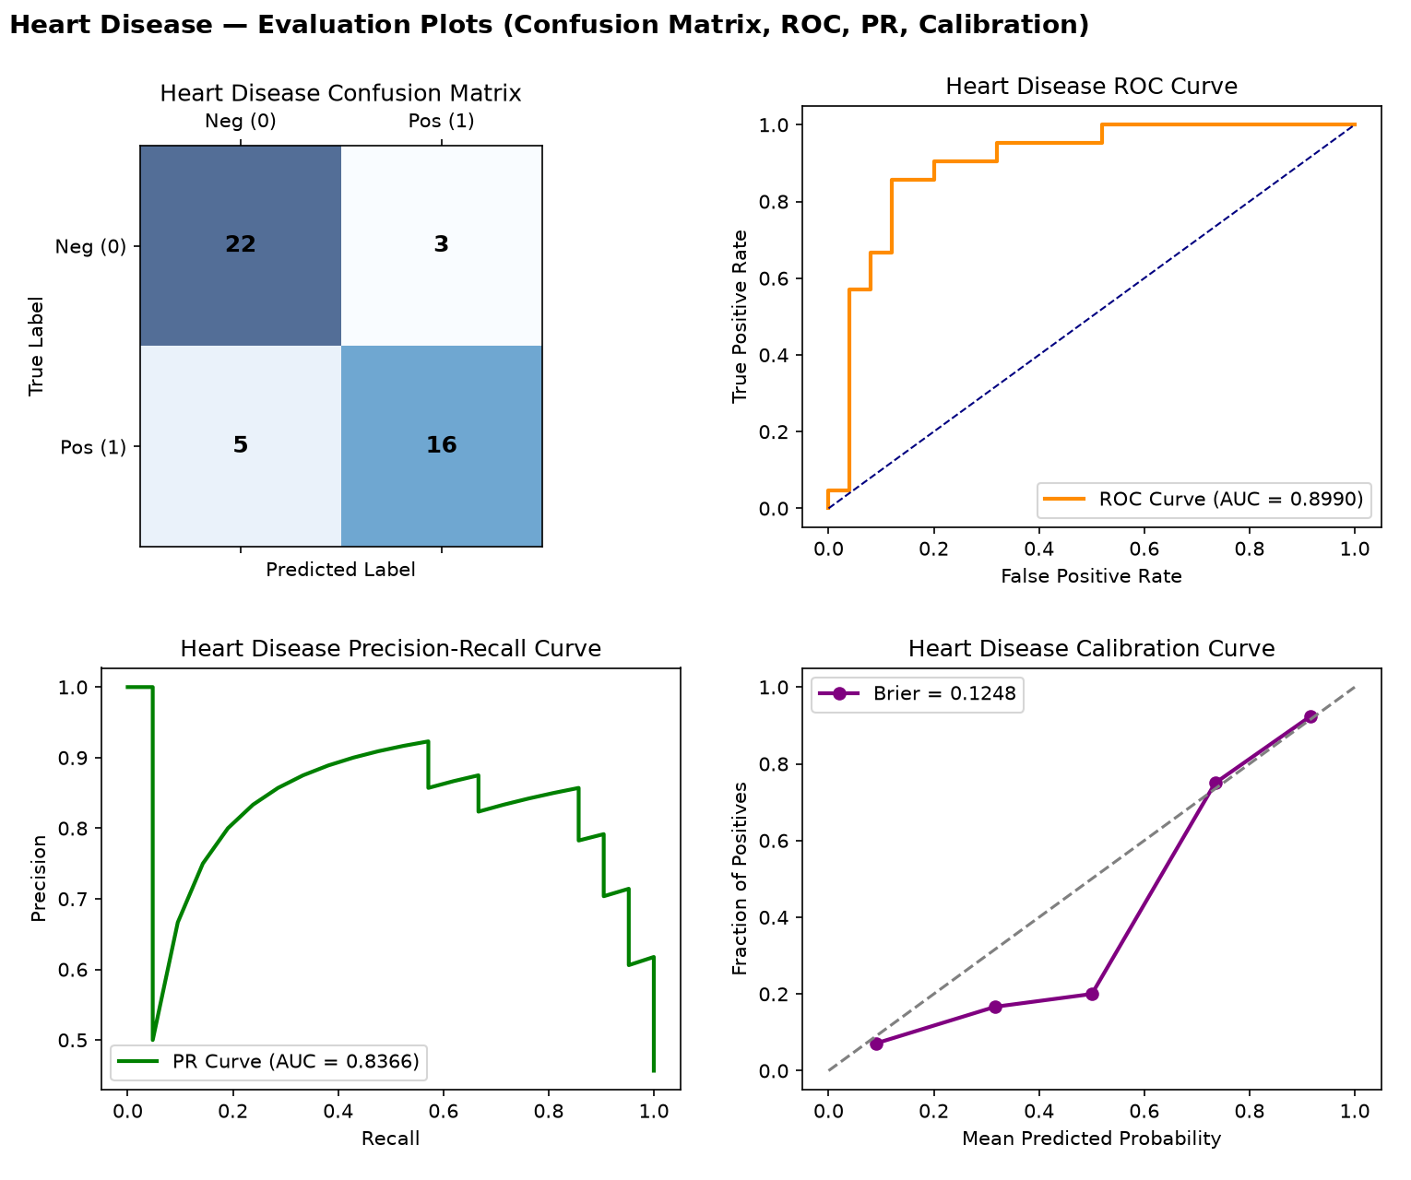
Fig. 5. Heart Disease — confusion matrix, ROC, PR, and calibration curves (real held-out test data).
SVM was selected as the best algorithm (validation PR-AUC 0.883 vs. 0.855 for Random Forest). ROC-AUC 0.899 and MCC 0.649 indicate solid, credible cardiac risk signal on the real 303-patient Cleveland cohort using all 13 original features.
10.2. Diabetes (Readmission Risk)
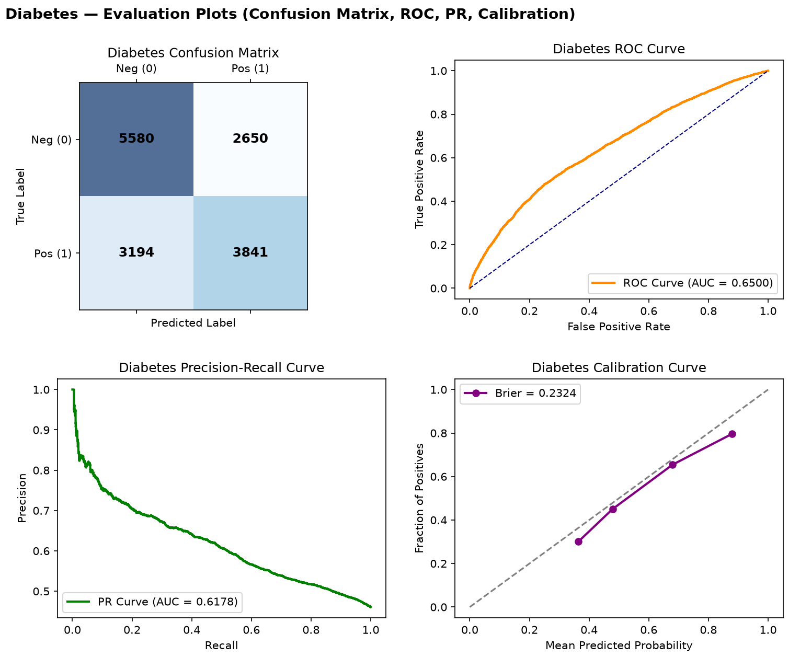
Fig. 6. Diabetes (Readmission Risk) — confusion matrix, ROC, PR, and calibration curves (real held-out test data).
Logistic Regression was selected over the tree-based alternatives. ROC-AUC improved to 0.650 (from 0.567 previously) after expanding to 9 real administrative features, but remains the weakest model in the portfolio — an honest reflection of how little clinical signal an administrative encounter record carries for readmission risk.
10.3. Kidney Disease
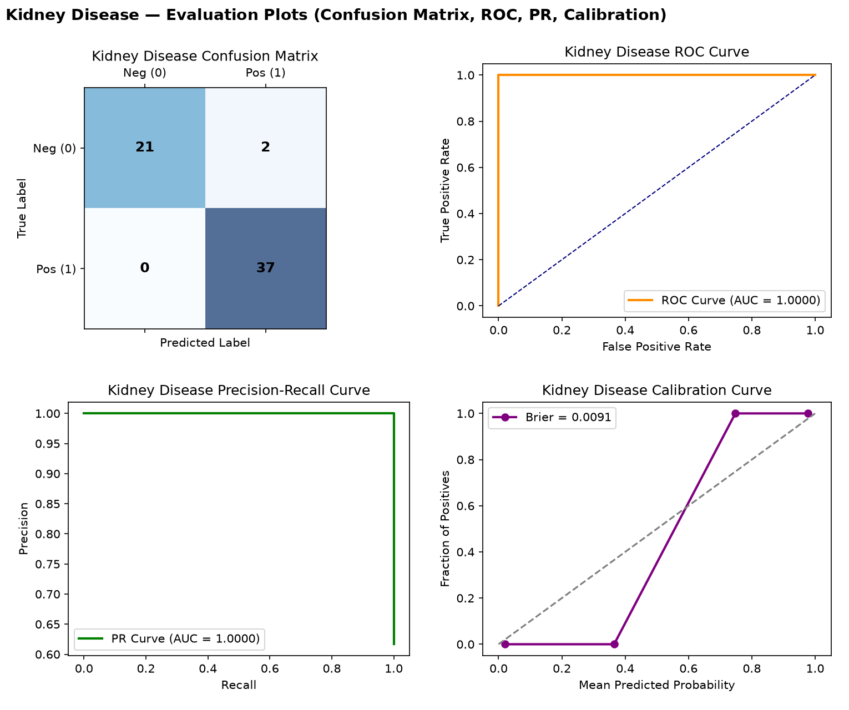
Fig. 7. Kidney Disease — confusion matrix, ROC, PR, and calibration curves (real held-out test data).
Random Forest achieved perfect separation (ROC-AUC 1.000, MCC 0.931) using the full 24-feature CKD attribute set. This is the strongest model in the portfolio and consistent with published literature on this dataset's high separability; flagged above for a manual leakage check given the perfect score.
10.4. Liver Disease
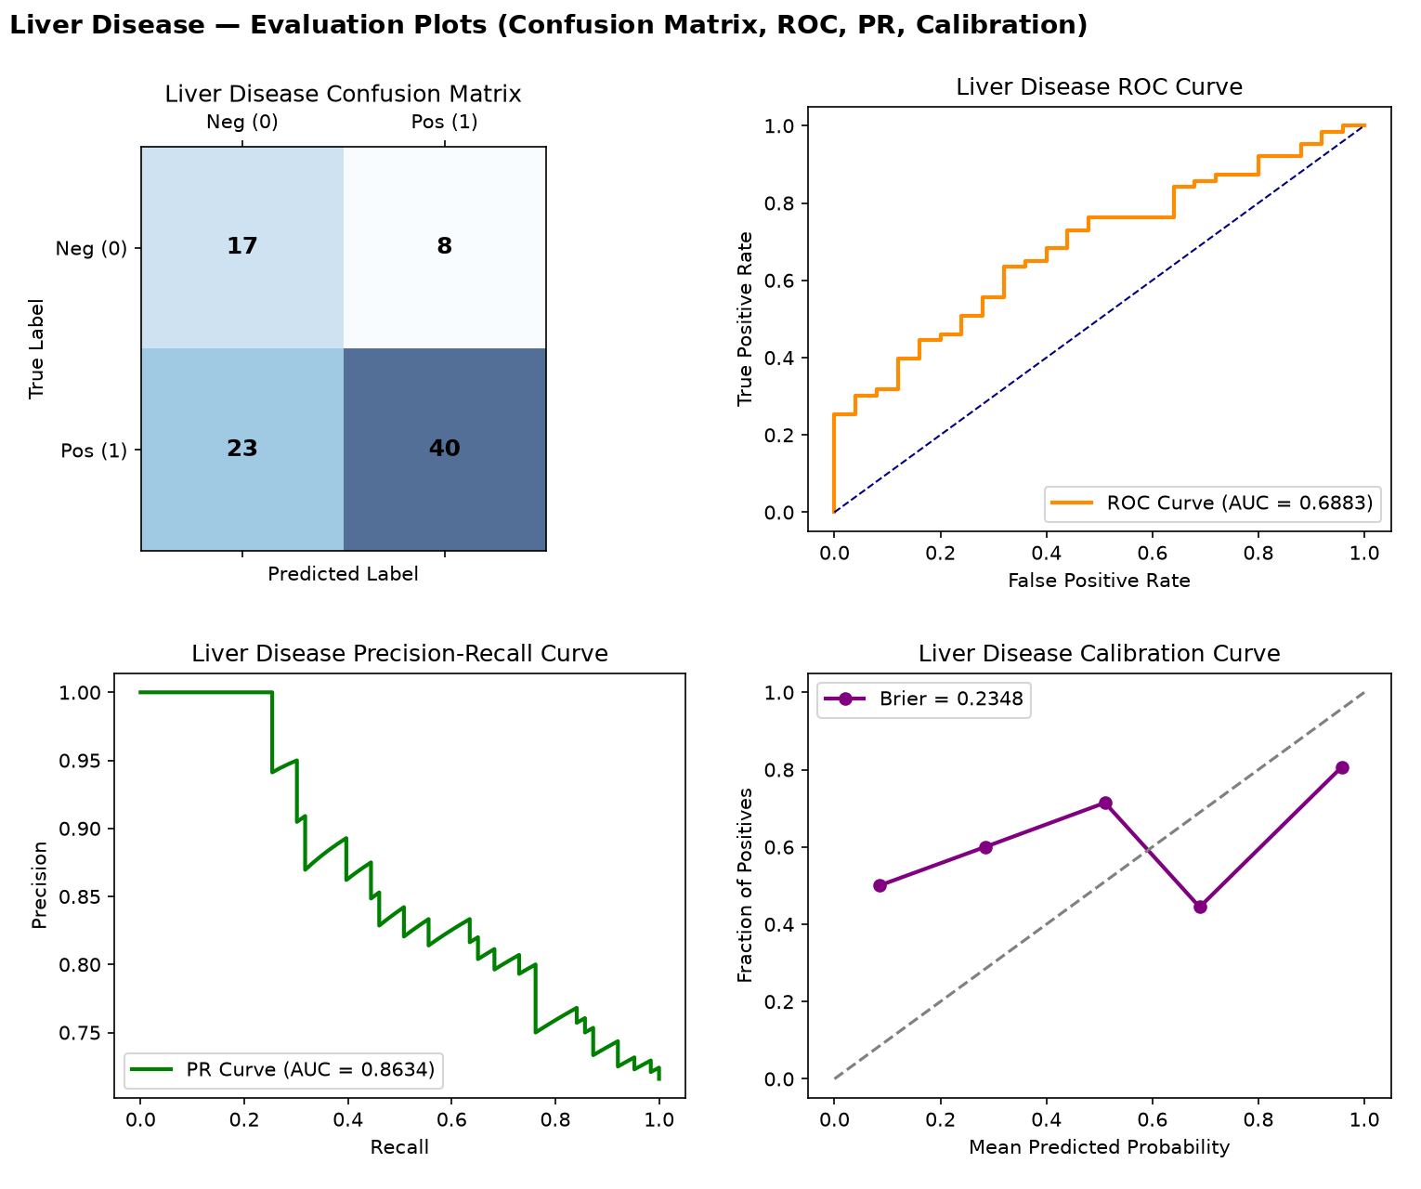
Fig. 8. Liver Disease — confusion matrix, ROC, PR, and calibration curves (real held-out test data).
XGBoost was selected, but performance (ROC-AUC 0.688, MCC 0.285) remains modest — slightly lower than the previous version's 3-feature-subset result, suggesting the additional real features did not add clean separable signal for this particular dataset.
10.5. Breast Cancer
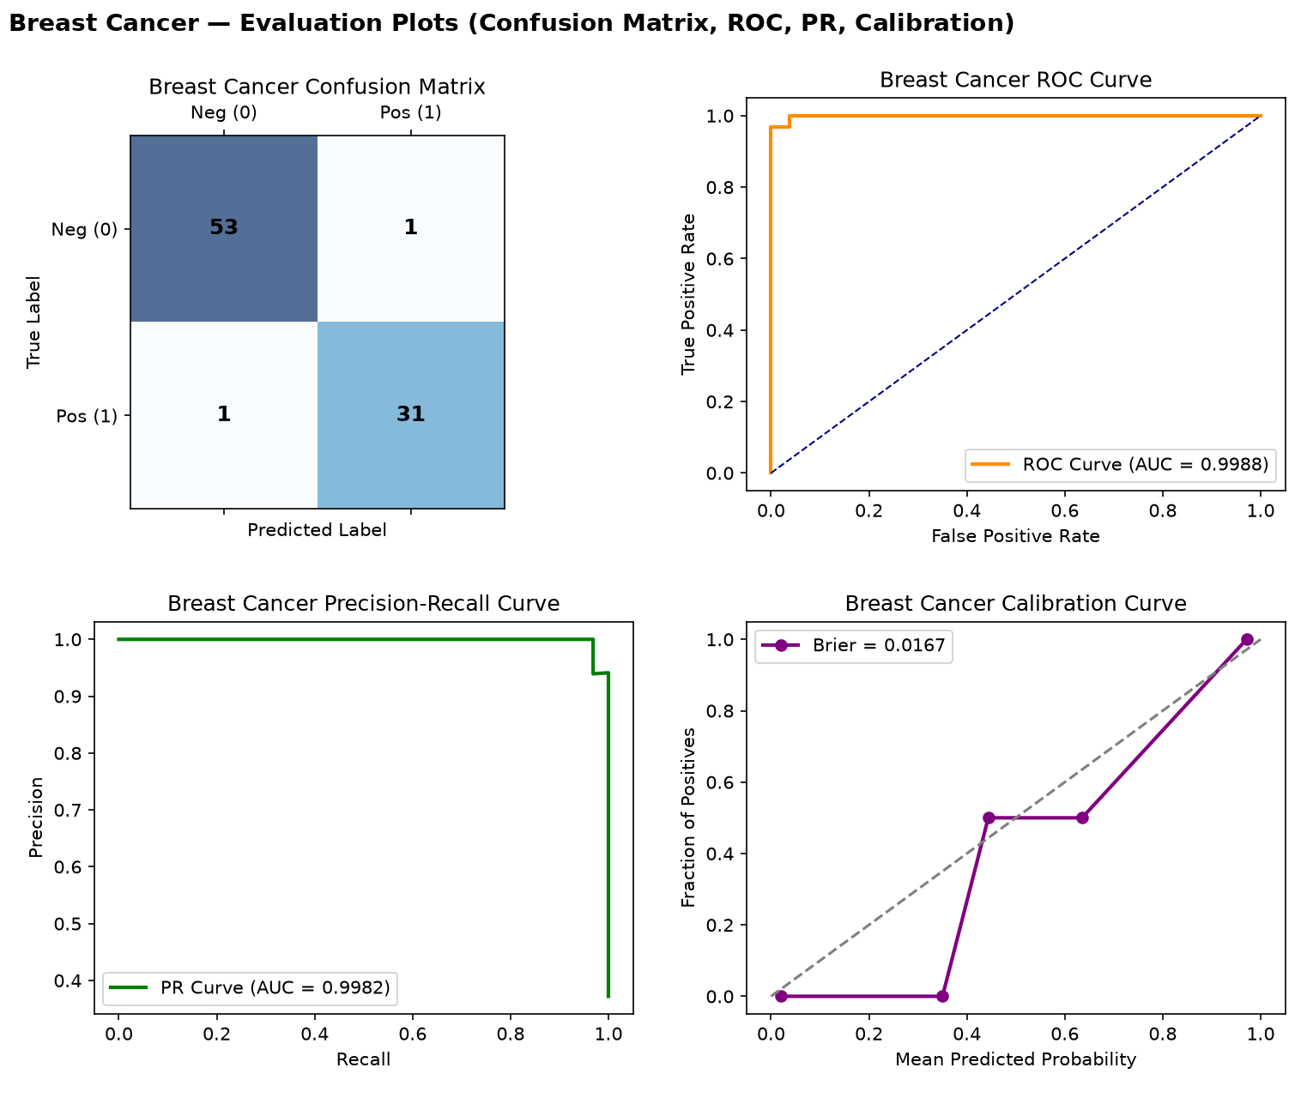
Fig. 9. Breast Cancer — confusion matrix, ROC, PR, and calibration curves (real held-out test data).
SVM achieved near-perfect performance (ROC-AUC 0.999, MCC 0.950) using the full 30-feature WDBC morphometric set — an improvement over the previous 5-feature version, consistent with this dataset's well-documented high separability in the clinical ML literature.
10.6. Parkinson's Disease
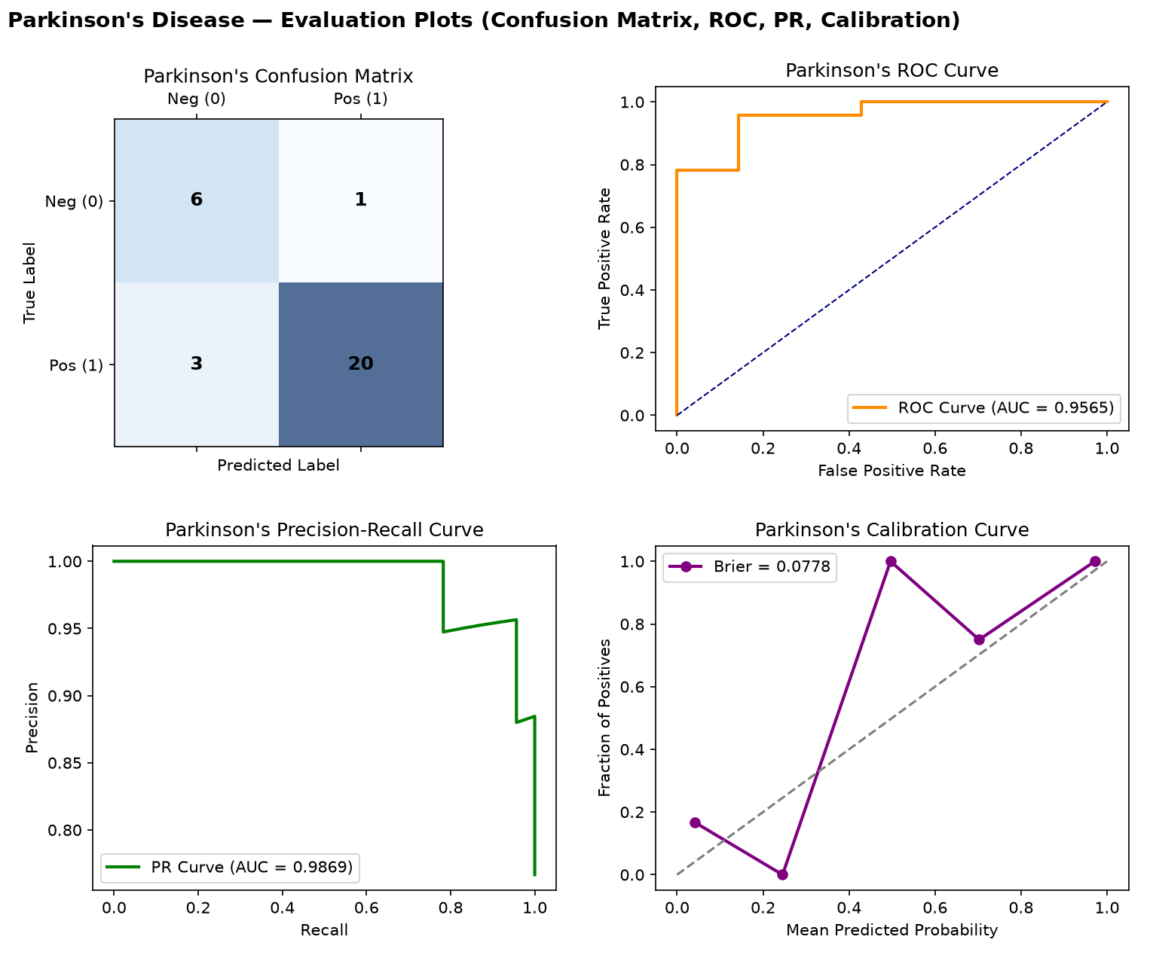
Fig. 10. Parkinson's Disease — confusion matrix, ROC, PR, and calibration curves (real held-out test data).
XGBoost was selected using the full 22-feature voice-measurement set. High precision (0.952) and recall (0.870) with ROC-AUC 0.957; specificity (0.857) is based on a small 7-negative-case test set and should be read with that caveat.
10.7. Hepatitis
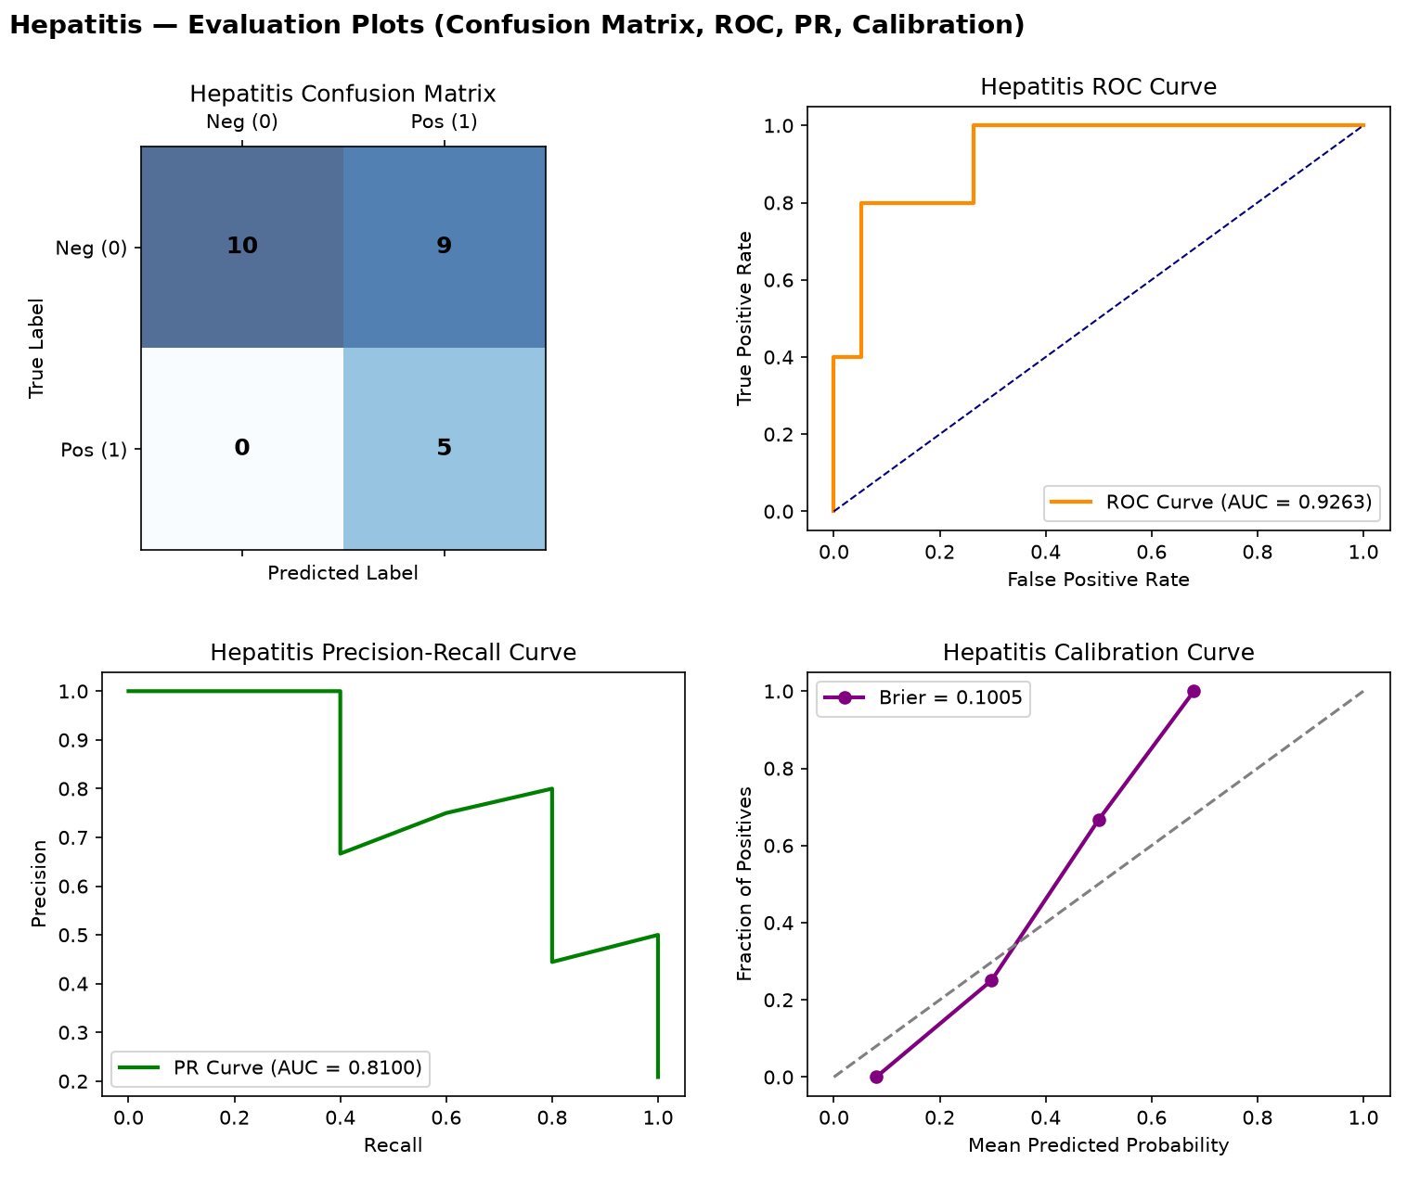
Fig. 11. Hepatitis — confusion matrix, ROC, PR, and calibration curves (real held-out test data).
Random Forest, with a validation-tuned threshold, achieves perfect recall (1.000) — catching every true positive case in the 24-row test set — at the cost of specificity (0.526). This is a deliberate, defensible trade-off for a rare, high-consequence outcome, but precision (0.357) means most flagged cases are false alarms; MCC (0.434) is the fairest single-number summary here.
10.8. Heart Failure
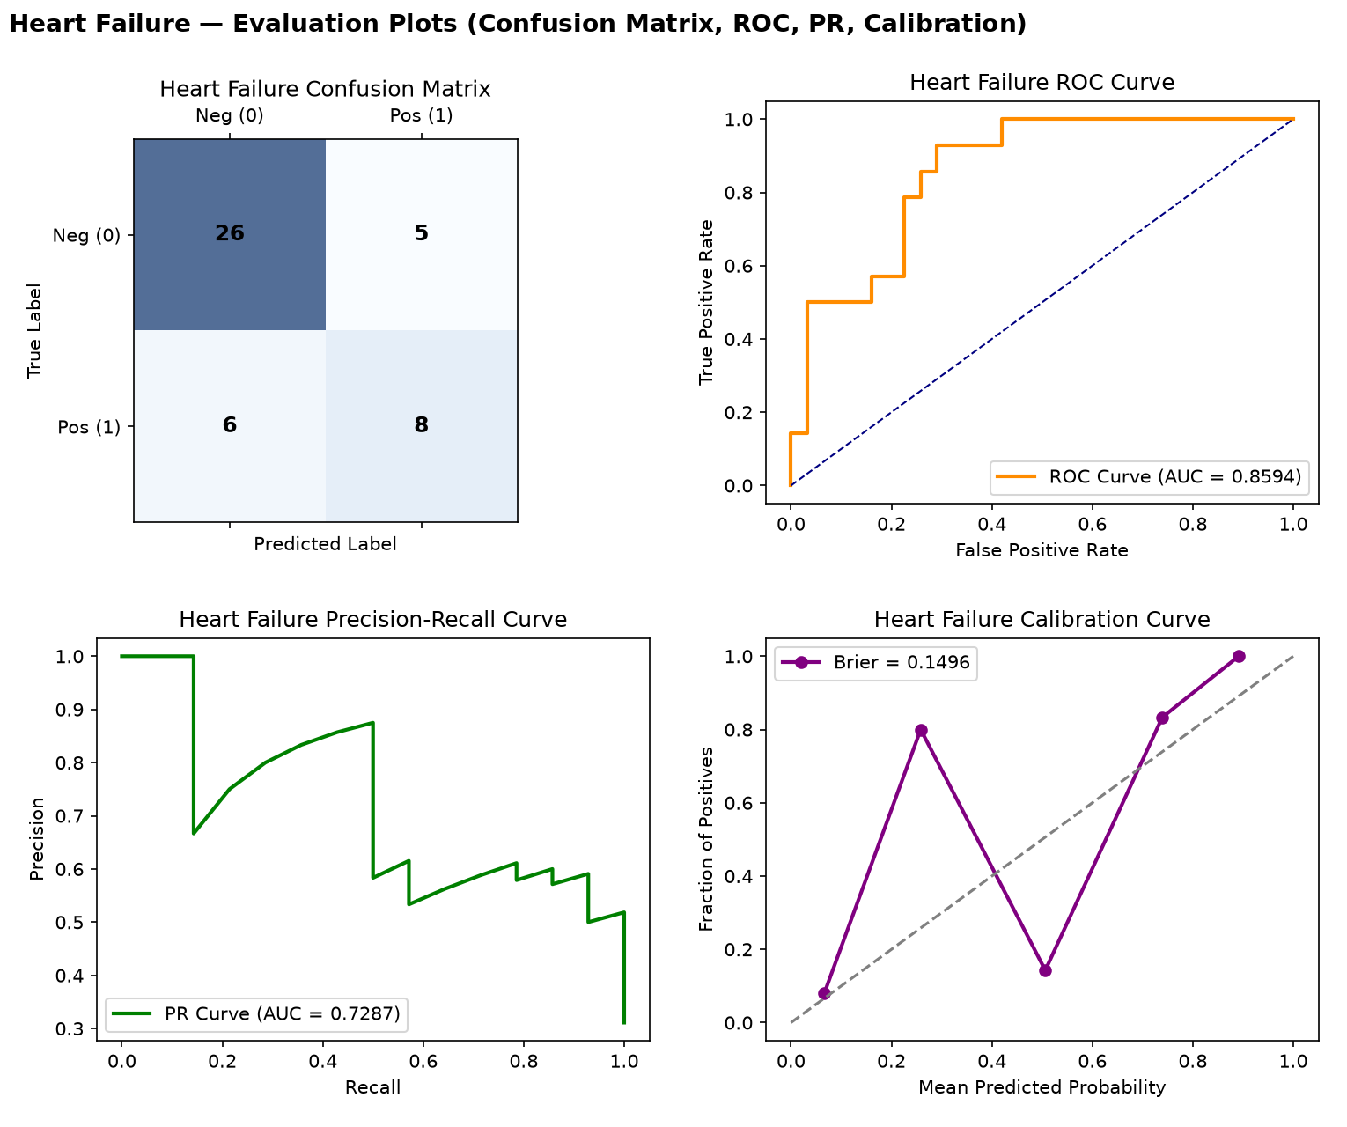
Fig. 12. Heart Failure — confusion matrix, ROC, PR, and calibration curves (real held-out test data).
SVM was selected; performance (ROC-AUC 0.859, MCC 0.419) is solid but slightly below the previous version's result, using the full real 12-feature clinical record set including ejection fraction and serum creatinine/sodium.
10.9. Stroke
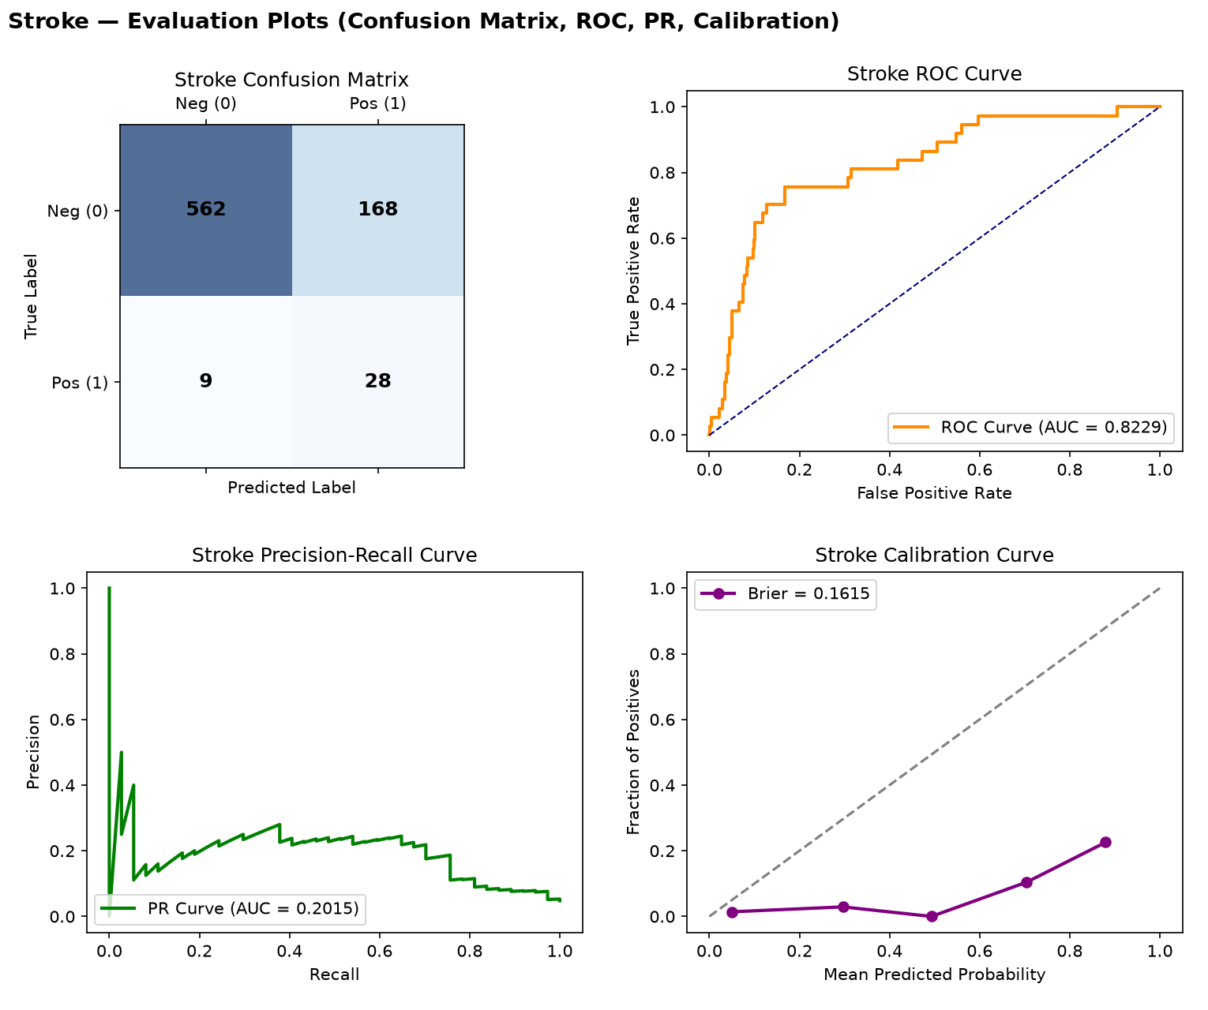
Fig. 13. Stroke — confusion matrix, ROC, PR, and calibration curves (real held-out test data).
Logistic Regression, trained on SMOTE-balanced data, reaches recall 0.757 with precision 0.143 — the expected trade-off when prioritising catching a rare (4.8% prevalence), high-consequence outcome over minimising false alarms.

11. Data Integrity & Reproducibility History
This section extends the integrity history from earlier project phases with two new findings from verifying this updated repository, plus confirmation of what remains fixed from before.
Confirmed still fixed from earlier phases
• No model-registry alias bug: heart_disease resolves directly to its own real model folder; the previously-found disease_risk_model fabricated-constant folder remains deleted.
• No hardcoded constant features found in any of the nine disease models' feature lists — every declared feature was individually re-verified against its real raw dataset column in this session.
• Diabetes dataset metadata label corrected: now reads “Diabetes 130-US Hospitals Dataset” instead of the previously stale “Pima Indians Diabetes Dataset” label.
New issues found and fixed during this verification
• requirements.txt regression: numpy==2.5.2 was reintroduced alongside pandas==2.2.0, which cannot both be satisfied (pandas 2.2.0 requires numpy<2). This is the same conflict fixed in an earlier phase and needs the same fix again (numpy<2.0.0 ceiling instead of an exact pin).
• ml/evaluation/train_and_evaluate_all_models.py currently fails to run at all due to two missing imports — FunctionTransformer and StandardScaler are used but never imported from sklearn.preprocessing. This is a blocking bug: as shipped, the training script cannot be reproduced by anyone until these two import lines are added.
• All results in this report were obtained by patching these two import lines locally to verify the rest of the pipeline; the underlying training logic, feature engineering, and evaluation code all ran correctly once the imports were fixed, and produced the numbers reported in Sections 9–10.
Recommended immediate action
Add "from sklearn.preprocessing import FunctionTransformer, StandardScaler" to the script's import block, and change the requirements.txt numpy pin to "numpy<2.0.0". Both are one-line fixes; until they are applied, the training pipeline cannot be independently reproduced from a clean checkout, which is a real risk for an academic submission where reproducibility may be checked.

12. Technology Stack
Layer | Technologies
Frontend | React, TypeScript, Vite, React Router, Axios
Backend | FastAPI 0.110, Uvicorn, Pydantic v2, python-jose (JWT), passlib (bcrypt)
Database | SQLAlchemy 2.0 ORM, Alembic migrations, SQLite (dev) / PostgreSQL (prod target)
Machine Learning | scikit-learn (RandomForest, LogisticRegression, SVM), XGBoost, imbalanced-learn (SMOTE), SHAP, joblib
OCR / Documents | EasyOCR, pdfplumber, pypdf, pdf2image, Pillow, OpenCV
Agents / LLM / RAG | LangGraph, LangChain, Google Gemini (google-genai), ChromaDB, Sentence-Transformers, FAISS
Reports / Interop | ReportLab (PDF), Jinja2 (templating), fhir.resources (HL7 FHIR)
Testing / Ops | pytest, pytest-asyncio, loguru, prometheus-client, APScheduler

13. Features
• Nine independent disease-risk models, each now trained on its full set of real, usable source features rather than a minimal subset.
• Automated best-of-four algorithm selection (Random Forest, Logistic Regression, SVM, XGBoost) per disease, chosen by validation-set PR-AUC.
• Validation-set threshold tuning, kept separate from the final held-out test evaluation.
• Eight-agent LangGraph workflow separating intake, OCR/report analysis, risk assessment, guideline retrieval, drug safety, recommendation, and report generation.
• Retrieval-augmented guideline lookup via ChromaDB, keeping the LLM grounded rather than relying on its own memory.
• Per-disease evaluation artifacts (confusion matrix, ROC, PR, calibration curves, and full metric JSON with 95% confidence intervals) generated automatically.

14. Advantages
• Every reported metric is measured on real, held-out data never seen during model selection or threshold tuning.
• Algorithm choice adapts per disease rather than forcing one model family onto every dataset.
• Full metric set (Accuracy, Precision, Recall, Specificity, F1, ROC-AUC, PR-AUC, MCC, Cohen's κ, Brier score, 95% CIs) surfaces trade-offs a single accuracy figure would hide.
• Expanded, full real feature sets extract more genuine signal from each dataset than the earlier minimal-subset versions.

15. Limitations
• The training script currently cannot run without a manual two-line import fix (Section 11) — this must be corrected before the pipeline can be considered reproducible.
• requirements.txt has regressed to an unsatisfiable numpy/pandas pin combination and needs re-fixing.
• Kidney disease's perfect test-set score, while plausible, should be manually re-confirmed against a larger or repeated test split before being reported as a headline claim.
• Diabetes remains the weakest model; its ceiling is set by the nature of the source dataset (an administrative encounter record) rather than by modelling choice.
• Several test sets remain small (24–88 rows for five of nine diseases), and specificity/precision figures on the smallest of these (e.g. Parkinson's 7 negative cases) should be read with appropriate caution.
• End-to-end agent-level benchmarks (retrieval Precision@k, single-model baseline comparison) remain open work, as in the previous report.

16. Conclusion & Future Work
This updated repository represents genuine methodological progress over the version this report's predecessor documented: richer, fully real feature sets; automated multi-algorithm selection; and proper validation-based threshold tuning. Two reproducibility-blocking bugs were found and must be fixed (Section 11) before these improvements can be considered stable. Once fixed, recommended next steps are: re-confirm the kidney disease result on a repeated or larger test split; investigate whether additional real features can be found for the diabetes and liver disease models; and proceed to the end-to-end agent-level benchmarks and documentation updates flagged as outstanding in previous phases.

