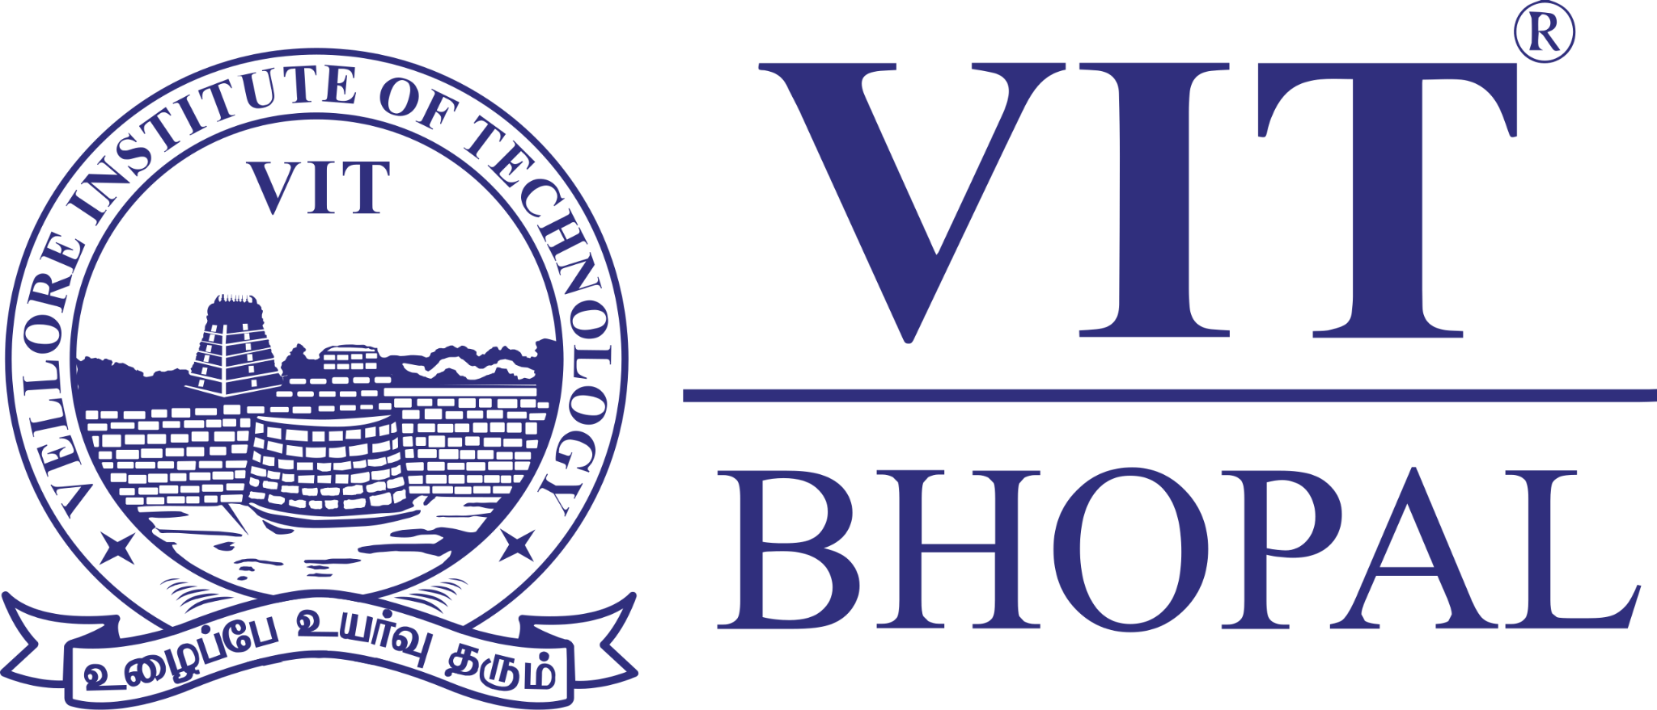

DIGITAL LITERACY PROJECT REPORT

NAME: Piyush Pandey
REGISTRATION NUMBER: 25BAI10854

TASK 1:
For this task, I designed a one-page visual resource titled "Digital Literacy Awareness: Module 1" using Canva. The objective was to provide my batchmates with a concise yet comprehensive guide to navigating the modern digital landscape. I chose a clean, three-column layout to ensure the information was digestible and visually organised.
The design covers three essential pillars:
- Definition of Digital Literacy: Explaining it as a combination of technical skills and critical thinking.
- Safe Internet Practices: Highlighting the importance of Password Managers, Multi-Factor Authentication (MFA), and link verification.
- Email Etiquette: Providing actionable tips on subject lines, proofreading, and the responsible use of "Reply All."
One thing I found particularly interesting during the design process was the "less is more" challenge. I initially had much more text, but I realised that for an infographic to be effective, I had to boil complex security concepts down into "snackable" bullet points. Balancing the VIT Bhopal colour palette with custom illustrations helped make the technical advice feel more approachable and professional.

TASK 2:
For this module, I established my professional digital presence by setting up and optimising profiles on GitHub, Kaggle, and LinkedIn. Each platform serves a distinct purpose in my growth as a student and future professional.
- GitHub functions as my version-controlled code repository where I maintain a profile README to showcase my current projects and technical interests.
- Kaggle provides a platform for me to engage with data science competitions, datasets, and a global community of machine learning enthusiasts.
- LinkedIn acts as my professional landing page, connecting me with the academic community and potential internship coordinators.
Over the next four years, I plan to use these platforms as a living record of my progress. I will use GitHub to host my academic assignments and personal coding projects to demonstrate my consistency. On Kaggle, I aim to build a portfolio of notebooks and datasets to prove my analytical capabilities. Finally, I will use LinkedIn to document my certifications, network with industry leaders, and stay updated on emerging technologies. Maintaining these profiles will ensure that my skills are visible to employers long before I graduate.

TASK3:
For the third module of the Digital Ambassador program, I focused on enhancing my technical proficiency and digital assessment skills using HackerRank and Google Workspace. These platforms represent the dual pillars of modern engineering: individual technical mastery and effective group collaboration.
- Part A: I utilized HackerRank to strengthen my foundational programming skills. I completed several Python challenges, including "Say Hello, World!", "Loops," and "Write a Function." By solving these problems, I earned a 2-star Python badge, demonstrating my ability to handle basic syntax, logic, and algorithmic thinking. This platform is an excellent resource for practising competitive coding and preparing for technical interviews.

- Part B: I developed a Digital Literacy Awareness Quiz using Google Forms to educate my batchmates on cyber hygiene. The quiz features five targeted questions covering topics like password complexity, phishing identification, and the mechanics of Two-Factor Authentication (2FA). To manage the data, I linked the form to a Google Sheet for real-time response tracking and analysis.
Academically, these tools are indispensable. HackerRank provides a structured environment for continuous skill building, while Google Workspace streamlines data collection and project management. Together, they allow me to solve complex technical problems and collaborate efficiently on academic projects, ensuring a well-rounded digital skillset for my undergraduate journey.

TASK4:
For this module, I practised the essential skill of professional digital correspondence by drafting two distinct emails and a social media conduct guide.
- Email 1: I addressed a professor to request an assignment extension due to health issues, ensuring the tone remained respectful and the request was clear.
- Email 2: I drafted an internship inquiry highlighting my background in B.Tech CSE (AI/ML) and my experience with projects like a URL Safety Checker. Both documents utilised clear subject lines and formal sign-offs to maintain professional standards.
Furthermore, I created a Social Media Checklist to promote responsible online behaviour. This included "Do's" such as verifying information before sharing and "Don'ts" like engaging in online harassment or oversharing personal details.
A hypothetical situation where poor digital communication causes real-world problems is a "Reply All" chain in a large university. If a student accidentally sends a private health update or a grievance to an entire batch, it can lead to a significant breach of privacy and digital clutter. This could be avoided by always double-checking the recipient field and ensuring that sensitive information is only sent to the necessary individuals.
TASK5:
For the final module of the Digital Ambassador program, I focused on the critical issue of UPI and Online Payment Fraud, a rapidly growing threat in India. I developed a comprehensive case study based on a real 2025 incident in Delhi where fraudsters stole ₹20 lakh by exploiting stolen smartphones and linked banking applications. The study details the sophisticated step-by-step process used by scammers—from obtaining a lost device to resetting PINs through Aadhaar-linked authentication—to highlight how vulnerable personal data can be if a phone is not properly secured.
To complement this research, I created a "Stay Safe Online" Prevention Checklist specifically for college students. This resource provides ten actionable tips, including essential financial safety rules such as never entering a UPI PIN to receive money and immediately blocking SIM cards if a device is lost. I also included the vital reporting channels: the National Cyber Crime Portal (cybercrime.gov.in) and the 1930 Helpline.
What surprised me most during this research was how quickly scammers can bypass security on a stolen device simply by having access to the SIM card and linked apps. It made me realise that a simple screen lock is not enough. As a result, the one habit I will personally change is enabling a SIM card PIN. This extra layer of security ensures that even if my phone is stolen, the scammers cannot receive OTPs or reset my banking credentials using my mobile number.

Conclusion: Overall Learning
This project has been a transformative experience in my journey as a Student Digital Ambassador. By navigating these five modules, I have transitioned from a passive technology user to an informed digital citizen. I learned that professional presence is multifaceted—requiring a balance of technical proof on platforms like GitHub and HackerRank, and soft-skill excellence through disciplined email etiquette and social media responsibility.
The most significant takeaway was the realisation of how thin the line is between convenience and vulnerability. Researching UPI fraud highlighted that digital literacy is not just about using tools, but about actively defending one’s data through habits like enabling SIM locks and verifying every transaction request. I am now better equipped to guide my batchmates at VIT Bhopal toward a safer, more professional digital future.

References

Digital Tools & Platforms
- Design: Canva (Used for Module 1 Infographic)
- Version Control & Portfolio: GitHub (Profile README and repository management)
- Professional Networking: LinkedIn (Education and career documentation)
- Data Science & Coding: Kaggle and HackerRank (Skill validation and Python certifications)
- Collaboration: Google Workspace (Forms and Sheets for data collection)

Security & Reporting Resources
- National Cyber Crime Portal: [suspicious link removed]
- Cyber Crime Helpline: 1930
- Case Study Source: Delhi Police reported incidents (2025) regarding UPI/Smartphone theft.

