**Table of Content**

Chapter 1: Abstract

Chapter 2:Tools and Languages Used

Chapter 3: Services Used(Detailed)

Chapter 4: Code of Website

Chapter 5: Database

Chapter 6: Accessing Database

Chapter 7: Summary

Chapter 8: References

**Chapter-1**

**Abstract**

“In this project, I made a website using HTML, CSS, PHP AND BootStrap Titled ‘MyBlog”.  
It is a platform which allows users to write their blogs and let it be available for others to read.

Moreover, they can also read other user’s blogs too.

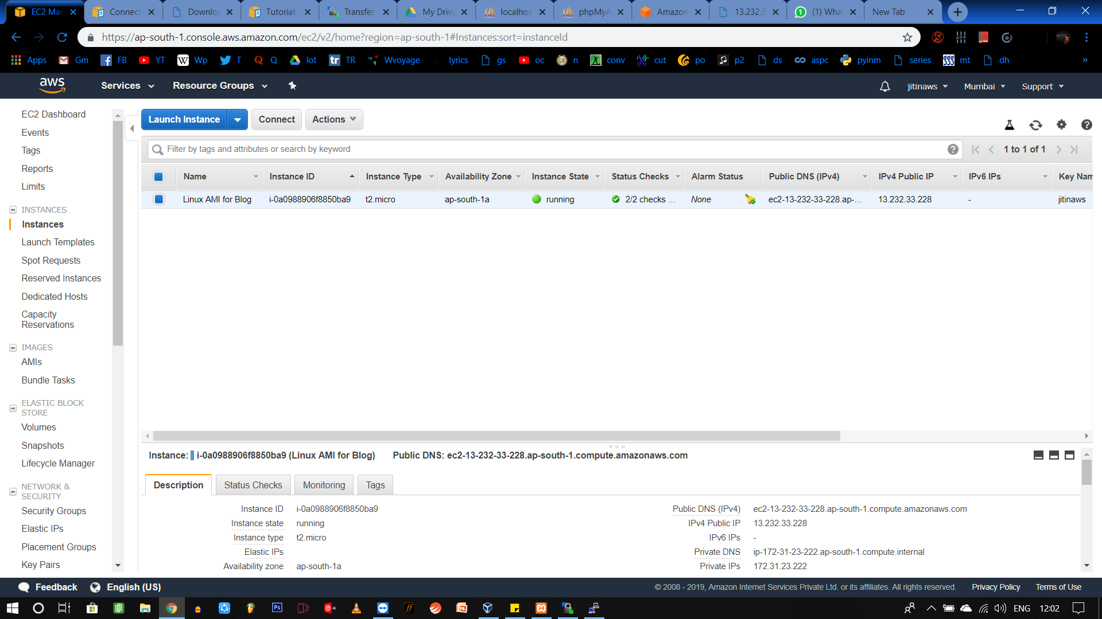

(Image of Linux AMI Instance on AWS Website)

**Chapter-2**

**Tools and Languages Used**

1. HTML
2. CSS
3. BOOTSTRAP
4. PHP
5. MYSQL
6. APACHE WEB SERVER
7. PHPMYADMIN

**Chapter – 3**

**Services Used** (Detailed)

In this, we used EC2 service provided by AWS.  
The Steps are as follows:

**1-Instance:**

**We** made an instance “Amazon Linux AMI” using EC2 and added 3 protocols in it i.e, HTTP, HTTPS, SSH.

# 2 -Installed a Lamp Web Server with AMAZON Linux AMI

# Connected my instance (This is explained in next points)

**A.Software package updated using:**

**$ sudo yum update –y**

**B. Installed Apache Web Server**

**$ sudo yum install -y httpd24 php70 mysql56-server php70-mysqlnd**

**C.Started the server**

**$ sudo service httpd start**

**D. Configured the Apache web server to start at each system boot using:**

**$chkconfig**

**E. Some security groups that were already added while creating the instance :**

* **Type: HTTP**
* **Protocol: TCP**
* **Port Range: 80**
* **Source: Custom**

**F. Then file permissions were set accordingly.**

**G. phpmyadmin is installed to make database using MYSQL.**

# 3-Connected Linux Instance from Windows Using PuTTY & Working in PuTTY session.

In this, we first converted the public key pair downloaded from AWS website of our instance to private key using PuTTY Gen and then added it to PuTTY and proceeded to PuTTY terminal as ec2-user.

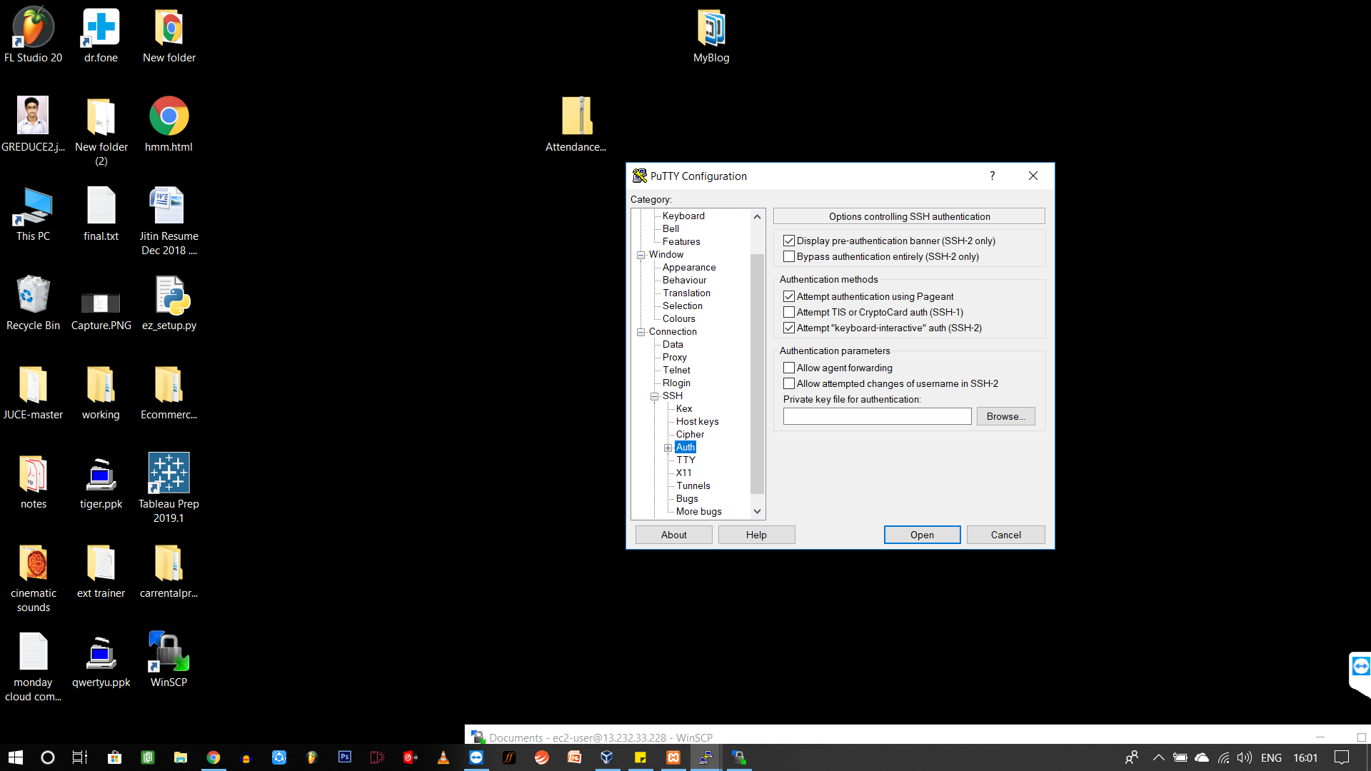

(While configuring PuTTY)

## **4-Transferring Files to Your Linux Instance Using WinSCP**

Downloaded and installed WinSCP from  <http://winscp.net/eng/download.php>

Added PuTTY private key in it.

Login and connected.

Now transferred Website files using drag and drop.

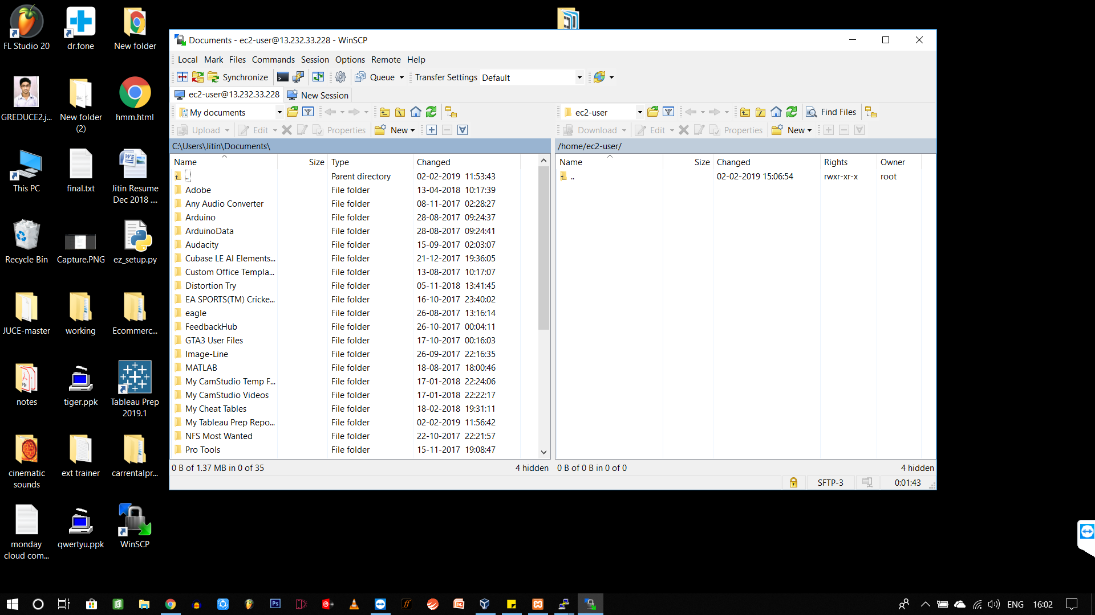

**(Transferring files in WinSCP software)**

**Chapter – 4**

**Code of Website**

INDEX:

<html>

<head>

<link type="text/css" rel="stylesheet" href="css/bootstrap.css"/>

<script src="js/bootstrap.js"></script>

<script src="js/jquery.min.js"></script>

<style>

#head{

background-color: cornflowerblue;

color: white;

}

</style>

</head>

<body>

<div class="container-fluid">

<?php 'conn.php' ?>

<div id="head" class="row">

<div class="col-xs-6"><h2>MyBlog</h2></div>

<div class="col-xs-6"></div>

</div> <br>

<div id=info>

<h2>Login here</h2>

<form action="login.php" method="post">

<label>Username:</label>

<input type="text" name="uname" placeholder="User name"><br><br>

<label>Password:</label>

<input type="text" name="pass" placeholder="Password"><br><br>

<button style="background-color:#6495ed;color:white;" type="submit"><b>Login</b></button>

</form>

<h2>Signup here</h2>

<form action="signup.php" method="post">

<label>Username:</label>

<input type="text" name="name" placeholder="User name"><br><br>

<label>Password:</label>

<input type="text" name="pass" placeholder="Password"><br><br>

<button style="background-color:#6495ed;color:white;" type="submit"><b>Signup</b></button>

</form>

</div>

</div>

</body>

</html>

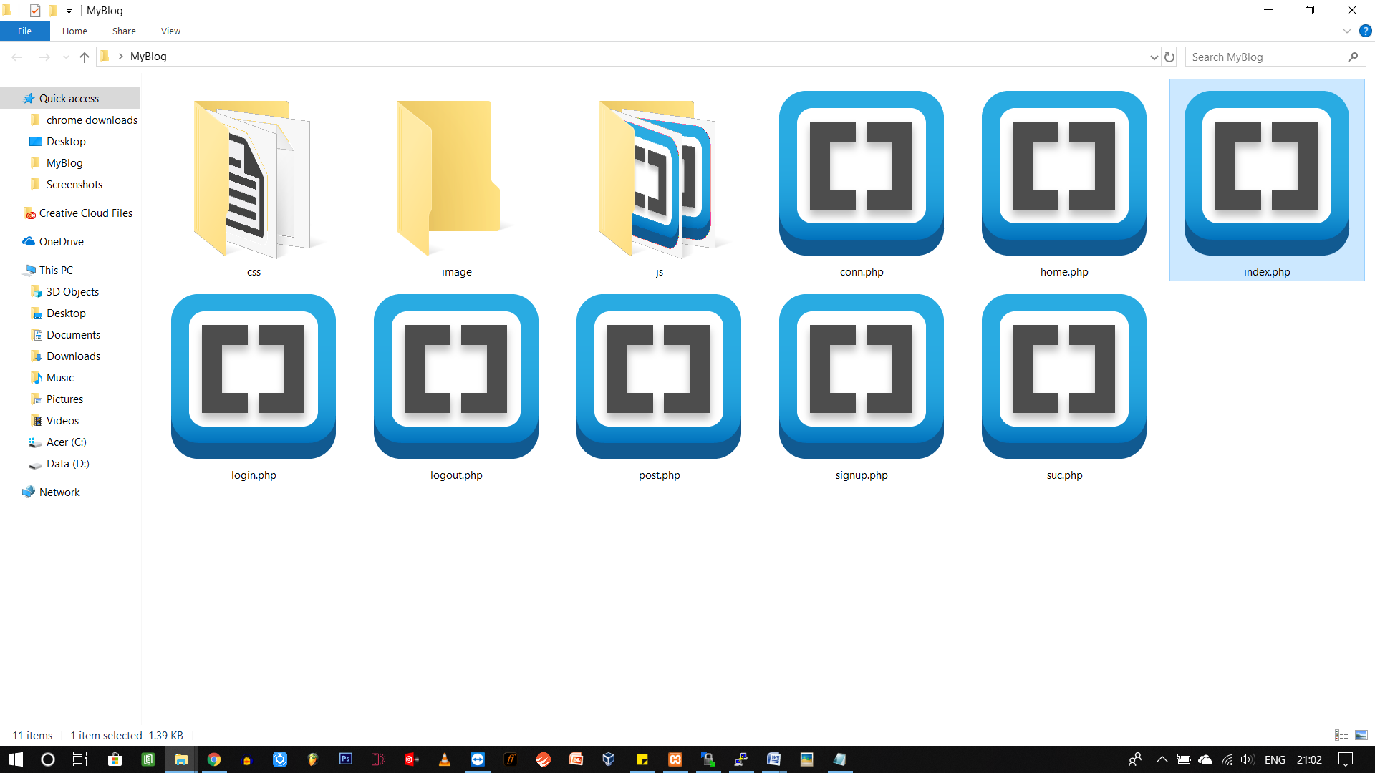(Folder containing files of website)

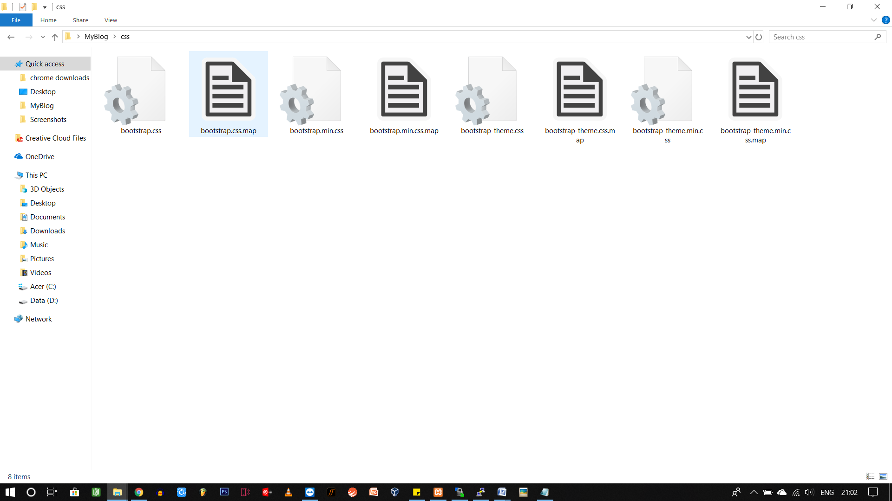(Folder containing BootStrap and CSS Files)

**Chapter 5**

**Database**

* Made using **phpMyAdmin** installed in last step.

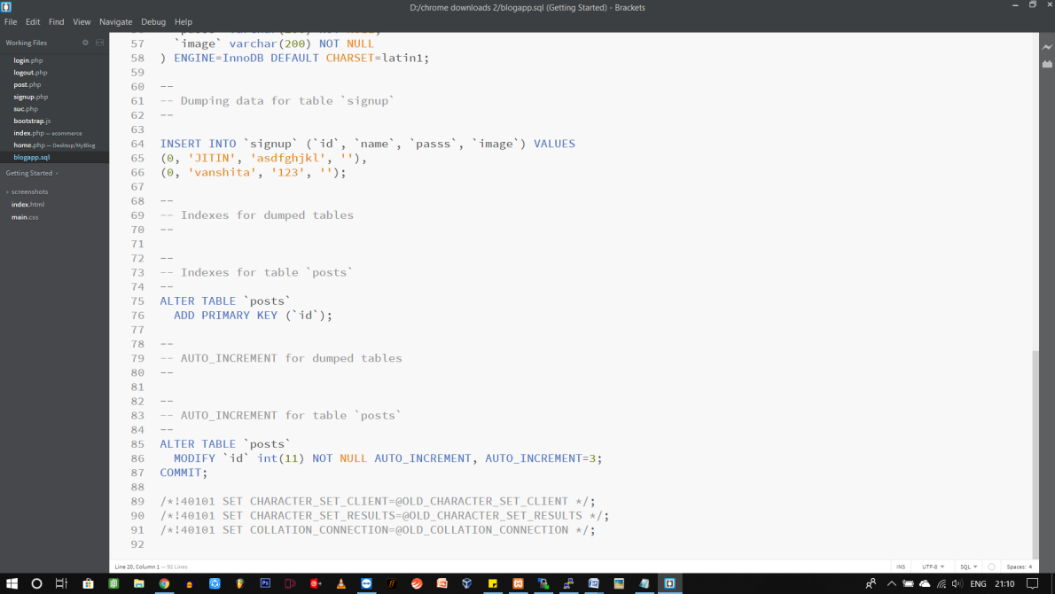

(SQL Code of Database {Dynamic})

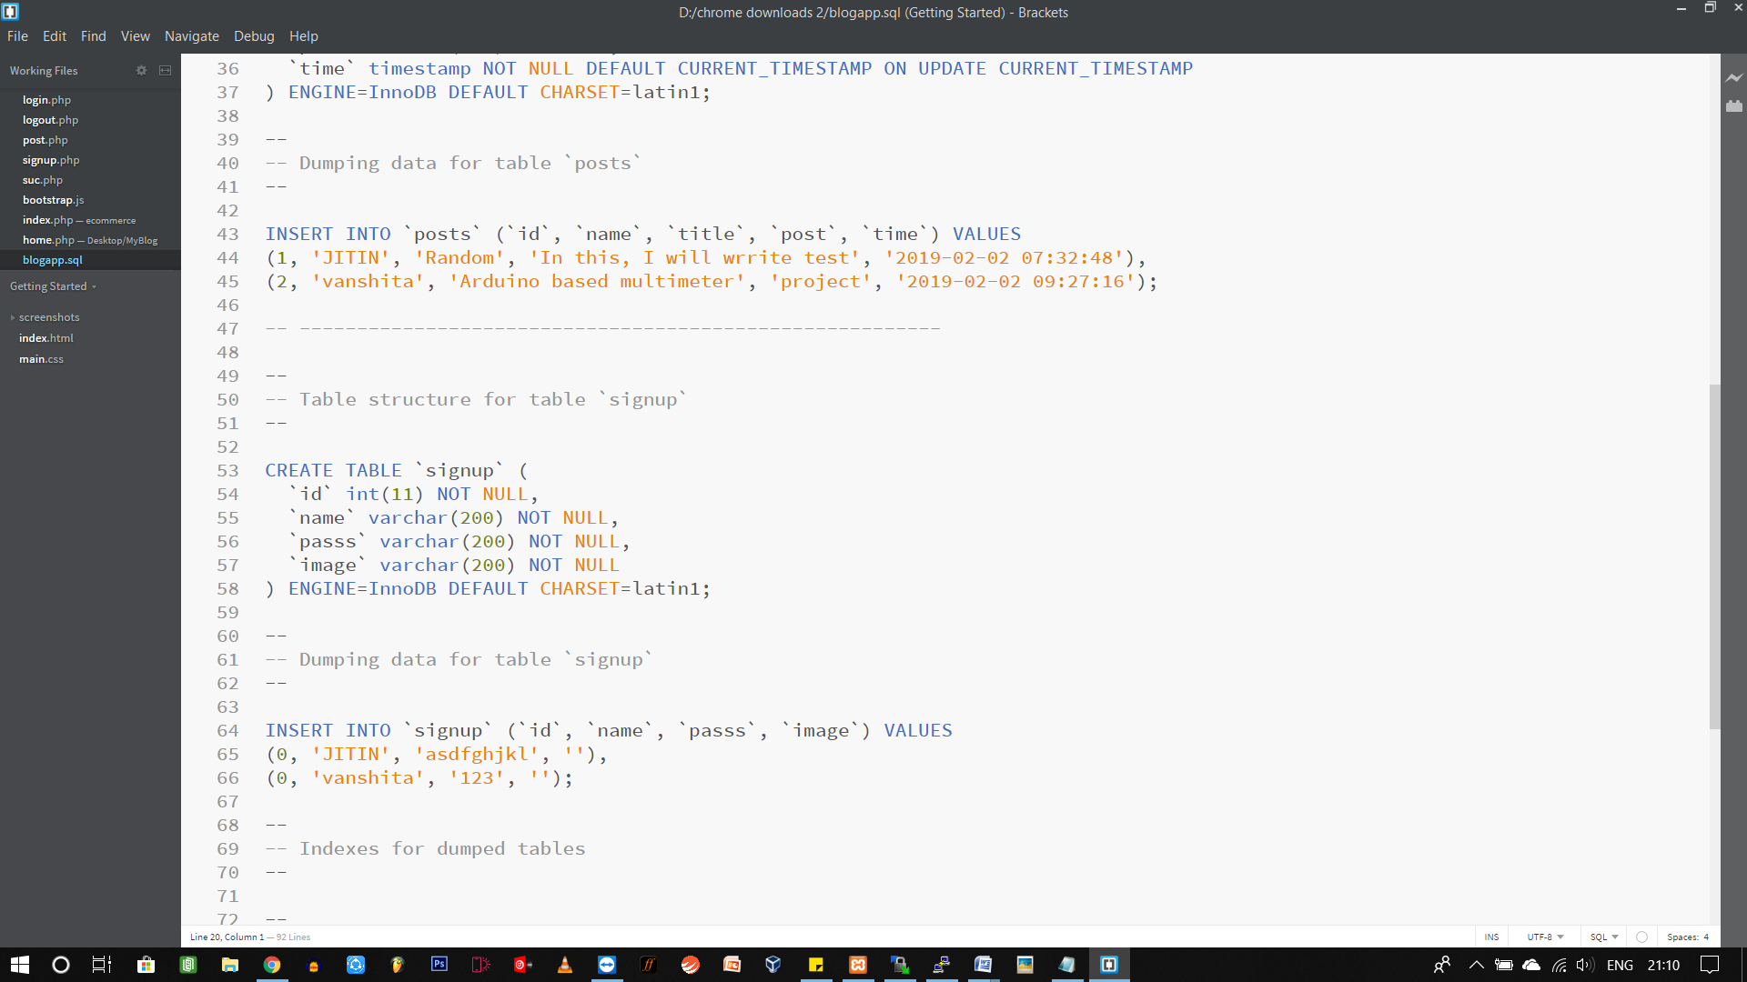

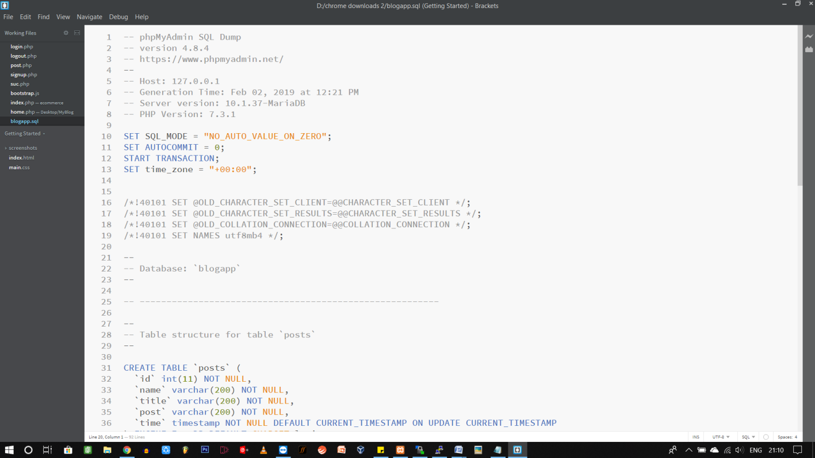

(SQL Code of Database {Dynamic})

**Chapter – 6**

**Accessing Database**

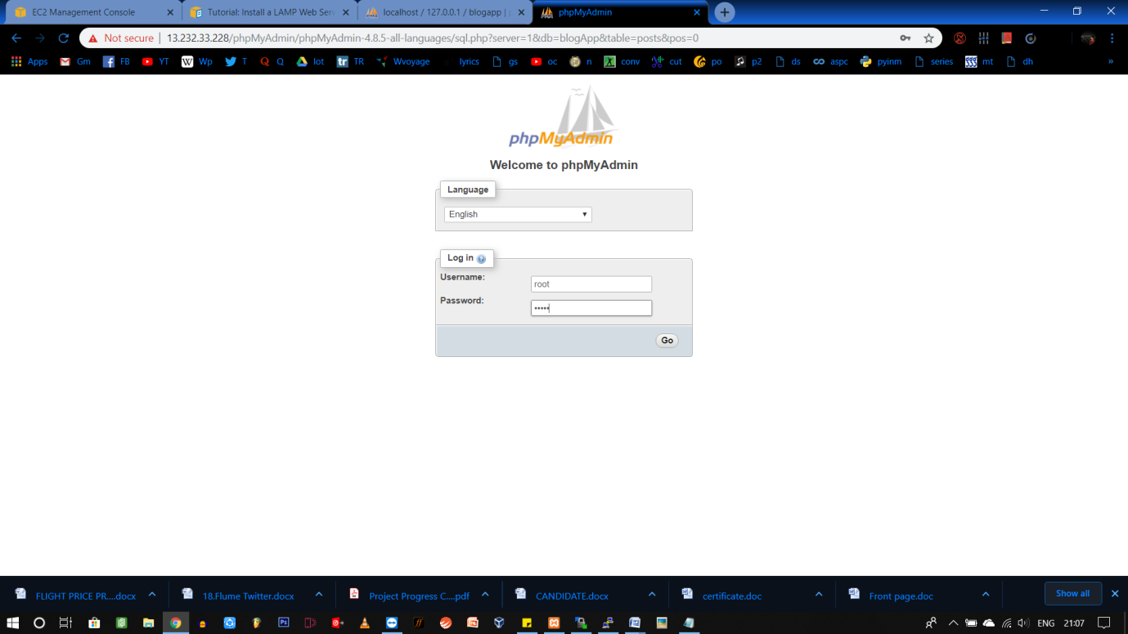

**(Using Ip_address/myPhpAdmin, we accessed the database)**

**ID: root**

**Password-\*\*\*\*\***

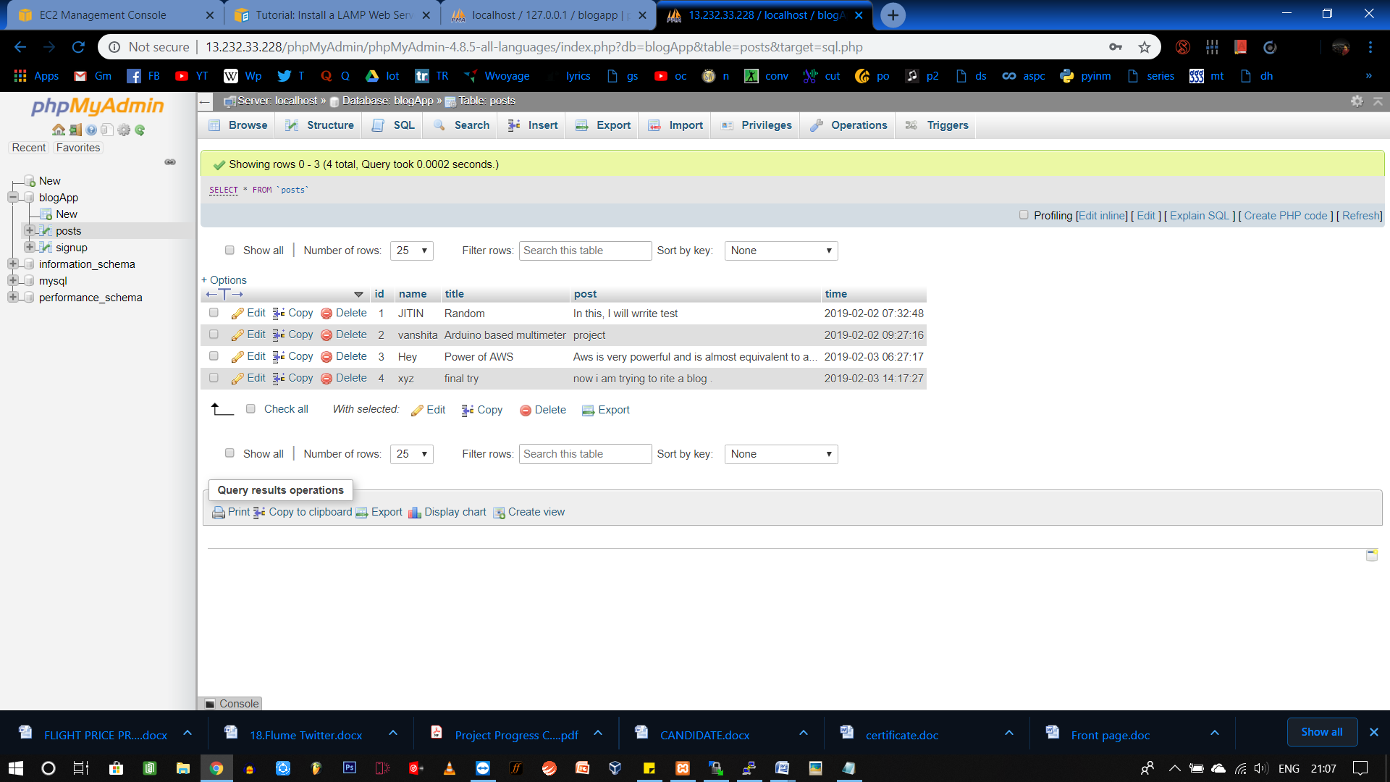

**(**Posts database in phpMyAdmin)

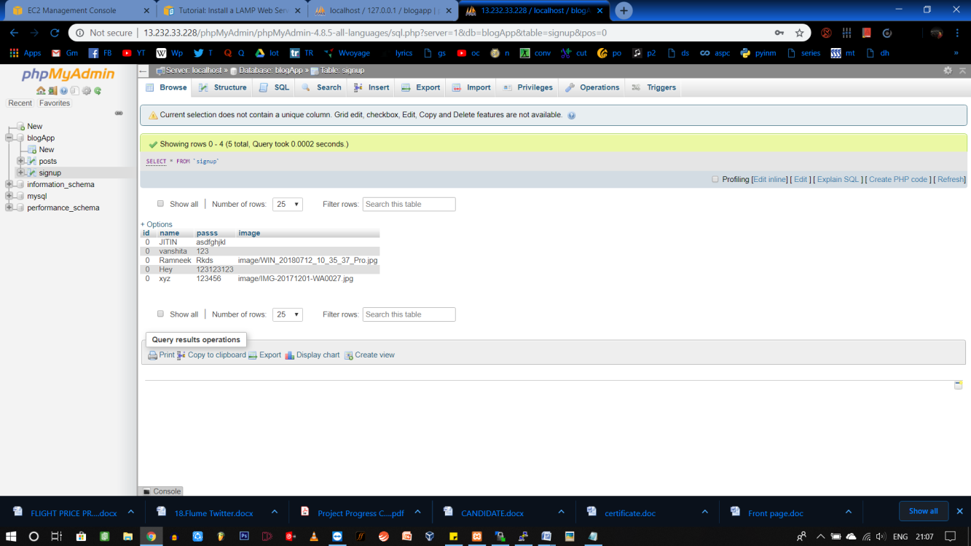

**(**SignUp database in phpMyAdmin)

**Chapter – 7**

**Summary**

The website is available on m the public DNS of instance and can be accessed by anyone with the link. Users can add their blog by signing up and read blogs of other people.

People can also upload their image.

Moreover, with AWS the website is deployed very easily and with less cost ( only if you don’t use more storage and services other than free-tier eligible)

**Chapter – 8**

References

* <https://docs.aws.amazon.com/AWSEC2/latest/UserGuide/install-LAMP.html>
* <https://docs.aws.amazon.com/AWSEC2/latest/UserGuide/EC2_GetStarted.html#ec2-connect-to-instance-linux>
* <https://docs.aws.amazon.com/AWSEC2/latest/UserGuide/putty.html>