package java_assignment2_quest1;

import java.util.*;

public class UserMainCode{

public static int calculateElectricityBill(String inp, String inpu, int input) {

int a = Integer.parseInt(inp.substring(5, inp.length()));

int b = Integer.parseInt(inpu.substring(5, inpu.length()));

int result = Math.abs((b - a) * input);

return result;

}

public static void main(String[] args) {

try (Scanner sc = new Scanner(System.in)) {

String sc1 = sc.nextLine();

String sc2 = sc.nextLine();

int a = sc.nextInt();

int b = calculateElectricityBill(sc1, sc2, a);

System.out.println(b);

}

}

}

Output--

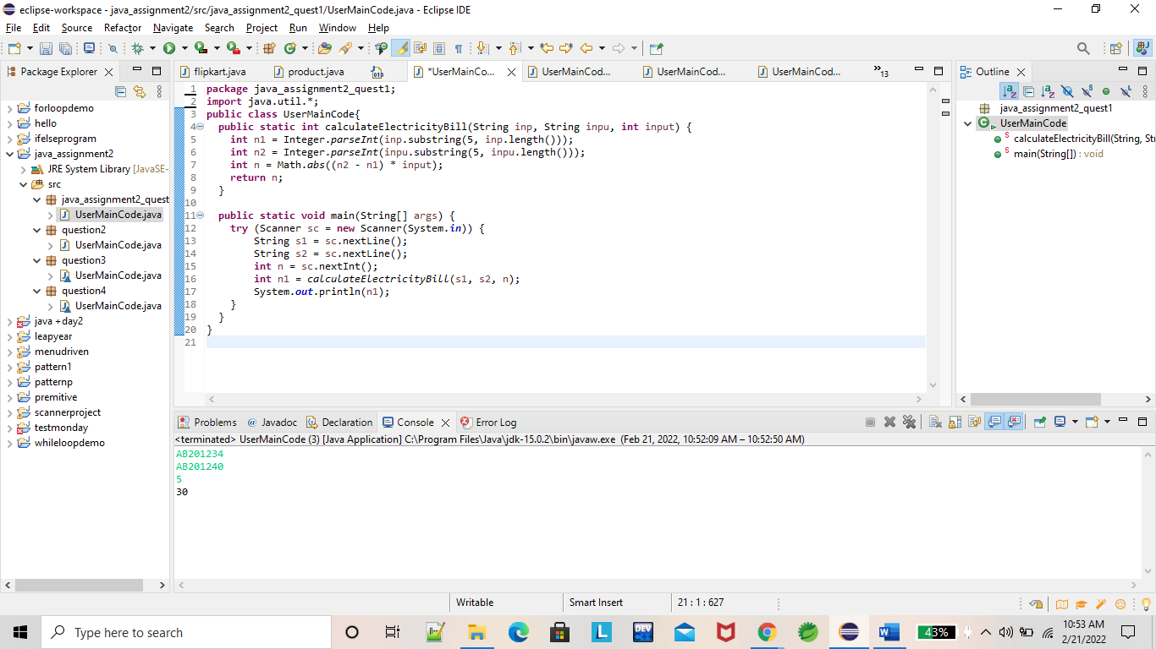

package question2;

import java.util.Scanner;

public class UserMainCode {

public static void main(String[] args) {

try (Scanner sc = new Scanner(System.in)) {

String s1 = sc.next();

boolean b = ValidColorCode(s1);

if (b == true)

System.out.println("Valid");

else

System.out.println("Invalid");

}

}

public static boolean ValidColorCode(String s1) {

boolean b = false;

boolean b1 = false;

String s2 = s1.substring(1, s1.length());

if (s1.length() == 7)

if (s1.charAt(0) == '#')

b1 = true;

if (b1 == true)

for (int i = 0; i < s2.length(); i++) {

char c = s2.charAt(i);

if (c != '#') {

if (s2.matches("[A-Fa-f0-9]{6}|[A-Fa-f0-9]{3}"))

b = true;

else {

b = false;

break;

}

}

}

return b;

}

}

Output--

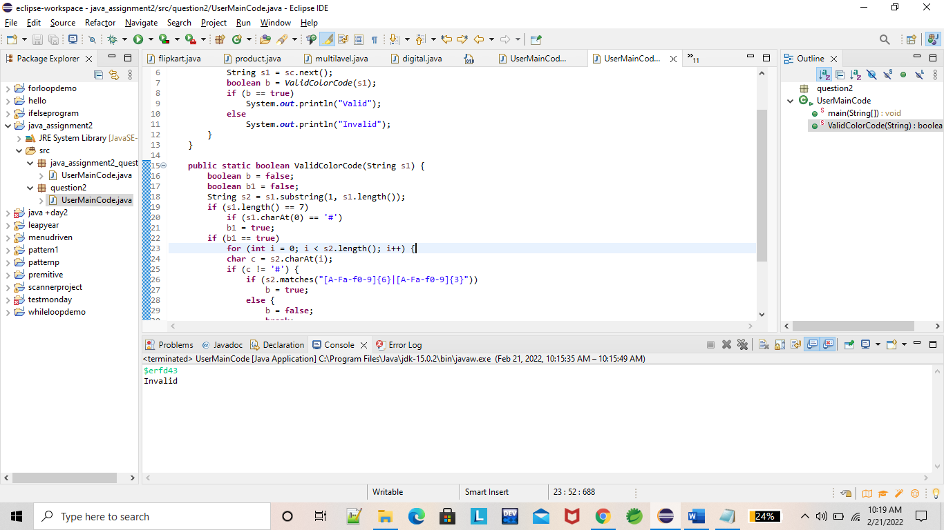

package question3;

import java.util.Scanner;

class UserMainCode {

static int findnCr(int n, int r)

{

return factorial(n) / (factorial(r) *

factorial(n - r));

}

static int factorial(int n)

{

int res = 1;

for (int i = 2; i <= n; i++)

res = res * i;

return res;

}

public static void main(String[] args)

{

try (Scanner sc = new Scanner(System.in)) {

int n=sc.nextInt();

int r=sc.nextInt();

System.out.println(findnCr(n, r));

}

}

}

Output--

