Google Cloud Platform

Google Cloud platform also term as GCP is a cloud service offer my google. Which provide dozens of IaaS/PaaS/SaaS service to the user. Internally it uses the same infrastructure that google uses to provide end to end products. It provides various products and tools like Computing, Storage, Networking, Stack-Driver, Big Data, Artificial Intelligence and other google solutions. So, user can build deploy and manage his code in just few clicks.

**Cloud Platform Products:**

Compute:

-Compute Engine is an IaaS service that provides virtual Machine to user. Where one can install and use the VM as per his requirement.

-App Engine is a PaaS service mainly use to build web application, where uses can deploy or create new web application without worrying about the server and other hardware/software. As everything is provided my GCP.

Storage:

-Storage is a cloud service for storing the data where user can put anything what he wants to upload. In other term we can say. It stores the data in file format without looking much about the file been uploaded means, we can update any file which we want to upload like word, excel, ppt, pdf, bmp jpeg, java etc.

-SQL is a cloud service for storing structure data where one can configure, manage the database in google cloud. One just need to fire the query all other things will be provided by GCP.

-Spanner is a cloud service for storing the structure data which act same as SQL cloud, but only the different is that one can scale horizontally, and it provide high availability.

Network:

-VPC network is also term as Virtual private cloud is a GCP provided services use to make interaction between two system or resources. For example, if two VM wants to share the data or share a common resource term there External IP must be configured to VPC. We can also use VPC network sharing when we want to access sometime with static and must be private which also include to hide SSH, certain back-end and must be access by internal from LAN.

-Network service is a cloud service to manage the package drop and network flow for the services. For example, let two VM are created for different regions then to provide the good though put their response time must be less this can be managed by load balancing.

-Hybrid Connectivity is a service use to migrate the service from another vender to GCP.

The main advantage for the google cloud platform is that we can get all service at one location (in GCP). We just need to create account at minimal cost. We can also use its service free. I login though my email and registered on GCP. Where I got Rs 21,351,41 for 364 days. As shown:



We can register to GCP by its URL i.e. <https://console.cloud.google.com>. After registering successfully, we will able to access the home screen contain two section as Dashboard and Activity for all the project. As we will change the project its Dashboard and activity will also be updated.

Creating a new project: To track any task and work, we need to create a project. Which also used to provide permission to the resource and managing API and billing for the resources been used. We simply need to click on the top menu to select or to create a new project.

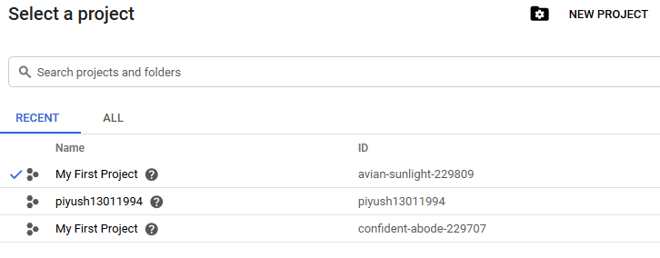

**Click here to Create a new project.**

After selecting any project, we can check the Dash board and activity will get updated as per the activity performed last in the project.

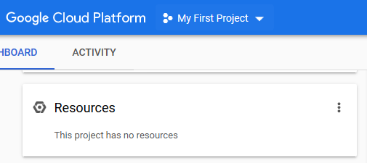 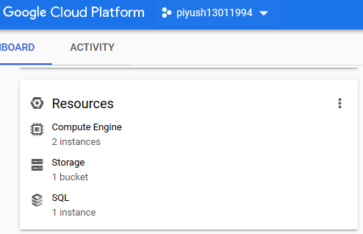

**3 Resources are in use for this project.**

**No Resources**

Dashboard is used to view, manage and delete resources in the clusters. It contains all the information regarding the project and have below following sections:

*Note: Dashboard change/update as per the project selected*

1. Project info: we need to take care of this as it contains all information of project like Name, ID, Number and project setting.
2. Resources: Information regarding the resources are been used by the project selected. Like compute engine, Storage, SQL etc. all will be shown here where we can manage our resources.
3. Trace: we can check the data flow and trace the API calls for certain past 7 days.
4. Getting Started: is a documentation part where all the information and help is present and provide different modules to start learning about the GCP.
5. Google cloud platform status will show all the service status which are currently up and running. Most of the time it will always be “normal”. As GCP provide on demand service to use and its management is also to fast.
6. Billing section will show the billing status of your current selected project.
7. Error Reporting: will show all the error that are been generated while running any API or managing any services. Sometime there might be problem deploying any services and there might be some problem with the measuring the quantity or logs or usability of service. (Note: There might be problem from user end, as GCP services are most reliable)
8. News and Document: will show the additional information to make user updated with the new services been offered to the user.

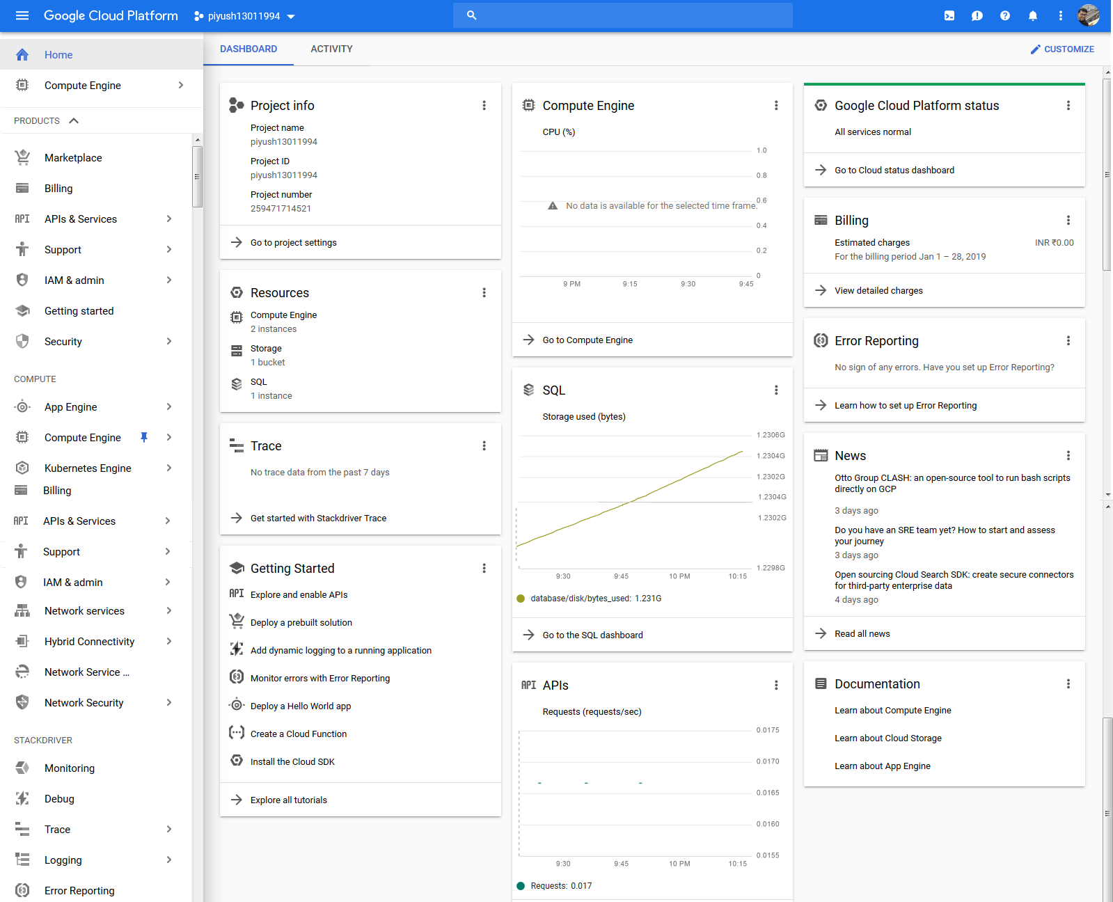

**8**

**7**

**6**

**5**

**4**

**3**

**2**

**1**

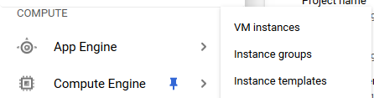**Compute Engine:** Let start with creating a VM and write first python program. VM is provided under Compute🡪 Compute Engine🡪VM instances🡪create instance🡪(Name of VM)🡪(Boot disk)🡪(Select any region and zone)🡪Click on create.

New instance will be created, and green check sign will show that VM is ready to start working. We need to click on SSH and then selected VM to start. (better to start with browser window)

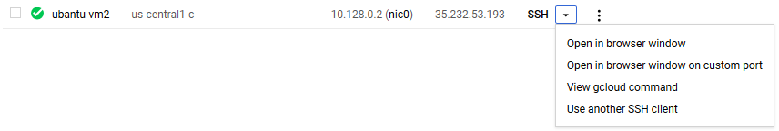

A new window will get displayed with installed disk in the VM, write below code to install and update the required software in the VM. In my case I install ubuntu18.0 and I will use python software to use with installing all its dependency.

1. Sudo apt-get update
2. Sudo apt-get install python3
3. Sudo apt-get upgrade

Above command will update and upgrade all the package & dependency in ubuntu. After completion for all the command now we can use python in our VM and we can run python by writing ‘python3’ in VM. We can test this my writing a simple hello program.

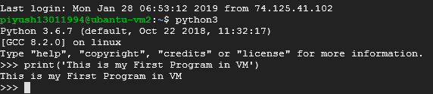

As till time python is install in the VM but we need to work with some more library, so we need to add them manually by below code:

1. Sudo apt-get install python3-pandas.

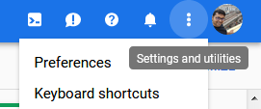As till time we were running the python in shell or we can say we were using CUI to interact with the code and sometimes it’s become difficult to manager the big program in one go. So, we can use cloud shell which is GUI and provide better graphical interphase to the user to interact and provide the code. To start the system in Cloud shell we need to follow as: select the project🡪click on the cloud shell icon on the top right corner as shown:

1. Active Cloud shell
2. Send feedback
3. Help
4. Notification
5. Setting and notification
6. Account open with registered Email id

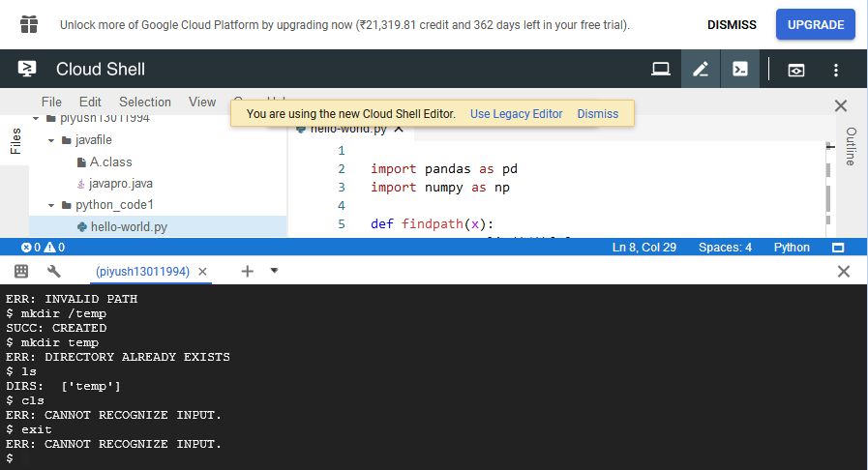Active cloud shell will we shown as below where we can write our code and execute them in GCP computer engine VM.

Active Cloud shell is a GCP Service running with Linux Operating system this VM Can be used for to Management task like Creating VM, storing bucket, Docker images or accessing DB’s. it also provides

services like text editors

and compiler editor for

python, java, ruby and

node JS.

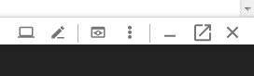 Writing Python code with editors (with GUI): Once Active cloud shell has been launched now click on “Launch Code Editor”. This will provide us to create folder, file and write code as per requirement. Here we should remember its a platform in depended, so two code can we executed at the same time without any problems. Like in my case I used java and python in the shell. I have created a folder

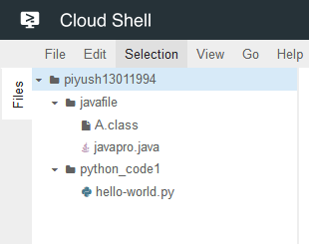and sub folder as javafile and python_code1 and created an .java and .py file in it. We can use active cloud shell to execute the code in python and java. For getting output we should compile the code and then execute it. with below command:

Note: Active cloud already had Java, Python, Ruby and Node Js pre-install. So we just need to compile and run our code with worrying about software installation.

|  |  |
| --- | --- |
| >> javac javapro.java | >> python3 hello-world.py |
| >> java A |  |

**for Java: for Python:**

**App Engine:** Provide all the infrastructure to deploy the code on GCP platform where one only need to focus on the writing code and all other thing like monitoring and operation work will be mange by google. It provides user to write the code in any choose-ed platform. We can also use any custom container like docker. We can use below code use create a new Web-application and can deploy to app engine.

1. *Select the project at which you want to deploy the code*.
2. git clone \ https://github.com/GoogleCloudPlatform/python-docs-samples
3. cd \ python-docs-samples/appengine/standard_python37/hello_world
4. cat main.py
5. cat app.yaml
6. virtualenv --python python3 \ ~/envs/hello_world
7. source \ ~/envs/hello_world/bin/activate
8. pip install -r requirements.txt
9. python main.py
10. *Click on the icon to open the web page as shown*
11. gcloud app create
12. 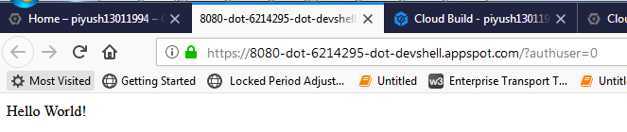gcloud app deploy app.yaml --project \ piyush13011994

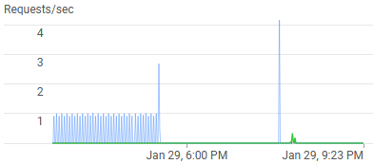

by the above code a web-based application will be deployed and will monitor and managed by GCP. We can track all it requests in API section on project dashboard. As shown in Request/Sec figure.

To delete or stop the app by utilizing the resources. we can follow below steps:

1. Go to App Engine🡪Setting
2. Disable application.

**Storage:** we can upload file in the bucket and can share by any resource. To update the file to storage of GCP we simply need to create bucket and then upload our file to the bucket. There is two way to do the same.

1. We can use direct drag and drop by clicking on any new created bucket🡪Upload file/Folder.

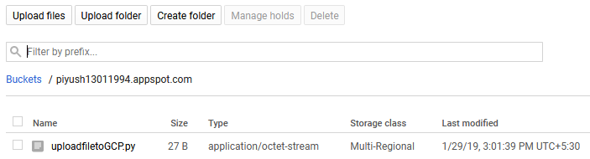

1. We can use google SDK to manage (push and pop) repository in GCP storage. For this we need to install the google SDK from <https://cloud.google.com/sdk/> provided for different OS. Then we can use below some of command to perform the relevant task:
2. To List all file in current directory: *gsutil ls*
3. 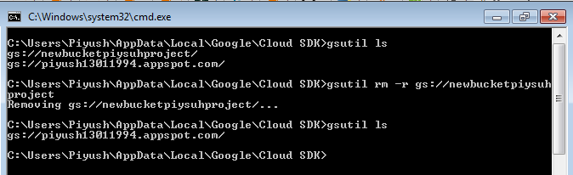To remove directory: *gsutil rm -r gs://(Bucket name)*
4. 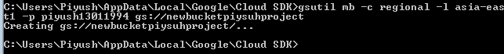To create directory: *gsutil mb -c regional -l asia-east1 -p (project name) gs://(Bucket name)*

we can also connect storage to our compute Engine to use the updated file in VM by mounting the bucket in any directory (in VM). Below is the command for the same.

1. export GCSFUSE_REPO=gcsfuse-`lsb_release -c -s`
2. echo "deb http://packages.cloud.google.com/apt $GCSFUSE_REPO main" | sudo tee /etc/apt/sources.list.d/gcsfuse.list
3. curl https://packages.cloud.google.com/apt/doc/apt-key.gpg | sudo apt-key add -
4. sudo apt-get update
5. sudo apt-get install gcsfuse
6. $ mkdir / (*Directory to mount*)
7. $ gcsfuse example-bucket / *(Directory to mount)*
8. $ ls / (*Directory to mount*)

Now we can directly use the updated file in Bucket to our VM.

**SQL:** is used to manage the structure data and can be access from VM or cloud shell.

Let check with both the method and create instance for SQL:

SQL instance in GCP can be created with below steps:   
Click on Home🡪SQL🡪create Instance🡪MySQL🡪Choose Second Generation🡪(Provide Instance ID)🡪(provide the root password)🡪(choose Region/Zone)🡪Click on create.

Once the SQL instance has been created and ready, it will be displayed as below with Green sign

1. Cloud shell: provide easy instruction with the preinstall cloud shell we can use with steps as select the instance of SQL🡪 on the “Connect to this instance” section click on “Connect using cloud Shell”🡪 provide a root and press enter; Now can write our query in the shell.
2. Connecting the MySQL in VM: if we want to connect the VM to user SQL instance we need to configure the setting to VPN. This can we done by following the below steps:

Pre-requisite: VM instance, SQL instance and VM External id must be handy.

1. 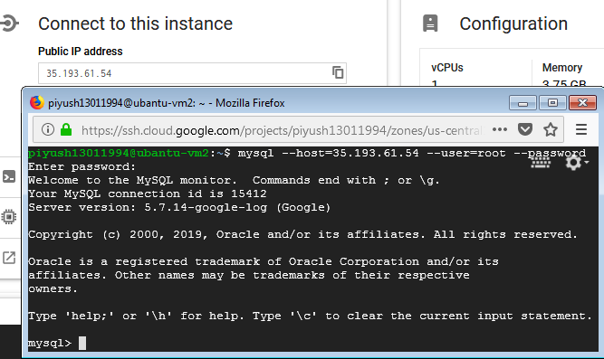Copy the VM External id and then go to VPL Network🡪 External IP address 🡪Type and select type as ‘Static’
2. Go to SQL and then select the instance for SQL🡪 on the “Connect to this instance” provide the copied VM external id and save🡪close.
3. Start the VM instance and install the MySQL.

Now we are done to run MySQL on VM run the query to access MySQL instance in the VM

After connecting to MySQL now we can access the SQL and perform the task. Let try some code to create Database and table and insert some data:

>> create database newpiyush

>> use newpiyush

>> create table emp (Id int (10), name varchar2 (30));

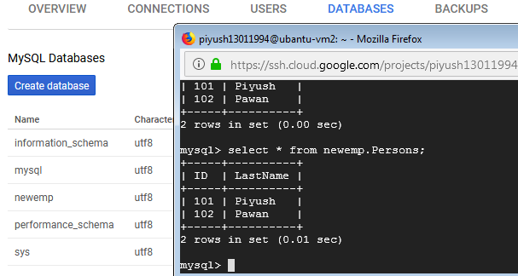We can use below

command:

1. Alter
2. Update-set
3. Select
4. Insert
5. Delete
6. Drop
7. Create
8. Rename
9. Join
10. Sequence
11. TRUNCATE
12. Union
13. As

SQL is a cloud service for storing structure data where one can configure, manage the database in google cloud. One just need to fire the query and GCP with provide management & storage.

**Spanner:** is same as SQL, but provide better availability, Scalability and Replication. It also provides automatic sharing with Transactional Consistency. We can create a Spanner in GCP with below steps:

Click on home🡪 Spanner🡪 Create Instance 🡪(Provide Instance Name)🡪(select regional and configuration)🡪click on create.

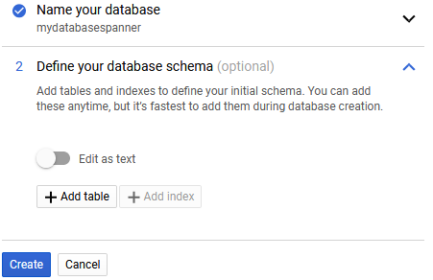As like in SQL, Spanner also have database. After successful creation of Spanner next window is will displayed to create Database followed by table and its attributes.as shown

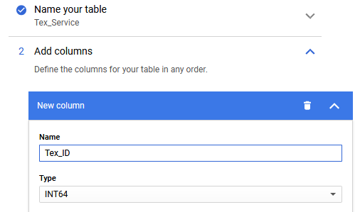

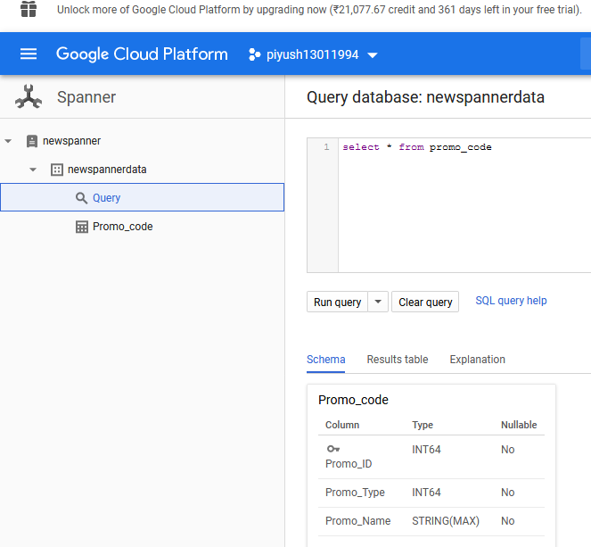After completing above steps now we have schema in place with table and its attributes. We can perform any task as per the code learn in SQL. To fire any query just we need to select the Spanner instance then database name and click on Query. A place holder will get prompted with table details.

1. Select Project.

**2**

**1**

1. Select Spanner from Home.
2. Select the Spanner Instance.

**3**

1. Select Database.
2. Click on Query.

**6**

**4**

1. Write your Query.

**5**

1. Click on ‘Run query’.
2. Verify the output in ‘Result table’.

**7**

1. See Schema of table in ‘Schema’

**10**

**9**

**8**

1. Explanation will show all information about how the query performed.

**VPC:** stand for Virtual private cloud. it is a gateway manage by google, which provides interconnection between two virtual system in GCP. It contains all the IP connection for VM and other instance. It provides feature like dynamic routing, authentication of channel and calls, support site to site VPN with simple topology or with redundancy.

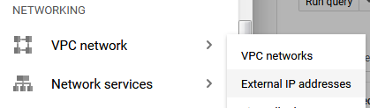As I already discussed in SQL, we control the incoming call from VM to SQL with configuring the External IP address in VPC network.   
we can configure VPC with below steps.

1. Click on Home.
2. Select VPC Network
3. External IP address.

On the provided screen we can select the VM or resource for which *External IP addresses* need to be configured and provide the static id as we have done while configuring SQL to connect to our system. Shown below:

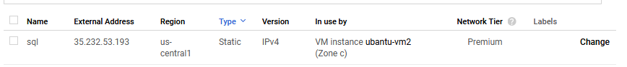

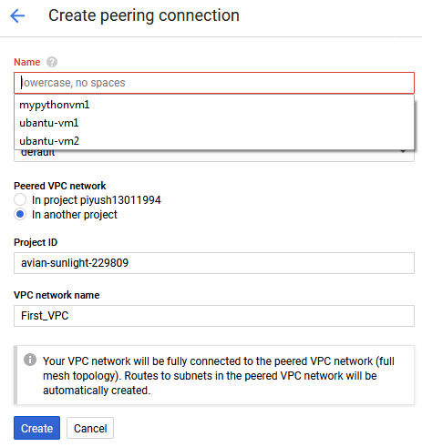For connecting the network between two different projects. We can use *VPC network Peering*. In other word we can say it connect across two VPC networks regardless of whether they belong to the same project or the same organization. We can create VPC in GCP with following below steps:

1. Click on home.
2. Select ‘VPC Network’
3. Click on ‘VPC network peering’.
4. Create a create connection🡪Continue.
5. Select the instance you want to use (In my case I have 3 instances of my VM)
6. We can select the Peered VPC in same project or in different project.
7. If we select another then we must provide Project ID
8. Provide the VPC network Name.
9. Click on create button.

Once the instance has been created we can share, now VM from both the project will share a common resource and will be on the same network.

**Network Service:** to control the data flow to our network can be mange by Network service. It provides higher thought put and latency at lower cost. Let take an example to understand it better it we have created two application one to play a video and second it just to upload log file to internet. As its known that data will be more flow thought the network in first app in compression to second. So, this control of data flow can we manage by the service of Network called load balancing. Where two servers will distribute the work among them so that load can be distributed equally with any service failure or delay in response. GCP provide 3 main service in load balancing given as

1. HTTP(S) Load Balancing
2. TCP Load Balancing
3. UDP Load Balancing

**Hybrid connectivity:** (VPN) is a service provided by GCP used when we want to create any tunnel to access the hidden data though our LAN from internet. In other word we can say when we want to hide the SSH or other back-end connectivity ports and make then not to be access publicly then we need to create a VPN. By which data will be in internet but can only be access the LAN or by VPN, it will private. We can create VPN by following below steps:

1. Click on home
2. Select Hybrid connectivity
3. Click on VPN
4. Create an VPN connection.
5. Provide VPN name.
6. Select Network & Region
7. Provide IP-address (static)
8. Provide remote peer IP address
9. On IKE version select IKEv2
10. Provide Remote Network IP Range
11. Click on Create.

Once VPN has been created it can be used to access the network with the privilege setting for IP’s.



we can check status of our configuration and all activity on the notification icon shown at top right corner shown as

Notification icon shows all the activity done by the user like crating/modifying/starting/stopping/error for our services. It will display last 7 activity by the user if we want to see all the activity then we can click on to ‘Show all activity’ or we can go to home and then click on activity tab.

Small Projects in GCP:

1. Linux Path Traversal:



1. Titanic Logistic Regression:



 *My Account Left Balance (Rs18,979.06):*