Milestone 1 Report
Fault-Tolerant Distributed Rate Limiter: Redis vs Raft Consensus
Gautam Raju | Piyush Daga | CS 7680 | March 2026
GitHub: github.khoury.northeastern.edu/29gautamraju/RedisVsRaft-Consistency | Project Board: GitHub Projects

1. Problem Statement & Motivation
Rate limiting is a foundational primitive in large-scale API platforms. The most common implementation uses Redis: fast, simple, and widely deployed. However, Redis uses asynchronous replication. When a primary node fails before propagating a write, the system loses the record of consumed tokens. Users can silently exceed their limits, breaking the core correctness guarantee rate limiting exists to provide.

Any system requiring strict per-user, per-organization, or per-IP enforcement (billing APIs, abuse prevention, SLA enforcement) cannot tolerate this failure mode. Existing solutions either accept the risk or add costly coordination on top of Redis.

We are building a distributed rate limiter using Raft consensus in Go and comparing it against a Redis baseline. Our hypothesis: Raft provides strong consistency at the cost of latency; Redis offers lower latency at the cost of correctness under failure. We aim to quantify this tradeoff precisely and produce a reproducible benchmark that any team can run.

2. Team
Member | Role | Contributions
Gautam Raju | Redis implementation lead | Token bucket (Lua + Go), Docker Compose setup, Locust load testing, initial experimental results
Piyush Daga | Raft implementation lead | Raft cluster bootstrap (hashicorp/raft), FSM + BucketStore, HTTP leader forwarding, AWS infrastructure

3. Codebase & Architecture

3.1 Repository Structure
The repository is organized into three modules reflecting our two systems and the shared test infrastructure:

- redis/: Go HTTP server with Lua-based token bucket rate limiter backed by Redis
- raft/: In progress. 3-node Raft cluster using hashicorp/raft with FSM-backed BucketStore
- locust/: Python load testing scripts with custom 429 tracking
- results/: Locust HTML reports from each experimental run (also available in the repo under /results)

3.2 Redis Rate Limiter (Complete)
The Redis implementation uses a Lua script executed atomically via EVALSHA. Each request passes a key, capacity, fill rate, and current Unix timestamp. The script reads the token count and last refill time from a Redis hash, computes elapsed time, refills tokens proportionally, then deducts one token (200 OK) or rejects the request (429) if tokens < 1. The operation is atomic with no race conditions.

Key design decisions: using HMGET/HMSET on a hash to store both tokens and last_refill atomically; passing the timestamp from Go rather than using Redis TIME to avoid clock skew; setting a 1-hour TTL per key to prevent unbounded memory growth.

3.3 Raft Rate Limiter (In Progress)
The Raft implementation uses hashicorp/raft with a custom FSM (Finite State Machine) wrapping an in-memory BucketStore. Every token deduction is a Raft log entry, committed only when a majority of nodes acknowledge it. The API layer is stateless on ECS behind an ALB. Non-leader nodes forward requests to the current leader. A token deduction is never lost even if the leader crashes immediately after committing.

4. Initial Experimental Results

4.1 Summary
We ran two Locust load tests against the Redis rate limiter locally via Docker Compose (Redis 7, Go API, Locust). The second run added a fix to surface 429 responses as a distinct metric row, revealing the true rejection rate. Full HTML reports are available in the repository under /results.

Metric | Run 1 (50 users) | Run 2 (200 users) | Notes
Total Requests | 69,494 | 119,081
Throughput (RPS) | ~950 | ~1,900 | Scales with users
Median Latency | 1 ms | 1 ms (200s) / 16 ms (429s) | 429s are cheaper
p95 Latency | 3 ms | 72 ms (200s)
429 Rate (rejected) | 0% (hidden) | ~47% (56,023 reqs) | Token bucket working
503 Rate (Redis down) | 5.8% (4,057) | 3.7% (4,456) | Failure injection
Recovery Time | ~20 seconds | ~15 seconds | Auto-recovery

Figure 1: Locust Statistics (Run 2, 50 users)
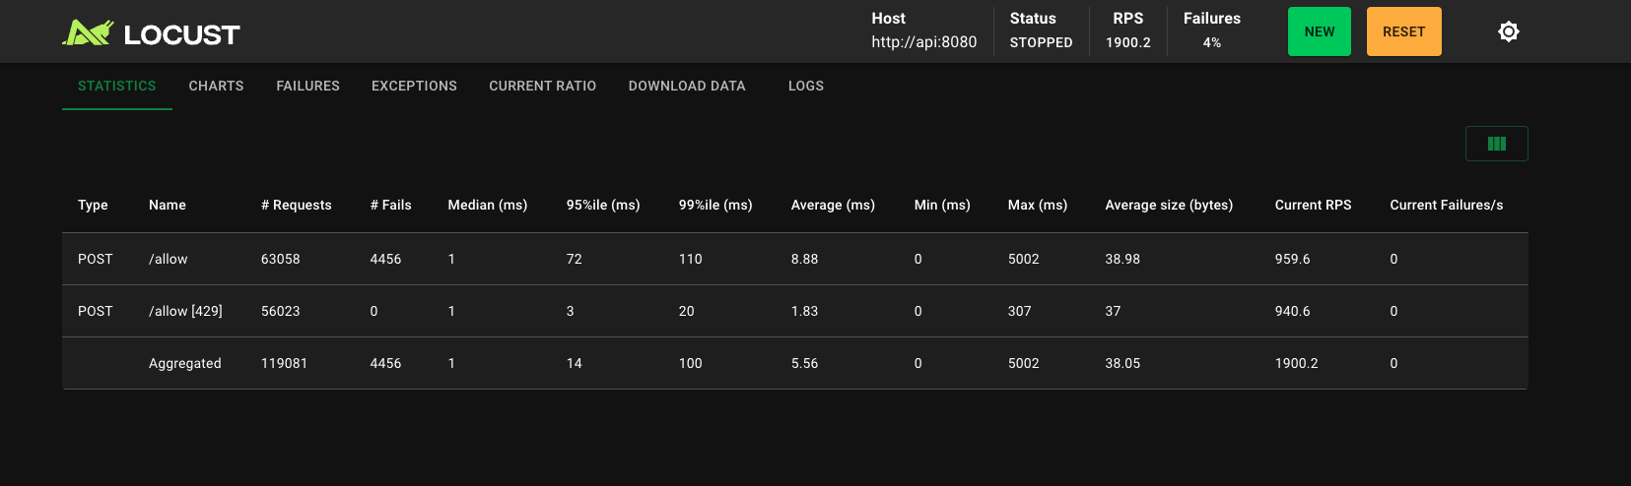

Figure 2: Locust Charts (RPS, failures, response time over time)

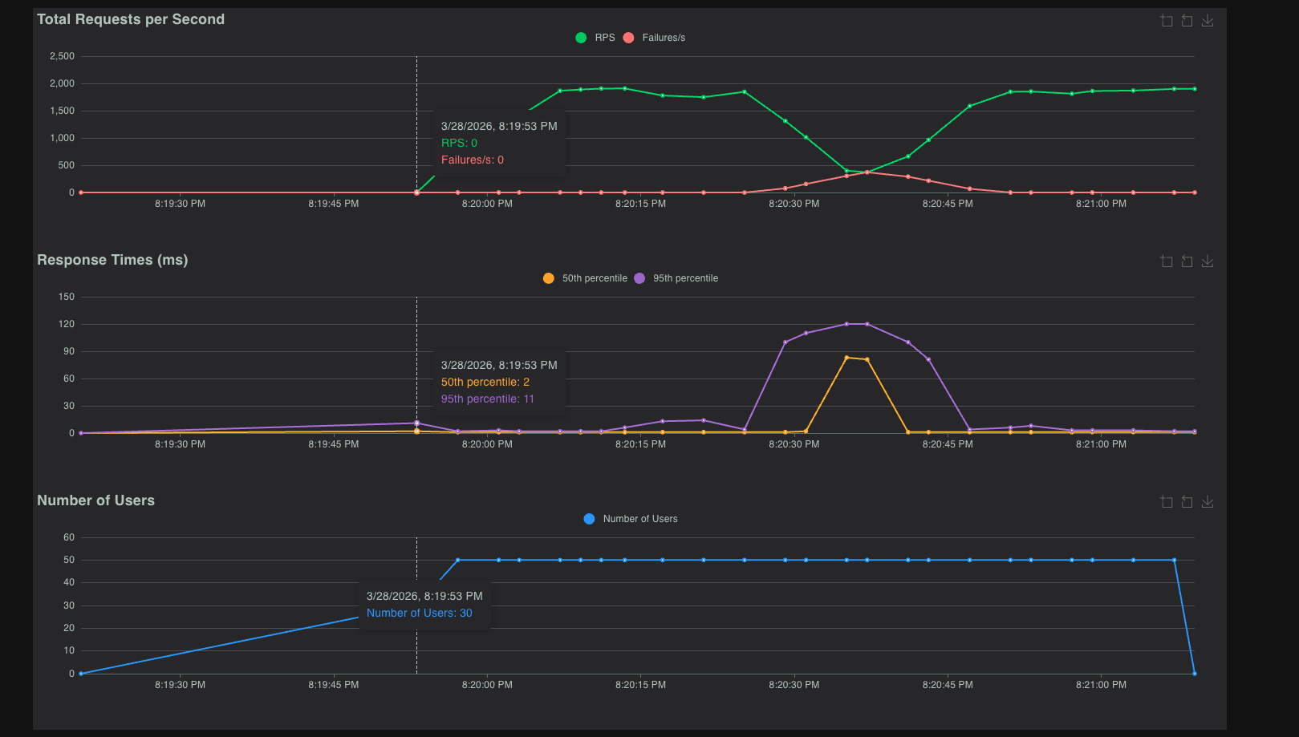

4.2 Key Findings
- The rate limiter correctly rejects ~47% of requests at 200 concurrent users with capacity=60 and fill_rate=1. Redis state inspection confirmed buckets draining to near-zero (0.002 tokens remaining).: Token bucket correctness confirmed
- When Redis was stopped mid-test, 503 errors spiked within seconds. Recovery was automatic and complete within 15–20 seconds of Redis restart, with no manual intervention.: Fast recovery from failure
- Under normal operation, median latency is 1ms and p95 is under 5ms, consistent with Redis's in-memory performance characteristics.: Low baseline latency
- Rate-limited (429) responses have lower latency than allowed (200) responses (median 1ms vs 16ms at 200 users) because rejected requests skip the Redis write path.: 429s are fast

4.3 Observability
Current observability is via Locust's built-in dashboard and HTML report exports. Planned: Prometheus metrics endpoint on both Redis and Raft API servers, with Grafana dashboards showing per-key token counts, rejection rates, Raft leader identity, and election events. This will allow side-by-side comparison of both systems under identical load.

5. Project Plan
Phase | Timeline | Tasks | Owner
Phase 1  (Now) | Weeks 1–2 | Redis rate limiter (token bucket, Lua script, Go HTTP layer)  Local Docker Compose setup  Locust load testing baseline | Gautam
Phase 2 | Weeks 3–4 | Raft cluster bootstrap (hashicorp/raft)  FSM + BucketStore  HTTP layer with leader forwarding | Piyush
Phase 3 | Weeks 5–6 | Failure experiments (follower, leader, partition)  Prometheus + Grafana observability  AWS EC2 + ECS deployment | Both
Phase 4 | Weeks 7–8 | Performance load testing (100–10k RPS)  Auto-scaling + caching experiments  Final Raft vs Redis comparison + report | Both

Full task breakdown with assignees and status is tracked on our GitHub Projects board:
github.khoury.northeastern.edu/users/29gautamraju/projects/1

6. Planned Experiments
# | Experiment | What We Measure | Expected Outcome
1 | Follower Failure | Latency impact, continued availability with 2/3 nodes | System continues serving; slight latency increase
2 | Leader Failure | Election time, requests failed during failover window | New leader elected in <500ms; minimal dropped requests
3 | Network Partition | CAP theorem in practice: majority side serves, minority pauses | Only majority partition serves; state reconciles on heal
4 | Load Testing | Throughput, p50/p95/p99 latency, error rate at 100–10k RPS | Raft bottleneck visible at high RPS; Redis stays flat
5 | Auto-Scaling + Cache | RPS absorbed by ECS layer vs reaching Raft cluster | Local rejection cache cuts Raft load significantly
6 | Raft vs Redis Final | Correctness under failure + latency tradeoff quantified | Redis: lower latency; Raft: no token loss under failure

7. Impact & Significance
Rate limiting is widely deployed but not consistently correct. Redis primary failures cause replication lag, leaving replicas with stale token counts and allowing users to burst through limits undetected. Most teams accept this risk; few add coordination primitives on top, at high cost.

Our project produces a concrete answer to: how much latency does correctness cost? If Raft adds 5ms of median latency in exchange for zero token loss under any single-node failure, many teams would accept that tradeoff. If it adds 200ms, most would not. No clean apples-to-apples number currently exists because no one has built both systems under identical conditions and run the same failure experiments against both.

The benchmark suite will be open source. Classmates can clone the repo, run docker compose up, and reproduce our results or run their own experiments by adjusting capacity, fill rate, or failure timing. We plan to share our Locust scripts on Piazza for other teams to use.

8. Related Work
- Three Piazza project teams are working in adjacent areas, identified during HW9: a Raft-based distributed task queue (similar failure experiments, different application layer), a consensus-based key-value store (shared infrastructure patterns), and a distributed session management system (overlapping consistency concerns). We plan to cross-reference experimental methodology with these teams.
- The hashicorp/raft library (used in production by Consul and Nomad) provides our Raft implementation. Its election timeout and heartbeat configuration directly affects our Experiment 2 results.
- The go-redis/redis_rate library provides a reference Redis token bucket implementation. Our implementation differs by using nanosecond timestamps and storing state in HMGET/HMSET rather than a single string key.
- The Jepsen project's Redis analysis documents the consistency failure mode we are studying: async replication loss under primary failure. Experiment 6 is designed to reproduce this in a controlled setting.
- The CAP theorem (Brewer, 2000) and the Raft consensus paper (Ongaro & Ousterhout, 2014) provide the theoretical foundation for Experiment 3 (network partition) and our overall system design.

