Multiuser in Visible Light Communication

Piyush Srivastava Poornika Singh Vivek Prakash
piyush18184@iiitd.ac.in poornika18185@iiitd.ac.in vivek18179@iiitd.ac.in

Abstract— Visible Light Communication (VLC) is another innovation that permits both correspondence and enlightenment. It is favored as a result of its high data transfer capacity and invulnerability to impedance from electromagnetic sources. It offers free-range, high flag to-commotion proportion (SNR) and high security. VLC frameworks likewise confront the issue of low information rate because of the constrained balance data transfer capacity of the LEDs. Optical OFDM procedures have been researched with the end goal to acknowledge broadband and high-rate transmission. OFDM signals are constrained to be real-valued and non-negative. The high PAPR in OFDM which is a weakness for can be abused valuably in unmistakable light correspondence to force regulate LEDs.

VLC MU remote innovation is utilized to give expanded connection limit and phantom proficiency joined with enhanced connection unwavering quality. In practice, MU-VLC frameworks can be acknowledged by utilizing numerous LED exhibits which together transmit flag to clients.

The BER performance has verified via simulation for the multiuser method in the VLC framework. The capacity of the system per user has additionally been plotted.

Keywords—VLC, SNR, MU, BER, PAPR, OFDM, DCO-OFDM

Introduction
Visible Light Communication (VLC) is a subset of optical remote correspondence, It utilizes obvious light range somewhere in the range of 400 and 800 THz (780– 375 nm).VLC can be utilized as an interchanges mechanism for omnipresent registering and IoT environments since light-creating gadgets, for example, indoor/open-air lights, TVs, movement signs, business showcases, and vehicle headlights are utilized all over the place. Multiuser in opens special interchanges abilities including enormously parallel transmission. We utilize the DCO-OFDM strategy to expand the information rate in VLC frameworks.

MULTIPLEXING TECHNIQUE

OFDM
Orthogonal Frequency Division Multiplexing (OFDM) plans are utilized for broadband and high-information rate noticeable light correspondences (VLCs).OFDM is invented for execution upgrade, control, and unearthly effectiveness advancement and talk about changed optical OFDM plots under lighting limitations. In the power regulation and direct-discovery (IM/DD) conspire, the adequacy of the optical OFDM signals is compelled to be genuine esteemed and nonnegative.

DCO-OFDM
The orthogonality of subcarriers guarantees that the images in the equivalent OFDM square don't meddle with one another. We have utilized 4 DCO-OFDMs on the grounds that OFDM is fit for moderating ISI adequately, it is a perfect balance plot for VLC for high-rate transmission. The vast majority of all, optical OFDM is specifically balanced on the force of radiated light and obliged to be real-valued and nonnegative. Assuming that the total of N subcarriers are allotted in a single OFDM block, where N is commonly an extensive considerably number. At the transmitter, the sequential bit stream is first changed over to a parallel arrangement and afterward mapped to the N/2 − 1 complex-valued symbols as indicated by the explicit tweak star grouping X, for example, 16-quadrature amplitude modulation(QAM),64-QAM,128-QAM,256 QAM.

The modulated OFDM block
X = [X0 X1 · XN−1],
where subscript number signifies the related subcarrier file, is developed as pursues:

X0 = 0 and X1 to XN/2−1 convey the N/2 − 1 data images, while XN/2 to XN−1 fulfill the Hermitian symmetry as

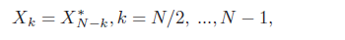 (1)
where the superscript mark “*” represents the conjugate operation. Setting X0 =XN/2 = 0 is to avoid the DC and complex-valued harmonic components, while the Hermitian symmetry of X enables the transmitter to generate real-valued time domain signals. The OFDM symbol vector X is fed to the processor of inverse fast Fourier transform(IFFT) and converted to discrete time-domain samples efficiently as

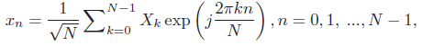, (2)

where xn represents the nth discrete time-domain sample. Considering the imposed Hermitian symmetry, the IFFT operation (4.2) is further expressed as

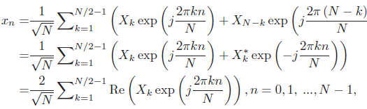 (3)

where Re (Z) denotes the real part of Z. The imaginary parts of the time-domain signal samples are forced to zero. It is worth emphasizing again that the total number of used subcarriers is N/2 − 1 and the rest of the subcarriers are exploited to impose the Hermitian symmetry. The converted electrical signal x (t) is still bipolar and is not feasible for intensity modulation. A DC bias BDC should be added to x (t).

In DCO-OFDM, the DC bias BDC is set to
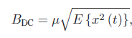 (4)
where E {·} denotes the expectation operation and μ is a constant coefficient.

Other than that, the negative amplitudes of the one-sided signals are cut as zero for intensity modulation. Subsequent to biasing and clipping, the electrical DCO-OFDM flag x DCO (t) is utilized to drive the LED and to be balanced on the power of enlightenment. According to the central limit theorem, x (t) approximates a Gaussian distribution with zero mean when N ≥ 64. In this way, the optical intensity of DCO-OFDM is BDC, while it's electric power is

At the receiver, the photodiode (PD) part catches the optical signal from the VLC channel and changes it into the electrical signal y (t). In the PD, the thermal noise and shot noise interference with the received flag. These two kinds of noise can be both displayed as Additive White Gaussian Noise(AWGN)

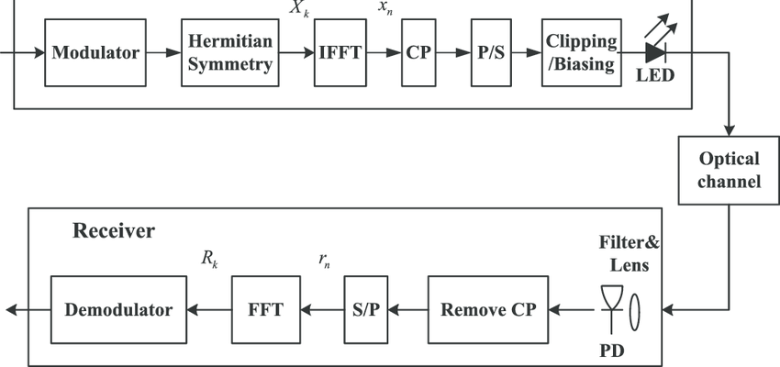
Fig1 DCO-OFDM

At the receiver, the photodiode (PD) component captures the optical signal from the VLC channel and transforms it into the electrical signal y (t). A lens can be placed in front of the PD to filter the background light. In the PD, the thermal noise and shot noise interfere with the received signal. These two types of noise can be both modeled as additive white Gaussian noise (AWGN) [6]. Thus, for the dispersive VLC channel with the impulse response h (t), the received signal y (t) is expressed as

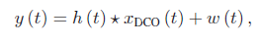 (5)

where the notation “_” denotes the convolution operation and w (t) is the AWGN with zero mean. After analog-to-digital converter (ADC), the received DCO-OFDM discrete sample block is acquired with the CP removed and then is reshaped as the parallel sequence {yn, n = 0, 1, ...,N − 1}.

Interleaving
An alternative to combat the effect of burst errors is interleaving. Interleaving simply involves interleaving symbols from two or more codewords before transmission on the channel. The number of codewords that are interleaved is referred to as the depth of the interleaver, figure 4 shows an interleaver with an interleaving depth of m = 6 and a codeword length of N = 8. The data is written row-by-row into a m×N matrix and read out column-by-column by the interleaver before sending it over the channel. The reverse process is performed at the deinterleaver. Therefore, between successive symbols of any given codeword there are

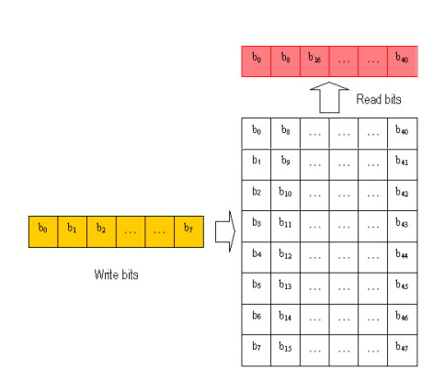
Fig2 Interleaving Blobk Matrix

m − 1 symbols that belong to the m − 1 other codewords being interleaved. If the interleaver has sufficient depth the fading processes that affect successive symbols belonging to the same codeword will be uncorrelated. Therefore, from the perspective of any single codeword, interleaving makes a burst error channel appear as one which has only random errors. The use of interleaving results in extra delay because deinterleaving can be started only after all the interleaved data is received. The interleaving chosen is function of the type of the channel and the coding technique used. In Gaussian channels, the error distribution can not be changed by relocating the bits so that interleaving is not useful.

Singuar value decomposition (SVD)
Consider a MIMO channel with Mr × Mt channel gain matrix H that is known to both the transmitter and the receiver. Let RH denote the rank of H. For any matrix H we can obtain its singular value decomposition (SVD) as

H = U_VH, (6)

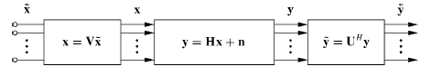
Fig3 SVD

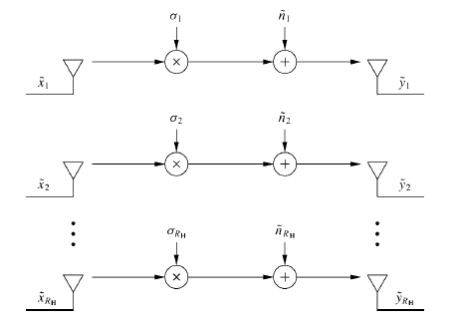
Fig4 SVD representation

The transmit precoding and receiver shaping transform the MIMO channel into RH parallel single-input single-output (SISO) channels with input ˜x and output ˜y, since from the
SVD we have that
˜y = UH(Hx + n)
= UH(U_VHx + n)
= UH(U_VHV˜x + n)
= UHU_VHV˜x + UHn
= _˜x + ˜n, (7)

where ˜n = UHn and where _ is the matrix of singular values of H with σi on the ith diagonal and zeros everywhere else.

results
We have used 4 DCO-OFDM blocks with different modulation schemes and the data is transmitted over a single channel. The SNR is varied from 0-30dB and the bit error rate (BER) of each data is calculated accordingly. Interleaving is used to avoid interference. Also, capacity for users are plotted against SNR to compare the performance of the system.

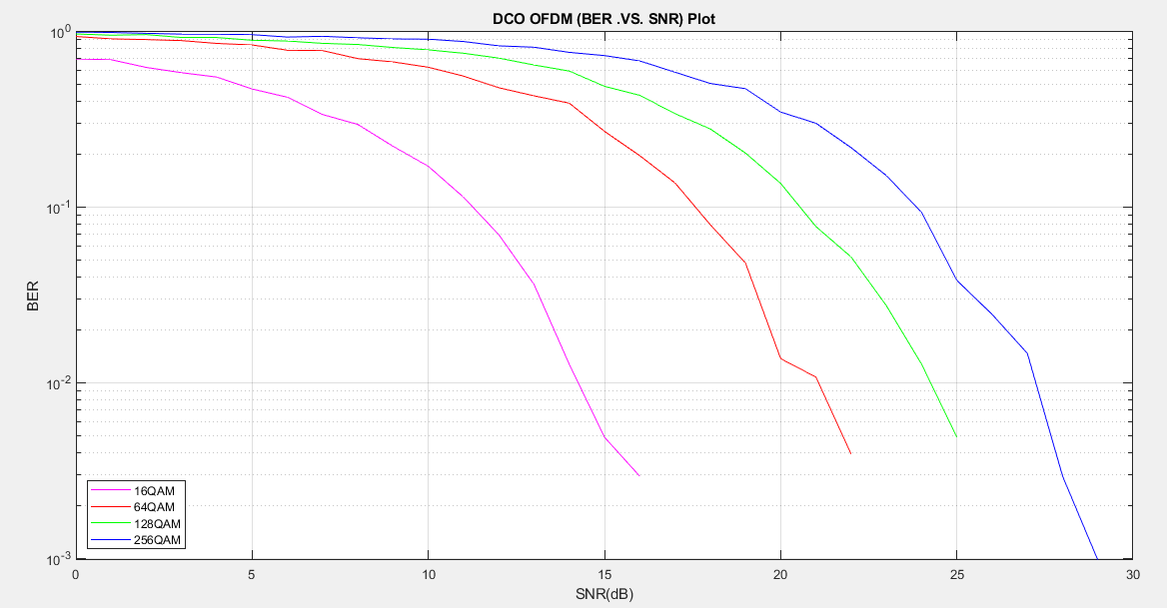
Fig5 BER versus SNR(dB) plot

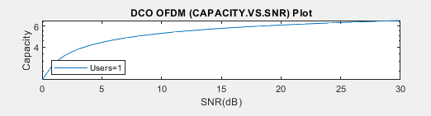
Fig6 Capacity per unit Bandwidth versus SNR(dB) plot for 1 users

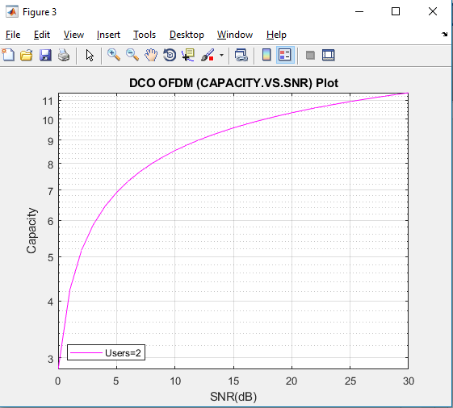
Fig7 Capacity per unit Bandwidth versus SNR(dB) plot for 2 users

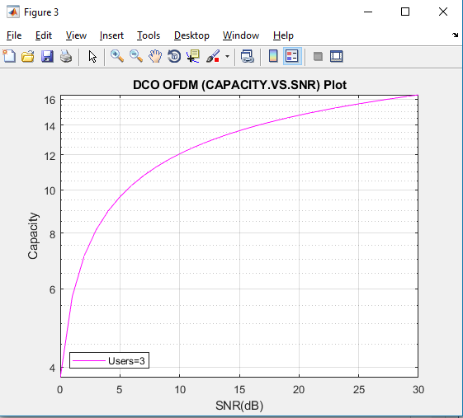
Fig8 Capacity per unit Bandwidth versus SNR(dB) plot for 3 users

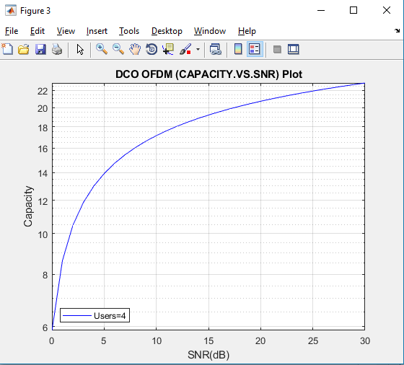
Fig 9 Capacity per unit Bandwidth versus SNR(dB) plot for 4 users

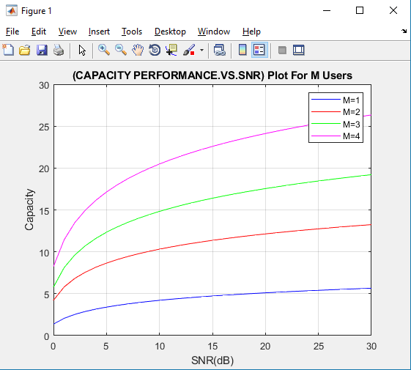
Fig10 Capacity Comparison versus SNR(dB) plot for M users

References
- Zhaocheng Wang ,Qi Wang, Wei Huang , Zhengyuan Xu; “Visible Light Communications-Modulation and Signal Processing”, IEEE Press
- Atiyah Abdulkafi, Mohamad Yusoff Ali, Yaseein Soubhi Hussein, “Performance analysis of DCO-OFDM in VLC system”’ 2015 IEEE 12th Malaysia International Conference on Communications,Ayad
- Sarangi Devasmitha Dissanayake, Jean Armstrong “Comparison of ACO-OFDM, DCO-OFDM and ADO-OFDM in IM/DD Systems”
- Andrea Goldsmith “Wireless Communications-Cambridge University Press(2005)”
- Biglieri E., Divsalar D., McLane P., Simon M, Introduction to Trellis-Coded Modulation with Applications,, Macmillan, 1991

