1. Create a directory 'project dir' & cd to 'project dir'.

2. Initialize git version database. (git init)

3. Create a new file Index.html.

4. Check the git status. You should find index.html as untracked file.

5. Stage the Index.html file.

6. Commit index.html 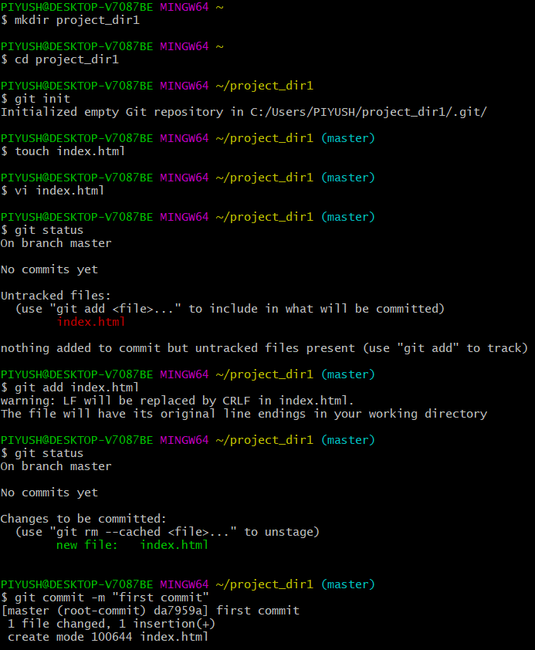

7. Make few changes in index.html & create a new file info.txt file.

8. Check git status. You should find index.html & info.txt

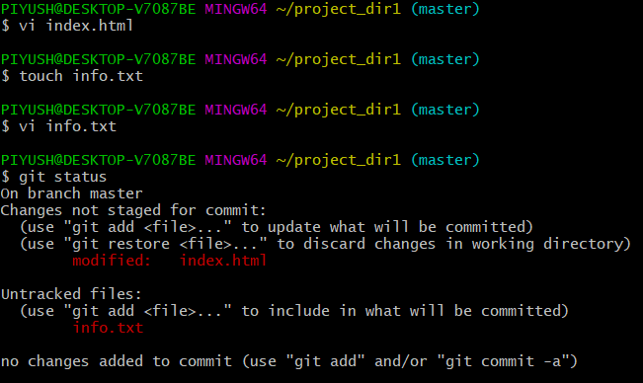

9. Configure GIT to ignore all txt files. untracked files.

10. Again check the git status. You should find only index.html as untracked

11. State & commit index.html

12. Log all your comments so far.

13. Make some changes in index.html.

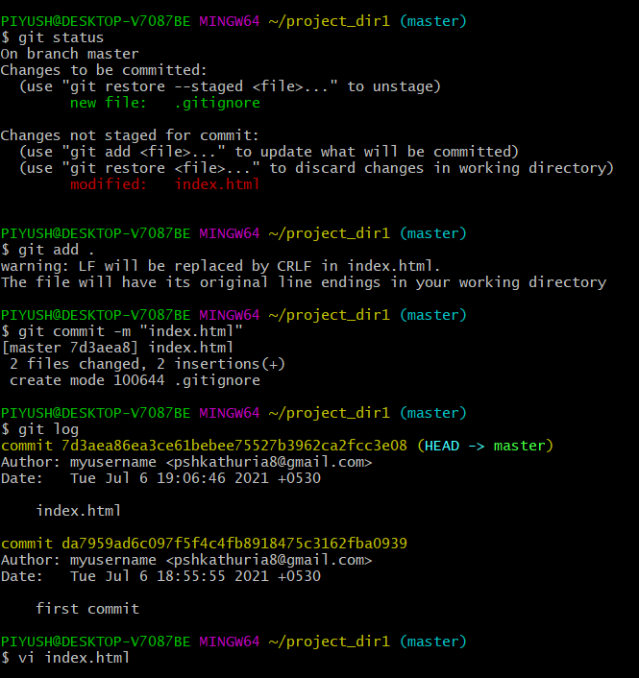

14. Revert the change made in the previous step using git command.



15. Again change index.html.

16. Stage index.html

17. Revert back the last stage

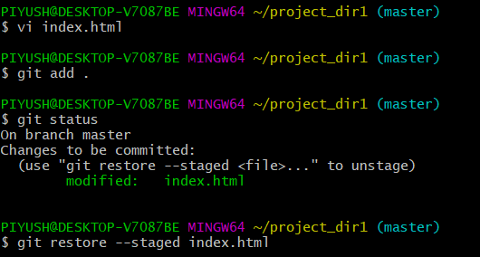

18. Rename 'add' command to 'my-add'.

19. Using my add command Stage index.html again & commit the changes.

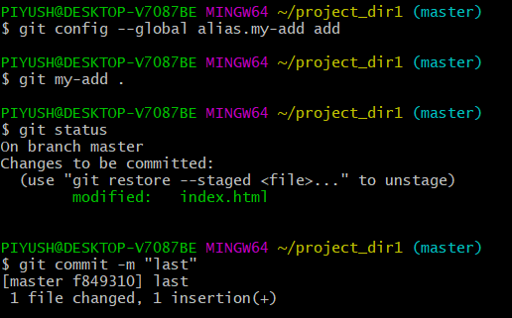

20. Revert the last commit.

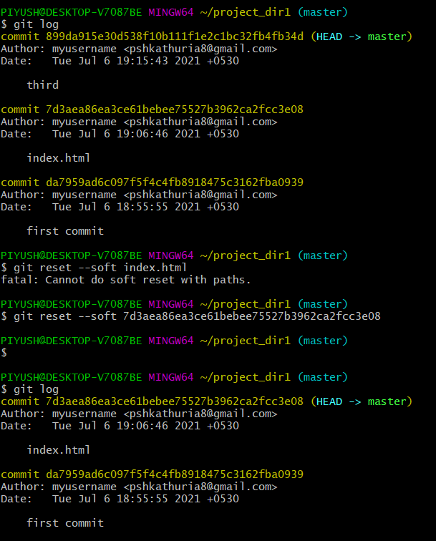

Objective Commit HTML, CSS & JavaScript assignments into GIT.

**SECTION-1 [HTML asignments)-Steps to follow**

PIYUSH@DESKTOP-V7087BE MINGW64 ~

$ mkdir Assignments

PIYUSH@DESKTOP-V7087BE MINGW64 ~

$ cd Assignments

PIYUSH@DESKTOP-V7087BE MINGW64 ~/Assignments

$ touch README.txt

PIYUSH@DESKTOP-V7087BE MINGW64 ~/Assignments

$ vi readme.txt

PIYUSH@DESKTOP-V7087BE MINGW64 ~/Assignments

$ git add readme.txt

fatal: not a git repository (or any of the parent directories): .git

PIYUSH@DESKTOP-V7087BE MINGW64 ~/Assignments

$ git add readme.txt

fatal: not a git repository (or any of the parent directories): .git

PIYUSH@DESKTOP-V7087BE MINGW64 ~/Assignments

$

PIYUSH@DESKTOP-V7087BE MINGW64 ~/Assignments

$ git add readme.txt

fatal: not a git repository (or any of the parent directories): .git

PIYUSH@DESKTOP-V7087BE MINGW64 ~/Assignments

$ git init

Initialized empty Git repository in C:/Users/PIYUSH/Assignments/.git/

PIYUSH@DESKTOP-V7087BE MINGW64 ~/Assignments (master)

$ git add readme.txt

PIYUSH@DESKTOP-V7087BE MINGW64 ~/Assignments (master)

$ git commit -m "first readme commit"

On branch master

Initial commit

Untracked files:

(use "git add <file>..." to include in what will be committed)

README.txt

nothing added to commit but untracked files present (use "git add" to track)

PIYUSH@DESKTOP-V7087BE MINGW64 ~/Assignments (master)

$ git add readme.txt

PIYUSH@DESKTOP-V7087BE MINGW64 ~/Assignments (master)

$ git status

On branch master

No commits yet

Untracked files:

(use "git add <file>..." to include in what will be committed)

README.txt

nothing added to commit but untracked files present (use "git add" to track)

PIYUSH@DESKTOP-V7087BE MINGW64 ~/Assignments (master)

$ git add README.txt

warning: LF will be replaced by CRLF in README.txt.

The file will have its original line endings in your working directory

PIYUSH@DESKTOP-V7087BE MINGW64 ~/Assignments (master)

$ git status

On branch master

No commits yet

Changes to be committed:

(use "git rm --cached <file>..." to unstage)

new file: README.txt

PIYUSH@DESKTOP-V7087BE MINGW64 ~/Assignments (master)

$ git commit -m "first readme commit"

[master (root-commit) 3c709ec] first readme commit

1 file changed, 1 insertion(+)

create mode 100644 README.txt

PIYUSH@DESKTOP-V7087BE MINGW64 ~/Assignments (master)

$ git branch html-assignments

PIYUSH@DESKTOP-V7087BE MINGW64 ~/Assignments (master)

$ git checkout html-assignments

Switched to branch 'html-assignments'

PIYUSH@DESKTOP-V7087BE MINGW64 ~/Assignments (html-assignments)

$ touch index.html

PIYUSH@DESKTOP-V7087BE MINGW64 ~/Assignments (html-assignments)

$ vi index.html

PIYUSH@DESKTOP-V7087BE MINGW64 ~/Assignments (html-assignments)

$ touch index2.html

PIYUSH@DESKTOP-V7087BE MINGW64 ~/Assignments (html-assignments)

$ vi index2.html

PIYUSH@DESKTOP-V7087BE MINGW64 ~/Assignments (html-assignments)

$ git add .

warning: LF will be replaced by CRLF in index.html.

The file will have its original line endings in your working directory

warning: LF will be replaced by CRLF in index2.html.

The file will have its original line endings in your working directory

PIYUSH@DESKTOP-V7087BE MINGW64 ~/Assignments (html-assignments)

$ git status

On branch html-assignments

Changes to be committed:

(use "git restore --staged <file>..." to unstage)

new file: index.html

new file: index2.html

PIYUSH@DESKTOP-V7087BE MINGW64 ~/Assignments (html-assignments)

$ git commit -m "commiting index.html and index1.html"

[html-assignments d76c652] commiting index.html and index1.html

2 files changed, 12 insertions(+)

create mode 100644 index.html

create mode 100644 index2.html

PIYUSH@DESKTOP-V7087BE MINGW64 ~/Assignments (html-assignments)

$ git checkout master

Switched to branch 'master'

PIYUSH@DESKTOP-V7087BE MINGW64 ~/Assignments (master)

$ git checkout html-assignments

Switched to branch 'html-assignments'

PIYUSH@DESKTOP-V7087BE MINGW64 ~/Assignments (html-assignments)

$ git checkout master

Switched to branch 'master'

PIYUSH@DESKTOP-V7087BE MINGW64 ~/Assignments (master)

$ vi readme.txt

PIYUSH@DESKTOP-V7087BE MINGW64 ~/Assignments (master)

$ git add .

warning: LF will be replaced by CRLF in README.txt.

The file will have its original line endings in your working directory

PIYUSH@DESKTOP-V7087BE MINGW64 ~/Assignments (master)

$ git commit -m "commiting readme with some change"

[master b960a6a] commiting readme with some change

1 file changed, 1 insertion(+)

PIYUSH@DESKTOP-V7087BE MINGW64 ~/Assignments (master)

$ git checkout html-assignments

Switched to branch 'html-assignments'

PIYUSH@DESKTOP-V7087BE MINGW64 ~/Assignments (html-assignments)

$ vi index.html

PIYUSH@DESKTOP-V7087BE MINGW64 ~/Assignments (html-assignments)

$ vi index1.html

PIYUSH@DESKTOP-V7087BE MINGW64 ~/Assignments (html-assignments)

$ git rm index1.html

fatal: pathspec 'index1.html' did not match any files

PIYUSH@DESKTOP-V7087BE MINGW64 ~/Assignments (html-assignments)

$ vi index2.html

PIYUSH@DESKTOP-V7087BE MINGW64 ~/Assignments (html-assignments)

$ git add .

PIYUSH@DESKTOP-V7087BE MINGW64 ~/Assignments (html-assignments)

$ git status

On branch html-assignments

Changes to be committed:

(use "git restore --staged <file>..." to unstage)

modified: index.html

modified: index2.html

PIYUSH@DESKTOP-V7087BE MINGW64 ~/Assignments (html-assignments)

$ git commit -m "commiting index and index2 with some change"

[html-assignments f8d01bb] commiting index and index2 with some change

2 files changed, 2 insertions(+)

PIYUSH@DESKTOP-V7087BE MINGW64 ~/Assignments (html-assignments)

$ git checkout master

Switched to branch 'master'

PIYUSH@DESKTOP-V7087BE MINGW64 ~/Assignments (master)

$ git merge html-assignments

Merge made by the 'recursive' strategy.

index.html | 8 ++++++++

index2.html | 6 ++++++

2 files changed, 14 insertions(+)

create mode 100644 index.html

create mode 100644 index2.html

PIYUSH@DESKTOP-V7087BE MINGW64 ~/Assignments (master)

$ git branch --merged

html-assignments

* master

PIYUSH@DESKTOP-V7087BE MINGW64 ~/Assignments (master)

$ git branch -d html-assignments

Deleted branch html-assignments (was f8d01bb).

**SECTION-2-(CSS assignments) Steps to follow:**

PIYUSH@DESKTOP-V7087BE MINGW64 ~/Assignments (master)

$ git branch

* master

PIYUSH@DESKTOP-V7087BE MINGW64 ~/Assignments (master)

$ git branch css-assignments

PIYUSH@DESKTOP-V7087BE MINGW64 ~/Assignments (master)

$ git checkout css-assignment

error: pathspec 'css-assignment' did not match any file(s) known to git

PIYUSH@DESKTOP-V7087BE MINGW64 ~/Assignments (master)

$ git checkout css-assignments

Switched to branch 'css-assignments'

PIYUSH@DESKTOP-V7087BE MINGW64 ~/Assignments (css-assignments)

$ touch xyz.css

PIYUSH@DESKTOP-V7087BE MINGW64 ~/Assignments (css-assignments)

$ vi xyz.css

PIYUSH@DESKTOP-V7087BE MINGW64 ~/Assignments (css-assignments)

$ touch xyz2.css

PIYUSH@DESKTOP-V7087BE MINGW64 ~/Assignments (css-assignments)

$ vi xyz2.css

PIYUSH@DESKTOP-V7087BE MINGW64 ~/Assignments (css-assignments)

$ git add .

warning: LF will be replaced by CRLF in xyz.css.

The file will have its original line endings in your working directory

warning: LF will be replaced by CRLF in xyz2.css.

The file will have its original line endings in your working directory

PIYUSH@DESKTOP-V7087BE MINGW64 ~/Assignments (css-assignments)

$ git commit -m "first commit of css"

[css-assignments 7f12813] first commit of css

2 files changed, 2 insertions(+)

create mode 100644 xyz.css

create mode 100644 xyz2.css

PIYUSH@DESKTOP-V7087BE MINGW64 ~/Assignments (css-assignments)

$ vi readme.txt

PIYUSH@DESKTOP-V7087BE MINGW64 ~/Assignments (css-assignments)

$ git add .

PIYUSH@DESKTOP-V7087BE MINGW64 ~/Assignments (css-assignments)

$ git commit -m "minor change in readme"

[css-assignments 6e3d8da] minor change in readme

1 file changed, 1 insertion(+), 1 deletion(-)

PIYUSH@DESKTOP-V7087BE MINGW64 ~/Assignments (css-assignments)

$ git checkout master

Switched to branch 'master'

PIYUSH@DESKTOP-V7087BE MINGW64 ~/Assignments (master)

$ vi readme.txt

PIYUSH@DESKTOP-V7087BE MINGW64 ~/Assignments (master)

$ git add .

PIYUSH@DESKTOP-V7087BE MINGW64 ~/Assignments (master)

$ git commit -m "readme 3 rd"

[master aeeed1e] readme 3 rd

1 file changed, 1 insertion(+)

PIYUSH@DESKTOP-V7087BE MINGW64 ~/Assignments (master)

$ git checkout css-assignments

Switched to branch 'css-assignments'

PIYUSH@DESKTOP-V7087BE MINGW64 ~/Assignments (css-assignments)

$ vi xyz.css

PIYUSH@DESKTOP-V7087BE MINGW64 ~/Assignments (css-assignments)

$ vi xyz2.css

PIYUSH@DESKTOP-V7087BE MINGW64 ~/Assignments (css-assignments)

$ git add .

PIYUSH@DESKTOP-V7087BE MINGW64 ~/Assignments (css-assignments)

$ git commit -m "second commit"

[css-assignments a227043] second commit

2 files changed, 2 insertions(+), 2 deletions(-)

PIYUSH@DESKTOP-V7087BE MINGW64 ~/Assignments (css-assignments)

$ git checkout master

Switched to branch 'master'

PIYUSH@DESKTOP-V7087BE MINGW64 ~/Assignments (master)

$ git merge css-assignments

Auto-merging README.txt

Merge made by the 'recursive' strategy.

README.txt | 2 +-

xyz.css | 1 +

xyz2.css | 1 +

3 files changed, 3 insertions(+), 1 deletion(-)

create mode 100644 xyz.css

create mode 100644 xyz2.css

PIYUSH@DESKTOP-V7087BE MINGW64 ~/Assignments (master)

$ git merge css-assignments

Already up to date.

PIYUSH@DESKTOP-V7087BE MINGW64 ~/Assignments (master)

$ git branch -d css-assignments

Deleted branch css-assignments (was a227043).

**SECTION -3**

PIYUSH@DESKTOP-V7087BE MINGW64 ~/Assignments (master)

$ git branch

* master

PIYUSH@DESKTOP-V7087BE MINGW64 ~/Assignments (master)

$ git branch js-assignments

PIYUSH@DESKTOP-V7087BE MINGW64 ~/Assignments (master)

$ git checkout js-assignments

Switched to branch 'js-assignments'

PIYUSH@DESKTOP-V7087BE MINGW64 ~/Assignments (js-assignments)

$ touch 123.js

PIYUSH@DESKTOP-V7087BE MINGW64 ~/Assignments (js-assignments)

$ vi 123.js

PIYUSH@DESKTOP-V7087BE MINGW64 ~/Assignments (js-assignments)

$ touch 234.js

PIYUSH@DESKTOP-V7087BE MINGW64 ~/Assignments (js-assignments)

$ vi 234.js

PIYUSH@DESKTOP-V7087BE MINGW64 ~/Assignments (js-assignments)

$ git add .

warning: LF will be replaced by CRLF in 123.js.

The file will have its original line endings in your working directory

warning: LF will be replaced by CRLF in 234.js.

The file will have its original line endings in your working directory

PIYUSH@DESKTOP-V7087BE MINGW64 ~/Assignments (js-assignments)

$ git commit -m "first js commit"

[js-assignments 64e1e1e] first js commit

2 files changed, 2 insertions(+)

create mode 100644 123.js

create mode 100644 234.js

PIYUSH@DESKTOP-V7087BE MINGW64 ~/Assignments (js-assignments)

$ vi readme.txt

PIYUSH@DESKTOP-V7087BE MINGW64 ~/Assignments (js-assignments)

$ git add .

PIYUSH@DESKTOP-V7087BE MINGW64 ~/Assignments (js-assignments)

$ git commit -m "readme commit js"

[js-assignments 0b00a75] readme commit js

1 file changed, 1 insertion(+), 1 deletion(-)

PIYUSH@DESKTOP-V7087BE MINGW64 ~/Assignments (js-assignments)

$ git checkout master

Switched to branch 'master'

PIYUSH@DESKTOP-V7087BE MINGW64 ~/Assignments (master)

$ vi readme.txt

PIYUSH@DESKTOP-V7087BE MINGW64 ~/Assignments (master)

$ git add .

PIYUSH@DESKTOP-V7087BE MINGW64 ~/Assignments (master)

$ git commit -m "readme 1st line changed"

[master 69fcb43] readme 1st line changed

1 file changed, 1 insertion(+), 1 deletion(-)

PIYUSH@DESKTOP-V7087BE MINGW64 ~/Assignments (master)

$ git checkout js-assignments

Switched to branch 'js-assignments'

PIYUSH@DESKTOP-V7087BE MINGW64 ~/Assignments (js-assignments)

$ vi 123.js

PIYUSH@DESKTOP-V7087BE MINGW64 ~/Assignments (js-assignments)

$ git add .

PIYUSH@DESKTOP-V7087BE MINGW64 ~/Assignments (js-assignments)

$ git commit -m "second cahnge in js"

[js-assignments f4dcf01] second cahnge in js

1 file changed, 1 insertion(+), 1 deletion(-)

PIYUSH@DESKTOP-V7087BE MINGW64 ~/Assignments (js-assignments)

$ git checkout master

Switched to branch 'master'

PIYUSH@DESKTOP-V7087BE MINGW64 ~/Assignments (master)

$ git merge js-assignments

Auto-merging README.txt

CONFLICT (content): Merge conflict in README.txt

Automatic merge failed; fix conflicts and then commit the result.

PIYUSH@DESKTOP-V7087BE MINGW64 ~/Assignments (master|MERGING)

$ git status

On branch master

You have unmerged paths.

(fix conflicts and run "git commit")

(use "git merge --abort" to abort the merge)

Changes to be committed:

new file: 123.js

new file: 234.js

Unmerged paths:

(use "git add <file>..." to mark resolution)

both modified: README.txt

PIYUSH@DESKTOP-V7087BE MINGW64 ~/Assignments (master|MERGING)

$ git merge --abort

PIYUSH@DESKTOP-V7087BE MINGW64 ~/Assignments (master)

$ git status

On branch master

nothing to commit, working tree clean

PIYUSH@DESKTOP-V7087BE MINGW64 ~/Assignments (master)

$ git merge js-assignments

Auto-merging README.txt

CONFLICT (content): Merge conflict in README.txt

Automatic merge failed; fix conflicts and then commit the result.

PIYUSH@DESKTOP-V7087BE MINGW64 ~/Assignments (master|MERGING)

$ git status

On branch master

You have unmerged paths.

(fix conflicts and run "git commit")

(use "git merge --abort" to abort the merge)

Changes to be committed:

new file: 123.js

new file: 234.js

Unmerged paths:

(use "git add <file>..." to mark resolution)

both modified: README.txt

PIYUSH@DESKTOP-V7087BE MINGW64 ~/Assignments (master|MERGING)

$ vi readme.txt

PIYUSH@DESKTOP-V7087BE MINGW64 ~/Assignments (master|MERGING)

$ git add .

PIYUSH@DESKTOP-V7087BE MINGW64 ~/Assignments (master|MERGING)

$ git commit

[master fc688b3] Merge branch 'js-assignments'

PIYUSH@DESKTOP-V7087BE MINGW64 ~/Assignments (master)

$ git merge js-assignments

Already up to date.

PIYUSH@DESKTOP-V7087BE MINGW64 ~/Assignments (master)

$ git branch -d js-assignments

Deleted branch js-assignments (was f4dcf01).

PIYUSH@DESKTOP-V7087BE MINGW64 ~/Assignments (master)

$ git branch

* master

**GIT REMOTING**

**SECTION 3**

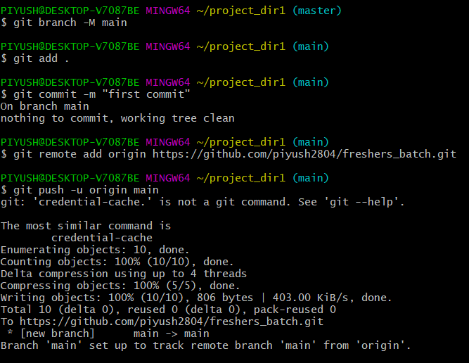

**SECTION 4**

**(Pushing source code to remote repository using Eclipse GIT plugin) - Steps**

**to follow.**

1. One developer from project team will create eclipse projects SampleProj & add sample source code files. Then commit all files through eclipse GIT plugin.

2. Collaborate other team members with your github account so that they can also modify the committed files

3. Other developers from same team will checkout all files from remote repository. This might get conflicts since certain files fail to merge. In such case, merge it manually.

4. Commit & push the "SampleProj' project.

