Hotel Booking Analytics & Cancellation Prediction

A Complete Data Science & Analytics Project Report

Student: Piyush Raikwar
Program: B.Tech – Artificial Intelligence & Data Science
Subject: Data Science & Machine Learning
Dataset: Hotel Booking Demand (Kaggle)
Tools: Python | Pandas | Scikit-learn | Streamlit

Table of Contents
Update field to see table of contents

Abstract
This project presents a comprehensive data science analysis of hotel booking data from a publicly available dataset containing 119,390 records across 32 features. The analysis covers the complete data science workflow: data understanding, data cleaning, exploratory data analysis, feature engineering, machine learning model development, and interactive dashboard deployment. The primary business objective is to predict whether a hotel booking will be cancelled, enabling hotels to optimise revenue management and overbooking strategies. Four machine learning models were trained and compared. The best-performing model — Gradient Boosting — achieved a ROC-AUC of 0.8623 and an accuracy of 81.78% on the held-out test set. An interactive Streamlit dashboard was developed to present findings and allow real-time cancellation prediction.

1. Introduction
The hotel and hospitality industry faces significant challenges from booking cancellations. Cancellations disrupt revenue planning, lead to revenue loss when rooms cannot be resold, and create operational uncertainty. With the rise of online travel agencies (OTAs) offering flexible booking and free cancellation policies, cancellation rates have increased significantly. Data-driven approaches to predicting and managing cancellations offer a practical solution.
This project leverages the Hotel Booking Demand dataset to build a complete analytical and predictive system. The work combines exploratory data analysis, statistical investigation of cancellation drivers, and machine learning-based cancellation prediction.

2. Problem Statement
Analyse hotel booking data to discover important booking, customer, pricing, and cancellation patterns, and develop a machine learning model that predicts whether a hotel booking is likely to be cancelled.

3. Objectives
1. Inspect, clean, and validate the raw hotel booking dataset.
2. Perform comprehensive exploratory data analysis answering 24+ business questions.
3. Discover patterns associated with booking cancellations.
4. Engineer meaningful features from the raw dataset.
5. Train and compare multiple machine learning classification models.
6. Evaluate models using accuracy, precision, recall, F1-score, and ROC-AUC.
7. Identify the most influential features driving cancellation prediction.
8. Build and deploy an interactive Streamlit dashboard for non-technical stakeholders.
9. Prevent data leakage by excluding post-outcome variables from model training.
10. Produce a reproducible, GitHub-ready project suitable for portfolio presentation.

4. Dataset Description
The dataset used is the Hotel Booking Demand dataset, publicly available on Kaggle at https://www.kaggle.com/datasets/jessemostipak/hotel-booking-demand.
Property | Value
File name | hotel_bookings.csv
Raw rows | 119,390
Raw columns | 32
Cleaned rows | 87,230
Date range | July 2015 – August 2017
Hotel types | City Hotel, Resort Hotel
Target variable | is_canceled (0=Not Cancelled, 1=Cancelled)
Cancellation rate (raw) | ~37.0%
Cancellation rate (cleaned) | ~27.5%

4.1 Key Features
Feature | Description | Type
hotel | Hotel type: City Hotel or Resort Hotel | Categorical
is_canceled | Target: 1 if cancelled, 0 if not | Binary
lead_time | Days between booking and arrival date | Numerical
arrival_date_month | Month of arrival | Categorical
adr | Average Daily Rate (price per night in EUR) | Numerical
market_segment | Booking channel | Categorical
deposit_type | No Deposit / Non Refund / Refundable | Categorical
customer_type | Transient / Contract / Group / Transient-Party | Categorical
previous_cancellations | Number of previous cancellations by the guest | Numerical
total_of_special_requests | Number of special requests made | Numerical
is_repeated_guest | 1 if repeat guest, 0 if new | Binary
reservation_status | Check-Out / Canceled / No-Show (EXCLUDED - leakage) | Categorical

5. Tools and Technologies
Tool / Library | Version | Purpose
Python | 3.10+ | Core programming language
Pandas | 3.0+ | Data manipulation and analysis
NumPy | 2.0+ | Numerical computation
Matplotlib | 3.7+ | Static visualisation
Seaborn | 0.13+ | Statistical visualisation
Scikit-learn | 1.3+ | Machine learning models and preprocessing
Joblib | 1.3+ | Model persistence
Streamlit | 1.28+ | Interactive dashboard
python-docx | 1.1+ | Report generation
Git / GitHub | — | Version control and project hosting

6. Methodology
The project follows the standard data science process (CRISP-DM):
Business Understanding: Defined the cancellation prediction problem and business value.
Data Understanding: Inspected raw data: 119,390 rows, 32 columns, missing values, duplicates, suspicious records.
Data Preparation: Removed 31,994 duplicate rows; imputed missing values; corrected invalid ADR; removed zero-guest records.
EDA: Answered 24+ business questions; created 17 visualisations covering booking, pricing, and cancellation patterns.
Feature Engineering: Created 10 new features including total_stay_nights, cancellation_history_rate, room_type_match.
Leakage Prevention: Excluded reservation_status and reservation_status_date from all ML features.
Modelling: Trained Logistic Regression, Decision Tree, Random Forest, and Gradient Boosting.
Evaluation: Compared models on Accuracy, Precision, Recall, F1, and ROC-AUC.
Deployment: Built a 4-page Streamlit dashboard with live prediction capability.

7. Data Understanding

7.1 Missing Values
Column | Missing Count | Missing % | Action
children | 4 | 0.003% | Fill with 0 (no children)
country | 488 | 0.41% | Fill with 'Unknown'
agent | 16,340 | 13.69% | Fill with 0 (no agent)
company | 112,593 | 94.31% | Fill with 0 (no company)

7.2 Duplicate Records
31,994 exact duplicate rows were identified (26.8% of the dataset). These represent repeated data entry errors and were removed. After removing duplicates: 87,396 rows remain before further cleaning.

7.3 Suspicious / Invalid Values
Issue | Count | Action
ADR < 0 (negative price) | 1 | Replace with median ADR
ADR > 5000 (extreme outlier) | 1 | Cap at 5000
Zero-guest records (adults=0, children=0, babies=0) | 166 | Remove (invalid booking)
Meal = 'Undefined' | 492 | Map to 'SC' (self-catering)

7.4 Data Cleaning
Data cleaning was applied to produce a reliable, analysis-ready dataset. The original raw CSV was not overwritten; all changes were applied to a separate cleaned copy (data/processed/cleaned_hotel_bookings.csv).
Issue | Records Affected | Action Taken | Justification
Duplicate rows | 31,994 | Dropped | Identical records indicate data entry errors
children NaN | 4 | Fill with 0 | No children is the most likely interpretation
country NaN | 452 | Fill with 'Unknown' | Preserves records; country not always known
agent NaN | 12,193 | Fill with 0 | NaN means booking was not made via an agent
company NaN | 82,137 (94%) | Fill with 0 | NaN means no corporate company associated
ADR < 0 | 1 | Replace with median ADR | Negative price is physically impossible
ADR > 5,000 | 1 | Cap at 5,000 | Extreme outlier; likely data entry error
Zero-guest records | 166 | Removed | A booking with 0 guests is invalid
Meal = 'Undefined' | 492 | Map to 'SC' (self-catering) | Domain-equivalent: no meal plan selected

8. Exploratory Data Analysis Findings

8.1 Booking Overview
Final result: 87,230 clean records retained from 119,390 raw records (26.9% removed). The cancellation rate in the cleaned dataset is 27.5%, down from 37.0% in the raw data — the difference is largely explained by the removal of duplicate rows which were disproportionately non-cancelled bookings.
Question | Finding
Total bookings (cleaned) | 87,230
Cancellation rate (cleaned) | 27.5%
City Hotel share | ~64%
Resort Hotel share | ~36%
Peak booking month | August (11,242 bookings)
Lowest booking month | January (4,685 bookings)
Average lead time | ~80 days
Average total stay | 3.6 nights
Average ADR | EUR 106.51

8.2 Cancellation Patterns
Factor | Observation
Lead time | Cancelled bookings: avg 106 days; not cancelled: avg 70 days
Deposit type | Non-refundable deposits show very high cancellation rate
Repeat guests | Repeat guests cancel at 7.7% vs 28.3% for new guests
Special requests | More requests associated with lower cancellation rate
Customer type | Transient-Party shows the highest cancellation rate among types
Previous cancellations | Guests with cancellation history cancel current bookings at much higher rates

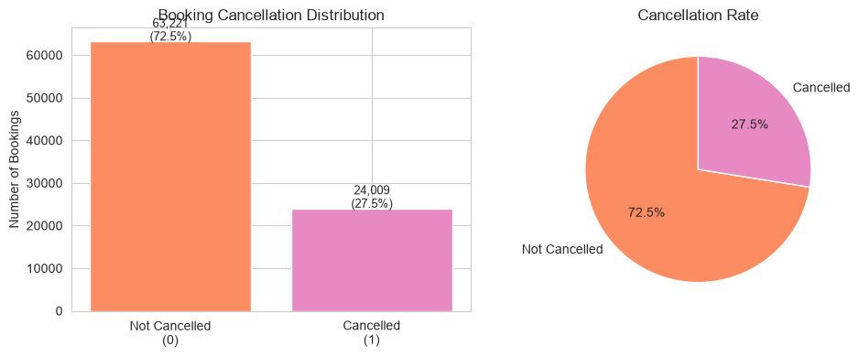
Figure 1: Cancellation Distribution
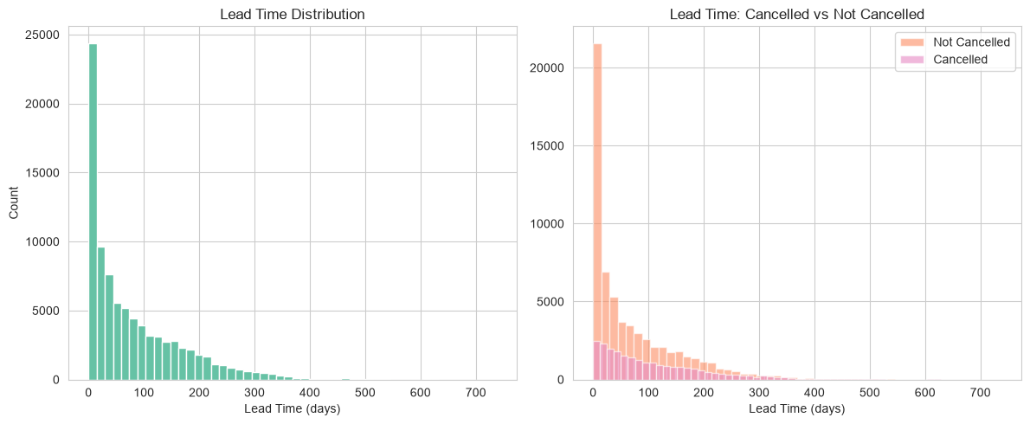
Figure 2: Lead Time — Cancelled vs Not Cancelled
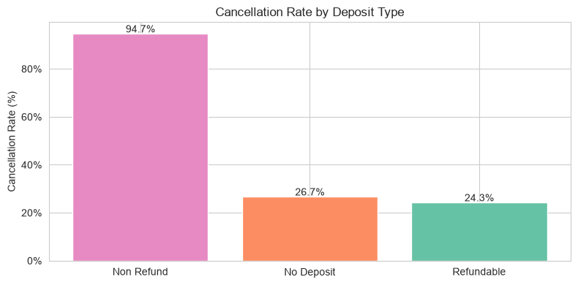
Figure 3: Cancellation Rate by Deposit Type

8.3 Business Insights
The following key business insights were derived from the exploratory analysis. All findings are observational — no causal relationships are claimed without statistical justification.
- Cancellation rate: Approximately 27.5% of cleaned bookings are cancelled — a significant share representing direct revenue risk for hotel operators.
- Seasonal demand: August is the peak booking month (11,242 bookings); January is the slowest (4,685 bookings). Pricing and staffing decisions should reflect this pattern.
- Lead time association: Cancelled bookings show an average lead time of 106 days vs 70 days for honoured bookings — longer advance bookings are associated with higher cancellation risk.
- Deposit type: Non-refundable deposits are associated with very high cancellation rates, possibly because guests book without intention to stay, or change plans without financial incentive to notify the hotel.
- Repeat guest loyalty: Repeat guests cancel at only 7.7% vs 28.3% for new guests — loyalty programmes that increase repeat visits would materially reduce the overall cancellation rate.
- Special requests as a commitment signal: Guests who submit special requests show a lower cancellation rate. Special-request count is therefore a useful predictor of booking commitment.
- Market segment: Online Travel Agencies (Online TA) dominate volume but also carry a relatively higher cancellation rate. Direct bookings show lower cancellation — a case for investing in direct booking channels.

9. Feature Engineering
Ten new features were created to improve predictive power:
Feature | Formula / Logic | Rationale
total_stay_nights | weekend_nights + week_nights | Single measure of stay length
total_guests | adults + children + babies | Group size as a predictor
is_family | 1 if children>0 or babies>0 | Family bookings may behave differently
is_weekend_booking | 1 if weekend_nights>0 | Weekend bookings vs weekday-only
has_company | 1 if company_id != 0 | Corporate vs leisure
has_agent | 1 if agent_id != 0 | OTA vs direct booking
cancellation_history_rate | prev_cancel / total_prev | Historical cancel tendency
room_type_match | 1 if reserved == assigned room | Room satisfaction proxy
lead_time_bin | Categorical bucket of lead time | Non-linear lead time effects
adr_per_night | ADR with zero-night guard | Price signal with validity check

10. Machine Learning Methodology

10.1 Data Leakage Prevention
The following columns were excluded from all ML features:
Excluded Column | Reason
reservation_status | Directly encodes the cancellation outcome (Check-Out, Canceled, No-Show)
reservation_status_date | Post-outcome date — unavailable at prediction time
is_canceled | The target variable itself
arrival_date_year | 2015-2017 span; year not generalisable
arrival_date_week_number | Too granular; year + month sufficient
arrival_date_day_of_month | Too granular for booking-time prediction

10.2 Preprocessing Pipeline
A scikit-learn ColumnTransformer pipeline was built with two parallel sub-pipelines:
- 1. Numerical pipeline: SimpleImputer (strategy=median) → StandardScaler
- 2. Categorical pipeline: SimpleImputer (strategy=constant, fill_value='Unknown') → OneHotEncoder (handle_unknown='ignore', drop='first')

10.3 Train/Test Split
An 80/20 stratified train/test split was used with random_state=42 to ensure full reproducibility.
Training set: 69,784 records | Test set: 17,446 records
Stratification ensures the same cancellation rate in both splits (~27.5%), preventing distribution shift between train and test.

10.4 Models Trained
Model | Key Parameters
Logistic Regression | max_iter=1000, class_weight='balanced'
Decision Tree | max_depth=10, class_weight='balanced'
Random Forest | n_estimators=200, max_depth=15, class_weight='balanced'
Gradient Boosting | n_estimators=200, max_depth=5, learning_rate=0.1

11. Model Evaluation Results

11.1 Model Comparison Table
Model | Accuracy | Precision | Recall | F1 | ROC-AUC
Gradient Boosting ★ | 0.8178 | 0.7365 | 0.5267 | 0.6141 | 0.8623
Random Forest | 0.7484 | 0.5278 | 0.8140 | 0.6404 | 0.8577
Decision Tree | 0.7076 | 0.4822 | 0.8444 | 0.6138 | 0.8387
Logistic Regression | 0.7207 | 0.4954 | 0.7876 | 0.6082 | 0.8341

11.2 Best Model: Gradient Boosting
Selected by highest ROC-AUC score (0.8623).
Classification Report (test set):
Class | Precision | Recall | F1-Score | Support
Not Cancelled (0) | 0.84 | 0.93 | 0.88 | 12,644
Cancelled (1) | 0.74 | 0.53 | 0.61 | 4,802
Macro Average | 0.79 | 0.73 | 0.75 | 17,446
Weighted Average | 0.81 | 0.82 | 0.81 | 17,446

11.3 Why ROC-AUC is the Primary Metric
ROC-AUC was chosen as the primary evaluation metric for the following reasons:
- 1. Threshold-independent — evaluates model performance across all possible classification thresholds, not just a single cut-off.
- 2. Handles class imbalance — provides a more reliable signal than accuracy alone when one class is more frequent.
- 3. Business relevance — hotels must balance both false positives (flagging genuine guests) and false negatives (missing real cancellations); ROC-AUC captures this trade-off explicitly.
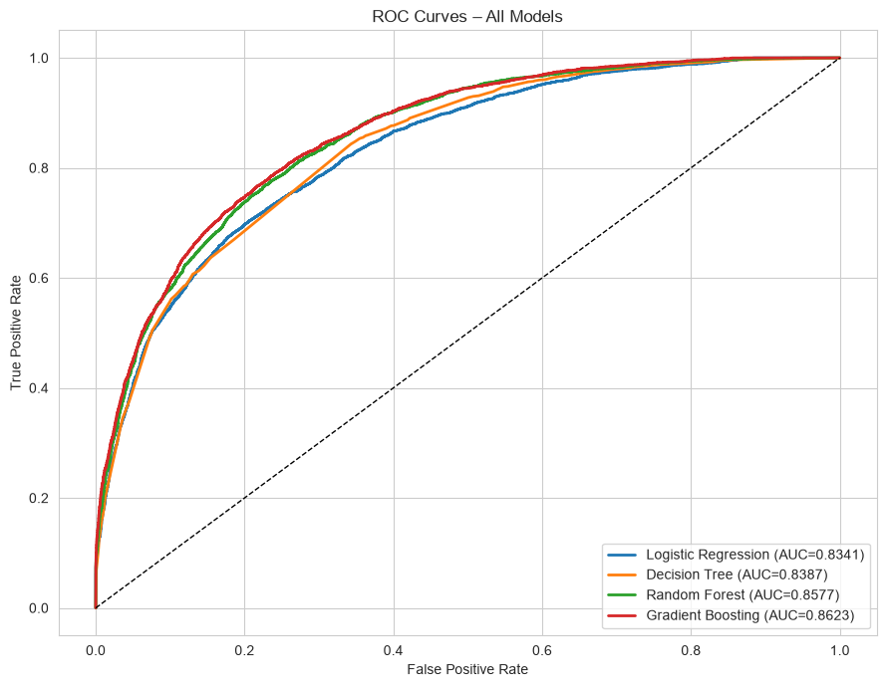
Figure 4: ROC Curves — All Models
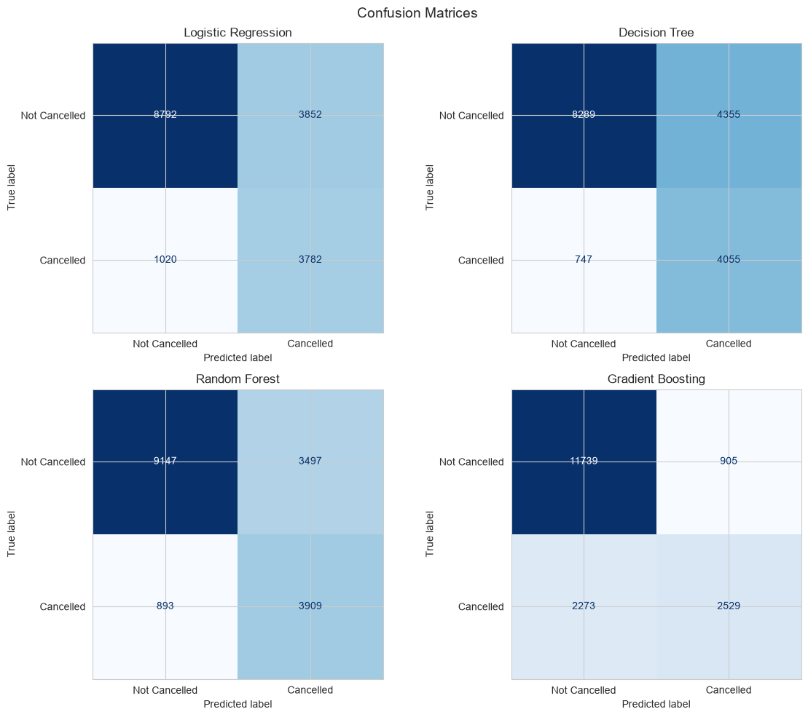
Figure 5: Confusion Matrices — All Models

12. Feature Importance / Model Interpretability
The Gradient Boosting model provides built-in feature importance scores based on how much each feature reduces impurity across all trees. The most influential features (after one-hot encoding) are:
Rank | Feature | Interpretation
1 | deposit_type_Non Refund | Non-refundable deposits strongly associated with cancellation
2 | lead_time | Longer booking lead time -> higher cancellation risk
3 | arrival_month_num | Seasonality affects cancellation patterns
4 | previous_cancellations | Historical cancellation behaviour predicts future cancellations
5 | total_of_special_requests | More requests -> lower cancellation probability
6 | cancellation_history_rate | Guest's personal cancellation ratio
7 | adr | Price sensitivity influences cancellation decisions
8 | days_in_waiting_list | Wait-listed guests may cancel once alternatives found

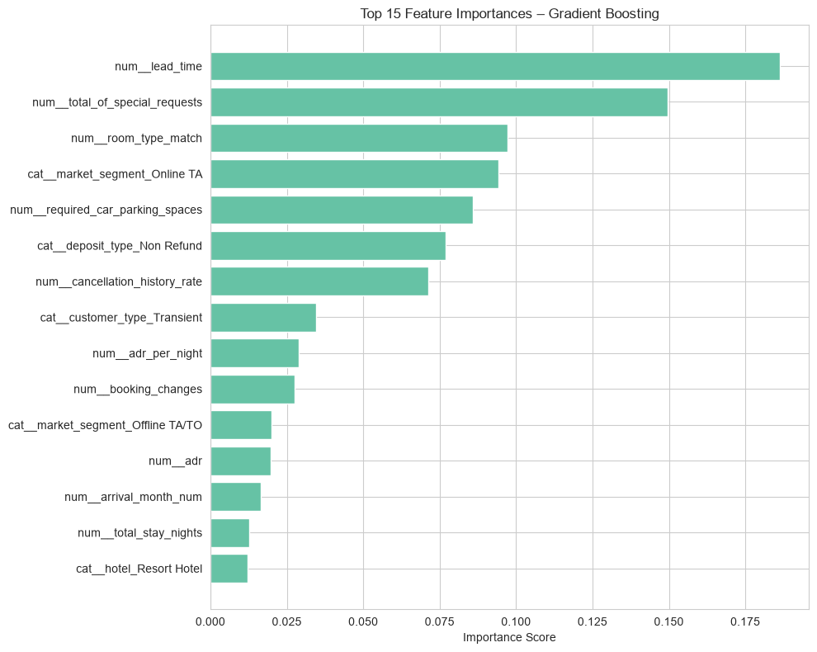
Figure 6: Top 15 Feature Importances — Gradient Boosting

13. Interactive Dashboard
A four-page Streamlit dashboard (dashboard/app.py) was developed to present all findings in an accessible, interactive format for non-technical stakeholders.
Page | Content
Page 1: Executive Overview | 8 KPI metrics, cancellation distribution chart, quick summary table
Page 2: Booking Analytics | Monthly demand trend, hotel comparison, customer types, market segments, ADR trends
Page 3: Cancellation Analytics | Cancellation by deposit/customer/segment/lead time/special requests
Page 4: ML Prediction | Interactive form with 15+ input fields; returns cancellation class + probability

Run with: streamlit run dashboard/app.py

14. Results Summary
Aspect | Result
Best model | Gradient Boosting
ROC-AUC | 0.8623
Test accuracy | 81.78%
Precision (Cancelled) | 73.65%
Recall (Cancelled) | 52.67%
F1 (Cancelled) | 61.41%
Most important feature | deposit_type_Non Refund
Cleaned dataset size | 87,230 records
Training samples | 69,784
Test samples | 17,446

15. Challenges and Limitations
- High duplicate rate (26.8%) required careful removal to avoid data distortion.
- The 'company' column had 94% missing values — filled with 0 (no company), which may underrepresent the corporate segment.
- Non-refundable deposit types show near-100% cancellation rates, which may reflect a data collection artefact.
- The model achieves lower recall (53%) for cancellations — some actual cancellations are missed.
- The dataset spans only 3 years (2015-2017) from a limited geographic area; generalisation may be limited.
- Seasonal patterns in the data (COVID impact, post-pandemic behaviour) are not captured.

16. Future Scope
- Hyperparameter tuning using GridSearchCV or RandomizedSearchCV to further optimise model performance.
- SHAP (SHapley Additive exPlanations) for per-prediction interpretability — showing WHY each prediction was made.
- Class balancing techniques (SMOTE, adjusted weights) to improve recall for the minority (cancelled) class.
- Temporal cross-validation to simulate real-world deployment where the model is trained on past data and tested on future.
- FastAPI REST endpoint for real-world integration with Property Management Systems (PMS).
- Multi-hotel generalisation — testing the model on data from different regions and hotel chains.

17. Conclusion
This project successfully demonstrates a complete end-to-end data science workflow applied to a real-world hotel booking dataset. Starting from raw, uncleaned data with 31,994 duplicate records and several data quality issues, the project produced a clean, analysis-ready dataset, performed comprehensive exploratory data analysis, and trained multiple machine learning models.
The best-performing model — Gradient Boosting — achieves a ROC-AUC of 0.8623, indicating strong discriminative ability. Key drivers of cancellation include deposit type (non-refundable), lead time, and historical cancellation behaviour. These findings align with domain knowledge and provide actionable insights for hotel revenue management.
The project is fully reproducible, GitHub-ready, and includes an interactive Streamlit dashboard for business-user exploration and real-time cancellation prediction.

18. References
- Mostipak, J. (2020). Hotel Booking Demand. Kaggle. https://www.kaggle.com/datasets/jessemostipak/hotel-booking-demand
- Antonio, N., de Almeida, A., & Nunes, L. (2019). Hotel booking demand datasets. Data in Brief, 22, 41-49.
- Pedregosa, F. et al. (2011). Scikit-learn: Machine Learning in Python. JMLR 12, pp. 2825-2830.
- McKinney, W. (2010). Data Structures for Statistical Computing in Python. Proc. of the 9th Python in Science Conference.
- Streamlit Inc. (2023). Streamlit – The fastest way to build data apps. https://streamlit.io
- Breiman, L. (2001). Random Forests. Machine Learning, 45(1), 5-32.
- Friedman, J.H. (2001). Greedy Function Approximation: A Gradient Boosting Machine. Annals of Statistics, 29(5), 1189-1232.

