**PIYUSH KUMAR**

Email: krpiyush48@gmail.com

Ph: 7899026624

|  |
| --- |
| CAREER OBJECTIVE |

To pursue a challenging career and be a part of progressive organization that gives a scope to

enhance my knowledge and utilizing my skills towards the growth of the organization.

|  |
| --- |
| EDUCATION |

|  |  |  |  |  |
| --- | --- | --- | --- | --- |
| **Institution** | **Course** | **Board** | **year** | **result** |
| CMR Institute of technology ,Bangalore | B.E(Computer Science and Engineering) | VTU | 2015-2019 | 7.64 |
| Sainik School Tilaiya | 12TH Standard | CBSE | 2014 | 87.2% |
| Sainik School Tilaiya | 10TH Standard | CBSE | 2012 | 9.4 |

|  |
| --- |
| PROJECT |

1.VTU DBMS Mini project

Developed a interactive web application on university management system.

Backend language used-MySQL and PHP scripiting language.

Frontend language used- HTML ,CSS,JAVA SCRITP

2.Sport Management System using Web Application

|  |
| --- |
| PROFESSIONAL SKILLS |

Programming Languages- C ,C++, Java, Python

DataBase –MySQL

Markup Languages-HTML, CSS,

Scripiting Language-Basic PHP

|  |
| --- |
| WORKSHOPS |

1.Google Android Developers Fest Organized on October 27th, 2017

2.Participated in 2days workshop on Cyber Security Disciples India Group,Bengaluru,2017

3.Participated in ethical hacking workshop held during 24th and 25th February 2016

4.Attended the workshop on Animation and Game Design using Blender held from 30th Sept to 2nd Oct 2016

|  |
| --- |
| ACHIEVEMENTS |

1.Awarded CMR Scholarship

2.Represented Basketball Team

3.Secured 3rd place in 400m Race

4.Winner of the Capture the flag contest conducted by RevEngg at CMRIT ,2017

5.Was the part of the SWACHHTA PAKHWADA ,2017

6.Particitaed in CLUSTER Basketball Tournament

7.Participated in National Basketball Championship

|  |
| --- |
| PERSONAL INFORMATION |

Date of Birth: August-08-1996

Father Name: Jay Kumar Yadav

Permanent address: Vill-Pinja,Dist-Chatra ,Jharkhand

|  |
| --- |
| HOBBIES |

Basketball,Cricket

**SEMESTER-1** -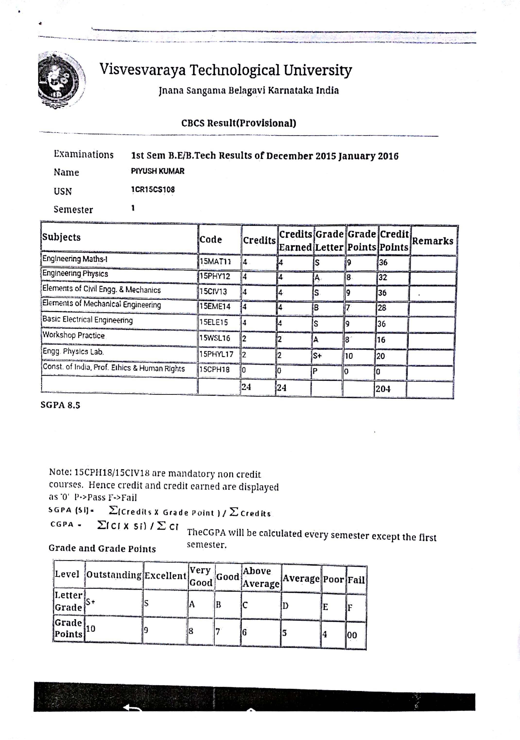

**SEMESTER-2**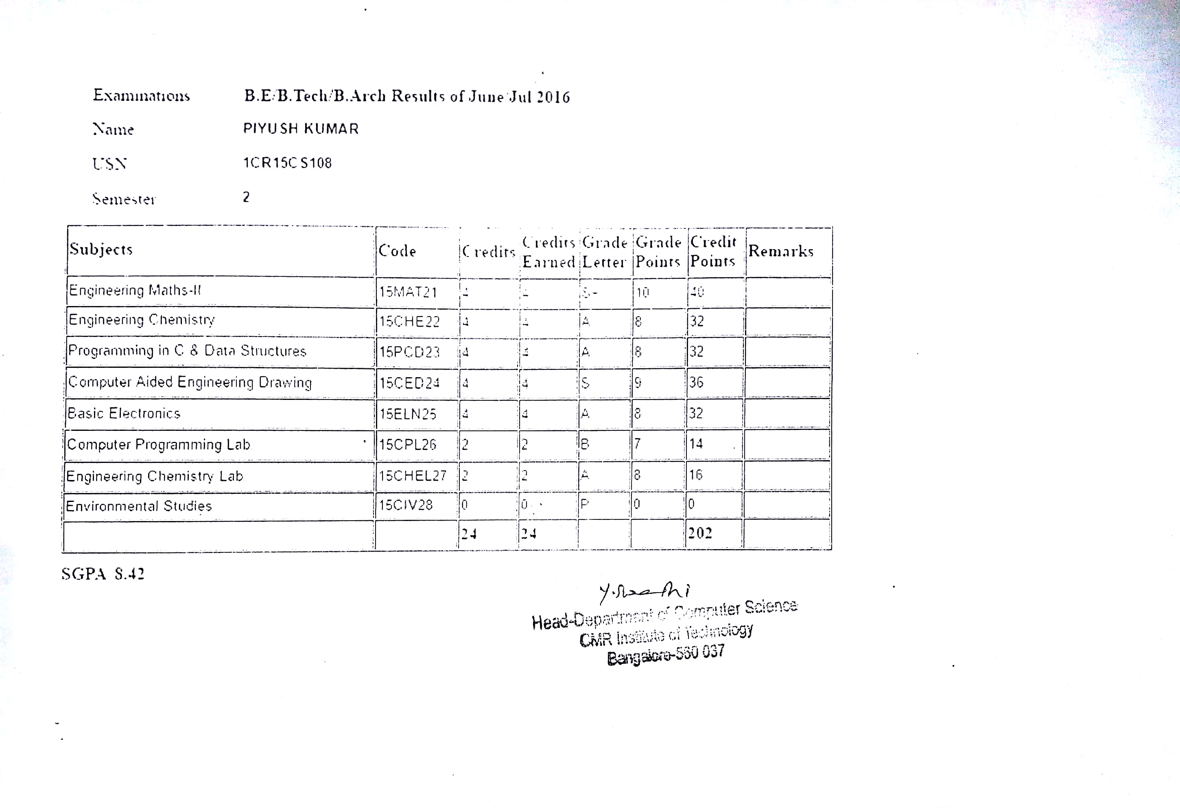

**SEMESTER-3**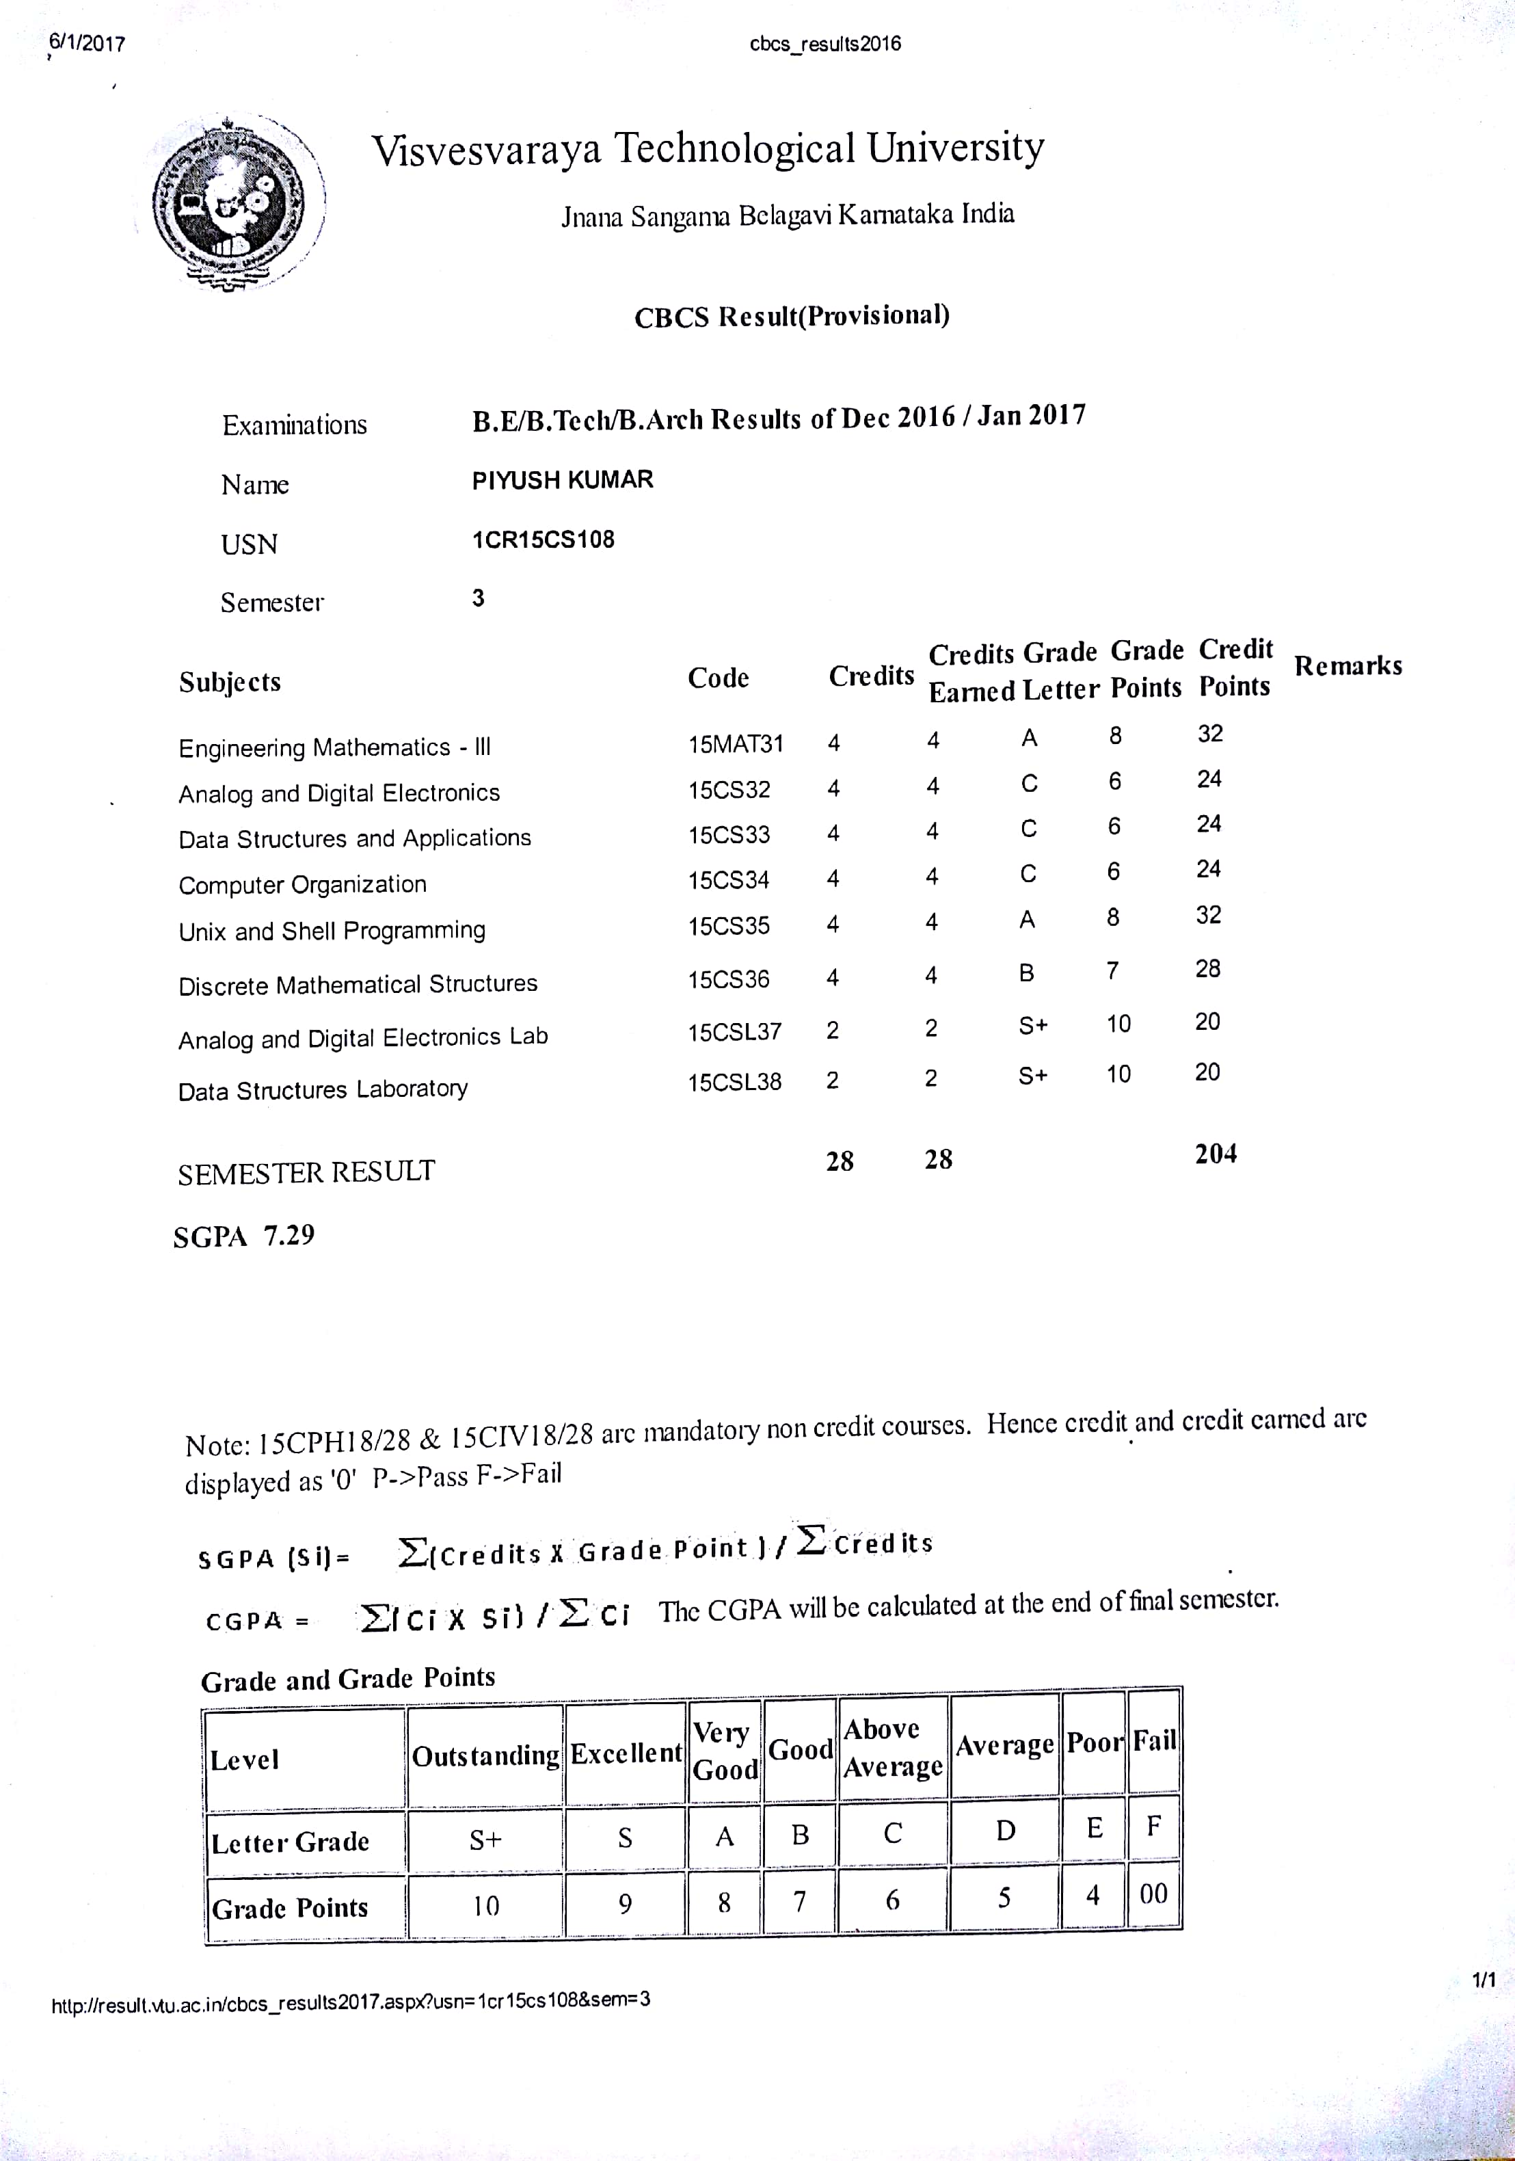

**SEMESTER-4**

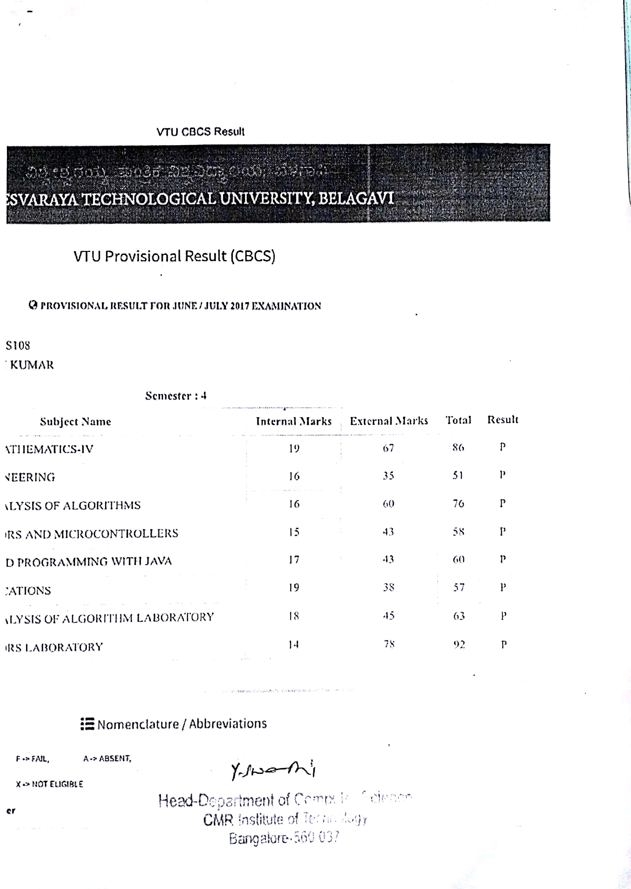

**SEMESTER-5**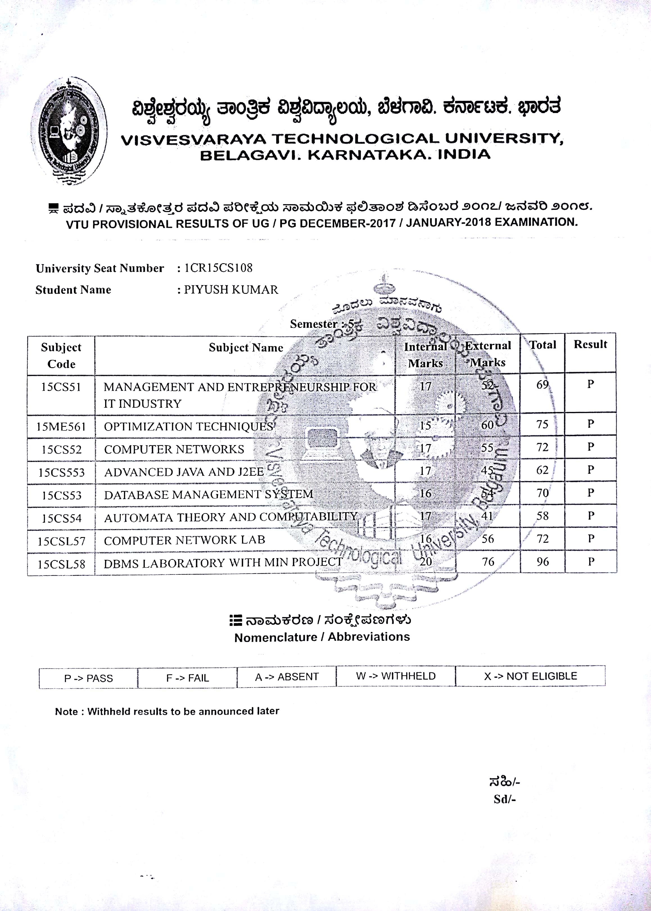

**SEMESTER-6**

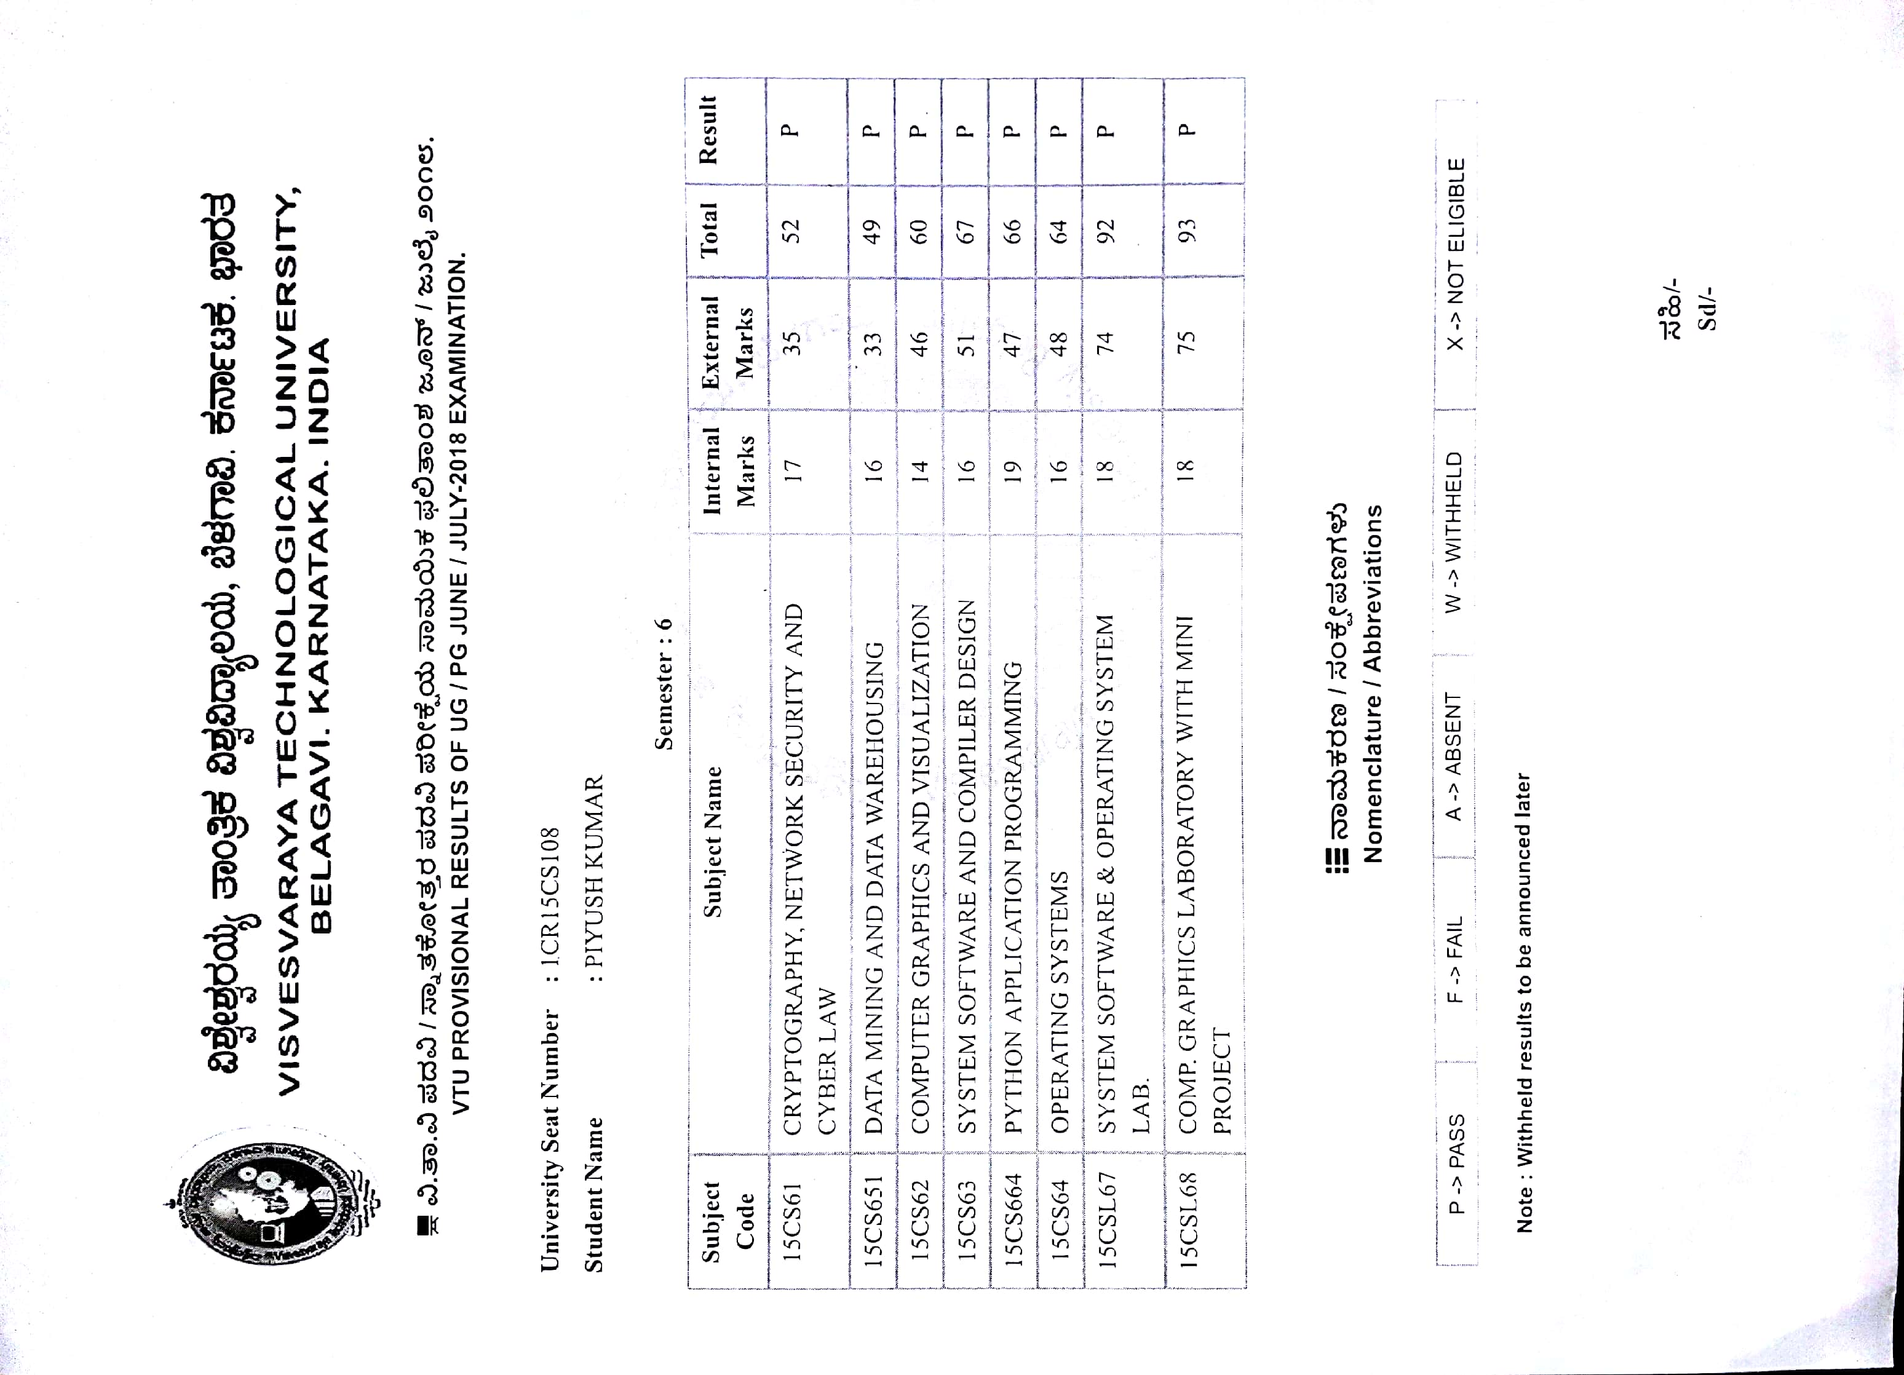

**CLASS-12TH**

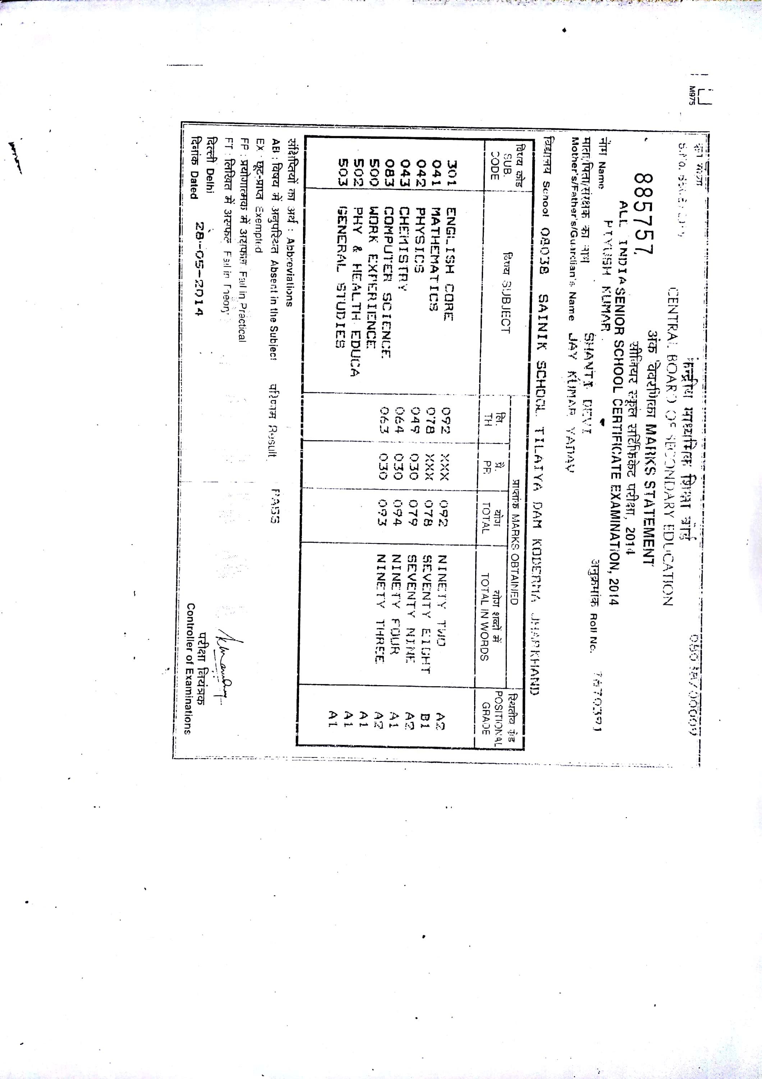

**CLASS-10TH**

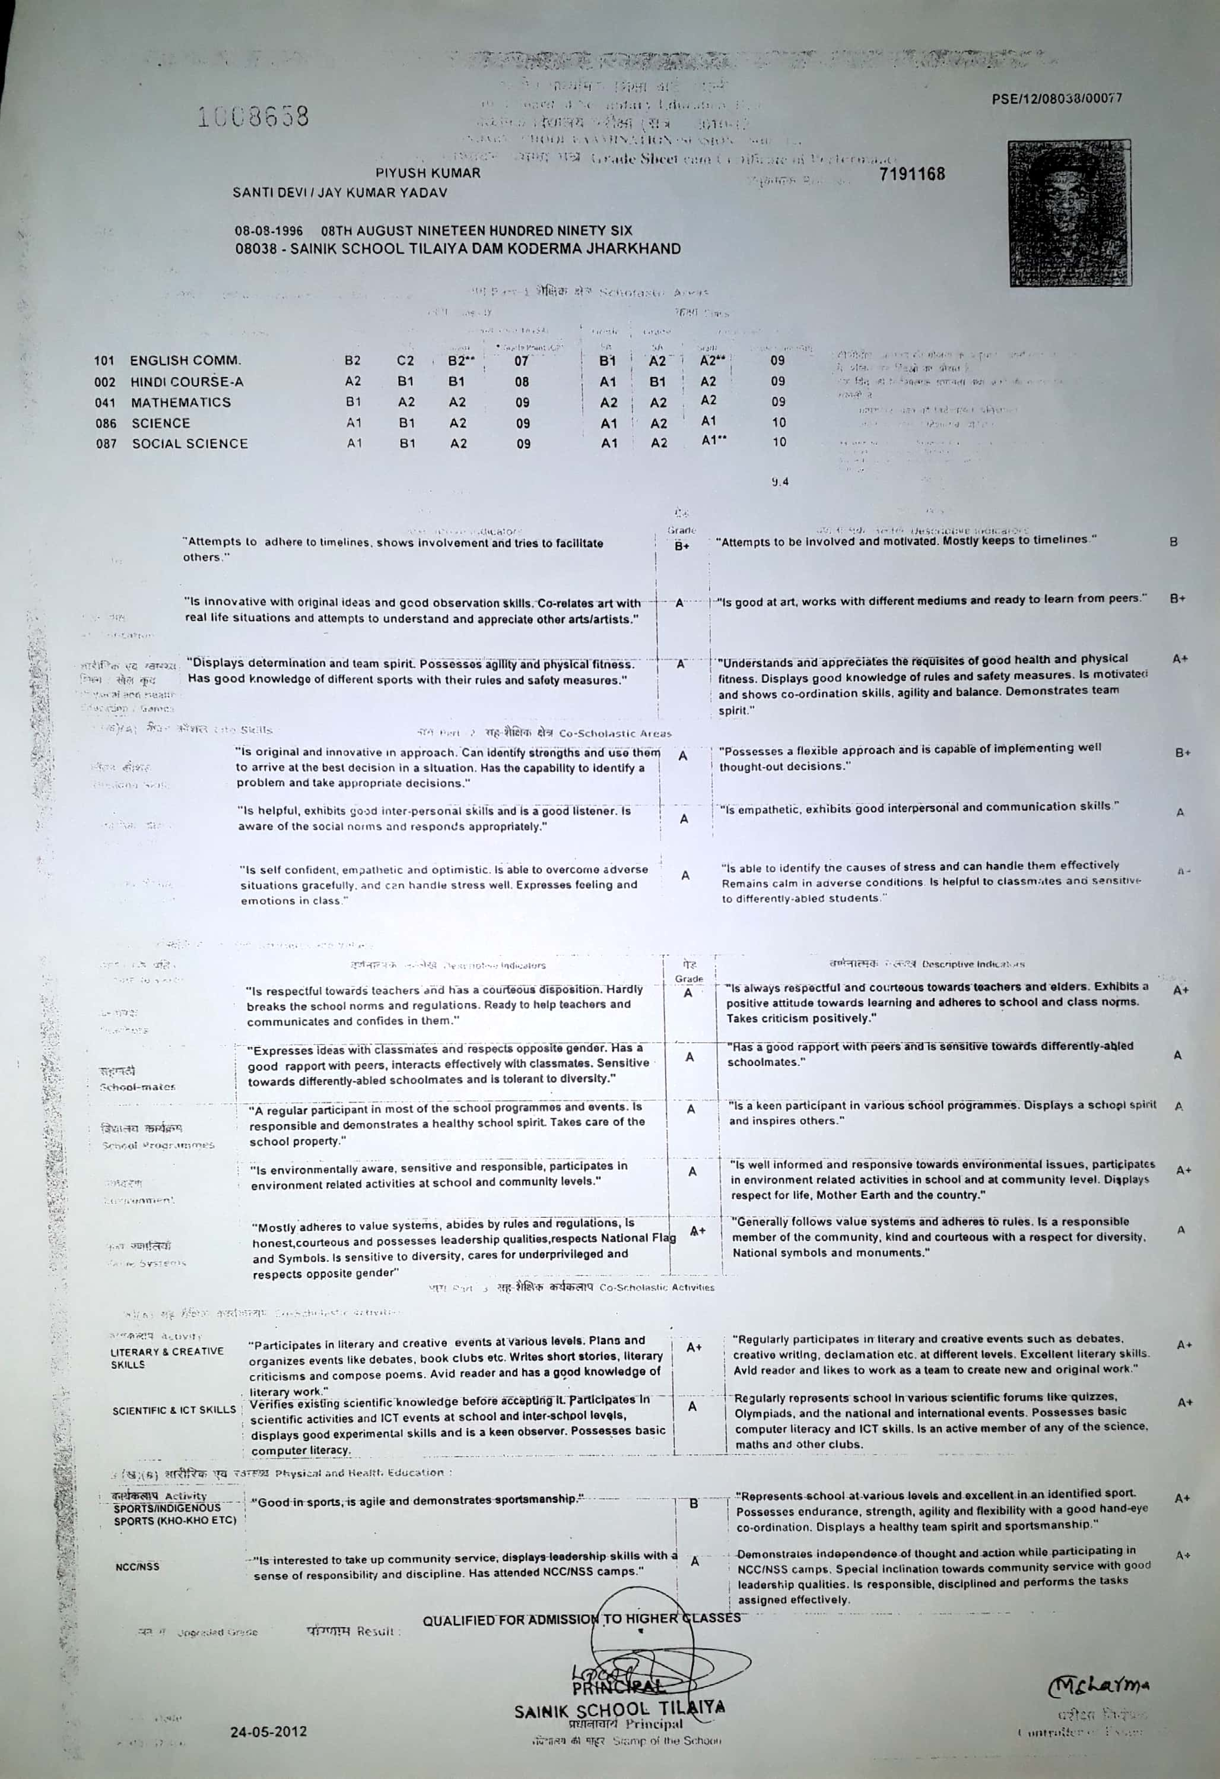

**AADHAR CARD**

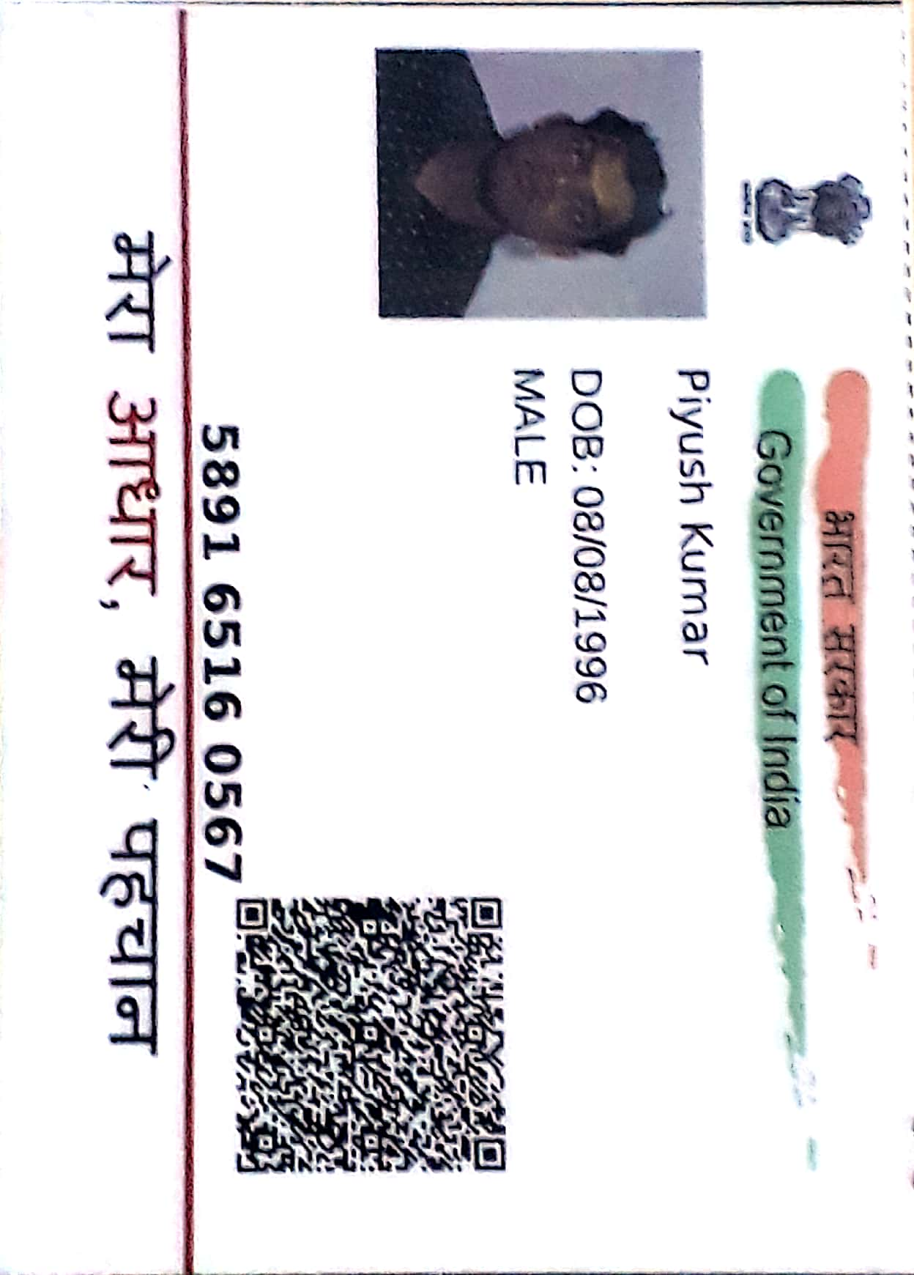

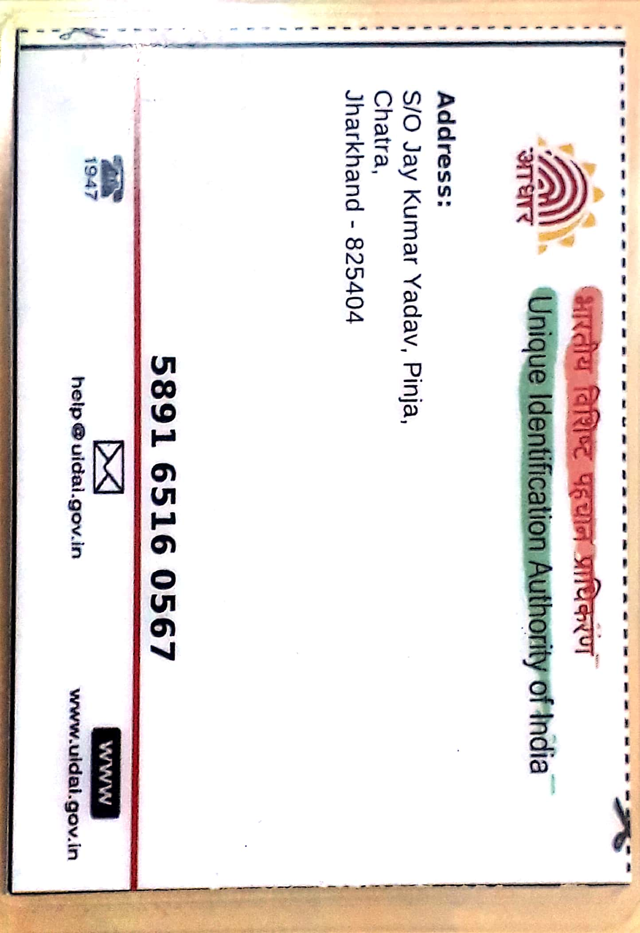

**PANCARD**

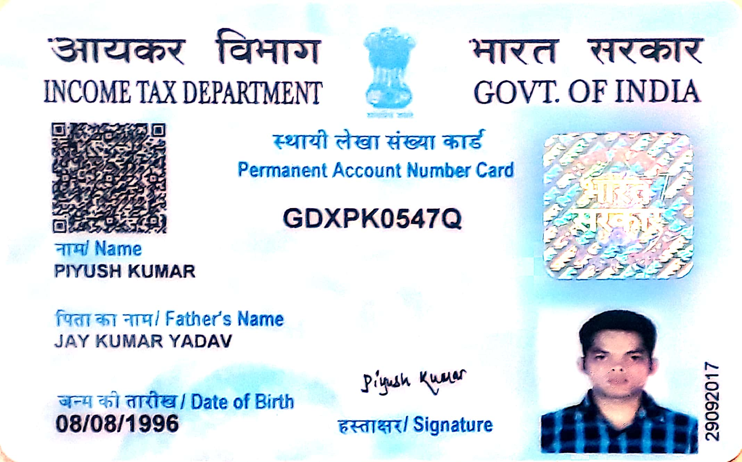

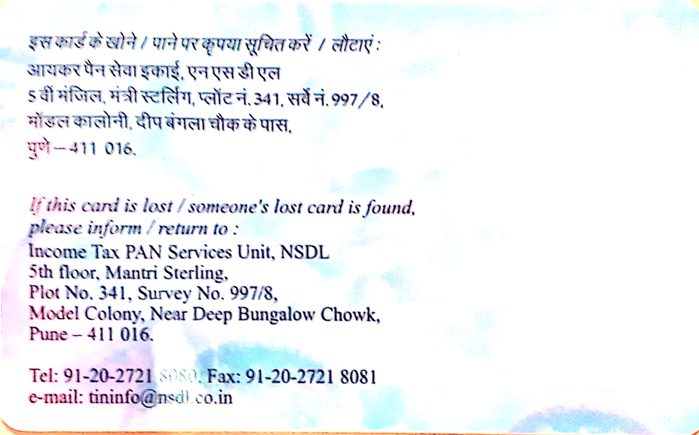

**PASSPORT**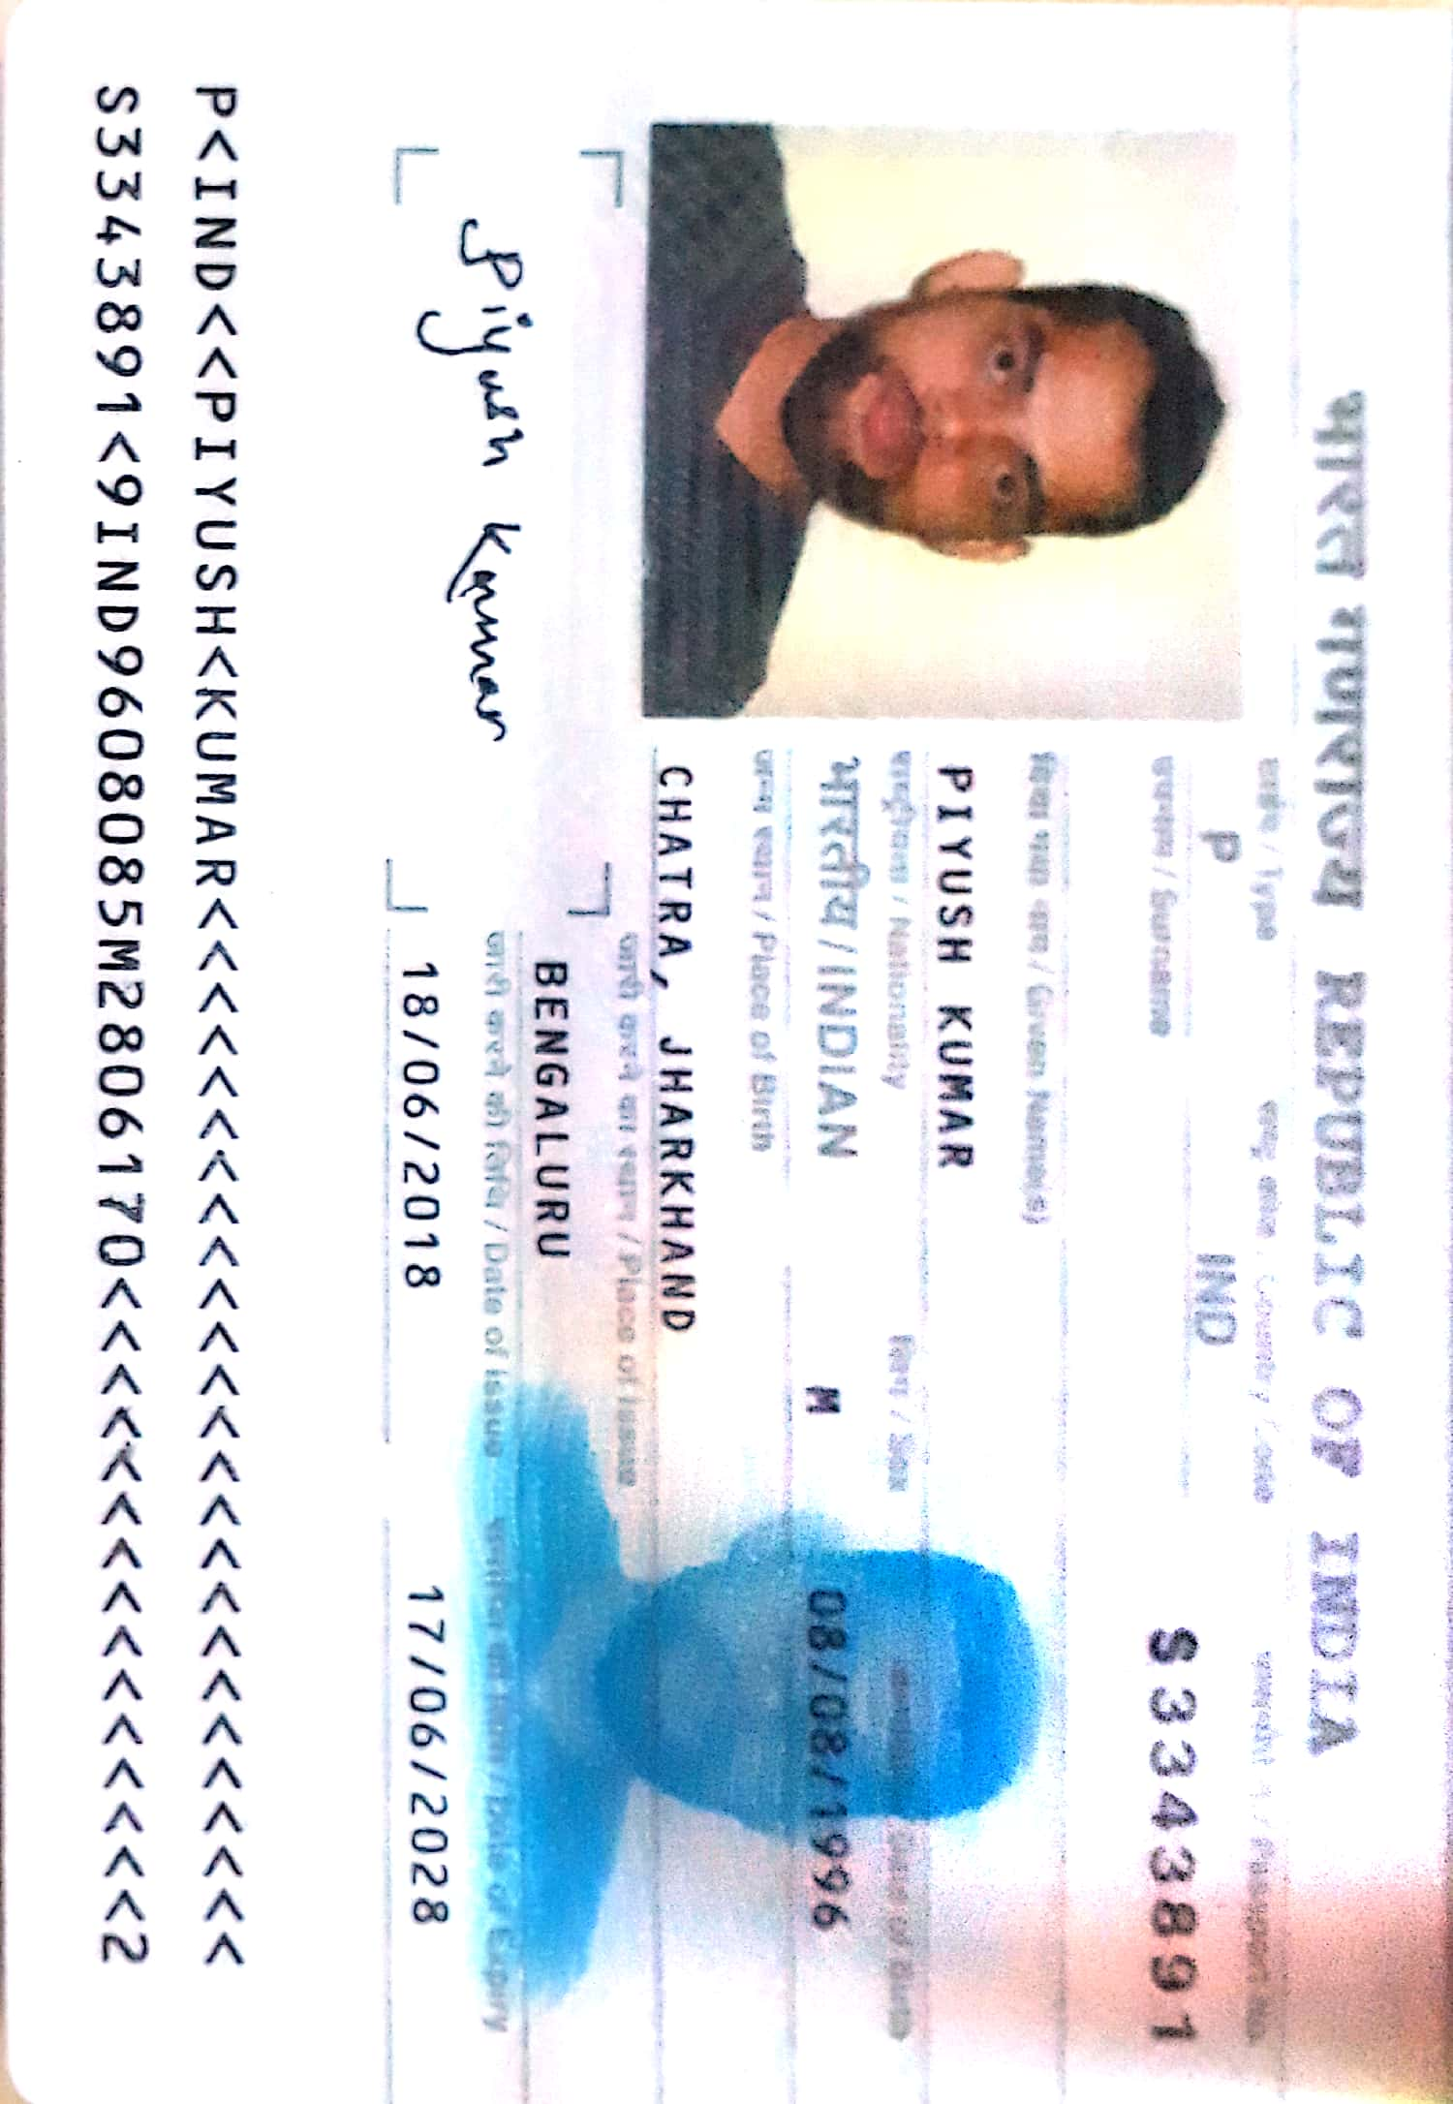

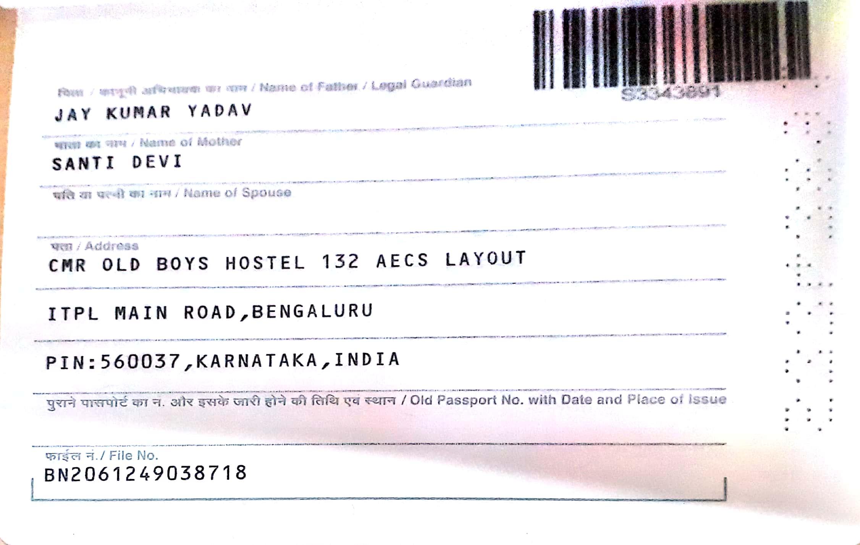

**PHOTO**

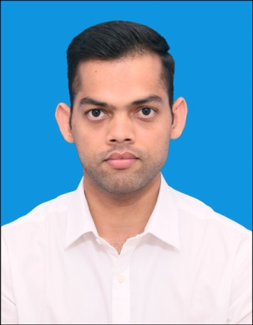

**Father’s Name-Jay Kumar Yadav**

**Permanent Address-Vill-Pinja ,Post-Kunda ,Dist-Chatra,Jharkhand**

**DOB-08th August 1996**

**Student Name-Piyush Kumar**