Project Workflow: AI-Based Disaster Response Management System
This document outlines the end-to-end workflow of the Disaster Response Management platform.

Architecture Flowchart
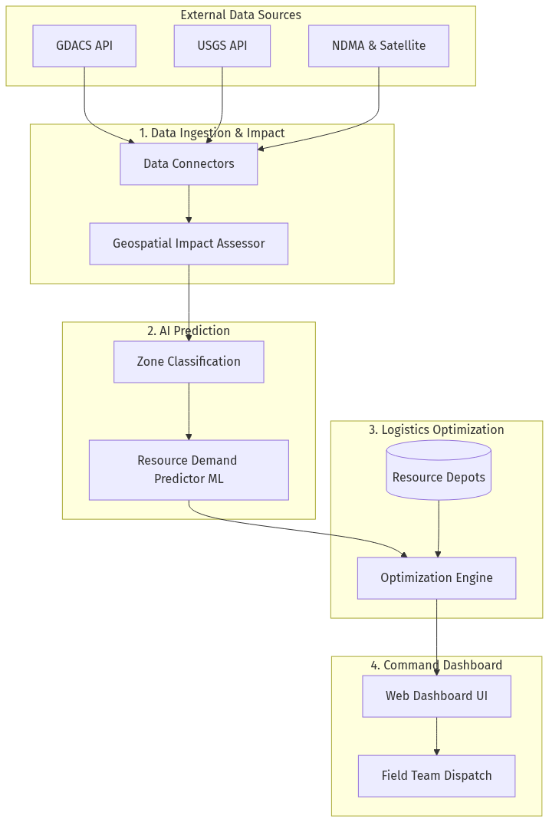

Workflow Phases

1. Disaster Data Ingestion & Geospatial Impact Assessment
• Integrate real-time disaster event data feeds from GDACS, USGS (earthquakes), NDMA, and satellite imagery APIs.
• Build a geospatial impact assessment module dividing disaster-affected areas into grid cells with impact severity scores.

2. Resource Demand Prediction Engine
• Train a regression model predicting resource demand (food packets, water, medical kits, shelter capacity) per affected zone.
• Build a vulnerability weighting module adjusting demand estimates based on population data.

3. Logistics Planning & Optimization
• Implement an optimization model allocating available resources across demand zones from various depots.
• Build a logistics routing engine generating optimized delivery routes.

4. Disaster Operations Dashboard
• Develop a command dashboard with a real-time disaster impact map, resource allocation overlays, and field team tracking.
• Display the complete end-to-end integration: disaster feeds → impact assessor → demand predictor → logistics optimizer → command dashboard.

