TWITTER ANALYTICS DASHBOARD
USING MICROSOFT POWER BI
Internship Report

Submitted By: Piyush Raj Singh
Email: singhpiyushraj57@gmail.com
Organization: Elevance Skills
Submission Date: _______________________________________

Table of Contents

1. Introduction
This report summarizes my internship with Elevance Skills, where I built a Twitter Analytics Dashboard using Microsoft Power BI. The project involved importing a Twitter engagement dataset, shaping it with Power Query and DAX, and designing six analytical visuals that were consolidated into one interactive dashboard.

2. Background
Organizations rely on social media analytics to understand audience behavior, measure campaign performance, and identify high-performing content. This internship used a Twitter engagement dataset — covering impressions, clicks, replies, retweets, likes, and media interactions — to practice turning raw social data into decision-ready Power BI reports.

3. Learning Objectives
- Learn Microsoft Power BI fundamentals, including Power Query and DAX.
- Create calculated columns and measures to support business logic.
- Design interactive, filterable dashboards.
- Analyze tweet engagement and user interaction patterns.
- Strengthen analytical thinking and data visualization skills.

4. Activities and Tasks
Using Microsoft Power BI Desktop, Power Query, and DAX, I imported a Twitter activity dataset (tweet text, timestamps, impressions, engagement rate, likes, replies, retweets, clicks, media metrics, and app opens) and built six analytical visuals, each shaped by purpose-built DAX measures and filters, then combined into a single dashboard.

Task 1 – Tweet Interaction Breakdown by Category
Compared URL Clicks, User Profile Clicks, and Hashtag Clicks across tweet categories (Media, Links, Hashtags, Other) using a clustered bar chart.
Key DAX Measures
- Tweet Category – classifies each tweet using SWITCH/TRUE() logic based on media, URL, and hashtag clicks.
- Word Count, Even Date, Has Interaction – support filtering logic below.
Filters Applied
- Has Interaction = True; Even Date = True; Word Count > 40; visibility restricted to 3–5 PM.
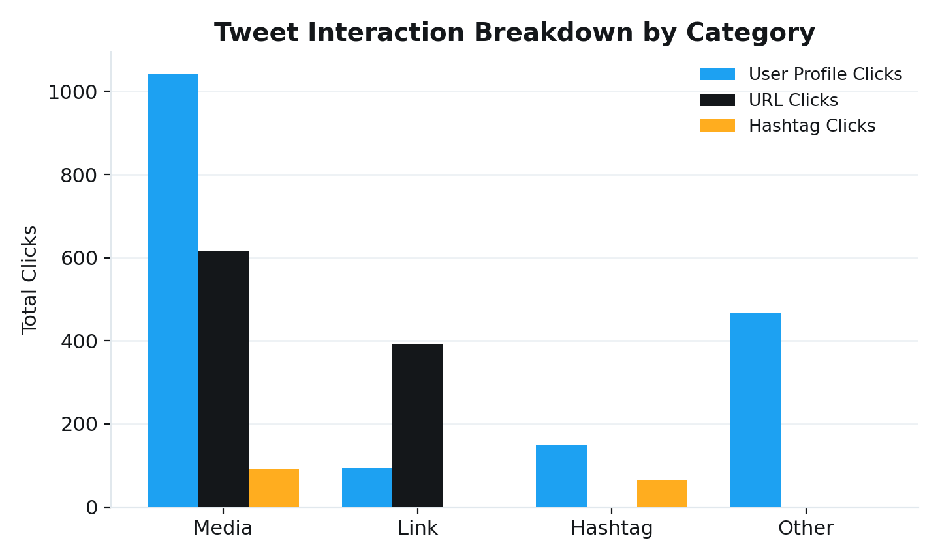
Figure 1 – Tweet Interaction Breakdown by Category

Task 2 – Engagement Rate Comparison
Compared average engagement rate for tweets with app opens versus without, using a clustered column chart.
Key DAX Measures
- App Open Status, Tweet Hour, Weekday, Even Impression, Odd Date, Character Count, Contains D.
Filters Applied
- Weekdays only, 9 AM–5 PM; Even Impression and Odd Date = True; Character Count > 30; excludes tweets containing “D”; visibility 7–11 AM and 12–6 PM.
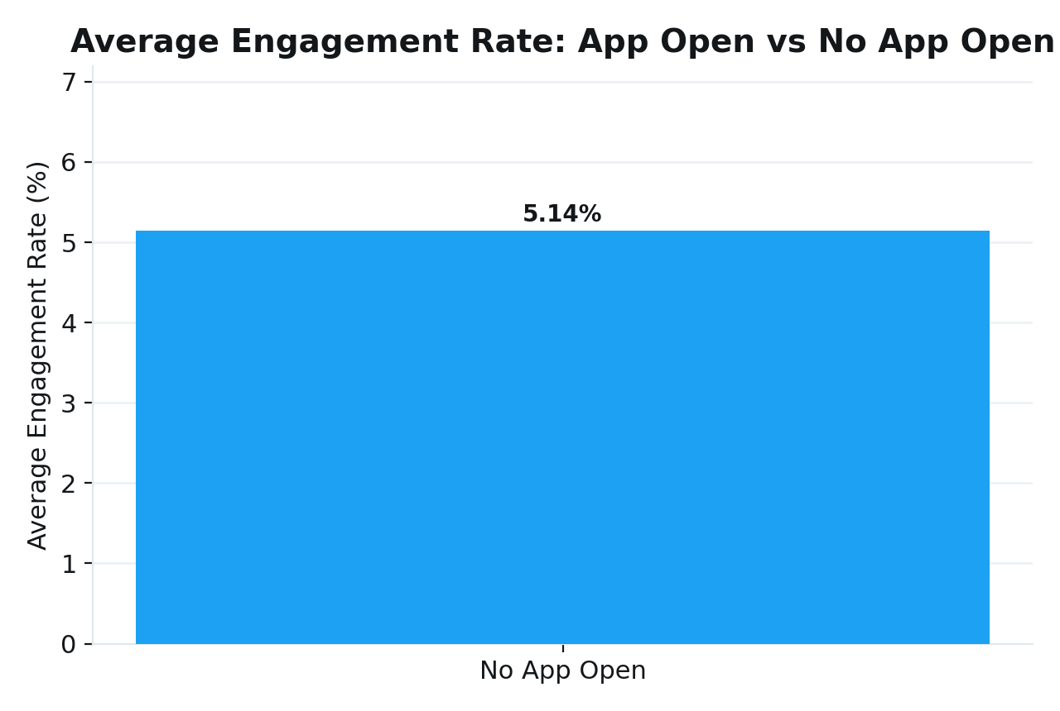
Figure 2 – Engagement Rate Comparison

Task 3 – Media Interaction by Day of Week
Plotted Media Views and Media Engagements by day of the week for the most recent quarter, using a combined line-and-column chart.
Key DAX Measures
- Day Name, Day Number, Quarter, Contains H, Character Count, Even Impression, Odd Date.
Filters Applied
- Last quarter only; Even Impression and Odd Date = True; Character Count > 30; excludes tweets containing “H”; visibility 7–11 AM and 3–5 PM.
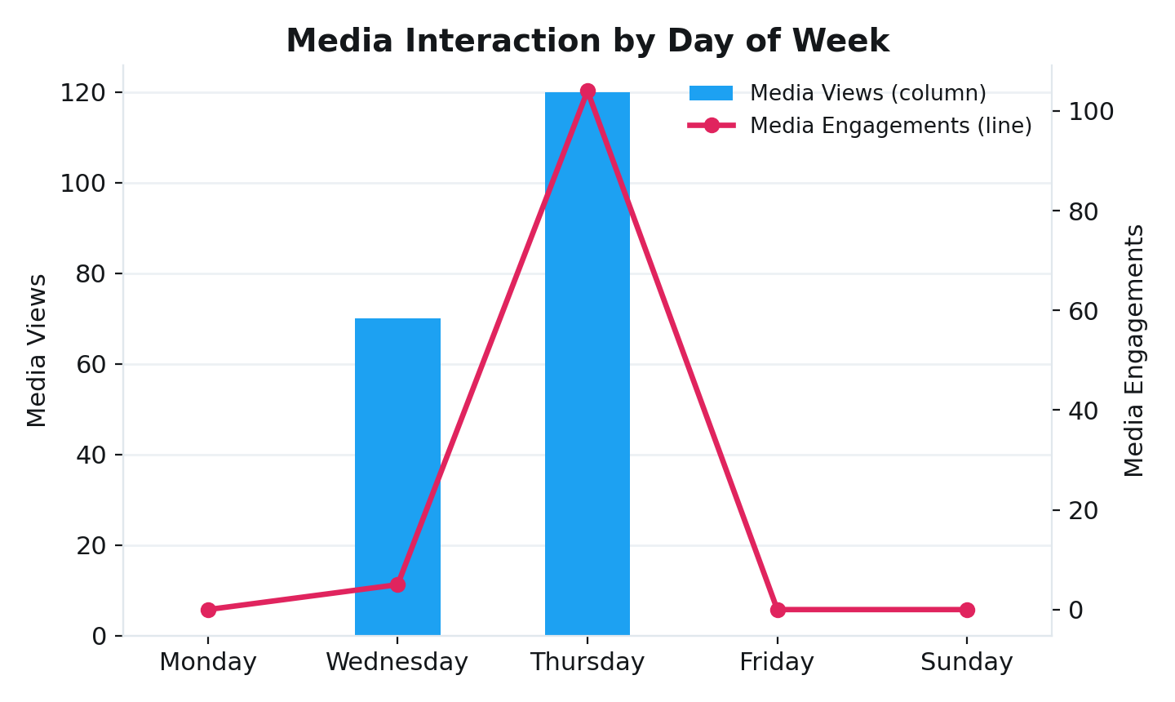
Figure 3 – Media Interaction by Day of Week

Task 4 – Replies, Retweets and Likes Comparison
Compared total Replies, Retweets, and Likes for tweets posted between June and August 2020, using a clustered bar chart and SUM aggregations.
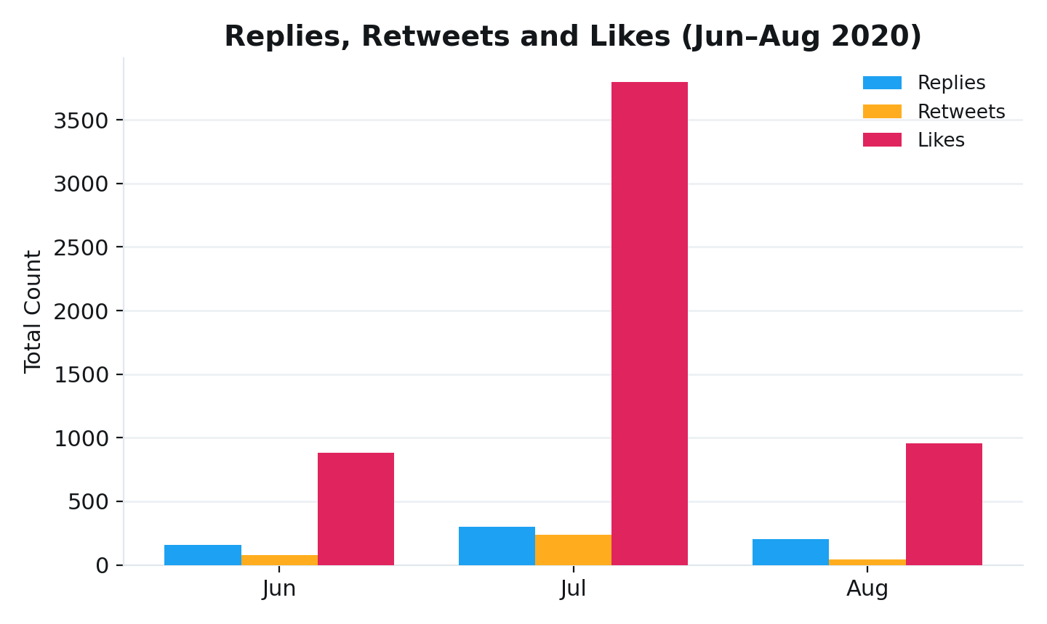
Figure 4 – Replies, Retweets and Likes Comparison

Task 5 – Monthly Engagement Rate Trend
Tracked monthly average engagement rate, split by tweets with and without media, using a line chart with Media Status as the legend.
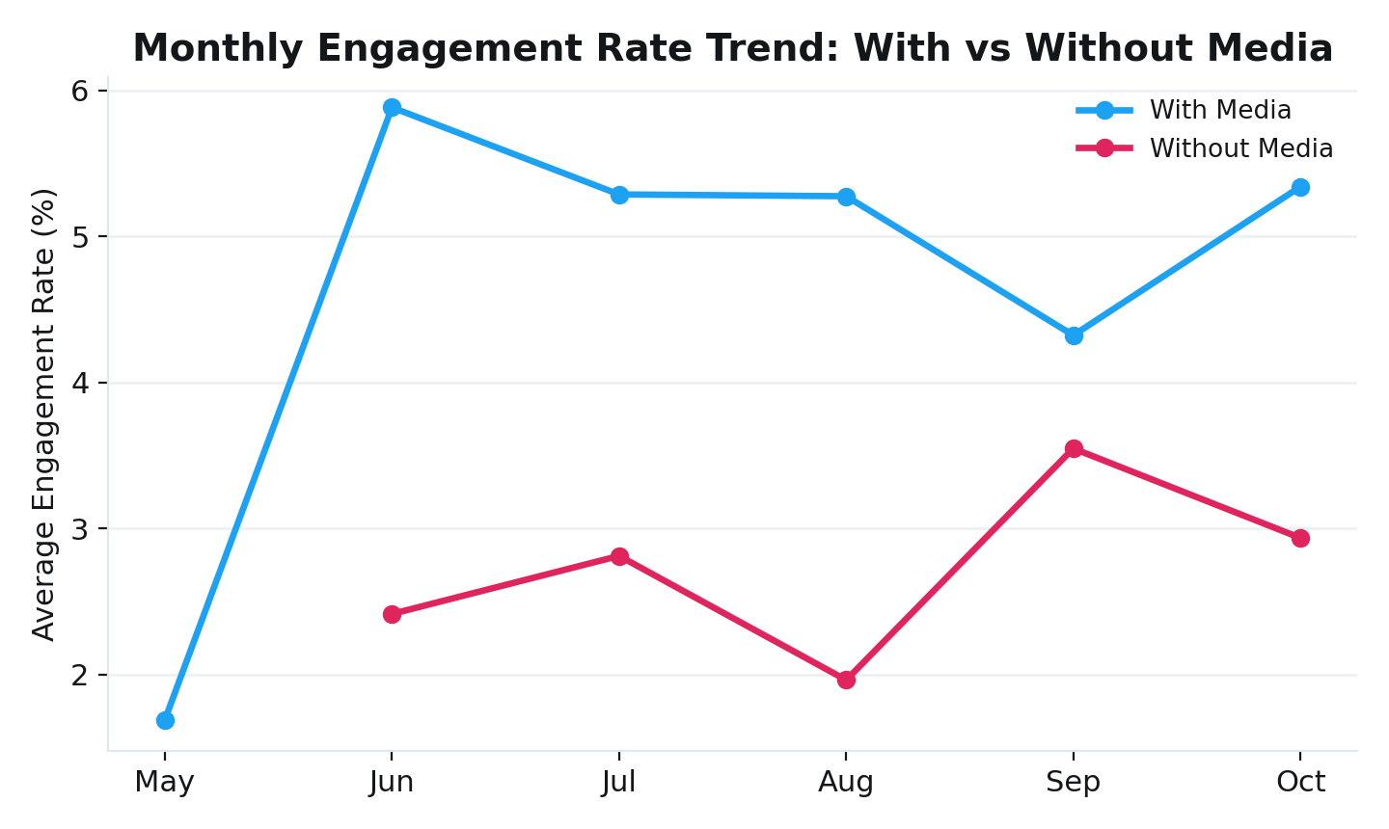
Figure 5 – Monthly Engagement Rate Trend

Task 6 – Top 10 Tweets by Engagement
Identified the ten highest-performing tweets by combined Likes and Retweets, using a Total Engagement measure and a bar chart.
Total Engagement
Total Engagement =
SUM('SocialMedia'[retweets]) +
SUM('SocialMedia'[likes])

Filters Applied
- Weekend = False; Even Impression and Odd Date = True; Word Count < 30; Top N = 10; visibility 3–5 PM.
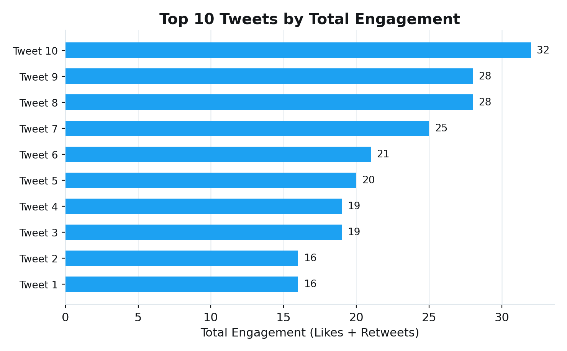
Figure 6 – Top 10 Tweets by Engagement

Consolidated Dashboard
All six visuals were combined into a single interactive dashboard for end-to-end exploration of tweet performance and engagement.
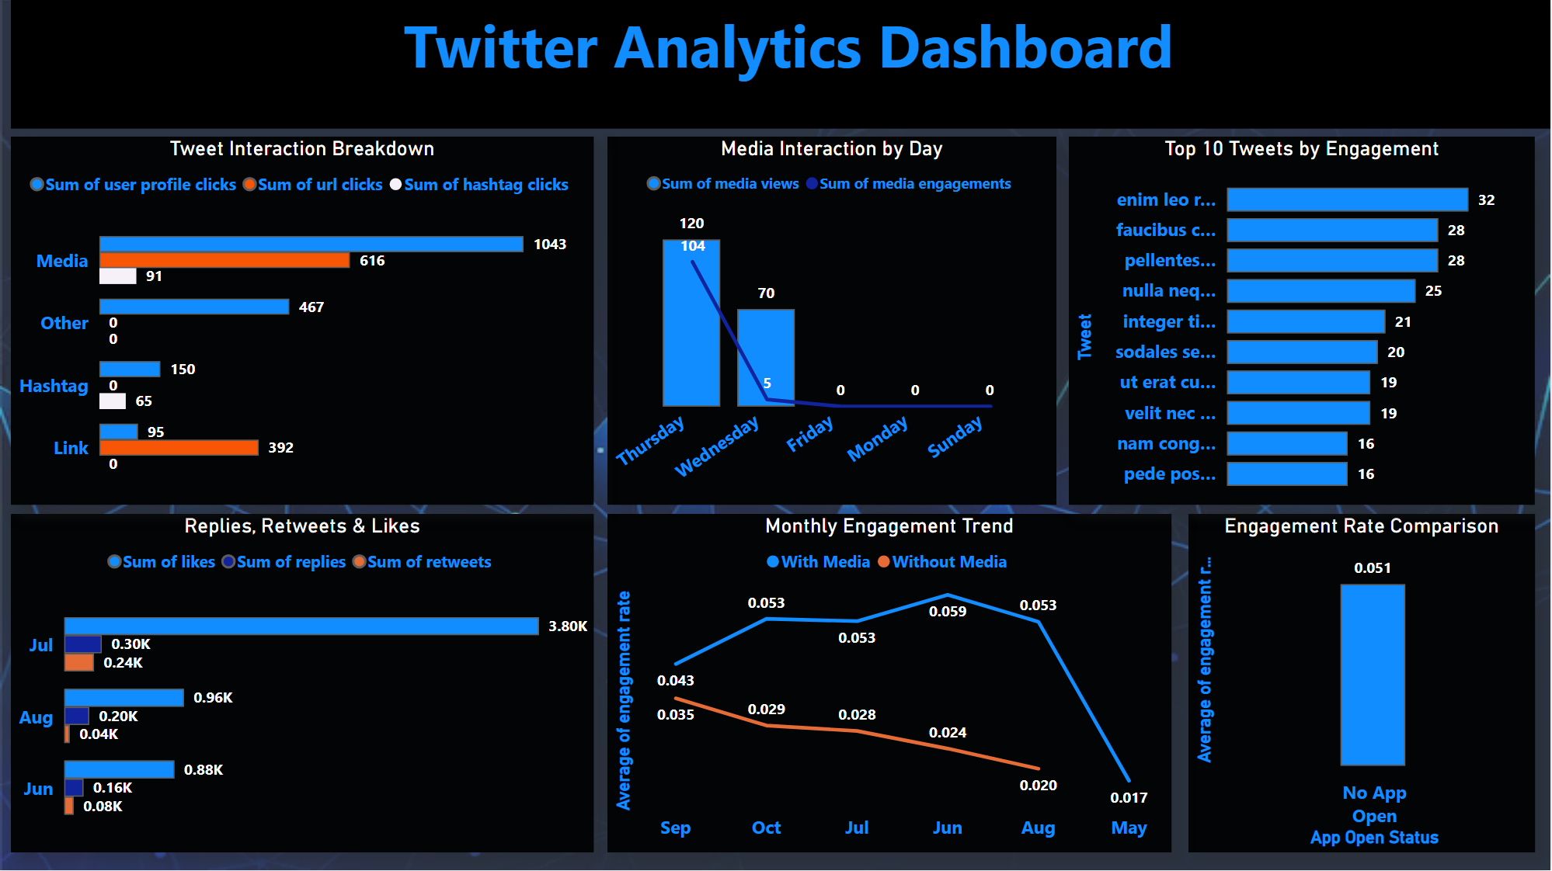
Figure 7 – Full Dashboard, Consolidated View

5. Skills and Competencies
- Power BI dashboard development and data visualization
- Power Query data cleaning and transformation
- DAX calculated columns and measures
- Business intelligence reporting and analytical thinking
- Problem solving and report design

6. Feedback and Evidence
Evidence of completed work is provided throughout Section 4 in the form of chart visuals and the consolidated dashboard (Figures 1–7), each generated directly from the underlying Power BI data exports.
Supervisor / Mentor Feedback
Feedback: _______________________________________
Reviewed By: _______________________________________

7. Challenges and Solutions
Implementing layered filters and time-based visual visibility in DAX required iterative testing against the dataset to confirm each condition produced the intended result. Working through these issues by building calculated columns, validating outputs, and cross-checking against raw data improved my troubleshooting skills and understanding of business reporting logic.

8. Outcomes and Impact
This internship strengthened my practical command of Power BI and core BI concepts. I gained hands-on experience building dashboards, writing DAX, applying business filters, and presenting insights through interactive visuals — experience that has prepared me for future Data Analyst roles.

9. Conclusion
Completing all six tasks deepened my technical knowledge of Power BI, DAX, and data analysis, while reinforcing the value of presenting data clearly and meaningfully. These skills will directly support my continued growth in data analytics and business intelligence.

