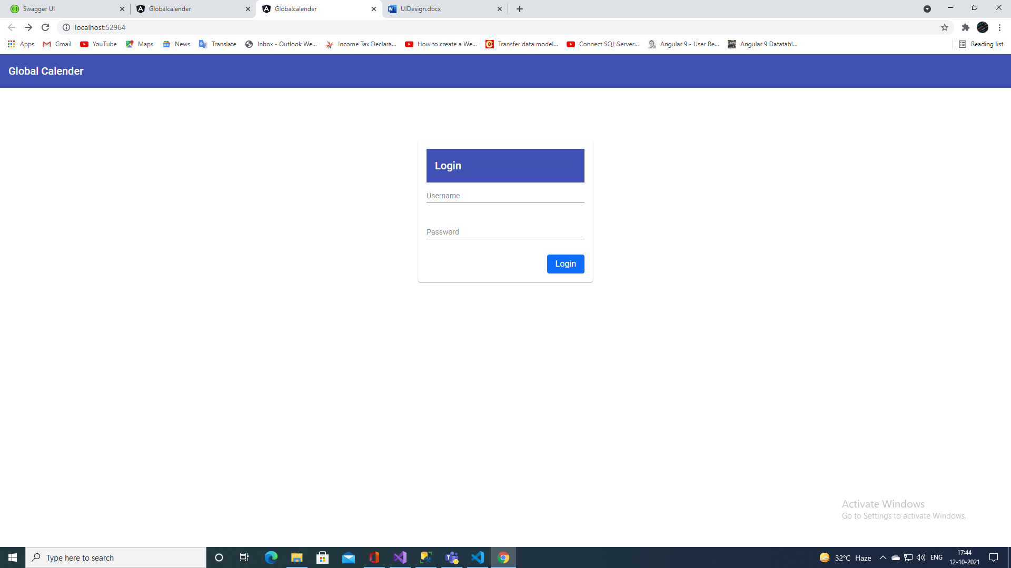

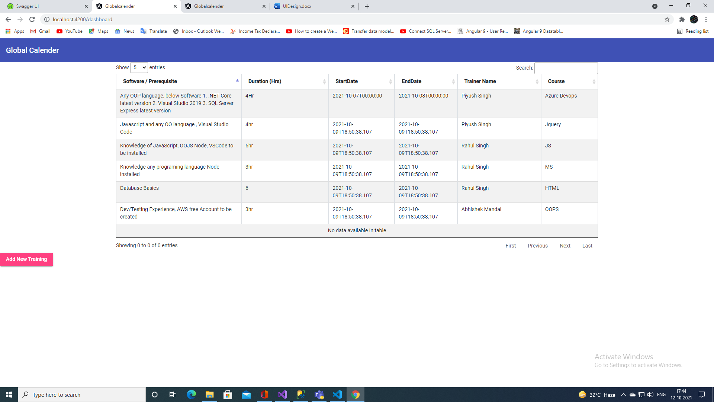

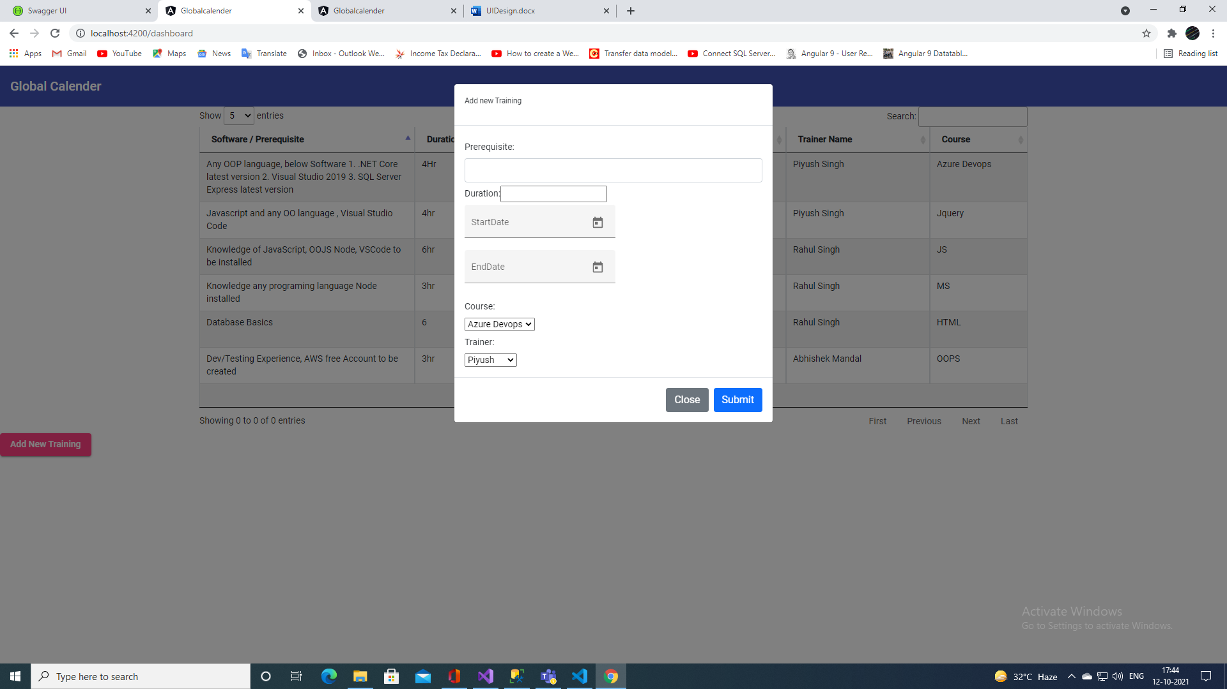

API Desgin Documentation

|  |  |  |  |
| --- | --- | --- | --- |
| S.No | Key values | Http Verbs | Description |
| 1. | Login | POST | Logged in with valid credentials. |
| 2. | Trainer Name | GET | Get all the list of trainer name. |
| 3. | List of Schedule Training | GET | Get all the list of scheduled training. |
| 4. | Add New Trainning | POST | Add new trainning programs. |
| 5. | Update Training | PUT | Update scheduled training programs. |
| 6. | Delete Training | DELETE | Delete scheduled training programs. |