**Architecture**

**Introduction**

What is Architecture Design Document?

Any Software needs the Architectural Design to represent the design of Software. IEEE Defines architectural design as “the process of defining a collection of hardware and software components and their interfaces to establish the framework for the development of a computer system.”

Each Style will a system category that consist of:

1. A Set of components (e.g.: a database computational modules) that will perform a function required by the systems.
2. The set of Connector will help in coordination, communication, and cooperation between the components.
3. Conditions that how Components can be integrated to form the system.
4. Semantic models that help the designer to understand the overall properties of the

system.

**Scope**

Architecture Design Document (ADD) is an architecture design process that follows a step-by-step

refinement process. The process can be used for designing data structures, required software

architecture, source code and ultimately, performance algorithms. Overall, the design principles

may be defined during requirement analysis and then refined during architectural design work.

**Architecture**

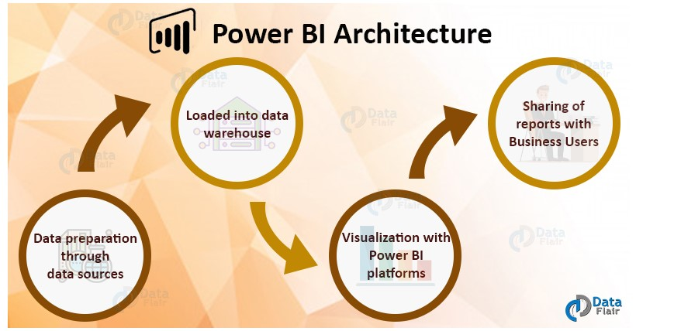

**Power BI Architecture**

*Power BI is a business suite that includes several technologies that work together.* To deliver outstanding business intelligence solutions, Microsoft Power BI technology consists of a group of components such as:

* Power Query (for data mash-up and transformation)
* Power BI Desktop (a companion development tool)
* Power BI Mobile (for Android, iOS, Windows phones)
* Power Pivot (for in-memory tabular data modeling)
* Power View (for viewing data visualizations)
* Power Map (for visualizing 3D geo-spatial data)
* Power Q&A (for natural language Q&A)

In simple terms, a Power BI user takes data from various data sources such as **files, Azure source, online services, Direct Query or gateway sources.**

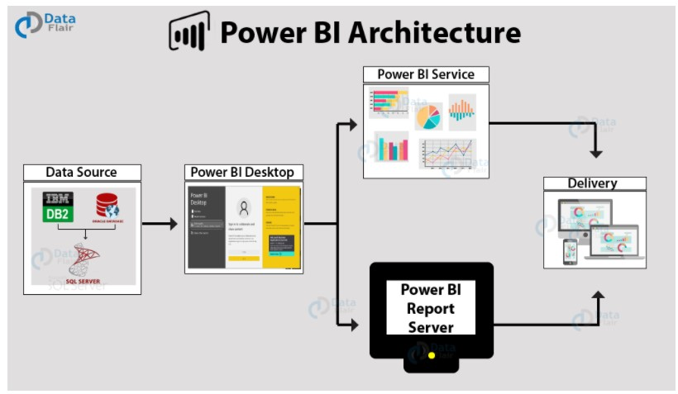

### **Components of Power BI Architecture**

#### **Data Sources**

An important component of Power BI is its vast range of data sources. You can import data from files in your system, cloud-based online data sources or connect directly to live connections. If you import from data on-premise or online services there is a limit of 1 GB. Some commonly used data sources in Power BI are:

* Excel
* Text/CSV
* XML
* JSON
* Oracle Database
* IBM DB2 Database
* MySQL Database
* PostgreSQL Database
* Sybase Database
* Teradata Database
* SAP HANA Database
* SAP Business Warehouse server
* Amazon Redshift
* Impala
* Google Big Query (Beta)
* Azure SQL Database
* Salesforce Reports
* Google Analytics
* Facebook

#### **Power BI Desktop**

Power BI Desktop is a client-side tool known as a companion development and authoring tool.

This desktop-based software is loaded with tools and functionalities to connect to data sources, transform data, data modeling and creating reports.

You can download and install Power BI Desktop in your system for free. Using Power BI Desktop features, one can do data cleansing, create business metrics and data models, define the relationship between data, define hierarchies, create visuals and publish reports.

#### **Power BI Service**

Power BI Service is a web-based platform from where you can share reports made on Power BI Desktop, collaborate with other users, and create dashboards.

It is available in three versions:

* Free version
* Pro version
* Premium version

Power BI Service is also known as, **“Power BI.com”**,**“Power BI Workspace”,** **“Power BI Site”** and **“Power BI Web Portal”**. This component also offers advanced features like natural language Q&A and alerts.

#### **Power BI Report Server**

The Power BI Report Server is similar to the Power BI Service. The only difference between these two is that Power BI Report Server is an on-premise platform. It is used by organizations who do not want to publish their reports on the cloud and are concerned about the security of their data.

Power BI Report Server enables you to create dashboards and share your reports with other users following proper security protocols. To use this service, you need to have a Power BI Premium license.

#### **Power BI Gateway**

This component is used to connect and access on-premise data in secured networks. Power BI Gateways are generally used in organizations where data is kept in security and watch. Gateways help to extract out such data through secure channels to Power BI platforms for analysis and reporting.

#### **Power BI Mobile**

Power BI Mobile is a native Power BI application that runs on iOS, Android, and Windows mobile devices. For viewing reports and dashboards, these applications are used.