High Level Design (H.L.D.)

**Amazon Sales Data Analysis**

***Introduction***

**1.Why this High-Level Design Document?**

The purpose of this High-Level Design (HLD) Document is to add the necessary detail to the

current project description to represent a suitable dashboard for analysis. This dashboard is also

intended to help business stakeholders to take decisions based on our dashboard.

**Problem Statement**

Analysing Amazon Sales data from year 2017 to 2019 to meet increasing competition around the globe and the need for improved methods of distribution to reduce cost and to increase profits.

**Tools used**

Business Intelligence tools and libraries such as Excel, Power BI are used to build the whole framework & Dashboard.

**How BI Really Works**

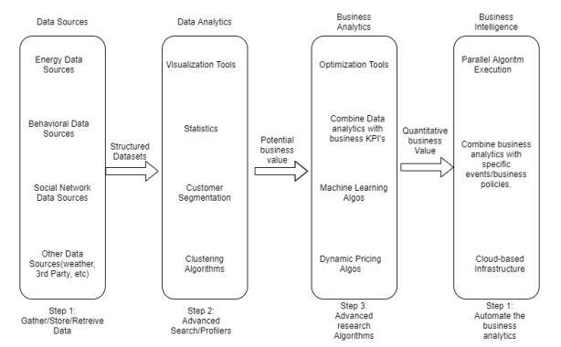

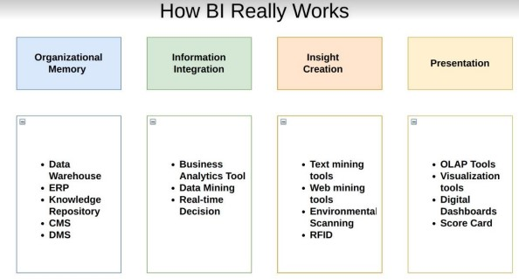

**Optimization**

* Your data strategy drives performance
* Minimize the number of fields
* Minimize the number of records
* Optimize extracts to speed up future queries by materializing calculations, removing
* columns and the use of accelerated views
* enable include in report refresh option

**KPIs (Key Performance Indicators)**

Key indicators displaying a summary of the Sales Analysis and its relationship with different Metrics.

* Impact of Region on Sales
* Type of customers generating sales and profit
* Impact of season parameter on Sale and profit
* Which quarter of the year results in higher sales and profit

**Deployment**

Prioritizing data and analytics couldn’t come at a better time. Your company, no matter what

size, is already collecting data and most likely analysing just a portion of it to solve business

problems, gain competitive advantages, and drive enterprise transformation. With the

explosive growth of enterprise data, database technologies, and the high demand for

analytical skills, today’s most effective IT organizations have shifted their focus to enabling

self-service by deploying and operating Tableau at scale, as well as organizing, orchestrating,

and unifying disparate sources of data for business users and experts alike to author .

**Power Bi service For Deployment:**

Power BI Service is a web-based platform from where you can share reports made on Power BI Desktop, collaborate with other users, and create dashboards.

It is available in three versions:

* Free version
* Pro version
* Premium version

Power BI Service is also known as, **“Power BI.com”**,**“Power BI Workspace”,** **“Power BI Site”** and **“Power BI Web Portal”**. This component also offers advanced features like natural language Q&A and alerts.