**Introduction**

**Why this Low-Level Design Document?**

**The goal of the LDD or Low-level design document (LLDD) is to give the internal logic design of the**

**actual program code for the House Price Prediction dashboard. LDD describes the class diagrams**

**with the methods and relations between classes and programs specs. It describes the modules so**

**that the programmer can directly code the program from the document.**

**Scope**

**Low-level design (LLD) is a component-level design process that follows a step-by-step refinement**

**process. The process can be used for designing data structures, required software architecture,**

**source code and ultimately, performance algorithms. Overall, the data organization may be**

**defined during requirement analysis and then refined during data design work.**

**Power Bi Communication Flow**

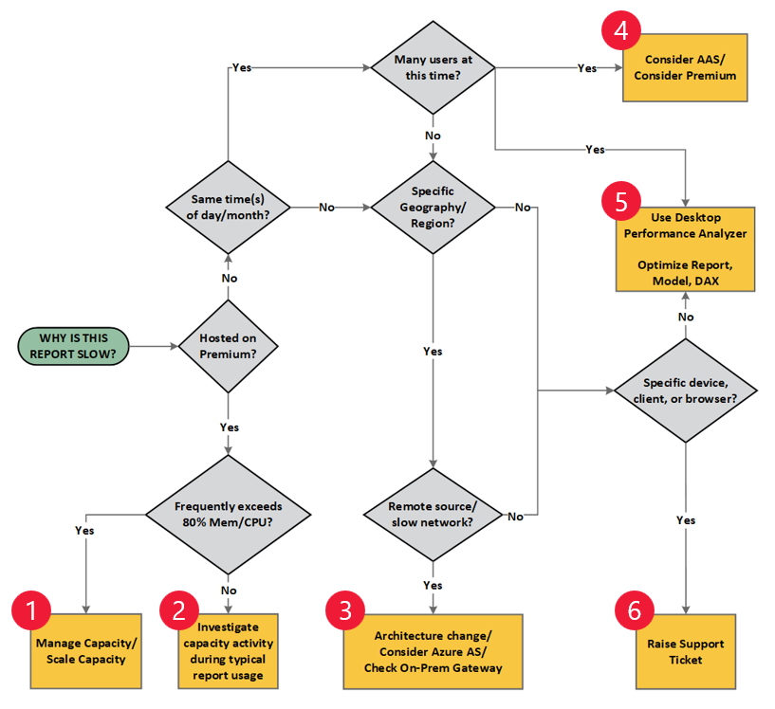

***Architecture Description***

**Problem Statement**

Analysing Amazon Sales data from Year 2017 to 2019 to meet increasing competition around the globe and the need for improved methods of distribution to reduce cost and to increase profits.

**Data Description**

Our dataset is around 14 mb. We have customer region and division date tables as our dimension table and sales table as fact table with 18 columns.

**Data Gathering**

Description of Data Transformation:

* Grouping our tales as fact and dimension.
* Merging customer address table with customer table using customer number
* Removing unwanted columns and adding conditional columns taking column type as base column.
* Creating date table using dax.

**Description of Data Transformation**

* Grouping our tales as fact and dimension.
* Merging customer address table with customer table using customer number
* Removing unwanted columns and adding conditional columns taking column type as base column.
* Creating date table using Dax.

Data Modelling

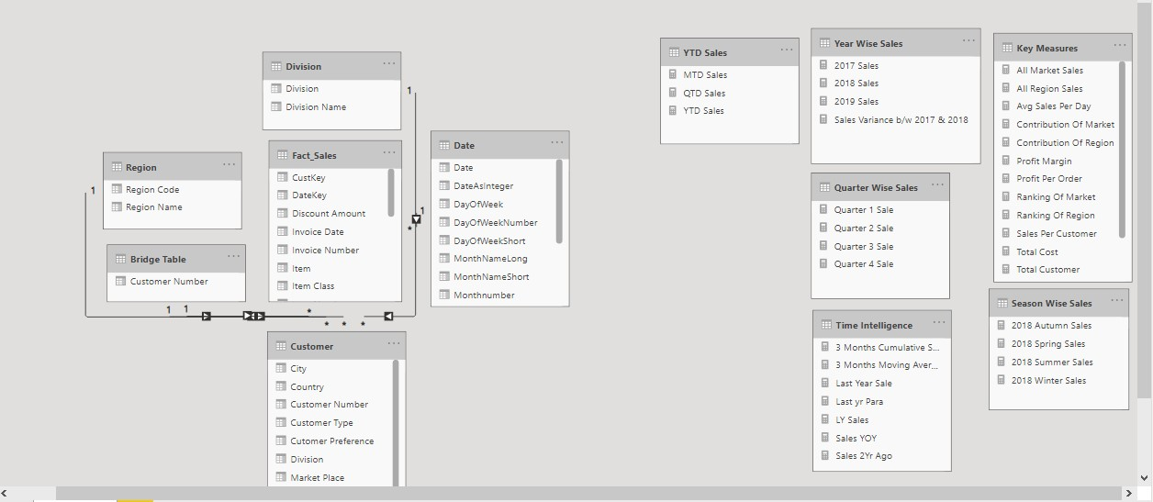

**Deployment**

Once you’ve completed your dashboard, publish your dashboard to Power BI Service.