***Analysing Amazon Sales data***

***Wireframe Documentation***

Homepage



Total cost Total Sales Total Profit

  

Relation between Total Sales Total Profit and Total Cost By Region

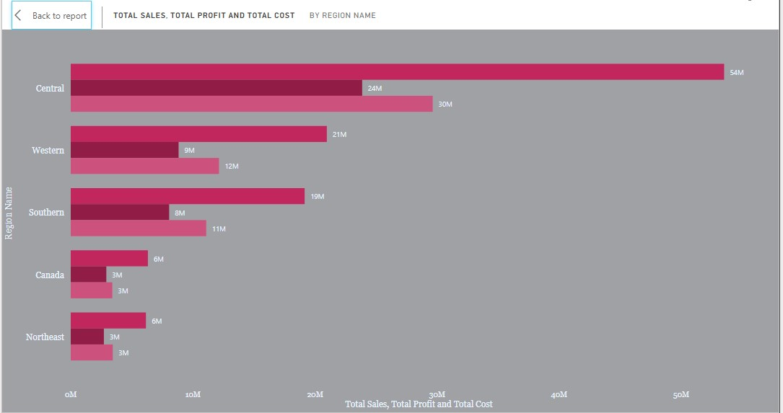

Total Sales By Division

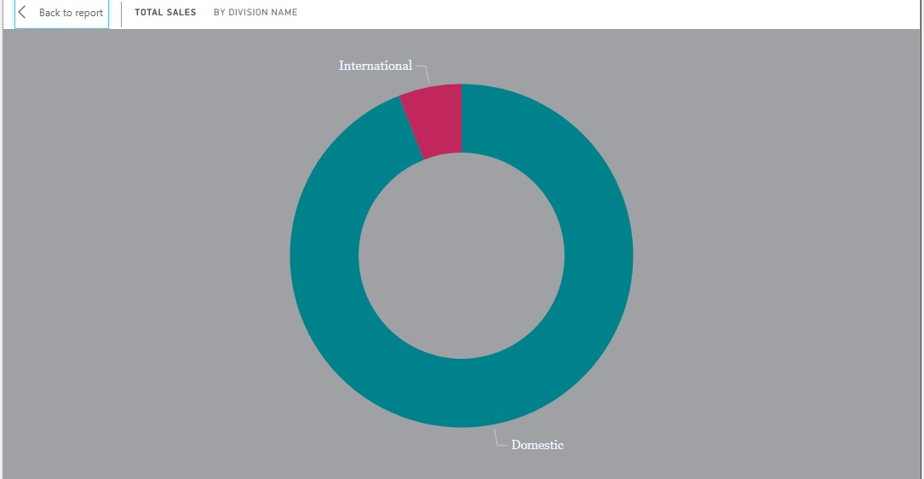

Customer By City

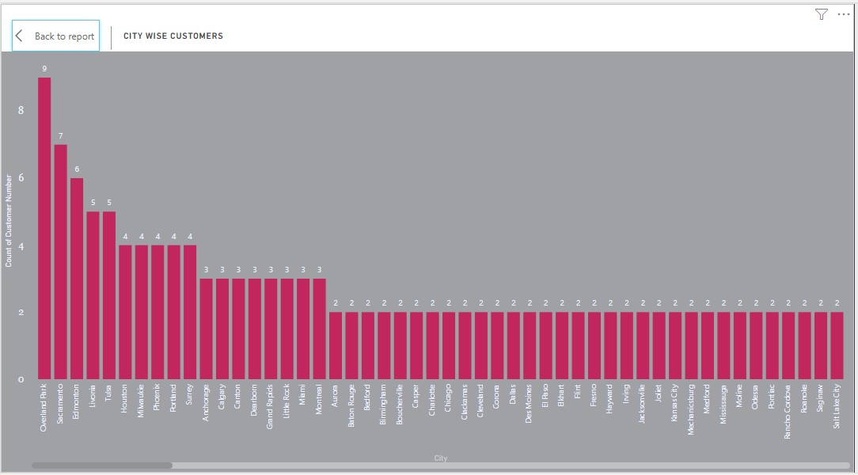

Market Place By Profit

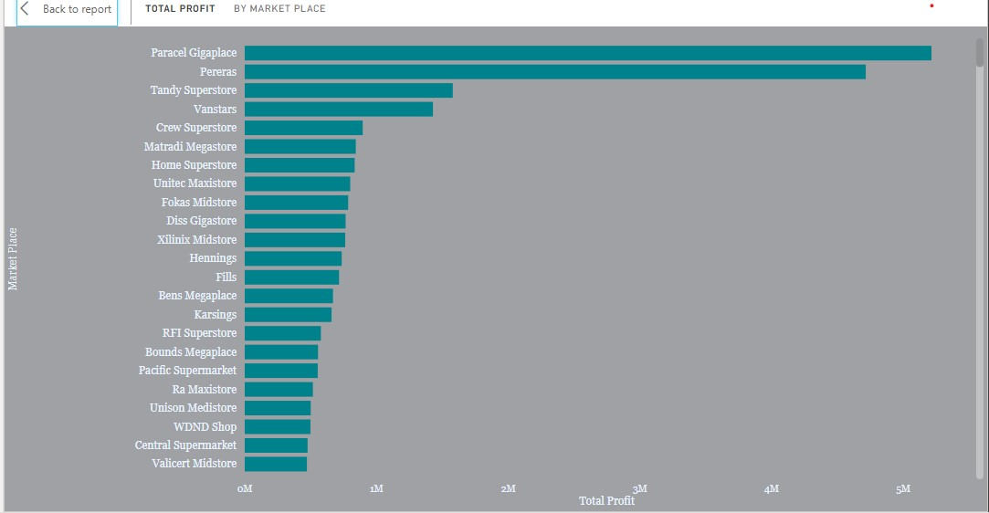

Quaterly Sales By Region

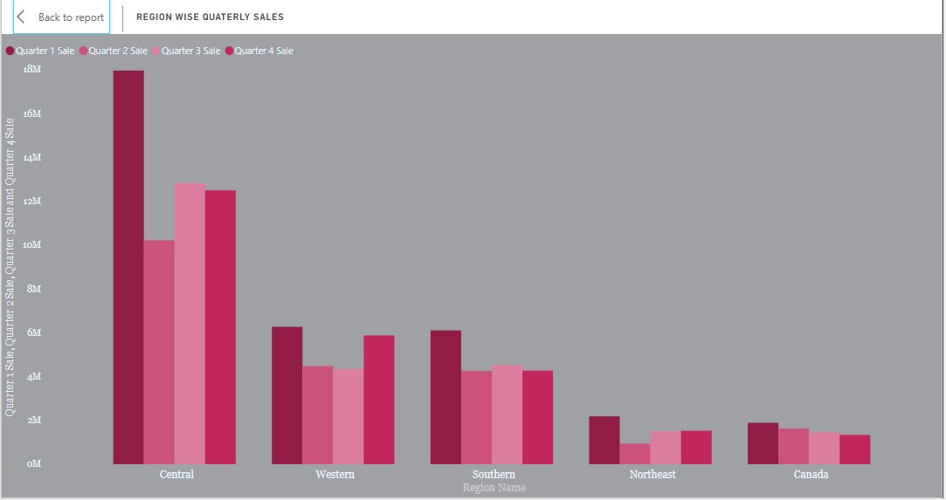

Total sales By Markets and their Contributions



Profit & Sales by Customers

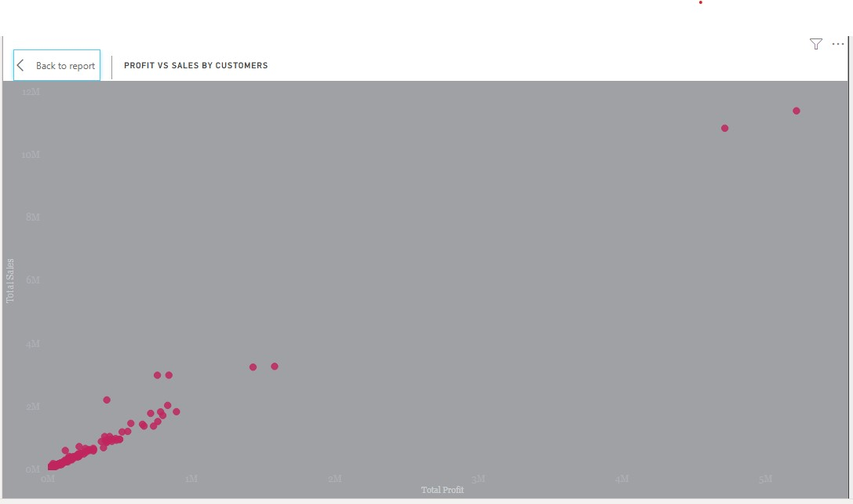

2017 vs 18 vs 19 Sales by city

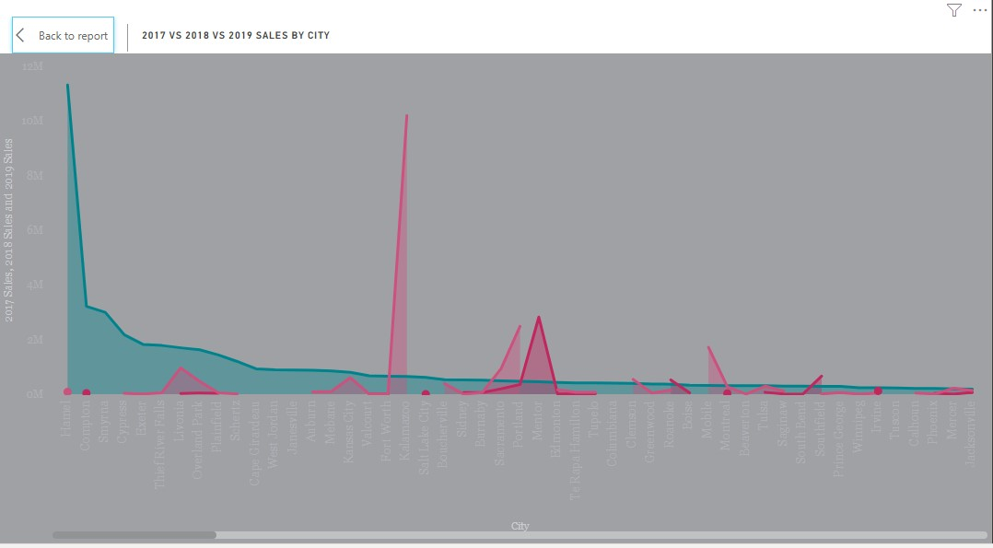

Total Sales & Profit By Date

