Output on ec2 based on user input:

1. generate a dockerfile for python flask app on port 8000
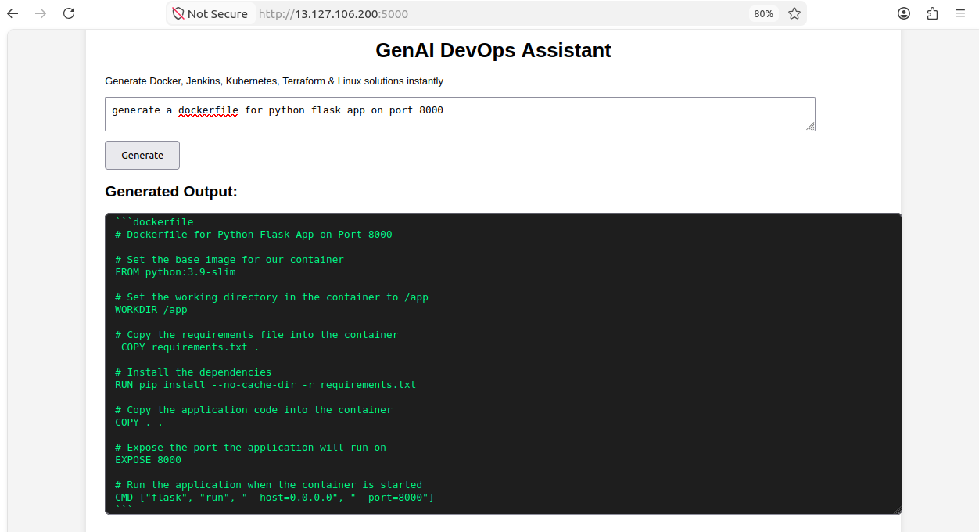
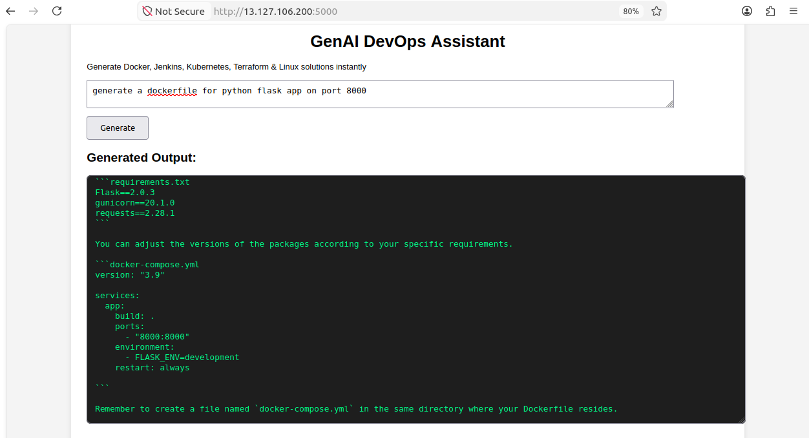
2 Generate basic Jenkins pipeline for Node.js project where we pull from github, build image and push to dockerhub with withcredentialsId function and then deploy.
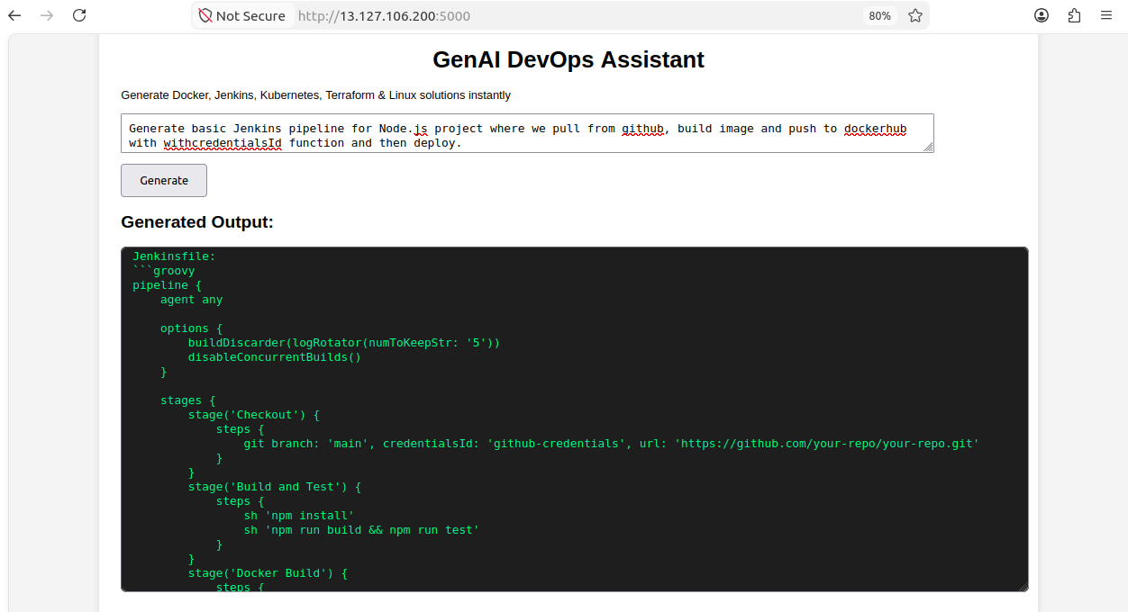
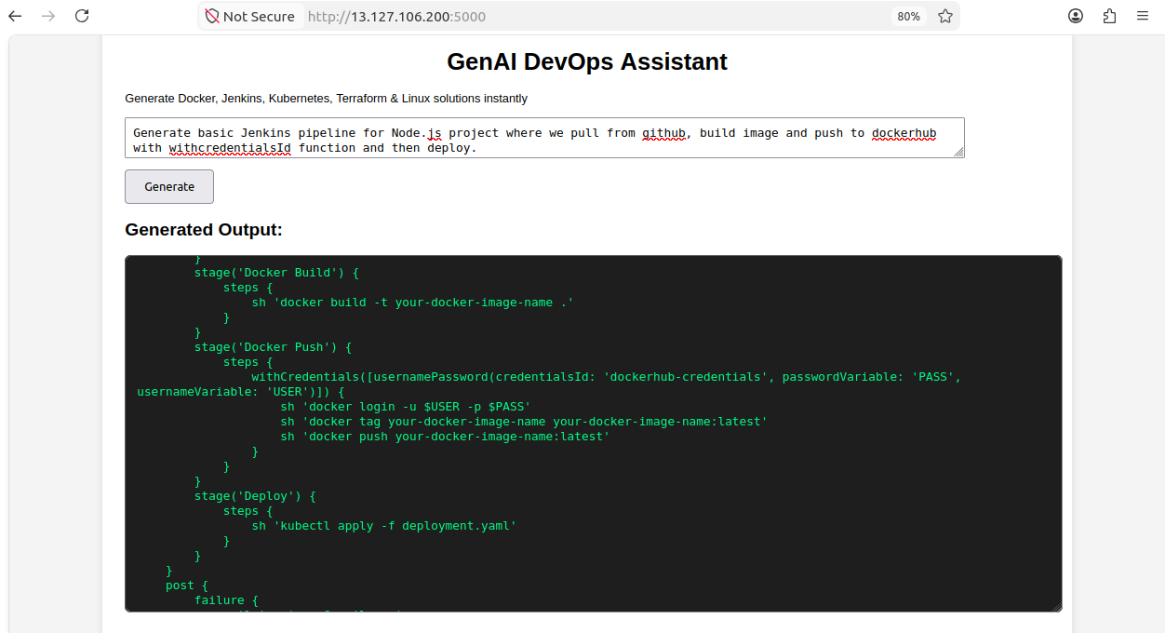
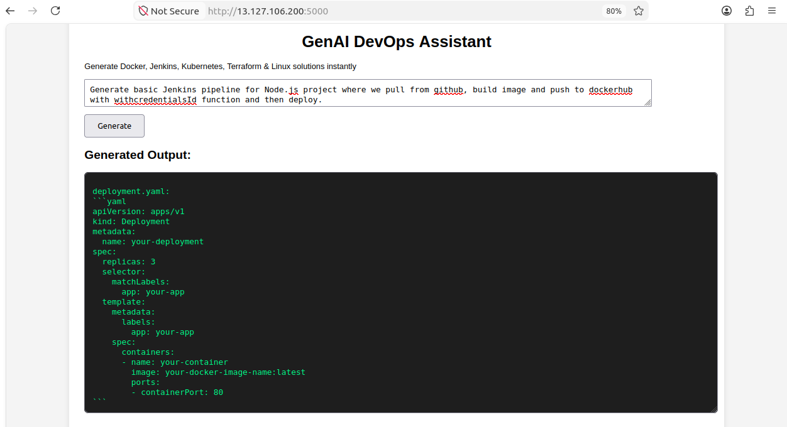

3 Generate Terraform for AWS EC2 Ubuntu instance
