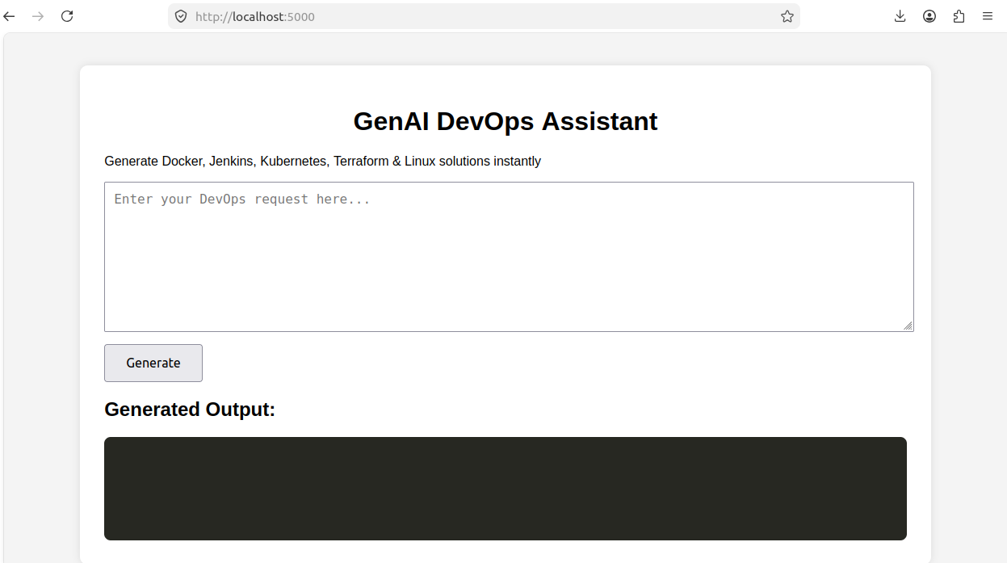
Before user_input

After generating output depending on user input

1. create a Dockerfile for python flask app.
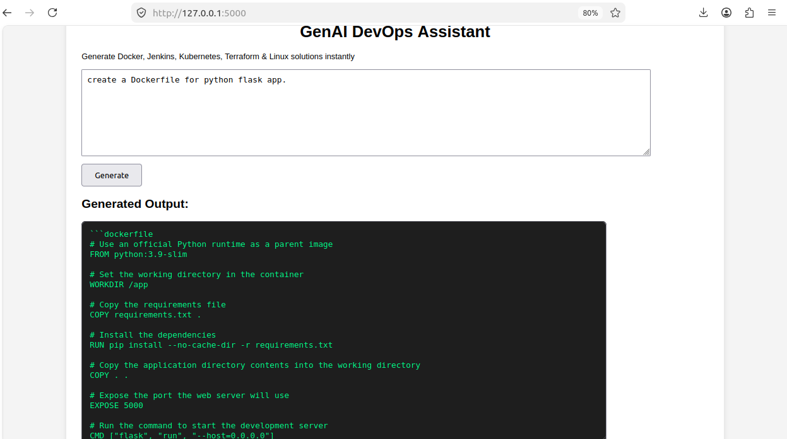
2. create a Dockerfile for node.js app running on port 8000
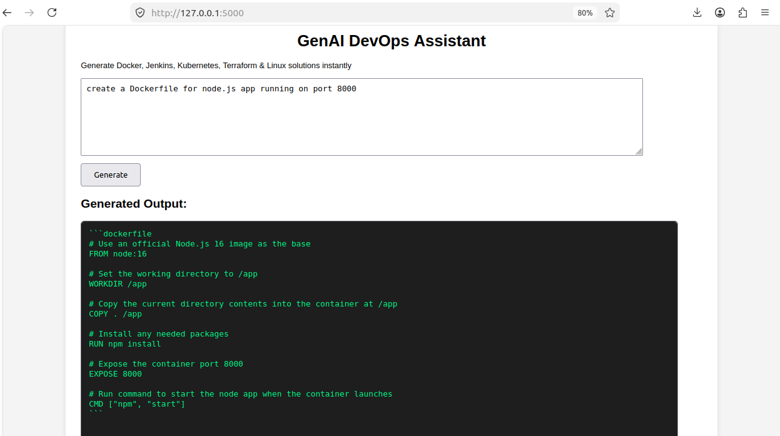
3. Generate Jenkins pipeline for Node.js project where we pull from github, build image and push to dockerhub with withcredentialsId function and then deploy.
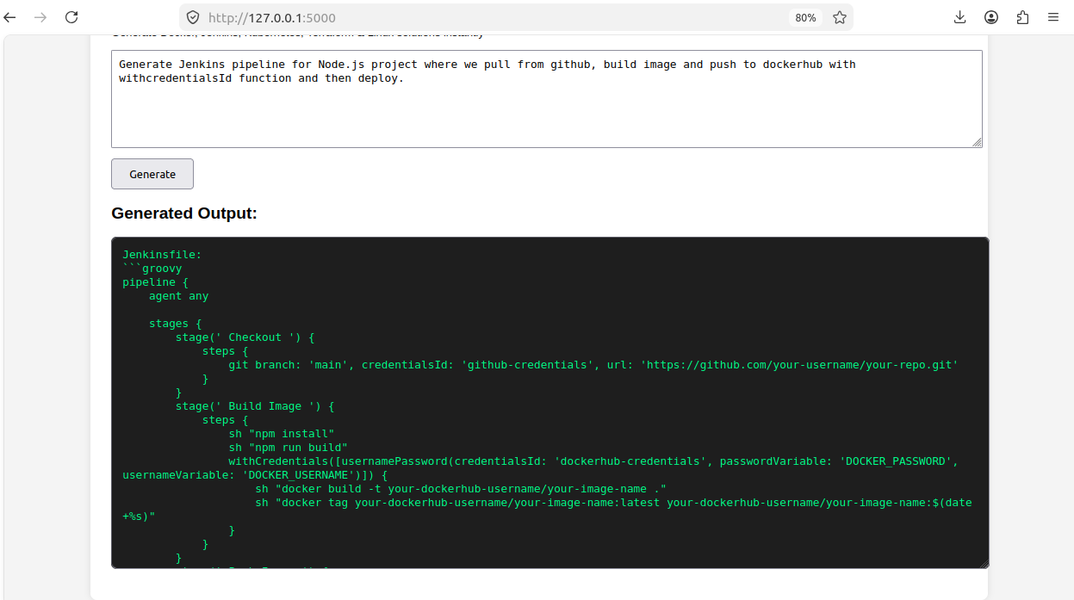
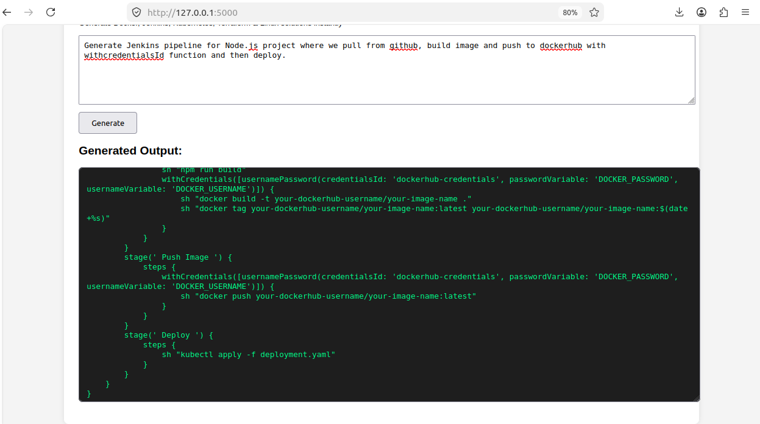

4. Generate Terraform for AWS EC2 Ubuntu instance
