Annual Industry Institute Interaction Program 2009

SYMPOSIUM REPORT

NEW AND INNOVATIVE TECHNOLOGY IN UPSTREAM OIL INDUSTRY

Department of Petroleum Engineering, Maharashtra Institute of Technology, and the Society of Petroleum Engineers, Student Chapter of MIT, organized its **Annual Industry Institute Interaction Program 2009** between 20th & 22nd March 2009. A symposium, “New and Innovative Technology in Upstream Oil Industry” was organized as a part of the celebrations of the college on a grand scale. The prize distribution function and panel discussion were held on the 20th evening for which **Mr. Atul Chandra, President, (International Operations) Reliance Industry (E&P) was the Chief Guest.**

# The symposium was divided into

# Presentations of innovative ideas by students

# Presentations by Experts from Industry

Student Paper Presentation contest, on innovative ideas was held on Saturday, 20th March, 2009. Following students presented papers on a wide variety of topics listed below:

|  |  |  |
| --- | --- | --- |
|  | Paper Titles | Name |
|  | Quantum Telemetry Systems | Suyog Dani |
|  | Error Free Directional Drilling | Venkat |
|  | Wetttability Alteration of an Oil Wet Rock | Nikhil Ghodke |
|  | Frictionless Drawworks and Pulley system | Ranu Sahay |
|  | Risk Analysis | Vaishali Sali |
|  | Jatropha based Bio-Diesel as a Drilling Fluid | Rahul Mark |
|  | Cures for Gas Hydrates in Pipelines | George John |
|  | Fines Migration Solutions | Pranav Tetali |
|  | Use of Biodegradable Chelating Agent | Atul Khemnar |
|  | Mass Spectrometry in Oil Industry | Amith Nair |
|  | Polymer based Sand consolidation | Nakul Mahalle |
|  | Mangala Oil Field-CMG study | I. Kuravale |
|  | Static Steerable System | Dheeraj |
|  | New recovery technique for CBM | Krishna |
|  | Smart Concrete Telemetry | Shawn |
|  | Crustal Velocity Structure From Earthquake Data | Arash |

**Dr. P. B. Jadhav, Head, Department of Petroleum Engineering felicitated the Judges**: Dr. Rajesh Kumar, Chief Manager (Reservoir), Mumbai High Asset, ONGC, Mr. Nick West, Interim Head, HSSE Advisor, Shell Technology India, Bangalore, Mr. Gregory Dean, Engineering Manager, B J Services, Mr. Arijit Ray, Principal Reservoir Engineer, Gujarat State Petroleum Corporation, Gandhinagar, Mr. A. V. K. Suryanarayana, GGM(Geophysics), ONGC, Mumbai and Mr. Jesper Vinge, Operations Manager, Weltec, Mumbai, were the judges for the contest.

During the week long celebrations, a number of competitions were also held, like a model making competition, ENP Experience, Ewing Business Challenge, a debate competition, a technical quiz competition, Poster Presentation, a Photography competition.

# AWARDS

# Pranav Tetalli, Nikhil Peshwe and Sourabh Jain were the winners of the paper presentation contest.

* George John, Timmy Thomas, Ann John were winners of the Ewing Challenge
* Pranav Tetalli and Joal John were the winners of the debate competition.
* Nikhil Kosambia, Rohit Pandey, Nitin Gandhare, Aman Arora, Nitish Srivastav were the winners for the modeling competition.
* Ann John, Ankita Sinha and Jitin K were the winners of the photography contest.
* Nikhil Godkhe, Kaustubh Shete and Satish Muley were the winners of the Poster contest.
* Rahul Fonseca, Rohit Patil, Krishna Chandak were the winners of the Quiz contest.

## SPEECHES & PANEL DISCUSSION

Dr. L. K. Kshirsagar, Principal, MIT Pune, felicitated the Chief Guest, Mr. Atul Chandra and other distinguished guests of honor on the dais.

**Mr. Krupa Kannan,** MIT-SPE Chapter President, spoke about the chapter achievements.

**Dr. L. K. Kshirsagar** acknowledged the help of the industry and thanked the Petroleum Industry Experts for attending the function and encouraging the young Petroleum Engineers.

**Dr. L. K. Kshirsagar chaired the panel discussion**. The panelists were Mr. Atul Chandra, Mr. Nick West, Mr Gregory Dean, Mr. Santanu Hati, ONGC, Mr. A. V. K. Suryanarayana, Dr. Rajesh Kumar, Mr. Avinash Korde, Country Manager, Weatherford, Mr. V. Ramanathan, Domain Manager (Stimulation) Schlumberger, Mr. Arijit Ray, GSPC, Dr. Achala Danait, Principal Scientist, Halliburton, and Mr. Tejas Deshmukh, BG India, Mr. Mark Davidson, Engg. Manager, Baker Oil Tools, Mumbai,

Mr. Nick West announced the “Shell Outstanding Award” which went to Rahul Mark Fonseca of B.E. Petroleum Engineering.

The function concluded with a vote of thanks to all the distinguished guests who took time out of their busy schedule to come and attend the function. Special thanks to all the alumni who made it a point to attend the function. In all about 15 Alumni were also present; Mr. Arunabh Parasher and Gaurav Shah(Cairn), Sameer Kale (B.J. Services), Prakash Kamble(Niko), Jigar Thakar, Nikhil Tamanhe (Weatherford), Sumit Bhat (Halliburton), Swayamraj Kale, Konark Ogra (Schlumberger), Anish Phade, Hemant Gurav, (Relainace), Parvez Khan(Baker Oil Tools), Sudeepto Banerjee(Maersk Oil)

# GUEST LECTURES

A series of presentations by guests was organized on Sunday, 22nd March, covering nearly every aspect of the Petroleum Sector.

|  |  |  |
| --- | --- | --- |
|  | Speaker /Affiliation | **Topic** |
| 1. | Mr. A. V. K. Suryanarayana, ONGC | Role of ONGC in Energy Security |
| 2. | Mr. Jesper Vinge, Welltec | Well Intervention |
| 3. | Mr. Nick West, Shell Tech India | Nakika-Planning & Development |
| 4. | Mr. Nitin Kulkarni, Weatherford | Underbalanced Drilling |
| 5. | Mr. Mark Davidson,BOT | Completion Tools |
| 6. | Mr. V. Ramanathan, Schlumberger | Production Enhancement Solutions |
| 7. | Mr. Arijit Ray, GSPC | Gas Lift Optimization |
| 8. | Dr. Rajesh Kumar, ONGC | Mumbai High Getting Younger |
| 9. | Mr. Jigar Thakar, Weatherford | RFID chip for smart wells |

**Mr. Pranav Tetalli, MIT-SPE Student Chapter,** thanked all the guests who spent their valuable time on our campus and also to all the student participants in the various events.

We gratefully acknowledge corporate sponsors and individual sponsors for making the event successful.

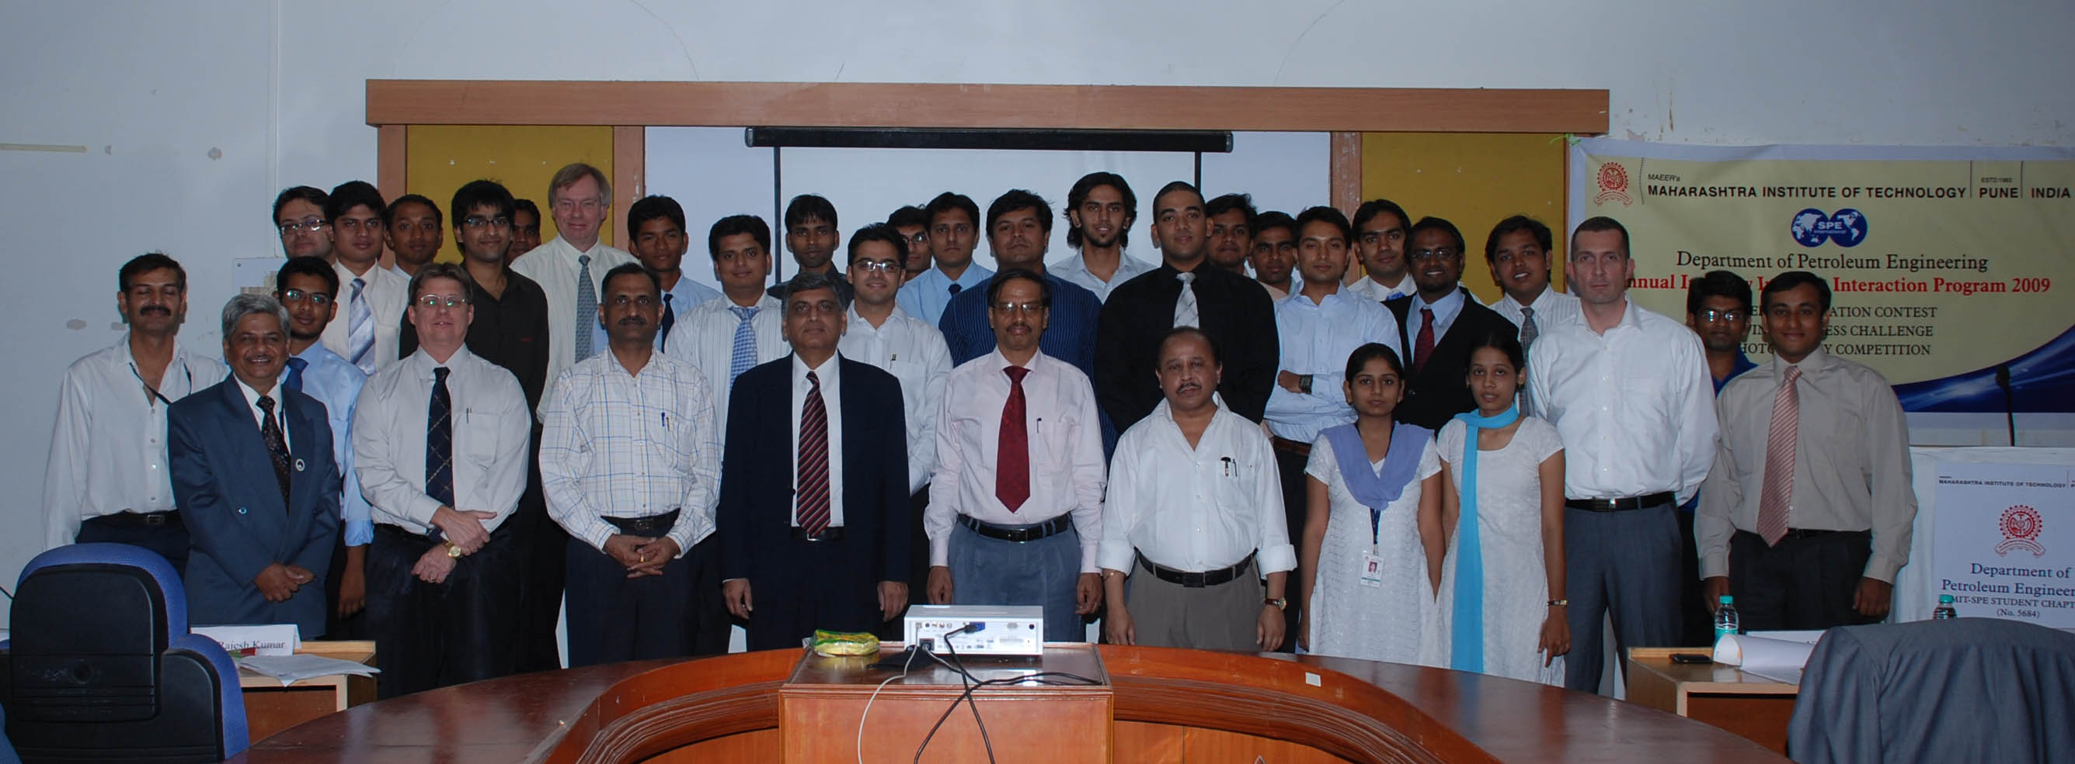

Participants in the Symposium on New and Innovative Technology in Upstream Oil Industry, MIT–SPE Student Chapter, Pune, held on 21th and 22nd March, 2009.