ANNUAL INDUSTRY INSTITUTE INTERACTION PROGRAM – 2010

SYMPOSIUM REPORT

NEW AND INNOVATIVE TECHNOLOGY IN UPSTREAM OIL INDUSTRY

Department of Petroleum Engineering, Maharashtra Institute of Technology, and the Society of Petroleum Engineers, Student Chapter of MIT, organized its **Annual Industry Institute Interaction Program–2010** between 12th & 14th March 2010. A symposium, “New and Innovative Technology in Upstream Oil Industry” was organized as a part of the month long series of technical competitions. The prize distribution function and panel discussion were held on the 13th evening for which **Dr. Ramashish Rai, Executive Director, IOGPT, ONGC, Panvel, was the Chief Guest.**

# The symposium was divided into

# a) Presentations of innovative ideas by students and

# b) Presentations by experts from Industry as a part of ONGC Chair Program

The Student Paper Presentation contest, on innovative ideas was held on Saturday, 13th March, 2010. Following students presented papers on a wide variety of topics listed:

|  |  |  |
| --- | --- | --- |
|  | **Paper Title** | **Name** |
|  | Self Healing Polymers | Chaitanya Padalkar |
|  | Antifreeze Proteins-Gas Inhibitor | Mayur Deshmukh |
|  | Constant Flow Rate Pressure Drawdown | Satish Muley |
|  | Silicone for Packers | Nikhil Kosambia |
|  | NMR Logging-for better DOI | Tejas Gadekar |
|  | Copper Nanorods | Bhavna Raina |
|  | Gas Deliquification Using Microwaves | Mohammed Kamal |
|  | Mud-Pulse Telemetry | Ruturaj Deshmukh |
|  | Soyabean-Anticongelant | Abhishek Punase |
|  | Activated Carbon in Cement | Venkat Iyer |
|  | Scale removal in CBM wells | Aditya Nikam |
|  | Induction Heaters for Heavy Oil | Ashish Kumar |
|  | Drilling Solutions for HPHT wells | Jayesh Patil |
|  | EOR-Carbon dioxide Flooding | Uma Kulkarni |
|  | New Geared Bit | Machindra Garge |
|  | EOR-Sugar Dust | Panchamlal |

**Dr. P. B. Jadhav, Head, Department of Petroleum Engineering, felicitated the Judges**: Mr. S.R. Athawale, Ex Director (Chief M&M), ONGC, New Delhi, Mr. A. V. K. Suryanarayana, GGM (Geophysics), ONGC, Mumbai, Mr. John Hoppe, Discipline Lead, & Dr. Joniek Hage Shell Technology India, Bangalore, Mr. Piyush Pankaj, Schlumberger, Mr. Ashish Rai, Country Manager-Cementing, & Mr. Sumit Bhat, Halliburton, Mr. R. K. Vij, DGM, ONGC. During the lunch break, the poster presentation and photography competition was held.

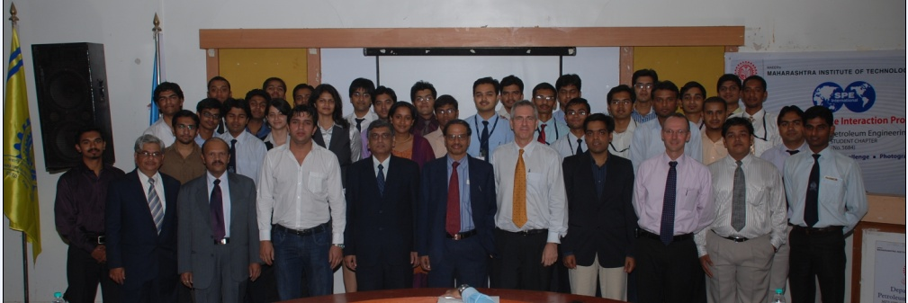

Industry Judges and Student Paper Presenters for the Paper Presentation Contest

# AWARDS

# P.S. Venkat Iyer, H. Mahajan, N. Gandhare were the winners of the Paper Presentation Contest

# N. Panigrahi was the winner of the SE Paper Presentation Contest

# N. Gandhare, Y Shendre, A. Ajwani, P. Shrivastava, S. Krishna were the winners of the Modeling Contest

# Jitin K., K. Chandak, A. Sinha, R. Chandak, A. Dongre were winners of the Darcy Business Challenge;

# Ravi, M. Rampurwala were the winners of the Debate Competition

# Patane, A. Punase, V. Bankar were the winners of the Photography Contest

# K. Bhatia, A. Sinha, A. Rajput were the winners of the Poster Contest

# S. Viegas, A. Muley, A Raina, G. Singhvi were the winners of the Quiz Contest

# Z. Haindade, A. Deore, S. Viegas, A. Patil, S. Patil were the winners of the Case Study.

## SPEECHES & PANEL DISCUSSION

Dr. Vishwanath Karad, Director, MIT-Pune, felicitated the Chief Guest, and other distinguished Guests of Honor on the dais.

**Dr. Ramashish Rai** was felicitated for playing an important role in developing the department, extensive and tirelessly helping and teaching the students and for being a guide for many students in their projects.

**Mr. Venkat Iyer,** **President**, **MIT-SPE Student Chapter** spoke about the chapter achievements.

**Dr. P. B. Jadhav, Head, Department of Petroleum Engineering**, highlighted the achievements of the department and the help we are constantly receiving from SPE Mumbai and alumni.

**Dr. L. K. Kshirsagar, Principal, MIT-Pune,** acknowledged the help from the industry and thanked the Petroleum Industry Experts and alumni for attending the function and encouraging the young Petroleum Engineers.

**Dr. L. K. Kshirsagar chaired the panel discussion for which the theme was “Bridging the Gap”**. The panelists were Dr. Ramashish Rai, Mr. John Hoppe, Dr. Joneik Hage, Mr. Uday Singh Jadon, Manager, HSSE, BG-India, Mr. Sanjay Goyal, Field Service Manager, Schlumberger, Mr. Mukesh Jain, COO(Technical), Essar Energy, Mr. Avinash Korde, Country Manager-SLS, Weatherford, Mr. Ravindra Kumar, Advisor, Finance, DGH, New Delhi, Dr. Suraj Sharma, DGM, Reliance and Mr. R. K. Vij, DGM(P), ONGC.

**Mr. Sumit Bhat, Sr. Technical Professional, Halliburton, gave away the “LNNN Scholarship” to Mr. Panchamlal from Third Year Petroleum Engineering.**

**Mr. John Hoppe announced the “Shell Outstanding Student Award” which went to Neelendra Nath of Final Year Petroleum Engineering.**

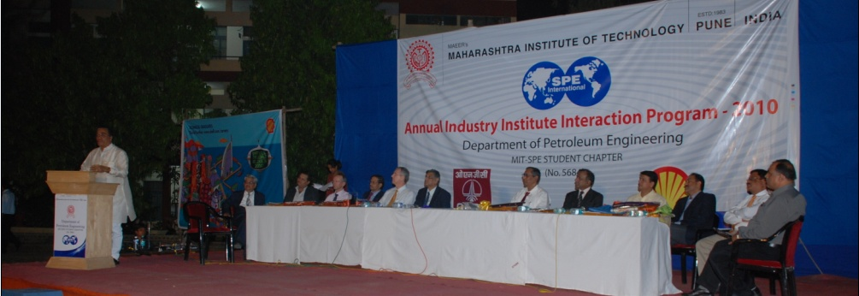

(L-R: Prof. Karad, Prof. Jadhav, Mr. Goyal, Dr. Hage, Mr. Suryanarayana, Mr. Hoppe, Prof. Kshirsagar, Dr. Rai, Mr. Jain, Mr. Korde, Mr. Jadon, Mr. R. Kumar, Mr. Vij)

# GUEST LECTURES

A series of presentations by guests was organized on Sunday, 14th March, as a part of the ONGC Chair Program, covering nearly every aspect of the Petroleum Sector. The students were delighted to hear Dr. Ram Agarwal speak in very lucid language on a very complicated subject-Well Testing and had a very lively interactive session with him after the lecture.

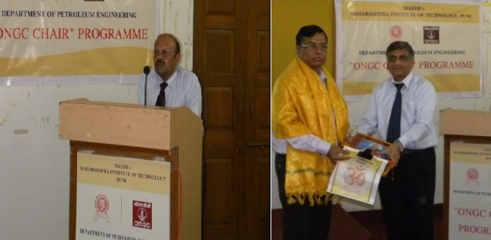

Mr. S.R. Athawale delivering a lecture Mr. N. K. Mitra felicitated by Dr. Kshirsagar

|  |  |
| --- | --- |
| Speaker /Affiliation | **Topic** |
| 1. Mr. A. V. K. Suryanarayana, ONGC | Sub Basalt Imaging |
| 2. Mr. Chiranjit Barua, Shell | Integrated Waterflood Oil Reservoir |
| 3. Mr. S. R. Athawale, ONGC | Future of the Oil Industry |
| 4. Mr. Piyush Pankaj,Schlumberger | Engineering Behind Hydraulic Fracturing |
| 5. Dr. Girija Padhy, BG-India | Quantification of Vuggy Porosity & Application |
| 6. Mr. N. K. Mitra, Reliance, SPE Distinguished Lecturer | Global Oil and Gas Industry Reviews |
| 7. Mr. Rakesh Kumar, Schlumberger | Productive Drilling |
| 8. Mr. Adrian Tiburzio, Weatherford | High Energy Gas Stimulation Techniques |
| 9. Dr. Ram Agarwal, Consultant-USA | Why and How of Well Testing |

**Mr. Satish Muley, Secretary, MIT-SPE Student Chapter,** thanked all the guests who spent their valuable time on our campus and also to all the participants in the various events.

Special thanks to all the alumni who made it a point to attend the function. In all about 20 Alumni present: Ashish Rai, Sumit Bhat, Halliburton; Narendra Thatte, Rajesh Joshi, Aker Solutions; Mandar Pathak, Transocean; Konark Ogra, Sambhaji Devkar, Schlumberger; Sujit Bhatevera, Smith International, Chiranjit Barua, Neeti Joshi, Amit Nair, Shell, Ashish Tiku, Madhavi Jadhav, Mounraj Sharma, Reliance; Mahesh Jorwekar, Aarti Dange, Weatherford; Nikhil Hardikar, Sandeep Tatake, Pervez Khan, Baker Hughes, Mohit Kaul, DGH.

We gratefully acknowledge corporate sponsors **ONGC, Shell Technology India, Oil India** and individual sponsors & the management of MIT-Pune for making the event successful.