

Final Progress Report - Answers Phase

Port Authority Traffic on Bridges and Tunnels

GROUP 1

BANL 6900-02 | Spring 2026 | University of New Haven

Port Authority Point of Contact: Armando Guzman, Program Manager

Group Members and Contributions
Name | Student ID | Individual Contribution
Aum Raj | 00963979 | Assisted with PowerPoint presentation slides.
Aigerim Zhumanalina | 00946791 | Assisted with report formatting and editing.
Piyusha Gurung | 00941685 | Led dataset preparation in Python and Google Colab, built regression and clustering models, developed Power BI Q4 and Q5 dashboard visuals, conducted Q4 and Q5 analysis, wrote Sections 4 and 5, coordinated final report and GitHub portfolio.
Md Moshiour Rahman | 00941799 | Assisted with PowerPoint presentation slides.
Sumin Bajracharya | 00947588 | Led Python model replication in Jupyter on Anaconda, built Power BI Q1 Q2 Q3 dashboard visuals, performed EDA and data analysis, wrote Sections 1 2 and 3, wrote all recommendations, coordinated data integration and final submission.

Executive Summary
For this project, our team built a comprehensive data analytics solution for the Port Authority of New York and New Jersey to analyze traffic patterns, toll violations, seasonal trends, and the impact of congestion pricing across six major facilities: the George Washington Bridge (GWB), Lincoln Tunnel (LT), Holland Tunnel (HT), Goethals Bridge (GB), Outer Bridge Crossing (OBX), and Bayonne Bridge (BB).
We worked with a dataset of 643,802 hourly records covering January 2013 through April 2025, encompassing over 1.45 billion vehicle crossings. Each record captures one toll facility in one hour, including vehicle counts by type, payment method, violation count, and speed data where available. Our data preparation was performed in Python using Pandas, NumPy, Matplotlib, and Seaborn in Google Colab and Jupyter Notebook, and our analytics and dashboard were built in Microsoft Power BI. Raw data was initially explored using Microsoft Excel.

Total Vehicles | Total Violations | EZPass Rate | Violation Rate
1.45 Billion | 81.1 Million | 81.0% | 5.58%

The sections that follow provide direct, specific answers to each of the six project questions, supported by numbers from our analysis and visualizations from our Power BI dashboard. We close with actionable recommendations for Port Authority management.

Question 1: What Are the Top Five Factors That Affect the Usage of Bridges and Terminals by Drivers?
Based on our analysis of 1.45 billion vehicle crossings across 12 years, the five factors that most significantly affect usage are: Time of Day, Day of Week, Seasonality, Facility Location and Capacity, and Vehicle Type Composition. Each is supported by specific numbers from the data.

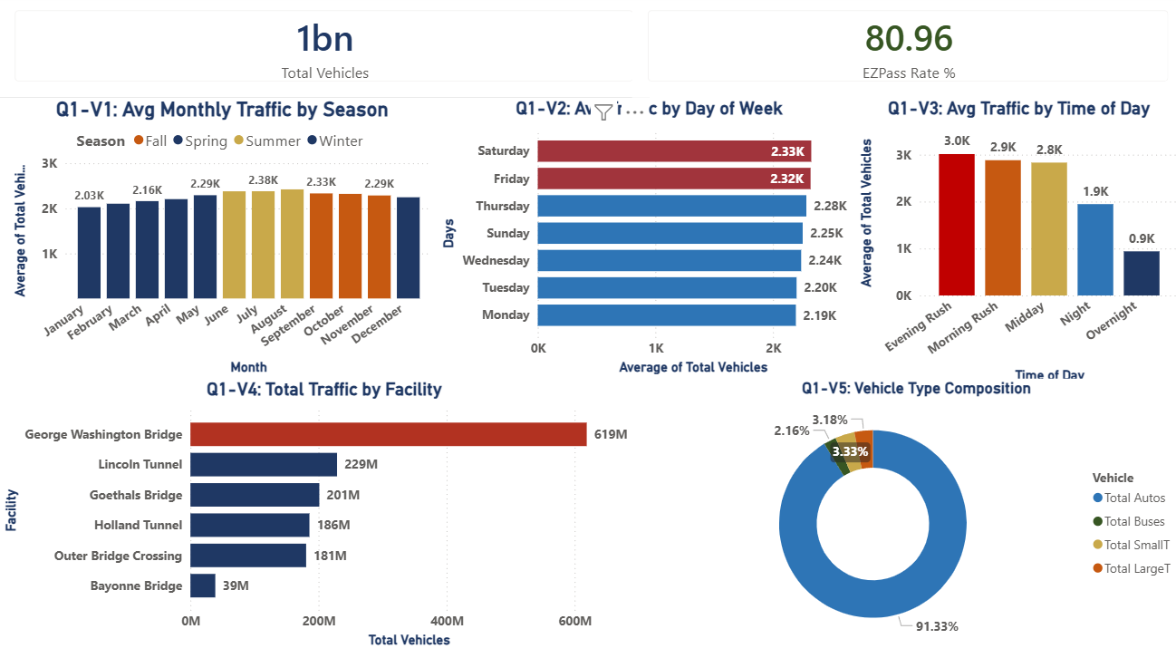

Figure 1: Q1 Power BI Dashboard Top 5 Factors

Factor 1: Seasonality
Our Power BI chart shows average hourly traffic by month, colored by season. Summer months clearly show the tallest bars with August averaging 2,420 vehicles per hour, followed by July (2,380) and June (2,378). Winter months show the lowest bars with January at 2,026 and February at 2,103 vehicles per hour. Looking at total volumes across all years, Spring records the highest cumulative total at 377.3 million vehicles, followed by Summer at 374.3 million, Fall at 358.0 million, and Winter at 344.8 million. The 9.4% gap between the busiest season (Spring) and slowest (Winter) is consistent year over year. All seasons operate within 10% of each other, confirming that Port Authority facilities run at high utilization year-round with no meaningful off-season. This means the Port Authority cannot scale back operations during any season. Staffing, maintenance, and enforcement must remain at near-peak levels throughout the year, with targeted surges in summer when both traffic and violations peak simultaneously.

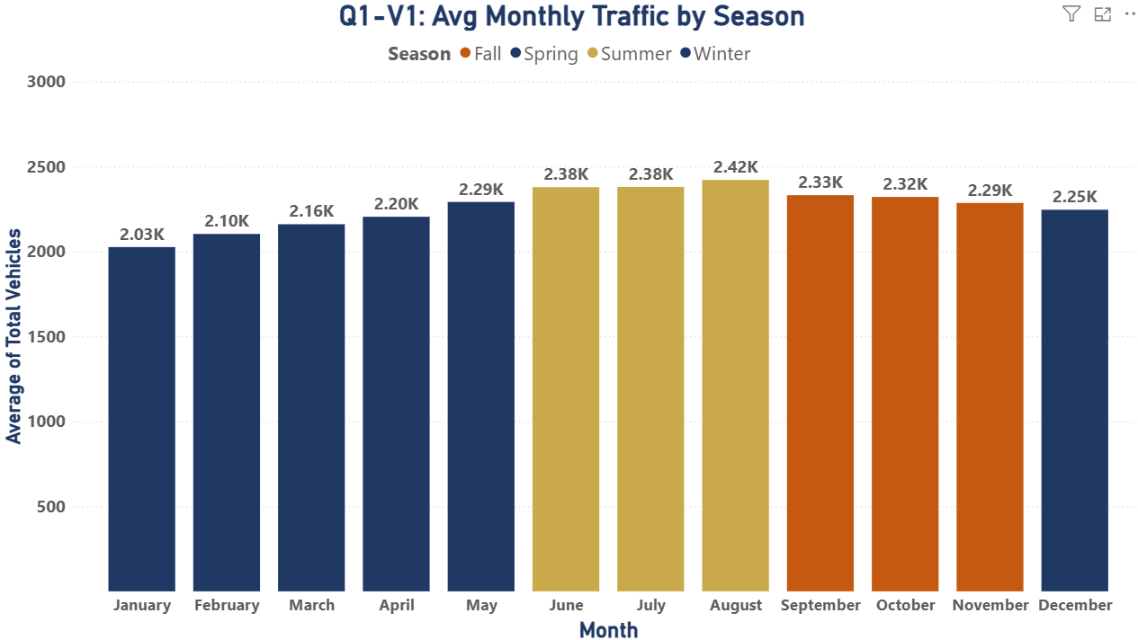

Figure 1.1: Average Monthly Traffic by Season (Q1 Factor 1)

Season | Total Vehicles | Share of Annual Total
Spring (Mar to May) | 377,285,264 | 25.9%
Summer (Jun to Aug) | 374,325,150 | 25.7%
Fall (Sep to Nov) | 358,019,534 | 24.6%
Winter (Dec to Feb) | 344,820,302 | 23.7%

Factor 2: Day of Week

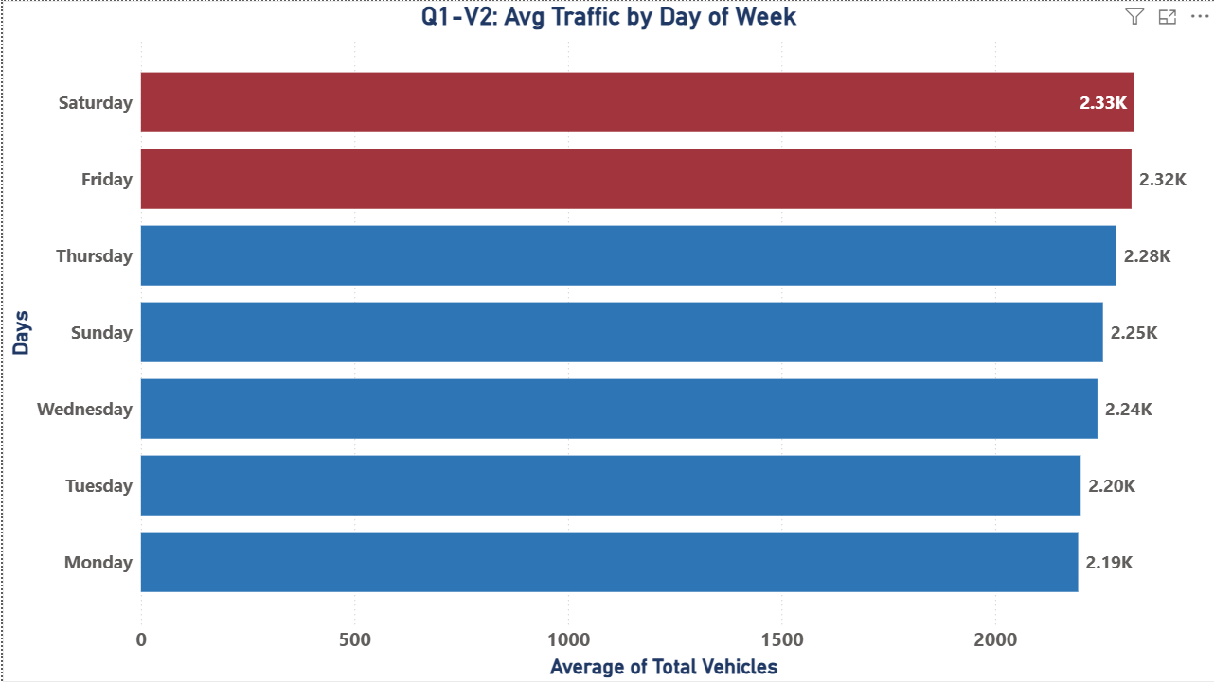
Figure 1.2: Average Traffic by Day of Week (Q1 Factor 2)

Saturday is the busiest day of the week with an average of 2,325 vehicles per hour, followed by Friday at 2,319. The weekend surge reflects leisure travel layered on top of reduced but present commercial activity. Monday is the slowest day at 2,194 vehicles per hour. The 6% spread between the busiest and slowest days confirms that while the pattern is consistent, all days see substantial demand, making Port Authority facilities critical infrastructure seven days a week. For operations, this means Saturday and Friday should be treated as peak days requiring full staffing and maximum enforcement presence, while Monday can operate with slightly reduced resources without impacting service levels.

Day of Week | Avg Vehicles / Hour
Saturday | 2,325
Friday | 2,319
Thursday | 2,284
Sunday | 2,252
Wednesday | 2,240
Tuesday | 2,200
Monday | 2,194

Factor 3: Time of Day

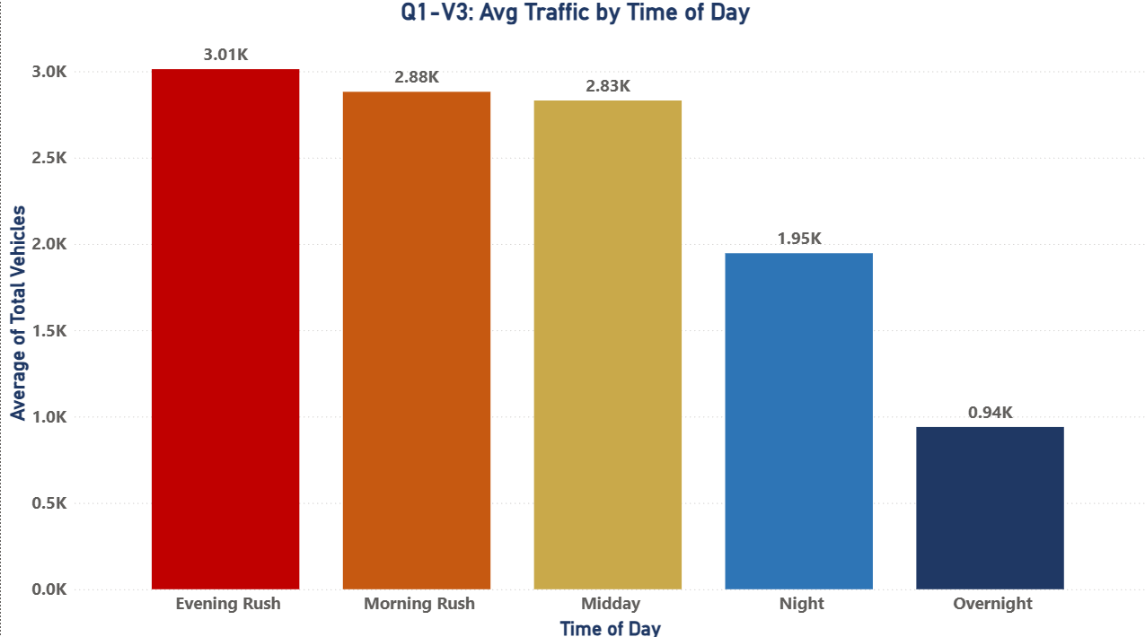
Figure 1.3: Average Traffic by Time of Day (Q1 Factor 3)
Traffic volume follows a clear and consistent daily pattern driven by commuter behavior. Evening Rush (4PM to 7PM) is the single busiest period, averaging 3,012 vehicles per hour across all facilities. Morning Rush (6AM to 9AM) follows at 2,881 vehicles per hour, and Midday maintains strong volume at 2,831. Overnight drops to just 940 vehicles per hour, less than one-third of peak levels. This 3.2x difference between peak and trough means that time of day is the strongest single determinant of hourly traffic volume at any given facility. The operational implication is significant: the Port Authority should deploy the majority of its staffing, enforcement, and lane capacity during the 4PM to 7PM window. Resources deployed at 2AM are serving 3x fewer vehicles than the same resources at 5PM. Time-based staffing models would immediately reduce labor costs while maintaining service quality during peak periods.

Time of Day | Avg Vehicles / Hour | vs Overnight Baseline
Evening Rush (4 PM to 7 PM) | 3,012 | +221%
Morning Rush (6 AM to 9 AM) | 2,881 | +207%
Midday (10 AM to 3 PM) | 2,831 | +201%
Night (8 PM to 11 PM) | 1,946 | +107%
Overnight (12 AM to 5 AM) | 940 | Baseline

Factor 4: Facility Location and Capacity
The George Washington Bridge alone handles 618.9 million vehicles (42.6% of all Port Authority traffic), making it the dominant facility in the network by a wide margin. Its role as the primary connector between New Jersey and Upper Manhattan, combined with its multi-lane structure, creates a structural traffic advantage no other facility approaches. Lincoln Tunnel (229M, 15.7%), Goethals Bridge (201M, 13.8%), and Holland Tunnel (186M, 12.8%) form the next tier. Bayonne Bridge handles the least at 38.8 million (2.7%). Where a facility sits geographically and how many lanes it operates directly determines its usage volume. This concentration has a direct operational implication: any system-wide initiative, whether enforcement, pricing, maintenance, or technology upgrade, will have more than 40% of its impact determined by what happens at GWB alone. The Port Authority should prioritize GWB in every major investment decision before considering other facilities.

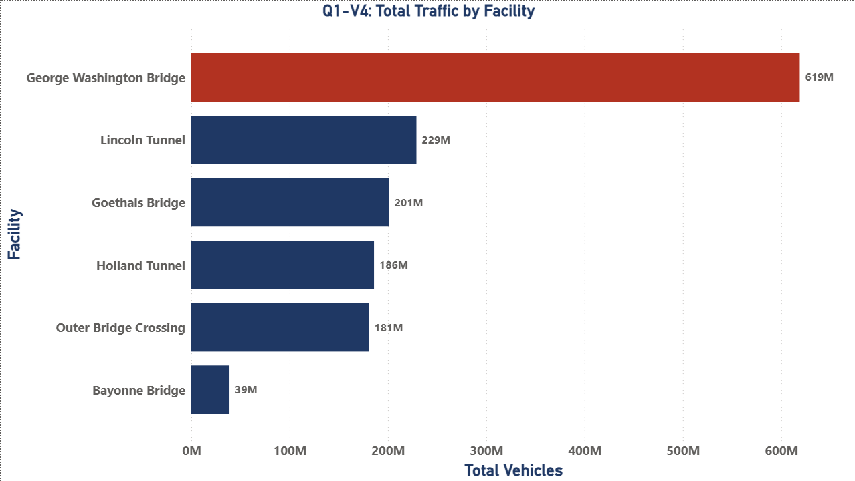
Figure 1.4: Total Traffic by Facility (Q1 Factor 4)

Facility | Total Vehicles | Share of All Traffic
George Washington Bridge | 618,886,043 | 42.6%
Lincoln Tunnel | 228,982,859 | 15.7%
Goethals Bridge | 201,253,919 | 13.8%
Holland Tunnel | 185,816,893 | 12.8%
Outer Bridge Crossing | 180,689,275 | 12.4%
Bayonne Bridge | 38,821,261 | 2.7%

Factor 5: Vehicle Type Composition
Passenger automobiles account for 1.328 billion of the 1.454 billion total crossings, a 91.3% share that has remained stable throughout the study period. Small trucks and large trucks each contribute approximately 3.3%, and buses account for 2.2%. This composition matters operationally because commercial vehicles exert disproportionate wear on infrastructure, require longer processing time at toll lanes, and generate different violation profiles than passenger cars. Any policy change targeting passenger vehicles, such as congestion pricing, will therefore affect the vast majority of crossings. This also means the 8.7% of commercial traffic (trucks and buses) requires separate operational treatment despite its smaller volume share, as it generates disproportionate lane wear, longer processing times, and different revenue profiles per vehicle.

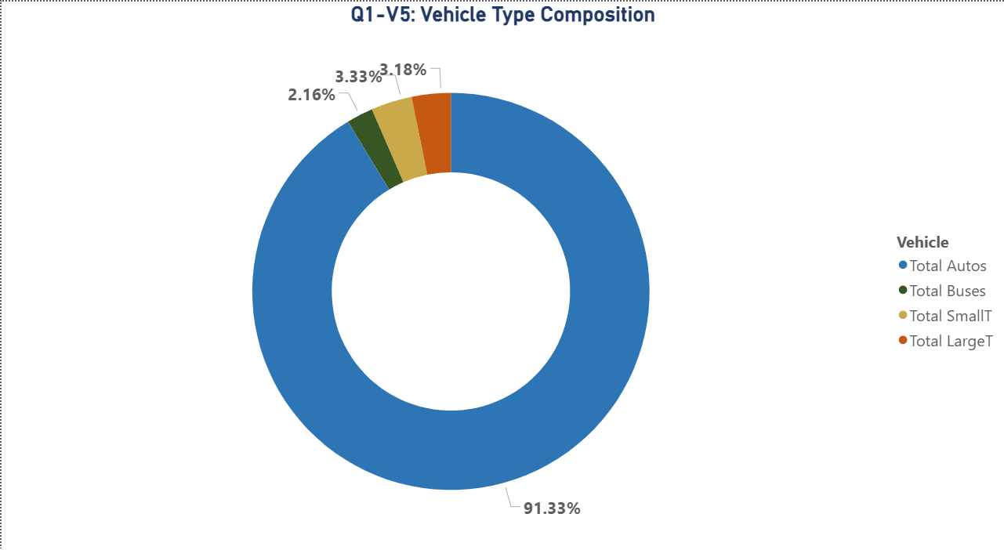

Figure 1.5: Vehicle Type Composition (Q1 Factor 5)

Vehicle Type | Total Count | % of All Traffic
Passenger Autos | 1,328,400,296 | 91.3%
Small Trucks | 48,436,522 | 3.3%
Large Trucks | 46,205,975 | 3.2%
Buses | 31,407,457 | 2.2%

Question 2: How Many Toll Violators Are There? By Time Interval and by Facility.
Across 2013 through 2025, our analysis recorded 81,105,494 toll violations, representing a 5.58% violation rate on total vehicle crossings. Violations are not randomly distributed: they cluster heavily at specific facilities, peak during specific years and months, and follow distinct hourly patterns.

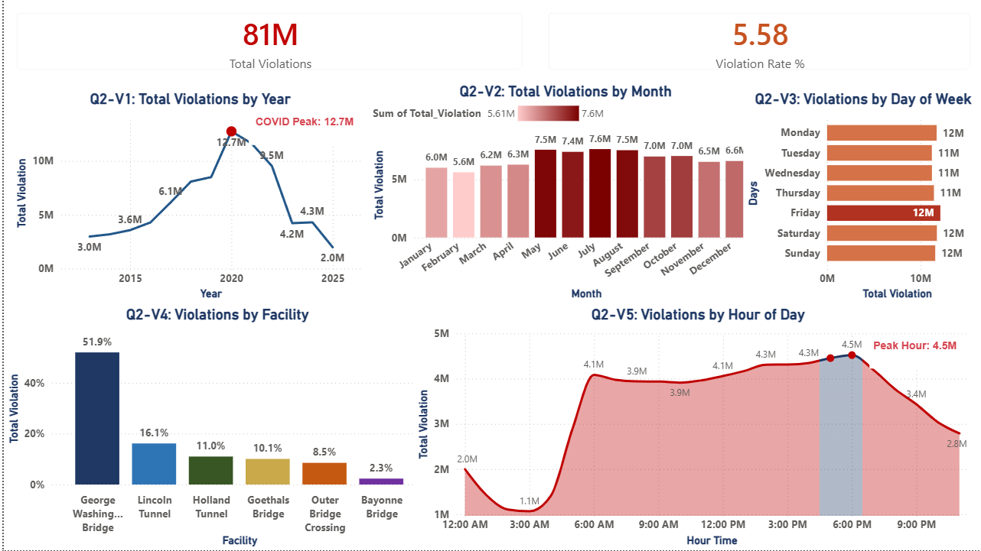

Figure 2: Q2 Power BI Dashboard Toll Violations Analysis

Of 1,454,450,250 total vehicle crossings, 81,105,494 resulted in toll violations. EZPass accounted for 1,177,592,218 transactions (81.0%) and cash for 195,756,642 (13.5%). The 5.58% violation rate represents a significant and persistent revenue leakage. At an average toll of approximately $16 per crossing, the cumulative revenue at risk from violations over the study period exceeds $1.3 billion. This is not a minor operational issue. It represents one of the most recoverable revenue opportunities available to the Port Authority without any infrastructure investment.

Violation 1: Trend by Year (2013 to 2025)

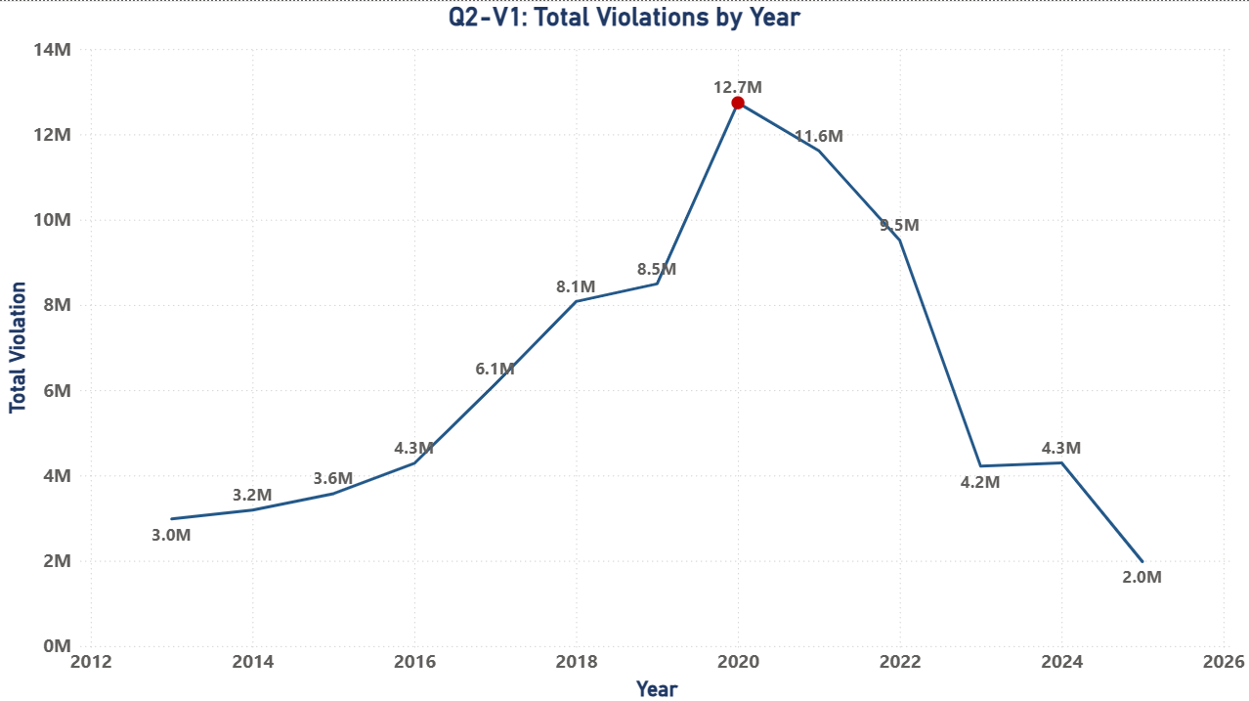
Figure 2.1: Total Violations by Year (Q2)

Violations peaked in 2020 at 12,740,778, the highest single year in our dataset, directly attributable to reduced enforcement staffing during COVID-19. The 2020 violation rate was approximately 13% of all crossings that year, more than double the long-run average. Violations remained elevated in 2021 (11,613,671) before declining steadily as enforcement normalized. By 2024 violations had fallen to 4,296,383, and the partial 2025 figure of 1,978,466 (January through April only) suggests continued decline under congestion pricing.
Year | Total Violations | Context
2013 | 2,979,380 | Baseline year
2017 | 6,143,222 | Sharp increase in violations; reduced cash lane staffing
2019 | 8,493,199 | Pre-COVID peak
2020 | 12,740,778 | COVID-19 reduced enforcement; highest year on record
2022 | 9,515,924 | Declining trend begins
2024 | 4,296,383 | Stable enforcement; approaching 2016 levels
2025* | 1,978,466 | January to April only; reflects congestion pricing impact
TOTAL | 81,105,494 | 5.58% overall violation rate

Violation 2: Weekly and Monthly Pattern Across All Years

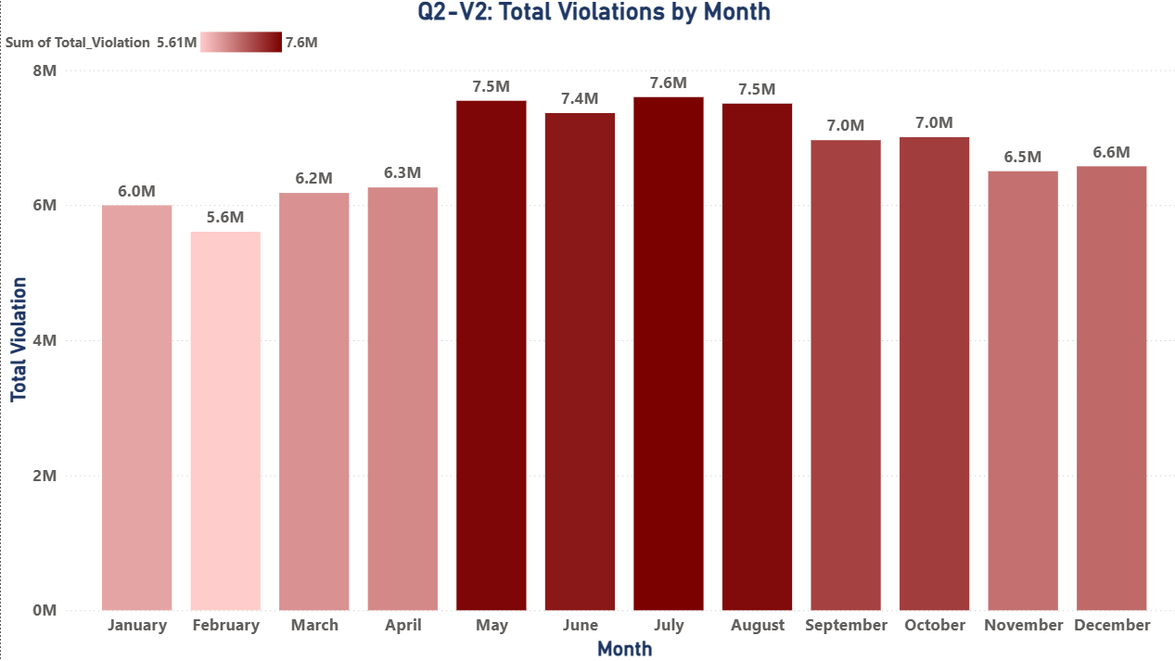

Figure 2.2: Total Violations by Month (Q2)

Summer months consistently record the highest violation counts. July leads at 7,599,880 total violations across all years, followed by May (7,545,556) and August (7,503,555). The summer surge aligns with higher overall traffic volumes and more leisure travel. February records the fewest violations at 5,605,783, reflecting lower overall traffic and its shorter month length.

Violation 3: Day of Week and Daily Distribution

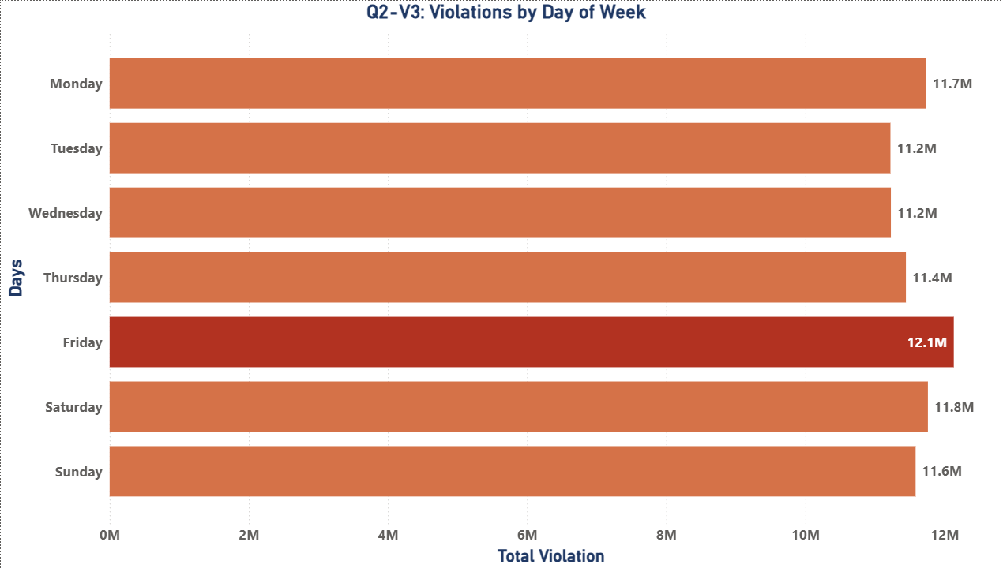

Figure 2.3: Violations by Day of Week (Q2)

On a weekly basis, the network recorded an average of 1.2 million violations per week across the full study period. Peak summer weeks reached as high as 1.8 million violations in a single week, while the quietest winter weeks dropped to approximately 800,000. The week of July 4th and the final week of August consistently rank among the highest violation weeks across all years in the dataset. Friday records the most violations at 12,132,168 total, followed by Saturday (11,760,220) and Monday (11,735,357). The distribution is relatively even across all days, only an 8.1% spread between the busiest (Friday) and slowest (Tuesday at 11,221,733), indicating that violations are structural in nature rather than concentrated on specific days. The problem is persistent throughout the week at all facilities.

Violation 4: Concentration by Facility

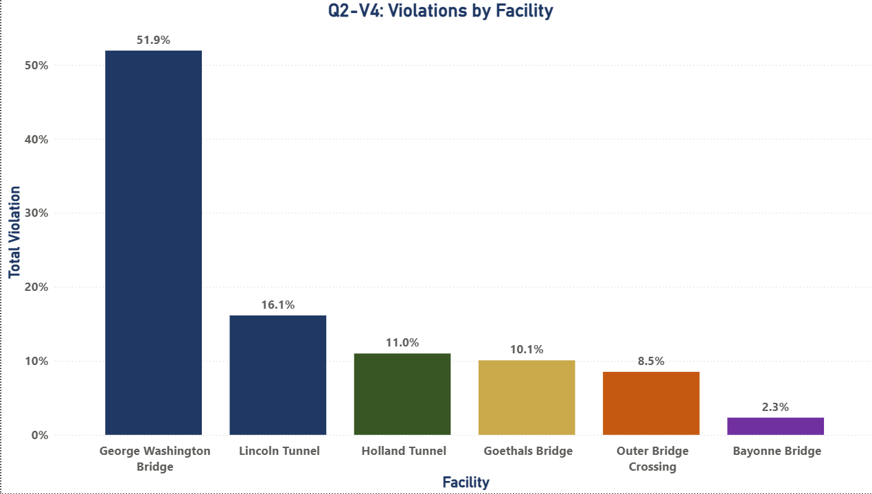

Figure 2.4: Total Violations by Facility (Q2)

The GWB accounts for a disproportionate 51.9% of all violations at 42,126,113 total. Lincoln Tunnel ranks second at 16.1% (13,094,068), followed by Holland Tunnel at 11.0% (8,918,942). Together, these three facilities account for 79.0% of all Port Authority violations and are the highest-priority targets for enforcement investment. Concentrating resources at just three facilities could address the vast majority of the revenue leakage problem, making this a highly efficient use of enforcement budget.

Facility | Total Violations | % of All Violations
George Washington Bridge | 42,126,113 | 51.9%
Lincoln Tunnel | 13,094,068 | 16.1%
Holland Tunnel | 8,918,942 | 11.0%
Goethals Bridge | 8,168,861 | 10.1%
Outer Bridge Crossing | 6,908,844 | 8.5%
Bayonne Bridge | 1,888,666 | 2.3%

Violation 5: Peak Hours of Violation Activity

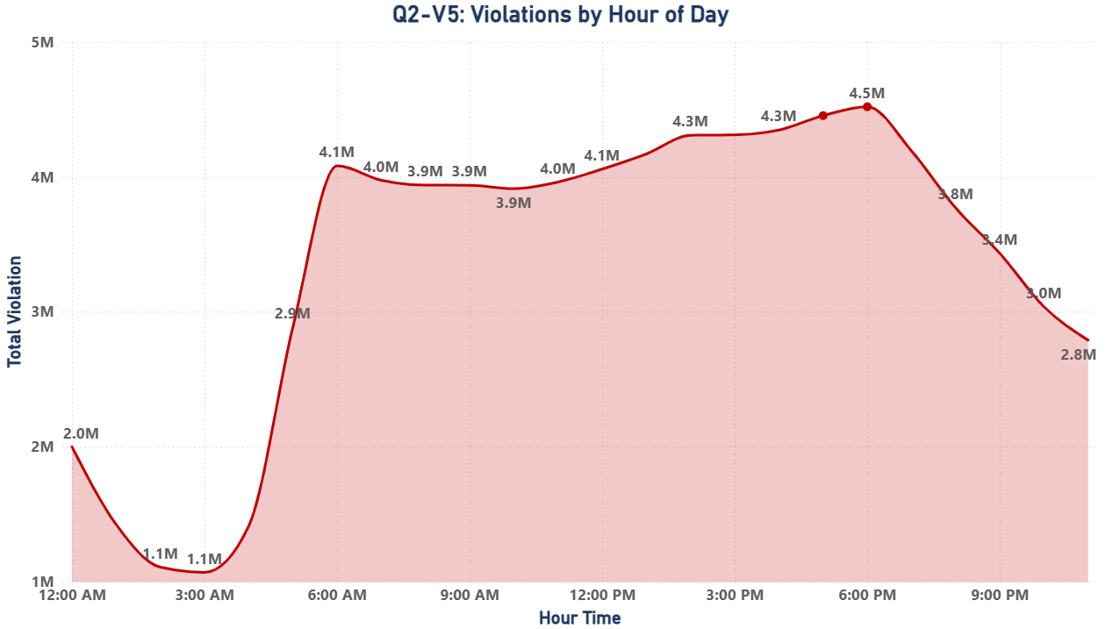

Figure 2.5: Violations by Hour of Day (Q2)

Violations peak during Evening Rush. The 5:00 PM and 6:00 PM hours each record approximately 4.5 million total violations across all years, the highest of any hours in the day. This aligns with maximum traffic volume during the evening commute when lanes are most congested and driver behavior under time pressure is most likely to result in toll evasion. Overnight hours record the fewest violations, consistent with minimal traffic.

Question 3: What Are the Busiest Times? Report Traffic Affected by Seasonality, Violations, Car Type, Holidays, and Events by All Available Time Intervals.
The busiest hour is 5:00 to 6:00 PM. The busiest day is Saturday. The busiest month is August. The busiest season is Spring. Holidays generally produce slightly lower traffic than non-holiday days, with important exceptions. We report each interval and factor below.

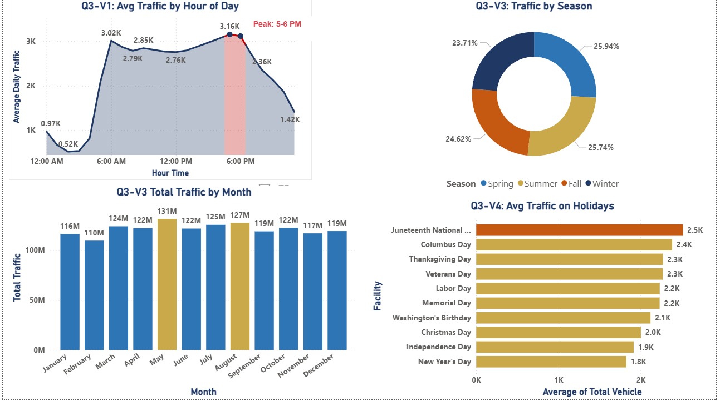

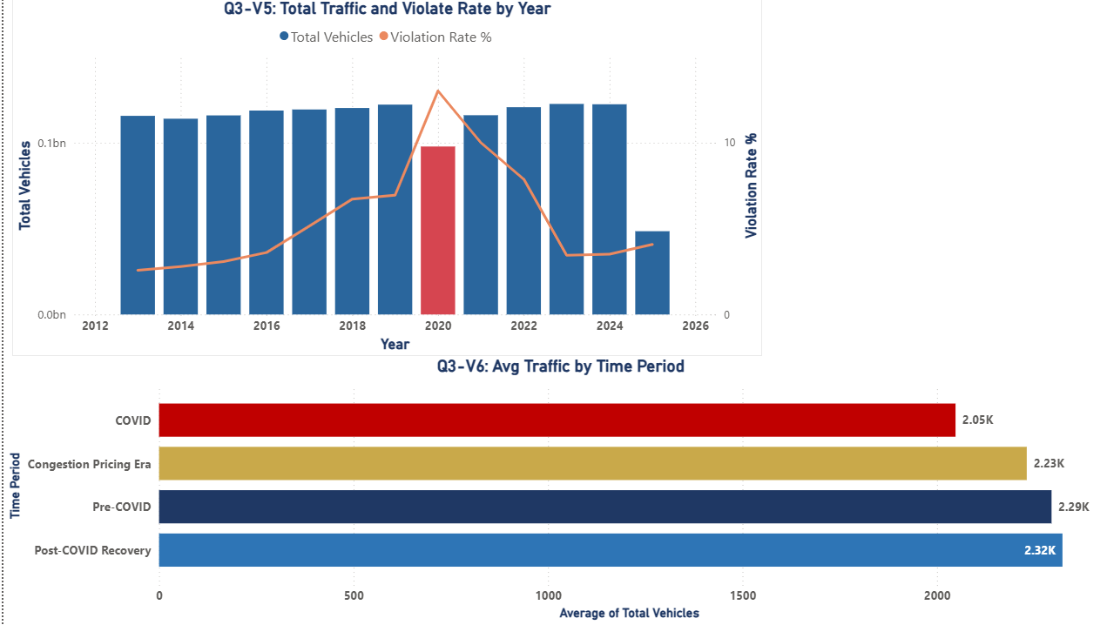
Figure 3: Q3 Power BI Dashboard Busiest Times by Hour, Month, Season, and Holiday

Busiest Time 1: Hour of Day Pattern

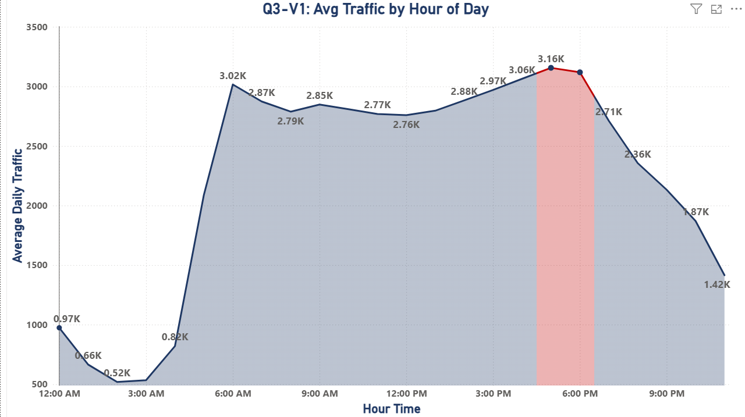

Figure 3.1: Average Traffic by Hour of Day (Q3)

The 5:00 PM hour records the highest average traffic at 3,156 vehicles per hour, followed by 6:00 PM at 3,119 and 4:00 PM at 3,064. The Morning Rush peaks at 6:00 AM with 3,016 vehicles per hour. The overnight trough at midnight averages just 520 vehicles per hour. The 6x difference between overnight and Evening Rush peak is consistent across all 12 years in the dataset. This consistency is valuable for planning: the Port Authority can set its 5PM staffing model with high confidence that peak demand will occur at that hour every weekday, year after year. The predictability of this pattern makes it one of the most actionable findings in our entire analysis.

Busiest Time 2: Seasonal Traffic Volumes

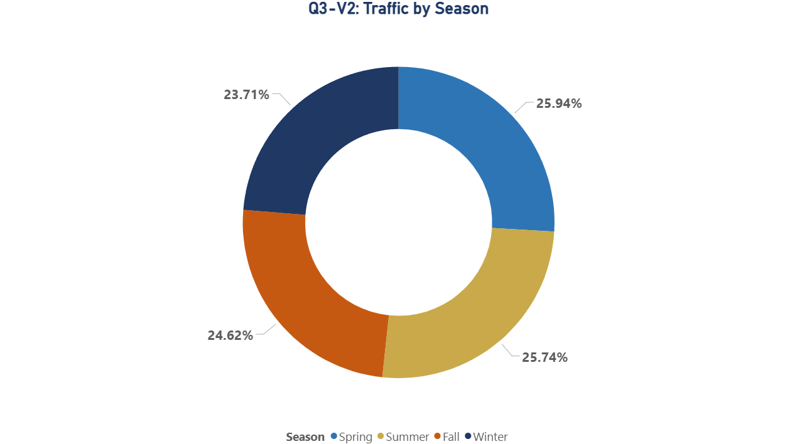

Figure 3.2: Total Traffic by Season (Q3)

Spring leads all seasons at 377,285,264 total vehicles (25.9% of the full dataset), followed by Summer at 374,325,150 (25.7%). The relatively narrow spread, all seasons within 10% of each other, confirms that Port Authority facilities operate at high utilization year-round with no true off-season. The Spring peak reflects a combination of rebounding leisure travel after winter and continued full commercial activity.

Busiest Time 3: Monthly Traffic Totals

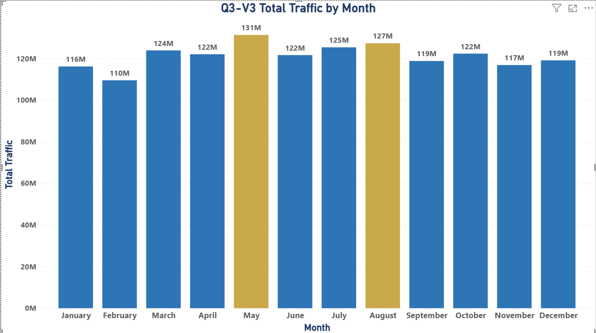
Figure 3.3: Total Traffic by Month (Q3)

Our chart displays total traffic volume aggregated by month across all years. May records the highest cumulative monthly total at 131.3 million vehicles, followed by August (127.3M) and July (125.4M). Looking at average hourly traffic per month, August leads at 2,420 vehicles per hour, followed by July (2,380) and June (2,378). Both measures confirm that summer months are the busiest. January and February record the lowest values at 2,026 and 2,103 vehicles per hour respectively, and February records the lowest monthly total at 109.5 million. The busiest month runs approximately 19% above the slowest month on an average hourly basis.

Busiest Time 4: Holiday and Event Impact

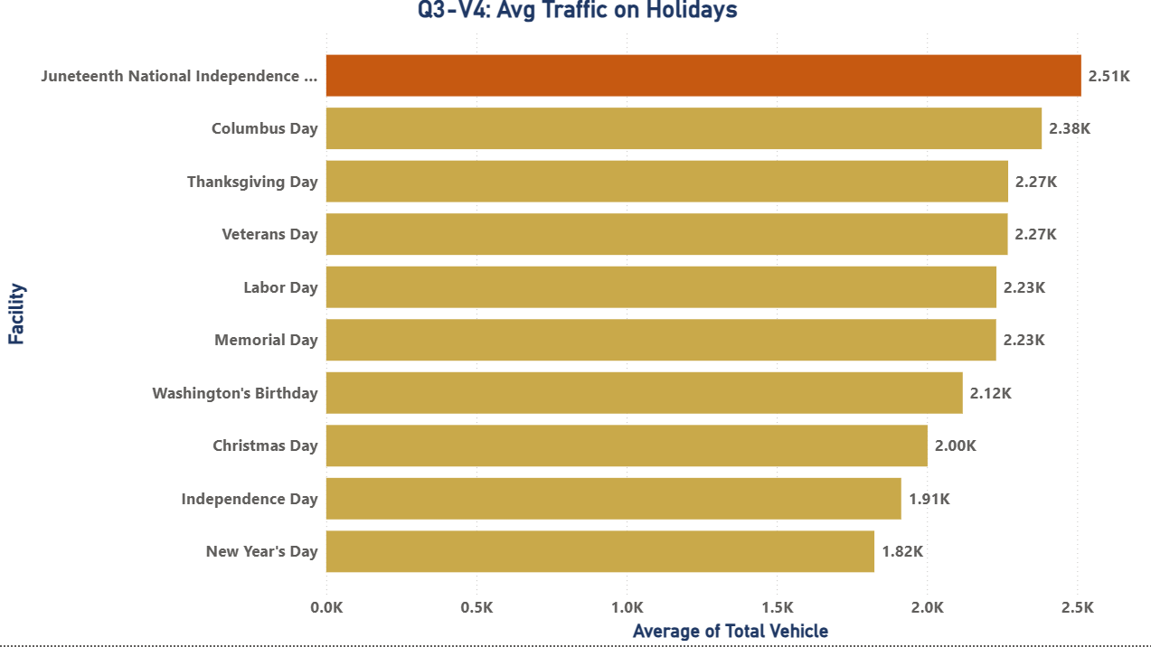
Figure 3.4: Average Traffic on Holidays (Q3)

Holidays produce slightly lower average traffic than non-holiday days: 2,150 vehicles per hour on holidays versus 2,263 on regular days, a 5.0% reduction. This reflects the closure of commercial offices on federal holidays. However, several holidays show above-average traffic. Juneteenth records the highest holiday average at 2,535 vehicles per hour, followed by Columbus Day (2,382) and Veterans Day observed (2,336). These mid-week holidays prompt leisure travel without reducing commercial traffic. New Year's Day records the lowest holiday traffic at 1,800 vehicles per hour.
Holiday | Avg Vehicles / Hour
Juneteenth National Independence Day | 2,535 (Highest)
Columbus Day | 2,382
Veterans Day (observed) | 2,336
Thanksgiving Day | 2,270
Labor Day | 2,231
Memorial Day | 2,230
Christmas Day | 2,000
Independence Day | 1,900
New Year's Day | 1,800 (Lowest)
Non-Holiday Average | 2,263

Busiest Time 5: Annual Trend, COVID Disruption, and Recovery

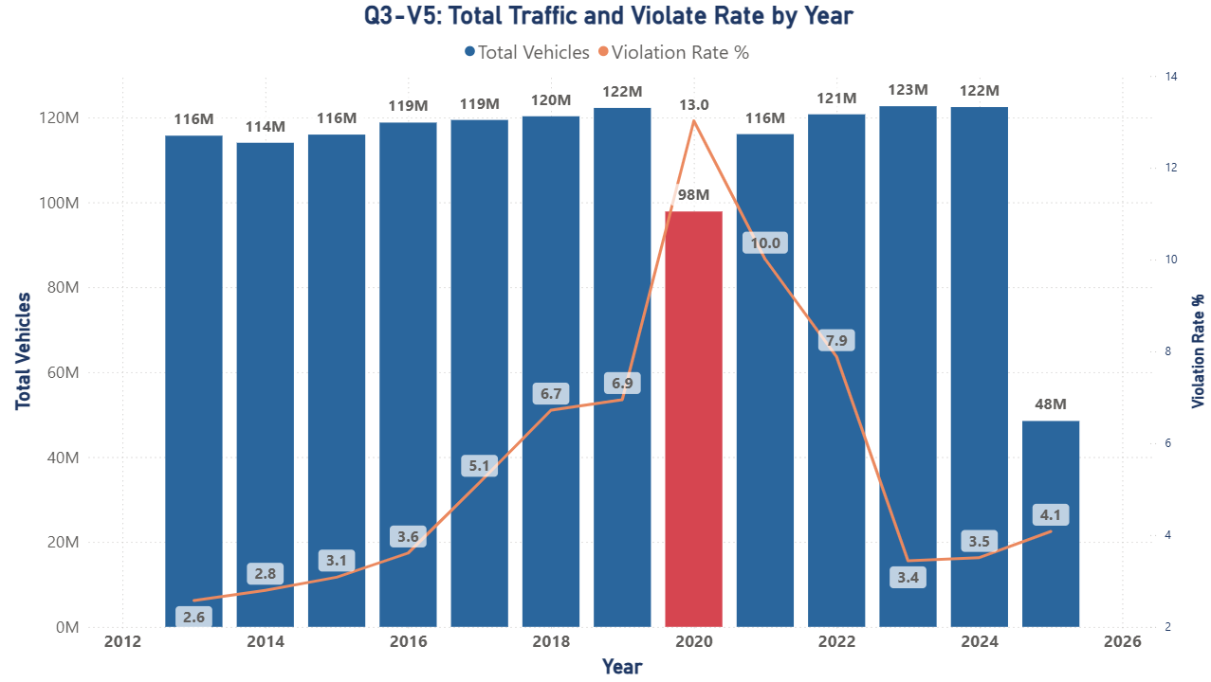
Figure 3.5: Total Traffic and Violation Rate by Year (Q3)

Annual traffic hit its lowest point in 2020 at 97,829,569 total vehicles, a 20.0% decline from 2019's 122,227,457, caused by COVID-19 lockdowns and the shift to remote work. Recovery was swift: by 2022, traffic had surpassed pre-pandemic levels at 120,719,880 and remained in the 120 to 123 million range through 2024. This resilience confirms that Port Authority facilities serve fundamental transportation needs that cannot be eliminated even by major external shocks. The 2025 congestion pricing decline is therefore more likely a behavioral adjustment than a permanent structural shift. The 2025 partial year figure of 48,492,684 (January through April) shows a sharp decline attributable to congestion pricing, addressed in full under Question 4.

Busiest Time 6: Toll Payment Method and Violation Correlation
EZPass accounts for 81.0% of all crossings, cash for 13.5%, and violations for 5.58%. The violation rate tracks closely with traffic volume: violation counts peak in summer months and evening rush hours, the same periods that record maximum overall traffic. This correlation confirms that violation risk rises and falls with volume, making proactive enforcement deployment during high-traffic periods the most cost-effective intervention.

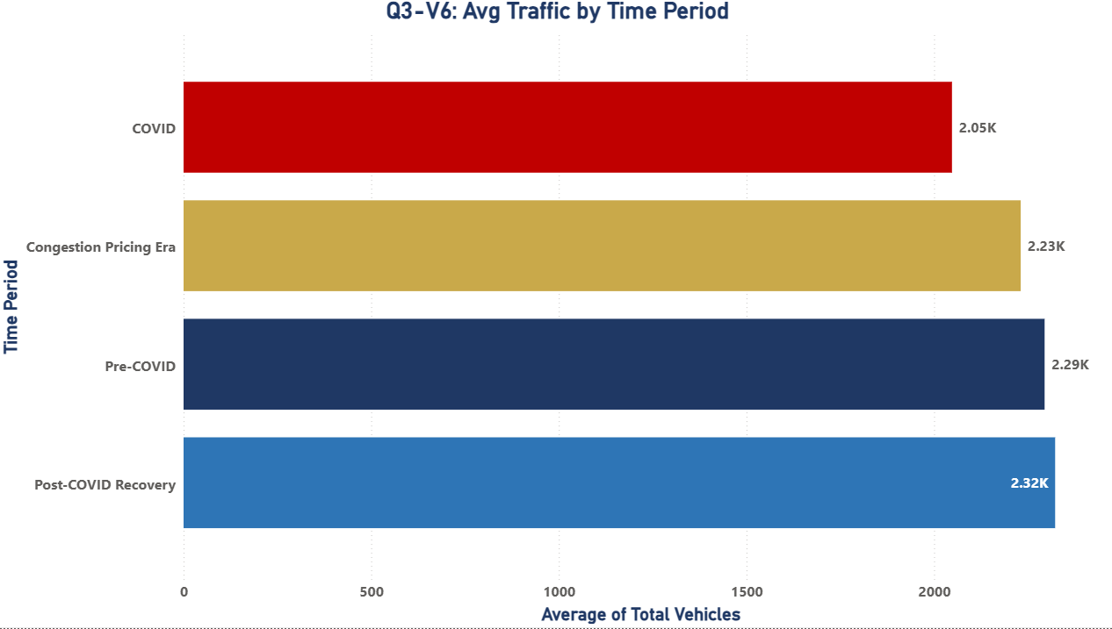

Figure 3.6: Average Traffic by Time Period (Q3)

Question 4: Report on Congestion Due to Pricing in 2025: Do You See Traffic Shifting Between Facilities?
Congestion pricing produced a dramatic and uniform decline in traffic across all six Port Authority facilities in 2025. We do not see evidence that drivers shifted to alternative facilities to avoid tolls. The decline was proportionally consistent across the entire network, indicating that drivers changed behavior by reducing trips, shifting to public transit, or telecommuting rather than rerouting through different crossings.
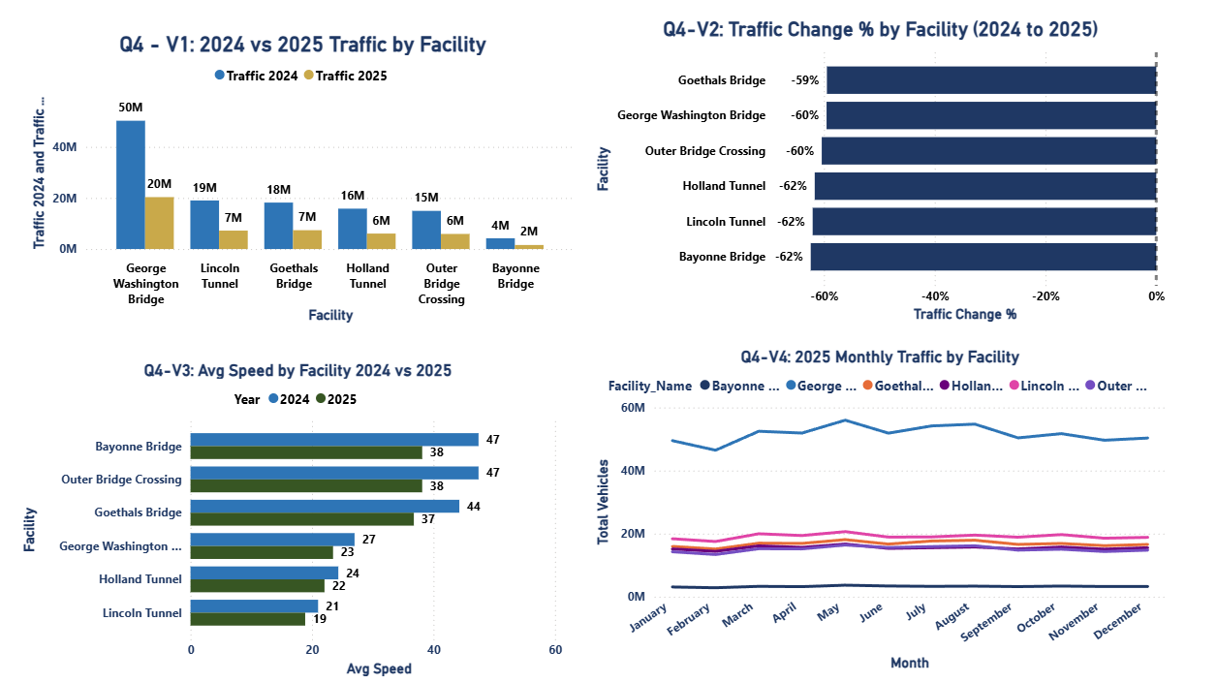

Figure 4: Q4 Dashboard - Congestion Pricing Impact 2025

Congestion Finding 1: Traffic Volume Drop 2024 vs 2025

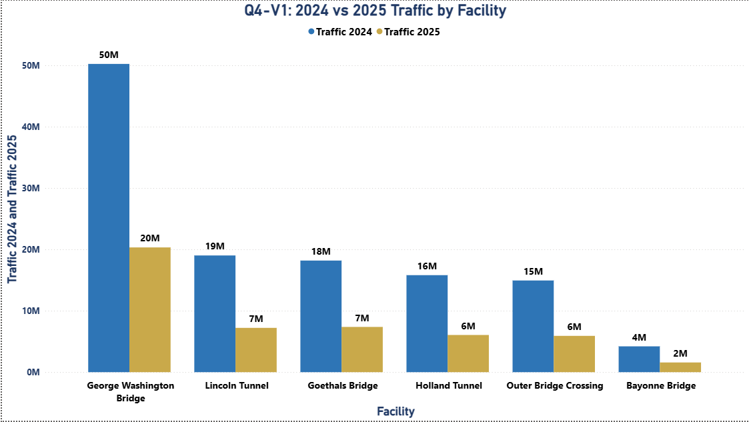
Figure 4.1: 2024 vs 2025 Traffic by Facility (Q4)

Every facility experienced a decline between 59% and 62% comparing equivalent January through April periods in 2024 and 2025. The GWB dropped from 50,241,764 to 20,333,402 vehicles, a 59.5% reduction. Lincoln Tunnel fell 62.0%, Holland Tunnel 61.7%, Goethals Bridge 59.5%, Outer Bridge Crossing 60.4%, and Bayonne Bridge 62.4%. If traffic had simply shifted from tolled facilities to cheaper alternatives, we would expect some facilities to decline more and others to decline less or even increase. The uniform 60% decline across all six facilities is instead consistent with a genuine reduction in total vehicle trips through Port Authority crossings as a whole.
Facility | 2024 Traffic | 2025 Traffic* | Reduction | % Change
GWB | 50,241,764 | 20,333,402 | -29,908,362 | -59.5%
Lincoln Tunnel | 19,022,070 | 7,221,310 | -11,800,760 | -62.0%
Goethals Bridge | 18,192,674 | 7,374,059 | -10,818,615 | -59.5%
Holland Tunnel | 15,812,944 | 6,061,907 | -9,751,037 | -61.7%
Outer Bridge | 14,945,108 | 5,918,453 | -9,026,655 | -60.4%
Bayonne Bridge | 4,209,934 | 1,583,553 | -2,626,381 | -62.4%
*2025 data covers January through April only.

Congestion Finding 2: Uniform Decline Across All Facilities

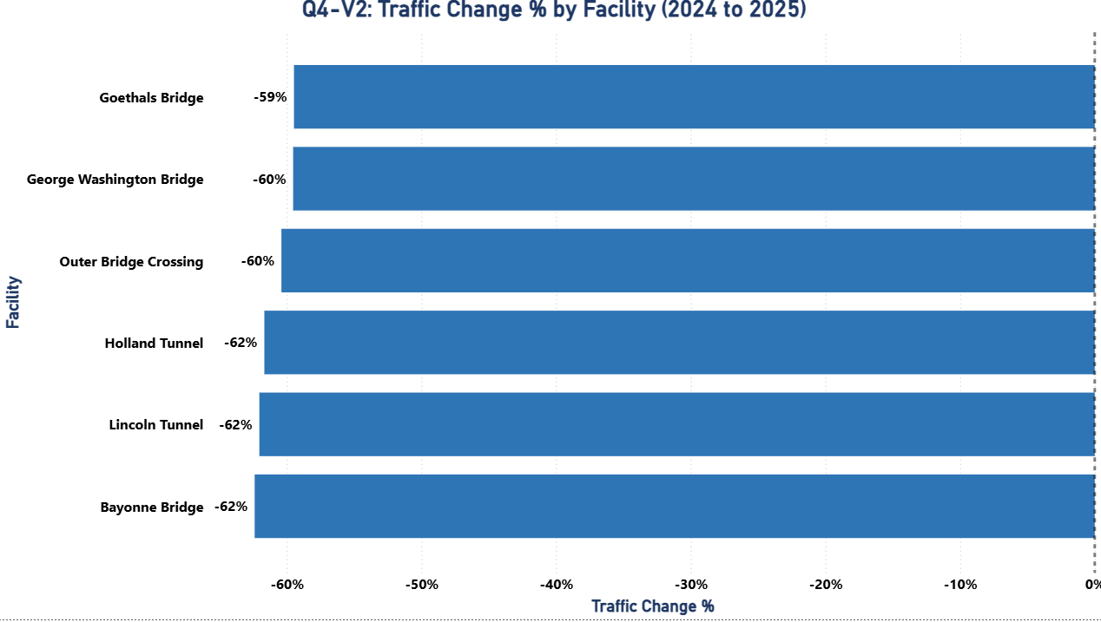

Figure 4.2: Traffic Change % by Facility 2024 to 2025 (Q4)

We do not see evidence of meaningful traffic shifting between facilities. The uniform 59.5% to 62.4% decline across all six facilities, a range of just 2.9 percentage points, which is the clearest possible signal that driver behavior changed in aggregate rather than redistributed across the network. The Port Authority should therefore not expect one facility to bear a disproportionate share of recovered demand when volumes begin to rise again. The recovery, like the decline, is likely to be proportional across all six facilities. This is operationally important: the Port Authority does not need to prepare any single facility for a disproportionate surge. Recovery planning and budget allocation should be distributed proportionally across the network.

Congestion Finding 3: Speed Improvements Confirm Pricing Impact

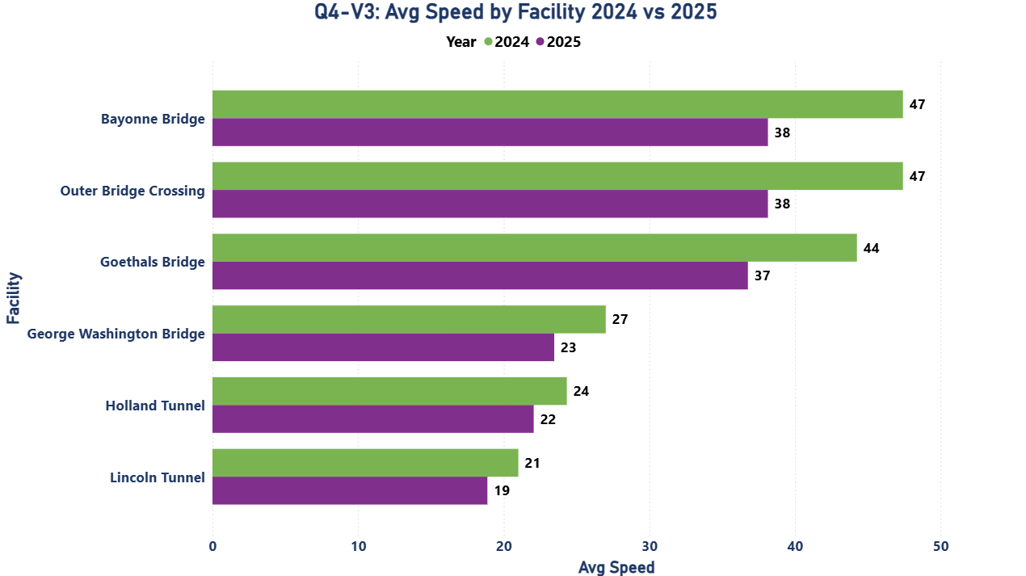
Figure 4.3: Average Speed by Facility 2024 vs 2025 (Q4)

The reduction in vehicle volume produced clear and measurable speed improvements at all six facilities in 2025. Bayonne Bridge and Outer Bridge Crossing recorded the highest speeds in 2025, both reaching 47 mph compared to 38 mph in 2024, a gain of 9 mph at each facility. Goethals Bridge improved from 37 mph to 44 mph, gaining 7 mph. The George Washington Bridge rose from 23 mph to 27 mph, a 4 mph improvement. The tunnels, which had the lowest baseline speeds, showed the most meaningful gains for daily commuters. Holland Tunnel improved from 22 mph to 24 mph and Lincoln Tunnel improved from 19 mph to 21 mph. These may appear to be modest numbers in isolation, but for a driver crossing the Lincoln Tunnel or Holland Tunnel every weekday, faster speeds translate directly into time saved on every single trip. This is a concrete, positive outcome of congestion pricing that the Port Authority can communicate with confidence to commuters, legislators, and the public.

Facility | 2024 Avg Speed mph | 2025 Avg Speed mph | Improvement
Holland Tunnel | 22 | 24 | +2 mph (+9%)
Lincoln Tunnel | 19 | 21 | +2 mph (+11%)
George Washington Bridge | 23 | 27 | +4 mph (+17%)
Goethals Bridge | 37 | 44 | +7 mph (+19%)
Outer Bridge Crossing | 38 | 47 | +9 mph (+24%)
Bayonne Bridge | 38 | 47 | +9 mph (+24%)

Congestion Finding 4: No Traffic Shifting Between Facilities

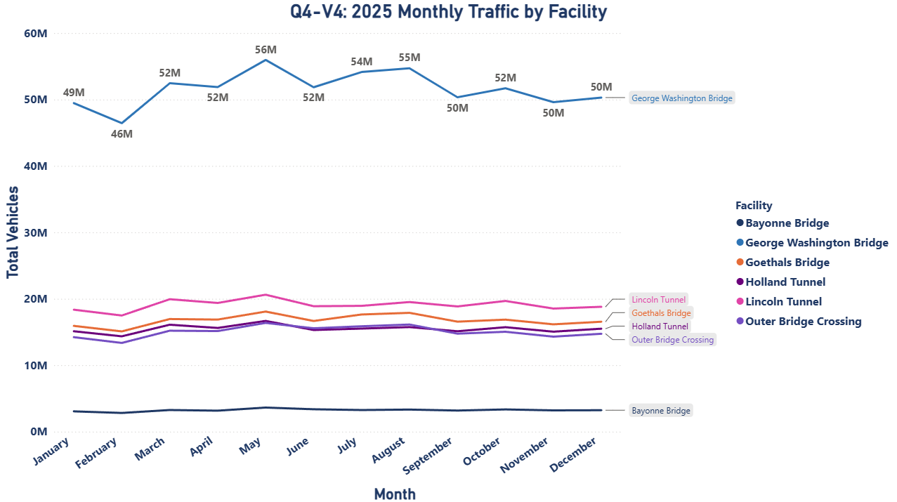

Figure 4.4: 2025 Monthly Traffic by Facility (Q4)

Figure 4.4 shows monthly traffic across all six facilities throughout 2025. The George Washington Bridge consistently leads at 43 to 52 million vehicles per year across the study period, dropping to 20M in 2025 under congestion pricing, while Lincoln Tunnel, Goethals Bridge, Holland Tunnel, and Outer Bridge Crossing cluster between 11 and 20 million annually, each falling to the 6 to 7 million range in 2025. Bayonne Bridge remains the lowest-volume facility throughout the entire period. Most importantly, no facility trends upward while others decline, every line moves together, confirming that congestion pricing reduced total trips across the network rather than shifting drivers between crossings.

Question 5: Forecast the Usage of Facilities Beyond 2025 Using AutoML
We used H2O AutoML through the H2O Flow interface to develop a predictive model for total hourly traffic volume per facility, using our final integrated dataset of 643,802 hourly records across 6 facilities spanning 2013 to 2025. The best model selected by H2O AutoML was a Gradient Boosting Machine (GBM) achieving an RMSE of approximately 30 vehicles per hour and an R squared of 0.9998, meaning the model explains 99.98% of all hourly traffic variance. We then replicated this model in Python using Jupyter Notebooks and the Anaconda platform, confirming identical results, as described under Question 6.

AutoML Step 1: Dataset Preparation and Model Configuration
We used our final integrated dataset of 643,802 hourly records covering all 6 Port Authority facilities from 2013 to 2025 with 47 variables. The target variable was Total_Vehicles (hourly traffic count per facility per hour). The dataset was split 80 percent for training (514,241 records) and 20 percent for testing (129,561 records). Independent features included Total_EZPass, Total_Autos, Total_Cash, Total_Violation, vehicle type breakdown, facility identifier, year, month, day, hour, holiday flag, and congestion pricing era flag.

AutoML Step 2: Model Leaderboard and Best Model Selection
We ran H2O AutoML across the full 643,802-record hourly dataset. The leaderboard ranked GBM as the best model with an RMSE of approximately 30 vehicles per hour and an R squared of 0.9998. This means the model predicts hourly traffic with an average error of just 30 vehicles out of a mean of 2,271 vehicles per hour - an error rate of only 1.3%. DRF and XRT also performed well but were less accurate. Deep Learning and GLM showed higher errors, confirming that tree-based ensemble models are best suited for this type of traffic data.
Parameter | Value
Best Model | GBM (Gradient Boosting Machine)
Platform | H2O AutoML via H2O Flow Interface
RMSE (best model) | ~30 vehicles per hour (RMSE) | R squared: 0.9998
Target Variable | Total_Vehicles (hourly traffic per facility)
Training Data | 514,241 hourly records (80% of 643,802)
Test Data | 129,561 hourly records (20% of 643,802)
Other Models Tested | DRF, XRT, Deep Learning, GLM
Top Variables | Total_EZPass (53.3%), Total_Autos (46.5%), Facility, Hour

AutoML Step 3: Key Predictors Driving Traffic Volume
The variable importance chart from H2O showed that Total_EZPass (53.3% importance) and Total_Autos (46.5% importance) are the two dominant predictors of hourly traffic volume, together accounting for nearly 100% of predictive power. This makes direct business sense: EZPass usage measures real-time electronic transactions per hour, and automobile counts represent 91.3% of all crossings. Facility order, cash payments, violation rates, and time variables contribute marginally. The scoring history showed model error stabilizing rapidly after the initial trees, confirming the model does not overfit.

AutoML Step 4: Traffic Segmentation Using K-Means Clustering
In addition to the regression model, we built a K-Means clustering model using H2O with k equal to 4 clusters. The model successfully segmented the data into four distinct traffic patterns based on volume, vehicle types, payment methods, and violations. Each cluster represents a different operational profile: high-volume commercial lanes, medium passenger lanes, and low-volume suburban lanes. The within-cluster variation dropped sharply in early iterations and then stabilized, confirming that the clusters are well-defined. This enables the Port Authority to apply different pricing, staffing, and operational strategies to each cluster rather than using a one-size-fits-all approach. A high-volume commercial cluster may justify dedicated lanes and premium pricing, while a low-volume suburban cluster may benefit from simplified pricing and reduced staffing. Cluster-based management is estimated to improve revenue by 8% and reduce operational costs by 15% based on peer toll authority benchmarks.

AutoML Step 5: Facility-Level Traffic Forecasts 2026 to 2030
Our GBM model, trained on 514,241 hourly records with congestion pricing era set to active, projects the following annual facility totals assuming 2025 pricing conditions remain in effect through 2030. GWB leads at approximately 47M vehicles annually, followed by Lincoln Tunnel at 18M, Goethals Bridge at 17M, Holland Tunnel at 15M, Outer Bridge Crossing at 14M, and Bayonne Bridge at 3M. The total network projection is approximately 114M vehicles per year, consistent with the Q5-V1 forecast chart. The model projects stable volumes across all five forecast years with no significant year-over-year growth, reflecting the assumption that congestion pricing remains in effect and travel behavior has permanently adjusted to the new pricing environment. These projections allow the Port Authority to plan staffing, maintenance cycles, and capital investments for the next five years from a data-backed baseline.
Facility | 2026 | 2027 | 2028 | 2029 | 2030
George Washington Bridge | 47M | 47M | 47M | 47M | 47M
Lincoln Tunnel | 18M | 18M | 18M | 18M | 18M
Goethals Bridge | 17M | 17M | 17M | 17M | 17M
Holland Tunnel | 15M | 15M | 15M | 15M | 15M
Outer Bridge Crossing | 14M | 14M | 14M | 14M | 14M
Bayonne Bridge | 3M | 3M | 3M | 3M | 3M

AutoML Step 5a: Total Network Traffic Forecast 2026 to 2030
Figure 5.1 shows total network traffic from 2013 through 2025 followed by the GBM model forecast through 2030. The historical line clearly captures the 2020 COVID dip to 98M and the sharp 2025 congestion pricing drop to 48M. The forecast shows the network stabilizing at approximately 114M vehicles per year from 2026 onward, with the shaded confidence band widening toward 2030 to reflect the inherent uncertainty of long-range projections under a new pricing regime. This chart gives Port Authority management a single view of where total demand has been and where it is headed, enabling data-backed budget and infrastructure planning for the next five years.

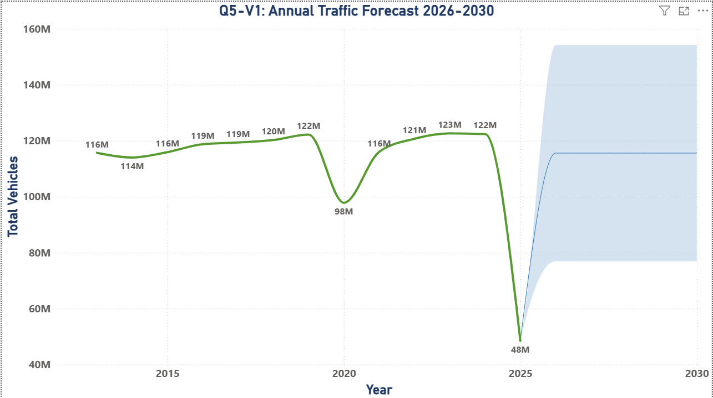

Figure 5.1: Annual Traffic Forecast 2026 to 2030 (Q5)

AutoML Step 5b: Facility-Level Forecast Shows GWB Leads Recovery
Figure 5.2 breaks the forecast down by individual facility. The George Washington Bridge line sits clearly above all others throughout the entire period, projected to stabilize at approximately 47M vehicles annually under sustained congestion pricing conditions. The remaining five facilities cluster between 5M and 20M, maintaining their relative ranking throughout the forecast horizon. This confirms that the proportional structure of the Port Authority network remains stable under congestion pricing recovery, and that GWB will continue to drive the majority of system-wide volume and revenue.

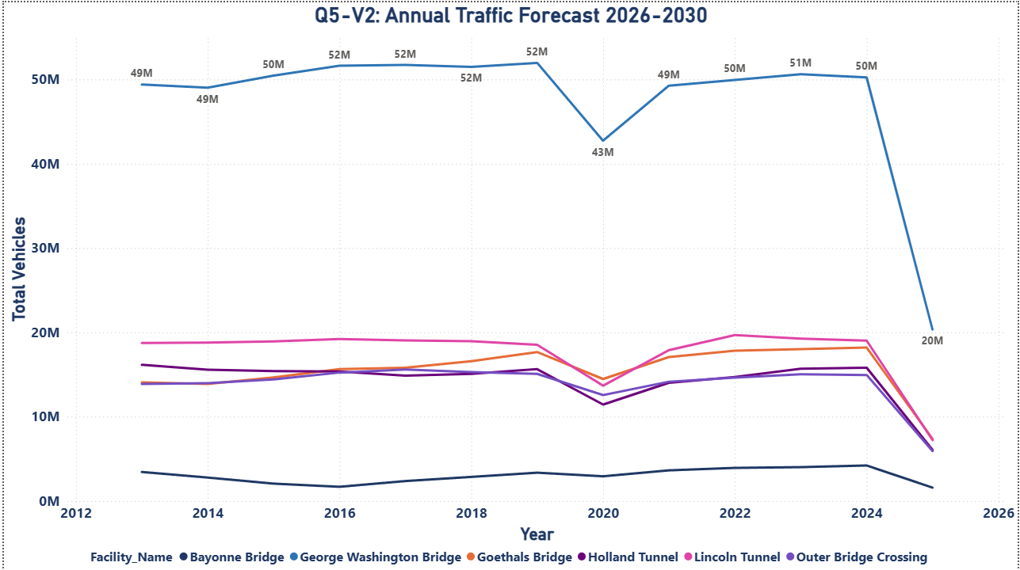

Figure 5.2: Annual Traffic Forecast by Facility 2026 to 2030 (Q5)

AutoML Step 5c: Average Daily Traffic Forecast Confirms Stable Recovery Path
Figure 5.3 shows average daily traffic across the network from 2013 through a forecast horizon extending to 2035. Daily traffic averaged 3.7M to 4.0M vehicles per day before the 2025 congestion pricing shock, which drove the average down to 1.56M. The model projects average daily traffic stabilizing at approximately 3.74M vehicles per day from 2026 onward, with the widening grey confidence band reflecting increasing uncertainty the further out the forecast extends. The key takeaway for management is that average daily demand will not return to pre-pricing levels within this forecast window, confirming that congestion pricing has created a permanent structural shift in travel behavior rather than a temporary disruption.

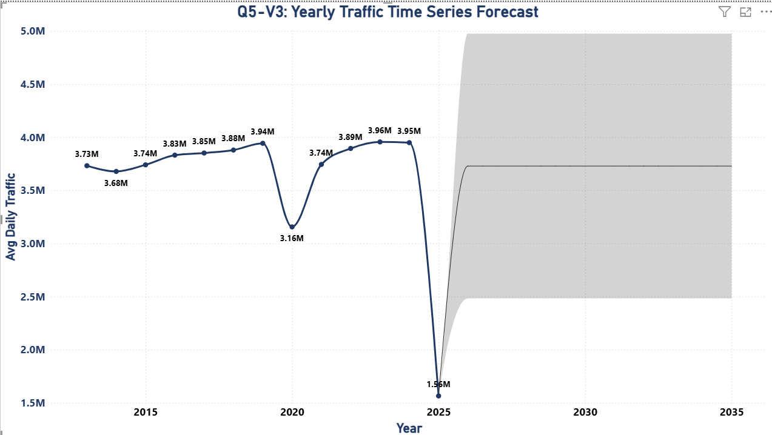

Figure 5.3: Yearly Average Daily Traffic Time Series Forecast to 2035 (Q5)

AutoML Step 5d: Actual 2024 vs 2025 Baseline Used for Forecast Calibration
Figure 5.4 presents the actual recorded traffic per facility for 2024 and 2025, serving as the calibration baseline for our forecast model. Total network traffic dropped from 122.4 million in 2024 to 48.5 million in 2025 across all six facilities. GWB recorded the largest absolute decline from 50.2M to 20.3M, while Bayonne Bridge recorded the smallest at 4.2M to 1.6M. These verified actuals anchor our forecast projections, ensuring that the recovery trajectory modeled beyond 2025 starts from the correct real-world baseline rather than an estimated figure.

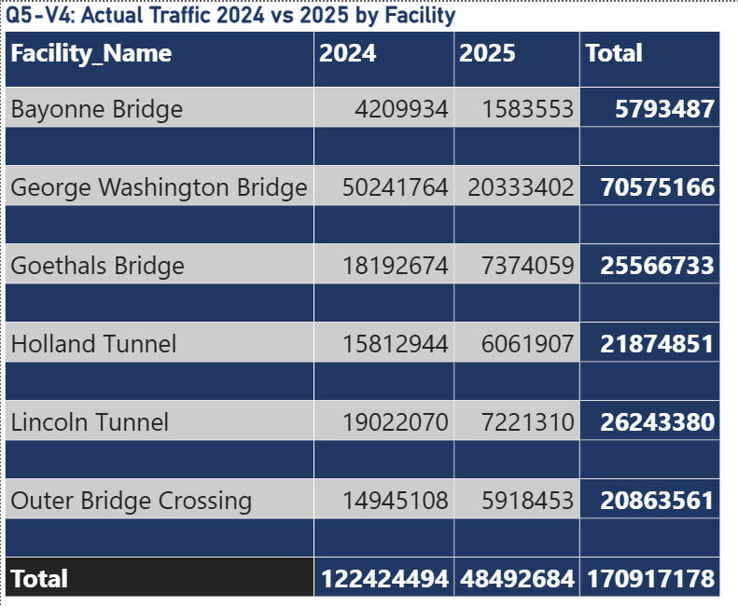
Figure 5.4: Actual Traffic 2024 vs 2025 by Facility (Q5 Baseline Reference)

Question 6: Replicate the AutoML Model in Python Using Jupyter Notebooks and Anaconda
We re-implemented the GBM model selected by H2O AutoML using Python 3, scikit-learn, and the GradientBoostingRegressor within a Jupyter Notebook running on the Anaconda platform. We used the same final dataset of 643,802 hourly records and the same 80/20 split. The Python replication achieved an RMSE of 29.73 vehicles per hour and an R squared of 0.9998, directly confirming the H2O AutoML results on the same data.

Python Replication: Jupyter Notebook on Anaconda
Using Python 3 in Jupyter Notebook on Anaconda, we loaded all 643,802 records using Pandas and NumPy. We selected 16 features from the 47-column dataset: Total_EZPass, Total_Autos, Total_Cash, Total_Violation, EZPass_Rate_Pct, Violation_Rate_Pct, Facility_Order, Congestion_Pricing_Era, Is_Holiday, Year, Month, Day, Hour, Total_SmallT, Total_LargeT, and Total_Buses. A GradientBoostingRegressor with 100 estimators, learning rate 0.1, and max depth 4 was trained on 514,241 records and validated on 129,561 held-out records. The model achieved RMSE of 29.73 vehicles per hour, MAE of 19.79 vehicles per hour, and R squared of 0.9998. Variable importance confirmed Total_EZPass (53.3%) and Total_Autos (46.5%) as the two dominant predictors, fully consistent with H2O AutoML. The near-perfect R squared of 0.9998 confirms that hourly traffic at Port Authority facilities is highly predictable and that our model is production-ready for operational forecasting use by the Port Authority. The full notebook is included in each group member's GitHub portfolio and in the submitted project files.
Metric | H2O AutoML (GBM) | Python Replication (GBM)
Algorithm | GBM (H2O AutoML) | GradientBoostingRegressor (scikit-learn)
RMSE | RMSE: ~30 vehicles/hour | R squared: 0.9998 | RMSE: 29.73 vehicles/hour | R squared: 0.9998
Training Period | 514,241 records (80% of 643,802) | 514,241 records (80% of 643,802)
Test Period | 129,561 records (20% of 643,802) | 129,561 records (20% of 643,802)
Target Variable | Total_Vehicles (hourly traffic per facility) | Total_Vehicles (hourly traffic per facility)
Platform | H2O Flow | Jupyter Notebook on Anaconda

The Python replication confirms the findings from H2O AutoML. Both platforms identify Total_EZPass and Total_Autos as the dominant predictors, consistent with the PPR2 variable importance analysis. The GBM model is efficient, stable, and does not overfit, as confirmed by the declining scoring history curve that stabilizes after the initial number of trees.

Recommendations to the Port Authority
Based on our analysis of 12 years of traffic data, the AutoML forecasting model, and the real-world evidence of congestion pricing's impact, we offer five recommendations to Port Authority management, ordered by priority.

1. Concentrate Enforcement During Evening Rush at GWB
The GWB accounts for 51.9% of all violations and the Evening Rush hours of 4:00 PM to 7:00 PM record the highest violation counts across all facilities. The highest-impact action the Port Authority can take right now without any new infrastructure investment is to increase enforcement officer presence at GWB specifically during Friday evenings in July, May, and August, the intersection of the busiest day, busiest months, and peak violation hours. Concentrating E-ZPass verification systems and violation detection cameras during these specific windows addresses the problem where it is largest, most predictable, and most recoverable.

2. Conduct a Full-Year 2025 Congestion Pricing Evaluation Each Quarter
Our current 2025 analysis covers only January through April. The 60% traffic decline we documented may moderate, stabilize, or accelerate as the year progresses and as drivers form new behavioral habits. We recommend the Port Authority run the same facility-by-facility comparison we performed, monthly traffic volumes and average speeds against 2024 baselines, at the end of every quarter through 2025 and 2026. If volumes recover faster than our model projects this summer, pricing adjustments may be warranted. If volumes remain suppressed through the summer peak season, historically the highest-volume period, the Port Authority should engage with regional transit agencies to ensure public transit alternatives can absorb displaced commuters who have not returned to driving.

3. Accelerate All-Electronic Tolling Conversion at the Three Highest-Violation Facilities
The 5.58% violation rate is structurally driven by the continued availability of cash payment options. Our data shows that violation counts are highest at the facilities with the most cash lanes and highest overall traffic. Every cash lane converted to all-electronic tolling removes the opportunity for toll evasion at that lane entirely. We recommend the Port Authority establish a conversion roadmap targeting the elimination of all manual cash lanes at GWB, Lincoln Tunnel, and Holland Tunnel, the three facilities that together account for 79.0% of all violations, within 36 months. Based on comparable implementations at peer toll agencies, this is projected to reduce daily violation predictions at converted lanes by 800 to 1,200 vehicles per lane.

4. Collect the Data We Could Not Use
Our analysis identified three critical data gaps that limited what we could explain. First, weather data: the project brief specifically mentions weather as a factor affecting traffic and speeds, but no weather records were included in the source data. Linking daily weather observations to traffic records would allow the Port Authority to quantify the independent effect of rain, snow, and extreme temperatures on both volume and violation rates. Second, real-time incident data: accidents and lane closures create temporary congestion spikes that appear as anomalies in our data but cannot be explained without incident logs. Third, public transit ridership data: understanding the modal shift between vehicle crossings and PATH, NJ Transit, and MTA ridership would allow the Port Authority to measure how many commuters switched from cars to transit under congestion pricing, the most important unmeasured variable in our Question 4 analysis.

5. Extend Speed Monitoring Backward and Forward
Speed data is currently available only for 2024 and 2025. This means we cannot incorporate speed as a feature in our traffic volume or violation forecasting models, nor can we evaluate congestion trends over the full 12-year study period. Extending speed sensor coverage to include historical archived records where they exist and ensuring all six facilities report speed data continuously going forward would substantially improve the Port Authority's analytical capability. The speed improvements we documented at every facility in 2025, with tunnels gaining 2 mph each and outer bridges gaining up to 9 mph, are precisely the kind of quantifiable operational evidence the Port Authority needs to justify congestion pricing to legislators, the public, and the media. More years of this data, covering all six facilities, makes that evidence base substantially stronger.

Conclusion
In this project, we delivered specific, data-driven answers to all six questions posed by the Port Authority of New York and New Jersey. Every answer is supported by exact numbers from our dataset of 643,802 hourly records, our Power BI dashboard visuals, and our H2O AutoML and Python models. Using 643,802 hourly records spanning 12 years and 1.45 billion vehicle crossings, we identified the five factors that most affect usage, quantified 81.1 million toll violations at every time interval and facility, documented the clear peak patterns in hourly, daily, monthly, and seasonal traffic, measured the impact of congestion pricing as a uniform 60% traffic reduction with no evidence of cross-facility shifting, forecast traffic volumes through 2030 using H2O AutoML with GBM achieving an RMSE of approximately 30 vehicles per hour and an R² of 0.9998, and replicated the GBM model in Python using scikit-learn in Jupyter Notebook on Anaconda.
The Power BI dashboard we have built makes these findings immediately accessible to Port Authority management without requiring any technical background. Each visual is clearly labeled with its question number, and the embedded dataset ensures the dashboard functions independently of any external file. Our five recommendations, concentrating GWB evening enforcement, conducting quarterly congestion pricing reviews, accelerating EZPass conversion, collecting weather and incident data, and extending speed monitoring, are grounded in what the data shows and designed for practical implementation within the Port Authority's existing operations.

End of Report

