CoGS member guide to the PhD Student Portal

# Logging in

The student portal is available at <https://student-portal.sanger.ac.uk>.

On your first visit you will be presented with a login screen: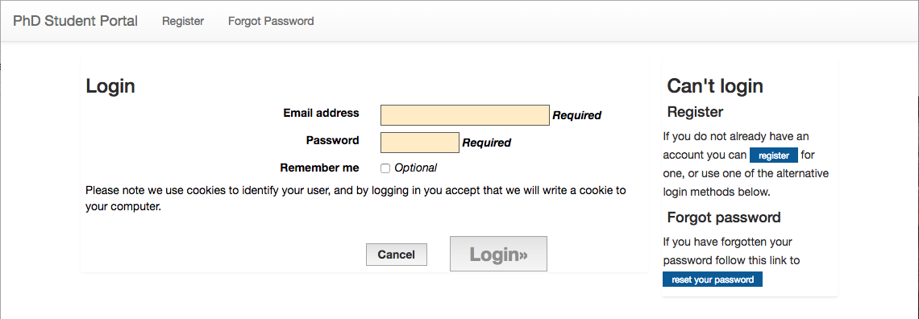

Log in with your @sanger.ac.uk email address and password.

*Now: the Graduate Office creates a new rotation, supervisors create projects, students choose projects, the Graduate Office finalises project choices, and students upload project reports.*

# Marking projects

Click the “Markable Projects” button: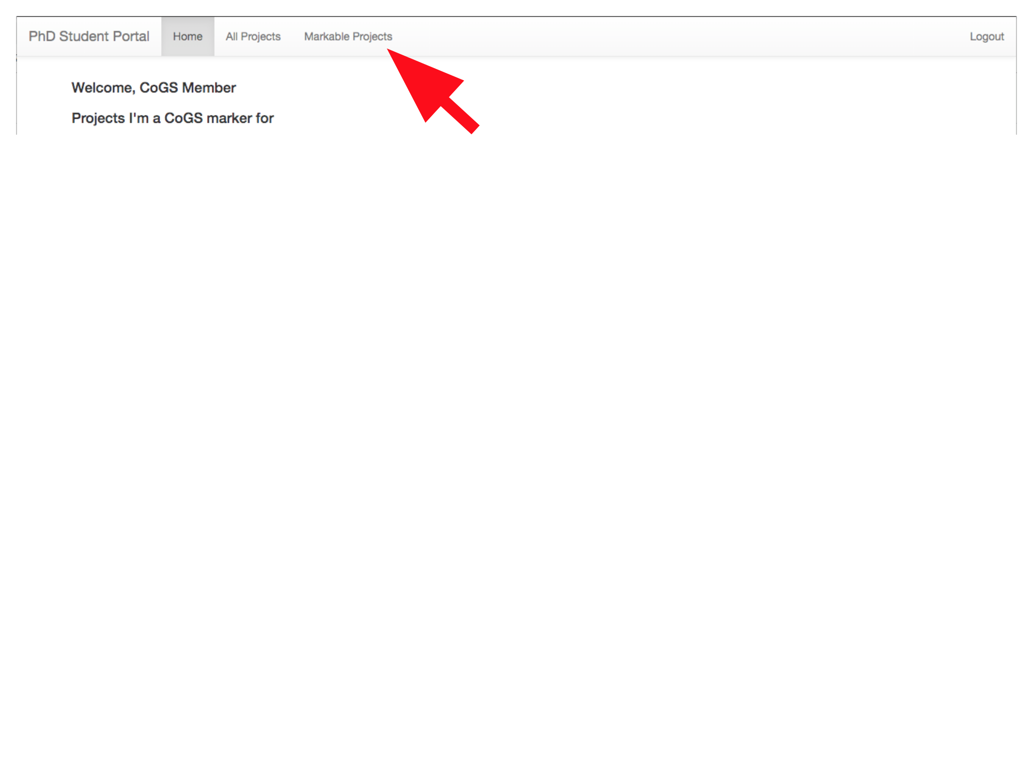

Click the “Provide Feedback” link below the title of the project to be marked: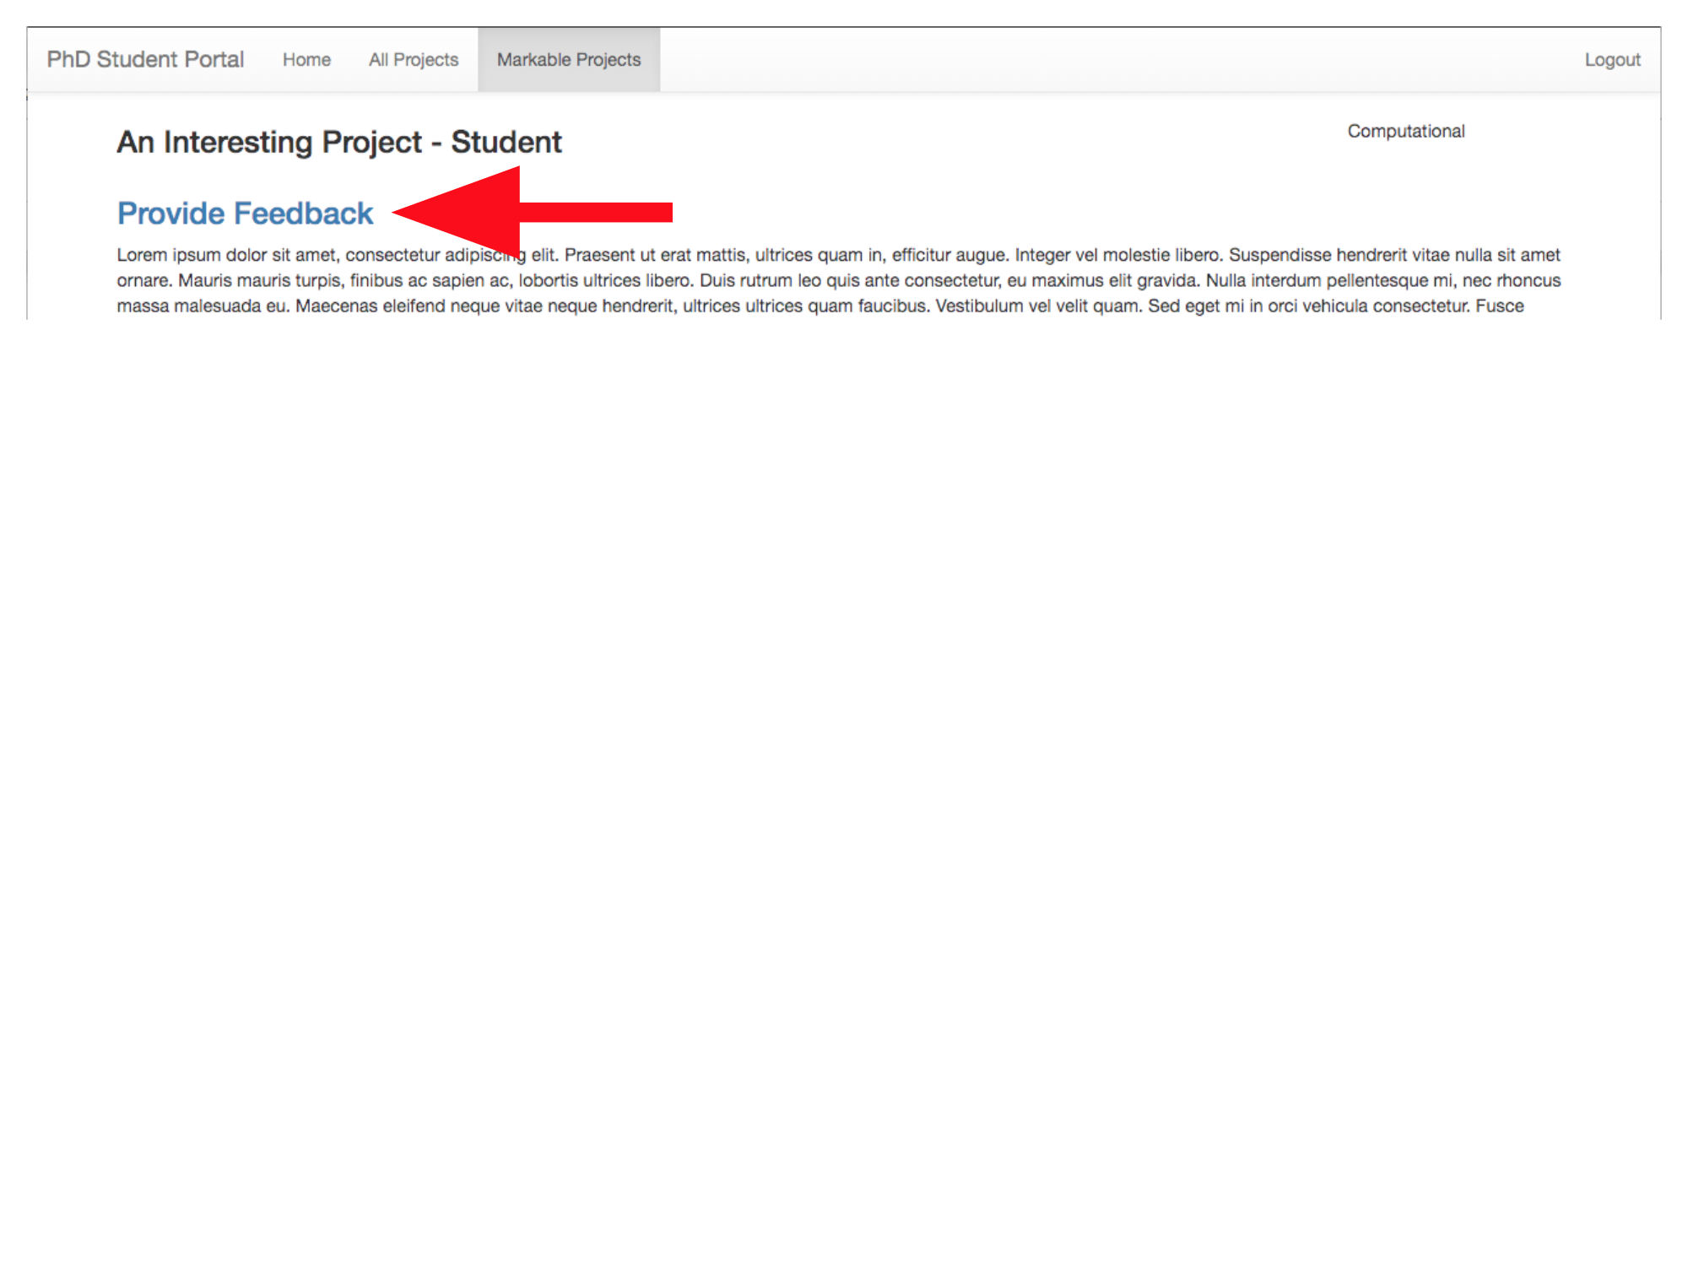

Fill in the feedback form: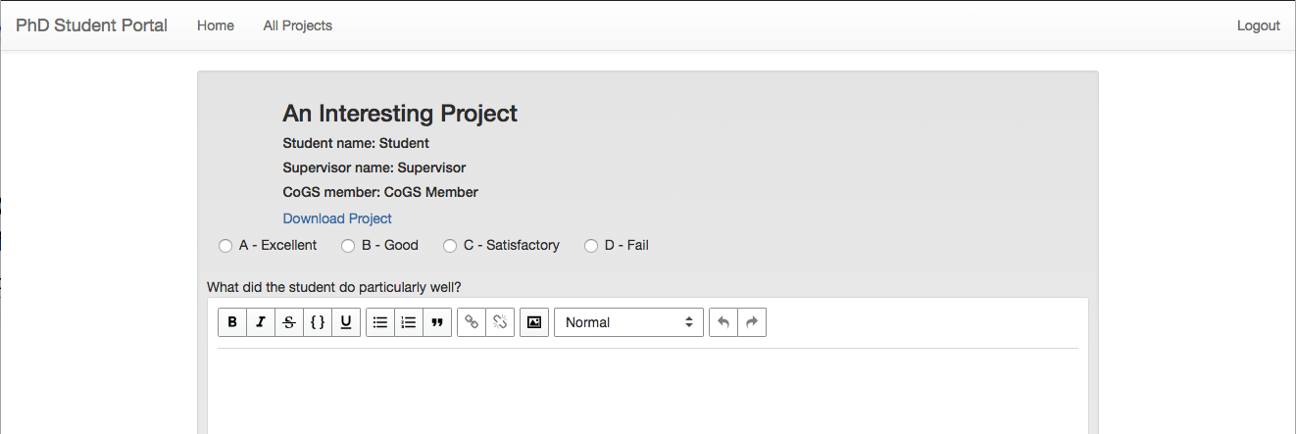

When completed, press the “Send Feedback” button: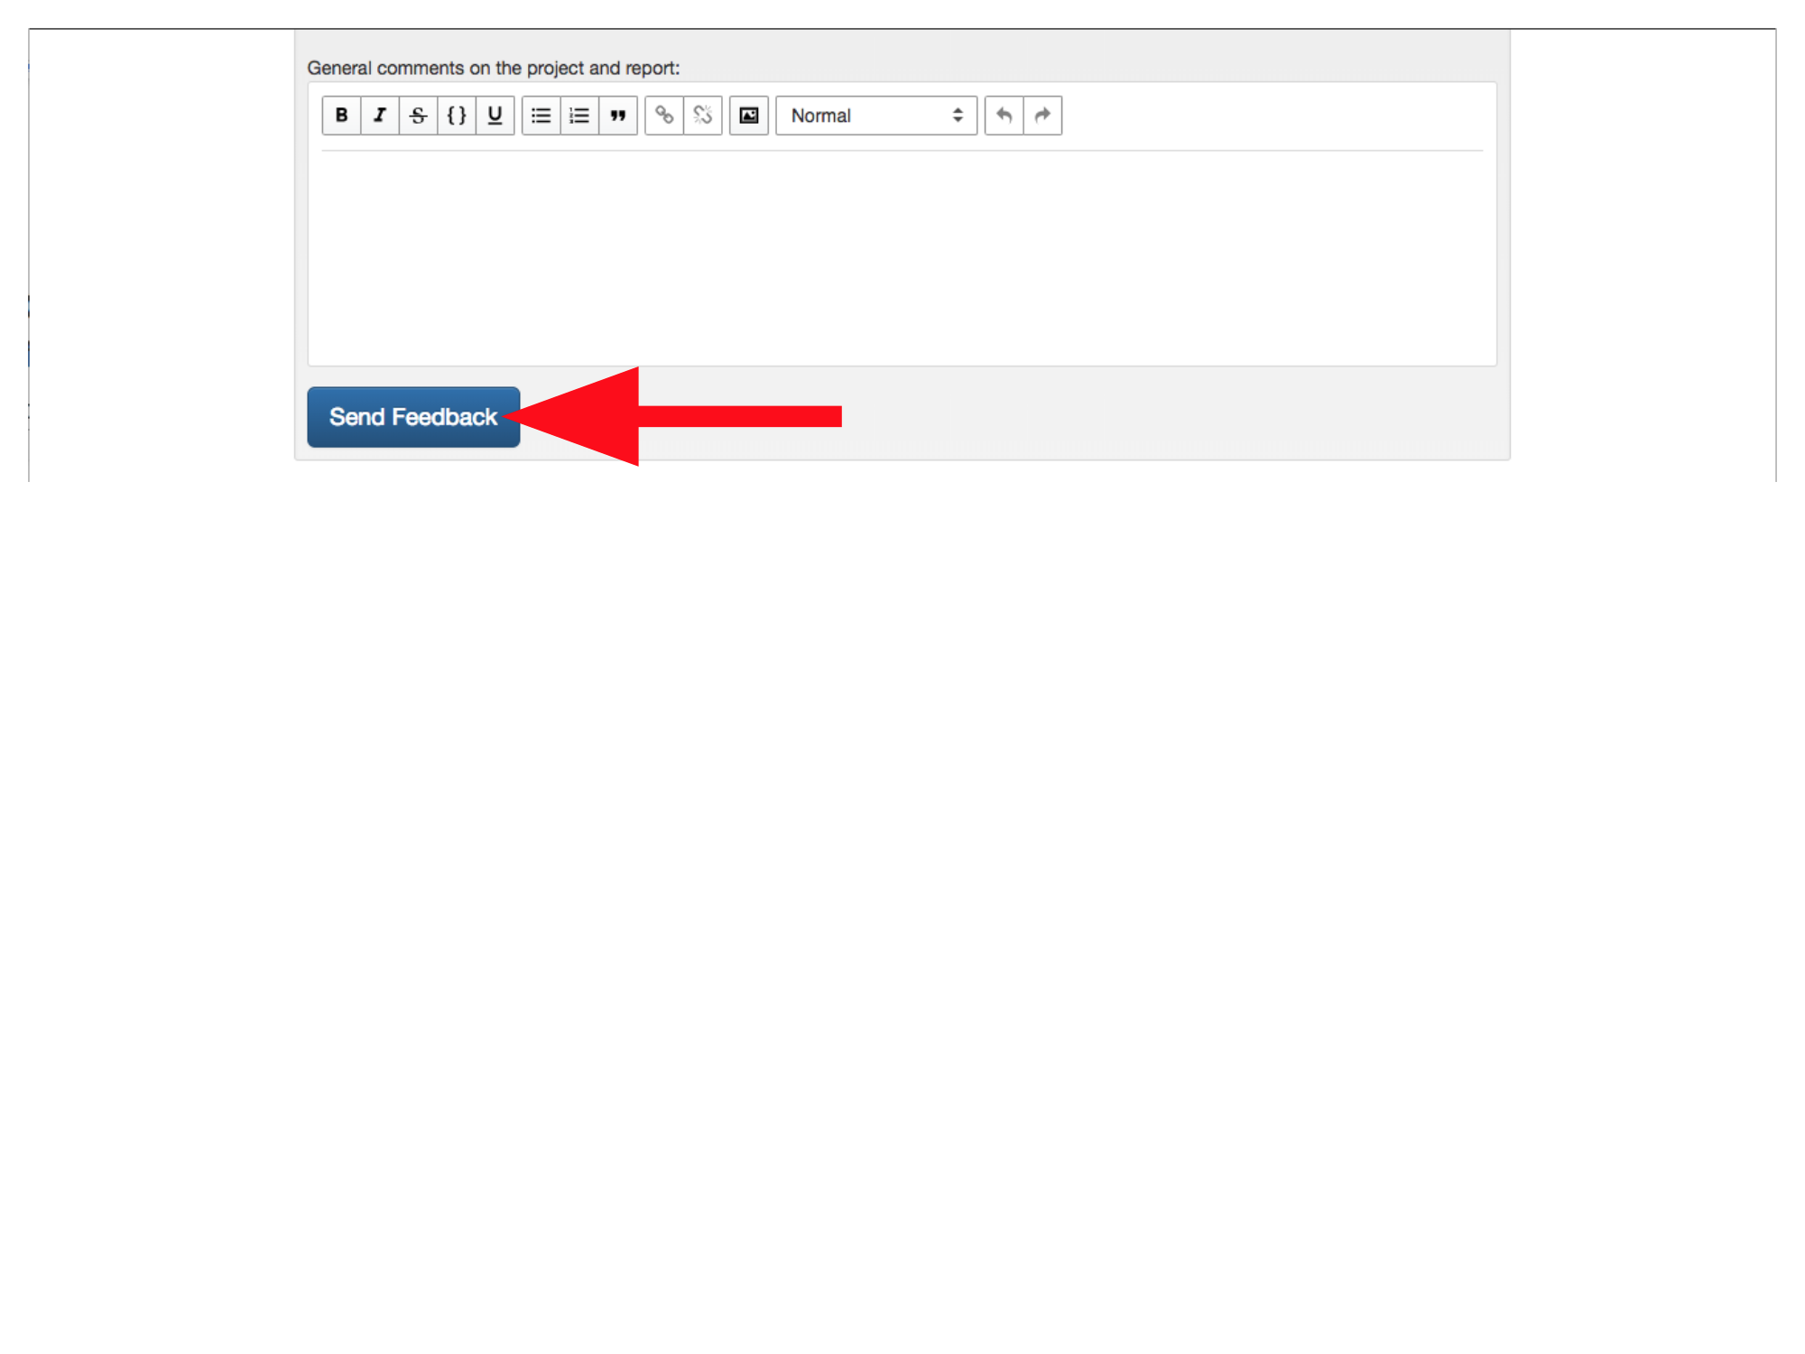

*Now: Students view project marks.*