Graduate office guide to the PhD Student Portal

# Logging in

The student portal is available at <https://student-portal.sanger.ac.uk>.

On your first visit you will be presented with a login screen: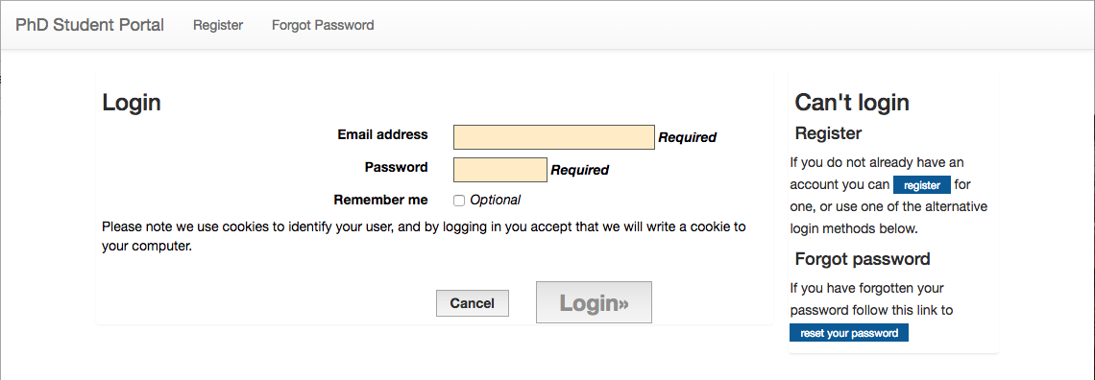

Log in with your @sanger.ac.uk email address and password.

# Creating a new rotation

Click the “Create Rotation” button (NB: this button will only be visible once the current rotation has ended):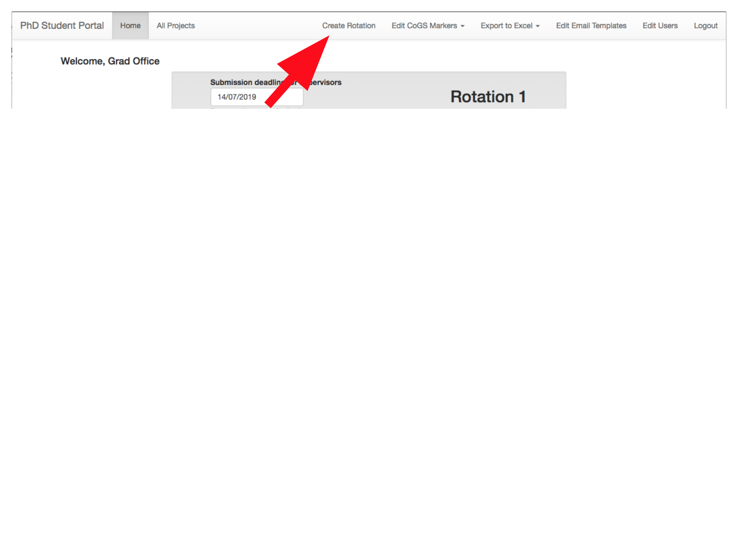

Verify that the rotation year and number are correct, enter the deadlines for the rotation, then click “Create Rotation”: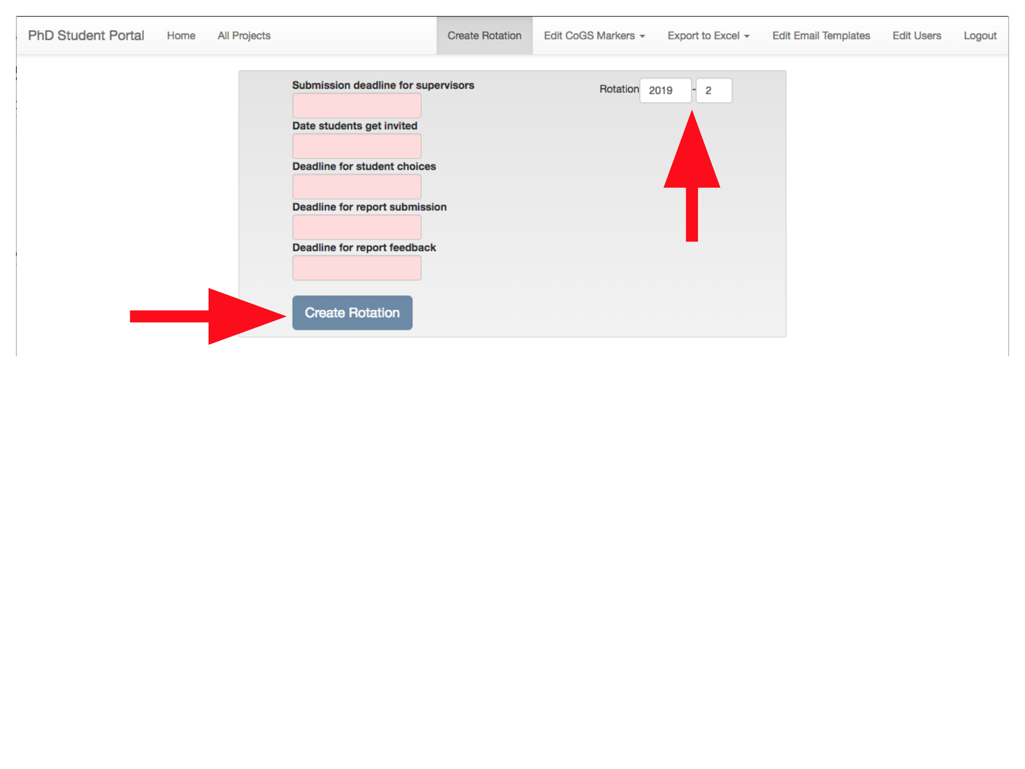

*Now: Supervisors create projects, and students choose projects.*

# Finalising project choices

Press the “Finalise Student Choices” button (NB: this button will only be visible once the deadline for students to make their project choices has passed):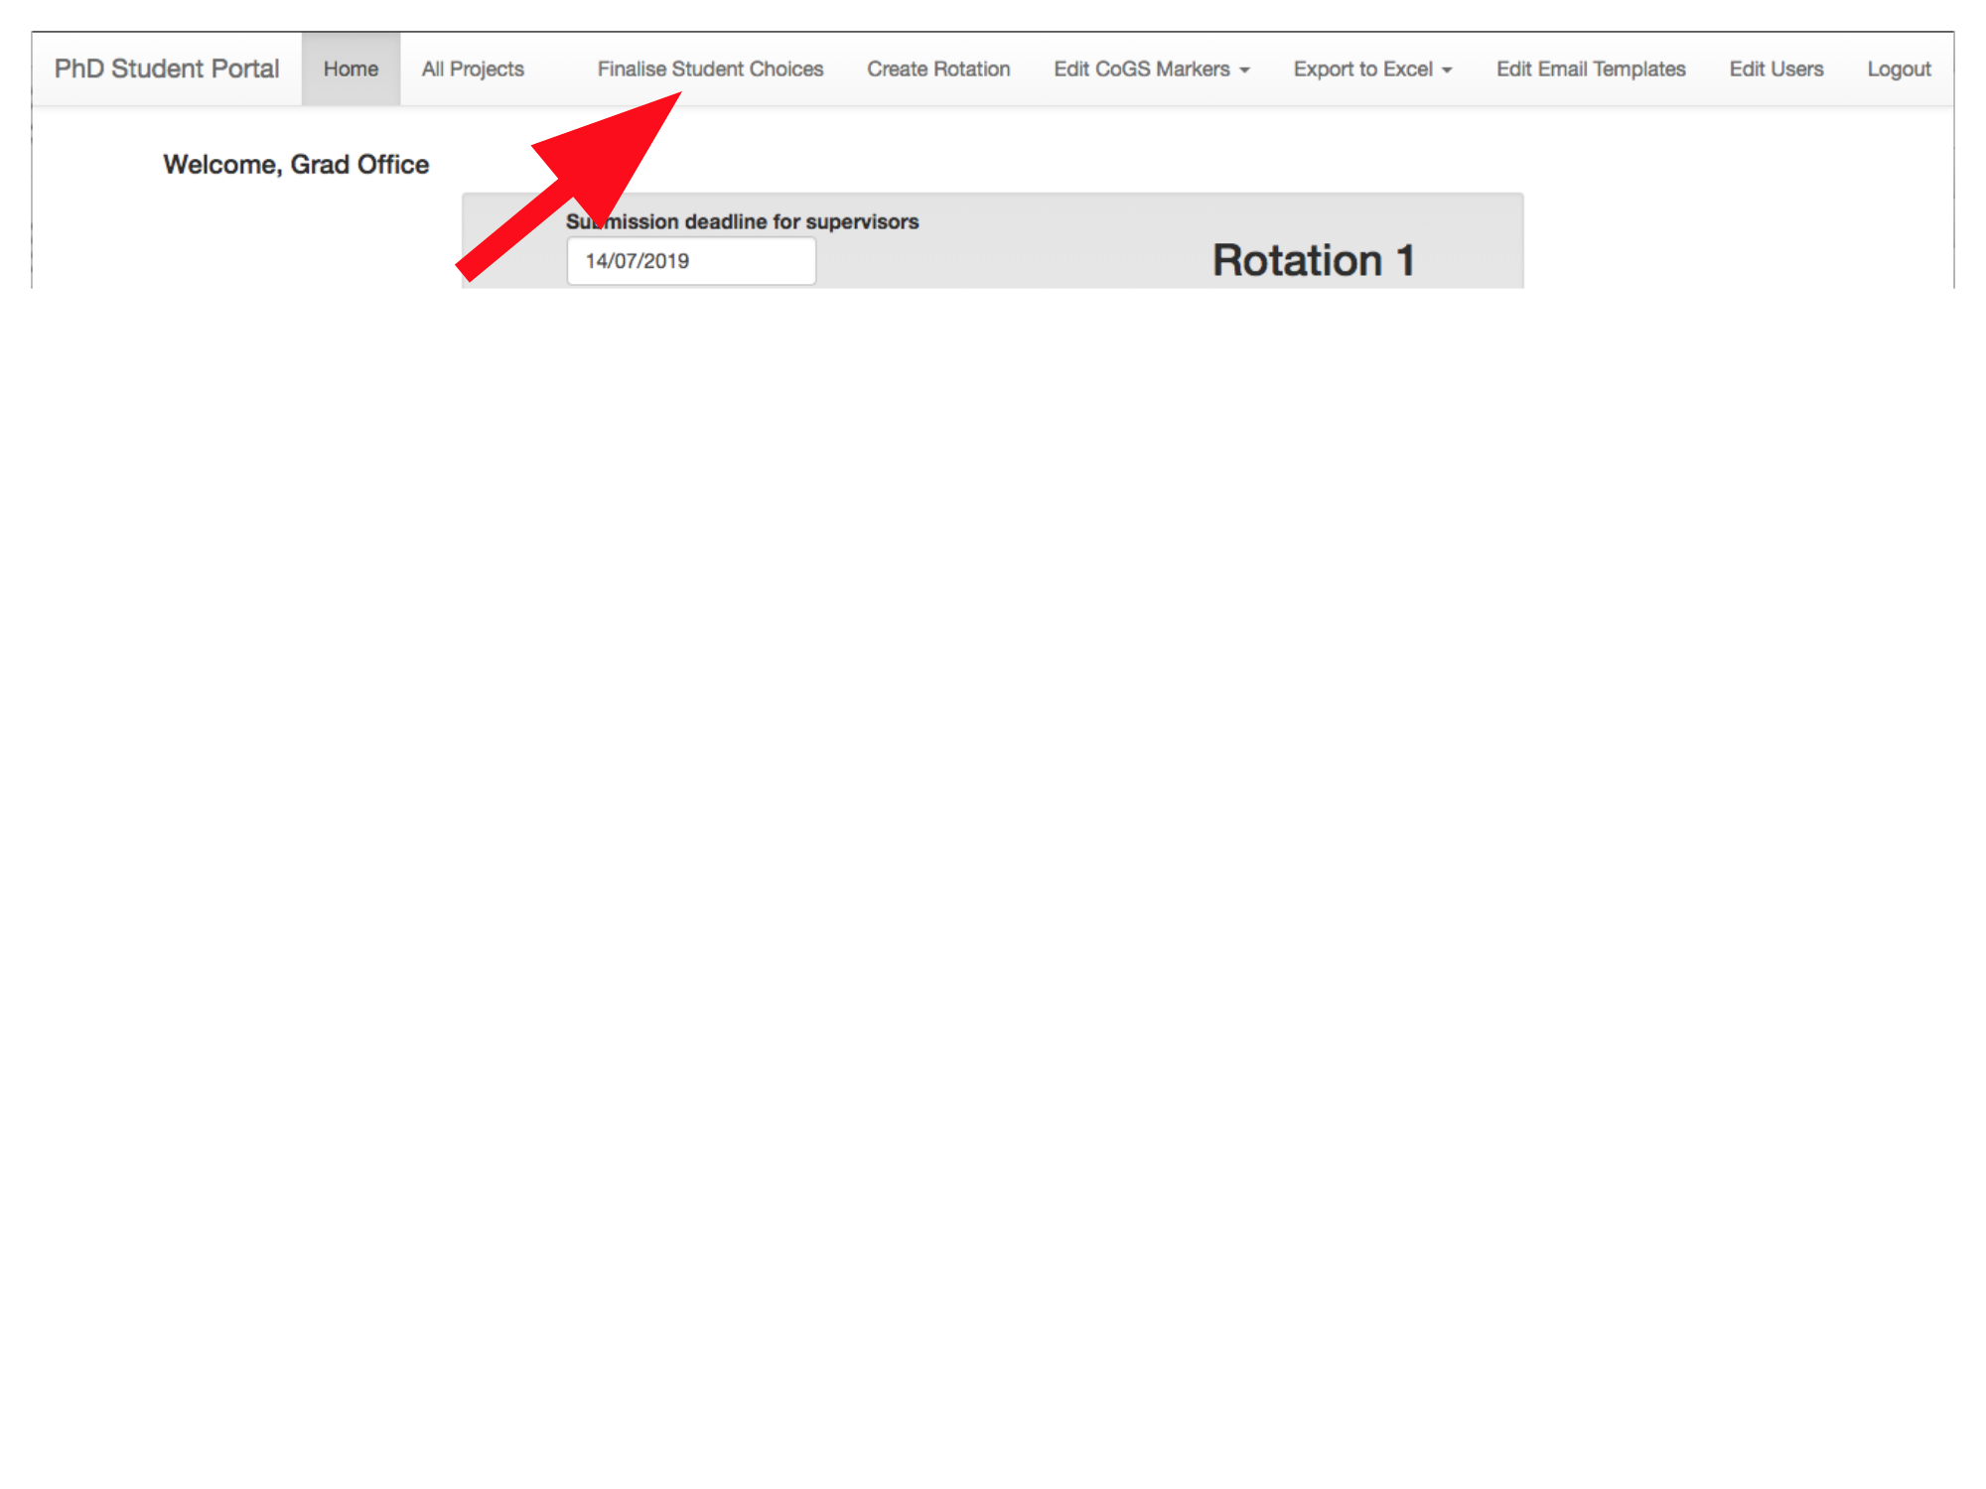

A table showing which projects students have chosen will be displayed: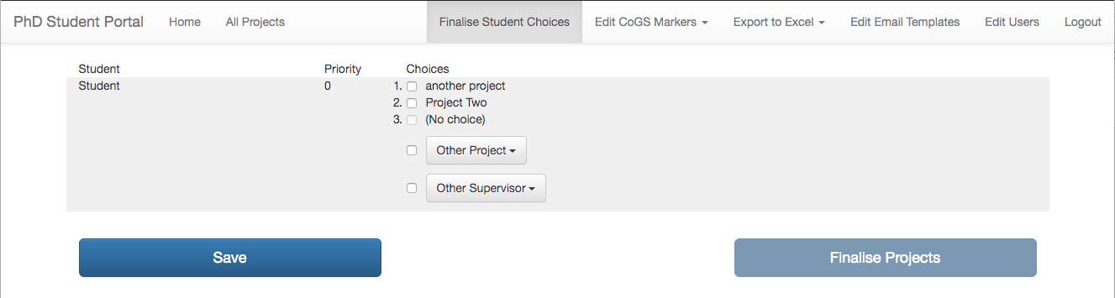

Select a project for each student, either from one of their choices (shown in order of preference) or from the “Other Project” dropdown, listing all other available projects. Students can also be assigned directly to a particular supervisor (“Other Supervisor” dropdown); this will create a project called “Dummy project for [student’s name]”, assigned to the supervisor chosen, which should then be filled in by the supervisor with details of the project.

NB: if supervisors have chosen to pre-assign students to projects, then these assignments will be displayed in the same way that assignments made by the Graduate Office are displayed (and, if necessary, the Graduate Office can also change these assignments).

At any point, the “Save” button will save the project choices made so far (if multiple students have been assigned the same project, this button will be disabled):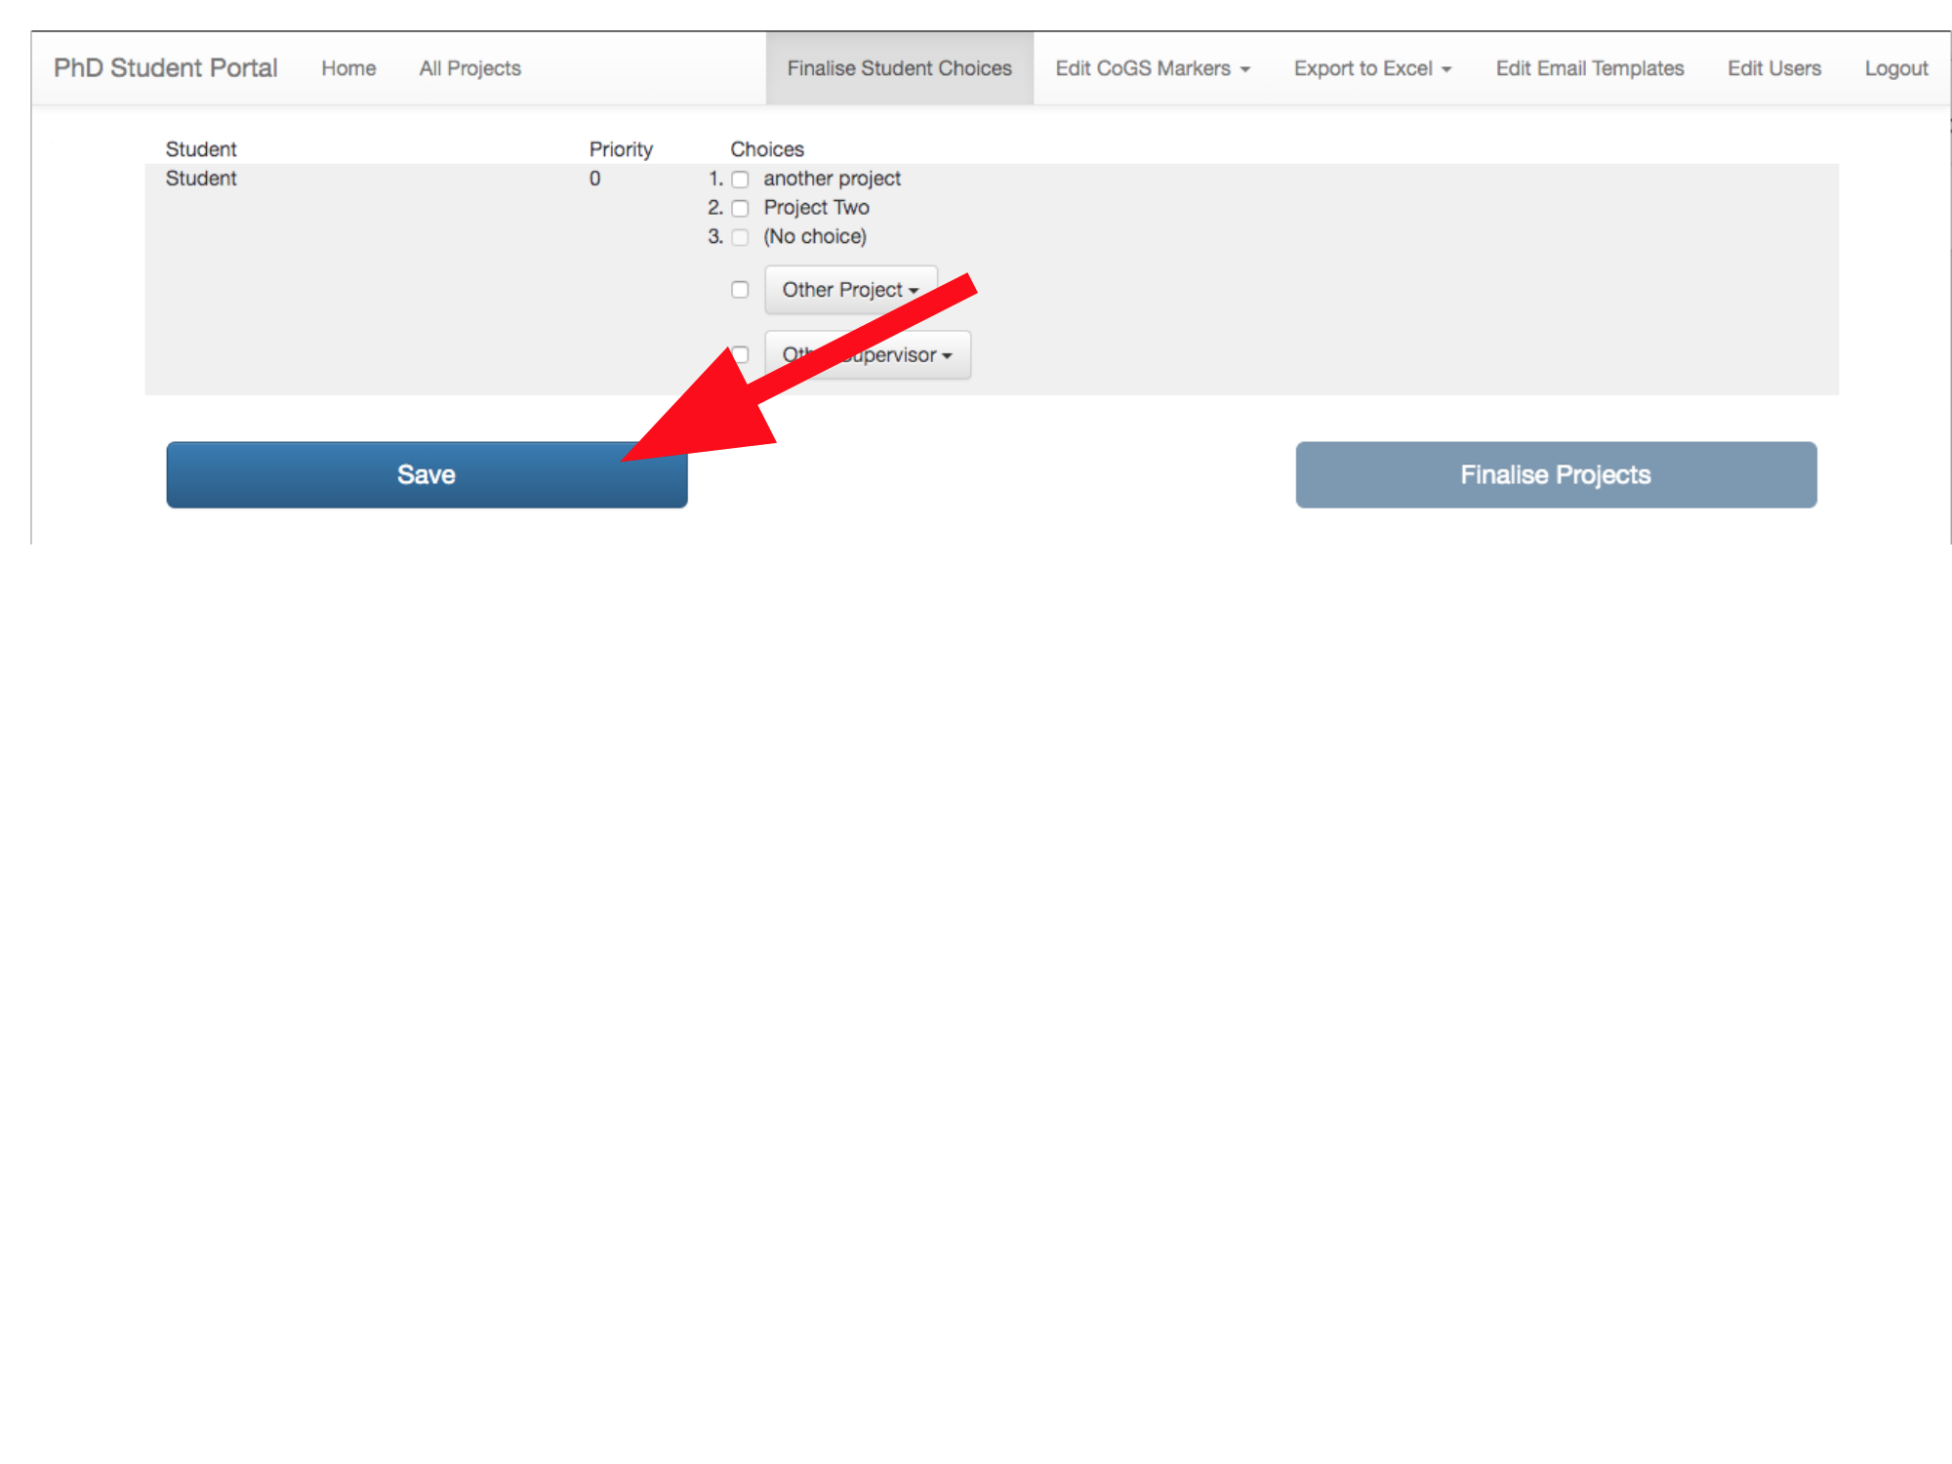

If you are ready to finalise project assignments for this rotation, press the “Finalise Projects” button (if multiple students have been assigned the same project, or if not every student has been assigned a project, this button will be disabled):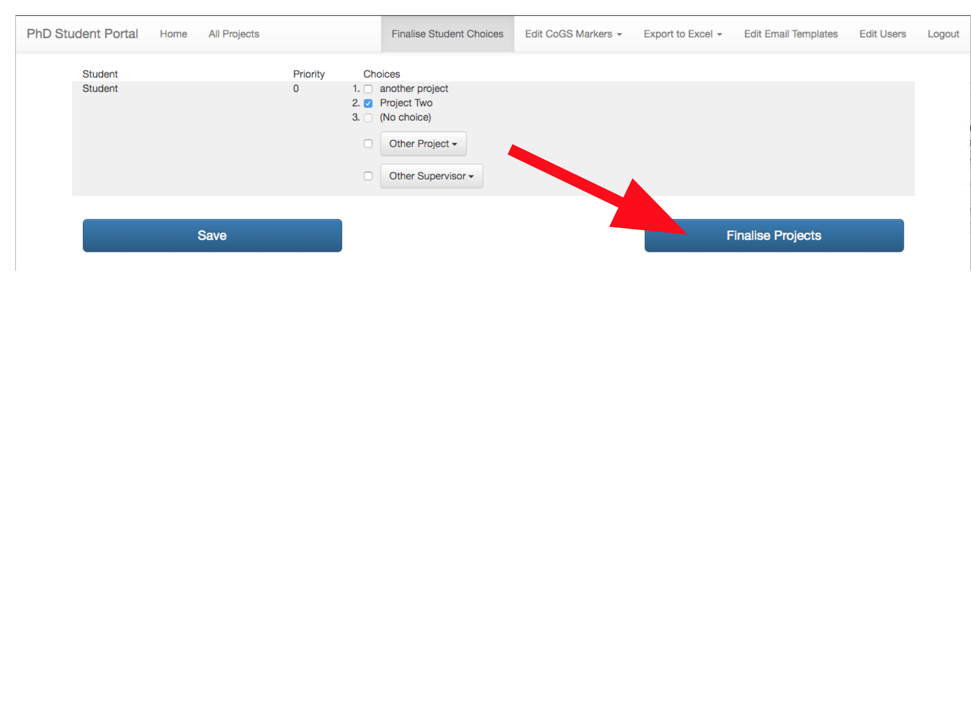

After this point, you will not be able to change project assignments: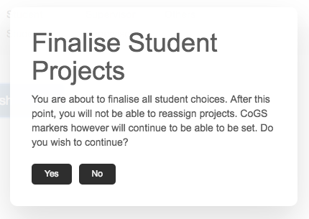

Alternatively, if you would like to assign CoGS markers to projects before finalising them, use the “Edit CoGS Markers” dropdown: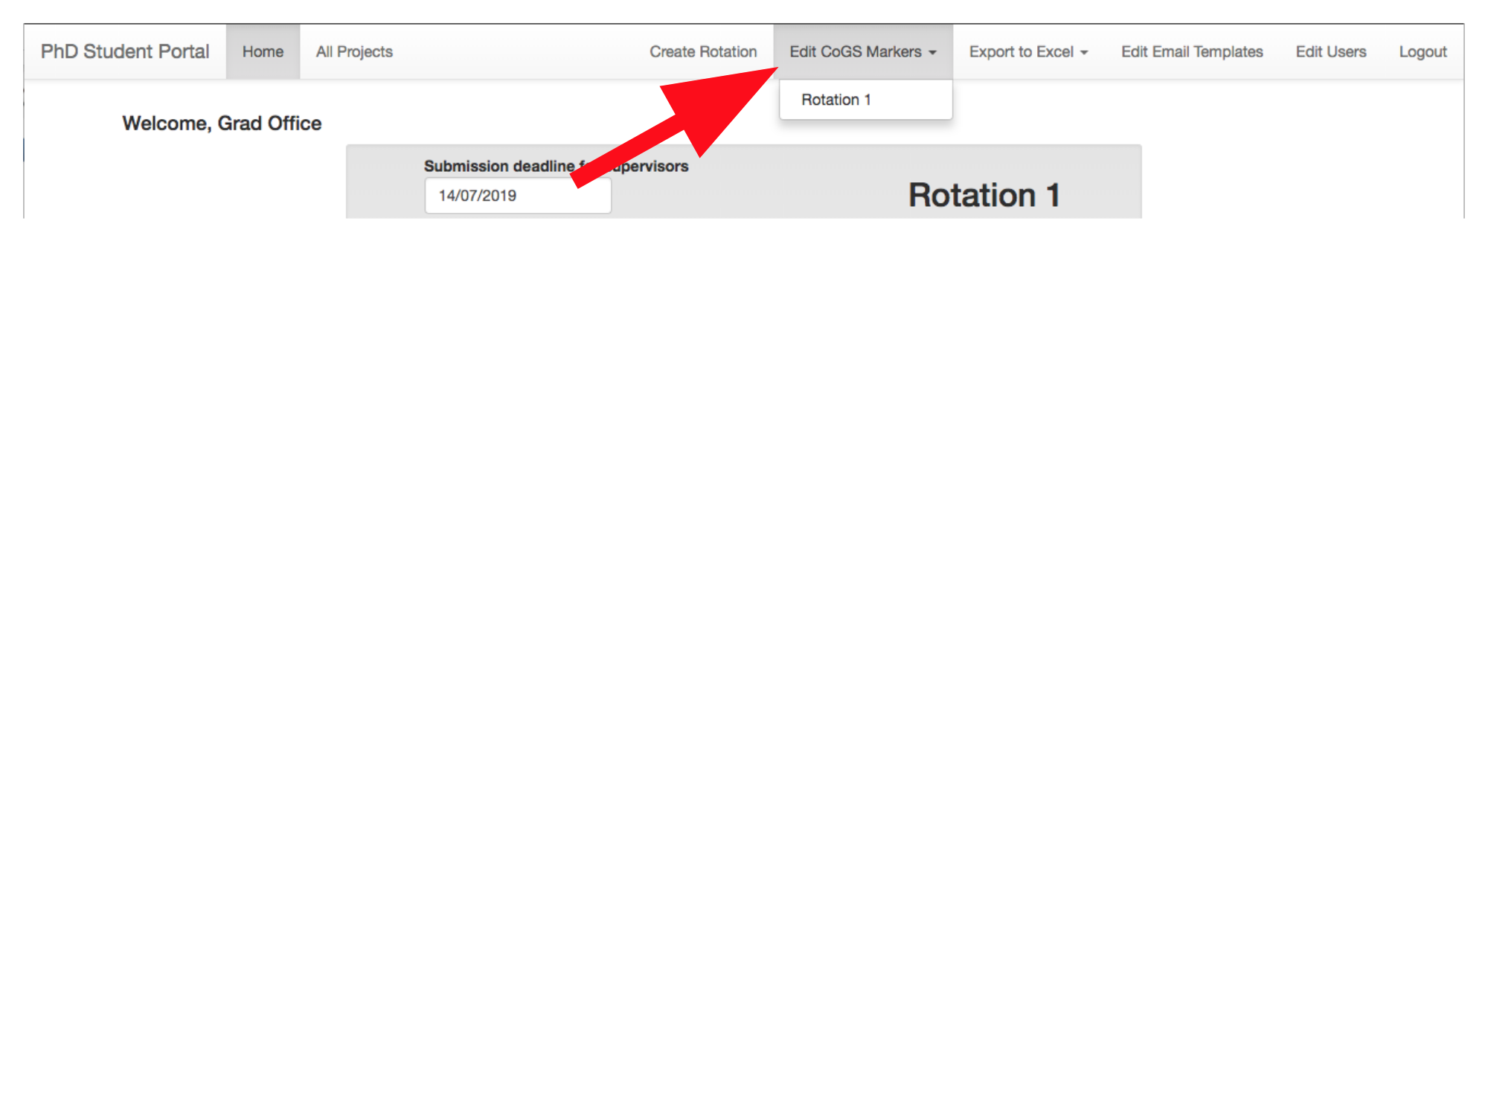

This dropdown will be available even once project choices are finalised.

# Assigning CoGS markers

Before students submit their projects, a CoGS marker must be allocated for each project. If you have just finalised project choices, you will be automatically redirected to the correct page; otherwise, click the “Edit CoGS Markers” dropdown and select the latest rotation:

When editing CoGS markers, a table of projects will be displayed. Assign each project a CoGS marker from the dropdown on the right: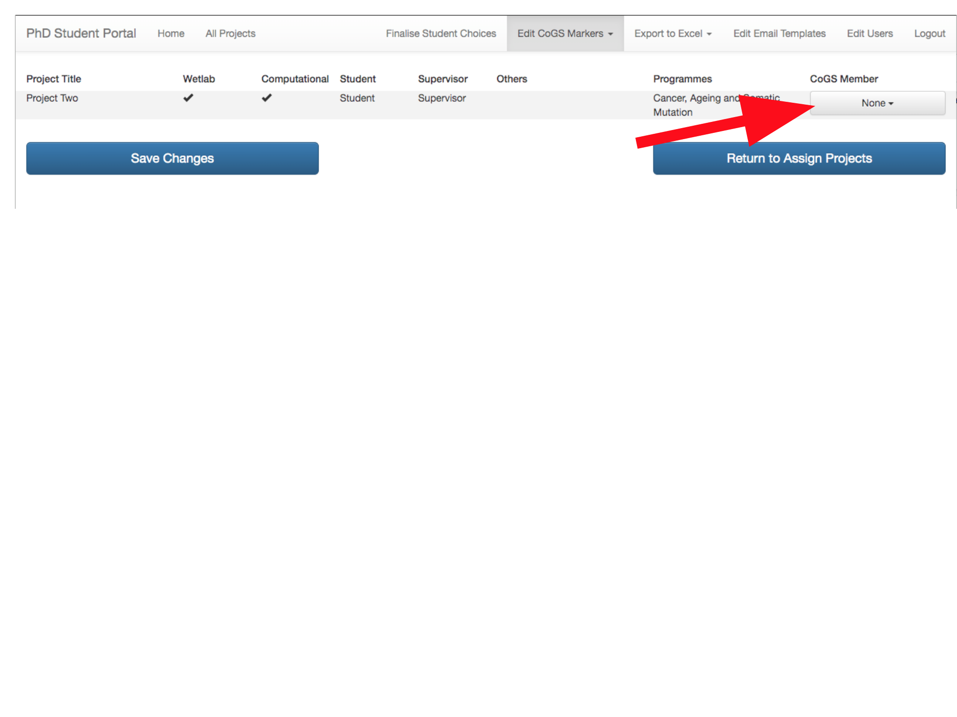

At any point, the “Save Changes” button will save the choices made so far.

If you have not yet finalised project choices, the “Return to Assign Projects” button will save the changes you have made and return you to the Finalise Student Choices screen. If project choices have already been finalised, the “Return to Assign Projects” button will not be displayed, but you can still make changes to CoGS markers and save them by pressing “Save Changes”.

*Now: Students upload project reports, CoGS members and supervisors mark projects, and students view project marks.*

# Managing users

Click the “Edit Users” button: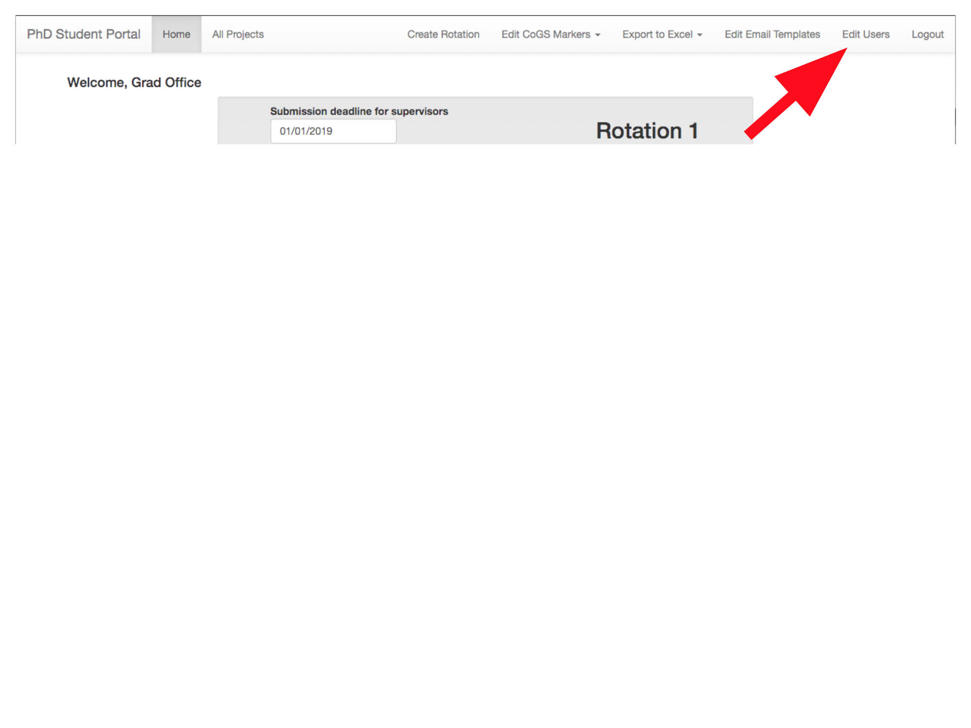

You can set users’ names, email addresses (primary and personal), priority (for students, this is a measure of how much of the time they have been assigned their preferred project – a high priority means they have not been assigned the projects they wanted), and user type: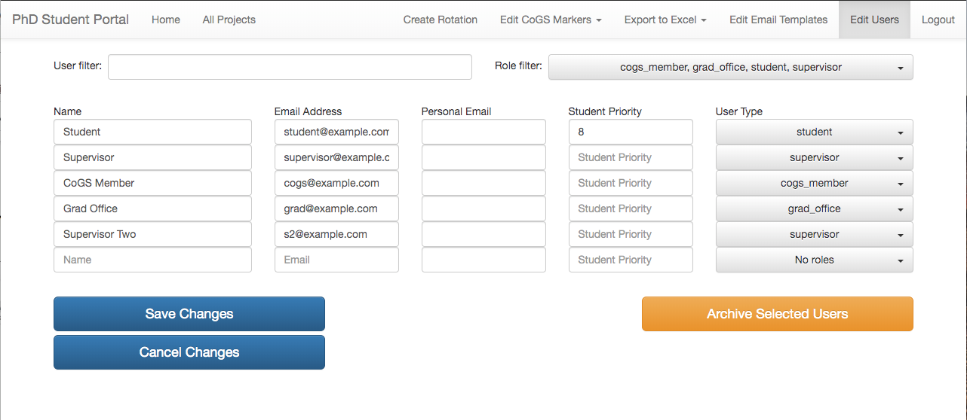

You can also filter the list of users shown by entering a string in the “User filter” textbox, and/or by selecting roles to show with the “Role filter” dropdown.

After making changes, press the “Save Changes” button. The “Archive Selected Users” button changes the roles of all currently-visible users to “archive”, which means that those users will be hidden from the list by default (you can view them by selecting the “archive” role in the role filter dropdown in the top-right) – a typical use for this button might be to archive all students currently registered in the system before adding new students at the start of an academic year.

# Exporting Excel spreadsheets

Press the “Export to Excel” dropdown: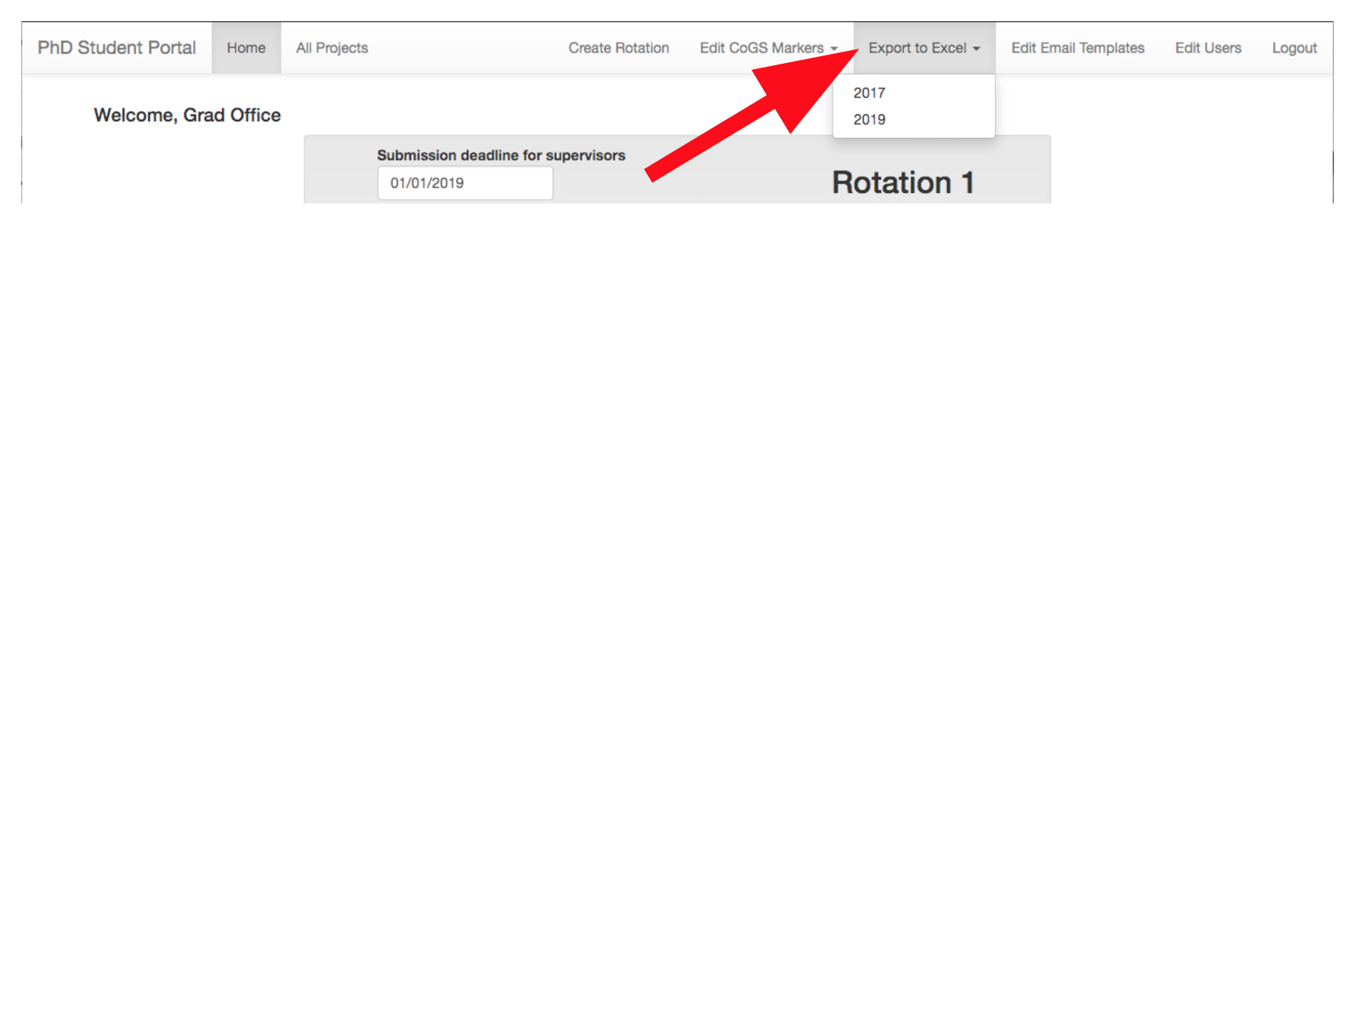

You can then select an academic year to download as an Excel spreadsheet.

# Editing email templates

Click the “Edit Email Templates” button: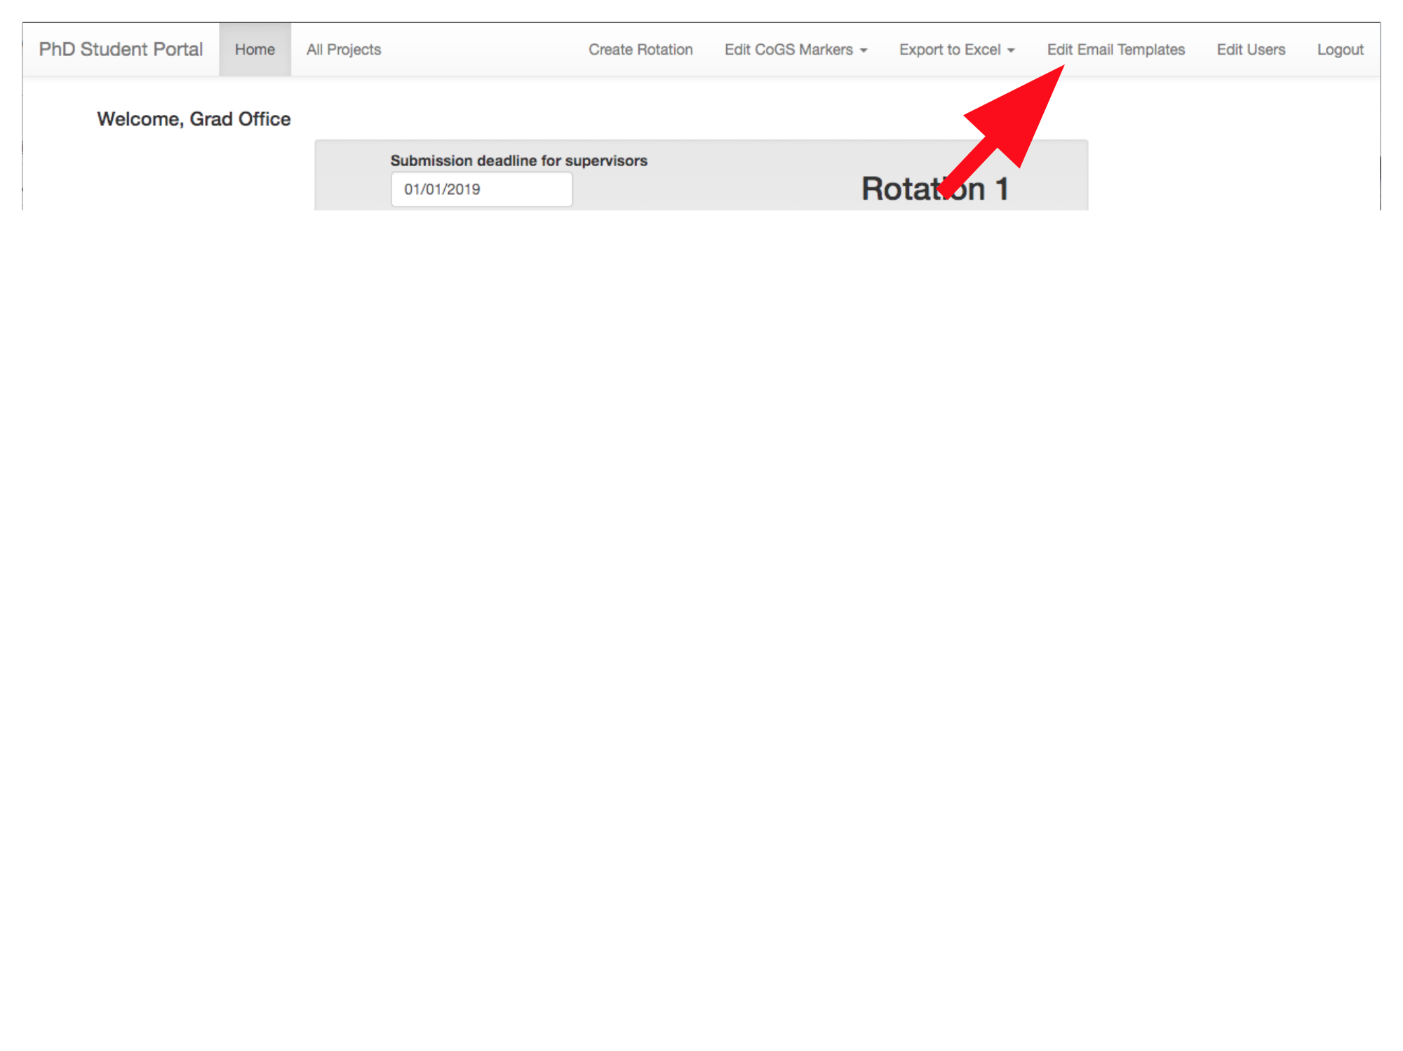

Then use the “Template Select” dropdown to select a template to edit: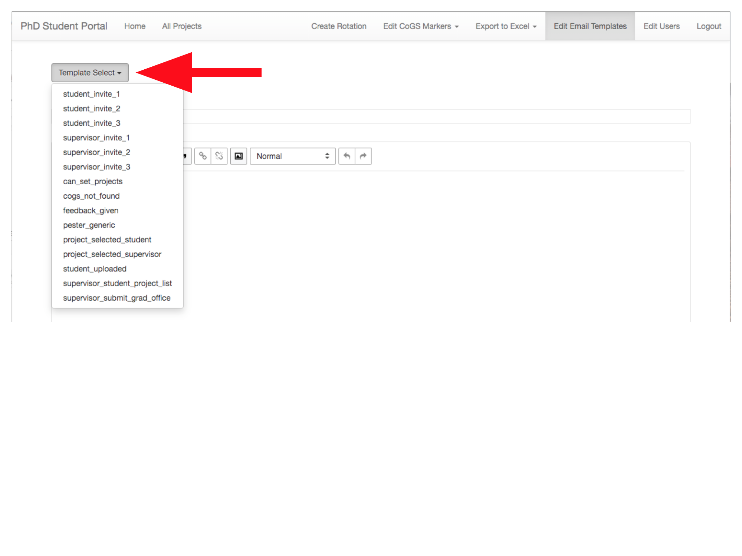

Both the email subject and the contents of the email are editable for each template: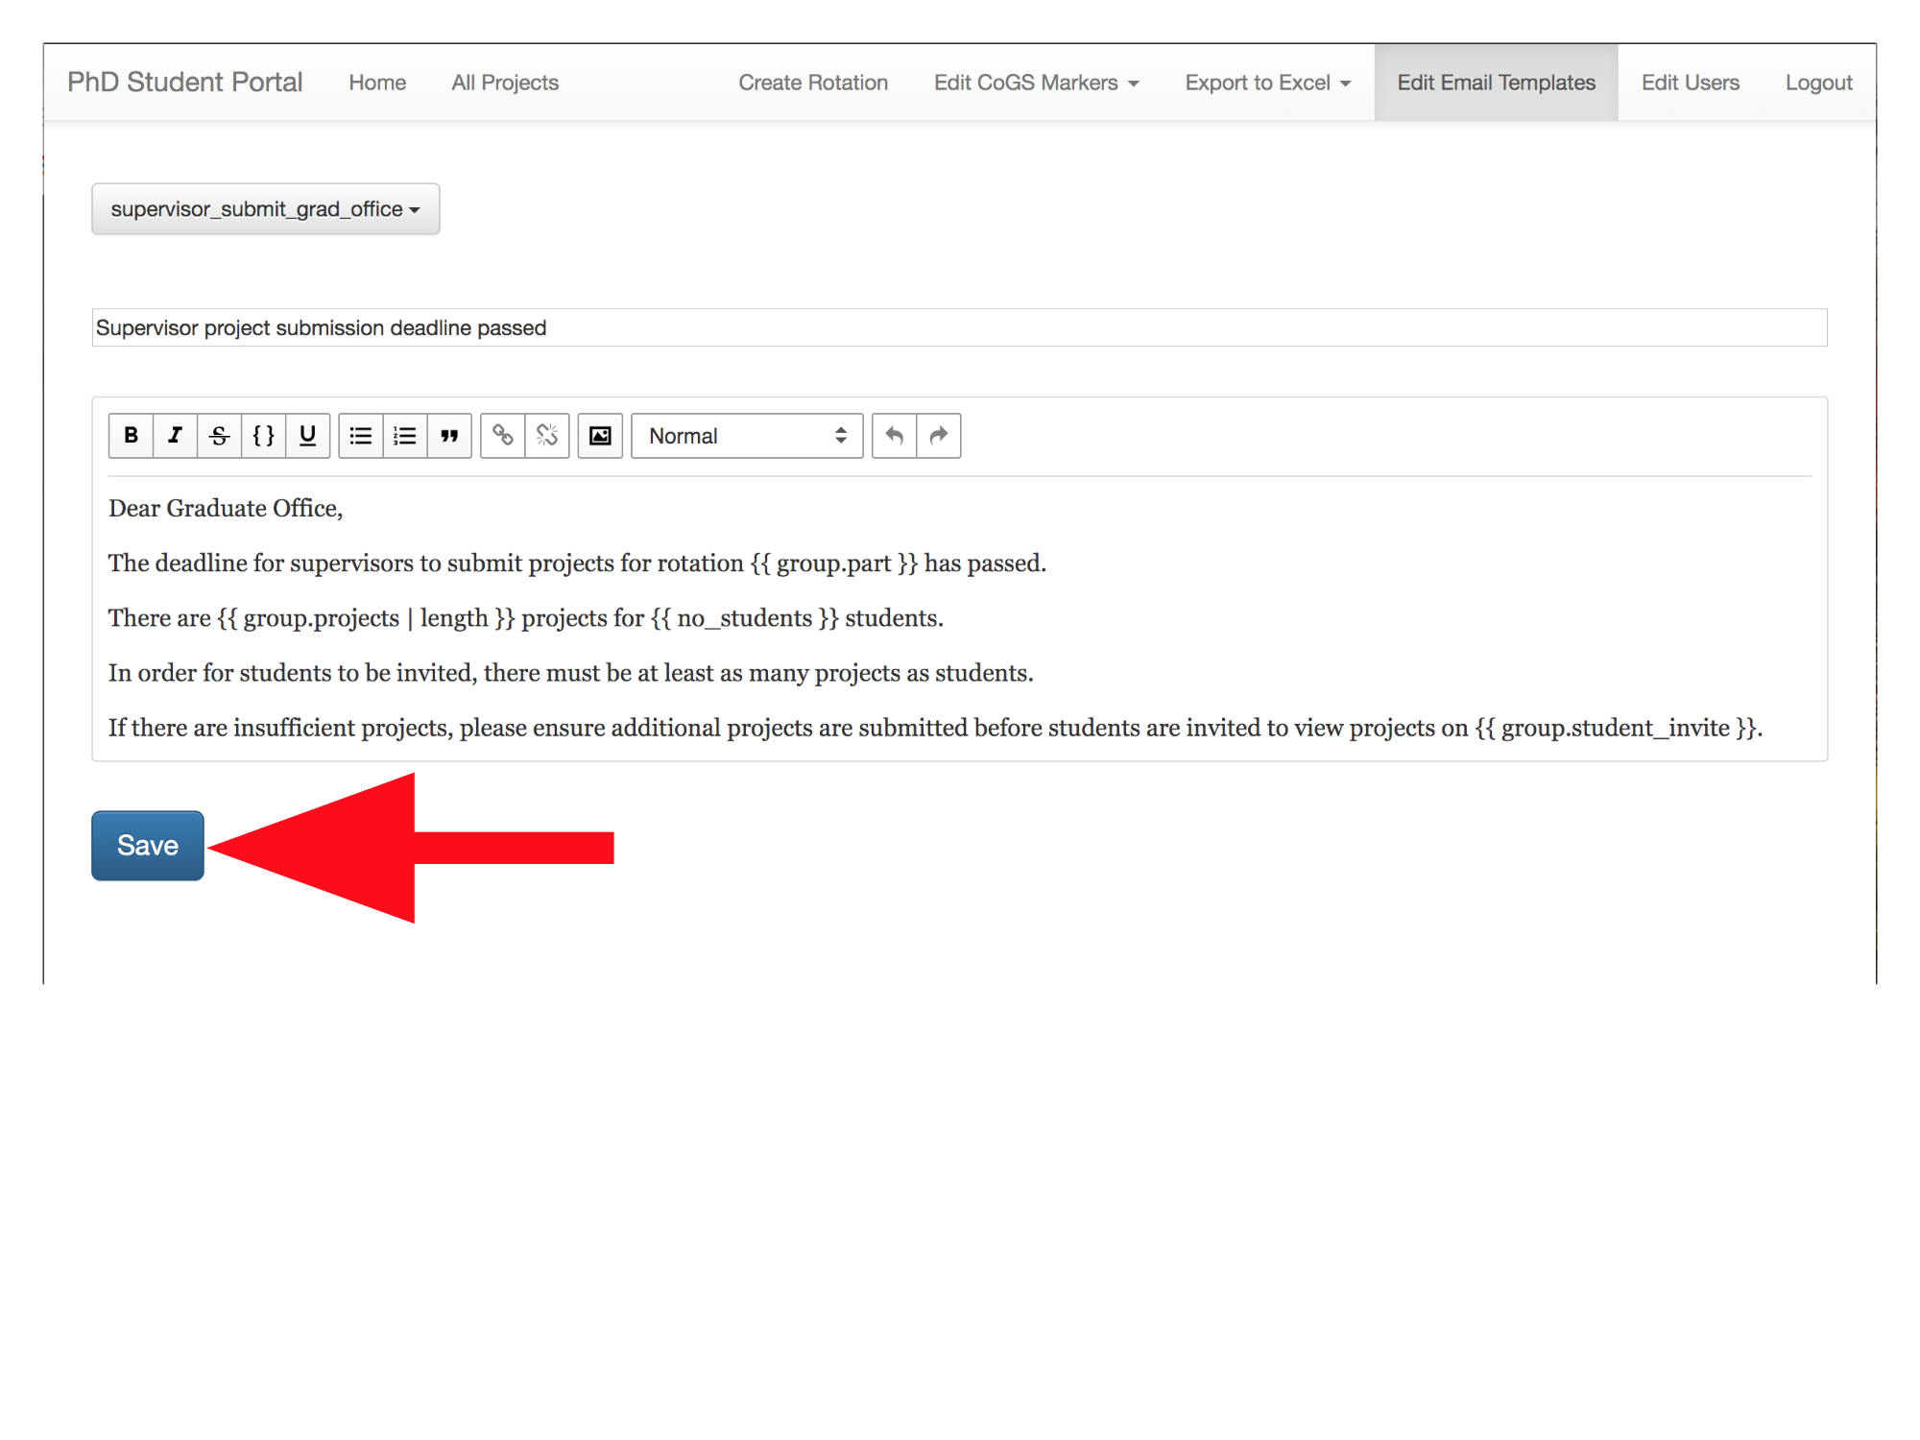

The templates use the Jinja2 templating language. You don’t need to know Jinja2 to make simple changes to the templates (just don’t change anything inside curly braces), but if you are planning to make more drastic changes, understanding the templating language may be helpful. The Jinja2 website has comprehensive documentation: <http://jinja.pocoo.org/docs/2.10/templates/>

Available templates:

* can_set_projects: Sent to the Graduate Office once the deadline for student choices has passed, reminding them that they should now assign students to projects.
* change_of_deadline: Sent to relevant users when any of the deadlines associated with a rotation are changed:
  + sent to supervisors when the deadline to submit project proposals is changed
  + sent to students when the deadline to select project choices is changed
  + sent to students when the deadline to upload project reports is changed
  + sent to supervisors & CoGS markers when the deadline to submit marks/feedback is changed
* cogs_not_found: Sent to the Graduate Office when a student uploads a project report but there is no CoGS marker assigned to the project, asking them to assign a CoGS marker.
* feedback_given: Sent to students and the Graduate Office when a supervisor or CoGS marker marks a project, with the mark and feedback.
* late_submission_reminder: Sent to students who have not uploaded a project report when the deadline to upload project reports passes.
* pester_generic: A generic reminder informing users that a deadline is approaching (currently used to remind supervisors of the project submission deadline, the Graduate Office of the date students are invited to choose projects, and students of the deadline for uploading project reports).
* project_choice_receipt: Sent to students when they click the button to send themselves an email receipt of their project choices.
* project_selected_student: Sent to students when project choices are finalised, informing them of the project that they have been assigned to.
* project_selected_supervisor: Sent to supervisors when project choices are finalised, informing them that a student has been assigned to one of their projects.
* student_invite: Sent to students inviting them to choose projects for each rotation once the deadline for students being invited to view projects has passed.
* student_uploaded: Sent to supervisors and CoGS markers once a student’s submitted report is ready to be marked, reminding them to submit marks and feedback; also sent at intervals until a mark is submitted.
* supervisor_invite: Sent to supervisors to remind them to submit projects for each rotation, either when the rotation is created, when the “Remind Supervisors” button is pressed, or when the project submission deadline is changed (in which case a note explaining that the deadline has been extended is automatically included).
* supervisor_student_project_list: Sent to supervisors when project choices are finalised, with a list of students assigned to projects.
* supervisor_submit_grad_office: Sent to the Graduate Office once the deadline for supervisors to submit projects has passed, informing them of how many projects have been submitted and how many students are currently registered (in case there are fewer projects than students).