Student guide to the PhD Student Portal

# Logging in

The student portal is available at <https://student-portal.sanger.ac.uk>.

On your first visit you will be presented with a login screen: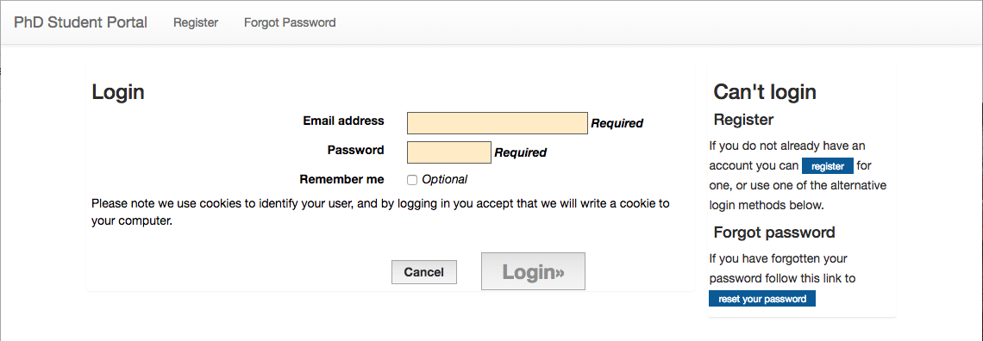

Log in with your @sanger.ac.uk email address and password.

*Now: the Graduate Office creates a new rotation, and supervisors create projects.*

# Choosing a project

Once you have received an invitation to view the available projects, you will be able to log in. Click the “All Projects” button: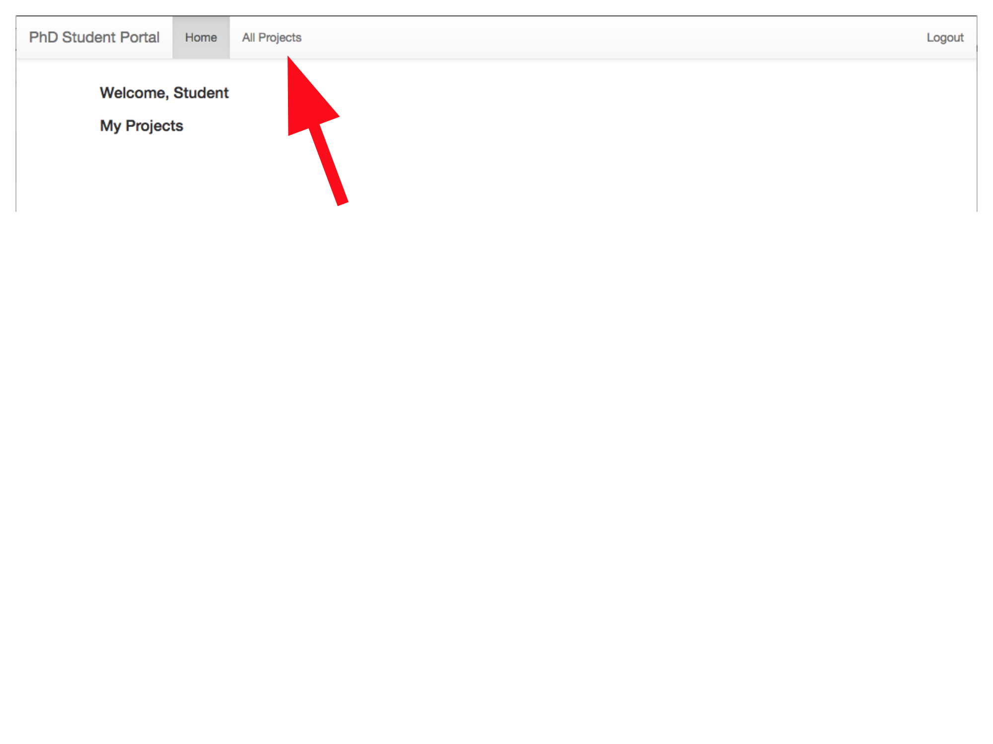

You will then be able to browse the available projects, and select a first, second, and third choice (you can filter the list of projects with the options at the top of the screen):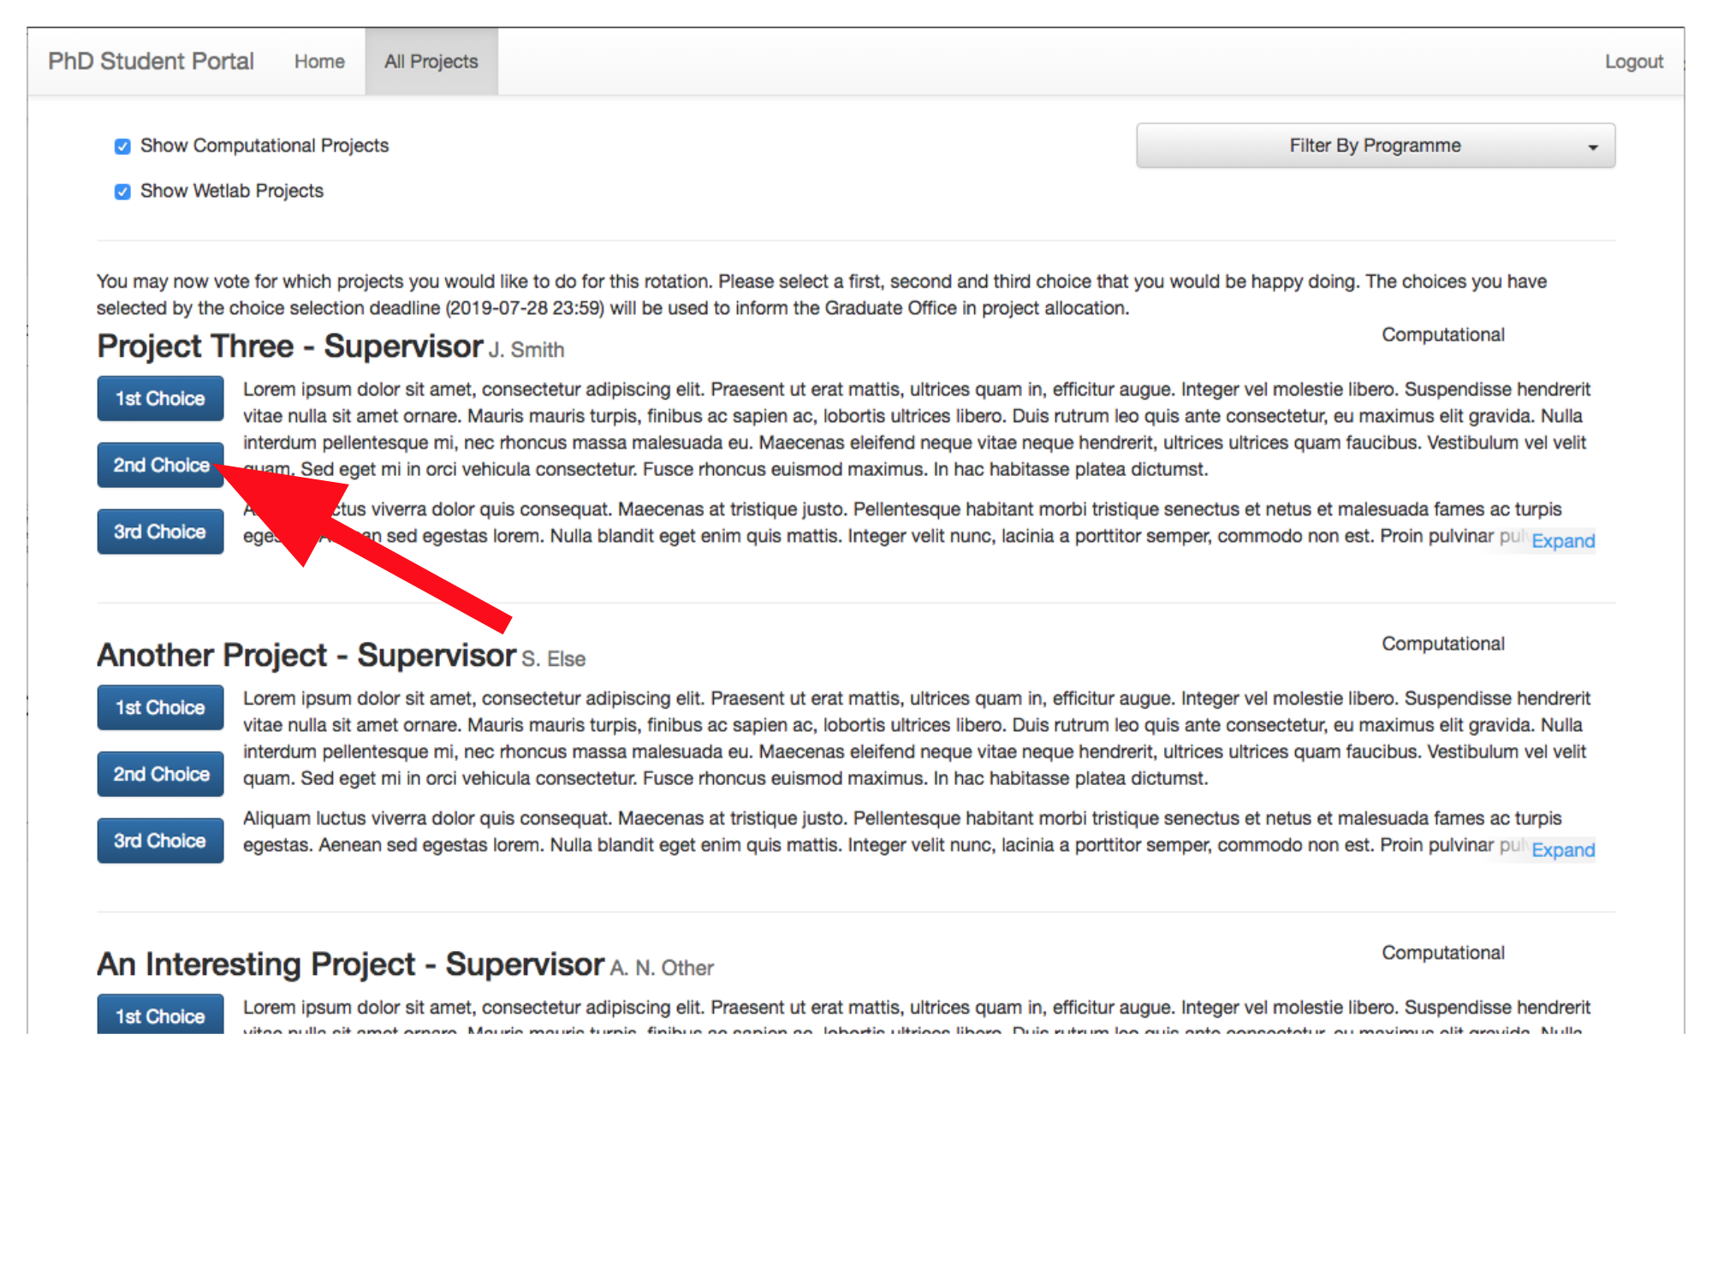

Your choices are automatically saved as you select them, and you can change your choices as many times as you like until the deadline.

*Now: the Graduate Office finalises project choices.*

# Uploading a project report

Press the “Upload final project” button, or the “Upload final project report” link: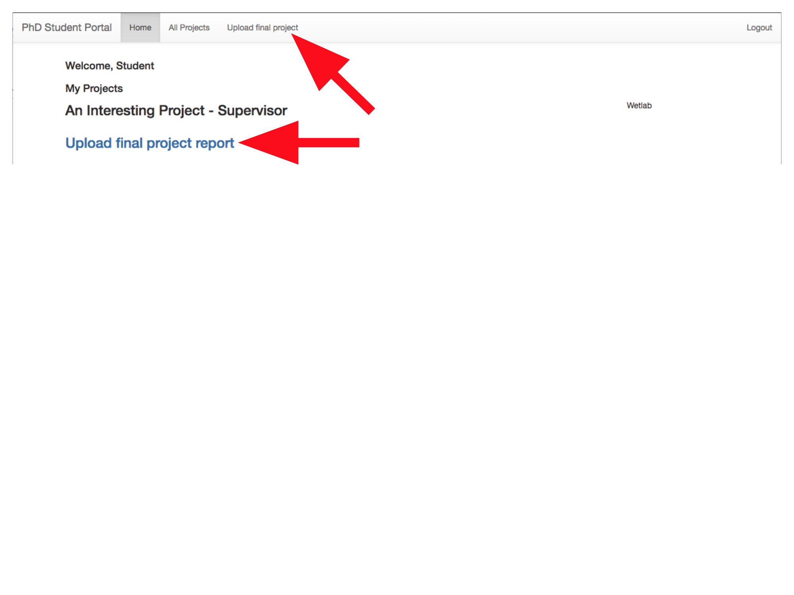

Click inside the dotted line to upload your report, then click “Upload”: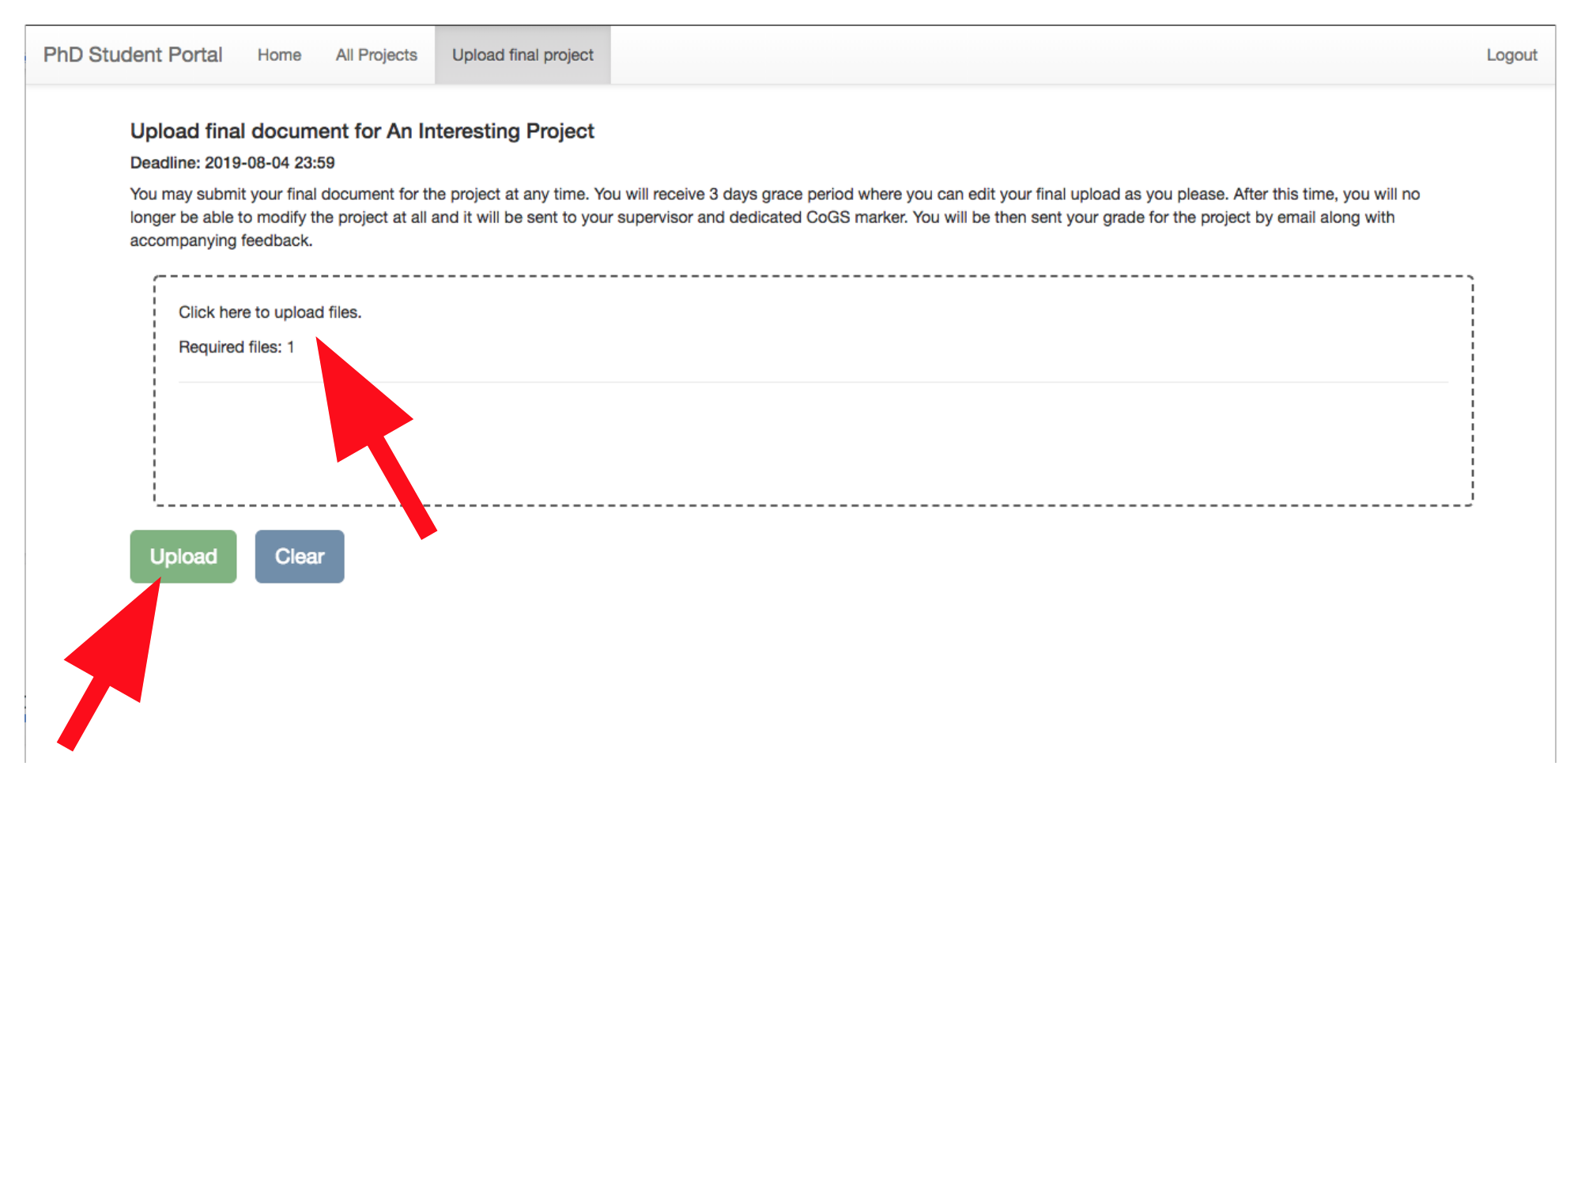

*Now: Supervisors and CoGS members mark projects.*

# Viewing project marks

Click the “CoGS Feedback” and “Supervisor Feedback” links below the project title: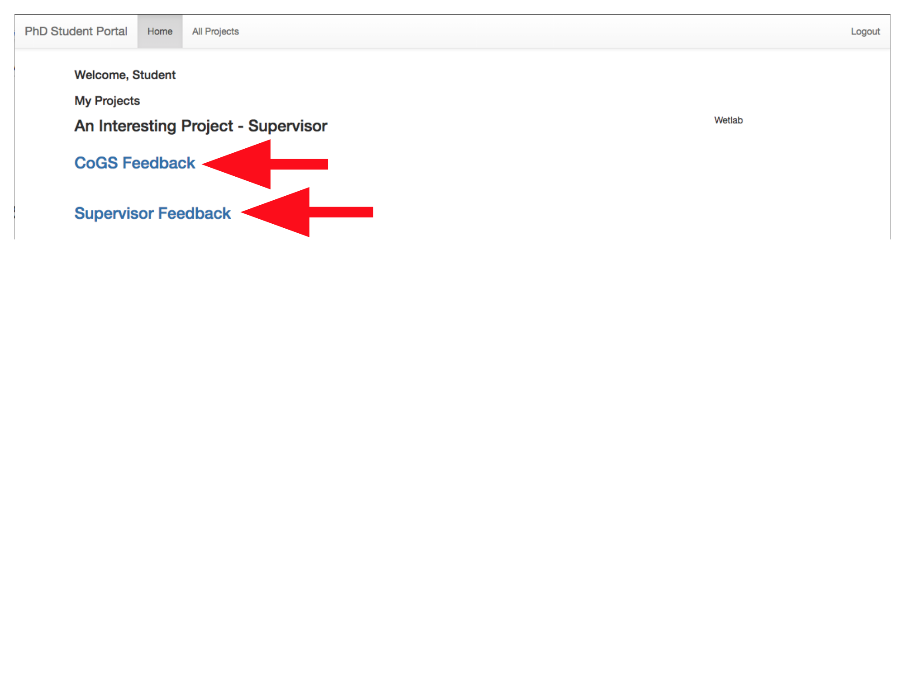

Marks and feedback will then be displayed: