Supervisor guide to the PhD Student Portal

# Logging in

The student portal is available at <https://student-portal.sanger.ac.uk>.

On your first visit you will be presented with a login screen: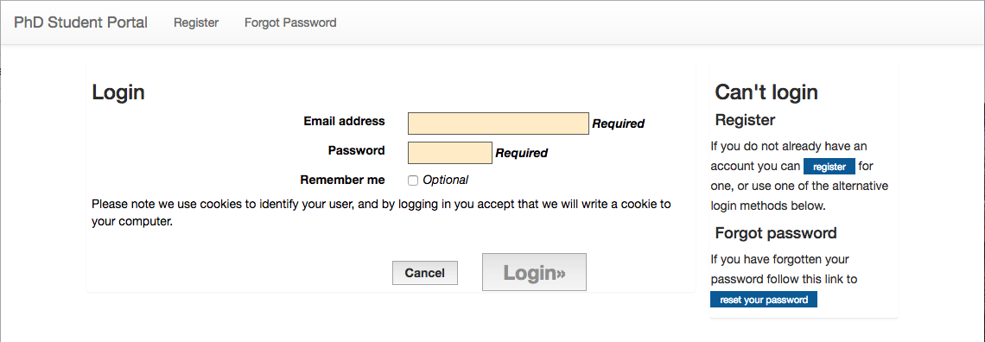

Log in with your @sanger.ac.uk email address and password.

*Now: the Graduate Office creates a new rotation.*

# Creating a project

Press the “Create Project” button: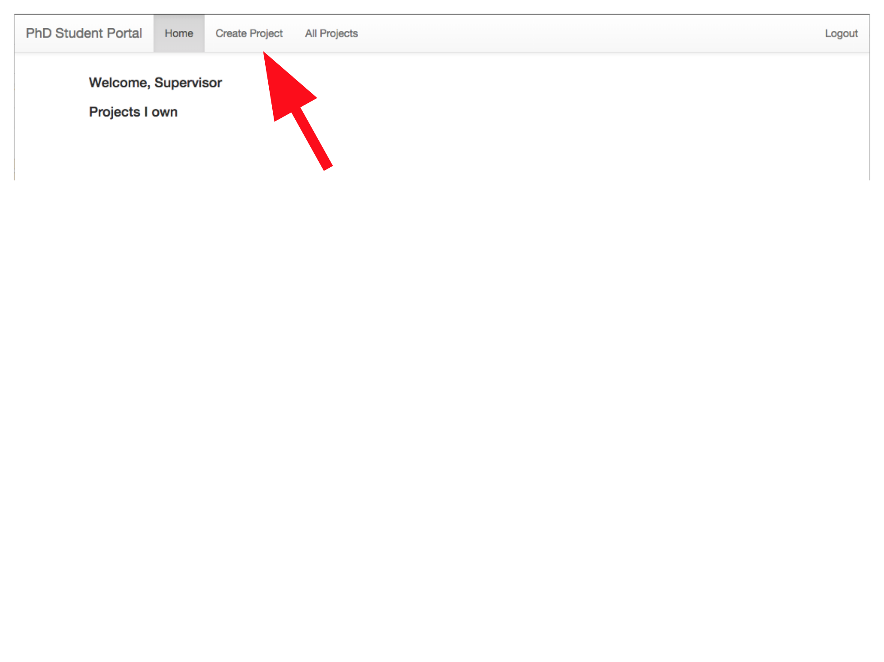

Enter the details for the project (title, others involved, programme, wetlab/computational, and an abstract):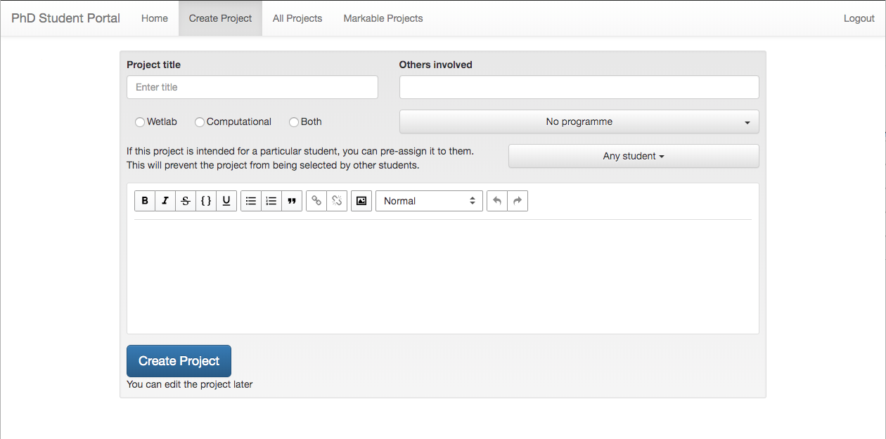

If this project is being created for a particular student, you can pre-assign the student to the project using the dropdown on the right (set to “Any student” in the screenshot). This will stop the project from going into the pool of projects visible to all students. NB: if the student has already been pre-assigned a project for this rotation, then you will not be able to assign another project to them (so if the student wishes to be pre-assigned a different project, the supervisor of the project they are currently pre-assigned to must unassign the student from the project before they can be assigned a different project).

Then press “Create Project”. The new project will be visible on your homepage: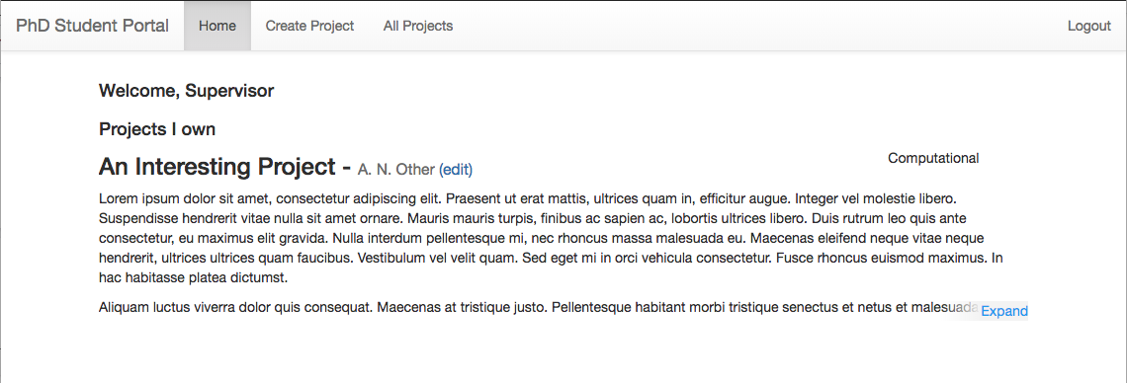

*Now: Students choose projects, the Graduate Office finalises project choices, and students upload project reports.*

# Marking projects

Click the “Markable Projects” button: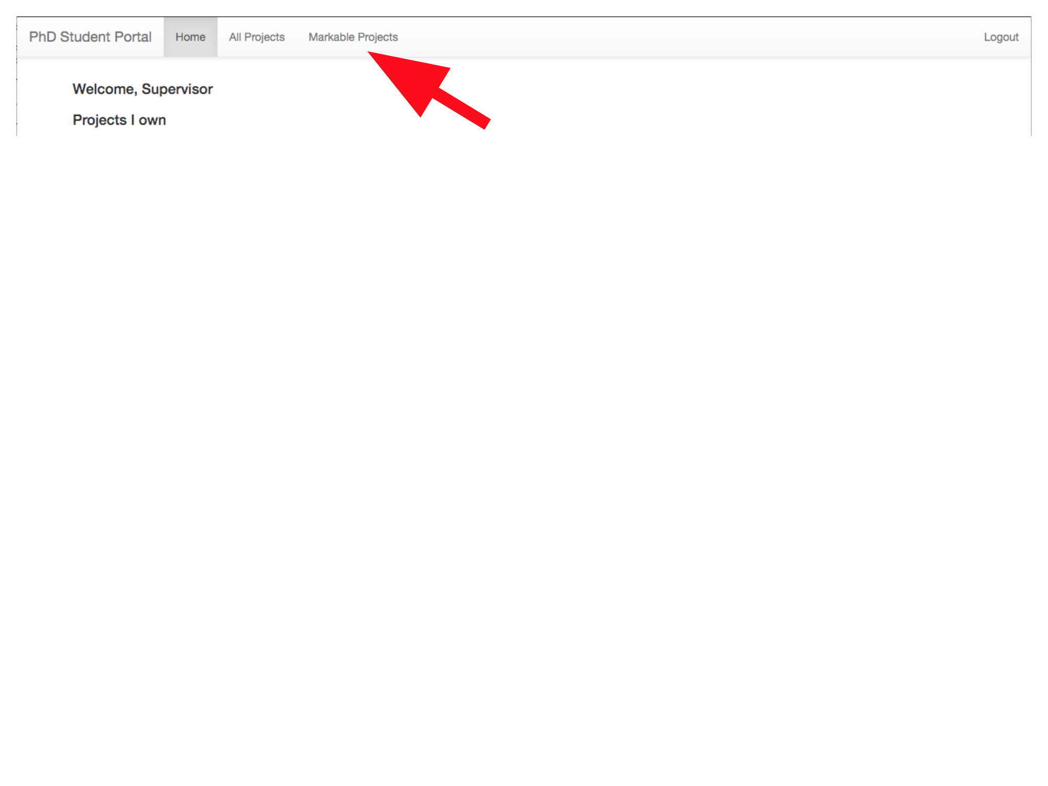

Click the “Provide Feedback” link below the title of the project to be marked: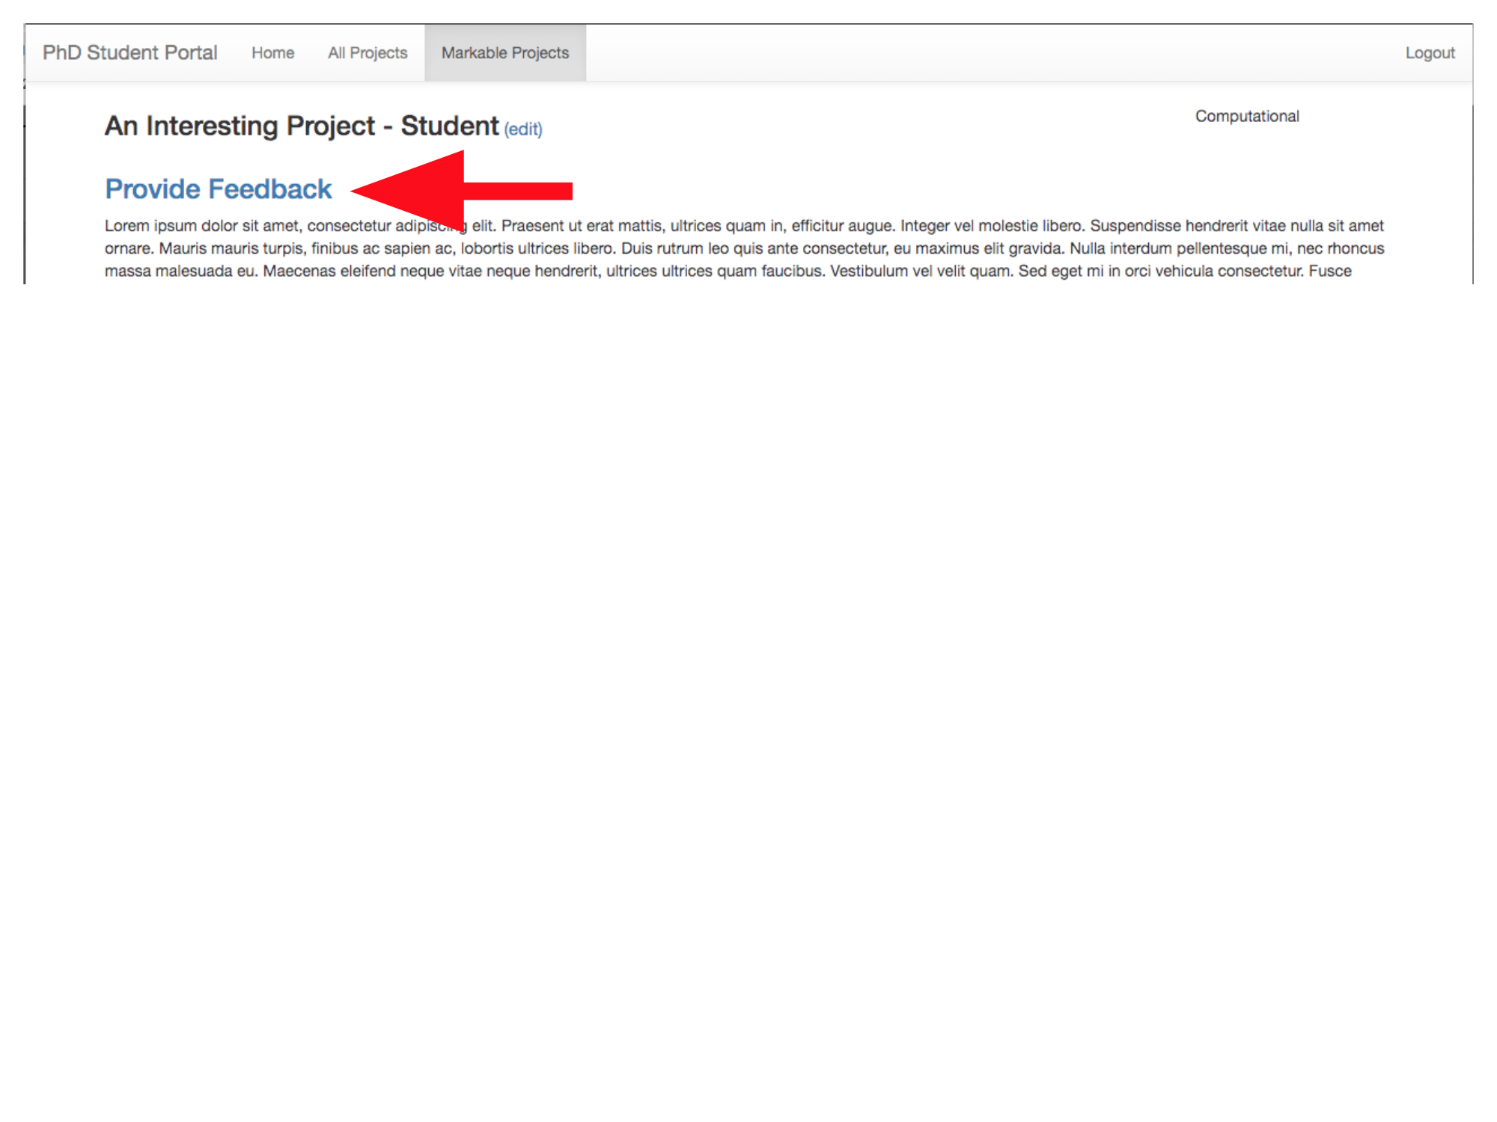

Fill in the feedback form: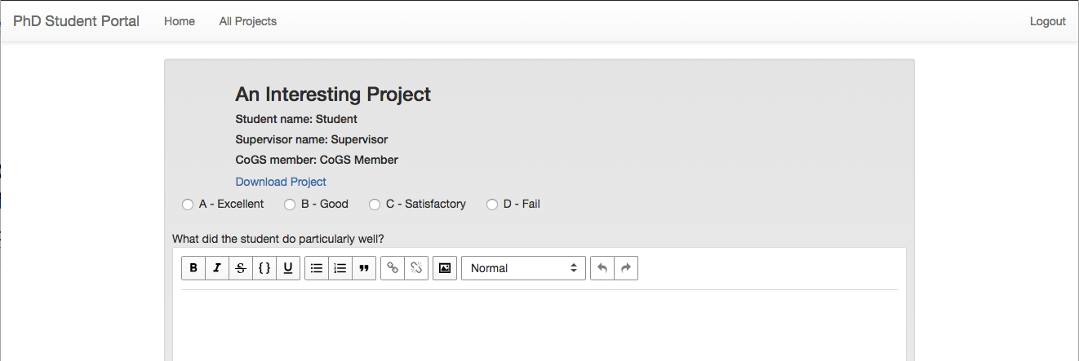

When completed, press the “Send Feedback” button: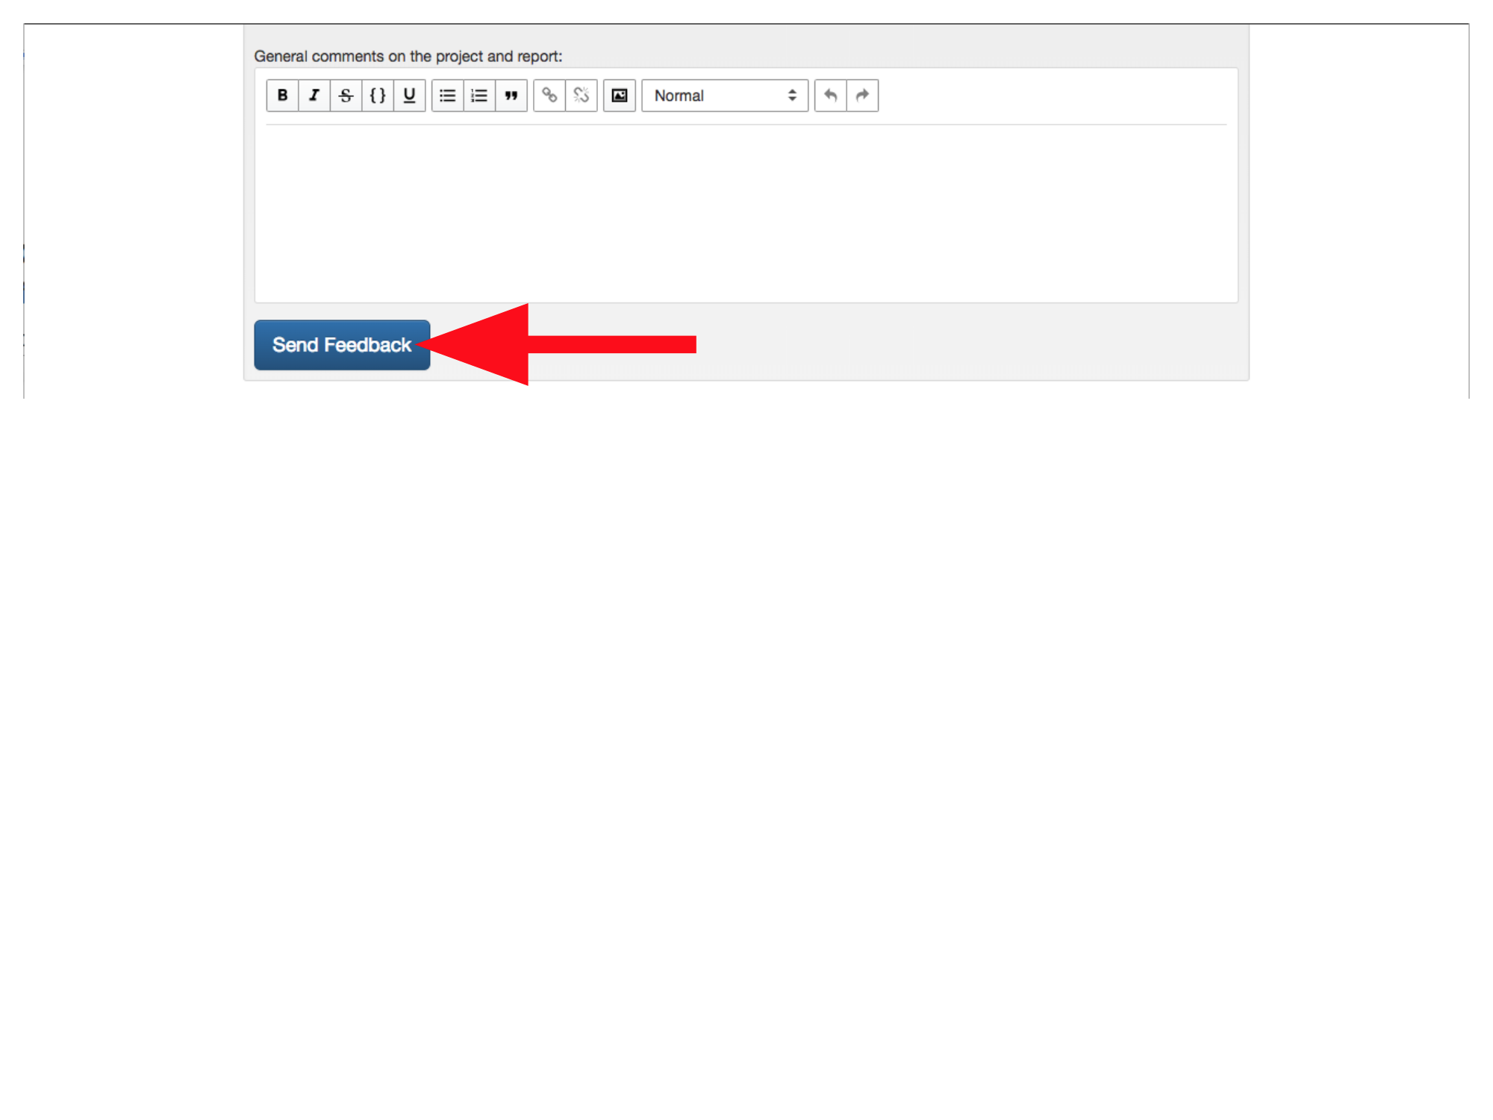

*Now: Students view project marks.*