**D.K.T.E Society’s Textile And Engineering Institute, Ichalkaranji.**

**(An Autonomous Institute, Affiliated to Shivaji University, Kolhapur)**

**Accredited with ‘A+’ Grade by NAAC**

Department of Computer Science & Engineering (Artificial Intelligence) 2023-24

THE MINI-PROJECT

Prediction of Jobs in Engineering & Technology with respect to skills & past grades

UNDER THE GAUIDENCE OF

Mr. S.D. RANE sir

Team Members:​

Piyusha Shinde.          21UAI059​

Prerana Shinde.        21UAI060​

Ankita Tonape.            21UAI065​

Sakshi Upadhye.        21UAI066​

Akanksha Yedrave.    21UAI072​

**D.K.T.E Society’s Textile And Engineering Institute, Ichalkaranji.**

**(An Autonomous Institute, Affiliated to Shivaji University, Kolhapur)**

Department of Computer Science & Engineering (Artificial Intelligence) 2023-24

**CERTIFICATE**

This is to certify that

|  |  |
| --- | --- |
| **Name of the students** | **PRN No.** |
| 1. Piyusha Shinde. | 21UAI059 |
| 1. Prerana Shinde. | 21UAI060 |
| 1. Ankita Tonape. | 21UAI065 |
| 1. Sakshi Upadhye. | 21UAI066 |
| 1. Akanksha Yedrave. | 21UAI072 |

Have successfully completed the mini project work, entitled, **Prediction of Jobs in Engineering & Technology** in partial fulfilment for the award of degree of Bachelor of Technology in Computer Science and Engineering. This is the record of their work carried out during the academic year 2023-2024.

**Prof. Mr. S.D.Rane** **Prof. Dr. Mrs. L.S. Admuthe** **Prof. Dr. S. K. Shirgave**

[Project Guide] [I/C Director] [Head of Department]

**INDEX**

**CONTENTS** **PAGE**

1. Abstract 4
2. Problem Statement 5
3. Problem Description 5
4. Purpose 6
5. Scope of the Project 6
6. Requirement Analysis 7

* Functional Requirements 7
* Non-Functional Requirements 7

1. System Requirements 8

* Software Requirements 8

1. System Design 9

* Use case Diagram 10
* Sequence Diagram 11

1. Testing 12
2. Snap shots 13
3. Conclusion 18
4. References 19

**ABSTRACT**

In response to the complex decision-making landscape faced by engineering and technology students and professionals in the job market, the "Prediction of Jobs in Engineering & Technology with respect to skills & past grades" web project has been conceived. This initiative seeks to provide a solution to the challenge of career decision-making by harnessing the power of data. The web platform allows users to input their skills and past academic performance, employing advanced data analysis and machine learning algorithms to predict and recommend job opportunities aligned with their profiles. By considering technical skills, soft skills, academic achievements, and industry trends, the project aims to empower individuals with the insights needed for making informed and strategic career choices in the dynamic field of engineering and technology.

**PROBLEM STATEMENT**

"Prediction of Jobs in Engineering & Technology with respect to skills & past grades"

**PROBLEM DESCRIPTION**

* In today's rapidly evolving job market, engineering and technology students and professionals often face uncertainty when it comes to selecting a career path that aligns with their skills and academic achievements. This web project seeks to provide a data-driven solution to this problem.
* The project will involve the development of a web platform that allows users to input their skills and academic grades. These inputs will be processed using advanced data analysis and machine learning algorithms to predict potential job opportunities within the field of engineering and technology that match the user's profile. The system will consider factors such as technical skills, soft skills, academic performance, and industry trends to make accurate predictions.
* In today's rapidly evolving job market, engineering and technology students and professionals often face uncertainty when it comes to selecting a career path that aligns with their skills and academic achievements. This web project seeks to provide a data-driven solution to this problem.
* The project will involve the development of a web platform that allows users to input their skills and academic grades. These inputs will be processed using advanced data analysis and machine learning algorithms to predict potential job opportunities within the field of engineering and technology that match the user's profile. The system will consider factors such as technical skills, soft skills, academic performance, and industry trends to make accurate predictions.

**PURPOSE**

* A college placement prediction website serves as a crucial resource for students navigating the transition from academia to the professional world.
* Additionally, college placement prediction websites often provide guidance on skill development, resume building, and interview preparation to enhance a student's employability.

**SCOPE OF PROJECT**

* TECHTALENTFORCAST student placement prediction is a web portal which will ease out the process of predicting placement status for students.
* The portal has a friendly easy to use interface and various features to fulfill the main purpose of the project.

**REQUIREMENT ANALYSIS**

Software requirement is a functional or non-functional need to be implemented in the system. Functional means providing particular service to the user.

Software requirement can also be a non-functional, it can be a performance requirement.

Following are the functional and non-functional requirements of TECHTALENTFORCAST (placement prediction).

**Functional Requirements:**

* Skills assessment
* Academic performance input
* Algorithms
* Application
* Tracking

**Non-Functional Requirements:**

* Performance
* Reliability
* Maintainability
* Serviceability
* Manageability
* Data Integrity
* Usability

**System Requirements**

System requirements are the required specifications a device must have in order to use certain software.

**Software Requirements:**

**Windows:**10 or newer

**Backend:** FLASK

**Frontend:** HTML, CSS

**ML Model**: Logistic Regression Model

**SYSTEM DESIGN**

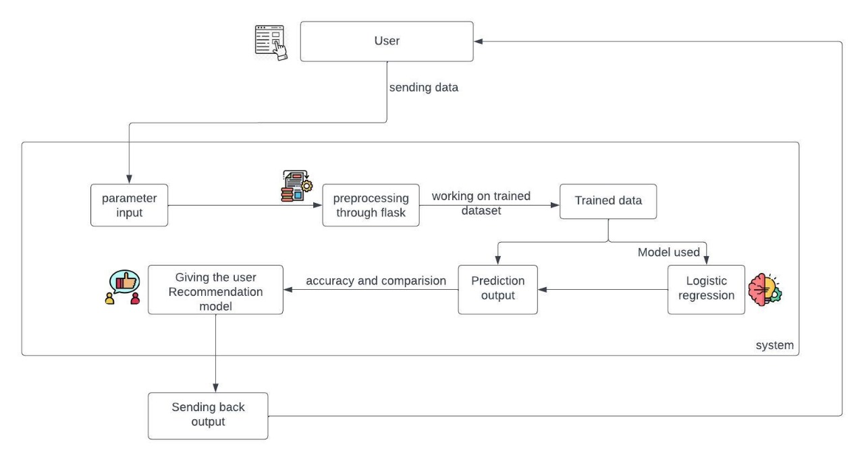

Following are the system designs for the mentioned project:

* Use case Diagram
* Sequence Diagram

**USE CASE DIAGRAM:**

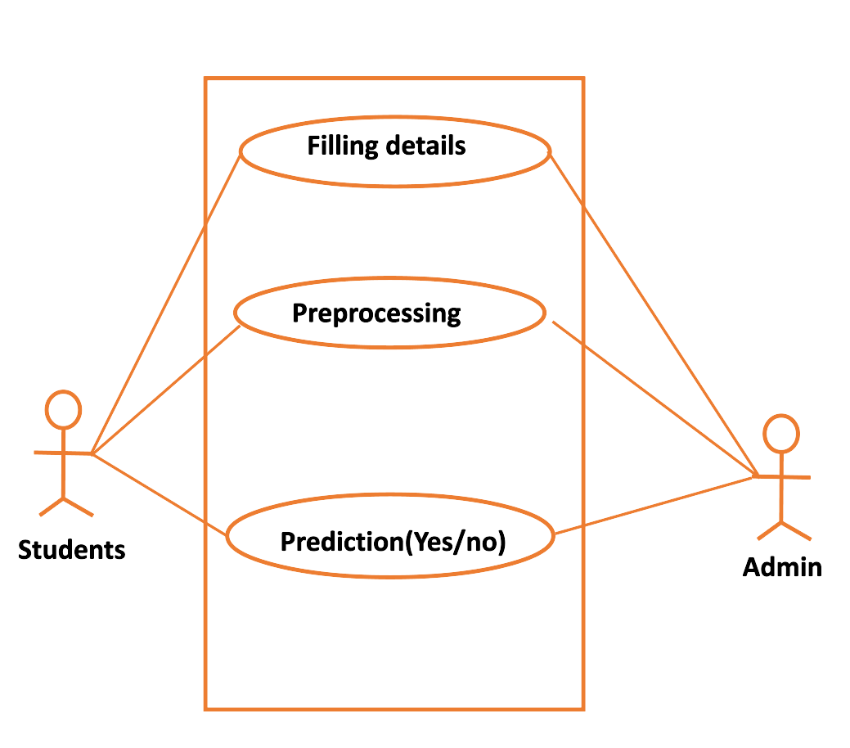

**SEQUENCE DIAGRAM:**

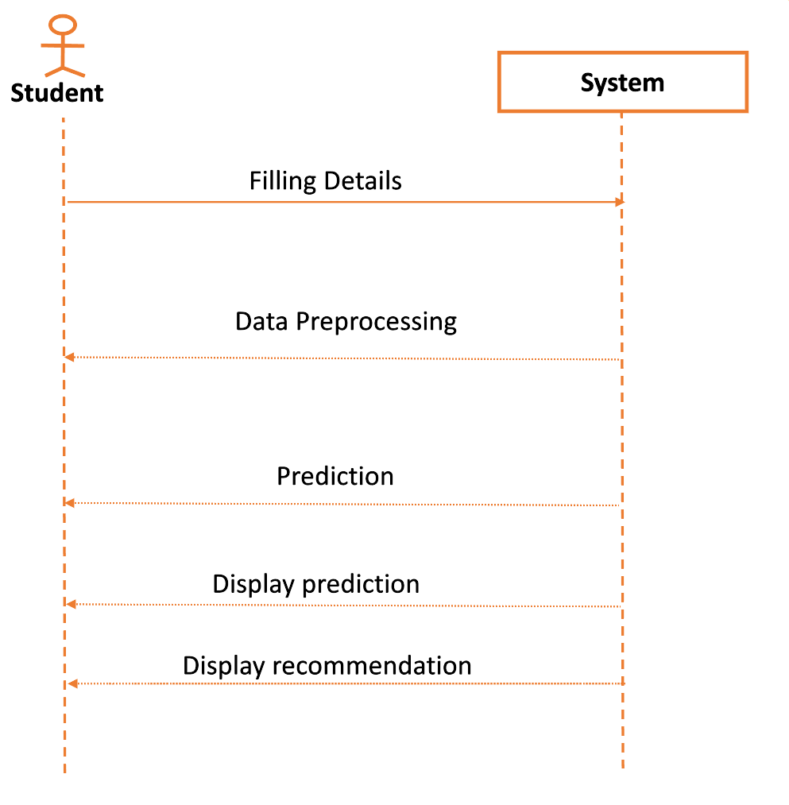

**Testing**

|  |  |  |  |  |
| --- | --- | --- | --- | --- |
| Case ID | Test Cases | Expected Output | Actual Output | Result  Pass/Fail |
| 1. | Home | * Home page of website | * Displays home page of website | Pass |
| 2. | Index | * Form for input student data | * Displays Form for input student data | Pass |
| 3. | about | * Information about website | * Displays Information about website | Pass |
| 4. | Feedback | * Feedback box | * Displays Feedback box | Pass |

**Snapshots**

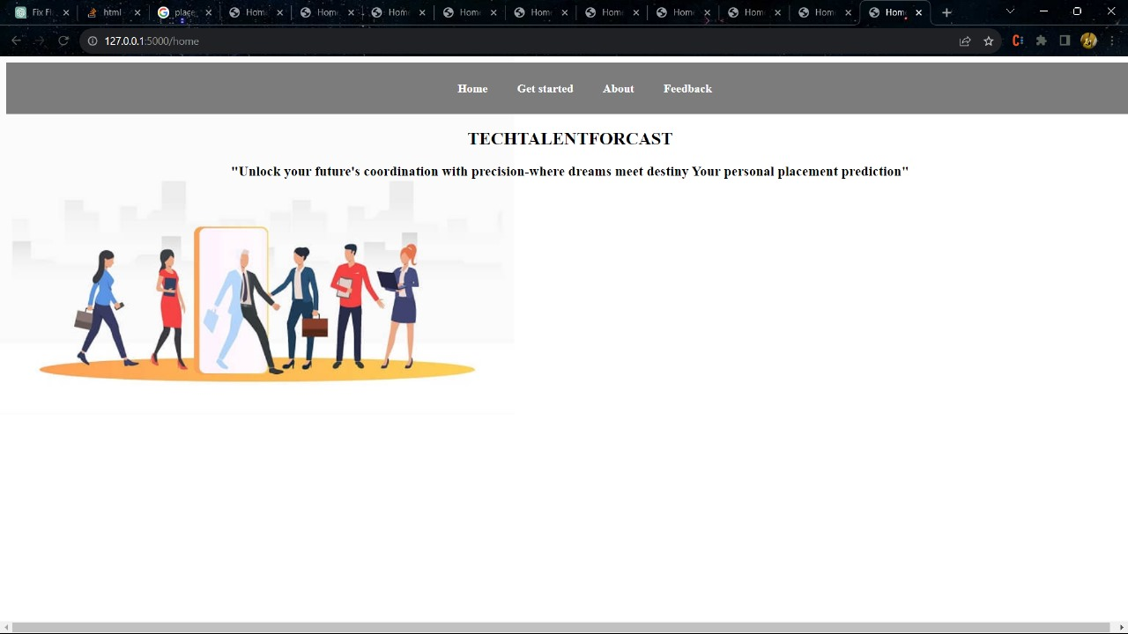

**Fig 1 :Home Page**

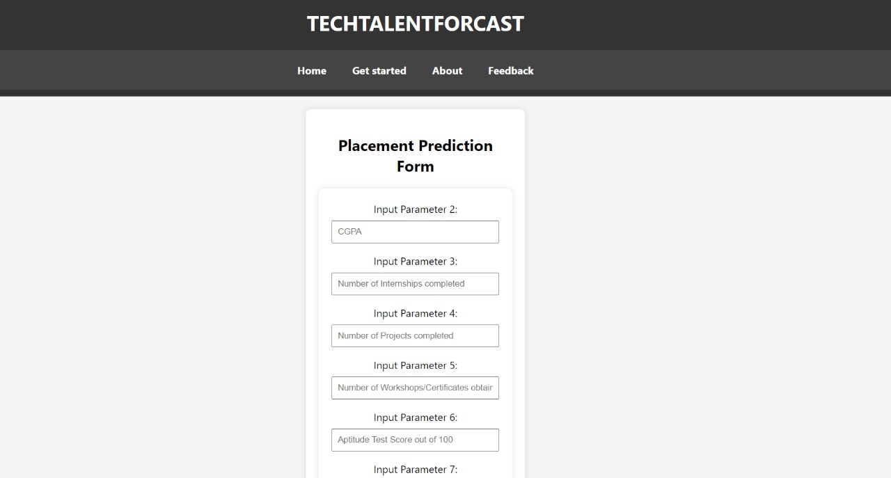

**Fig 2 : Get started**

Implementation:

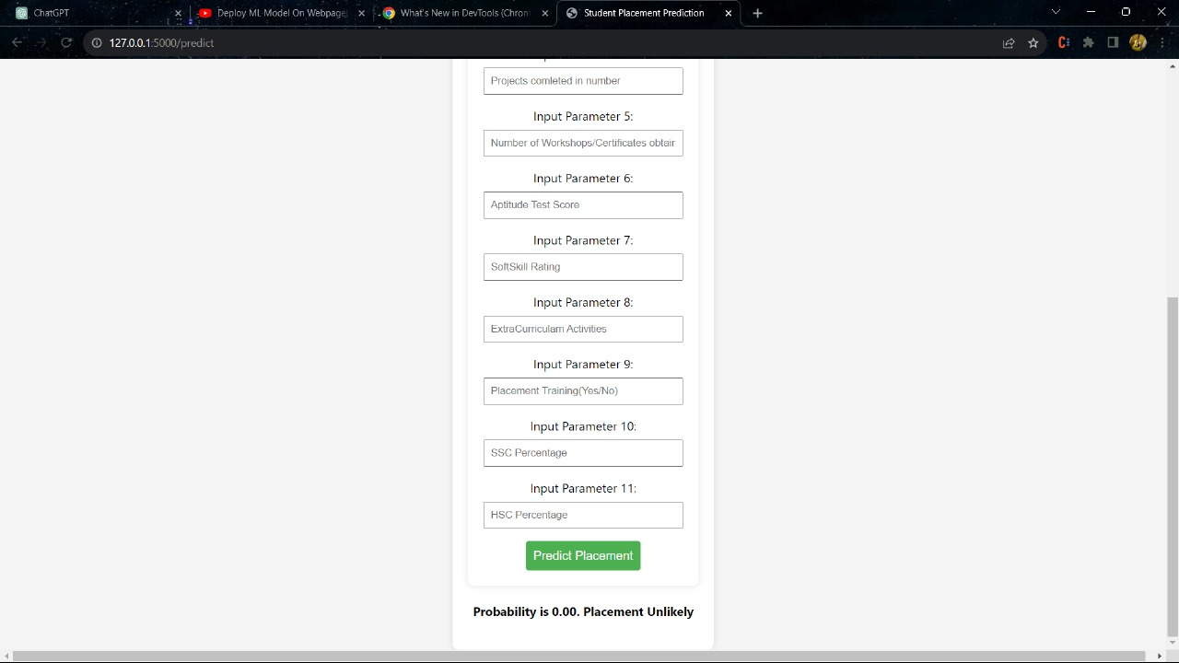 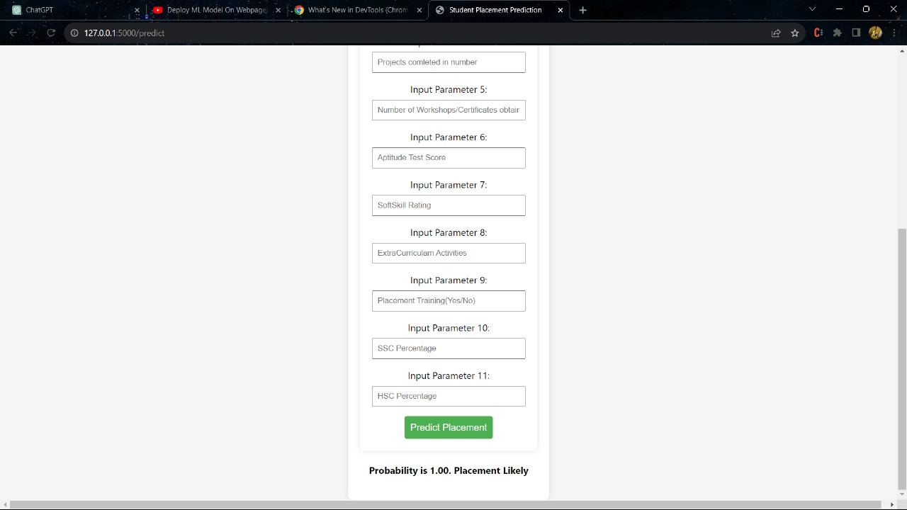

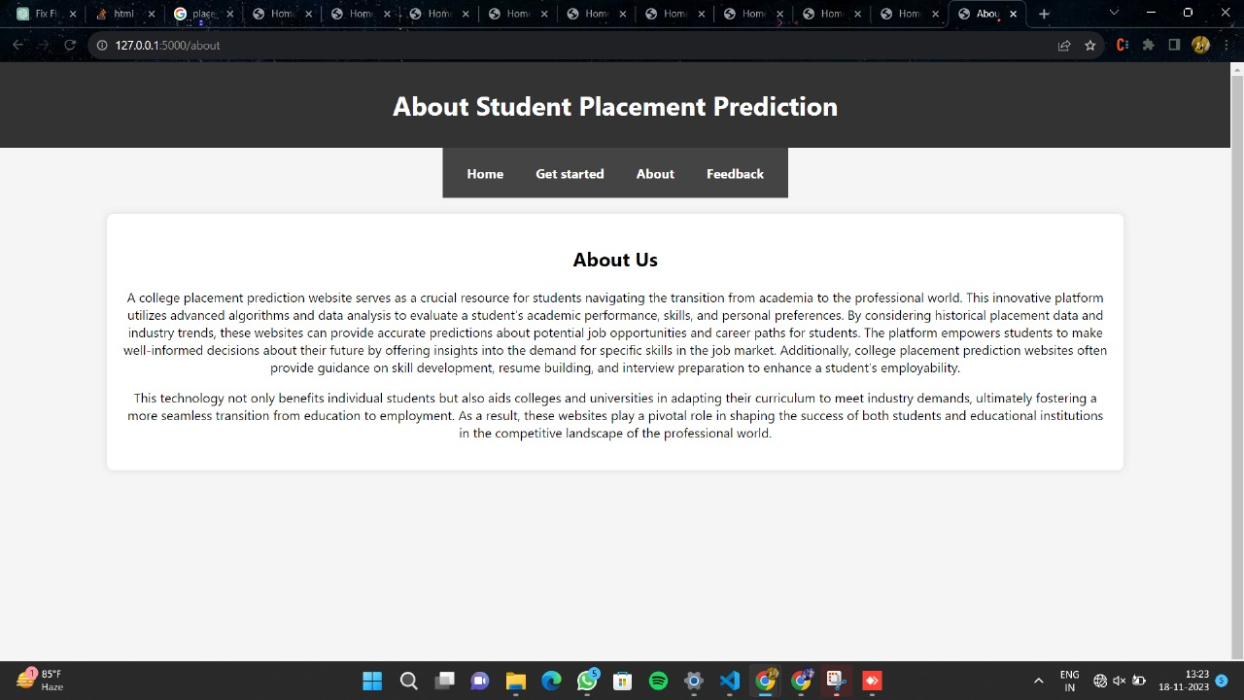

**Fig 3 :About**

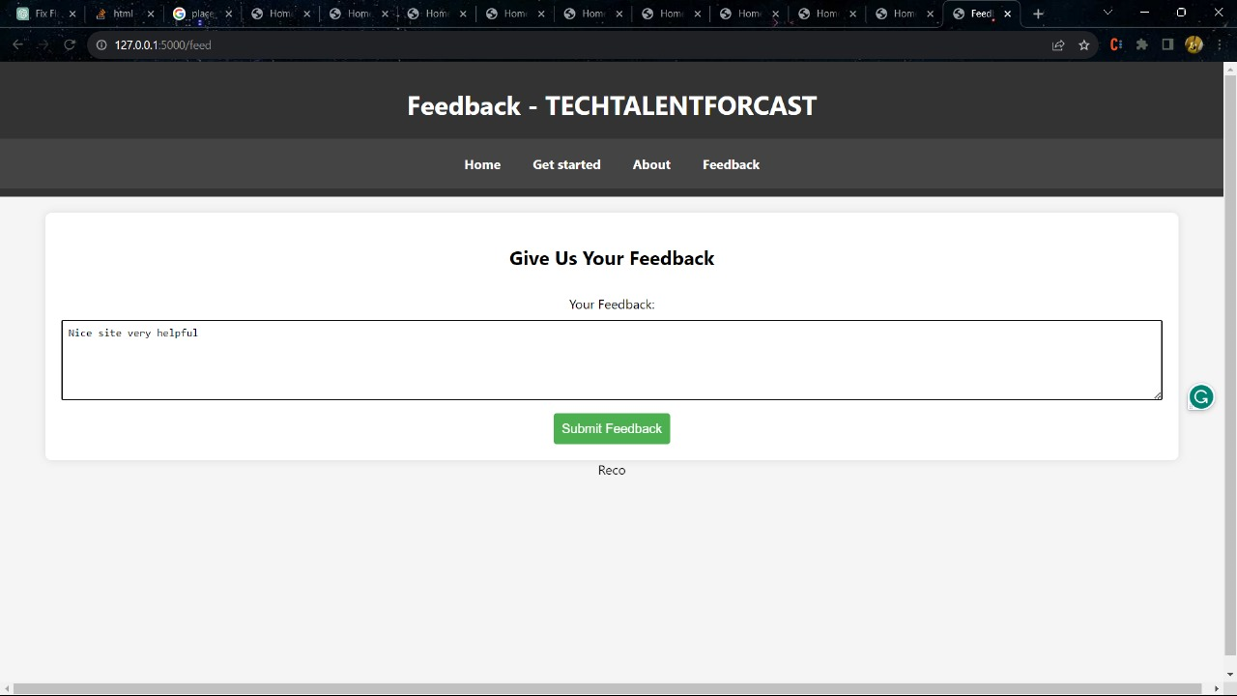

**Fig 4 :Feedback**

**CONCLUSION**

The "Prediction of Jobs in Engineering & Technology" web project endeavors to assist engineering and technology in informed career decision-making. Leveraging user skills and past academic performance, the project aims to predict placement probability, providing a valuable tool for navigating the complex landscape of career choices in the engineering and technology fields.

**REFERENCES**

<https://www.kaggle.com/>

<https://www.w3schools.com/>

<https://www.javatpoint.com/>