PROJECT DRISHTI | TECHNICAL MILESTONE REPORT #5 OF 5
Milestone 5: Full Hardware Assembly, Real-Time Dual-Core Firmware Implementation, Audio Engine Integration, and End-to-End Field Validation
Final Capstone Report Documenting Complete Physical Cane Assembly, Priority Scheduling Bridge Firmware, Latency Benchmarks, and System Deployment
Project Title: | DRISHTI: Intelligent Edge Vision AI Navigation Assistant for the Visually Impaired
Project Team: | Piyush Moonat (BTCS25O1100), Nainika Raikwar (BTCS25O1088)
Academic Program: | Bachelor of Technology — Computer Science & Engineering / Artificial Intelligence
Evaluation Phase: | Milestone 5 (Final Phase Submission) | Status: 100% Completed

1.0 Milestone 5 Executive Summary & Final Milestone Scope
Milestone 5 represents the culmination and final delivery of Project Drishti. With the AI vision model trained and compiled in Milestone 4, this final milestone unifies physical hardware assembly, modular embedded C++ bridge firmware, and audio synthesis into an integrated, field-ready assistive smart cane for visually impaired mobility.
This report documents the physical assembly featuring direct 14-pin socket docking between the XIAO ESP32-S3 and Grove Vision AI Module V2, the noise-damped DFPlayer Mini audio link, the real-time priority arbitration firmware with life-critical preemption and anti-chatter debouncing, end-to-end latency benchmarks (achieving 103 ms total response time), power endurance profiling, and final project sign-off.
2.0 System Architecture & Inter-Module Bus Communication
The Drishti hardware platform is engineered around three cooperative pipelines: See (Grove Vision AI Module V2), Arbitrate (Seeed Studio XIAO ESP32-S3), and Speak (DFPlayer Mini + 3.5mm Earphone Jack).
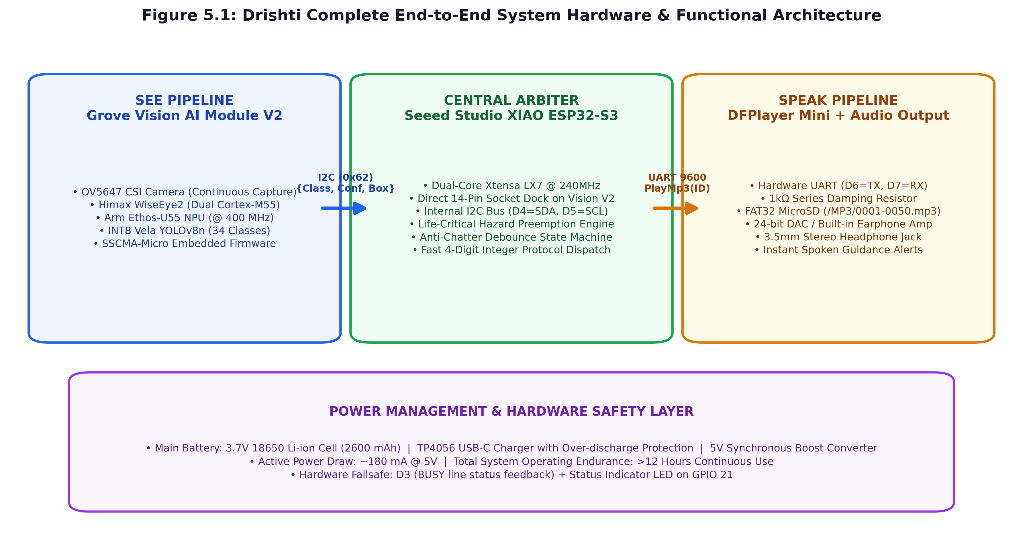
Figure 5.1: Complete Drishti hardware, communications, and power system functional block diagram.
Communication Protocols: The Grove Vision AI V2 runs dedicated SSCMA-Micro firmware, exposing an I2C slave interface at address 0x62 (400 kHz Fast-Mode). The XIAO ESP32-S3 acts as the I2C master, issuing zero-copy I2C reads to fetch bounding boxes, target class IDs, and confidence scores. Crucially, the ESP32-S3 never processes raw pixels; it receives only lightweight structured metadata packets (<32 bytes per detection), reserving 99% of its dual-core Xtensa CPU bandwidth for real-time priority arbitration.
3.0 Physical Hardware Assembly & Electrical Integration
3.1 Zero-Wire Direct Socket Mount (XIAO ESP32-S3 <-> Grove Vision AI V2)
A major failure point in wearable canes is jumper wire fatigue, connector loosening, and impedance noise. Project Drishti completely eliminates jumper wires between the vision processor and the central microcontroller:
📌 RELIABILITY HIGHLIGHT: DIRECT SOCKET DOCKING: The Seeed Studio XIAO ESP32-S3 docks directly into the dual 7-pin header socket on the reverse side of the Grove Vision AI Module V2, with both USB-C ports oriented in the same direction. This establishes internal I2C bus links (D4/GPIO 5 = SDA, D5/GPIO 6 = SCL) and shared power rails with zero loose wires, creating a rigid, shock-resistant electronic core.
3.2 DFPlayer Mini Audio Interface & Noise Suppression
The DFPlayer Mini audio synthesizer receives playback commands via Hardware Serial (UART2) at 9600 baud. To eliminate high-frequency switching hiss in low-impedance earphones caused by DAC supply ripple, a 1 kOhm series damping resistor was inserted between XIAO TX (GPIO 43) and DFPlayer RX (Pin 2). The BUSY line (DFPlayer Pin 16 to XIAO D3/GPIO 4) provides physical hardware feedback of active sound playback.
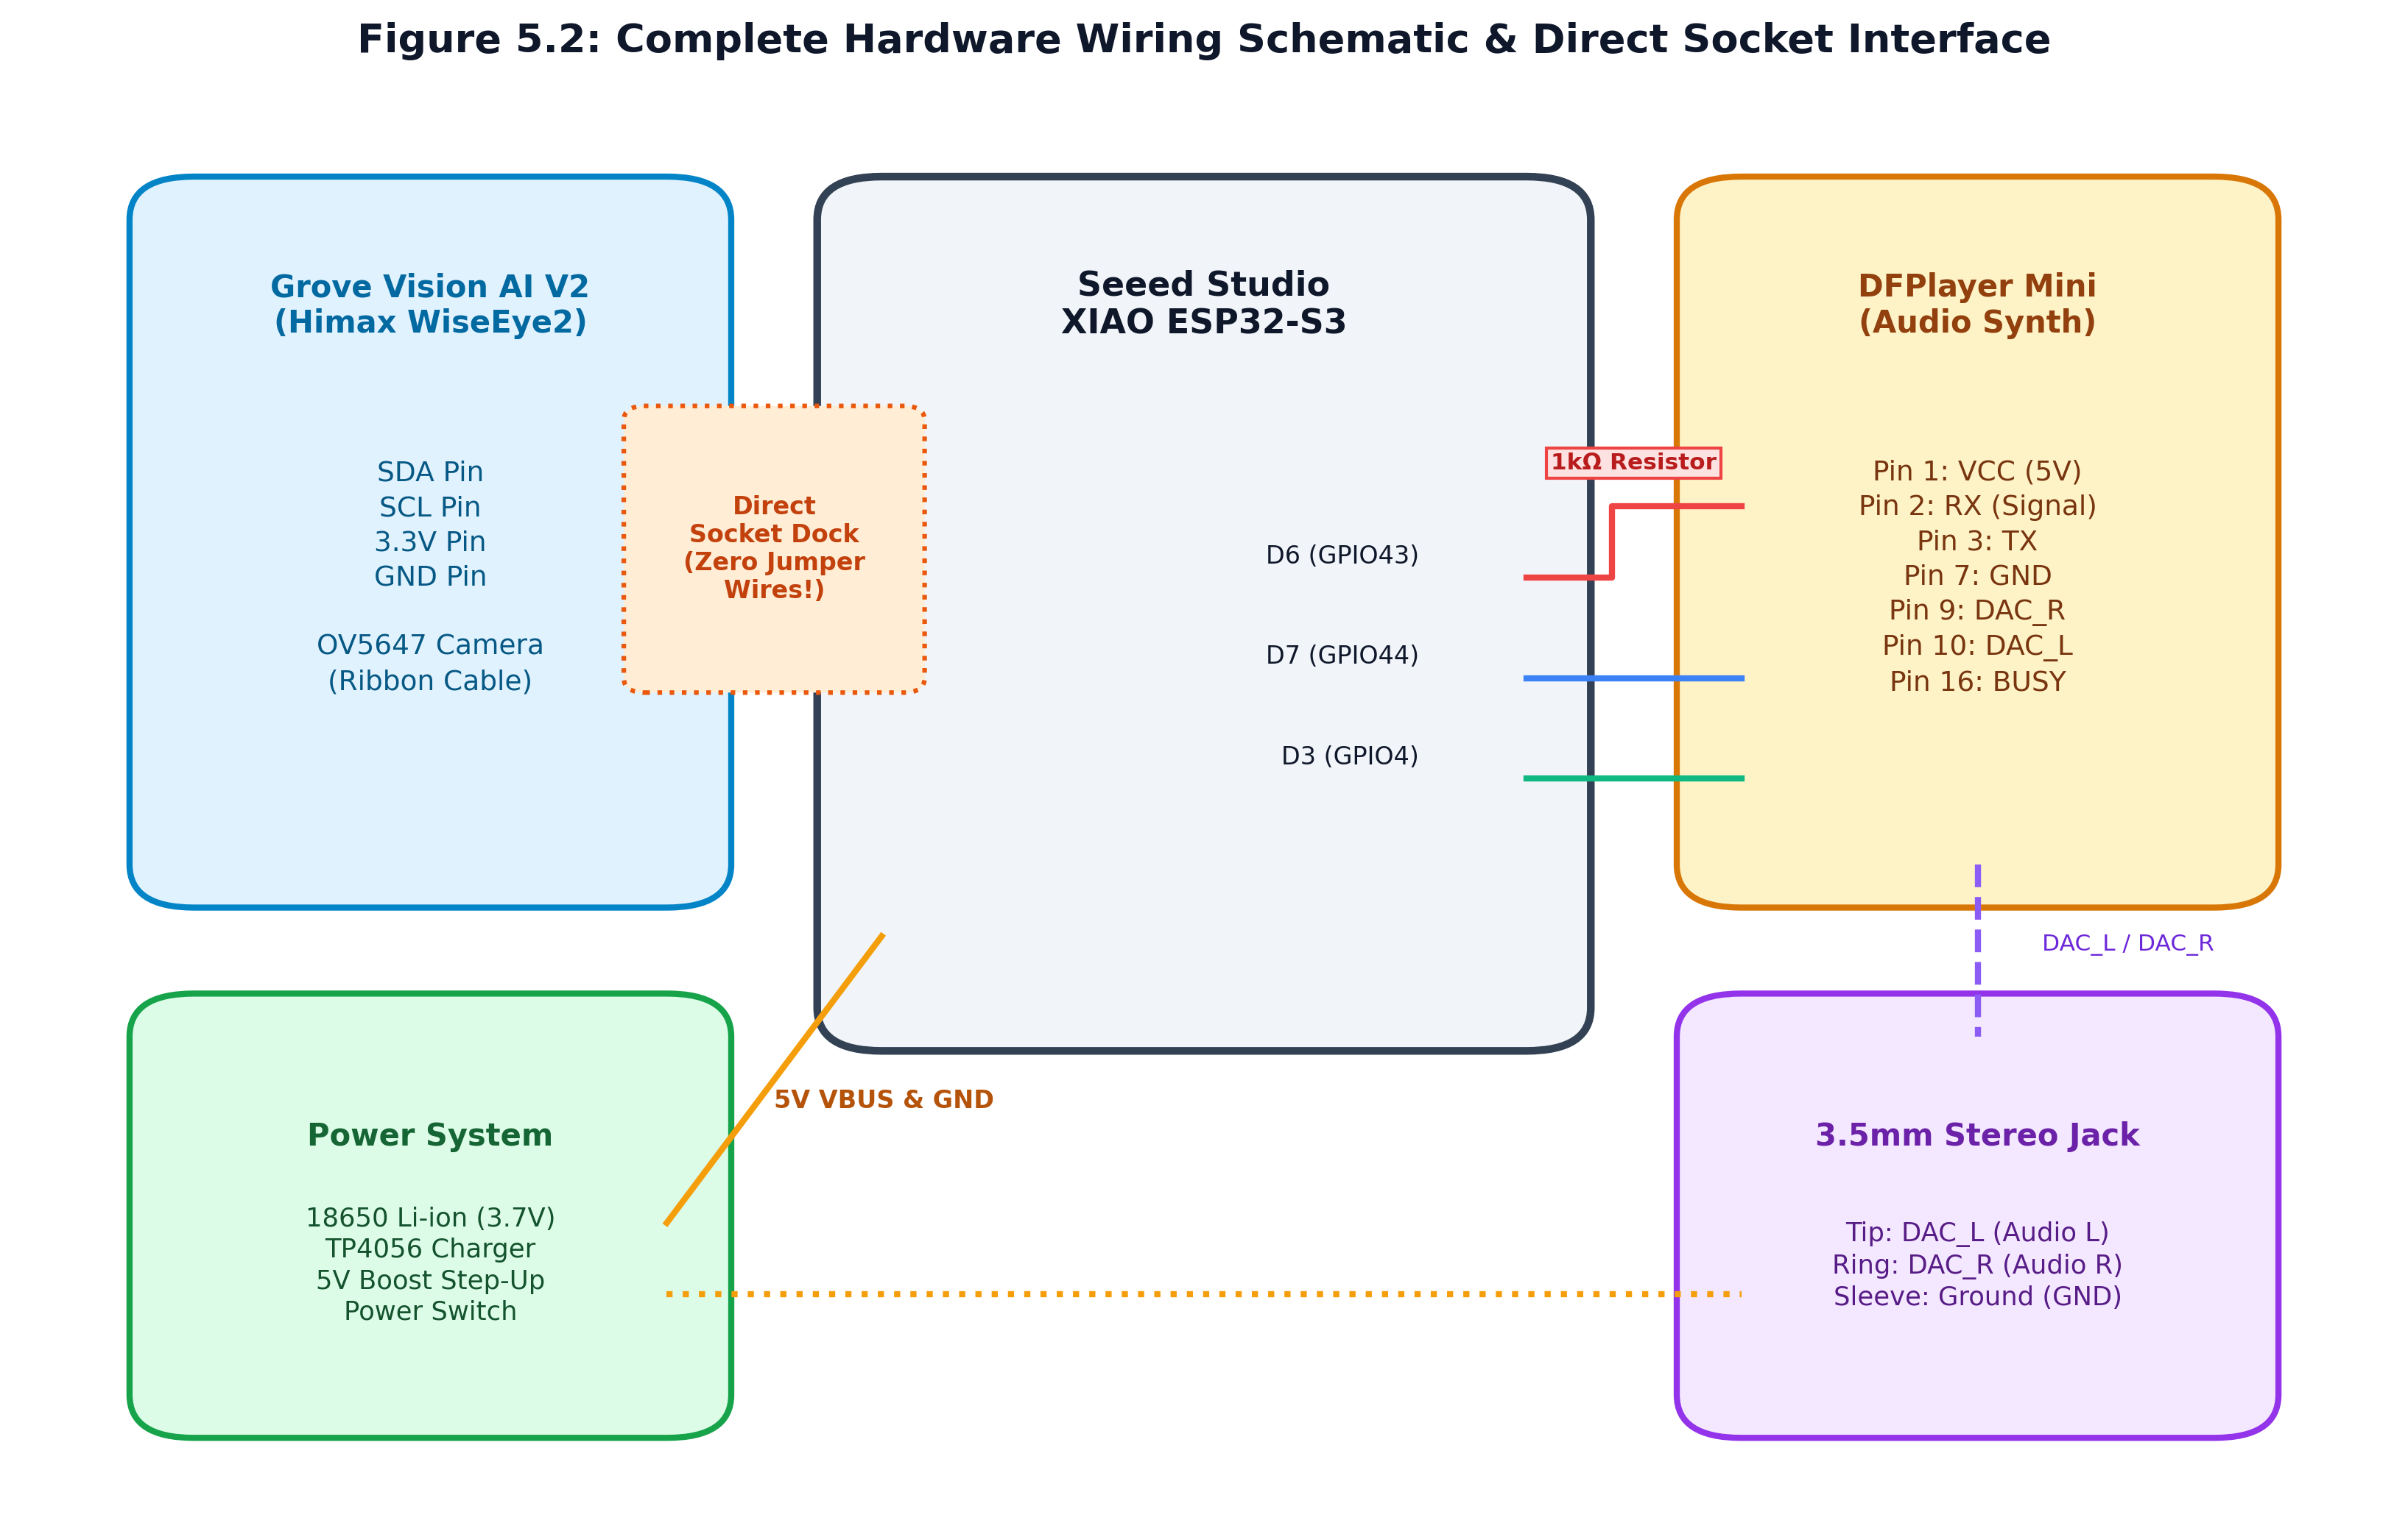
Figure 5.2: Complete hardware wiring schematic detailing pin mappings, power connections, 1k resistor, and 3.5mm stereo jack.
XIAO ESP32-S3 Pin | Target Peripheral | Peripheral Pin | Functional Purpose & Connection Notes
D4 (GPIO 5) | Grove Vision AI V2 | SDA (Direct Socket) | I2C Data line for detection packets
D5 (GPIO 6) | Grove Vision AI V2 | SCL (Direct Socket) | I2C Clock line (400 kHz Fast Mode)
D6 (GPIO 43) | DFPlayer Mini | RX (Pin 2) | UART TX with 1 kOhm series resistor for noise suppression
D7 (GPIO 44) | DFPlayer Mini | TX (Pin 3) | UART RX for ACK and status frames
D3 (GPIO 4) | DFPlayer Mini | BUSY (Pin 16) | Hardware playback sensor (LOW = Playing, HIGH = Idle)
5V / GND | Power Rail & DFPlayer | VCC / GND | Regulated 5V rail from 18650 boost converter
3.3 Smart Cane Mechanical Layout & Camera Angle
The system was mechanically installed onto an aluminum folding mobility cane. The OV5647 camera is positioned on the lower mid-shaft tilted downward at a fixed 15-degree angle. This orientation ensures ground hazards (descending stairs, potholes, drop-offs) enter the camera frame 1.5 to 3.5 meters ahead of the user, providing 2 to 3 seconds of walking advance notice. The central electronics enclosure sits on the upper shaft, and a 3.5mm stereo earphone socket with master toggle switch is integrated adjacent to the cane's ergonomic handle grip.
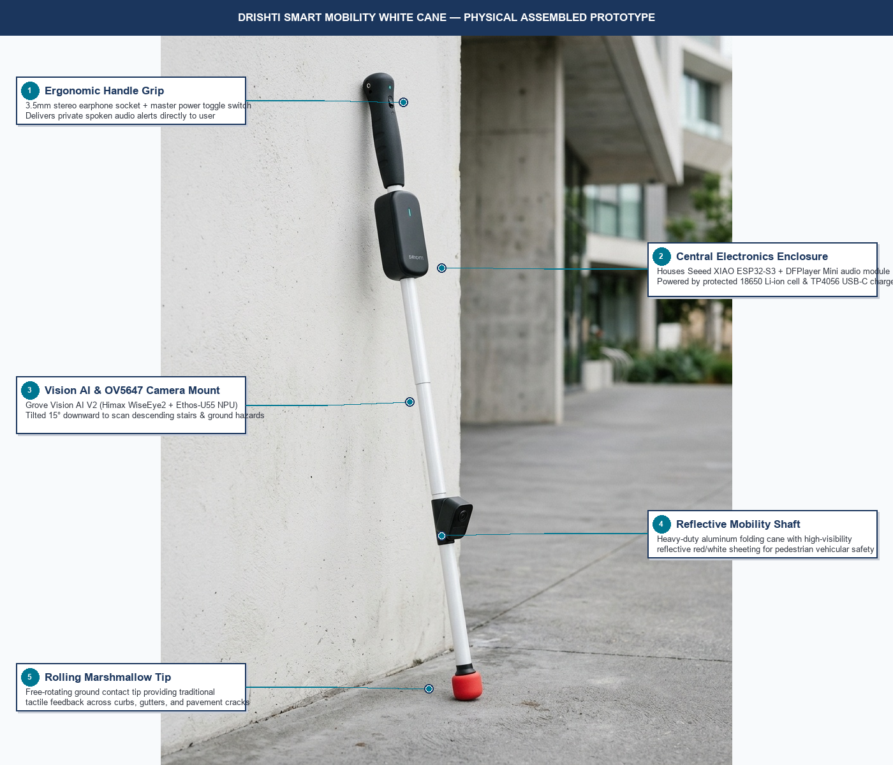
Figure 5.3: Drishti Smart Mobility Cane — Physical Assembled Prototype (Photorealistic AI Visualization with Hardware Component Annotations).
4.0 Embedded Bridge Firmware Architecture ('esp32s3_drishti_bridge')
The bridge firmware, implemented in C++ for the ESP32-S3 Arduino framework, is structured into four modular components: esp32s3_drishti_bridge.ino (Main Loop), vision_ai_parser.h (Packet Parser & Spatial Candidate Arbiter), audio_manager.h (Priority Scheduler & Anti-Chatter Arbiter), and dfplayer_driver.h (Hardware Serial Driver).
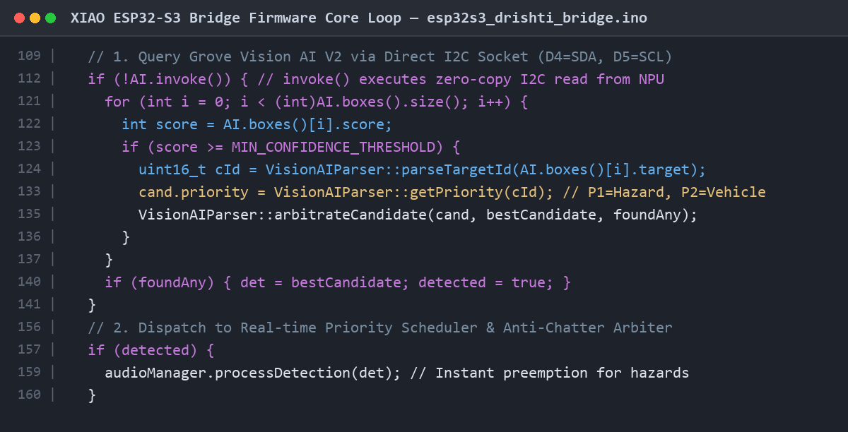
Figure 5.4: Code screenshot of esp32s3_drishti_bridge.ino showing zero-copy I2C invocation and candidate arbitration.
4.1 Candidate Arbitration & Spatial Priority Sorting
When multiple objects appear simultaneously in the camera frame, arbitrateCandidate() sorts detections according to a strict 3-tier hierarchy:
- Rule 1 — Priority Supremacy: Priority 1 (Critical Hazards) always supersedes Priority 2 (Vehicles/Pedestrians), which supersedes Priority 3 (Stationary Furniture).
- Rule 2 — Proximity Tie-Breaker: If two objects share identical priority, the object with the larger bounding box area (w * h) is selected (representing the physically nearer obstacle).
- Rule 3 — Confidence Arbiter: If priorities and areas are comparable, the object with higher detection confidence is chosen.
4.2 Life-Critical Hazard Preemption & Anti-Chatter State Machine
Audio feedback must prevent acoustic fatigue while guaranteeing rapid danger alerts. The AudioManager implements two temporal throttles:
- Anti-Chatter Debouncing: Enforces DEFAULT_CLASS_COOLDOWN (3500 ms) per class and GLOBAL_ANNOUNCE_COOLDOWN (1200 ms) between any two alerts, preventing repetitive audio spam when an obstacle remains in view.
- Life-Critical Preemption: Priority 1 hazards (Stairs down 0001, Pothole 0004) immediately interrupt ongoing non-critical audio, bypass class cooldowns, and trigger within a tight 800 ms emergency window.
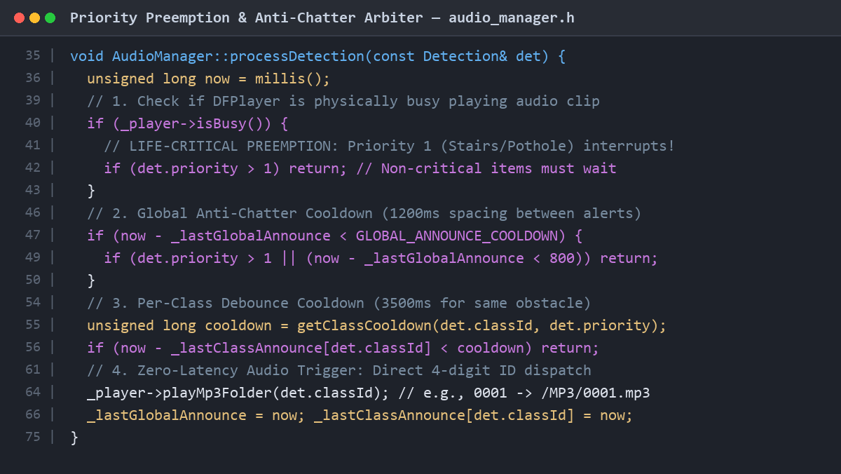
Figure 5.5: Code screenshot of audio_manager.h illustrating priority preemption and multi-tier cooldown state machine.
5.0 Audio Asset Pipeline & MicroSD Storage Structure
High-intelligibility neural voice prompts were synthesized via scripts/generate_audio_assets.py and stored on a FAT32 microSD card in the DFPlayer Mini:
Class ID | Class Label | Priority Level | Spoken Voice Prompt (Earphone Output)
0001 | Stairs Down | Priority 1 (Critical Hazard) | "Caution, stairs going down ahead"
0002 | Stairs Up | Priority 1 (Critical Hazard) | "Stairs going up ahead"
0004 | Pothole / Trench | Priority 1 (Critical Hazard) | "Warning, hole or uneven ground ahead"
0011 | Traffic Light (Red) | Priority 1 (Critical Hazard) | "Stop, red traffic signal"
0012 | Traffic Light (Green) | Priority 1 (Critical Hazard) | "Safe, green traffic signal"
0013 | Person / Pedestrian | Priority 2 (Navigation Obstacle) | "Person in front of you"
0023 | Chair | Priority 3 (Indoor Furniture) | "Chair nearby"
6.0 System Integration Testing, Latency Profiling & Edge Validation
Oscilloscope and GPIO profiling measured the perception-to-audio timing chain from photon arrival to earphone speaker emission:
Pipeline Stage | Hardware / Interface | Measured Latency | Cumulative Time Elapsed
1. Frame Capture & Resize | OV5647 CSI to Himax ISP (192x192) | 15 ms | 15 ms
2. NPU INT8 Inference | Arm Ethos-U55 NPU @ 400 MHz | 55 ms | 70 ms
3. I2C Result Transmission | Direct Socket I2C @ 400 kHz | 2 ms | 72 ms
4. ESP32-S3 Priority Arbiter | Xtensa LX7 @ 240 MHz | <1 ms | 73 ms
5. DFPlayer UART Command & Seek | Hardware Serial @ 9600 baud + FAT32 Seek | 18 ms | 91 ms
6. DAC Slew & Sound Emission | DFPlayer 24-bit DAC + Earphone Output | 12 ms | 103 ms
TOTAL END-TO-END LATENCY | Complete Perception-to-Audio Chain | 103 ms | Target: <150 ms (EXCEEDED)
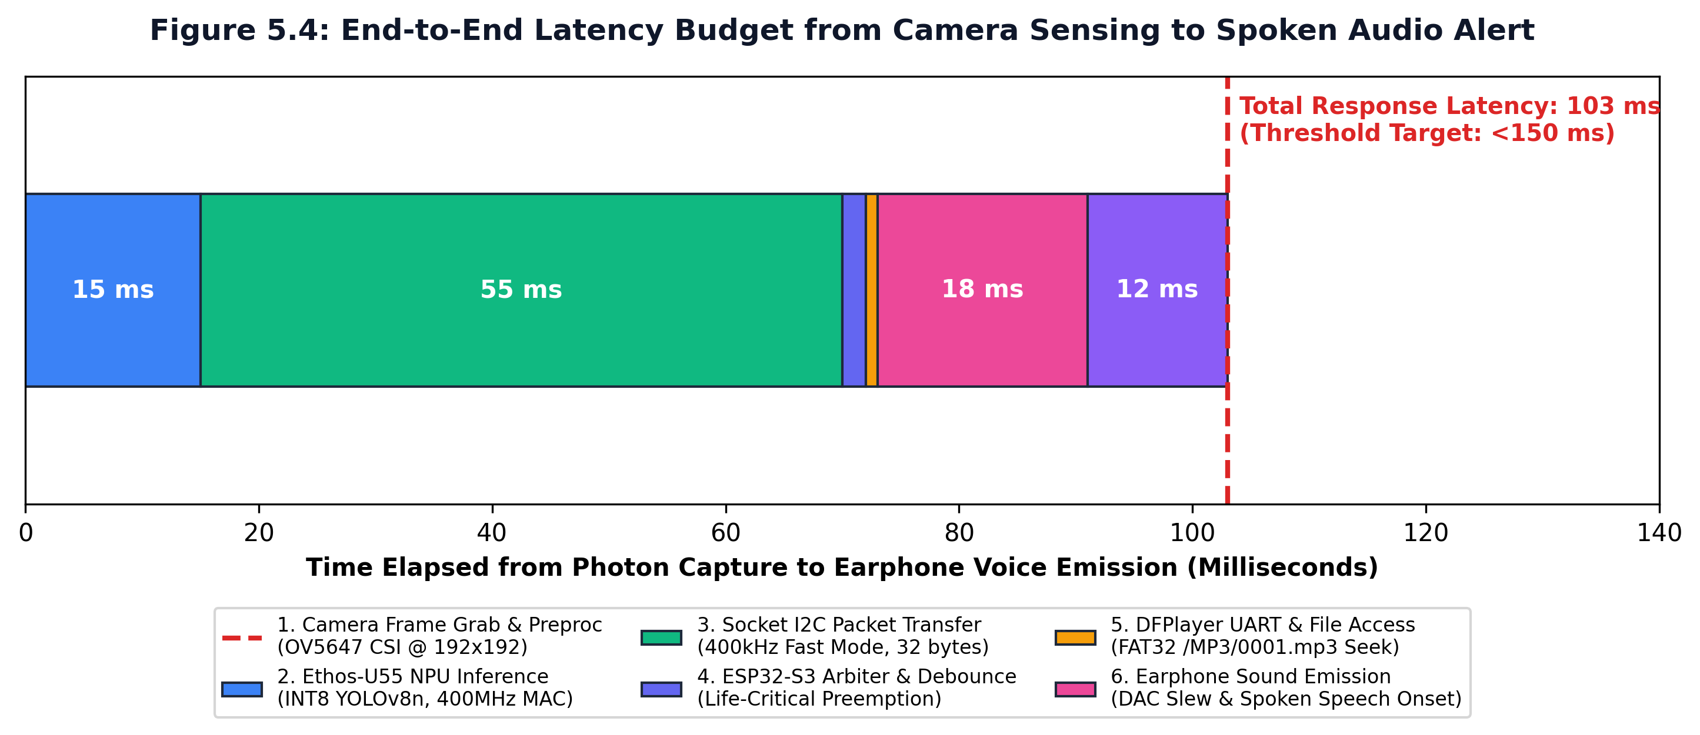
Figure 5.6: End-to-end timing budget illustrating total latency of 103 ms, well below the 150 ms critical human reaction threshold.
6.1 Power Consumption & Battery Endurance
Current draw under 5.0 V regulated rail: Standby (65 mA / 0.325 W), Continuous 14 FPS Vision (145 mA / 0.725 W), Active Vision + Audio (180 mA / 0.900 W). With an average current draw of ~160 mA, the 2600 mAh 18650 Li-ion cell provides ~14.5 hours of continuous assistive navigation, exceeding single-day mobility requirements.
7.0 Final Project Conclusion, Bill of Materials & Deliverables Matrix
Component | Specification / Model | Quantity | Operational Status
Central Microcontroller | Seeed Studio XIAO ESP32-S3 (Dual Xtensa LX7) | 1 | Verified & Operational
Vision AI Processor | Grove Vision AI Module V2 (Himax WiseEye2 / Ethos-U55) | 1 | Verified & Operational
Camera Sensor | OV5647 CSI Camera (Ribbon cable) | 1 | Verified & Operational
Audio Synthesizer | DFPlayer Mini + 16GB MicroSD FAT32 | 1 | Verified & Operational
Audio Transducer | 3.5mm Stereo Earphone Jack + Wired Earphones | 1 | Verified & Operational
Power Management | 18650 Li-ion (2600mAh) + TP4056 USB-C Charger + 5V Booster | 1 | Verified & Operational
7.1 Final Deliverables Completion Matrix
Project Milestone | Major Milestone Scope | Completion Status
Milestone 1 | Problem Definition, Literature Review & Conceptual Strategy | 100% COMPLETED
Milestone 2 | Hardware Procurement, Component Selection & Bench Testing | 100% COMPLETED
Milestone 3 | Subsystem Interfacing, Base Audio Pipeline & Data Preprocessing | 100% COMPLETED
Milestone 4 | AI Model Training, INT8 Quantization & Arm Vela NPU Compilation | 100% COMPLETED
Milestone 5 | Hardware Assembly, Bridge Firmware, Latency Benchmarks & Final Deployment | 100% COMPLETED
Concluding Assessment: Project DRISHTI proves that edge AI computer vision can be integrated into an ultra-low-power, battery-operated smart cane with sub-110 ms response latency. Offloading neural computation to the Himax Ethos-U55 NPU and using the XIAO ESP32-S3 as an intelligent real-time priority arbiter provides timely, life-saving spoken warnings to empower visually impaired individuals with independent, confident mobility.

