Project Proposal
for
Implementing DaaS

Version 1.0

Prepared by:
Team No: 11
Divya Gurnani 201306525
Lovlean Arora 201305590
Piyush Bansal 201102022
Vaibhav Gupta 201130109

Table of Contents
1. Problem Statement 1
2. Project Description 1
3. End Users 1
4. User Interaction 1
5. Block Diagram 2
6. Detailed Design Diagram 3
7. Technical Stack 3
8. Minimum Expectation from the project 4

Problem Statement
Build a platform for data as a service (data.gov.in) query the data, serve the data and results to web using json format.

Project Description
- Crawl the data on the site data.gov.in and index it. The data given to us is in csv format.
- Explore the database which we want to use such as MySQL, mongo DB, Hive, Spark.
- Provide a GUI to store the data on our servers.
- Provide the ReST API for database queries.

End Users
The data.gov.in website is designed to host information of various sectors like Agricultural based, health based, Indian statistics.

- The end users will be specific to the type of information being sought.
For eg:
Collect ambulance DB available in India- Health ministry, hospital management,patients
Construction of deep tube wells over the years– Bureaucrats of Agriculture dept, Farmers.
- Android/etc Application developers- Rajya Sabha Business App, All India Pincode Directory
- The project offers a GUI to Admin also, who can upload the new data.

User Interaction

Admin Interaction
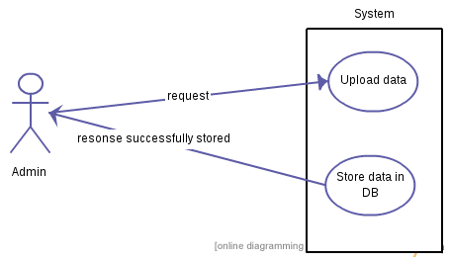

How the target user interacts with the system
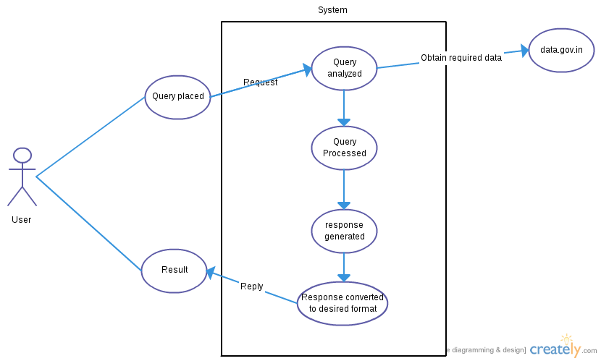

Block Diagram
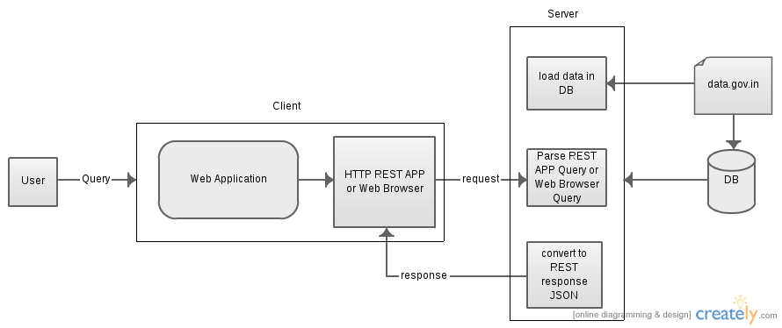

Detailed Design Diagram
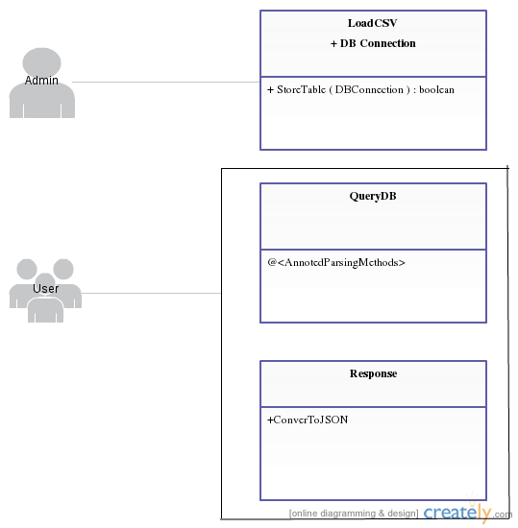

Technical Stack
The project will be based on MVC architecture.
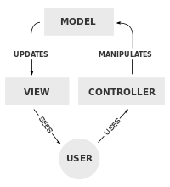

- The User interface and service will be provided by REST API
- J2EE/Web2py application, Apache/Tomcat server
- DataBase (MySQL, Hive, Spark)

Minimum Expectation from the project
User will be able to query the data and required response will be displayed in json format. As data.gov.in provide data of various sectors, we plan to cover few of them if not all.

