Food Delivery Time Prediction
Machine Learning Project
Linear Regression | Decision Tree | Random Forest | XGBoost

1. Problem Statement
Predicting food delivery time is an one of the most important problem for online delivery service.If delivery is late then, customer get unsatisfied, So if the time shown is too high, it may reduce user trust in the platform.
The goal of this project is to build a supervised machine learning regression model that correctly or accurately predict delivery time (minutes) on the basis of given information about the deliveries agent, rood conditions, environmental factors, and order characteristics.

2. Objectives
- Perform the exploratory data analysis & preprocessing(clean) on real-world delivery dataset.
- Created meaningful features like distance using GPS coordinates (haversine distance).
- Train and Test four different regression models: Linear Regression, Random Forest, Decision Tree, and XGBoost.
- Compare the performance of all models using MAE, RMSE, and R² score.
- Find the best-performing model and use it to predict delivery time on new test data.

3. Dataset Description
The dataset use in this project is a food delivery dataset which is split into train.csv and test.csv, It containing records or information of individual deliveries done by delivery agents in across various cities.

Attribute | Details
Source | Kaggle Dataset
Target Variable | Time_taken(min) — delivery duration (minutes)
Train Size | ~45,000 records (80% training, 20% validation)
Test Size | ~11,000 records
Total Features | 12 features after preprocessing the dataset
Feature Types | Numerical, categorical, and some created features (like GPS distance)

3.1 Selected Features
- Delivery_person_Age — Age of the delivery person or agent
- Delivery_person_Ratings — Customer rating of the agent
- distance_km — Haversine distance (engineered from GPS coordinates)
- order_hour — Hour of day extracted from timestamp
- Vehicle_condition — Condition score of the delivery vehicle
- multiple_deliveries — Whether agent is handling multiple orders
- Weatherconditions, Road_traffic_density, Type_of_order, Type_of_vehicle, Festival, City — Encoded categoricals

3.2 Target Variable Analysis (Graph 1)
The histogram and boxplot below show the distribution of delivery times across the training set, including mean and median markers.

Figure 1 · Delivery Time Distribution
Histogram with Mean & Median lines | Boxplot of Time_taken(min)
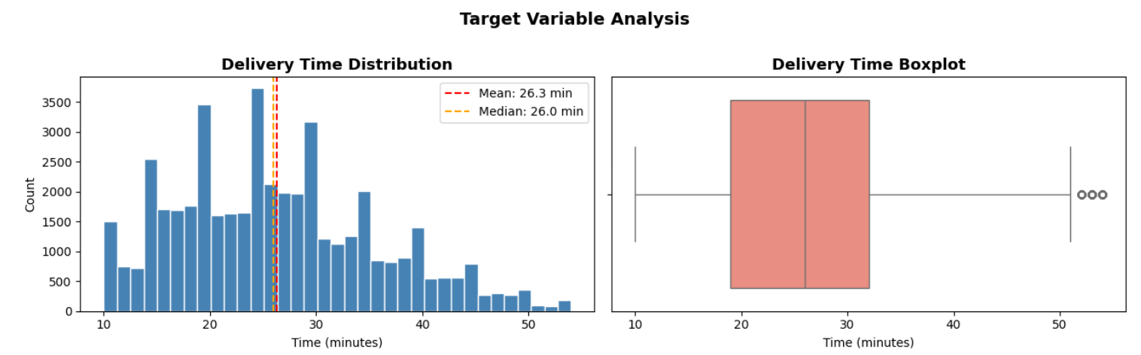
↑ Paste / insert your graph image here ↑

3.3 Feature vs Delivery Time (Graph 2)
This scatter graph shows the relationship between distance and delivery time, and the bar chart or graph shows average delivery time by traffic density level (Low / Medium / High / Jam).

Figure 2 · Distance & Traffic vs Delivery Time
Scatter — distance_km vs Time_taken(min) | Bar — Avg time by Road_traffic_density
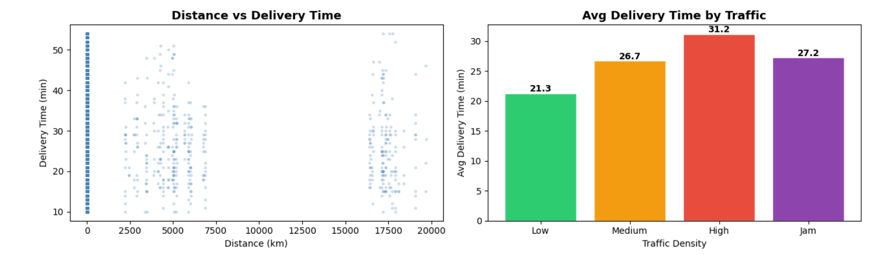

4. Methodology
The project follows a standard supervised machine learning pipeline with 8 key stages as mention below:

Step | Stage | Description
Step 1 | Data Loading | Load train.csv and test.csv into pandas. Check shape, Size, data types, and missing values.
Step 2 | Data Cleaning & Preprocessing | Clean the data by removing spaces, converting target to numeric, and Fill missing values for age, ratings, and multiple deliveries.
Step 3 | Feature Engineering | Compute haversine distance (km) from GPS coordinates. Extract order hour from time.
Step 4 | Encoding & Scaling | Convert 6 categorical columns data into numbers using LabelEncoder. Apply StandardScaler(Scaling) for Linear Regression only.
Step 5 | Train / Validation Split | Split data into 80% training and 20% validation (random_state=42) → ~36,000 training and ~9,000 validation samples.
Step 6 | Model Training | Train different model : Linear Regression, Decision Tree (max_depth=8), Random Forest (100 trees), XGBoost (200 estimators).
Step 7 | Evaluation & Comparison | Check model performance using MAE, RMSE, and R². Compare models or results using with bar charts.
Step 8 | Prediction & Submission | Make predictions on test data set.
.

5. Models & Hyperparameters
Model | Key Hyperparameters | Scaling
Linear Regression | Default (no regularisation) | Yes — StandardScaler
Decision Tree | max_depth=8, min_samples_leaf=20 | No
Random Forest | n_estimators=100, random_state=42 | No
XGBoost | n_estimators=200, lr=0.05, max_depth=6, subsample=0.8 | No

5.1 Additional Techniques
- Haversine Formula — geodesic distance from lat/lon pairs
- Label Encoding — fitted on combined train+test to prevent unseen-label errors
- 80/20 Train/Validation Split — random_state=42
- Feature Importance — extracted from Random Forest

5.2 Decision Tree Structure (Graph 3 — Tree Diagram)
The diagram below visualises the top 3 levels of the trained Decision Tree, showing the split conditions, feature names, and colour-coded leaf nodes.

Figure 3 · Decision Tree — Top 3 Levels
Full tree diagram rendered with sklearn plot_tree(), max_depth=3, filled=True
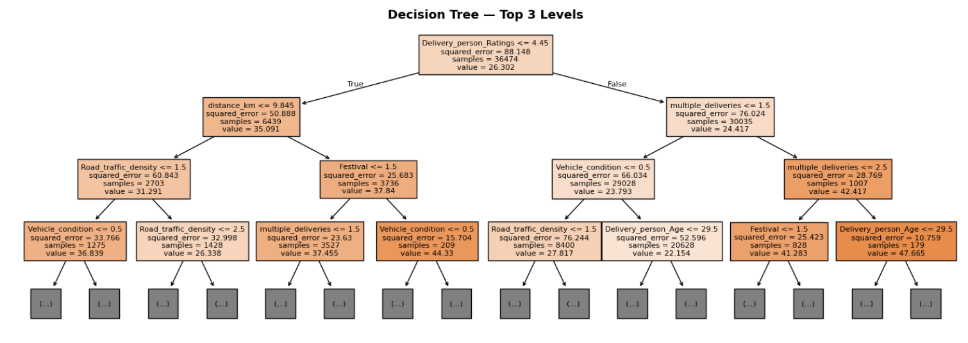
↑ Paste / insert your graph image here ↑

6. Results & Discussion
All four models were evaluated on the held-out validation set (20% of training data):

Model | MAE (min) | RMSE (min) | R² Score | Rank
Linear Regression | ~5.63 | ~7.05 | ~0.43 | 4th
Decision Tree | ~3.46 | ~4.38 | ~0.78 | 3rd
Random Forest | ~3.21 | ~4.06 | ~0.812 | 2nd
XGBoost ★ | ~3.17 | ~3.98 | ~0.819 | 1st

6.1 XGBoost — Actual vs Predicted (Graph 4)
The scatter plot compares actual vs predicted delivery times for XGBoost. The residual histogram shows the error distribution centred near zero.

Figure 4 · XGBoost: Actual vs Predicted + Residuals
Left: Scatter — Actual vs Predicted (darkorange dots + red dashed perfect-fit line) | Right: Residual histogram
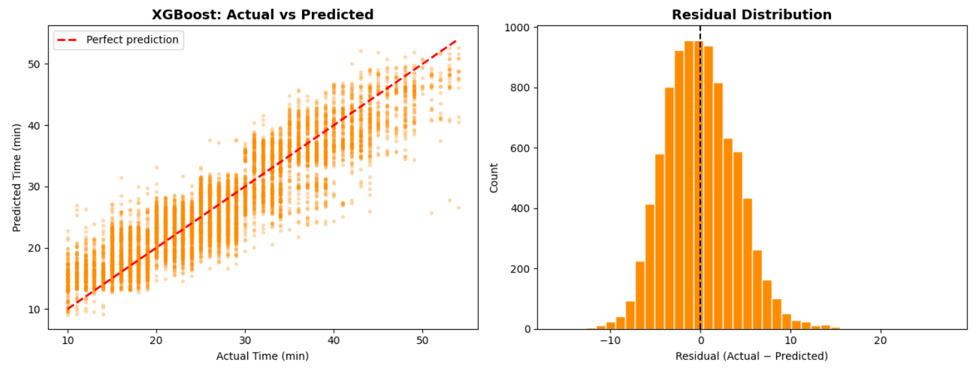
↑ Paste / insert your graph image here ↑

6.2 All Models — Performance Comparison (Graph 5)
Three horizontal bar charts compare MAE, RMSE, and R² across all four models, sorted best-to-worst per metric.
Figure 5 · All Models — MAE | RMSE | R² Comparison
Three side-by-side horizontal bar charts (steelblue / green / orange / tomato per model)
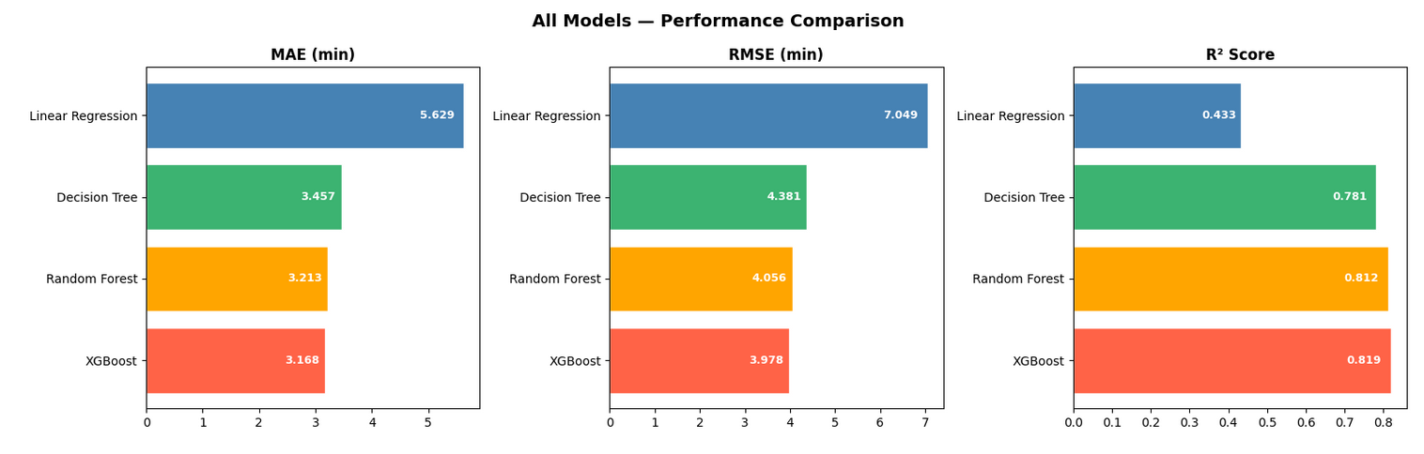
↑ Paste / insert your graph image here ↑

6.3 Feature Importance — Random Forest (Graph 6)
The horizontal bar chart ranks each feature by its importance score from the Random Forest model. distance_km, Road_traffic_density, and Delivery_person_Ratings are the top contributors.
Figure 6 · Feature Importance — Random Forest
Horizontal bars colour-coded: Red > 0.15 | Orange > 0.08 | Blue ≤ 0.08
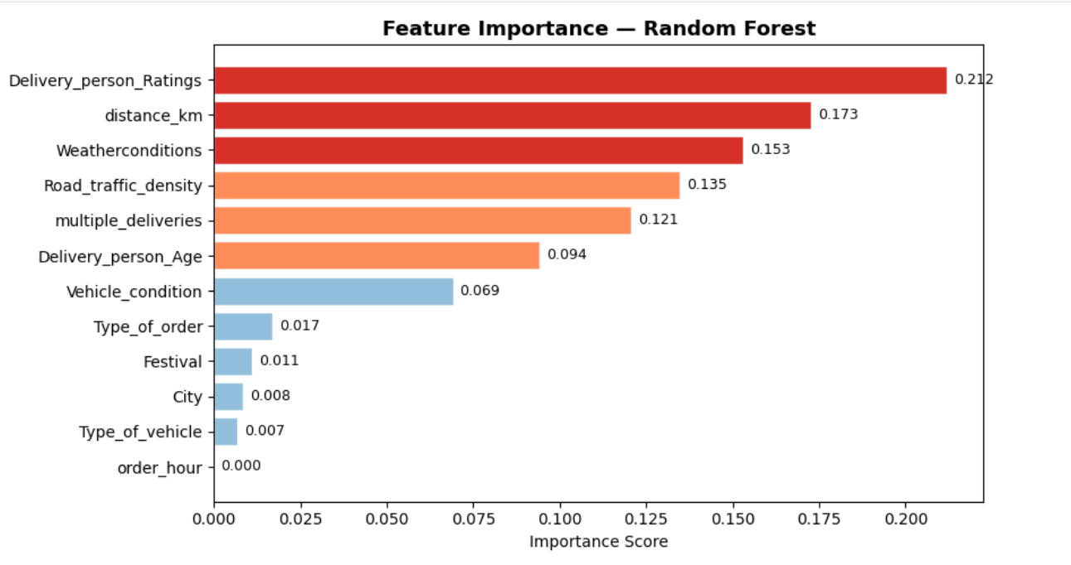
↑ Paste / insert your graph image here ↑

6.4 Key Observations
- Linear Regression (R² ≈ 0.43) shows that the data is not fully linear, so this model not perform well.
- Decision Tree improves by capturing non-linearities but it can sometimes overfit the data..
- Random Forest reduces variance by averaging 100 trees & improve Accuracy, outperforming single tree significantly.
- XGBoost is best overall — gradient boosting + regularisation (subsample=0.8) gives lowest or minimum error.
- Top most important predictors: distance_km, Road_traffic_density, Delivery_person_Ratings (from Random Forest importance).

7. Conclusion
In this project successfully developed and compared four different regression ML models for predicting food delivery time. It was observed that tree-based models perform better than linear models because the data is not purely linear..
Among all models, XGBoost Gives the best Result (R² ≈ 0.81, MAE ≈ 3.17 min), making it the recommended choice for deployment. Engineered features — haversine distance and order hour — proved to be strong predictors for Models.

7.1 Future Improvements
- Improves the model performance by tuning parameters by using GridSearchCV or Optuna
- Include the weather details in a more detailed way (as a continuous value)
- Combine the multiple models (stacking or blending) for the better accuracy
- Adding day-of-week & public holiday Features
- Deploy the model as a REST API for real-time prediction

