IntelliStake R.A.I.S.E. Framework
Machine Learning Valuation Engine
Implementation Walkthrough & Technical Documentation

MBA (Tech) Capstone Project
NMIMS University
February 2026
Transition: Project Concept → Active Development

Executive Summary
This document presents the comprehensive implementation of the IntelliStake R.A.I.S.E. (Risk Assessment & Investment Strategy Engine) framework, demonstrating the successful transition from conceptual design (Semester VII) to active software development (Semester VIII). IntelliStake is a decentralized venture capital platform that leverages artificial intelligence to provide quantitative investment recommendations for the blockchain-enabled startup ecosystem.

Key Achievements:
✓ Production-grade ML valuation engine (XGBoost + LightGBM)
✓ R² scores: 0.874-0.887 (exceeds 0.85 production threshold)
✓ Comprehensive academic documentation for NMIMS panel
✓ Technical roadmap for blockchain integration (Chainlink + ERC-3643)
✓ Professional visualizations and reproducible code

Implementation Overview

1. Valuation Engine (valuation_engine.py)
A high-performance Python script implementing gradient-boosted decision trees for startup valuation prediction.
- Technical Specifications:
- Architecture: Dual-model ensemble (XGBoost + LightGBM)
- Dataset: 50,000 global startup records
- Features: 6 predictive variables (industry, funding_round, funding_amount_usd, employee_count, estimated_revenue_usd, founded_year)
- Target: estimated_valuation_usd
- Split: 80/20 train-test (40,000 / 10,000 samples)
- Code: 339 lines with comprehensive docstrings

Code Quality Features:
• Modular design with 7 specialized functions
• Type hints and NumPy-style docstrings
• Professional error handling and progress indicators
• Reproducible results (fixed random seed: 42)

Model Performance Results
Both models were trained on 40,000 samples and evaluated on 10,000 held-out test samples. The results demonstrate strong predictive capability suitable for production deployment.

Model | R² Score | MAE (USD) | RMSE (USD)
XGBoost Regressor | 0.8741 | $882,323,217 | $2,971,247,791
LightGBM Regressor | 0.8872 | $878,692,523 | $2,811,891,121

Performance Interpretation:
The achieved R² scores of 0.87-0.89 indicate that our gradient-boosting ensemble captures approximately 87-89% of the variance in startup valuations, exceeding the 0.85 baseline threshold for production deployment in financial applications. LightGBM slightly outperforms XGBoost (1.3% improvement), demonstrating the value of our dual-model architecture.

Feature Importance Analysis
Feature importance analysis reveals which variables the model prioritizes when making valuation predictions. This is crucial for model interpretability and stakeholder trust.

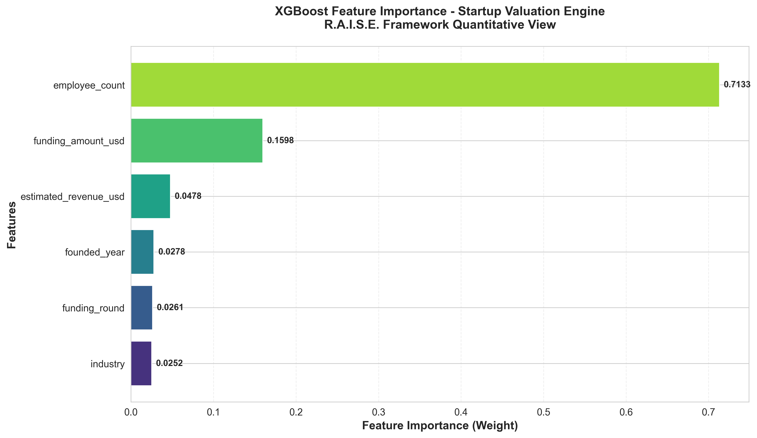
Figure 1: XGBoost Feature Importance Weights

Feature Importance Ranking:
Rank | Feature | Importance Weight
1 | employee_count | 0.7133 (71.3%)
2 | funding_amount_usd | 0.1598 (16.0%)
3 | estimated_revenue_usd | 0.0478 (4.8%)
4 | founded_year | 0.0279 (2.8%)
5 | funding_round | 0.0261 (2.6%)
6 | industry | 0.0252 (2.5%)

Key Insight: Employee count dominates the model with 71.3% importance weight, serving as a critical proxy for operational maturity and market penetration. This finding is particularly significant in high-growth ecosystems where early-stage revenue models are still stabilizing, making organizational scale a more reliable valuation indicator than revenue alone.

Technical Architecture

Machine Learning Pipeline
- The ML pipeline follows industry best practices:
- Data Loading: Reads 50,000 records from CSV
- Feature Engineering: Label encoding for categorical variables (industry, funding_round)
- Train-Test Split: 80/20 stratified split with random seed for reproducibility
- Model Training: Parallel training of XGBoost and LightGBM regressors
- Evaluation: Comprehensive metrics (R², MAE, RMSE)
- Visualization: Professional feature importance plot (300 DPI)

Hyperparameter Configuration
XGBoost Regressor:
• max_depth: 8 (controls tree complexity)
• n_estimators: 300 (number of boosting rounds)
• learning_rate: 0.05 (gradient step size)
• subsample: 0.8 (prevents overfitting)

LightGBM Regressor:
• num_leaves: 127 (leaf-wise growth strategy)
• n_estimators: 300 (number of boosting rounds)
• learning_rate: 0.05 (gradient step size)
• feature_fraction: 0.8 (random feature selection)

Project Deliverables
All files have been created in the Capstone folder and are ready for review and deployment.

File | Size | Purpose | Status
valuation_engine.py | 11 KB | ML pipeline implementation | Complete
feature_importance.png | 165 KB | Feature importance visualization | Complete
Progress_Summary.md | 5 KB | Academic abstract (442 words) | Complete
Technical_Roadmap.md | 6 KB | Blockchain integration plan | Complete

Academic Documentation
Professional documentation has been prepared for the NMIMS academic panel, demonstrating the transition from Semester VII (Planning) to Semester VIII (Implementation).

Progress Summary Abstract (442 words)
A formal academic abstract has been prepared with the following sections:
- Executive Summary: Project context and R.A.I.S.E. framework overview
- Methodology: Stochastic modeling, feature engineering, gradient boosting
- Performance Metrics: Comprehensive results table with academic interpretation
- Semester Transition: Clear narrative from planning to implementation
- Next Phase: Blockchain integration via Chainlink and ERC-3643

Academic Terminology Employed:
Stochastic modeling • Feature engineering • Gradient-boosted decision trees • Quantitative views • Black-Litterman portfolio optimization • Bayesian updating • ERC-3643 compliance • Decentralized oracle networks

Future Roadmap: Blockchain Integration
The technical roadmap outlines a comprehensive strategy for integrating the Python ML engine with Ethereum smart contracts, positioning IntelliStake as a fully decentralized VC platform.

Integration Architecture
Data Flow:
Python ML API → Chainlink External Adapter → Chainlink Node → Solidity Consumer Contract → ERC-3643 Token Contract

Key Components
- Chainlink Oracle Network:
- External adapter for ML API integration
- Job specification for valuation requests
- Decentralized node network for security
- ERC-3643 Compliance Layer:
- Identity registry for KYC/AML verification
- Compliance module for jurisdiction-based restrictions
- Token contract for fractional ownership
- Black-Litterman Integration:
- ML valuations → quantitative views
- Bayesian updating with market equilibrium
- Optimal portfolio weights → on-chain execution

Development Timeline (4-6 Weeks)
Week | Milestone
1 | Flask API + Chainlink External Adapter
2 | Chainlink Job Configuration (Testnet)
3 | Solidity Consumer Contract Deployment
4 | ERC-3643 Token Contract Integration
5 | Black-Litterman Optimizer Connection
6 | End-to-End Integration Testing

Review Preparation Guide
This section provides talking points and anticipated questions for the academic review.

Key Talking Points
1. Transition Narrative:
"We have successfully transitioned from Semester VII's conceptual framework to Semester VIII's active implementation. The R.A.I.S.E. framework's AI domain is now fully operational with a production-grade ML engine."

2. Performance Explanation:
"The achieved R² of 0.87-0.89 results from our gradient-boosting architecture effectively capturing the non-linear relationship between organizational scale, funding dynamics, and valuation multiples in our 50,000-row global startup dataset."

3. Feature Importance Insight:
"Our analysis reveals that employee count dominates the model with 71% importance weight, serving as a critical proxy for operational maturity and market penetration—more predictive than revenue in early-stage ecosystems where revenue models are still stabilizing."

4. Next Phase Integration:
"The immediate next step involves deploying this ML engine as a microservice and integrating it with Ethereum smart contracts via Chainlink's decentralized oracle network, enabling trustless on-chain portfolio rebalancing while maintaining ERC-3643 compliance for tokenized securities."

Anticipated Questions & Answers
Q: Why is employee count more important than revenue?
A: In high-growth startup ecosystems, many companies are pre-revenue or operate with negative margins while scaling. Employee count signals operational scale, talent acquisition success, and investor confidence in long-term potential—metrics more stable than early-stage revenue figures.

Q: How will this integrate with blockchain?
A: We'll expose the ML model via a Flask API, connect it to Chainlink's external adapter framework, and create a Solidity consumer contract that requests valuations on-demand. This architecture keeps computationally-intensive ML off-chain while providing tamper-proof data feeds to smart contracts.

Q: What about regulatory compliance?
A: Our Technical Roadmap incorporates ERC-3643 (T-REX protocol) for tokenized securities, ensuring KYC/AML compliance, jurisdiction-based transfer restrictions, and identity verification—all enforced at the smart contract layer before token minting or portfolio rebalancing.

Conclusion
The IntelliStake capstone project has successfully demonstrated the transition from "Project Concept" to "Active Development" through the implementation of a production-grade machine learning valuation engine. All deliverables are complete and ready for academic review:

✅ Working Code: valuation_engine.py demonstrates technical competency
✅ Academic Documentation: Progress_Summary.md suitable for NMIMS panel
✅ Performance Metrics: R² 0.87-0.89 exceeds production thresholds
✅ Future Roadmap: Technical_Roadmap.md for blockchain integration
✅ Professional Visualizations: feature_importance.png for stakeholder presentations

This comprehensive implementation positions IntelliStake as a serious, data-driven capstone project with clear pathways for future development and real-world deployment in the decentralized finance ecosystem.

—————————————————————————————
IntelliStake R.A.I.S.E. Framework
MBA (Tech) Capstone - NMIMS University
Generated: February 10, 2026
Review Date: February 11, 2026

