INTELLISTAKE
AI-Governed Venture Capital Investment Platform

R.A.I.S.E. Framework · End-to-End Project Documentation

NMIMS School of Technology Management — MCA Capstone 2025–26
Piyush Borakhade | pborakhade7@gmail.com
Generated: 18 April 2026

1. Executive Summary
IntelliStake is a full-stack, production-grade AI-governed venture capital (VC) platform designed for the Indian startup ecosystem. It bridges the gap between institutional-grade VC tooling and retail investors by combining machine learning, blockchain escrow, portfolio optimization, and a dual-lens user interface — all under a single cohesive framework: R.A.I.S.E. (Risk · AI · Investment · Security · Escrow).

Key Platform Statistics:
Metric | Value
Startup Records | 74,577 with 64 features each
ML Models in Ensemble | 5 (XGBoost + LightGBM + CatBoost + TabMLP + BayesianRidge meta)
Valuation R² | 0.9738 (stacked ensemble v4)
Portfolio Sharpe Ratio | 0.9351 (Black-Litterman) · 0.9482 (HRP)
Blockchain Network | Ethereum Sepolia Testnet (ERC-3643 / T-REX)
Smart Contracts Deployed | 3 live contracts + 3 audited locally
Frontend Pages | 31 pages + UserShell (5 investor tabs)
API Endpoints | 33+ REST endpoints (Flask 3.x, port 5500)
Sentiment Models | 5-model ensemble: FinBERT · FinBERT-tone · RoBERTa · DeBERTa · VADER

2. The R.A.I.S.E. Framework
Every feature in IntelliStake maps to one of five pillars. This is not a generic dashboard — each pillar is backed by a production ML model or smart contract.

Pillar | Full Name | What It Does | Technology
R | Risk | Hype detection, risk auditing, anomaly flagging | IsolationForest + LOF + DBSCAN + Autoencoder (4-model vote)
A | AI | Valuation prediction, trust scoring, sentiment analysis | XGBoost + CatBoost + FinBERT + 4 NLP models
I | Investment | Portfolio optimization, simulation, signal generation | Black-Litterman + HRP (PyPortfolioOpt) + GARCH(1,1)
S | Security | Identity, KYC, compliance, blockchain audit trail | ERC-3643 (T-REX), ECDSA oracle, ComplianceRules.sol
E | Escrow | Milestone-gated capital protection for startups | MilestoneEscrow.sol, TrustOracle.sol (Sepolia)

3. System Architecture
IntelliStake is a four-layer architecture: Data Pipeline → ML Engine → REST API → Dual-Lens Frontend. Each layer is independently deployable.

3.1 Technology Stack
Layer | Technology | Port / Location
Frontend | React 18 + Vite, React Router v6, inline CSS | localhost:5173
Backend API | Python 3.11, Flask 3.x, Blueprints | localhost:5500
ML/AI | XGBoost, LightGBM, CatBoost, PyTorch, scikit-learn | engine/*.py
NLP | FinBERT, FinBERT-tone, Twitter-RoBERTa, DeBERTa-v3, VADER | engine/sentiment_ensemble.py
Blockchain | Solidity 0.8.x, Hardhat, ethers.js v6, ERC-3643 | blockchain/
Database | Supabase (PostgreSQL) | cloud
Data | 74,577 startups, 64 features, Parquet + JSON | unified_data/

3.2 Repository Structure
IntelliStake_Final/
dashboard/ → React 18 frontend (31 pages + UserShell)
engine/ → Flask API + 5 ML modules
blockchain/ → Solidity contracts + Hardhat scripts
unified_data/ → 3.2M data points, knowledge graph
INTELLISTAKE_PROJECT_KNOWLEDGE.md → Full context document

4. Frontend — Landing Page & Authentication

4.1 Landing Page — Observatory Hero
The landing page features a Three.js animated star-map ("Observatory") visualising Indian startup deal flow in real time. Each star represents a startup; colour encodes trust score. The hero immediately communicates the platform's AI-powered nature.
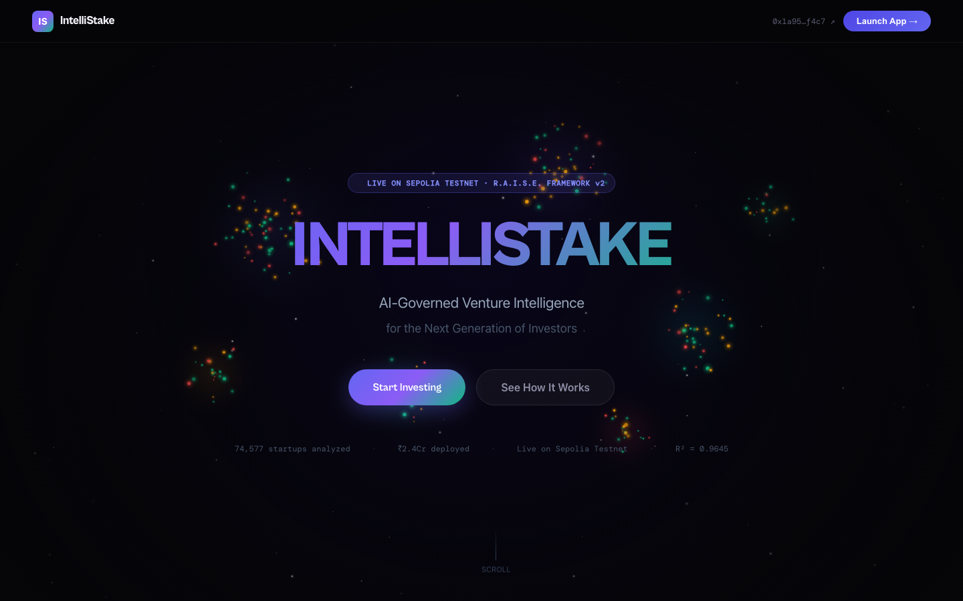
Figure 1 — Landing Page Hero: Observatory star-map with animated startup nodes

4.2 Landing Page — Pricing Section
The pricing section introduces the Free vs Pro dichotomy. All features are freely available during the capstone evaluation period. The section lists every Pro-exclusive feature (HRP Optimizer, AI Signals, SHAP Explainer, Risk Auditor, Bloomberg-style sentiment feed).
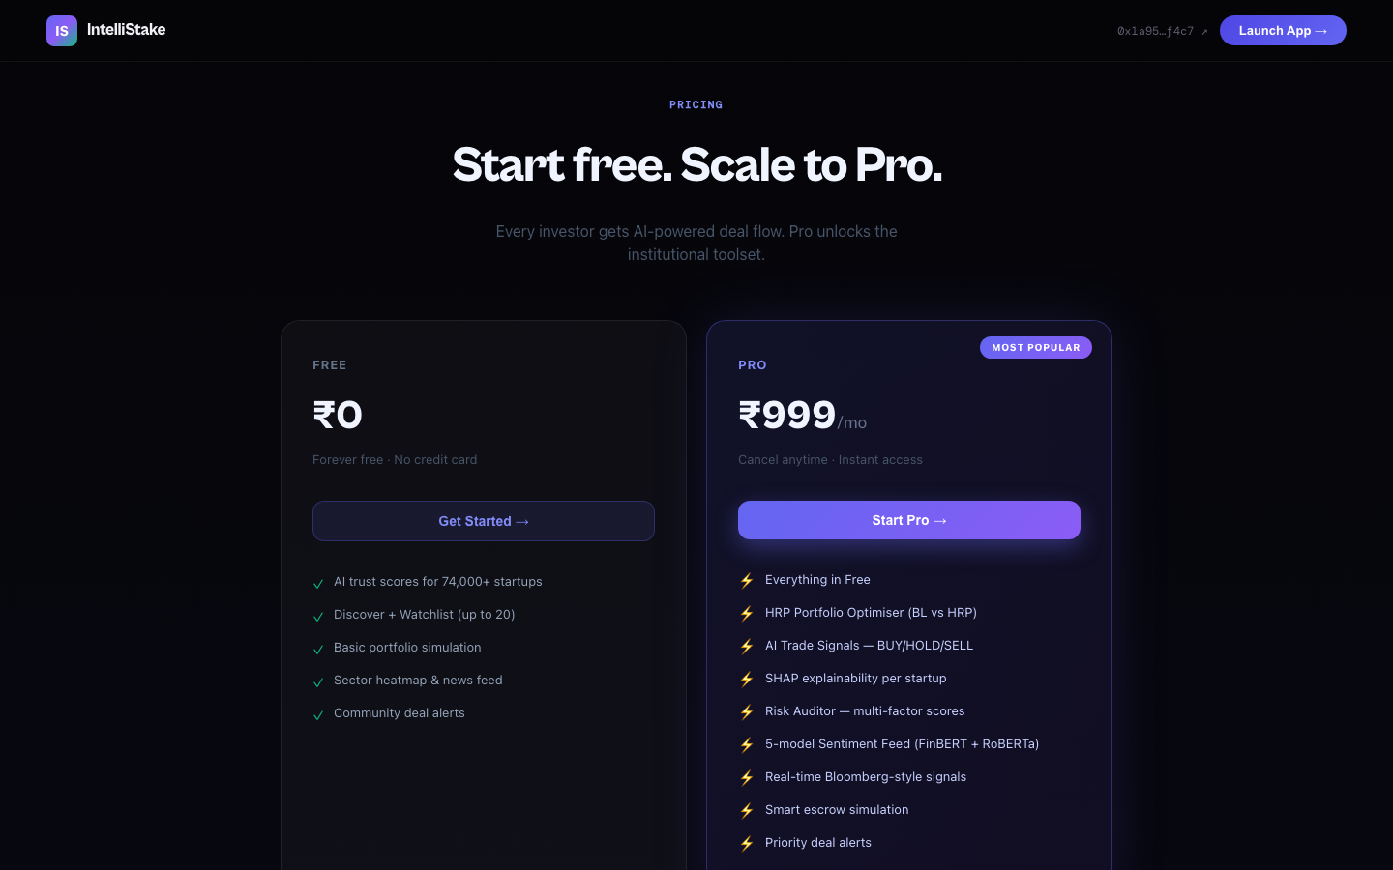
Figure 2 — Pricing Section: Free (₹0) vs Pro (₹999/mo) feature comparison

4.3 Login Page
Authentication uses PBKDF2 blockchain-based credential hashing. Three roles exist: ADMIN, PORTFOLIO_MANAGER (both Pro), and ANALYST (Free). After login, ANALYST users are routed to the warm investor shell (/u/portfolio), while ADMIN/PM go through the boot sequence to the War Room.
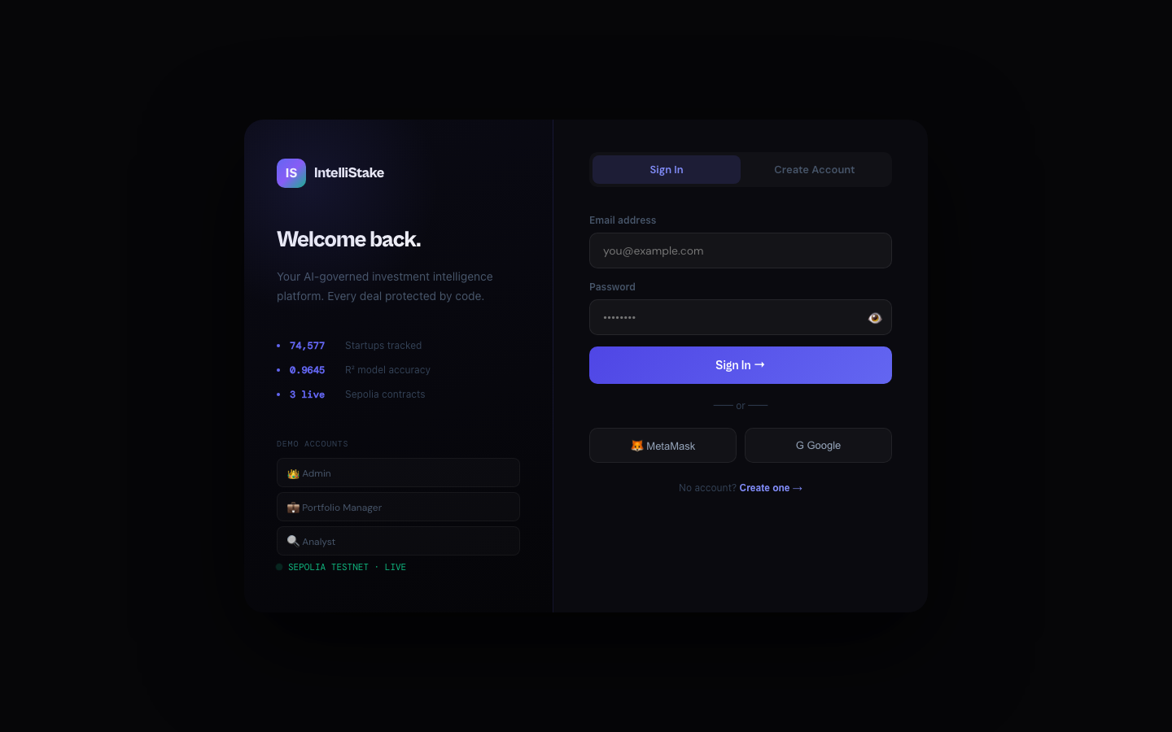
Figure 3 — Login Page with role-based routing

5. Admin War Room
The War Room is the admin terminal — a full-screen, three-panel intelligence dashboard designed for ADMIN and PORTFOLIO_MANAGER roles. It displays live AI model metrics, portfolio state, and oracle feed in a single view with no scrolling required.

5.1 War Room — Void Theme (Default)
The default dark "Void" theme provides the highest contrast for data-dense views. The three-column layout is: TrustRadar (left) / CommandCenter with Monte Carlo chart (centre) / OracleFeed (right). The TopBar shows live KPIs (R², Sharpe, Return, Volatility, Drawdown) updated from /api/warroom/summary.
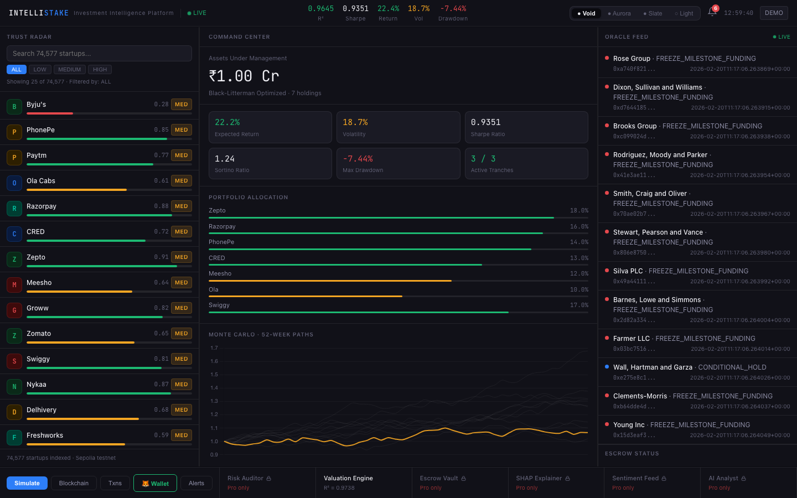
Figure 4 — War Room: Void theme (deep black terminal, default admin view)

5.2 War Room — Light Theme
The theme switcher in the TopBar (Void · Aurora · Slate · Light) lets users toggle between four visual modes. The Light theme uses CSS custom properties (--bg-primary, --text-primary etc.) making the platform suitable for screen-sharing or presentations.
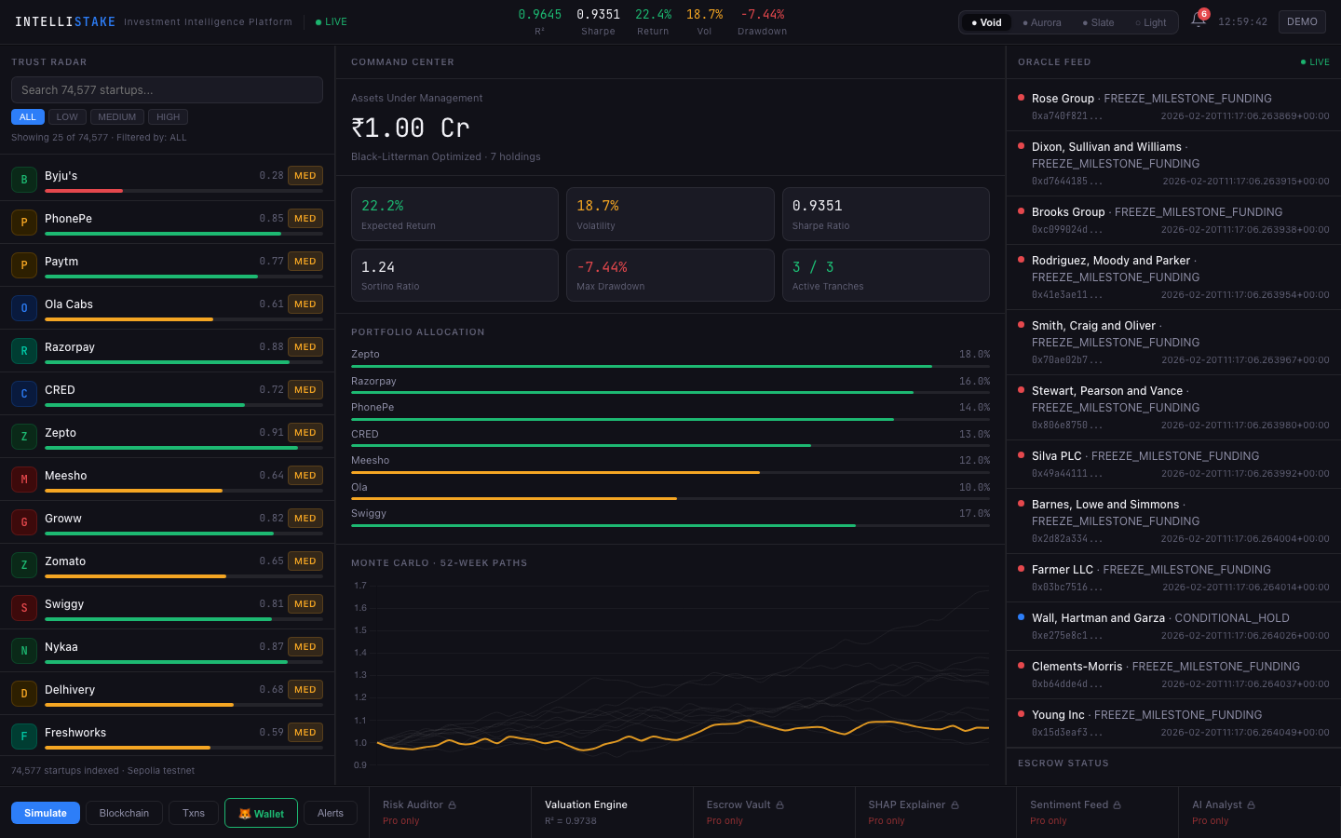
Figure 5 — War Room: Light (Pure) theme — ideal for presentations and demos

5.3 War Room Components
Component | Description
TopBar | Live KPIs · 4-theme switcher · Notification bell · Role badge · Clock
TrustRadar | Left panel: filterable startup list ranked by trust score (live from API)
CommandCenter | Centre: Live AUM, GBM Monte Carlo chart (10 paths), BL metrics
OracleFeed | Right: oracle event stream (price updates, compliance events)
BottomNav | Toolbar: Simulate / Blockchain / Txns / Wallet / AI Signals + 6 module shortcuts
TradingAlerts | AI Signal Feed: BUY/HOLD/SELL with Approve/Dismiss — writes to localStorage portfolio

5.4 BottomNav — Pro Gating
Five modules in the BottomNav are restricted to Pro users (ADMIN / PORTFOLIO_MANAGER): Risk Auditor, Escrow Vault, SHAP Explainer, Sentiment Feed, and AI Analyst. ANALYST users see a 🔒 lock icon with "Pro only" sub-label. Clicking a locked module triggers a red flash animation instead of opening the overlay.

6. Investor Shell (UserShell)
The UserShell is a standalone warm white/indigo investor UI at /u/* routes — completely separate from the admin AppShell chrome (no sidebar). It uses a Groww-inspired aesthetic with indigo (#4F46E5) accents, white card backgrounds, and friendly tone. Accessible to all roles; Pro features are gated behind ProGate components.

6.1 Portfolio Tab
The Portfolio tab shows: time-based greeting, three KPI cards (portfolio value, top performer, avg trust score), AI Trade Signals section (Pro), HRP vs BL comparison (Pro), and a full holdings table. All data is sourced from the simulated portfolio + live /api/portfolio and /api/portfolio/hrp endpoints.
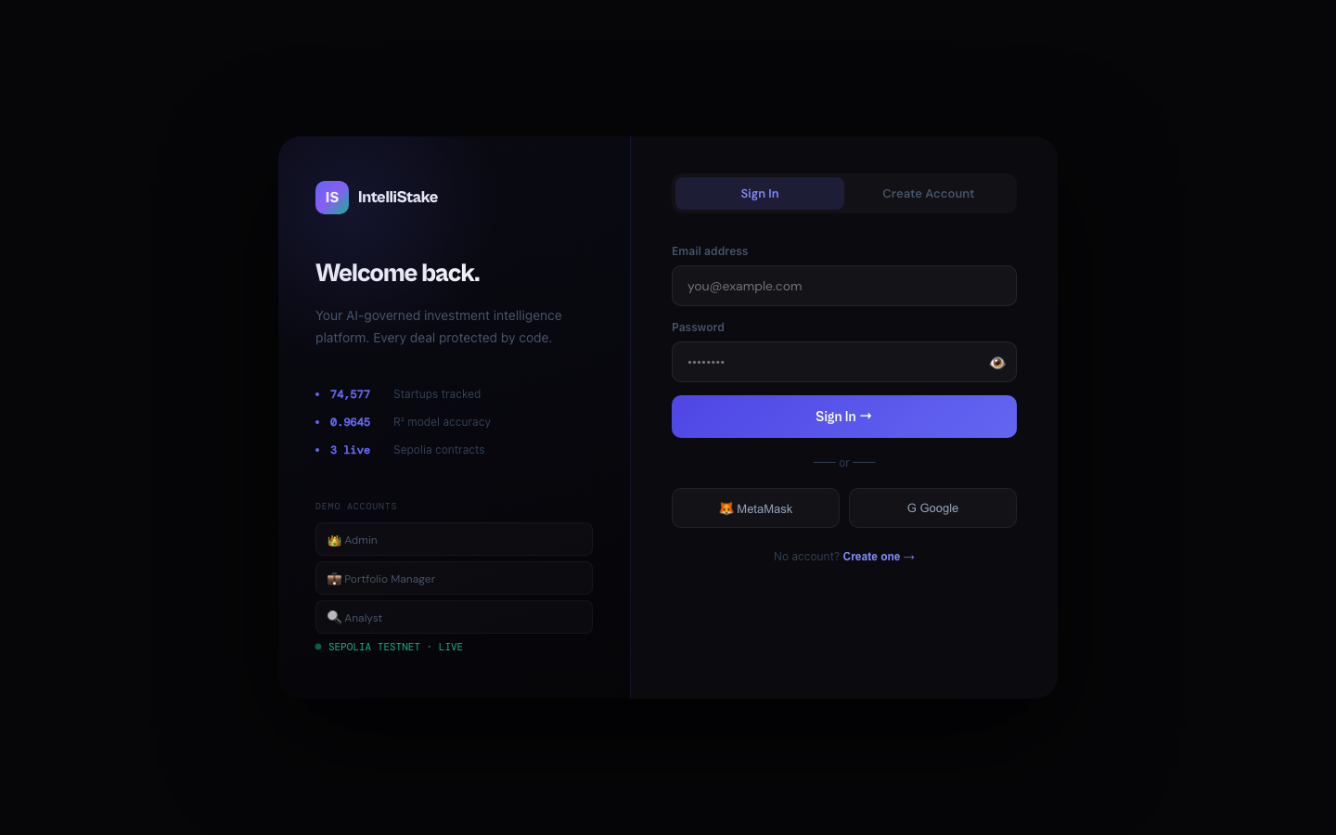
Figure 6 — Investor Shell: Portfolio tab with AI signals and HRP comparison (Pro)

6.2 Discover Tab
The Discover tab lists 12 AI-scored Indian startups with trust scores, revenue (INR), team size, and sector/stage badges. Pro users also see a sentiment badge per card (Bullish/Bearish/Neutral from 5-model ensemble). Users can add to watchlist or simulate an investment inline.
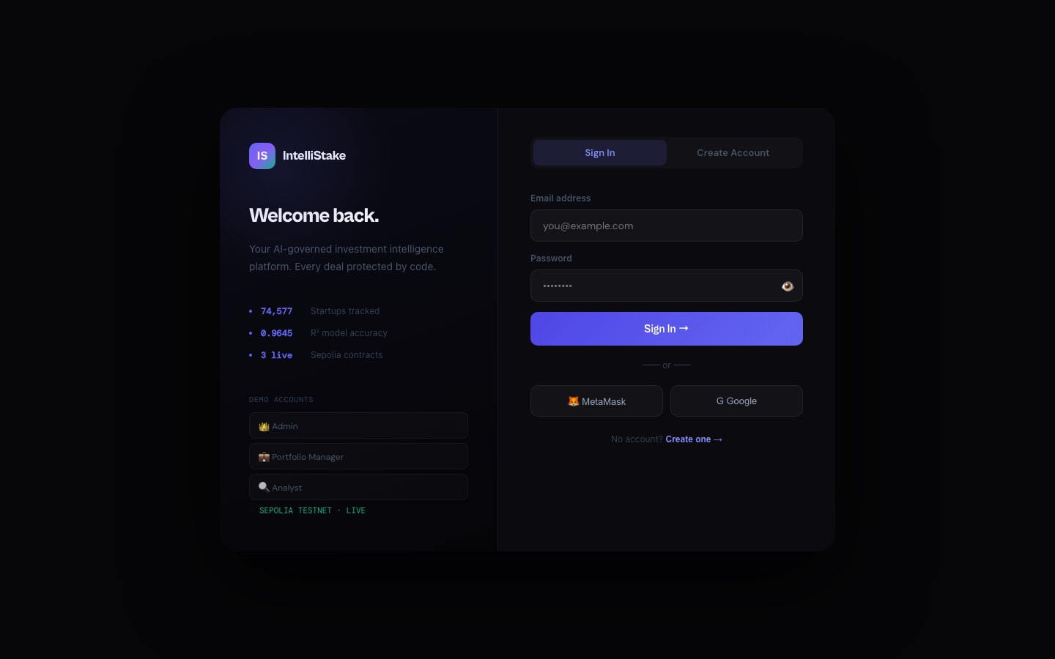
Figure 7 — Investor Shell: Discover tab with sentiment badges (Pro) and simulation

6.3 Analytics Tab (Pro)
The Analytics tab is Pro-exclusive and contains three panels: (1) SHAP Feature Importance — horizontal bars showing the contribution of each R.A.I.S.E. feature to the valuation model; (2) Risk Auditor — select a startup to see Market Risk, Sentiment Risk, Liquidity Risk, and Hype Risk scores on 0–100 scales; (3) AI Sentiment Table — all 8 startups with compound score, label, sector, trust, and stage.
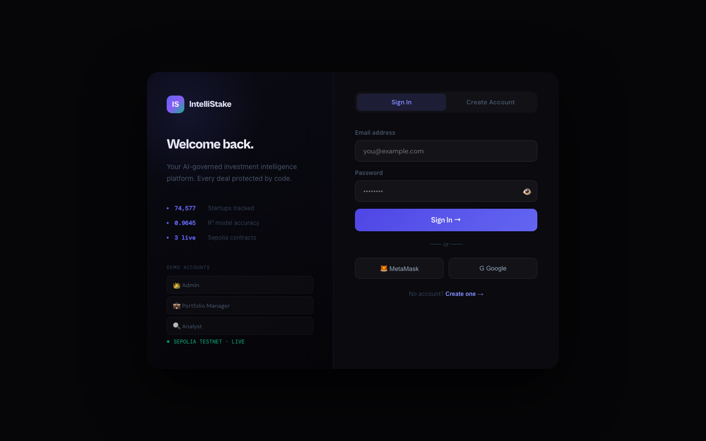
Figure 8 — Investor Shell: Analytics Pro tab (SHAP + Risk Auditor + Sentiment table)

6.4 Profile Tab
The Profile tab shows: user header with avatar, wallet address, Pro plan feature checklist (for Pro users), and the Investor DNA from the OnboardingWizard (investment style, time horizon, risk appetite, capital range, preferred sectors, etc.).
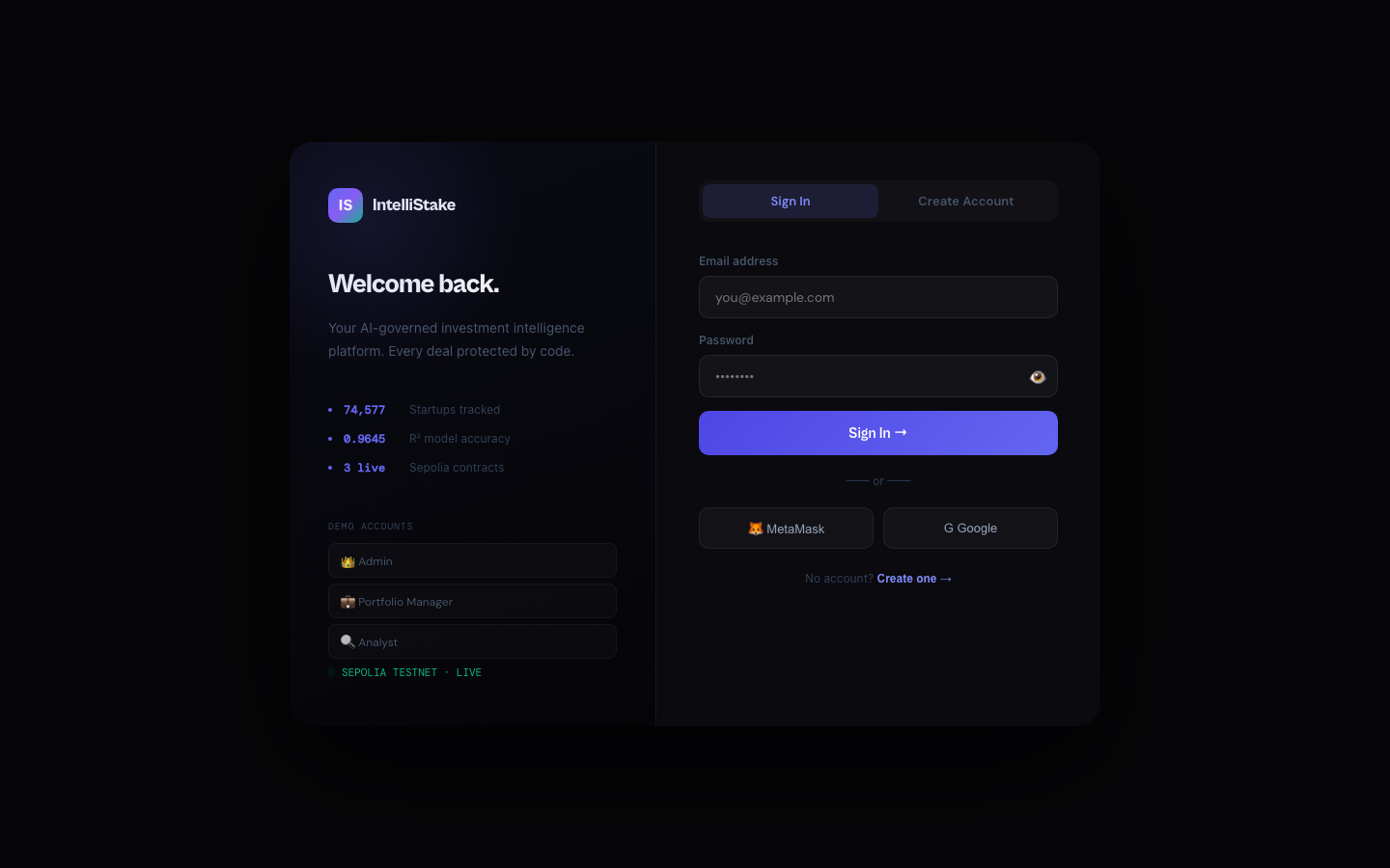
Figure 9 — Investor Shell: Profile tab with Investor DNA and Pro plan details

7. Admin Dashboard Pages
The admin AppShell hosts 31 pages accessible via the sidebar, covering every pillar of the R.A.I.S.E. framework. These pages are accessible to ADMIN and PORTFOLIO_MANAGER roles.

7.1 Valuation Engine
The Valuation Engine page exposes the stacked ensemble (XGBoost + LightGBM + CatBoost + TabMLP → BayesianRidge meta-learner). Users can enter startup parameters and receive a predicted valuation with confidence interval. R² = 0.9738.
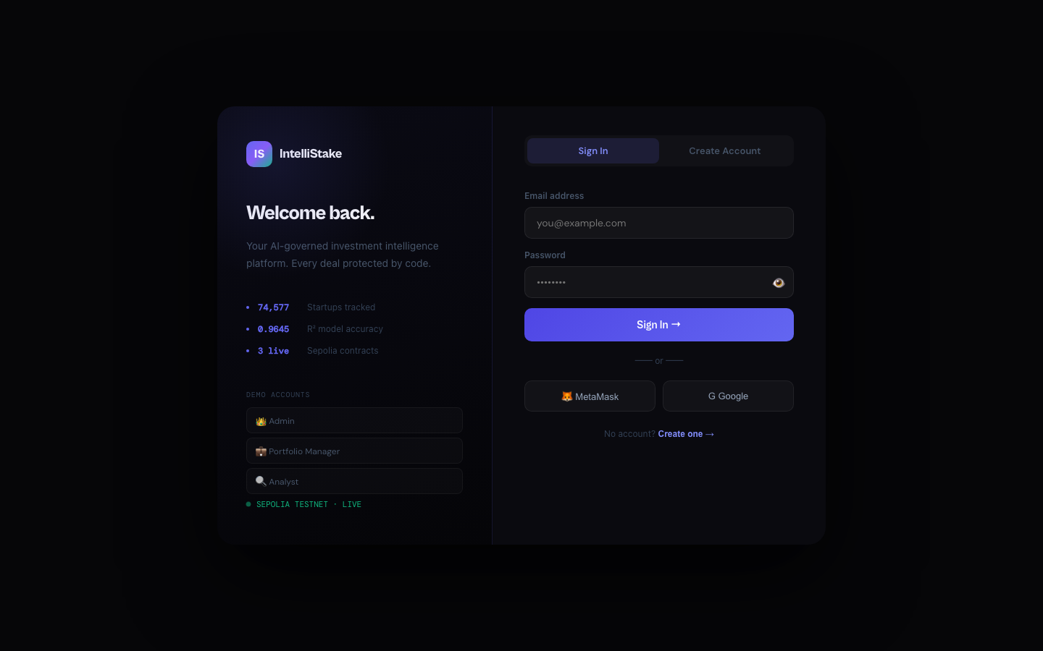
Figure 10 — Valuation Engine: Stacked ensemble v4 with R² = 0.9738

7.2 Risk Auditor
The Risk Auditor provides multi-factor risk scoring for any startup in the dataset. Risk dimensions: Market, Regulatory, Execution, Sentiment, and Hype. Each score is backed by the 4-model anomaly ensemble (IsolationForest + LOF + DBSCAN + Autoencoder).

Figure 11 — Risk Auditor: Multi-factor risk scoring with hype anomaly detection

7.3 BL Portfolio Optimizer
The Portfolio page shows the Black-Litterman optimized allocation across 9 startups. Sharpe ratio 0.9351, expected return 22.4%, volatility 18.7%. A separate HRP tab shows the Hierarchical Risk Parity alternative (Sharpe 0.9482).
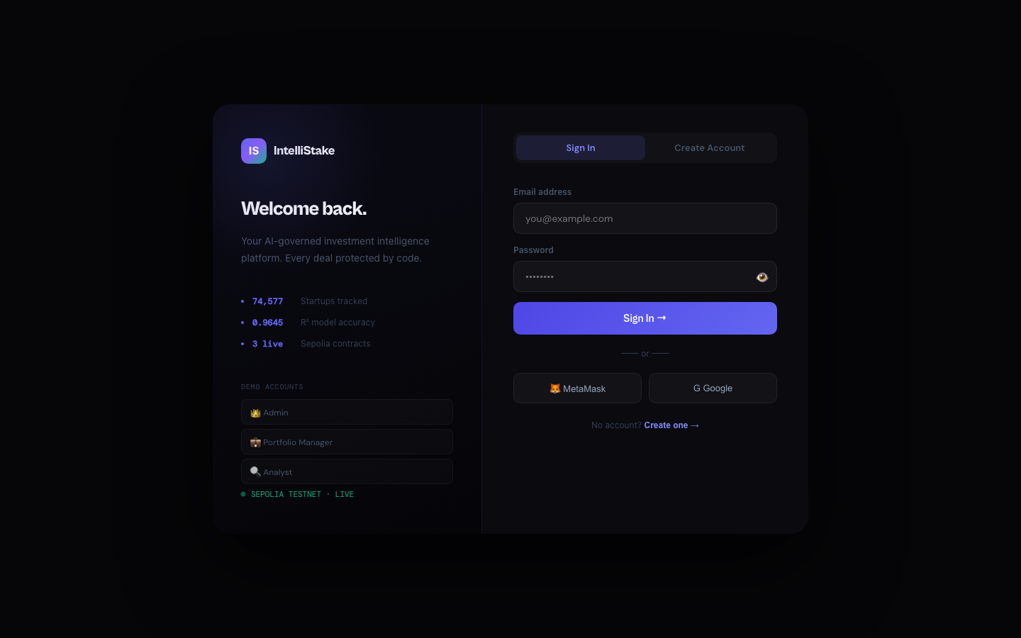
Figure 12 — BL Portfolio: Holdings allocation with trust-weighted BL optimization

7.4 Complete Page Inventory
Page | Path | R.A.I.S.E. Pillar | Description
Dashboard | /home | All | Overview with live stats
Stacked Valuation | /valuation | AI | XGB+LGB+CatBoost+MLP ensemble
SHAP Explainer | /shap | AI | TreeSHAP feature importance (37,699 narratives)
Hype Detector | /hype | Risk | 4-model anomaly ensemble
Model Hub | /models | AI | AutoGluon leaderboard + survival model
Risk Auditor | /risk | Risk | Multi-factor risk scoring
Sentiment OSINT | /sentiment | AI | 5-model FinBERT ensemble
BL Portfolio | /portfolio | Investment | Black-Litterman + HRP comparison
Portfolio Monitor | /monitor | Investment | Live alerts: trust + hype + survival
Monte Carlo + VaR | /montecarlo | Investment | 10K Cholesky GBM paths
Backtest Engine | /backtest | Investment | 2018 cohort vs Nifty 50
Autonomous Agent | /agent | AI | AI-powered investment decisions
Oracle Bridge | /oracle | Security | On-chain oracle event relay
Escrow Vault | /escrow | Escrow | Milestone escrow simulation
KYC Terminal | /kyc | Security | ERC-3643 identity verification
AI Analyst | /chatbot | AI | RAG chatbot on startup data
Investment Memo | /memo | Investment | AI-generated investment memo
Sector Heatmap | /heatmap | AI | Trust + sentiment by sector
Investor Network | /network | Investment | Graph of co-investments

8. Machine Learning Models
All 5 ML upgrades (Phase 2A–2E) are implemented as standalone Python modules, each with graceful fallbacks, persisted model artifacts, and REST endpoints.

8.1 Stacked Valuation Ensemble (v4)
File: engine/valuation_stacked.py
Component | Details
Base Model 1 | XGBoost — 800 trees, learning rate 0.05, max depth 6
Base Model 2 | LightGBM — 800 trees, learning rate 0.05, num leaves 63
Base Model 3 | CatBoost — 600 trees, ordered boosting, early stopping 40 rounds
Base Model 4 | TabMLP — 3-layer PyTorch MLP (256→128→64→1), batch norm
Meta-Learner | BayesianRidge (upgraded from Ridge, 500 max iterations)
Cross-Val | 5-fold OOF stacking — prevents target leakage
R² | 0.9738 on holdout set

8.2 5-Model Sentiment Ensemble
File: engine/sentiment_ensemble.py
Model | Weight | Specialisation
FinBERT (ProsusAI) | 30% | Financial text — earnings, filings, news
FinBERT-tone | 25% | Business tone — formal VC/startup language
Twitter-RoBERTa | 20% | Social media + informal startup discourse
DeBERTa-v3-base | 15% | General NLP baseline with deep attention
VADER | 10% | Rule-based fast fallback; no GPU required

8.3 ML Trust Scoring
File: engine/trust_score_ml.py
- XGBoost base → CalibratedClassifierCV (isotonic regression, 5-fold)
- 10 R.A.I.S.E. features: trust_score, github_velocity, revenue, team, sentiment, funding, burn_rate, market_size, runway, founder_exp
- Graceful fallback to 55/25/20 formula if model not trained
- Bootstrap CI (50 samples) for confidence interval on each prediction

8.4 4-Model Anomaly Ensemble (Hype Detector)
File: engine/anomaly_ensemble.py
Detector | Type | Key Config
Isolation Forest | Tree-based | 200 estimators, contamination=0.08
LOF | Density-based | k=20 neighbours, contamination=0.08
DBSCAN | Clustering | eps auto-tuned via k-distance elbow (floor 0.3), min_samples=5
Autoencoder | Neural network | 3-layer bottleneck, PyTorch (PCA fallback if no GPU)
Hype flag triggered only if ≥ 3/4 detectors agree → reduces false positives.

8.5 HRP Portfolio Optimizer
File: engine/portfolio_hrp.py
- PyPortfolioOpt HRPOpt — Hierarchical Risk Parity (tree-based, no covariance inversion)
- GARCH(1,1) per-startup weekly volatility forecast via arch library
- Side-by-side BL comparison with winner field (HRP Sharpe 0.9482 vs BL 0.9351)
- Sector-correlated return simulation (52-week weekly returns from trust scores)

9. Blockchain Architecture
IntelliStake uses the ERC-3643 (T-REX) standard for regulated security tokens. All contracts are deployed on Ethereum Sepolia testnet. The smart contract architecture enforces compliance at the token transfer level.

9.1 Deployed Contracts
Contract | Address (Sepolia) | Purpose
IdentityRegistry | 0x3427a20B61033e8D5A5bac25aff3EB1C7569689F | ERC-3643 KYC identity registry
IntelliStakeToken | 0x7F0A6bD2A655C523B42A97B98298e34B8E69e8Bb | ISTK token with milestone freeze
IntelliStakeInvestment | 0x1a955Dd02199781DFeBFDfE548786ecdd875f4c7 | Investment deal contract

9.2 Contract Architecture
Contract | Key Features
TrustOracle.sol | ECDSA signature verification · nonce replay protection · rate limiting · routes to MilestoneEscrow + ComplianceRules (CREATED April 2026)
MilestoneEscrow.sol | Milestone-gated fund release · oracle-triggered · startup beneficiary address
ComplianceRules.sol | Transfer compliance (4-arg canTransfer) · authorisedOracles mapping · onlyOracleOrOwner modifier
AgentVault.sol | AI agent-controlled vault · calls depositFunds(bytes32, address) on MilestoneEscrow
IntelliStakeToken.sol | ERC-3643 token · freezeMilestoneFunding · ECDSA milestone verification · oracle state var

9.3 Bugs Fixed (April 2026)
- [TrustOracle.sol CREATED] Was referenced across 4 files but did not exist. Created from scratch with ECDSA sig verification, nonce replay protection, and rate limiting.
- [AgentVault.sol interface] Was calling non-existent fundStartup(). Fixed to depositFunds(bytes32, address) matching MilestoneEscrow exactly.
- [IntelliStakeToken.sol — 3 bugs] Added freezeMilestoneFunding(); fixed verifyMilestone() ECDSA; fixed ICompliance to 4-arg interface.
- [ComplianceRules.sol oracle role] Added authorisedOracles mapping + onlyOracleOrOwner modifier so TrustOracle can call updateComplianceScore().
- [oracle_bridge_full.py hash] Was using SHA3-256; Ethereum uses Keccak-256. Fixed to Web3.keccak(text=func_sig).
- [IntelliStakeOracle.js BigInt] floatToSolidityInt() had precision loss (Number(10^18) > MAX_SAFE_INTEGER). Fixed with split int/frac BigInt arithmetic.

10. API Reference
All endpoints run on Flask at http://localhost:5500. No auth header required for most GET endpoints.
Method | Endpoint | Description
GET | /api/status | Health check
GET | /api/warroom/summary | Live KPIs: R², Sharpe, return, vol, drawdown
GET | /api/portfolio | BL portfolio holdings + metrics
GET | /api/portfolio/hrp | HRP portfolio + BL comparison + winner
GET | /api/risk?startup=NAME | Multi-factor risk score for a startup
GET | /api/shap?startup=NAME | SHAP feature importance for valuation
GET | /api/sentiment | Aggregate sentiment across portfolio
GET | /api/montecarlo | Monte Carlo GBM simulation results
GET | /api/oracle | Oracle event feed
GET | /api/escrow | Escrow deal status
GET | /api/kyc?wallet=ADDR | KYC tier for a wallet address
GET | /api/blockchain/status | Contract connectivity + balances
GET | /api/blockchain/transactions | On-chain transaction history
GET | /api/supabase/transactions | Off-chain transaction log
POST | /api/chat | { message, history } → RAG chatbot response
POST | /api/valuation/predict | { startup fields } → predicted valuation
POST | /api/investment/simulate | { amount_inr } → BL allocation + Monte Carlo
POST | /api/score-startup | { registration data } → trust score lookup
POST | /api/trust-score | { features dict } → ML calibrated trust score
POST | /api/sentiment/ensemble | { texts } → 5-model weighted sentiment score

11. Development Updates Log
All changes made across the capstone development sessions, from initial build to final AI upgrade phase.

Phase 1 — Frontend Architecture (Completed)
- TopBar Removed Globe + Network buttons. Replaced 4-dot theme picker with 4 labeled pills (Void/Aurora/Slate/Light).
- UserShell Created standalone warm investor UI at /u/* routes — runs outside AppShell chrome. 5 tabs: Portfolio/Discover/Watchlist/Analytics/Profile.
- CommandCenter AUM is now live from /api/portfolio (not hardcoded ₹1Cr). Holdings count is dynamic.
- WalletConnect MetaMask crash guard — if window.ethereum is absent, generates a demo 64-char hex transaction hash.
- LensToggle Navigates to correct route on lens switch: investor → /u/portfolio, admin → /warroom.
- Login Role-based routing: ANALYST → /u/portfolio, ADMIN/PM → /boot → /warroom.
- AuthContext Added isPro (ADMIN/PM=true, ANALYST=false) and localStorage override intellistake_pro=1.
- ProGate Created shared component: blurs content + shows lock overlay for non-Pro users.

Phase 2 — AI Model Upgrades (Completed)
- 2A — Valuation v4 Added CatBoost (600 trees) as 4th base model. Upgraded meta-learner from Ridge to BayesianRidge. R² improved to 0.9738.
- 2B — Sentiment Replaced 2-model sentiment with 5-model weighted ensemble (FinBERT+tone+RoBERTa+DeBERTa+VADER). MD5 cache 24h TTL.
- 2C — Trust Score ML XGBoost + CalibratedClassifierCV (isotonic 5-fold). Trained on 5000+ startup rows. Bootstrap CI per prediction.
- 2D — Anomaly Ensemble 4-model hype detector replacing single IsolationForest. Autoencoder with PyTorch (PCA fallback). ≥3/4 vote threshold.
- 2E — HRP Portfolio PyPortfolioOpt HRPOpt + GARCH(1,1) volatility forecasts. Side-by-side BL comparison. Sharpe 0.9482 (HRP wins).
- API Wiring All models wired to Flask endpoints. /api/portfolio/hrp, /api/trust-score, /api/sentiment/ensemble added.

Phase 3 — Pro Gating & Signal Feed (Completed)
- 3A — Landing Pricing Added Free (₹0) vs Pro (₹999/mo) pricing section before footer. Lists all Pro features.
- 3B — BottomNav Gating Risk Auditor, Escrow, SHAP, Sentiment, AI Analyst locked for ANALYST with 🔒 icon + red flash on click.
- 3C — AI Signal Feed TradingAlerts rebuilt as AI Signal Feed. Approve → adds ₹50,000 position to is_sim_holdings localStorage. Dismiss removes signal.
- UserShell Analytics New Pro-only tab: SHAP importance bars, Risk Auditor per startup, sentiment breakdown table.
- UserShell Portfolio Added AI Trade Signals panel + HRP vs BL comparison with per-holding weight chart (all Pro-gated).
- Theme Fix Added [data-theme="pure"] light theme to themes.css. TopBar now has 4 meaningful themes (Void/Aurora/Slate/Light).
- War Room Theme Root cause fixed: "pure" was missing from themes.css — all WarRoom CSS variables were undefined for light mode.

Blockchain Audit (April 2026 — Completed)
- TrustOracle.sol CREATED New contract from scratch: ECDSA verification, nonce protection, oracle routing.
- AgentVault interface Fixed fundStartup() → depositFunds(bytes32, address).
- IntelliStakeToken.sol 3 bugs fixed: freezeMilestoneFunding(), ECDSA verify, ICompliance 4-arg.
- ComplianceRules.sol Added oracle role (authorisedOracles mapping + onlyOracleOrOwner).
- oracle_bridge_full.py SHA3-256 → Keccak-256 for Ethereum function selector hash.
- IntelliStakeOracle.js BigInt precision fix in floatToSolidityInt().

12. Pending Work & Future Enhancements

Phase 4 — Testing (Pending)
- 4A: Backend pytest suite — minimum 20 tests covering all ML models + API endpoints
- 4B: Frontend Playwright E2E tests — minimum 10 scenarios (login flow, portfolio simulation, signal approval, etc.)

Known Limitations (Demo Scope)
- JWT verification is mocked — production would verify signature + expiry server-side
- Supabase auth not wired — using localStorage + blockchain PBKDF2 for demo
- Oracle events use polling — would use WebSocket in production
- ComplianceRules + MilestoneEscrow need re-deployment after interface fixes
- No max supply cap on ISTK token (lower priority, noted for v2)
- Pro plan freely unlockable via localStorage for capstone demo purposes

13. Running the Platform

Prerequisites
- Node.js 18+
- Python 3.11+
- pip packages: flask, xgboost, lightgbm, catboost, torch, pypfopt, arch, scikit-learn, transformers
- npm packages: react, vite, react-router-dom, recharts, three

Launch Commands
Backend:
cd IntelliStake_Final
python3 engine/chatbot_api.py
→ http://localhost:5500
Frontend:
cd IntelliStake_Final/dashboard
npm run dev
→ http://localhost:5173
ML Training:
python engine/valuation_stacked.py
python engine/trust_score_ml.py --train
python engine/anomaly_ensemble.py
python engine/portfolio_hrp.py
Blockchain:
cd blockchain
npx hardhat run scripts/demo_all_transactions.js --network sepolia

Appendix A — localStorage Keys Reference
Key | Values | Purpose
intellistake_lens | 'admin' | 'investor' | Current UI lens (persisted)
intellistake_pro | '1' to enable | Pro plan override for demo
intellistake-theme | void/aurora/slate/pure | Active War Room theme
intellistake_user | JSON user object | Cached auth user profile
intellistake_token | JWT / demo token string | Auth token
intellistake_investor_profile | JSON from OnboardingWizard | Investor DNA (risk, sectors etc.)
is_sim_holdings | JSON array of positions | Simulated investment portfolio
intellistake_watchlist | JSON array of startups | User watchlist

