Physics Mechanics 101: 2D Projectile Motion Analysis
Kinematics in Two Dimensions — Trajectory Modeling & Quantitative Analysis

Prepared by: Physics Mechanics 101 Course Staff | Unit 2: Kinematics in Two Dimensions | Document Type: Technical Report

1. Executive Summary & Overview
One-dimensional kinematics describes motion confined to a single straight-line axis, where position, velocity, and acceleration are captured by one signed coordinate. Two-dimensional (2D) kinematics extends this framework to motion in a plane — most commonly a horizontal and a vertical axis — allowing objects to trace curved paths such as the parabolic arc of a thrown ball, launched projectile, or kicked object. Projectile motion is the canonical example: an object launched with some initial speed and angle above the horizontal, moving under the influence of gravity alone.
The defining principle that makes 2D projectile motion tractable is the independence of the horizontal and vertical axes. Gravity acts exclusively along the vertical (y) direction, so the horizontal (x) velocity remains constant throughout the flight while the vertical velocity changes at a constant rate. This report derives the governing equations for both axes, computes the key trajectory metrics for a representative launch, and visualizes the resulting flight path.

2. Governing Mathematical Model
Under constant gravitational acceleration g and negligible air resistance, the horizontal and vertical motions decouple into independent 1D kinematics problems. The equations below describe position and velocity as functions of time t, given initial speed v0 and launch angle θ.
- Horizontal Position: x(t) = v0 · cos(θ) · t (constant velocity, no acceleration)
- Vertical Position: y(t) = v0 · sin(θ) · t − ½ g t² (constant downward acceleration)
- Horizontal Velocity: vx(t) = v0 · cos(θ) (unchanging for the entire flight)
- Vertical Velocity: vy(t) = v0 · sin(θ) − g t (decreases, then reverses sign)
- Maximum Height: H_max = (v0 · sin θ)² / (2g) (occurs when vy = 0)
- Total Range: R_max = v0² · sin(2θ) / g (requires launch/landing at equal height)
- Time of Flight: t_total = 2 · v0 · sin(θ) / g (twice the time to reach apex)

Key Modeling Assumptions
• Flat, level terrain — launch height and landing height are equal (y = 0 at both ends).
• Air resistance is negligible; drag and lift forces are not modeled.
• Gravitational acceleration g is constant in magnitude and direction throughout the flight.
• The projectile is treated as a point mass (no spin, no rotational dynamics).

3. Summary Table
Table 1 applies the governing equations above to a representative launch condition and reports the resulting trajectory metrics.
Parameter / Quantity | Formula | Calculated Value | Units
Initial Velocity, v0 | — (given) | 25.00 | m/s
Launch Angle, θ | — (given) | 45.0 | degrees
Horizontal Velocity, vx | v0 · cos(θ) | 17.68 | m/s
Vertical Velocity (initial), vy0 | v0 · sin(θ) | 17.68 | m/s
Maximum Height, H_max | (v0 sin θ)² / (2g) | 15.93 | m
Total Range, R_max | v0² sin(2θ) / g | 63.71 | m
Time of Flight, t_total | 2 v0 sin(θ) / g | 3.60 | s

4. Trajectory Plot & Visual Analysis
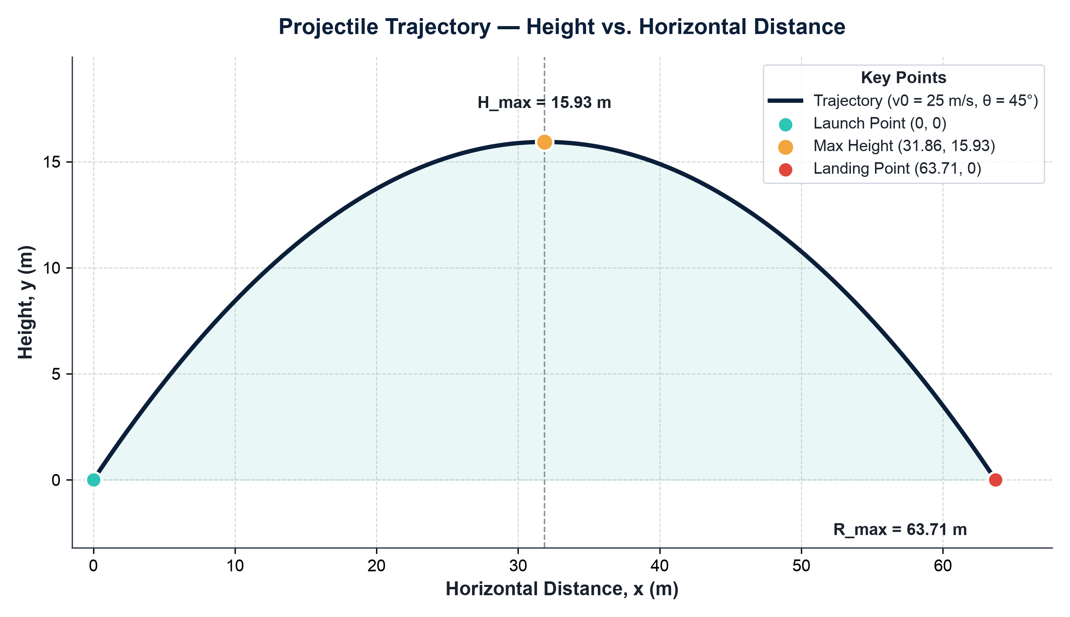
Figure 1. Projectile trajectory for v0 = 25 m/s, θ = 45°, g = 9.81 m/s², with the launch point, apex (maximum height), and landing point marked.
The plotted trajectory is symmetric about the vertical line passing through the apex: the time to climb from launch to maximum height equals the time to descend from the apex back to ground level, and the impact speed at landing equals the launch speed (25 m/s), mirrored in direction below the horizontal. This symmetry is a direct consequence of constant gravitational acceleration acting on a launch and landing at equal elevation.
The curvature of the path is parabolic rather than circular or linear because horizontal position grows linearly with time while vertical position is a quadratic function of time. Near the apex, the vertical velocity approaches zero and the path flattens, producing the characteristic rounded peak; away from the apex, the steeper vertical velocity component dominates and the path steepens, most visibly just before impact.

5. Conclusion & Key Takeaways
This report has demonstrated that 2D projectile motion under constant gravity, with no air resistance, reduces cleanly to two independent 1D kinematics problems: uniform velocity along the horizontal axis and uniformly accelerated motion along the vertical axis. For the representative launch analyzed here (v0 = 25 m/s, θ = 45°), the projectile reaches a maximum height of approximately 15.93 m, travels a horizontal range of approximately 63.71 m, and remains airborne for approximately 3.60 s.
- Horizontal and vertical motion are independent — gravity only affects the vertical component.
- A 45° launch angle maximizes range for a given launch speed on level ground.
- The trajectory is a symmetric parabola when launch and landing heights are equal.
- Real-world trajectories deviate from this ideal model once air resistance becomes significant.

