An Assignment of

**Soft Skill – Campus to Corporate**

Submitted to

Disha Pandya Ma’am

Tops Technologies Ahmedabad – S G Road



By

Piyush Dabhi

Oct 2024

* **Resume**

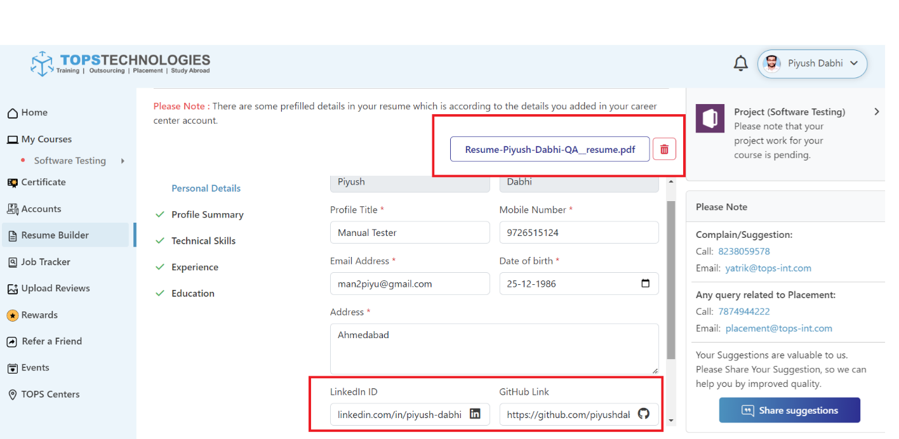

**Link**: <https://github.com/piyushdabhi25/Resume>

* **LinkedIn**

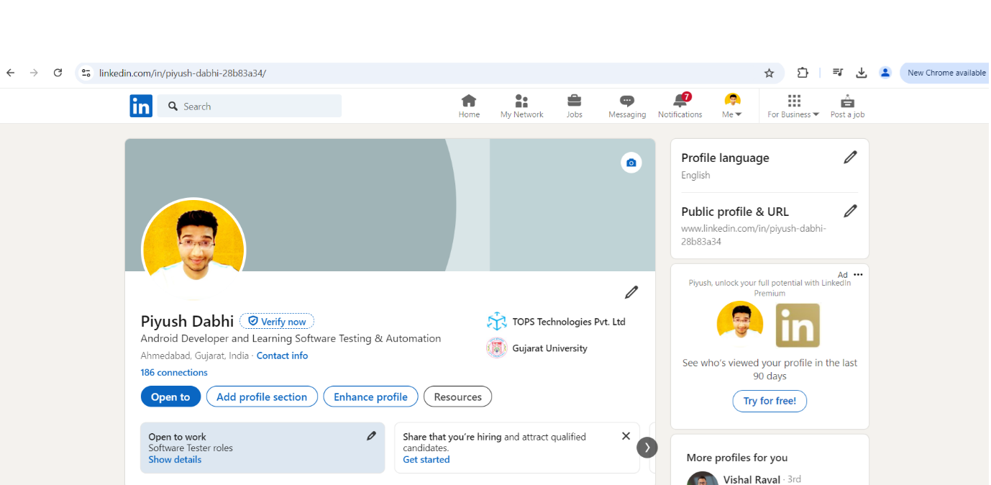

**Link:** [**www.linkedin.com/in/piyush-dabhi-28b83a34**](http://www.linkedin.com/in/piyush-dabhi-28b83a34)