Table of Contents

Version History 2

Getting Started: Shipping API 3

SOAP Introduction 4

SOAP Building Blocks 5

Using Shipping Services API 6

Structure Diagrams 7

Finders 8

Location Finder 8

Methods used in Location Finder 8

Detailed Description of each methods used in Location Finder 9

Transit Time 12

Methods used in Transit Time Finder 12

Detailed Description of each methods used in Transit Time Finder 12

Pickup 13

Pickup Registration 13

Methods used in Pickup Registration 13

Detailed Description of each methods used in Pickup Registration 13

Cancel Pickup Registration 16

Waybill Generation 18

Methods used in Waybill Generation 18

Detailed Description of each methods used in Waybill Generation 18

Detailed Description of Update EwayBill 25

Detailed Description of WayBill Cancelation 26

ALTInstruction Update 27

Master Download 28

Methods used in Master download 28

Detailed Description of each methods used in Master download 28

Common object 30

Common object details 30

User Profile 30

Common Master Details 30

Country Master 30

State Master 30

Products Master 33

Pack Type Master 34

Postal code format for Intel E-Comm. 34

Shipping API Client Application 35

Prerequisites of using Shipping API demo client 35

Simple Coding Demo of Client Application in Visual Studio 35

Excel File import 39

Common Terminology 41

Detailed description of common terminology used in this document 41

Shipping API Demo URLs 41

|  |  |
| --- | --- |
|  |  |

|  |  |  |  |
| --- | --- | --- | --- |
| Version History | | |  |
| |  |  |  | | --- | --- | --- | | **Version** | **Date** | **Changes** | | 0.1 Beta | Aug-2013 | Beta testing (Tracking) | | 0.2 Beta | Oct-2013 | Beta Testing (Pickup Registratiom) | | 0.3 Beta | Oct-2013 | Beta Testing (Cancel Pickup) | | 0.4 Beta | Nov-2013 | Beta Testing (Waybill Generation) | | 0.5 Beta | Dec-2013 | Beta Testing (Waybill Generation with Prin) | | 0.6 Live | Feb -2014 | Demo & Live Version | | 0.7 Live | Jul - 2014 | Basic Http & WsHttp ( Soap 1.2 is added) Multiple Waybill Generation | | 1.7 Live | Jul -2015 | * Incremental Master download. * Multiple Waybill generation request. * Waybill number to be pushed in pickup registration. * Cancel Waybill/RTO Compulsory. | | 1.8 Live | Jul-2016 | * Reverse Pickup Features | |  |

# Getting Started: Shipping API

**Connectivity diagram**

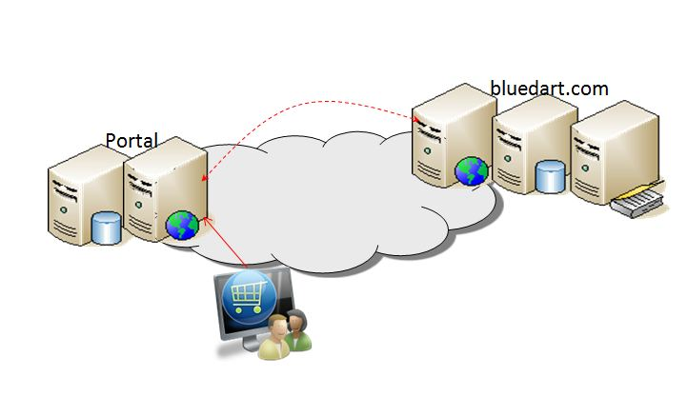

The Blue Dart Shipping API (Application Programming Interface) provides you with a wide range of functionalities which enables your systems and applications to integrate directly with Blue Dart’s systems in an easy and automated way. The APIs are built based on SOAP (Simple Object Access Protocol) providing a secure channel of communication, as all web calls are made through secured HTTPS. (This is also available via unsecure HTTP mode for customers who want this level of access)

# SOAP Introduction

SOAP is a simple XML-based protocol to let applications exchange information over HTTP.

Or more simply: SOAP is a protocol for accessing a Web Service.

What You Should Already Know

Before you study SOAP you should have a basic understanding of XML and XML Namespaces.

If you want to study these subjects first, please read our XML Tutorial.

**What is SOAP?**

SOAP stands for Simple Object Access Protocol

SOAP is a communication protocol

SOAP is for communication between applications

SOAP is a format for sending messages

SOAP communicates via Internet

SOAP is platform independent

SOAP is language independent

SOAP is based on XML

SOAP is simple and extensible

SOAP allows you to get around firewalls

SOAP is a W3C recommendation

**Why SOAP?**

It is important for application development to allow Internet communication between programs.

Today's applications communicate using Remote Procedure Calls (RPC) between objects like DCOM and CORBA, but HTTP was not designed for this. RPC represents a compatibility and security problem; firewalls and proxy servers will normally block this kind of traffic.

A better way to communicate between applications is over HTTP, because HTTP is supported by all Internet browsers and servers. SOAP was created to accomplish this.

SOAP provides a way to communicate between applications running on different operating systems, with different technologies and programming languages.

# SOAP Building Blocks

A SOAP message is an ordinary XML document containing the following elements:

An Envelope element that identifies the XML document as a SOAP message

A Header element that contains header information

A Body element that contains call and response information

A Fault element containing errors and status information

All the elements above are declared in the default namespace for the SOAP envelope:

http://www.w3.org/2001/12/soap-envelope

and the default namespace for SOAP encoding and data types is:

http://www.w3.org/2001/12/soap-encoding

**Syntax Rules**

Here are some important syntax rules:

A SOAP message MUST be encoded using XML

A SOAP message MUST use the SOAP Envelope namespace

A SOAP message MUST use the SOAP Encoding namespace

A SOAP message must NOT contain a DTD reference

A SOAP message must NOT contain XML Processing Instructions

# Using Shipping Services API

• The Shipping Services API uses a Web Service Definition Language (WSDL) that can be downloaded at

https://netconnect.bluedart.com/Ver1.8/ShippingAPI/Finder/ServiceFinderQuery.svc?wsdl

this will enable the developers to add reference to the web service in their code.

• The user must be registered at http://www.bluedart.com with a valid user name and password and must have a tracking api license key.

• Sample Codes is available in C# and can be downloadable at

http://netconnect.bluedart.com/samples/

|  |  |
| --- | --- |
| Dotnet | http://netconnect.bluedart.com/samples/Dotnet/ShippingAPItestClientsetup.zip |
| Java | http://netconnect.bluedart.com/samples/Java/ShippingAPIJavaClientineclipse.zip |
| PHP | http://netconnect.bluedart.com/samples/Php/PHPservice.zip |
| Document | http://netconnect.bluedart.com/samples/Document/BlueDartAPIService.docx |

Users are free to use any development tool provided these tools support the WSDL and messages conform to the standards and structure required. However the preferred programming languages for client implementations are:

* Visual Basic
* C#
* Java

# Structure Diagrams

# Finders

## Location Finder

The Location Finder provides you with information on locations serviced by Blue Dart. It also outlines the services available for each location. This service can be used by the customer to be better advised on the serviceability and reach of Blue Dart locations. This query input is based on pin code.

**Service information**:

WSDL : [https://netconnect.bluedart.com/Ver1.8/ShippingAPI/Finder/ServiceFinderQuery.svc?wsdl](https://netconnect.bluedart.com/ShippingAPI/Finder/ServiceFinderQuery.svc?wsdl)

### Methods used in Location Finder

|  |  |  |  |
| --- | --- | --- | --- |
| SR No | Method Name | Return Type | Input Values |
| 1 | GetServicesforPincode | ServiceCenterDetailsReference | pinCode,  profile |
| 2 | GetServicesforProduct | PinCodeServiceDetailsReference | pinCode, pProductCode, pSubProductCode profile |
| 3 | GetServicesforPincodeAndProduct | PinCodeServiceLocationDetailsReference | pinCode, ProductCode, SubProductCode,  PackType,  Feature profile |

### Detailed Description of each methods used in Location Finder

**GetServicesforPincode :**This method will return information about all types of services provided by Blue Dart for requested pin code.  
Request

|  |  |  |  |  |  |
| --- | --- | --- | --- | --- | --- |
| **Parameters Name** | **Data Type** | **Require** | **Length** | **Allowed Values** | **Description** |
| pinCode | string | Y | 6 | 0-9 | Pin code |
| profile | Object | Y |  |  | Client details,profile details are given in common objects sheet. |

Response :

|  |  |  |  |
| --- | --- | --- | --- |
| **Parameters Name** | **Data Type** | **Description** | |
| ServiceCenterDetailsReference | Object | Return service detail object for a pin code |

ServiceCenterDetailsReference Definition:

|  |  |  |  |  |
| --- | --- | --- | --- | --- |
| **Field Name** | **Data Type** | **Length** | **Allowed Values** | **Description** |
| PinCode | string | 6 | 0-9 | Pin Code |
| PincodeDescription | string | 25 | a-z,A-Z,0-9 | Pin code location description |
| AreaCode | string | 3 | A-Z | Area code of pin code |
| ServiceCenterCode | string | 3 | A-Z | Service centre code of pin code |
| DomesticPriorityInbound | string | 1 | Y/N | Domestic Priority Inbound service |
| DomesticPriorityOutbound | string | 1 | Y/N | Domestic Priority Outbound Service |
| ApexInbound | string | 1 | Y/N | Dart Apex Inbound service |
| ApexOutbound | string | 1 | Y/N | Dart Apex outbound service |
| GroundInbound | string | 1 | Y/N | Surface Inbound service |
| GroundOutbound | string | 1 | Y/N | Surface Outbound Service |
| eTailCODAirInbound | string | 1 | Y/N | eTail COD Apex Inbound Service |
| eTailCODAirOutbound | string | 1 | Y/N | eTail COD Apex Outbound Service |
| eTailCODGroundInbound | string | 1 | Y/N | eTail COD surface Inbound service |
| eTailCODGroundOutbound | string | 1 | Y/N | eTail COD surface Outbound service |
| eTailPrePaidAirInbound | string | 1 | Y/N | eTail Prepaid Apex Inbound Service |
| eTailPrePaidAirOutound | string | 1 | Y/N | eTail Prepaid Apex Outbound Service |
| eTailPrePaidGroundInbound | string | 1 | Y/N | eTail Prepaid surface Inbound service |
| eTailPrePaidGroundOutbound | string | 1 | Y/N | eTail Prepaid surface Outbound service |
| ApexEconomyInbound | string | 1 | Y/N | Apex Economy Inbound service |
| ApexEconomyOutbound | string | 1 | Y/N | Apex Economy Outbound service |
| DomesticPriorityTDD | string | 5 | 10:30 | DP TDD (Time Definite delivery) |
| ApexTDD | string | 5 | 12:30 | Apex TDD (Time Definite delivery) |
| Embargo | string | 1 | Y/N | Embargo Service |
| ErrorMessage | string | 500 |  | If any error , error message details |
| IsError | Boolean | 5 | True/False | If error then true , else false |
| AirValueLimit | double | 10,2 | 9999999.99 | Declared value limit |
| GroundValueLimit | double | 10,2 | 9999999.99 | Declared value limit |
| DPDutsValueLimit | double | 10,2 | 9999999.99 | Declared value limit |
| BlueDartHolidays | List <Holiday> |  |  | Holiday Object |
| eTailExpressCODAirInbound | string | 1 | Y/N | eTail Express COD Apex Inbound Service |
| eTailExpressCODAirOutbound | string | 1 | Y/N | eTail Express COD Apex Outbound Service |
| eTailExpressPrePaidAirInbound | string | 1 | Y/N | eTail Express Prepaid Apex Inbound Service |
| eTailExpressPrePaidAirOutound | string | 1 | Y/N | eTailExpressPrepaid Apex Outbound Service |
| RVPService | string | 9 | Full RVP, Open RVP, Close RVP | RVP embargo service |

Holiday Object

|  |  |  |  |  |
| --- | --- | --- | --- | --- |
| **Parameters Name** | **Data Type** | **Length** | **Allowed Values** | **Description** |
| Description | string | 30 | a-z,A-Z,0-9 | Holiday Description |
| HolidayDate | DateTime |  |  | Blue Dart Holiday dates |

**GetServicesforProduct**

This method will return service availablity for requested pincode,product / subproduct.

Request

|  |  |  |  |  |  |  |
| --- | --- | --- | --- | --- | --- | --- |
| **Parameters Name** | **Data Type** | | **Require** | **Length** | **Allowed Values** | **Description** |
| pinCode | string | Y | | 6 | 0-9 | Pin code |
| pProductCode | string | Y | | 1 | A-Z | Product code |
| pSubProductCode | string | Y | | 1 | A-Z | Sub product code |
| profile | Object | Y | |  |  | Client details, profile *details are given in common objects sheet.* |

Response :

|  |  |  |  |
| --- | --- | --- | --- |
| **Parameters Name** | **Data Type** | **Description** | |
| PinCodeServiceDetailsReference | Object | Return service detail object for a pin code,product /sub product |

PinCodeServiceDetailsReference Definition

|  |  |  |  |  |
| --- | --- | --- | --- | --- |
| **Field Name** | **Data Type** | **Length** | **Allowed Values** | **Description** |
| AreaCode | string | 3 | A-Z | Area Code |
| ServiceCenterCode | string | 3 | A-Z | Service centre code |
| PinCode | string | 6 | 0-9 | Pin Code |
| PinDescription | string | 25 | a-z,A-Z,0-9 | Pin code Description |
| Product | string | 1 | A-Z | Product code |
| SubProduct | string | 1 | A-Z | Sub product code |
| Service | string | 10 | A-Z,/,& | Service availability |
| ServiceName | string | 25 | A-Z | Product Description |
| IsError | Boolean | 5 | True/false | Error |
| ErrorMessage | string | 500 |  | Error Message |

**GetServicesforPincodeAndProduct**

This method will return service availablity for requested pincode,product / subproduct.

Request

|  |  |  |  |  |  |  |
| --- | --- | --- | --- | --- | --- | --- |
| **Parameters Name** | **Data Type** | | **Require** | **Length** | **Allowed Values** | **Description** |
| pinCode | string | Y | | 6 | 0-9 | Pin code |
| ProductCode | string | Y | | 1 | A-Z | Product code |
| SubProductCode | string | Y | | 1 | A-Z | Sub product code |
| PackType | string | Y | | 1 | A-Z | Packaging type refer master |
| Feature | string | Y | | 1 | “R” | For Reverse Logistic “R” |
| profile | Object | Y | |  |  | Client details, profile details are given in common objects sheet. |

Response :

|  |  |  |  |
| --- | --- | --- | --- |
| **Parameters Name** | **Data Type** | **Description** | |
| PinCodeServiceDetailsReference | Object | Return service detail object for a pin code,product /sub product |

PinCodeServiceLocationDetailsReference Definition

|  |  |  |  |  |
| --- | --- | --- | --- | --- |
| **Field Name** | **Data Type** | **Length** | **Allowed Values** | **Description** |
| PincodeAreaCode | string | 3 | A-Z | Area Code |
| PincodeServiceCenterCode | string | 3 | A-Z | Service centre code |
| PickupAreaCode | string | 3 | A-Z | Pickup Area Code |
| PickupServiceCenterCode | string | 3 | A-Z | Pickup Service centre code |
| PickupService | string | 10 | A-Z,/,& | Service availability |
| DeliveryAreaCode | string | 3 | A-Z | Delivery Area Code |
| DeliveryServiceCenterCode | string | 3 | A-Z | Delivery Service centre code |
| DeliveryService | string | 10 | A-Z,/,& | Service availability |
| PinCode | string | 6 | 0-9 | Pin Code |
| PinDescription | string | 25 | a-z,A-Z,0-9 | Pin code Description |
| Product | string | 1 | A-Z | Product code |
| SubProduct | string | 1 | A-Z | Sub product code |
| PackType | string | 1 | A-Z | Pack type |
| Feature | string | 1 | A-Z | “R” for Reverse logistics |
| ServiceName | string | 25 | A-Z | Product Description |
| IsError | Boolean | 5 | True/false | Error |
| ErrorMessage | string | 500 |  | Error Message |

## Transit Time

The Transit Time Finder provides you with the delivery date for a selected service.   
You are required to provide the Blue Dart service required by you, the Origin pin code, Destination pin code ,pickup date and time .

WSDL : [https://netconnect.bluedart.com/Ver1.8/ShippingAPI/Finder/ServiceFinderQuery.svc?wsdl](https://netconnect.bluedart.com/ShippingAPI/Finder/ServiceFinderQuery.svc?wsdl)

### Methods used in Transit Time Finder

|  |  |  |  |
| --- | --- | --- | --- |
| Sr No | Method Name | Return Type | Input Values |
| 1 | GetDomesticTransitTimeForPinCodeandProduct | DateTime | pPinCodeFrom,  pPinCodeTo,  pProductCode,  pSubProductCode pPudate,  pPickupTime,  profile |

### Detailed Description of each methods used in Transit Time Finder

**Method : GetDomesticTransitTimeForPinCodeandProduct:**

This method will return Expected delivery date of the shipment when it is shipped on a certain date for a selected service.

Request

|  |  |  |  |  |  |
| --- | --- | --- | --- | --- | --- |
| **Parameters Name** | **Data Type** | **Require** | **Length** | **Allowed Values** | **Description** |
| pPinCodeFrom | string | Y | 6 | 0-9 | Origin Pin code |
| pPinCodeTo | string | Y | 6 | 0-9 |  |
| pProductCode | string | Y | 1 | A-Z |  |
| pSubProductCode | string |  | 1 | 0-9,A-Z |  |
| pPudate | Date | Y | 8 | Date |  |
| pPickupTime | string | Y | 4 | 0-9 | 24 hrs format (e.g. 13:00) |
| profile | Object | Y |  |  | Client details, profile *details are given in common objects sheet.* |

response

|  |  |  |  |
| --- | --- | --- | --- |
| **Parameters Name** | **Data Type** | **Description** | |
| DomesticTranistTimeReference | Object | Return Transit time details |

DomesticTranistTimeReference Definition:

|  |  |  |  |  |  |
| --- | --- | --- | --- | --- | --- |
| **Field Name** | **Data Type** | **Length** | **Allowed Values** | **Default value** | **Description** |
| Area | String | 3 | A-Z |  | Delivery Area Code |
| ServiceCenter | String | 3 | A-Z |  | Delivery Service centre code |
| ExpectedDateDelivery | Date | 10 | DD-MON-YY |  | Expected delivery date |
| ExpectedDatePOD | Date | 10 | DD-MON-YY |  | Expected pod date, for non comp |
| AdditionalDays | String | 2 | 0-9 |  | Additional days for EDL |
| EDLMessage | String | 1 | Y/N |  | EDL Product Serviceability |
| IsError | Boolean | 5 | True/false | false | Error |
| ErrorMessage | String | 500 |  |  | Error Message |

# **Pickup**

## Pickup Registration

The Pickup registration API exposes methods those will be used to register a PIckup.

**Service information**:

WSDL : [https://netconnect.bluedart.com/Ver1.8/ShippingAPI/Pickup/PickupRegistrationService.svc?wsdl](https://netconnect.bluedart.com/ShippingAPI/Finder/ServiceFinderQuery.svc?wsdl)

### Methods used in Pickup Registration

|  |  |  |  |
| --- | --- | --- | --- |
| SR No | Method Name | Return Type | Input Values |
| 1 | RegisterPickup | PickupRegistrationResponse | PickupRegistrationRequest, UserProfile Object |
| 2 | GetAllProductsAndSubProducts | GetAllProductsAndSubProductsResponse | UserProfile Object |

### Detailed Description of each methods used in Pickup Registration

**Method : RegisterPickup:**

This method will register Pickup using all necessary data as input parameters.

Request

|  |  |  |  |
| --- | --- | --- | --- |
| **Parameters Name** | **Data Type** | **Require** | **Description** |
| Request | PickupRegistrationRequest | Y | Request Object containing all information required to register a Pickup |
| Profile | UserProfile | Y | Client details, UserProfile details are given in common objects sheet as P_ClientObject. |

PickupRegistrationRequest Definition:

|  |  |  |  |  |  |
| --- | --- | --- | --- | --- | --- |
| **Field Name** | **Data Type** | **Require** | **Length** | **Allowed Values** | **Description** |
| ProductCode | string | Y | 1 | a-z, A-Z | Product Code |
| AreaCode | string | Y | 3 | A-Z | Area code of pin code |
| CustomerCode | string | Y | 6 | A-Z,0-9 | Customer Code |
| CustomerName | string | Y | 30 | a-z,A-Z,0-9,./?;:'~!\\@\"#$%^&*()[]+=_ /- | Customer Name |
| CustomerAddress1 | string | N | 30 | a-z,A-Z,0-9,./?;:'~!\\@\"#$%^&*()[]+=_ /- | Pickup Address1 |
| CustomerAddress2 | string | N | 30 | a-z,A-Z,0-9,./?;:'~!\\@\"#$%^&*()[]+=_ /- | Pickup Address2 |
| CustomerAddress3 | string | N | 30 | a-z,A-Z,0-9,./?;:'~!\\@\"#$%^&*()[]+=_ /- | Pickup Address3 |
| ContactPersonName | string | N | 30 | a-z,A-Z,0-9,./?;:'~!\\@\"#$%^&*()[]+=_ /- | Contact Person Name |
| CustomerPincode | string | Y | 6 | 0-9 | Pickup Pincode |
| CustomerTelephoneNumber | string | N | 6-15 | 0-9 | Customer Telephone Number |
| MobileTelNo | string | N | 6-15 | 0-9 | Contact Person Mobile Number |
| ShipmentPickupDate | Date | Y |  |  | Shipment Pickup Date |
| ShipmentPickupTime | string | Y | 5 | 0-9,: | Shipment Pickup Time [00:00] |
| Remarks | string | N | 60 | a-z,A-Z,0-9,./?;:'~!\\@\"#$%^&*()[]+=_ /- | Special Instruction / Remarks |
| NumberofPieces | int | N | 4 | 0-9999 | Number of Pieces in shipment  [Default value : 1] |
| WeightofShipment | double | N | 8.2 | 0-99999999.99 | Actual Weight of Shipment |
| VolumeWeight | double | N | 8.2 | 0-99999999.99 | Volumetric Weight of Shipment |
| RouteCode | string | N | 2 | a-z,A-Z,0-9 | Pickup Route Code  [Default Value : 99] |
| OfficeCloseTime | string | Y | 5 | 0-9,: | Office close time of customer[00:00] |
| EmailID | string | N | 30 | Standard emailid format | Customer EmailID |
| isToPayShipper | bool | N | 1 | Y/N | ToPay Shipper or not  Default Value : false |
| DoxNDox | string | N | 1 | 1/2 | Dox or NDox |
| SubProducts | String[] | N | 5 |  | List Of SubProducts |
| ReferenceNo | string | N |  | a-z, A-Z, 0-9 | Reference No |
| AWBNo | String[] | N | 12 | 0-9 | Waybill Number , single waybill number need to be passed , rest all waybill numbers are ignored if you pass more than 1 |
| IsReversePickup | bool | N | 1 | True/false | If reverse pickup then true , else false |
| IsForcePickup | bool | N |  | True,false | True for register pickup |
| PackType | String | N | 1 | a-z, A-Z | Packaging type |
| IsDDN | bool | N | 1 | True/false | If Dedicated Delivery Network then true, else false |

Response :

|  |  |  |  |
| --- | --- | --- | --- |
| **Parameters Name** | **Data Type** | **Description** | |
| PickupRegistrationResponse | Object | Returns response object including status of operation |

PickupRegistrationResponse Definition:

|  |  |  |  |  |
| --- | --- | --- | --- | --- |
| **Field Name** | **Data Type** | **Length** | **Allowed Values** | **Description** |
| TokenNumber | string | 6 | 0-9 | Pickup registration Token Number |
| Status | Array of object of type ResponseStatus |  |  | Pickup registration status List |
| IsError | bool |  | True/false | Whether operation causes error or not |

PickupRegistrationResponse Definition:

|  |  |  |
| --- | --- | --- |
| **Field Name** | **Data Type** | **Description** |
| PickupRegistrationStatus | Enumerator | Pickup registration status code |
| ErrorMessage | string | Descriptive error message if there is any error / Failure |

## Cancel Pickup Registration

**Service information**:

WSDL : [https://netconnect.bluedart.com/Ver1.8/ShippingAPI/Pickup/PickupRegistrationService.svc?wsdl](https://netconnect.bluedart.com/ShippingAPI/Finder/ServiceFinderQuery.svc?wsdl)

**Method :** **CancelPickup**

This method will allow user to cancel pickup (which are registered by him).

Request

|  |  |  |  |
| --- | --- | --- | --- |
| **Parameters Name** | **Data Type** | **Require** | **Description** |
| Request | CancelPickupRequest | Y | Request object |
| Profile | UserProfile | Y | Client details, UserProfile details are given in common objects sheet as P_ClientObject. |

CancelPickupRequest Definition:

|  |  |  |  |  |  |
| --- | --- | --- | --- | --- | --- |
| **Field Name** | **Data Type** | **Require** | **Length** | **Allowed Values** | **Description** |
| Token No | int | Y | 8 | 0 - 99999999 | Pickup Token No |
| PickupRegistrationDate | DateTime | Y |  |  | Pickup Registration Date |
| Remarks | string | N | 60 | a-z,A-Z,0-9,./?;:'~!\\@\"#$%^&*()[]+=_ /- | Cancel Pickup Remarks |

Response :

|  |  |  |  |
| --- | --- | --- | --- |
| **Parameters Name** | **Data Type** | **Description** | |
| CancelPickupResponse**Entity** | Object | Returns response object including operation status & Exception list. |

CancelPickupResponseEntity Definition:

|  |  |  |  |
| --- | --- | --- | --- |
| **Field Name** | **Data Type** | **Allowed Values** | **Description** |
| status | Array of object 'CancelPickupResponseStatus' |  | Array of all status list |
| IsError | bool | True/false | Whether method returns error or not |

CancelPickupResponseStatus Definition:

|  |  |  |
| --- | --- | --- |
| **Field Name** | **Data Type** | **Description** |
| StatusCode | string | Response Status code |
| StatusDescription | string | Response status description |

**Method :** **GetAllProductsAndSubProducts:**

This method will return all product & subproduct codes details that will be used to send as input parameters in Pickup Registration method.

Request

|  |  |  |  |
| --- | --- | --- | --- |
| **Parameters Name** | **Data Type** | **Require** | **Description** |
| Profile | UserProfile | Y | Client details, UserProfile details are given in common objects sheet as P_ClientObject. |

Response :

|  |  |  |  |
| --- | --- | --- | --- |
| **Parameters Name** | **Data Type** | **Description** | |
| GetAllProductsAndSubProductsResponse**Entity** | Object | Returns all valid Product Codes & Sub Product Codes |

GetAllProductsAndSubProductsResponseEntity Definition:

|  |  |  |  |
| --- | --- | --- | --- |
| **Field Name** | **Data Type** | **Allowed Values** | **Description** |
| ProductList | Array of object 'Product' | 0-9 | Array of all valid Products used along with their respective subproducts |
| IsError | bool | True/false | Whether method returns error or not |
| ErrorMessage | string |  | Error Description (if any) |

Product Definition:

|  |  |  |
| --- | --- | --- |
| **Field Name** | **Data Type** | **Description** |
| ProductName | string | Name of Product |
| ProductDescription | string | Descriptive error message if there is any error / Failure |
| SubProducts | Array Of string | List of respective sub products |

# **Waybill Generation**

This API exposes methods those will be used to generate new Waybill.

**Service information**:

WSDL : [https://netconnect.bluedart.com/Ver1.8/ShippingAPI/WayBill/WayBillGeneration.svc?wsdl](https://netconnect.bluedart.com/ShippingAPI/Finder/ServiceFinderQuery.svc?wsdl)

### Methods used in Waybill Generation

|  |  |  |  |
| --- | --- | --- | --- |
| SR No | Method Name | Return Type | Input Values |
| 1 | GenerateWayBill | WayBillGenerationResponse | WayBillGenerationRequest,  UserProfile Object |
| 2 | ImportData | List<WayBillGenerationResponse> | List<WayBillGenerationRequest>, UserProfile Object |
| 3 | CancelWaybill | AWBCancelationResponse | AWBCancelationRequest ,  UserProfile Object |
| 4 | UpdateEwayBill | EwayBillResponse | EwayBillRequest,  UserProfile Object |

### Detailed Description of each methods used in Waybill Generation

**Method : GenerateWayBill:(Single Waybill Generation)**

This method will generate Waybill using all necessary data as input parameters.

Request

|  |  |  |  |
| --- | --- | --- | --- |
| **Parameters Name** | **Data Type** | **Require** | **Description** |
| Request | WayBillGenerationRequest | Y | Request Object containing all information required to generate Waybill |
| Profile | UserProfile | Y | Client details, UserProfile details are given in common objects sheet as P_ClientObject. |

#### WayBillGenerationRequest Definition:

|  |  |  |  |
| --- | --- | --- | --- |
| **Field Name** | **Data Type** | **Require** | **Description** |
| Shipper | Shipper Object | Y | Shipper Details |
| Consignee | Consignee Object | Y | Consignee Details |
| Services | Services Object | Y | Services Details i.e Product, Sub Product, Amt |
| ReturnAddress | ReturnAddress Object | N | Return Address details. |

#### Shipper Definition:

|  |  |  |  |  |  |
| --- | --- | --- | --- | --- | --- |
| **Field Name** | **Data Type** | **Require** | **Length** | **Allowed Values** | **Description** |
| OriginArea | string | Y | 3 | A-Z | Customer Area code |
| CustomerCode | string | Y | 6 | A-Z,0-9 | Customer Code |
| CustomerName | string | Y | 30 | a-z,A-Z,0-9,./?;:'~!\\@\"#$%^&*()[]+=_ /- | Customer Name |
| CustomerAddress1 | string | Y | 30 | a-z,A-Z,0-9,./?;:'~!\\@\"#$%^&*()[]+=_ /- | Customer Address1 |
| CustomerAddress2 | string | N | 30 | a-z,A-Z,0-9,./?;:'~!\\@\"#$%^&*()[]+=_ /- | Customer Address2 |
| CustomerAddress3 | string | N | 30 | a-z,A-Z,0-9,./?;:'~!\\@\"#$%^&*()[]+=_ /- | Customer Address3 |
| CustomerPincode | string | Y | 6 | 0-9 | Customer Pincode |
| CustomerTelephone | string | N | 6-15 | 0-9 | Customer Telephone Number |
| CustomerMobile | string | N | 10-15 | 0-9 | Customer Mobile Number |
| CustomerEmailID | string | N | 30 | Standard emailid format | Customer EmailID |
| Sender | string | N | 20 | a-z,A-Z,0-9,./?;:'~!\\@\"#$%^&*()[]+=_ /- | Sender Name |
| isToPayCustomer | bool | Y |  | True/false | ToPay Customer or not  Default Value : false |
| Vendor | string | N | 6 | A-Z,0-9 | Vendor Code |
| CustomerLatitude | String | N | 20 | 0-9 | Latitude |
| CustomerLongitude | String | N | 20 | 0-9 | Longitude |
| CustomerAddressinfo | String | N | 50 | a-z,A-Z,0-9,./?;:'~!\\@\"#$%^&*()[]+=_ /- | Address info |
| CustomerGSTNumber | String | N | 15 | a-z,A-Z,0-9 | Customer GST number |
| CustomerMaskedContactNumber | String | N | 50 |  | Customer Masked Contact number |

#### Consignee Definition:

|  |  |  |  |  |  |
| --- | --- | --- | --- | --- | --- |
| **Field Name** | **Data Type** | **Require** | **Length** | **Allowed Values** | **Description** |
| ConsigneeName | string | Y | 30 | a-z,A-Z,0-9,./?;:'~!\\@\"#$%^&*()[]+=_ /- | ConsigneeName |
| ConsigneeAddress1 | string | Y | 30 | a-z,A-Z,0-9,./?;:'~!\\@\"#$%^&*()[]+=_ /- | ConsigneeAddress1 |
| ConsigneeAddress2 | string | N | 30 | a-z,A-Z,0-9,./?;:'~!\\@\"#$%^&*()[]+=_ /- | ConsigneeAddress2 |
| ConsigneeAddress3 | string | N | 30 | a-z,A-Z,0-9,./?;:'~!\\@\"#$%^&*()[]+=_ /- | ConsigneeAddress3 |
| ConsigneePincode | string | Y | 6 | 0-9 | Consignee Pincode |
| ConsigneeTelephone | string | N | 6-15 | 0-9 | Consignee Telephone Number |
| ConsigneeMobile | string | N | 10-15 | 0-9 | Consignee Mobile Number |
| ConsigneeAttention | string | N | 30 | a-z,A-Z,0-9,./?;:'~!\\@\"#$%^&*()[]+=_ /- | Attention Details of consignee |
| ConsigneeEmailID | string | N | 50 | Standard emailid format | Customer Email ID |
| ConsigneeLatitude | String | N | 20 | 0-9 | Latitude |
| ConsigneeLongitude | String | N | 20 | 0-9 | Longitude |
| ConsigneeAddressinfo | String | N | 50 | a-z,A-Z,0-9,./?;:'~!\\@\"#$%^&*()[]+=_ /- | Address info |
| ConsigneeCountryCode | String | N | 2 | A-Z | For US & Australia Country Code is Mandatory for product code "I" and Sub product code as 'P' |
| ConsigneeStateCode | String | N | 20 | A-Z | For US & Australia, State code is Mandatory for product code "I" and Sub product code as 'P' |
| ConsigneeGSTNumber | String | N | 15 | a-z,A-Z,0-9 | GST number |
| ConsigneeMaskedContactNumber | String | N | 50 |  | Consignee Masked Contact number |
| ConsigneeAddressType | String | N | 1 | O, R, S | “O” Office address , “R” Residencial address , “S” Shop |
| AvailableTiming | String | N | 30 | 0 -9, (- or ,) | 0800-0900 ,1800-2000  Or 0930 – 1700 |
| AvailableDays | String | N | 7 | 1-7 | [1234567] [ 1 begin Monday and so on.. |

#### ReturnAddress Definition:

|  |  |  |  |  |  |
| --- | --- | --- | --- | --- | --- |
| **Field Name** | **Data Type** | **Require** | **Length** | **Allowed Values** | **Description** |
| ReturnAddress1 | string | Y | 30 | a-z,A-Z,0-9,./?;:'~!\\@\"#$%^&*()[]+=_ /- | Return Address1 |
| ReturnAddress2 | string | N | 30 | a-z,A-Z,0-9,./?;:'~!\\@\"#$%^&*()[]+=_ /- | Return Address2 |
| ReturnAddress3 | string | N | 30 | a-z,A-Z,0-9,./?;:'~!\\@\"#$%^&*()[]+=_ /- | Return Address3 |
| ReturnPincode | string | Y | 6 | 0-9 | Return Pincode |
| ReturnTelephone | string | N | 6-15 | 0-9 | Return Telephone Number |
| ReturnMobile | string | N | 10-15 | 0-9 | Return Mobile Number |
| ReturnEmailID | string | N | 30 | Standard emailid format | Return EmailID |
| ReturnContact | string | N | 20 | a-z,A-Z,0-9,./?;:'~!\\@\"#$%^&*()[]+=_ /- | Contact Person Name |
| ManifestNumber | string | N |  | A-Z,0-9 | Manifest Number |
| ReturnLatitude | String | N | 20 | 0-9 | Latitude |
| ReturnLongitude | String | N | 20 | 0-9 | Longitude |
| ReturnAddressinfo | String | N | 50 | a-z,A-Z,0-9,./?;:'~!\\@\"#$%^&*()[]+=_ /- | Address info |

#### Services Definition:

|  |  |  |  |  |  |
| --- | --- | --- | --- | --- | --- |
| **Field Name** | **Data Type** | **Require** | **Length** | **Allowed Values** | **Description** |
| ProductCode | string | Y | 1 | A-Z | Product Code |
| ProductType | ProductType  [Enumerator] | Y |  | ProductType.Docs, ProductType.Dutiables | Product Type [Docs/Dutiables] |
| SubProductCode | string | N | 1 | A-Z | SubProductCode[C/P] |
| PieceCount | int | Y | 1 | 0-9999 | Number of pieces |
| ActualWeight | double | Y | 8,2 | 0-99999999.99 | Shipment Actual Weight[ if its Beyond 2.5 kg, then dimesion mandatory for product "I"] |
| PackType | string | N | 1 | A-Z,0-9 | Pack Type Mandatory for Intel Ecomm product , Check packtype Master for more details |
| InvoiceNo | string | N | 10 | A-Z,0-9 | Invoice Number |
| SpecialInstruction | string | N | 50 | a-z,A-Z,0-9,./?;:'~!\\@\"#$%^&*()[]+=_ /- | Special Instruction |
| DeclaredValue | double | N | 10,2 | 0-9999999999.99 | Declared Value [Dutiable shipments]  Values in Rupees(INR) |
| CollactableAmount | double | N | 10,2 | 0-9999999999.99 | Collactable Amount [Mandatory  for COD] Values in Rupees(INR) |
| CreditReferenceNo | string | Y | 20 | A-Z,0-9 | Credit Reference Number (Should  be unique) |
| Dimensions | List of Dimension Object | N |  |  | List of dimension of multiple  pieces |
| PickupDate | DateTime | Y |  |  | Pickup Date |
| PickupTime | Pickup Time | Y | 4 | 0-9 | Pickup Time [0000] |
| Commodity | Object CommodityDetail | N |  |  | Commodity Details in object |
| PDFOutputNotRequired | bool | N |  | True,false | PDF is generated by default . When PDF file is not required as part of response pass the value as true |
| AWBNo | String | N | 12 | 0-9 | Waybill Number |
| RegisterPickup | bool | N |  | True,false | Register pickup if waybill is sucessful .Default false |
| DeliveryTimeSlot | String | N | 10 |  | Preferred delivery time slot |
| IsReversePickup | bool | N |  | True,false | True for RVP shipment else false |
| IsForcePickup | bool | N |  | True,false | True for register pickup |
| ParcelShopCode | String | N | 10 | A-Z,0-9 | Parcel Shop Code |
| ForwardAWBNo | String | N | 20 | A-Z,0-9 | Forward Waybill no in case of reverse Shipment |
| ForwardLogisticCompName | String | N | 30 | A-Z,0-9 | For reverse shipment ,Logistic Company name who has delivered forward waybill |
| CreditReferenceNo2 | String | N | 20 | A-Z,0-9 | Credit Reference Number 2 |
| CreditReferenceNo3 | String | N | 20 | A-Z,0-9 | Credit Reference Number 3 |
| PickupMode | String | N | 1 | P or C | P - Shipment to be Picked Up.(Default) C - Consignee will drop off the shipment at BD location  Default null would be treated as Picked Up |
| PickupType | String | N | 15 | A-Z,0-9 | * Additional feature code O Open Quality Check * Additional feature code T Slotted Return * Multiple value can be capture base above p/u type like ('OS' stands for Open as well as exchange p/u) |
| ItemCount | Int | N | 3 | 0-9 | Number of Items   * ( Mandatory only when PickupType='O') * Mandatory for Intel Ecomm product |
| IsPartialPickup | Bool | N | 1 | True,false | Partial Pickup true or false |
| TotalCashPaytoCustomer | double | N | 12,2 | 0-9 | Total Cash to be paid to consumer |
| PreferredPickupTimeSlot | String | N | 11 | A-Z,0-9 | Preferred Pickup Time Slot( Mandatory only when PickupType='T') |
| DeferredDeliveryDays | int |  |  |  | DeferredDeliveryDays |
| Officecutofftime | String |  |  |  | Officecutofftime |
| ItemDtl | List of Item Object | N |  |  | List of Item of multiple  Item Counts ( Mandatory only when PickupType='O') |
| PDFPrintContent | Array Of byte | N |  |  | New feature content in bytes which can be converted in only PDF file. packtype should be passed as "P" for sending PDFPrintContent. |
| CustomerEDD | Date | N | 8 | Date | Customer Expected delivery date |
| IsDDN | Bool | N | 1 | True,false | Dedicated Delivery Network |
| ExchangeWaybillNo | String | N | 12 | 0-9 | Exchange Waybill No for Exchange product |
| ItemImg | List of ItemImg Object | N |  |  | List of Item images of multiple  Item Counts |

#### Dimension Definition:

|  |  |  |  |  |  |
| --- | --- | --- | --- | --- | --- |
| **Field Name** | **Data Type** | **Require** | **Length** | **Allowed Values** | **Description** |
| Length | double | Y | 6,2 |  | Length |
| Breadth | double | Y | 6,2 |  | Breadth |
| Height | double | Y | 6,2 |  | Height |
| Count | Int | Y |  | 0-9 | Piece Count for respective  dimension entry |

#### Commodity Detail Definition:

|  |  |  |  |  |  |
| --- | --- | --- | --- | --- | --- |
| **Field Name** | **Data Type** | **Require** | **Length** | **Allowed Values** | **Description** |
| CommodityDetail1 | string | N | 30 | a-z,A-Z,0-9 | Commodity Detail1 |
| CommodityDetail2 | string | N | 30 | a-z,A-Z,0-9 | Commodity Detail2 |
| CommodityDetail3 | string | N | 30 | a-z,A-Z,0-9 | Commodity Detail3 |

#### ItemDtl Definition:

|  |  |  |  |  |  |
| --- | --- | --- | --- | --- | --- |
| **Field Name** | **Data Type** | **Require** | **Length** | **Allowed Values** | **Description** |
| ItemID | string | N | 15 | a-z,A-Z,0-9 | Item ID |
| ItemName | string | Y | 30 | a-z,A-Z,0-9 | * Item name, like Phone, T-Shirt, Sofa etc. ( Mandatory only when PickupType='O') * Mandatory for Intel Ecomm product |
| ProductDesc1 | string | N | 30 | a-z,A-Z,0-9 | * Brand name like Samsung, Reebok etc. * Mandatory for Intel Ecomm product |
| ProductDesc2 | string | N | 30 | a-z,A-Z,0-9 | Product description like Size 8, Note 2, black etc |
| SubProduct1 | string | N | 30 | a-z,A-Z,0-9 | Sub product 1 with product |
| SubProduct2 | string | N | 30 | a-z,A-Z,0-9 | Sub product 2 with product |
| SubProduct3 | string | N | 30 | a-z,A-Z,0-9 | Sub product 3 with product |
| SubProduct4 | string | N | 30 | a-z,A-Z,0-9 | Sub product 4 with product |
| ReturnReason | string | N | 30 | a-z,A-Z,0-9 | Reason for return |
| Instruction | string | N | 30 | a-z,A-Z,0-9 | Instruction 1 (IMEI number, Tags intact etc) |
| ItemValue | double | Y | 12,2 | 0-9 | * Value of the Product( Mandatory only when PickupType='O') * Mandatory for Intel Ecomm product |
| SKUNumber | String | N | 20 | a-z,A-Z,0-9 | * SKU# or Marketplace Item Code of shipment content  , * Mandatory for Intel Ecomm product |
| Itemquantity | Int | N | 4 | 0-9 | * Mandatory for Intel Ecomm product |
| countryOfOrigin | String | N | 2 | a-z,A-Z,0-9 | Manufactured country code of shipment content |
| HSCode | String | N | 20 | a-z,A-Z,0-9 | HS code for commercial clearance. Mandatory for Parcel International Direct shipments going to US |
| TaxableAmount | Double | N | 10,2 | 0-9 | Taxable amount |
| CGSTAmount | Double | N | 10,2 | 0-9 | CGST |
| SGSTAmount | Double | N | 10,2 | 0-9 | SGST |
| IGSTAmount | Double | N | 10,2 | 0-9 | IGST |
| TotalValue | Double | N | 10,2 | 0-9 | Total Value |
| PlaceofSupply | String | N | 15 | a-z,A-Z | Place of supply |
| InvoiceNumber | String | N | 20 | a-z,A-Z,0-9 | Invoice Number |
| InvoiceDate | Date | N | 8 | Date | Invoice Date |
| SellerName | String | N | 20 | a-z,A-Z | Seller name |
| SellerGSTNNumber | String | N | 15 | a-z,A-Z,0-9 | GST no of seller |
| cessAmount | Double | N | 10,2 | 0-9 | Cess Amount |
| eWaybillNumber | Int | N | 12 | 0-9 | EWayBill number |
| eWaybillDate | Date | N | 8 | Date | EWaybill generated date |
| supplyType | String | N | 1 | a-z,A-Z,0-9 | Supply Type |
| subSupplyType | Int | N | 2 | 0-9 | Sub Supply Type |
| docType | String | N | 3 | a-z,A-Z,0-9 | Doc Type |

#### ItemImage Definition:

|  |  |  |  |  |  |
| --- | --- | --- | --- | --- | --- |
| **Field Name** | **Data Type** | **Require** | **Length** | **Allowed Values** | **Description** |
| AWBNo | string | N | 12 | 0-9 | Commodity Detail1 |
| ItemID | string | N | 15 | a-z,A-Z,0-9 | Commodity Detail2 |
| ImageURL | string | N | 30 | a-z,A-Z,0-9,@,.,/ | Commodity Detail3 |

#### WayBillGenerationResponse Definition:

|  |  |  |
| --- | --- | --- |
| **Field Name** | **Data Type** | **Description** |
| Status | ArrayOf WaybillGenerationstatus object | List of Response Status |
| IsError | bool | Operation status : Success / Failure [true/false] |
| AWBNo | string | Waybill number |
| AWBPrintContent | Array Of byte | contain waybill Print content in bytes which can be converted in only PDF file. |
| DestinationArea | string | Destination area |
| DestinationLocation | string | Destination service centre |
| CCRCRDREF | String | Credit Reference number passed while request. |
| TokenNumber | string | Pickup registration Token Number |
| ShipmentPickupDate | DateTime | Shipment pickup date of Token number |
| IsErrorInPU | bool | Pickup Operation status : Success / Failure [true/false] |

#### Waybillgenerationstatus Definition:

|  |  |  |
| --- | --- | --- |
| **Field Name** | **Data Type** | **Description** |
| StatusCode | string | Response status code for Waybill generation |
| StatusInformation | string | Descriptive status message [error / Info] |

**Method : ImportData:(Multiple Waybill Generation )**This method will generate Waybill using all necessary data as input parameters.

Request

|  |  |  |  |
| --- | --- | --- | --- |
| **Parameters Name** | **Data Type** | **Require** | **Description** |
| Request | List<WayBillGenerationRequest> | Y | Request Object containing all information required to generate Waybill |
| Profile | UserProfile | Y | Client details, UserProfile details are given in common objects sheet as P_ClientObject. |

Response

|  |  |  |  |
| --- | --- | --- | --- |
| **Parameters Name** | **Data Type** | **Require** | **Description** |
| Response | List<WayBillGenerationResponse> | Y | Response Object |

#### For multiple WayBillGenerationRequest & WayBillGenerationResponse Definition is same as of single waybill generation

### Detailed Description of Update EwayBill

**Method : UpdateEwayBill**

Provision to update Ewaybill number generated by customer against blue dart waybill numbers.

Request

|  |  |  |  |
| --- | --- | --- | --- |
| **Parameters Name** | **Data Type** | **Require** | **Description** |
| Request | EwayBillRequest | Y | Request Object containing all information required to Update EWaybill |
| Profile | UserProfile | Y | Client details, UserProfile details are given in common objects sheet as P_ClientObject. |

Response

|  |  |  |  |
| --- | --- | --- | --- |
| **Parameters Name** | **Data Type** | **Require** | **Description** |
| Response | EwayBillResponse | Y | Response Object containing all information After Cancel Waybill |

EwayBillRequest Definition :

|  |  |  |  |  |  |
| --- | --- | --- | --- | --- | --- |
| **Field Name** | **Data Type** | **Require** | **Length** | **Allowed Values** | **Description** |
| Waybillnumber | string | Y | 12 | 0-9 | Blue Dart Airway bill Number |
| SellerGSTNo | string | Y | 15 | a-z,A-Z,0-9 | GST no of seller |
| eWaybillNumber | Int | Y | 12 | 0-9 | EwayBill Number |
| eWaybillDate | Date | Y | 8 | Date | EwayBill Generated Date |
| InvoiceNumber | string | Y | 20 | a-z,A-Z,0-9 | Invoice Number |
| InvoiceDate | Date | Y | 8 | Date | Invoice Generated Date |

EwayBillResponse Definition :

|  |  |  |
| --- | --- | --- |
| **Field Name** | **Data Type** | **Description** |
| Status | ArrayOf WaybillGenerationstatus object | List of Response Status |
| IsError | bool | Operation status : Success / Failure [true/false] |

### Detailed Description of WayBill Cancelation

**Method : CancelWaybill**

This method will Cancel Waybill request before Shipment Manifest(In-scan) .

Request

|  |  |  |  |
| --- | --- | --- | --- |
| **Parameters Name** | **Data Type** | **Require** | **Description** |
| Request | AWBCancelationRequest | Y | Request Object containing all information required to Cancel Waybill |
| Profile | UserProfile | Y | Client details, UserProfile details are given in common objects sheet as P_ClientObject. |

Response

|  |  |  |  |
| --- | --- | --- | --- |
| **Parameters Name** | **Data Type** | **Require** | **Description** |
| Response | AWBCancelationResponse | Y | Response Object containing all information After Cancel Waybill |

AWBCancelationRequest Definition :

|  |  |  |  |  |  |
| --- | --- | --- | --- | --- | --- |
| **Field Name** | **Data Type** | **Require** | **Length** | **Allowed Values** | **Description** |
| AWBNo | string | Y | 12 | 0-9 | Blue Dart Airway bill Number |

AWBCancelationRequest Definition :

|  |  |  |
| --- | --- | --- |
| **Field Name** | **Data Type** | **Description** |
| Status | ArrayOf WaybillGenerationstatus object | List of Response Status |
| IsError | bool | Operation status : Success / Failure [true/false] |
| AWBNo | string | Waybill number |

ALTInstruction UpdateThis method will.

Request

|  |  |  |  |
| --- | --- | --- | --- |
| **Parameters Name** | **Data Type** | **Require** | **Description** |
| Request | ALTInstructionRequest | Y | Request Object containing all information required to ALTInsruction |
| Profile | UserProfile | Y | Client details, UserProfile details are given in common objects sheet as P_ClientObject. |

Response

|  |  |  |  |
| --- | --- | --- | --- |
| **Parameters Name** | **Data Type** | **Require** | **Description** |
| Response | ALTInstructionResponse | Y | Response Object containing all information After Cancel Waybill |

ALTInstructionRequest Definition :

|  |  |  |  |  |  |
| --- | --- | --- | --- | --- | --- |
| **Field Name** | **Data Type** | **Require** | **Length** | **Allowed Values** | **Description** |
| AWBNo | string | Y | 12 | 0-9 | Blue Dart Airway bill Number |
| PreferDate | DateTime | Y/N |  | DateTimeFormat | Y for Reattempt, N for RTO |
| AltInstRequestType | string | Y | 8 | RTO/DT | Instruction Type |
| TimeSlot | string | N | 1 | A/B/C/D | Bluedart delivery time slot |
| MobileNo | string | N | 10 | 0-9 | Customer mobile number |
| PreferTime | string | N | 4 | 0-9 | Customer requested time slot for delivery |

ALTInstructionResponse Definition :

|  |  |  |
| --- | --- | --- |
| **Field Name** | **Data Type** | **Description** |
| Status | ArrayOf CustALTInstrucStatus object | List of Response Status |
| IsError | bool | Operation status : Success / Failure [true/false] |
| AWBNo | string | Waybill number |

# Master Download

This API exposes methods those will be used for masters download.

**Service information**:

WSDL : [https://netconnect.bluedart.com/Ver1.8/ShippingAPI/Master/MasterDownloadQuery.svc?wsdl](https://netconnect.bluedart.com/ShippingAPI/Finder/ServiceFinderQuery.svc?wsdl)

### Methods used in Master download

|  |  |  |  |
| --- | --- | --- | --- |
| SR No | Method Name | Return Type | Input Values |
| 1 | DownloadPinCodeMaster | List<ServiceCenterDetailsReference> | lastSynchDate,  UserProfile Object |

### Detailed Description of each methods used in Master download

**Method : DownloadPinCodeMaster**

This method will downloads incremental pin code master changes .

Request

|  |  |  |  |  |  |
| --- | --- | --- | --- | --- | --- |
| **Parameters Name** | **Data Type** | **Require** | **Length** | **Allowed Values** | **Description** |
| lastSynchDate | DateTime | Y | 6 | Valid Date | Last synch date to be passed |
| profile | Object | Y |  |  | Client details,profile details are given in common objects sheet. |

Response :

|  |  |  |  |
| --- | --- | --- | --- |
| **Parameters Name** | **Data Type** | **Description** | |
| List<ServiceCenterDetailsReference> | Object | Return service detail object for a pin code |

ServiceCenterDetailsReference Definition:

|  |  |  |  |  |
| --- | --- | --- | --- | --- |
| **Field Name** | **Data Type** | **Length** | **Allowed Values** | **Description** |
| PinCode | string | 6 | 0-9 | Pin Code |
| PincodeDescription | string | 25 | a-z,A-Z,0-9 | Pin code location description |
| AreaCode | string | 3 | A-Z | Area code of pin code |
| ServiceCenterCode | string | 3 | A-Z | Service centre code of pin code |
| DomesticPriorityInbound | string | 1 | Y/N | Domestic Priority Inbound service |
| DomesticPriorityOutbound | string | 1 | Y/N | Domestic Priority Outbound Service |
| ApexInbound | string | 1 | Y/N | Dart Apex Inbound service |
| ApexOutbound | string | 1 | Y/N | Dart Apex outbound service |
| GroundInbound | string | 1 | Y/N | Surface Inbound service |
| GroundOutbound | string | 1 | Y/N | Surface Outbound Service |
| eTailCODAirInbound | string | 1 | Y/N | eTail COD Apex Inbound Service |
| eTailCODAirOutbound | string | 1 | Y/N | eTail COD Apex Outbound Service |
| eTailCODGroundInbound | string | 1 | Y/N | eTail COD surface Inbound service |
| eTailCODGroundOutbound | string | 1 | Y/N | eTail COD surface Outbound service |
| eTailPrePaidAirInbound | string | 1 | Y/N | eTail Prepaid Apex Inbound Service |
| eTailPrePaidAirOutound | string | 1 | Y/N | eTail Prepaid Apex Outbound Service |
| eTailPrePaidGroundInbound | string | 1 | Y/N | eTail Prepaid surface Inbound service |
| eTailPrePaidGroundOutbound | string | 1 | Y/N | eTail Prepaid surface Outbound service |
| DomesticPriorityTDD | string | 5 | 10:30 | DP TDD (Time Definite delivery) |
| ApexTDD | string | 5 | 12:30 | Apex TDD (Time Definite delivery) |
| ErrorMessage | string | 500 |  | If any error , error message details  If no error , INSER/UPDATE/DELETE flag for any change in service |
| IsError | Boolean | 5 | True/False | If error then true , else false |
| AirValueLimit | double | 10,2 | 9999999.99 | Declared value limit |
| GroundValueLimit | double | 10,2 | 9999999.99 | Declared value limit |
| BlueDartHolidays | List <Holiday> |  |  | Holiday Object |
| eTailExpressCODAirInbound | string | 1 | Y/N | eTail Express COD Apex Inbound Service |
| eTailExpressCODAirOutbound | string | 1 | Y/N | eTail Express COD Apex Outbound Service |
| eTailExpressPrePaidAirInbound | string | 1 | Y/N | eTail Express Prepaid Apex Inbound Service |
| eTailExpressPrePaidAirOutound | string | 1 | Y/N | eTailExpressPrepaid Apex Outbound Service |

Holiday Object

|  |  |  |  |  |
| --- | --- | --- | --- | --- |
| **Parameters Name** | **Data Type** | **Length** | **Allowed Values** | **Description** |
| Description | string | 30 | a-z,A-Z,0-9 | Holiday Description |
| HolidayDate | DateTime |  |  | Blue Dart Holiday dates |

# Common object

Objects which used in all methods is known as common objects

### Common object details

|  |  |  |
| --- | --- | --- |
| **Sr No** | **Object Name** | **Description** |
| 1 | Profile | Client details (UserProfile) |

### User Profile

|  |  |  |  |  |  |  |
| --- | --- | --- | --- | --- | --- | --- |
| **Field Name** | **Data Type** | **Require** | **Length** | **Allowed Values** | **Default value** | **Description** |
| LoginID | string | Y | 30 | A-Z,0-9 |  | Login ID of client |
| LicenceKey | string | Y | 2000 | A-Z,0-9 |  | Licence key |
| Api_type | string | N | 1 | T/S | S | Shipping API |
| Version | string | N | 5 | 1.0 | 1.0 | Shipping API version |
| Area | string | N | 3 | A-Z |  | For Affiliates to login |
|  |  |  |  |  |  |  |

Common Master Details

### Country Master

|  |  |
| --- | --- |
| **Country Name** | **Code** |
| Australia | AU |
| United States | US |
| United Kingdom | GB |

### State Master

|  |  |  |  |  |
| --- | --- | --- | --- | --- |
| **US** | |  | **Australia** | |
| **State** | **State Code** |  | **State** | **State code** |
| Alabama | AL |  | Australian Capital Territory | ACT |
| Alaska | AK |  | Queensland | QLD |
| American Samoa | AS |  | New South Wales | NSW |
| Arizona | AZ |  | Northern Territory | NT |
| Arkansas | AR |  | South Australia | SA |
| California | CA |  | Tasmania | TAS |
| Colorado | CO |  | Victoria | VIC |
| Connecticut | CT |  | Western Australia | WA |
| Delaware | DE |  |  |  |
| Dist. of Columbia | DC |  |  |  |
| Florida | FL |  |  |  |
| Georgia | GA |  |  |  |
| Guam | GU |  |  |  |
| Hawaii | HI |  |  |  |
| Idaho | ID |  |  |  |
| Illinois | IL |  |  |  |
| Indiana | IN |  |  |  |
| Iowa | IA |  |  |  |
| Kansas | KS |  |  |  |
| Kentucky | KY |  |  |  |
| Louisiana | LA |  |  |  |
| Maine | ME |  |  |  |
| Maryland | MD |  |  |  |
| Marshall Islands | MH |  |  |  |
| Massachusetts | MA |  |  |  |
| Michigan | MI |  |  |  |
| Micronesia | FM |  |  |  |
| Minnesota | MN |  |  |  |
| Mississippi | MS |  |  |  |
| Missouri | MO |  |  |  |
| Montana | MT |  |  |  |
| Nebraska | NE |  |  |  |
| Nevada | NV |  |  |  |
| New Hampshire | NH |  |  |  |
| New Jersey | NJ |  |  |  |
| New Mexico | NM |  |  |  |
| New York | NY |  |  |  |
| North Carolina | NC |  |  |  |
| North Dakota | ND |  |  |  |
| Northern Marianas | MP |  |  |  |
| Ohio | OH |  |  |  |
| Oklahoma | OK |  |  |  |
| Oregon | OR |  |  |  |
| Palau | PW |  |  |  |
| Pennsylvania | PA |  |  |  |
| Puerto Rico | PR |  |  |  |
| Rhode Island | RI |  |  |  |
| South Carolina | SC |  |  |  |
| South Dakota | SD |  |  |  |
| Tennessee | TN |  |  |  |
| Texas | TX |  |  |  |
| Utah | UT |  |  |  |
| Vermont | VT |  |  |  |
| Virginia | VA |  |  |  |
| Virgin Islands | VI |  |  |  |
| Washington | WA |  |  |  |
| West Virginia | WV |  |  |  |
| Wisconsin | WI |  |  |  |
| Wyoming | WY |  |  |  |
|  |  |  |  |  |

Products Master  
 Product and Sub product details for waybill generation

|  |  |  |
| --- | --- | --- |
| Product | Sub Product | Product Description |
| D |  | Domestic Priority |
| E |  | Ground |
| A |  | Air/Apex |
| A | C | eTailCODAir |
| E | C | eTailCODGround |
| A | P | eTailPrePaidAir |
| E | P | ETailPrePaidGround |
| I | P | Intel E-comm. |

#### Product and Sub product details for Pickup Registration

|  |  |
| --- | --- |
| **PRODUCT CODE** | **SUB PRODUCT CODE** |
| A | DART PLUS |
| A | DC |
| A | DOD |
| A | EDL |
| A | E-Tailing |
| A | Express Pallete 100 |
| A | Express Pallete 50 |
| A | Express Pallete 75 |
| A | FOD |
| A | FOV |
| A | Smart Box 10 |
| A | Smart Box 25 |
| A | Smart Box Mult |
| A | TDD |
| A | Economy |
| D | Critical Express |
| D | TDD |
| E | DOD |
| E | EDL |
| E | E-Tailing |
| E | Express Pallete 100 |
| E | Express Pallete 50 |
| E | Express Pallete 75 |
| E | FOD |
| E | FOV/DC |
| E | Smart Box 10 |
| E | Smart Box 25 |
| E | Smart Box Mult |
| I | DTP |
| I | Express Easy 6 |
| I | Express Easy 8 |
| I | Express Pallete |
| I | Imp/EXP |
| I | SII |

### Pack Type Master

(for Waybill generation)

|  |  |  |  |
| --- | --- | --- | --- |
| **PRODCODE** | **SUBPRDCD** | **PACKTYPE** | **PACKDESC** |
| A |  |  | Dart Apex |
| A | C |  | Apex COD |
| A | C | T | Ecom Cod TDD 10.30 |
| A | C | N | Ecom Cod TDD 12.00 |
| A | C | L | Dart Plus COD |
| A | C | P | Ecom Cod Eship |
| A | P |  | Apex Prepaid |
| A | P | T | Ecom Prepaid TDD 10.30 |
| A | P | N | Ecom Prepaid TDD 12.00 |
| A | P | L | Dart Plus Prepaid |
| A | P | P | Ecom Prepaid eShip |
| A |  | T | Apex TDD |
| D |  |  | Domestic Priority |
| D |  | T | Domestic TDD 1030 |
| D |  | N | Domestic TDD 1200 |
| E |  |  | Dart SFC Line |
| E | C |  | Express COD |
| E | P |  | Express Prepaid |
| I | P | D | Parcel Intl Direct PLT |
| I | P | S | GM Packet Std PKD |
| I | P | P | GM Packet Plus Std PPS |

### Postal code format for Intel E-Comm.

|  |  |
| --- | --- |
| **Country** | **Pattern** |
| Australia (AU) | NNNN |
| United Kingdom (GB) | AN NAA |
|  | ANN NAA |
|  | ANA NAA |
|  | AAN NAA |
|  | AANN NAA |
|  | AANA NAA |
| United States (US) | NNNNN |
|  | NNNNNNNNN |
|  | NNNNN-NNNN |
|  | NNNNNNNNNNN |

### 

# Shipping API Client Application

### Prerequisites of using Shipping API demo client

* Dot Net framework 3.5
* ODBC Driver configuration for using Import Excel File.

### Simple Coding Demo of Client Application in Visual Studio

Step 1: Open WPF application and right click on reference in the solution explorer .

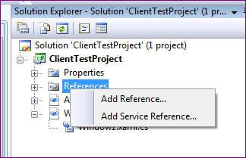

Enter the Service URL in address bar and click on Go button.

Right click on reference and add Service Reference

Step 2: Service Reference window will be open after step 1 , enter below address in address bar click on GO button : http://netconnect.bluedart.com/ShippingAPI/Finder/ServiceFinderQuery.svc

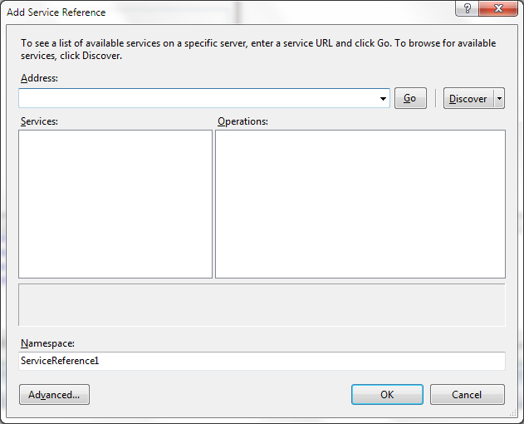

Step 3: After entering Endpoint address , below screen will be displayed , it will display all methods availabe in WSDL file.

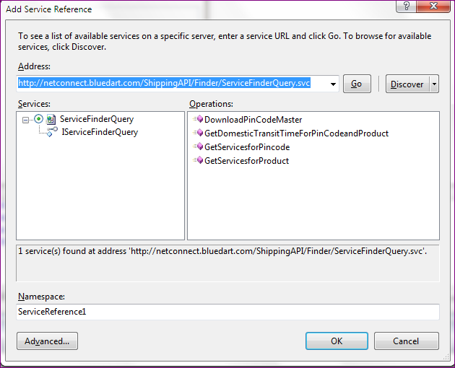

can change Namespace

Click to view all methods

existing methods in WSDL file

Click on ok to finish add reference

Step 4: click on Service reference1 in solution explorer , object browser window will open ,

Service reference is visible in solution explorer

Namespace of the proxy connection

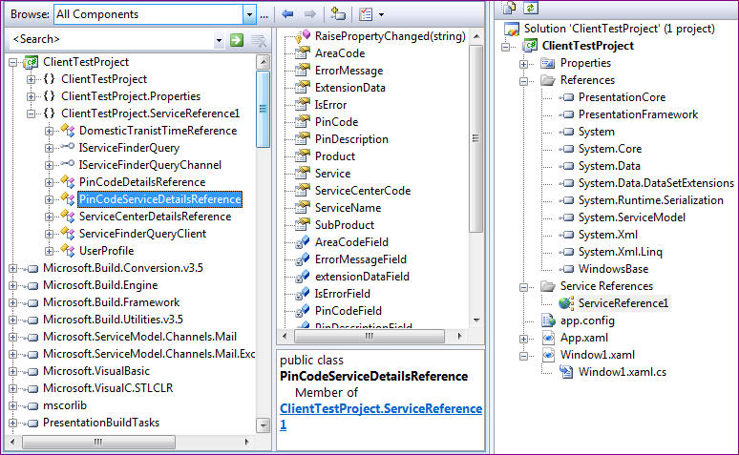

can view available class in existing namespace

Step5: Open calling form and write the code as given below.

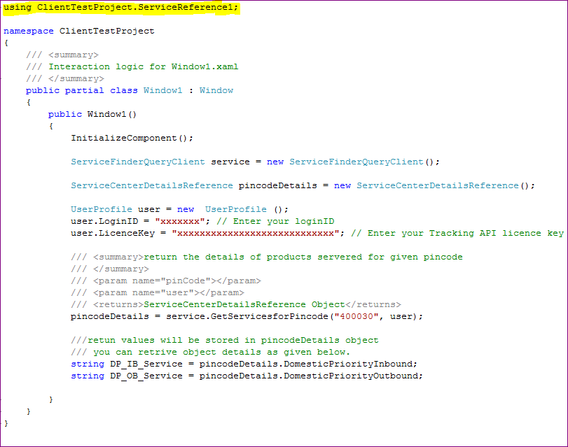

### Excel File import

Note: If client machine is not installed with MS Office then please install AccessDatabaseEngine.exe first

Step 1 : Create ODBC Driver for Excel Files ( If below highlighted entry is not there then click on Add button to add the entry )   
( ODBC is found in Control Panel--> Administrative Tools --> Data Source ODBC )

or

Run c:\Windows\SysWOW64\odbcad32.exe ( for windows 7)

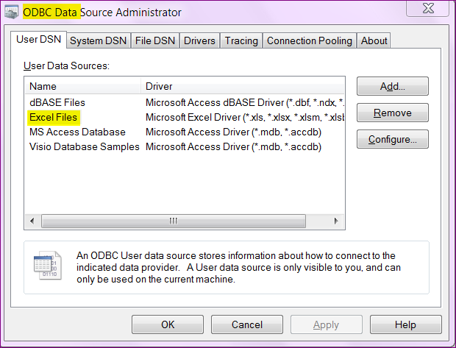

Step 2: For configuring ODBC Driver , Click on Configure button   
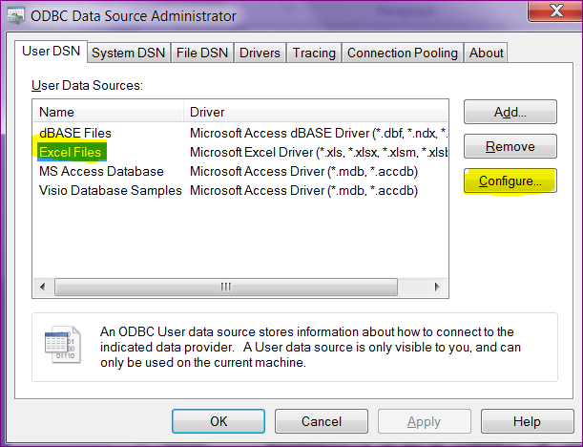

Step 3 : Set Data Source Name  
 Data Source Name should be "Excel Files" only don't change this  
 Select excel file for import by Clicking on Select workbook . ( One time only)  
 Uncheck on Read only if any .

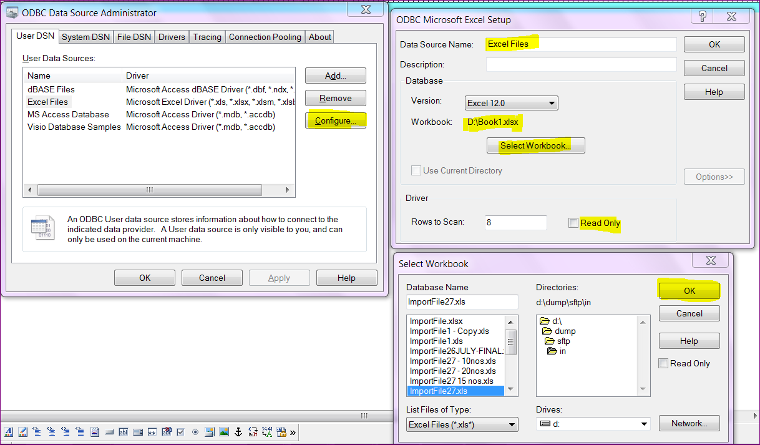

# Common Terminology

## Detailed description of common terminology used in this document

|  |  |  |
| --- | --- | --- |
| **Sr No** | **Common Terminology** | **Description** |
| 1 | Pin Code | Indian postal code |
| 2 | Area Code | 3 letter IATA code |
| 3 | ServiceCenterCode | Blue dart's pickup and delivery location code |
| 4 | TDD | Time Definite delivery |
| 5 | EDL | Extra delivery location |
| 6 | POD | Proof of Delivery |
| 7 | Pickup Date | Date on which shipment is connected/manifested in Blue Dart network |

# Shipping API Demo URLs

##### Pin Code Finder

[http://netconnect.bluedart.com/Ver1.8/Demo/ShippingAPI/Finder/ServiceFinderQuery.svc?wsdl](https://netconnect.bluedart.com/ShippingAPI/Finder/ServiceFinderQuery.svc?wsdl)

##### Transit Time

[http://netconnect.bluedart.com/ Ver1.8/Demo/ShippingAPI/Finder/ServiceFinderQuery.svc?wsdl](https://netconnect.bluedart.com/ShippingAPI/Finder/ServiceFinderQuery.svc?wsdl)

##### Pickup Registration

[https://netconnect.bluedart.com/ Ver1.8/ Demo/ShippingAPI/Pickup/PickupRegistrationService.svc?wsdl](https://netconnect.bluedart.com/ShippingAPI/Finder/ServiceFinderQuery.svc?wsdl)

##### Cancel Pickup Registration

https://netconnect.bluedart.com/ Ver1.8/Demo/ShippingAPI/Pickup/PickupRegistrationService.svc?wsdl

##### Waybill Generation

https://netconnect.bluedart.com/ Ver1.8/Demo/ShippingAPI/WayBill/WayBillGeneration.svc?wsdl

##### ALTInsruction Update

https://netconnect.bluedart.com/ Ver1.8/Demo/ShippingAPI/ ALTInstruction/ ALTInstructionUpdate.svc?wsdl