Press the **Hamburger** icon on the top left to access the **Navigation** menu

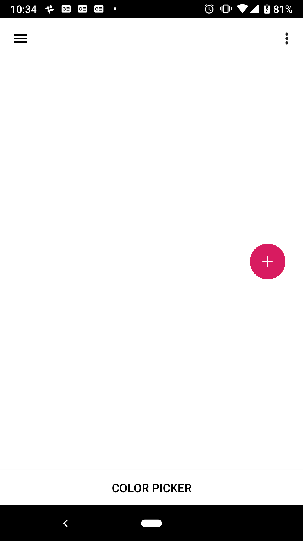

Press **Help** to view the help page

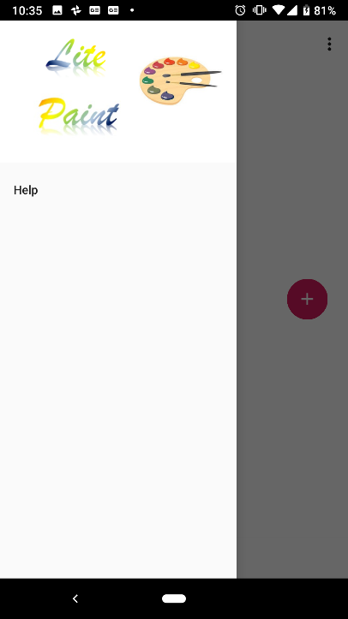

Press **Plus** icon to access **Drawing Tools**

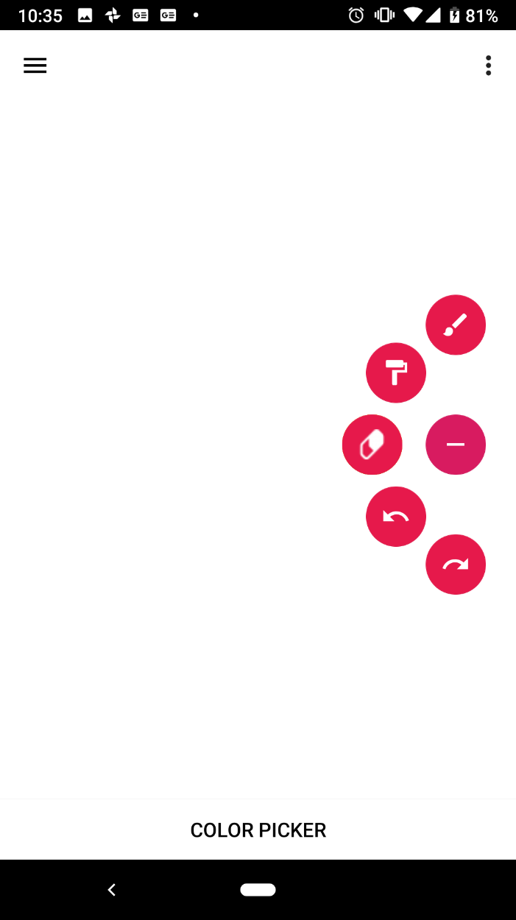

* 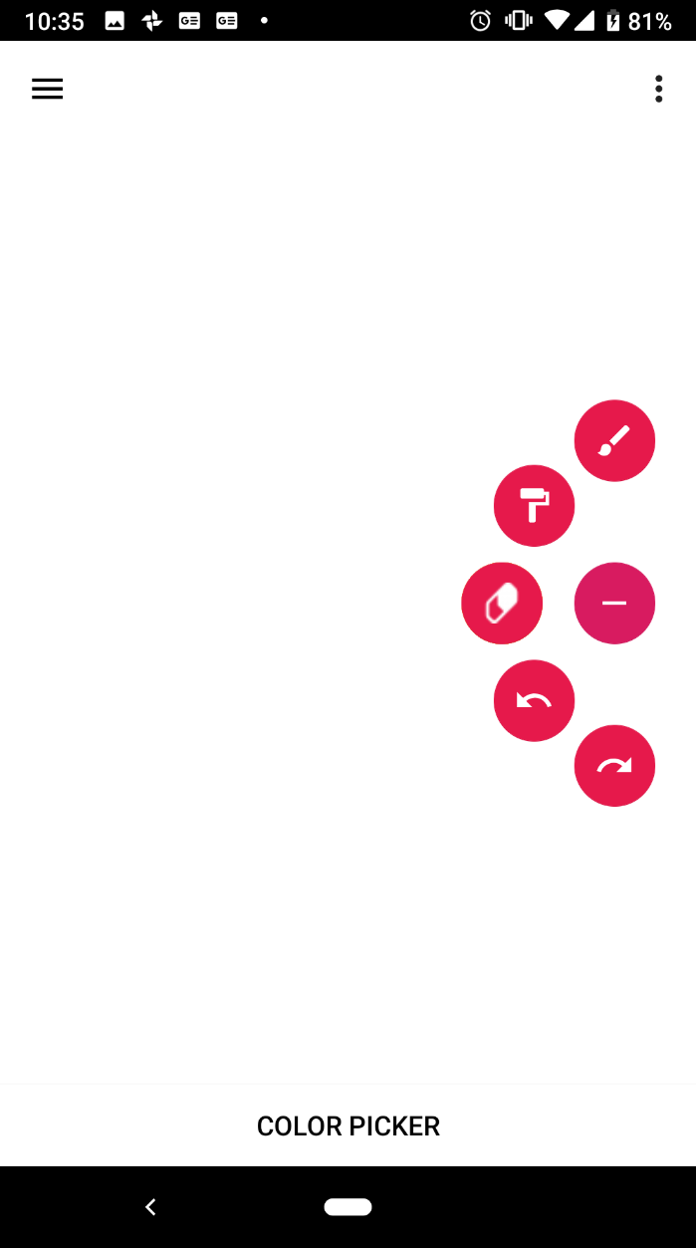 Brush Tool
* 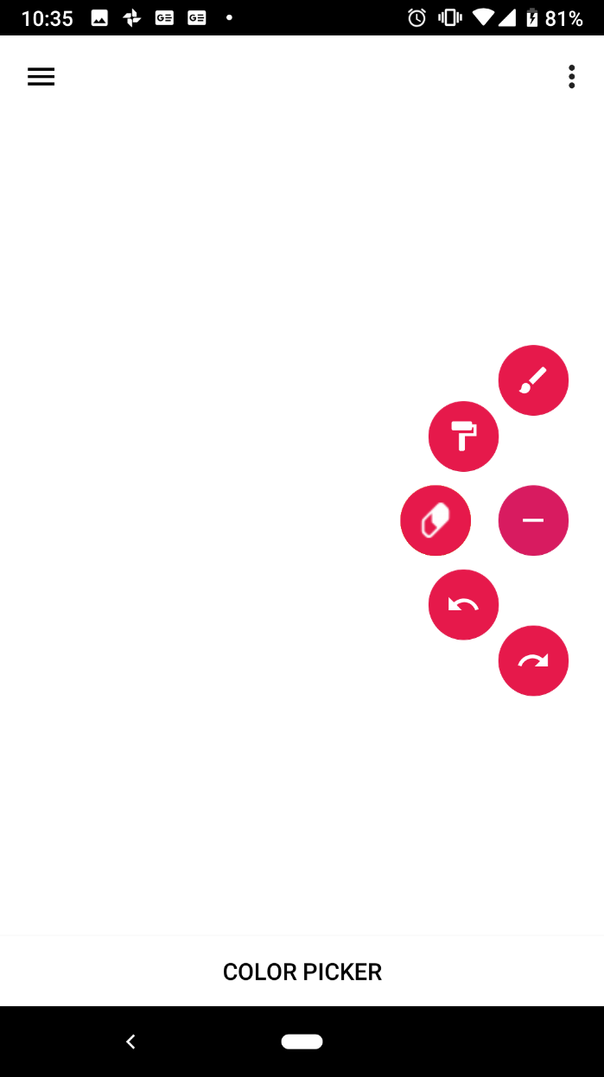 Roller Tool
*  Eraser Tool
*  Undo
*  Redo

Press individual **Tools** to access the **Size** options.

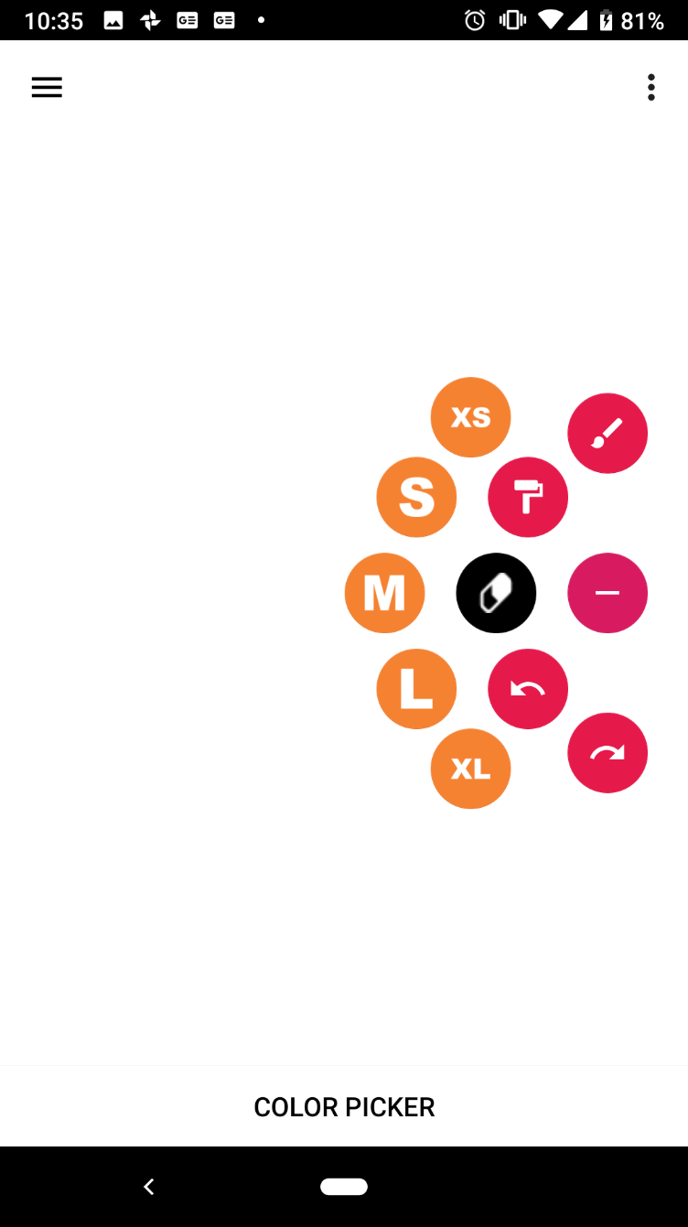

*  Extra Small
* Small
* 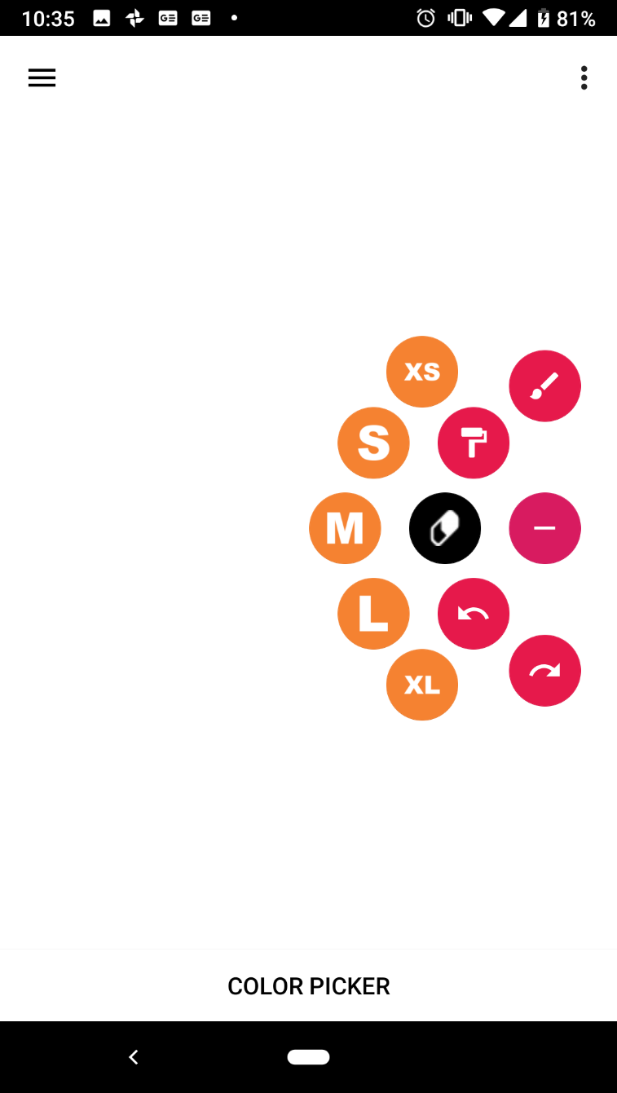Medium
* Large
* Extra Large

Click **Color Picker** to select colors

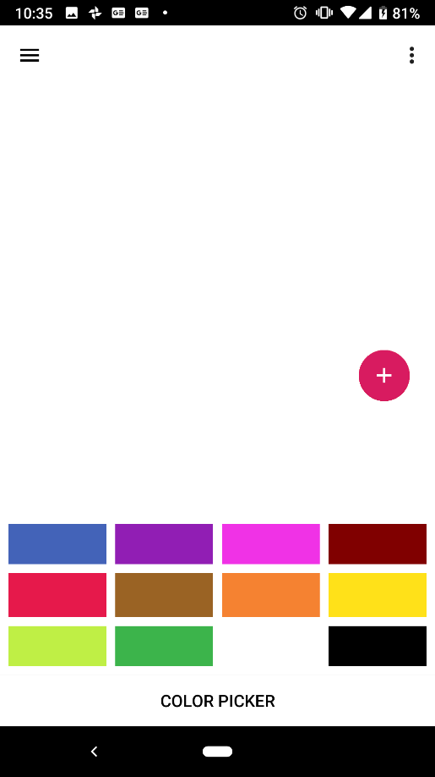

Press **Menu** icon to clear Canvas (This action cannot be undone)

 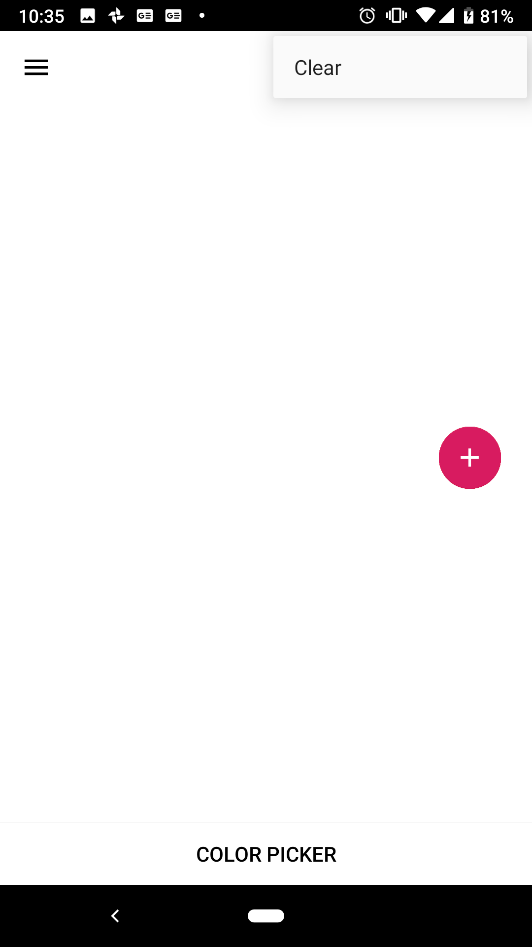 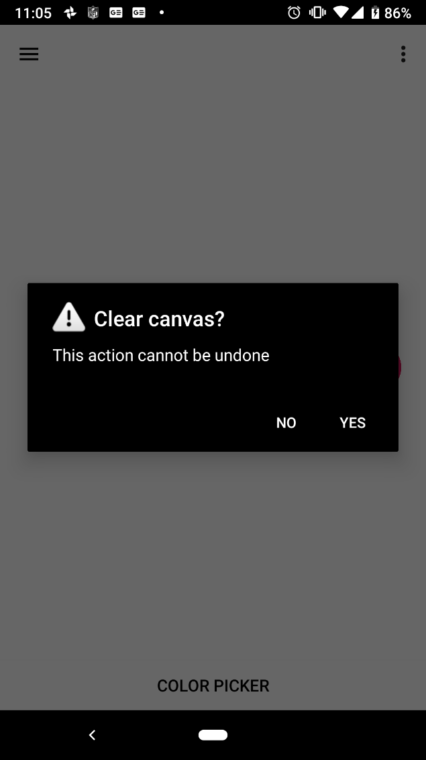

Press **System Back** button to exit

