

BHARATI VIDYAPEETH’S
INSTITUTE OF COMPUTER APPLICATIONS & MANAGEMENT
(Affiliated to Guru Gobind Singh Indraprastha University, Approved by AICTE, New Delhi)

Data and File Structures
Lab (MCA-152)
MCA - II Semester

Submitted To: Submitted By:
Dr. Arpita Nagpal Piyush Goel (09311604425)
Assistant Professor MCA 2nd Sem
BVICAM

I N D E X
(MCA-152- Data and File Structures - Lab)

Week No. | Lab. Assign.  No. | Detailed Statement of the Lab. Assignment | Date of Completion | Student’s Signature | Teacher’s Signature
 | 1. | Write a program which takes an array of n integers and displays the frequency of  each element present in the array.
 | 2. | Write a program which takes an array of n integers and performs Searching of an element by implementing linear search  and binary search techniques.
 | 3. | Write a program which takes an array of n integers and sorts the integers in descending order using bubble sort and  selection sort techniques.
 | 4. | Write a program which takes an array of n integers and sorts the integers in ascending order using insertion sort technique.
 | 5. | Write a program which takes an array of n integers and sorts the integers in ascending order using Selection sort technique.
 | 6. | Write a program which takes an array of n integers and sorts the integers in ascending order using quick sort technique.
 | 7. | Write a program which takes an array of n integers and sorts the integers in ascending order using merge sort technique.
 | 8. | Write a program which receives a matrix a[m][n] (represented by a two-dimensional array) of integers and determines whether the given matrix is sparse matrix or not. If it is sparse matrix, represent it through appropriate representation with array to save the memory space.
 | 9. | Write a menu-driven program which implements a linear linked list and  Perform insertion, deletion and searching in link list.
 | 10. | A polynomial is composed of different terms where each of them holds a coefficient and an exponent. Write a program to represent the following polynomials: 4x4 + 4x3 -2x2 + x and 11x3 + 7x2 - 4x with linear linked list, and then perform addition of the given  polynomials
 | 11. | Write a menu-driven program which implements a stack (using one-dimensional array) with following operations: a) Push (insert an element)  b) Pop (delete an element) c) Display  (print all the elements of stack)
 | 12. | Write a menu-driven program which implements a linear queue (using one-dimensional array) with following operations: a) Enqueue (insert an element) b) Dequeue (delete an element) c) Display (print all the elements of queue)
 | 13. | Write a menu-driven program which implements a circular queue (using one-dimensional array) with following operations: a) Enqueue (insert an element) b) Dequeue (delete an element) c) Display (print all the elements of queue).
 | 14. | Write a program that implements two stacks (double stack) in a single array. Both stacks should grow dynamically in opposite directions, one from lower index to higher index and second from  higher to lower index.
 | 15. | Write a program that accepts a postfix expression of the form ab+cd-*ab/ and evaluate it after accepting the values of a, b, c and d. The program should make  use of appropriate stack operations.
 | 16. | Write a menu-driven program which  implements a binary tree (using linked list) with following operations:  a) Insertion of a node  b) Deletion of a node  c) Preorder traversal  d) Inorder traversal  e) Postorder traversal  f) Determine total number of leaf nodes
 | 17. | Write a menu-driven program which implements a heap (using one dimensional array) with following operations: a) Insertion of a node b) Deletion of a node c) Display (print all the elements of heap)
 | 18. | Write a program to implement priority queue (using one dimensional array). For deletion of a node, the node having smallest data value will be considered to have highest priority.
 | 19. | Write a menu-driven program which implements a binary search tree (using linked list) with following operations: a) Insertion of a node b) Deletion of a node  c) Preorder traversal d) Inorder traversal  e) Postorder traversal
 | 20. | Write a program which takes an array of n integers and sorts the integers in ascending order using heap sort  technique.
 | 21. | Write a menu-driven program which implements a graph (using adjacency matrix) with following operations: g) Insertion of a vertex h) Insertion of an edge i) Deletion of a vertex j) Deletion of an edge k) Calculation of degree of each vertex l) Calculation of number of self- loops in the graph.
 | 22. | Write a program to traverse the graph using breadth first search.
 | 23. | Write a program to traverse the graph using depth first search techniques.
 | 24. | Apply Dijkstra’s algorithm/ Warshell’s algorithm to determine shortest path
 | 25. | Write a program to determine the minimum cost spanning tree (using Kruskal‟s or prim’s algorithm)
 | 26. | Write a program that generates n random integers and stores them in a text file, named as “All.txt”. Then, retrieve the stored integers from this file and copy to “Odd.txt” and „Even.txt‟ based upon the type of number, i.e. if the retrieved integer is odd number then store in “Odd.txt” file or if the retrieved integer is even then store in “Even.txt” file. Finally, display the contents of all three files.
 | 27. | Write a program to implement 20 integers (with some duplicate integers) in a hash table (with separate chaining for collision resolution).

Q1. Write a program which takes an array of n integers and displays the frequency of each element present in the array.

Solution:

#include <stdio.h>
int main(){
int n,i,j,counted;
printf("Enter n: ");
scanf("%d",&n);
int a[n];
printf("Enter elements: ");
for(i=0;i<n;i++) scanf("%d",&a[i]);
for(i=0;i<n;i++){
counted=0;
for(j=0;j<i;j++){
if(a[i]==a[j]){
counted=1;
break;
}
}
if(!counted){
int c=0;
for(j=0;j<n;j++) if(a[i]==a[j]) c++;
printf("%d occurs %d times\n",a[i],c);
}
}
return 0;
}

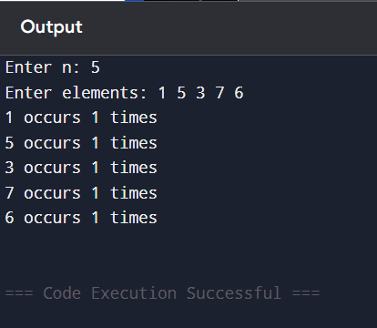

Q2. Write a program which takes an array of n integers and performs Searching of an element by implementing linear search and binary search techniques.

Solution:

#include <stdio.h>
void sort(int a[],int n){
int i,j,t;
for(i=0;i<n-1;i++) for(j=0;j<n-i-1;j++) if(a[j]>a[j+1]){
t=a[j]; a[j]=a[j+1]; a[j+1]=t;
}
}
int linear(int a[],int n,int x){
int i;
for(i=0;i<n;i++) if(a[i]==x) return i;
return -1;
}
int binary(int a[],int n,int x){
int l=0,r=n-1,m;
while(l<=r){
m=(l+r)/2;
if(a[m]==x) return m;
if(a[m]<x) l=m+1;
else r=m-1;
}
return -1;
}
int main(){
int n,i,x,p;
printf("Enter n: ");
scanf("%d",&n);
int a[n];
printf("Enter elements: ");
for(i=0;i<n;i++) scanf("%d",&a[i]);
printf("Enter element to search: ");
scanf("%d",&x);
p=linear(a,n,x);
if(p==-1) printf("Linear Search: Not found\n");
else printf("Linear Search: Found at position %d\n",p+1);
sort(a,n);
printf("Sorted array for binary search: ");
for(i=0;i<n;i++) printf("%d ",a[i]);
printf("\n");
p=binary(a,n,x);
if(p==-1) printf("Binary Search: Not found\n");
else printf("Binary Search: Found at position %d\n",p+1);
return 0;
}

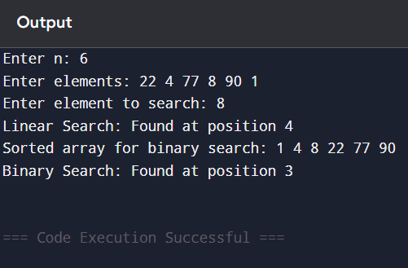

Q3. Write a program which takes an array of n integers and sorts the integers in descending order using bubble sort and selection sort techniques.

Solution:

#include <stdio.h>
void print(int a[],int n){
int i;
for(i=0;i<n;i++) printf("%d ",a[i]);
printf("\n");
}
void bubble(int a[],int n){
int i,j,t;
for(i=0;i<n-1;i++) for(j=0;j<n-i-1;j++) if(a[j]<a[j+1]){
t=a[j]; a[j]=a[j+1]; a[j+1]=t;
}
}
void selection(int a[],int n){
int i,j,max,t;
for(i=0;i<n-1;i++){
max=i;
for(j=i+1;j<n;j++) if(a[j]>a[max]) max=j;
t=a[i]; a[i]=a[max]; a[max]=t;
}}
int main(){
int n,i;
printf("Enter n: ");
scanf("%d",&n);
int a[n],b[n];
printf("Enter elements: ");
for(i=0;i<n;i++){ scanf("%d",&a[i]); b[i]=a[i]; }
bubble(a,n);
selection(b,n);
printf("Bubble sort descending: ");
print(a,n);
printf("Selection sort descending: ");
print(b,n);
return 0;
}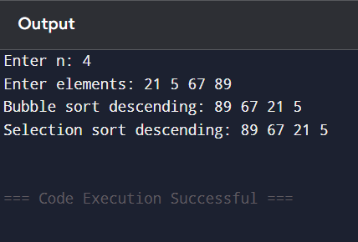

Q4. Write a program which takes an array of n integers and sorts the integers in ascending order using insertion sort technique.

Solution:

#include <stdio.h>
int main(){
int n,i,j,key;
printf("Enter n: ");
scanf("%d",&n);
int a[n];
printf("Enter elements: ");
for(i=0;i<n;i++) scanf("%d",&a[i]);
for(i=1;i<n;i++){
key=a[i];
j=i-1;
while(j>=0 && a[j]>key){
a[j+1]=a[j];
j--;
}
a[j+1]=key;
}
printf("Sorted array: ");
for(i=0;i<n;i++) printf("%d ",a[i]);
return 0;
}

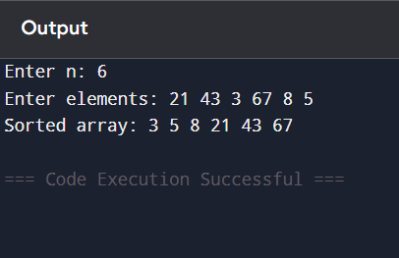

Q5. Write a program which takes an array of n integers and sorts the integers in ascending order using Selection sort technique.

Solution:

#include <stdio.h>

int main() {
int n, i, j, min, temp;

printf("Enter n: ");
scanf("%d", &n);

int a[n];

printf("Enter elements:\n");
for(i = 0; i < n; i++)
scanf("%d", &a[i]);

for(i = 0; i < n - 1; i++) {
min = i;
for(j = i + 1; j < n; j++) {
if(a[j] < a[min])
min = j;}
temp = a[i];
a[i] = a[min];
a[min] = temp;
}
printf("Sorted array:\n");
for(i = 0; i < n; i++)
printf("%d ", a[i]);
return 0;
}

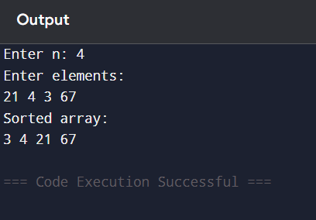

Q6. Write a program which takes an array of n integers and sorts the integers in ascending order using quick sort technique.

Solution:
#include <stdio.h>
int partition(int a[],int l,int h){
int pivot=a[h],i=l-1,j,t;
for(j=l;j<h;j++){
if(a[j]<=pivot){
i++;
t=a[i]; a[i]=a[j]; a[j]=t;
}
}
t=a[i+1]; a[i+1]=a[h]; a[h]=t;
return i+1;
}
void quick(int a[],int l,int h){
if(l<h){
int p=partition(a,l,h);
quick(a,l,p-1);
quick(a,p+1,h);
}
}
int main(){
int n,i;
printf("Enter n: ");
scanf("%d",&n);
int a[n];
printf("Enter elements: ");
for(i=0;i<n;i++) scanf("%d",&a[i]);
quick(a,0,n-1);
printf("Sorted array: ");
for(i=0;i<n;i++) printf("%d ",a[i]);
return 0;
}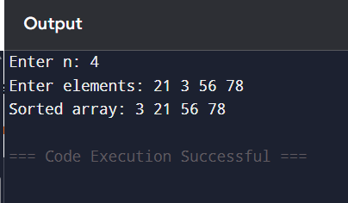
Q7. Write a program which takes an array of n integers and sorts the integers in ascending order using merge sort technique.

Solution:

#include <stdio.h>

void merge(int a[], int l, int m, int r) {
int i, j, k;
int n1 = m - l + 1;
int n2 = r - m;
int L[n1], R[n2];

for(i = 0; i < n1; i++)
L[i] = a[l + i];

for(j = 0; j < n2; j++)
R[j] = a[m + 1 + j];

i = 0;
j = 0;
k = l;

while(i < n1 && j < n2) {
if(L[i] <= R[j]) {
a[k] = L[i];
i++;
} else {
a[k] = R[j];
j++;
}
k++;
}

while(i < n1) {
a[k] = L[i];
i++;
k++;
}

while(j < n2) {
a[k] = R[j];
j++;
k++;
}
}

void mergeSort(int a[], int l, int r) {
if(l < r) {
int m = (l + r) / 2;
mergeSort(a, l, m);
mergeSort(a, m + 1, r);
merge(a, l, m, r);
}
}

int main() {
int n, i;

printf("Enter n: ");
scanf("%d", &n);

int a[n];

printf("Enter elements:\n");
for(i = 0; i < n; i++)
scanf("%d", &a[i]);

mergeSort(a, 0, n - 1);

printf("Sorted array:\n");
for(i = 0; i < n; i++)
printf("%d ", a[i]);

return 0;
}

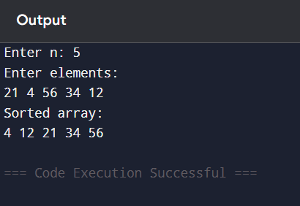

Q8. Write a program which receives a matrix a[m][n] and determines whether the given matrix is sparse matrix or not. If it is sparse matrix, represent it using appropriate representation with array to save the memory space.

Solution:

#include <stdio.h>
int main(){
int m,n,i,j,k=0,z=0;
printf("Enter rows and columns: ");
scanf("%d%d",&m,&n);
int a[m][n];
printf("Enter matrix:\n");
for(i=0;i<m;i++) for(j=0;j<n;j++){
scanf("%d",&a[i][j]);
if(a[i][j]==0) z++;
}
if(z>(m*n)/2){
int s[m*n-z][3];
for(i=0;i<m;i++) for(j=0;j<n;j++) if(a[i][j]!=0){
s[k][0]=i;
s[k][1]=j;
s[k][2]=a[i][j];
k++;
}
printf("Sparse matrix\n");
printf("Row Column Value\n");
for(i=0;i<k;i++) printf("%d %d %d\n",s[i][0],s[i][1],s[i][2]);
}else{
printf("Not a sparse matrix\n");
}
return 0;
}

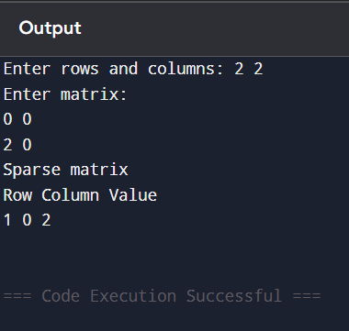

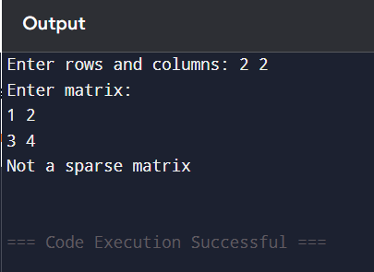

Q9. Write a menu-driven program which implements a linear linked list and perform insertion, deletion and searching in link list.

Solution:

#include <stdio.h>
#include <stdlib.h>
struct node{int data;struct node*next;};
struct node*head=NULL;
struct node*newnode(int x){
struct node*t=malloc(sizeof(struct node));
t->data=x; t->next=NULL; return t;
}
void insertBeg(int x){
struct node*t=newnode(x);
t->next=head; head=t;
}
void insertEnd(int x){
struct node*t=newnode(x),*p=head;
if(!head){head=t;return;}
while(p->next)p=p->next;
p->next=t;
}
void insertPos(int x,int pos){
int i;
if(pos<=1){insertBeg(x);return;}
struct node*t=newnode(x),*p=head;
for(i=1;p&&i<pos-1;i++) p=p->next;
if(!p){printf("Invalid position\n");free(t);return;}
t->next=p->next; p->next=t;
}
void deleteBeg(){
if(!head){printf("Empty\n");return;}
struct node*t=head; head=head->next; free(t);
}
void deleteEnd(){
struct node*p=head,*q=NULL;
if(!head){printf("Empty\n");return;}
if(!head->next){free(head);head=NULL;return;}
while(p->next){q=p;p=p->next;}
q->next=NULL; free(p);
}
void deletePos(int pos){
int i;
struct node*p=head,*q=NULL;
if(!head){printf("Empty\n");return;}
if(pos<=1){deleteBeg();return;}
for(i=1;p&&i<pos;i++){q=p;p=p->next;}
if(!p){printf("Invalid position\n");return;}
q->next=p->next; free(p);
}
void display(){
struct node*p=head;
if(!p){printf("Empty\n");return;}
while(p){printf("%d ",p->data);p=p->next;}
printf("\n");
}
void search(int x){
struct node*p=head; int pos=1;
while(p){
if(p->data==x){printf("Found at position %d\n",pos);return;}
p=p->next; pos++;
}
printf("Not found\n");
}
int main(){
int ch,x,pos;
while(1){
printf("\n1.Insert beginning 2.Insert position 3.Insert end 4.Delete beginning 5.Delete position 6.Delete end 7.Display 8.Search 9.Exit\n");
scanf("%d",&ch);
if(ch==1){scanf("%d",&x);insertBeg(x);}
else if(ch==2){scanf("%d%d",&x,&pos);insertPos(x,pos);}
else if(ch==3){scanf("%d",&x);insertEnd(x);}
else if(ch==4)deleteBeg();
else if(ch==5){scanf("%d",&pos);deletePos(pos);}
else if(ch==6)deleteEnd();
else if(ch==7)display();
else if(ch==8){scanf("%d",&x);search(x);}
else if(ch==9)break;
else printf("Invalid choice\n");
}
return 0;
}

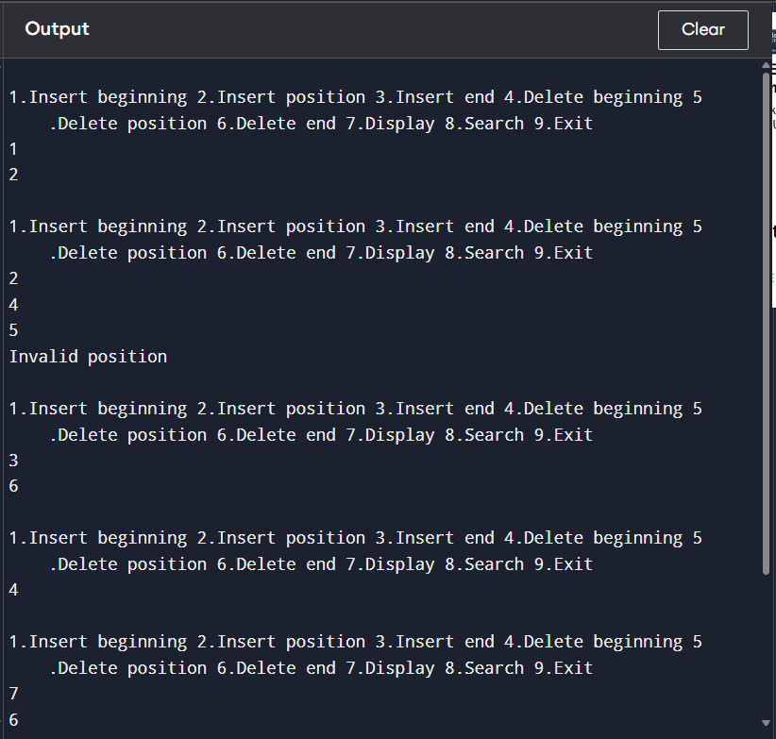

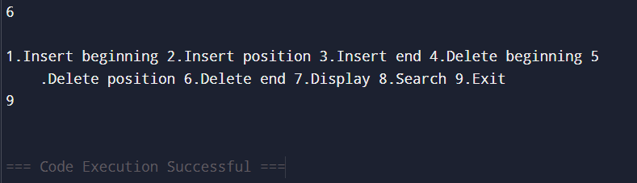

Q10. A polynomial is composed of different terms where each of them holds a coefficient and an exponent. Write a program to represent the following polynomials: 4x4 + 4x3 -2x2 + x and 11x3 + 7x2 - 4x with linear linked list, and then perform addition of the given polynomials.

Solution:

#include <stdio.h>
#include <stdlib.h>
struct node{int c,e;struct node*next;};
struct node*newnode(int c,int e){
struct node*t=malloc(sizeof(struct node));
t->c=c; t->e=e; t->next=NULL; return t;
}
void addTerm(struct node**h,int c,int e){
struct node*t=newnode(c,e),*p=*h;
if(!*h){*h=t;return;}
while(p->next)p=p->next;
p->next=t;
}
struct node*addPoly(struct node*a,struct node*b){
struct node*r=NULL;
while(a&&b){
if(a->e==b->e){addTerm(&r,a->c+b->c,a->e);a=a->next;b=b->next;}
else if(a->e>b->e){addTerm(&r,a->c,a->e);a=a->next;}
else{addTerm(&r,b->c,b->e);b=b->next;}
}
while(a){addTerm(&r,a->c,a->e);a=a->next;}
while(b){addTerm(&r,b->c,b->e);b=b->next;}
return r;
}
void display(struct node*p){
int first=1;
while(p){
if(p->c!=0){
if(!first && p->c>0) printf(" + ");
if(p->c<0) printf(" - ");
printf("%dx^%d",p->c<0?-p->c:p->c,p->e);
first=0;
}
p=p->next;
}
printf("\n");
}
int main(){
struct node*p1=NULL,*p2=NULL,*sum;
addTerm(&p1,4,4); addTerm(&p1,4,3); addTerm(&p1,-2,2); addTerm(&p1,1,1);
addTerm(&p2,11,3); addTerm(&p2,7,2); addTerm(&p2,-4,1);
printf("Polynomial 1: "); display(p1);
printf("Polynomial 2: "); display(p2);
sum=addPoly(p1,p2);
printf("Sum: "); display(sum);
return 0;
}

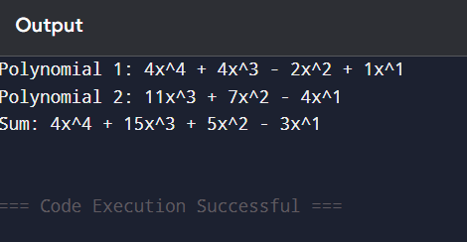

Q11. Write a menu-driven program which implements a stack using one-dimensional array with Push, Pop and Display operations.

Solution:

#include <stdio.h>
#define MAX 100
int s[MAX],top=-1;
void push(int x){if(top==MAX-1)printf("Overflow\n");else s[++top]=x;}
void pop(){if(top==-1)printf("Underflow\n");else printf("Popped %d\n",s[top--]);}
void display(){int i;if(top==-1)printf("Empty\n");else{for(i=top;i>=0;i--)printf("%d ",s[i]);printf("\n");}}
int main(){
int ch,x;
while(1){
printf("\n1.Push 2.Pop 3.Display 4.Exit\n");
scanf("%d",&ch);
if(ch==1){scanf("%d",&x);push(x);}
else if(ch==2)pop();
else if(ch==3)display();
else if(ch==4)break;
else printf("Invalid\n");
}
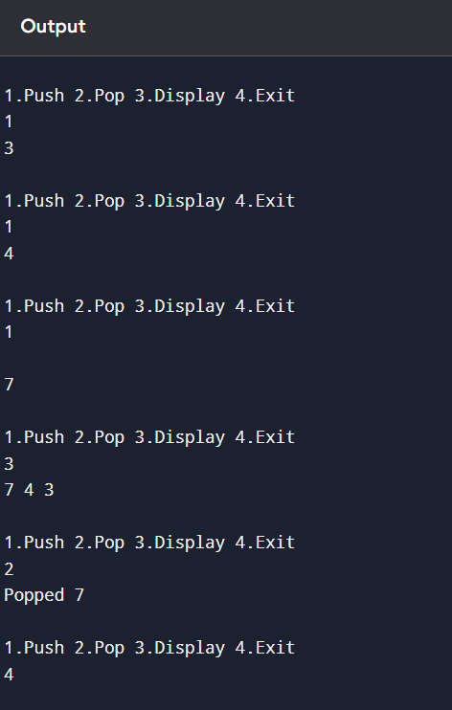
return 0;
}

Q12. Write a menu-driven program which implements a linear queue using one-dimensional array with Enqueue, Dequeue and Display operations.

Solution:

#include <stdio.h>
#define MAX 100
int q[MAX],front=-1,rear=-1;
void enqueue(int x){
if(rear==MAX-1)printf("Overflow\n");
else{if(front==-1)front=0;q[++rear]=x;}
}
void dequeue(){
if(front==-1||front>rear)printf("Underflow\n");
else printf("Deleted %d\n",q[front++]);
}
void display(){
int i;
if(front==-1||front>rear)printf("Empty\n");
else{for(i=front;i<=rear;i++)printf("%d ",q[i]);printf("\n");}
}
int main(){
int ch,x;
while(1){
printf("\n1.Enqueue 2.Dequeue 3.Display 4.Exit\n");
scanf("%d",&ch);
if(ch==1){scanf("%d",&x);enqueue(x);}
else if(ch==2)dequeue();
else if(ch==3)display();
else if(ch==4)break;
else printf("Invalid\n");
}
return 0;
}
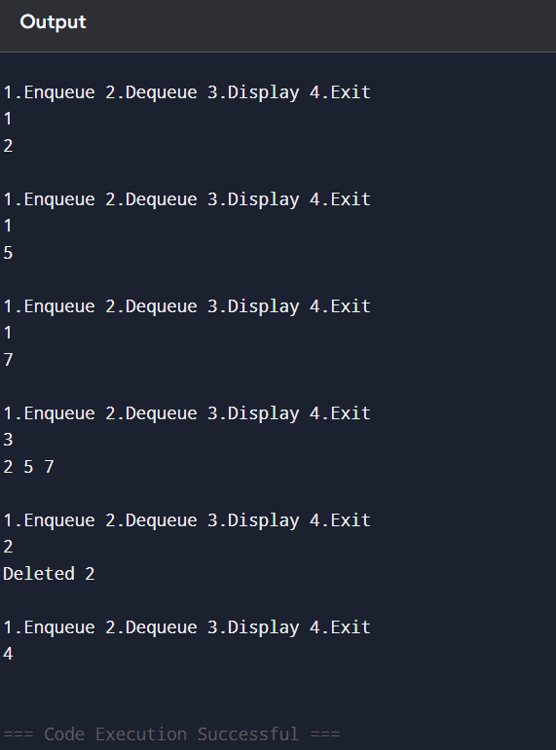

Q13. Write a menu-driven program which implements a circular queue using one-dimensional array with Enqueue, Dequeue and Display operations.

Solution:

#include <stdio.h>
#define MAX 100
int q[MAX],front=-1,rear=-1;
void enqueue(int x){
if((front==0&&rear==MAX-1)||front==rear+1)printf("Overflow\n");
else{
if(front==-1)front=rear=0;
else if(rear==MAX-1)rear=0;
else rear++;
q[rear]=x;
}
}
void dequeue(){
if(front==-1)printf("Underflow\n");
else{
printf("Deleted %d\n",q[front]);
if(front==rear)front=rear=-1;
else if(front==MAX-1)front=0;
else front++;
}
}
void display(){
int i;
if(front==-1){printf("Empty\n");return;}
i=front;
while(1){
printf("%d ",q[i]);
if(i==rear)break;
i=(i+1)%MAX;
}
printf("\n");
}
int main(){
int ch,x;
while(1){
printf("\n1.Enqueue 2.Dequeue 3.Display 4.Exit\n");
scanf("%d",&ch);
if(ch==1){scanf("%d",&x);enqueue(x);}
else if(ch==2)dequeue();
else if(ch==3)display();
else if(ch==4)break;
else printf("Invalid\n");
}
return 0;
}
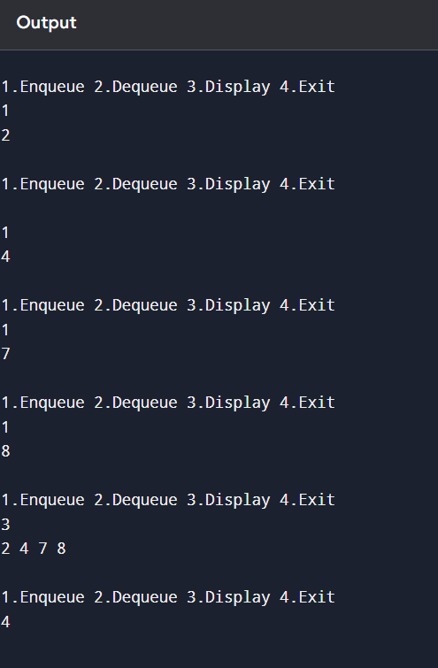

Q14. Write a program that implements two stacks in a single array. Both stacks should grow dynamically in opposite directions.

Solution:

#include <stdio.h>
#define MAX 100
int a[MAX],top1=-1,top2=MAX;
void push1(int x){if(top1+1==top2)printf("Overflow\n");else a[++top1]=x;}
void push2(int x){if(top1+1==top2)printf("Overflow\n");else a[--top2]=x;}
void pop1(){if(top1==-1)printf("Underflow\n");else printf("Popped %d\n",a[top1--]);}
void pop2(){if(top2==MAX)printf("Underflow\n");else printf("Popped %d\n",a[top2++]);}
void display1(){int i;for(i=top1;i>=0;i--)printf("%d ",a[i]);printf("\n");}
void display2(){int i;for(i=top2;i<MAX;i++)printf("%d ",a[i]);printf("\n");}
int main(){
int ch,x;
while(1){
printf("\n1.Push1 2.Push2 3.Pop1 4.Pop2 5.Display1 6.Display2 7.Exit\n");
scanf("%d",&ch);
if(ch==1){scanf("%d",&x);push1(x);}
else if(ch==2){scanf("%d",&x);push2(x);}
else if(ch==3)pop1();
else if(ch==4)pop2();
else if(ch==5)display1();
else if(ch==6)display2();
else if(ch==7)break;
else printf("Invalid\n");
}
return 0;
}

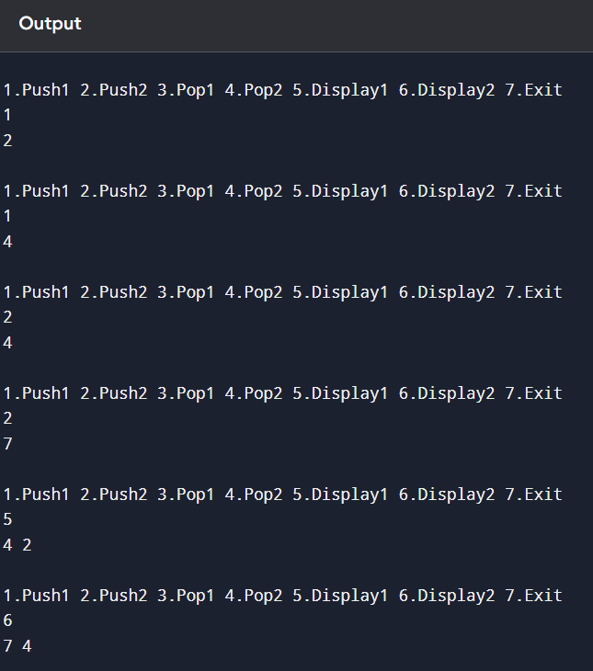

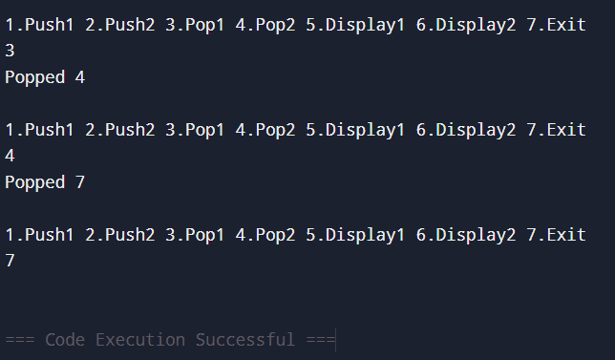

Q15. Write a program that accepts a postfix expression of the form ab+cd-*ab/ and evaluate it after accepting the values of a, b, c and d using stack operations.

Solution:
#include <stdio.h>
#include <ctype.h>
#include <math.h>
#define MAX 100
int st[MAX],top=-1,val[26],used[26];
void push(int x){st[++top]=x;}
int pop(){return st[top--];}
int main(){
char exp[MAX],c;
int i,a,b;
printf("Enter postfix expression: ");
scanf("%s",exp);
for(i=0;exp[i];i++){
c=exp[i];
if(isalpha(c) && !used[tolower(c)-'a']){
printf("Enter value of %c: ",c);
scanf("%d",&val[tolower(c)-'a']);
used[tolower(c)-'a']=1;
}
}
for(i=0;exp[i];i++){
c=exp[i];
if(isalpha(c)) push(val[tolower(c)-'a']);
else{
b=pop(); a=pop();
if(c=='+') push(a+b);
else if(c=='-') push(a-b);
else if(c=='*') push(a*b);
else if(c=='/') push(a/b);
else if(c=='%') push(a%b);
}
}
printf("Result = %d",pop());
return 0;
}
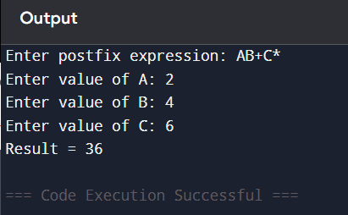

Q16. Write a menu-driven program which implements a binary tree using linked list with insertion, deletion, preorder, inorder, postorder traversal and total number of leaf nodes.

Solution:

#include <stdio.h>
#include <stdlib.h>
struct node{int data;struct node*left,*right;};
struct node*root=NULL;
struct node*newnode(int x){struct node*t=malloc(sizeof(struct node));t->data=x;t->left=t->right=NULL;return t;}
struct node*insert(struct node*r,int x){
if(!r)return newnode(x);
if(x<r->data)r->left=insert(r->left,x);
else if(x>r->data)r->right=insert(r->right,x);
return r;
}
struct node*minnode(struct node*r){while(r&&r->left)r=r->left;return r;}
struct node*del(struct node*r,int x){
if(!r)return r;
if(x<r->data)r->left=del(r->left,x);
else if(x>r->data)r->right=del(r->right,x);
else{
if(!r->left){struct node*t=r->right;free(r);return t;}
if(!r->right){struct node*t=r->left;free(r);return t;}
struct node*t=minnode(r->right);
r->data=t->data;
r->right=del(r->right,t->data);
}
return r;
}
void preorder(struct node*r){if(r){printf("%d ",r->data);preorder(r->left);preorder(r->right);}}
void inorder(struct node*r){if(r){inorder(r->left);printf("%d ",r->data);inorder(r->right);}}
void postorder(struct node*r){if(r){postorder(r->left);postorder(r->right);printf("%d ",r->data);}}
int leaves(struct node*r){if(!r)return 0;if(!r->left&&!r->right)return 1;return leaves(r->left)+leaves(r->right);}
int main(){
int ch,x;
while(1){
printf("\n1.Insert 2.Delete 3.Preorder 4.Inorder 5.Postorder 6.Leaf nodes 7.Exit\n");
scanf("%d",&ch);
if(ch==1){scanf("%d",&x);root=insert(root,x);}
else if(ch==2){scanf("%d",&x);root=del(root,x);}
else if(ch==3){preorder(root);printf("\n");}
else if(ch==4){inorder(root);printf("\n");}
else if(ch==5){postorder(root);printf("\n");}
else if(ch==6)printf("%d\n",leaves(root));
else if(ch==7)break;
else printf("Invalid\n");
}
return 0;
}

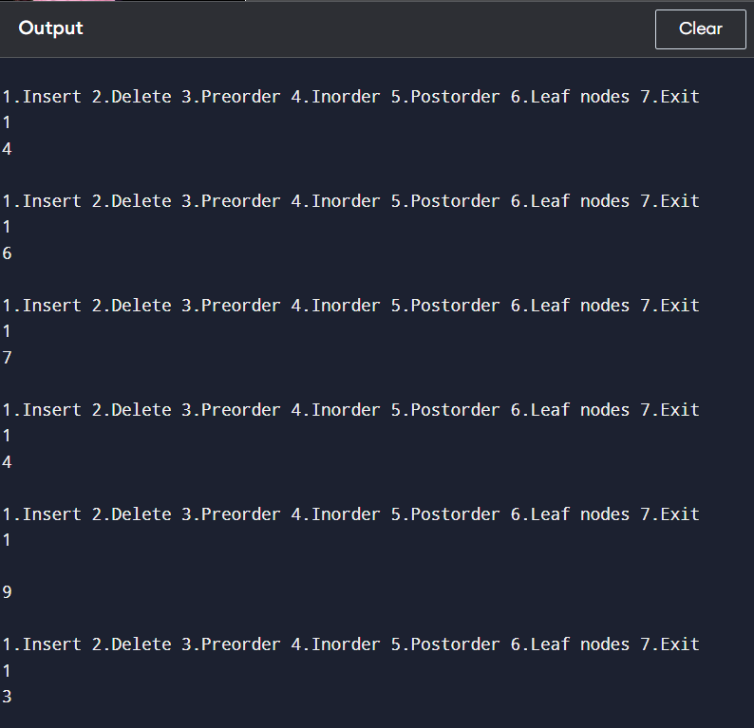

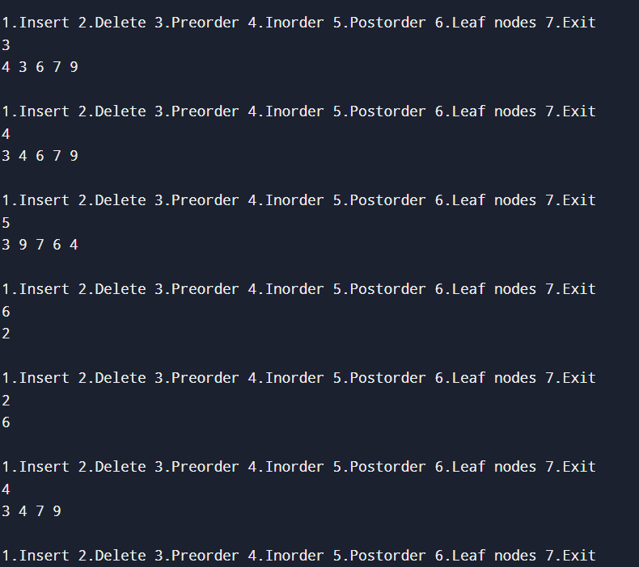

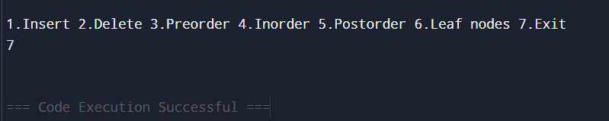

Q17. Write a menu-driven program which implements a heap using one dimensional array with insertion, deletion and display operations.

Solution:

#include <stdio.h>
#define MAX 100
int h[MAX],n=0;
void insert(int x){
int i,t;
if(n==MAX){printf("Full\n");return;}
h[++n]=x; i=n;
while(i>1&&h[i/2]<h[i]){
t=h[i/2];h[i/2]=h[i];h[i]=t;i/=2;
}
}
void del(){
int i=1,j,t;
if(n==0){printf("Empty\n");return;}
printf("Deleted %d\n",h[1]);
h[1]=h[n--];
while(1){
j=2*i;
if(j>n)break;
if(j+1<=n&&h[j+1]>h[j])j++;
if(h[i]>=h[j])break;
t=h[i];h[i]=h[j];h[j]=t;i=j;
}
}
void display(){int i;for(i=1;i<=n;i++)printf("%d ",h[i]);printf("\n");}
int main(){
int ch,x;
while(1){
printf("\n1.Insert 2.Delete 3.Display 4.Exit\n");
scanf("%d",&ch);
if(ch==1){scanf("%d",&x);insert(x);}
else if(ch==2)del();
else if(ch==3)display();
else if(ch==4)break;
else printf("Invalid\n");
}
return 0;
}

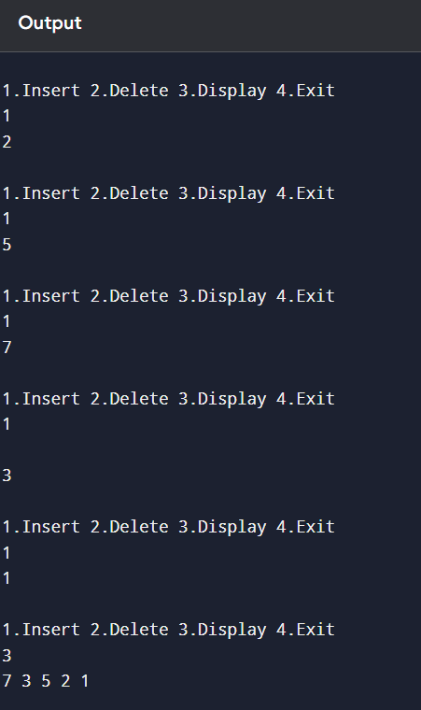

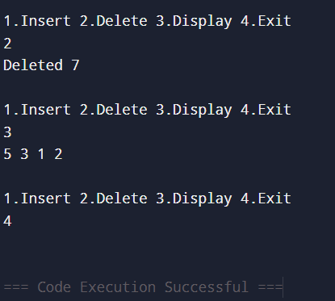

Q18. Write a program to implement priority queue using one dimensional array. For deletion, smallest data value has highest priority.

Solution:

#include <stdio.h>
#define MAX 100
int pq[MAX],n=0;
void insert(int x){if(n==MAX)printf("Full\n");else pq[n++]=x;}
void del(){
int i,min=0;
if(n==0){printf("Empty\n");return;}
for(i=1;i<n;i++)if(pq[i]<pq[min])min=i;
printf("Deleted %d\n",pq[min]);
for(i=min;i<n-1;i++)pq[i]=pq[i+1];
n--;
}
void display(){int i;for(i=0;i<n;i++)printf("%d ",pq[i]);printf("\n");}
int main(){
int ch,x;
while(1){
printf("\n1.Insert 2.Delete highest priority 3.Display 4.Exit\n");
scanf("%d",&ch);
if(ch==1){scanf("%d",&x);insert(x);}
else if(ch==2)del();
else if(ch==3)display();
else if(ch==4)break;
else printf("Invalid\n");
}
return 0;
}

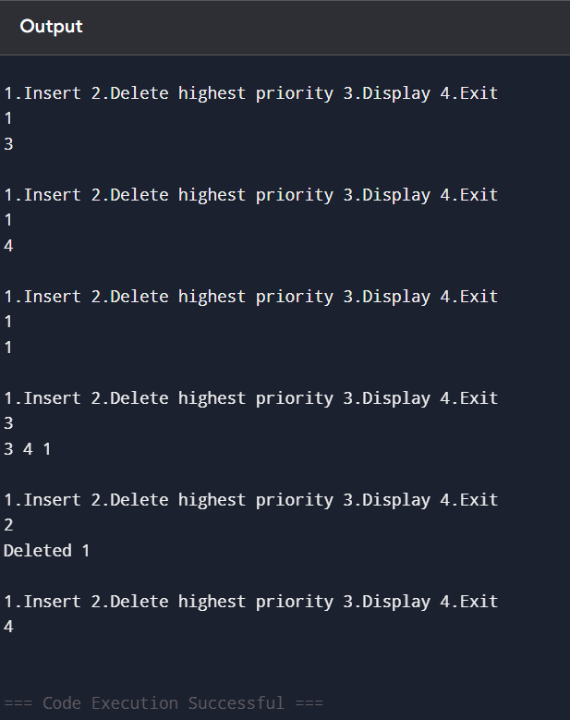

Q19. Write a menu-driven program which implements a binary search tree using linked list with insertion, deletion, preorder, inorder and postorder traversal.

Solution:

#include <stdio.h>
#include <stdlib.h>
struct node{int data;struct node*left,*right;};
struct node*root=NULL;
struct node*newnode(int x){struct node*t=malloc(sizeof(struct node));t->data=x;t->left=t->right=NULL;return t;}
struct node*insert(struct node*r,int x){
if(!r)return newnode(x);
if(x<r->data)r->left=insert(r->left,x);
else if(x>r->data)r->right=insert(r->right,x);
return r;
}
struct node*minnode(struct node*r){while(r&&r->left)r=r->left;return r;}
struct node*del(struct node*r,int x){
if(!r)return r;
if(x<r->data)r->left=del(r->left,x);
else if(x>r->data)r->right=del(r->right,x);
else{
if(!r->left){struct node*t=r->right;free(r);return t;}
if(!r->right){struct node*t=r->left;free(r);return t;}
struct node*t=minnode(r->right);
r->data=t->data;
r->right=del(r->right,t->data);
}
return r;
}
void preorder(struct node*r){if(r){printf("%d ",r->data);preorder(r->left);preorder(r->right);}}
void inorder(struct node*r){if(r){inorder(r->left);printf("%d ",r->data);inorder(r->right);}}
void postorder(struct node*r){if(r){postorder(r->left);postorder(r->right);printf("%d ",r->data);}}
int leaves(struct node*r){if(!r)return 0;if(!r->left&&!r->right)return 1;return leaves(r->left)+leaves(r->right);}
int main(){
int ch,x;
while(1){
printf("\n1.Insert 2.Delete 3.Preorder 4.Inorder 5.Postorder 6.Leaf nodes 7.Exit\n");
scanf("%d",&ch);
if(ch==1){scanf("%d",&x);root=insert(root,x);}
else if(ch==2){scanf("%d",&x);root=del(root,x);}
else if(ch==3){preorder(root);printf("\n");}
else if(ch==4){inorder(root);printf("\n");}
else if(ch==5){postorder(root);printf("\n");}
else if(ch==6)printf("%d\n",leaves(root));
else if(ch==7)break;
else printf("Invalid\n");
}
return 0;
}

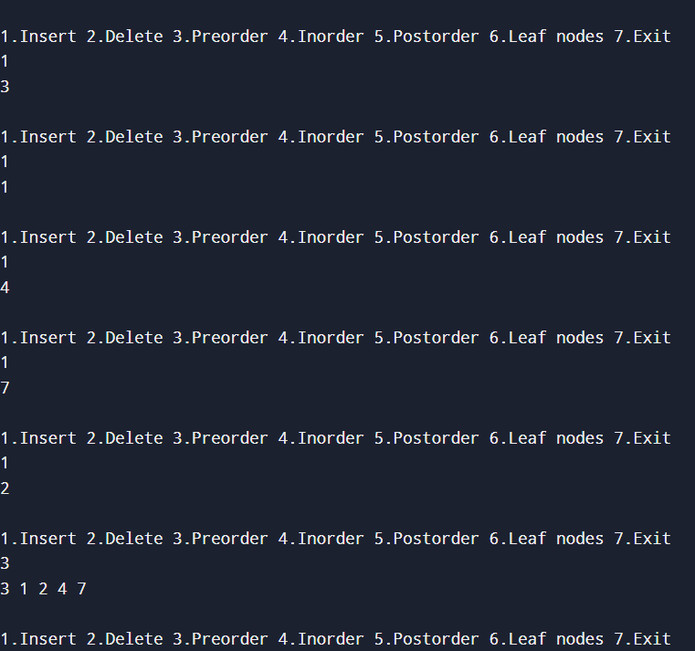

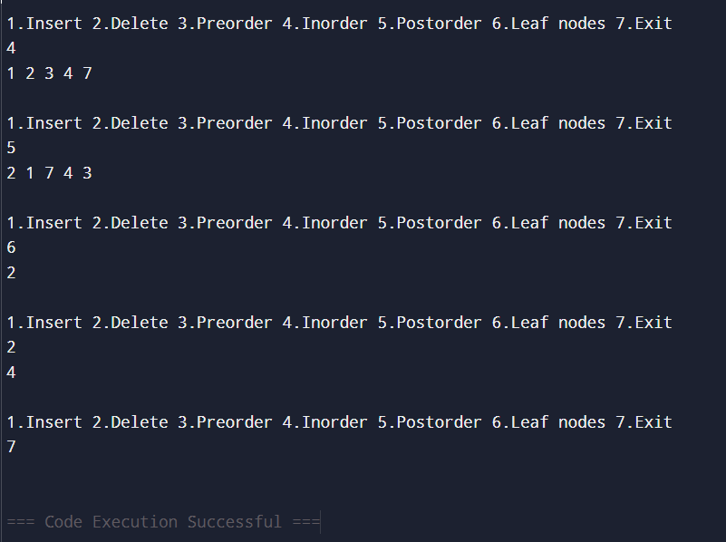

Q20. Write a program which takes an array of n integers and sorts the integers in ascending order using heap sort technique.

Solution:

#include <stdio.h>
void heapify(int a[],int n,int i){
int largest=i,l=2*i+1,r=2*i+2,t;
if(l<n&&a[l]>a[largest])largest=l;
if(r<n&&a[r]>a[largest])largest=r;
if(largest!=i){
t=a[i];a[i]=a[largest];a[largest]=t;
heapify(a,n,largest);
}
}
void heapsort(int a[],int n){
int i,t;
for(i=n/2-1;i>=0;i--)heapify(a,n,i);
for(i=n-1;i>0;i--){
t=a[0];a[0]=a[i];a[i]=t;
heapify(a,i,0);
}
}
int main(){
int n,i;
printf("Enter n: ");
scanf("%d",&n);
int a[n];
for(i=0;i<n;i++)scanf("%d",&a[i]);
heapsort(a,n);
for(i=0;i<n;i++)printf("%d ",a[i]);
return 0;
}

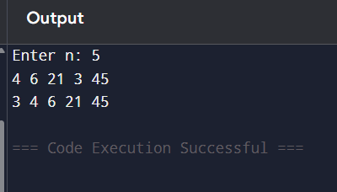

Q21. Write a menu-driven program which implements a graph using adjacency matrix with insertion/deletion of vertex/edge, degree calculation and self-loops.

Solution:

#include <stdio.h>
#define MAX 20
int a[MAX][MAX],n=0;
void insertVertex(){if(n==MAX)printf("Full\n");else{int i;n++;for(i=0;i<n;i++){a[n-1][i]=0;a[i][n-1]=0;}}}
void insertEdge(int u,int v){if(u<n&&v<n)a[u][v]=a[v][u]=1;else printf("Invalid\n");}
void deleteEdge(int u,int v){if(u<n&&v<n)a[u][v]=a[v][u]=0;else printf("Invalid\n");}
void deleteVertex(int v){
int i,j;
if(v>=n){printf("Invalid\n");return;}
for(i=v;i<n-1;i++)for(j=0;j<n;j++)a[i][j]=a[i+1][j];
for(j=v;j<n-1;j++)for(i=0;i<n;i++)a[i][j]=a[i][j+1];
n--;
}
void degree(){
int i,j,d;
for(i=0;i<n;i++){
d=0;
for(j=0;j<n;j++)if(a[i][j])d++;
if(a[i][i])d++;
printf("Degree of %d = %d\n",i,d);
}
}
void selfLoops(){int i,c=0;for(i=0;i<n;i++)if(a[i][i])c++;printf("Self loops = %d\n",c);}
void display(){int i,j;for(i=0;i<n;i++){for(j=0;j<n;j++)printf("%d ",a[i][j]);printf("\n");}}
int main(){
int ch,u,v;
while(1){
printf("\n1.Insert vertex 2.Insert edge 3.Delete vertex 4.Delete edge 5.Degree 6.Self loops 7.Display 8.Exit\n");
scanf("%d",&ch);
if(ch==1)insertVertex();
else if(ch==2){scanf("%d%d",&u,&v);insertEdge(u,v);}
else if(ch==3){scanf("%d",&u);deleteVertex(u);}
else if(ch==4){scanf("%d%d",&u,&v);deleteEdge(u,v);}
else if(ch==5)degree();
else if(ch==6)selfLoops();
else if(ch==7)display();
else if(ch==8)break;
else printf("Invalid\n");
}
return 0;
}

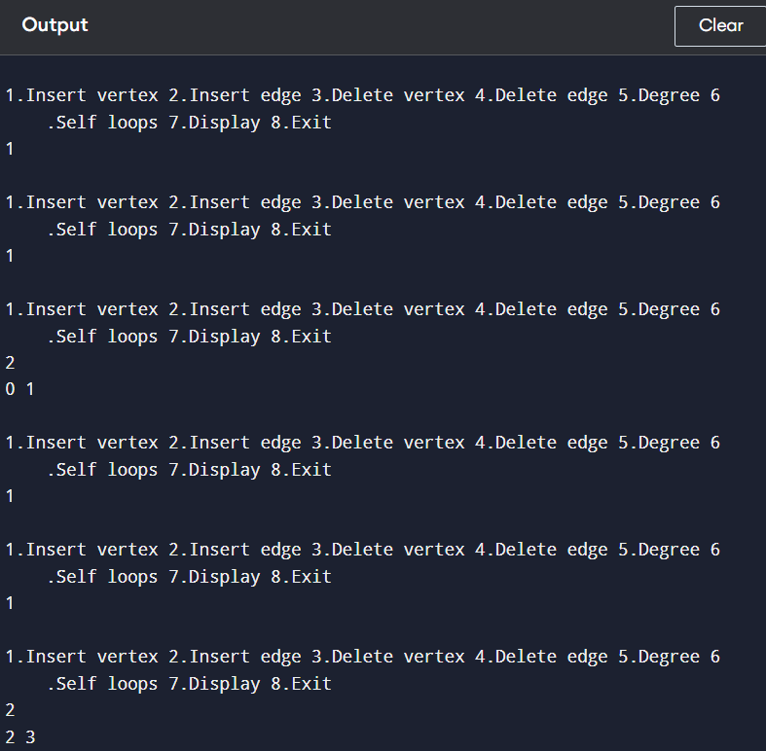

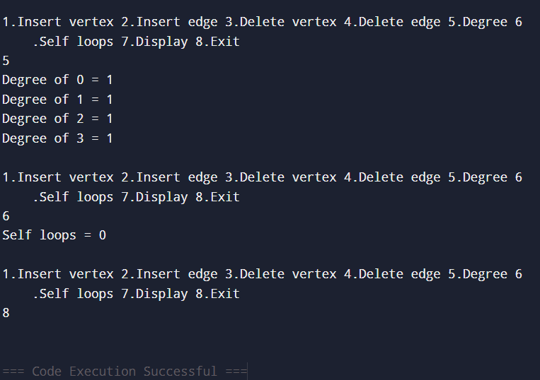

Q22. Write a program to traverse the graph using breadth first search.

Solution:

#include <stdio.h>
#define MAX 20
int a[MAX][MAX],vis[MAX],n;
void dfs(int v){
int i;
vis[v]=1;
printf("%d ",v);
for(i=0;i<n;i++) if(a[v][i]&&!vis[i]) dfs(i);
}
void bfs(int s){
int q[MAX],f=0,r=0,i,v;
for(i=0;i<n;i++)vis[i]=0;
q[r++]=s;vis[s]=1;
while(f<r){
v=q[f++];printf("%d ",v);
for(i=0;i<n;i++) if(a[v][i]&&!vis[i]){
q[r++]=i;vis[i]=1;
}}}
int main(){
int i,j,s;
printf("Enter number of vertices: ");
scanf("%d",&n);
printf("Enter adjacency matrix:\n");
for(i=0;i<n;i++)for(j=0;j<n;j++)scanf("%d",&a[i][j]);
printf("Enter starting vertex: ");
scanf("%d",&s);
printf("BFS: ");bfs(s);
for(i=0;i<n;i++)vis[i]=0;
printf("\nDFS: ");dfs(s);
return 0;
}

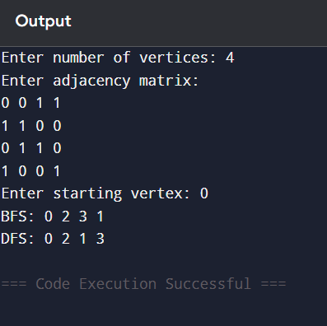

Q23. Write a program to traverse the graph using depth first search techniques.

Solution:

#include <stdio.h>
#define MAX 20
int a[MAX][MAX],vis[MAX],n;
void dfs(int v){
int i;
vis[v]=1;
printf("%d ",v);
for(i=0;i<n;i++) if(a[v][i]&&!vis[i]) dfs(i);
}
void bfs(int s){
int q[MAX],f=0,r=0,i,v;
for(i=0;i<n;i++)vis[i]=0;
q[r++]=s;vis[s]=1;
while(f<r){
v=q[f++];printf("%d ",v);
for(i=0;i<n;i++) if(a[v][i]&&!vis[i]){
q[r++]=i;vis[i]=1;
}
}
}
int main(){
int i,j,s;
printf("Enter number of vertices: ");
scanf("%d",&n);
printf("Enter adjacency matrix:\n");
for(i=0;i<n;i++)for(j=0;j<n;j++)scanf("%d",&a[i][j]);
printf("Enter starting vertex: ");
scanf("%d",&s);
printf("BFS: ");bfs(s);
for(i=0;i<n;i++)vis[i]=0;
printf("\nDFS: ");dfs(s);
return 0;
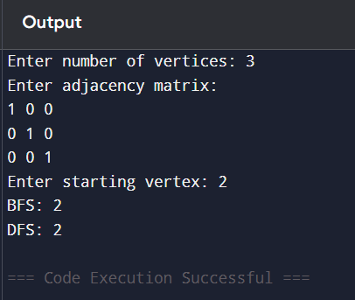
}

Q24. Apply Dijkstra’s algorithm/ Warshell’s algorithm to determine shortest path

Solution:

#include <stdio.h>
#define INF 99999
#define MAX 20
int main(){
int n,i,j,s,u,v,min;
printf("Enter number of vertices: ");
scanf("%d",&n);
int cost[n][n],dist[n],vis[n];
printf("Enter cost matrix, use 0 for no edge:\n");
for(i=0;i<n;i++)for(j=0;j<n;j++){
scanf("%d",&cost[i][j]);
if(i!=j&&cost[i][j]==0)cost[i][j]=INF;
}
printf("Enter source vertex: ");
scanf("%d",&s);
for(i=0;i<n;i++){dist[i]=cost[s][i];vis[i]=0;}
dist[s]=0;vis[s]=1;
for(i=1;i<n;i++){
min=INF;u=-1;
for(j=0;j<n;j++)if(!vis[j]&&dist[j]<min){min=dist[j];u=j;}
if(u==-1)break;
vis[u]=1;
for(v=0;v<n;v++)if(!vis[v]&&dist[u]+cost[u][v]<dist[v])dist[v]=dist[u]+cost[u][v];
}
for(i=0;i<n;i++)printf("Distance from %d to %d = %d\n",s,i,dist[i]);
return 0;
}

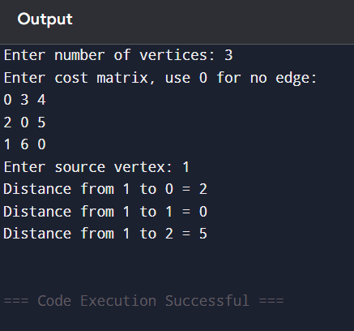

Warshall

#include <stdio.h>
#define MAX 20
int main(){
int n,i,j,k;
printf("Enter number of vertices: ");
scanf("%d",&n);
int a[n][n];
printf("Enter adjacency matrix:\n");
for(i=0;i<n;i++)for(j=0;j<n;j++)scanf("%d",&a[i][j]);
for(k=0;k<n;k++)for(i=0;i<n;i++)for(j=0;j<n;j++)a[i][j]=a[i][j]||(a[i][k]&&a[k][j]);
printf("Transitive closure:\n");
for(i=0;i<n;i++){for(j=0;j<n;j++)printf("%d ",a[i][j]);printf("\n");}
return 0;
}
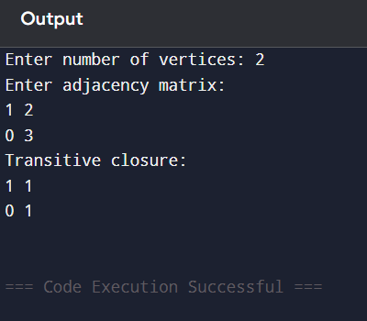

Q25. Write a program to determine the minimum cost spanning tree (using Kruskal‟s or prim’s algorithm)

Solution:

#include <stdio.h>
#define INF 99999
int main(){
int n,i,j,u=0,v=0,min,edges=0,total=0;
printf("Enter number of vertices: ");
scanf("%d",&n);
int cost[n][n],selected[n];
printf("Enter cost matrix, use 0 for no edge:\n");
for(i=0;i<n;i++)for(j=0;j<n;j++){
scanf("%d",&cost[i][j]);
if(cost[i][j]==0)cost[i][j]=INF;
}
for(i=0;i<n;i++)selected[i]=0;
selected[0]=1;
while(edges<n-1){
min=INF;
for(i=0;i<n;i++)if(selected[i])for(j=0;j<n;j++)if(!selected[j]&&cost[i][j]<min){
min=cost[i][j];u=i;v=j;
}
printf("%d - %d = %d\n",u,v,min);
total+=min;
selected[v]=1;
edges++;
}
printf("Minimum cost = %d\n",total);
return 0;
}

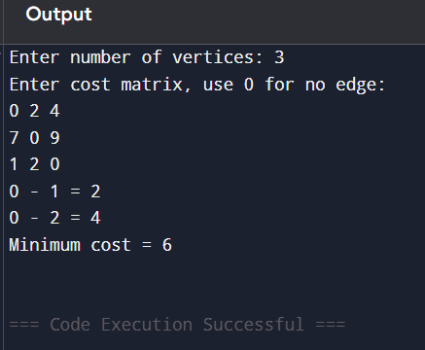

Kruskal

#include <stdio.h>
#define MAX 50
struct edge{int u,v,w;};
int parent[MAX];
int find(int x){while(parent[x]!=x)x=parent[x];return x;}
void unite(int a,int b){parent[find(a)]=find(b);}
int main(){
int n,e,i,j,total=0,count=0;
printf("Enter number of vertices and edges: ");
scanf("%d%d",&n,&e);
struct edge ed[e],t;
printf("Enter u v weight for each edge:\n");
for(i=0;i<e;i++)scanf("%d%d%d",&ed[i].u,&ed[i].v,&ed[i].w);
for(i=0;i<e-1;i++)for(j=0;j<e-i-1;j++)if(ed[j].w>ed[j+1].w){
t=ed[j];ed[j]=ed[j+1];ed[j+1]=t;
}
for(i=0;i<n;i++)parent[i]=i;
for(i=0;i<e&&count<n-1;i++){
if(find(ed[i].u)!=find(ed[i].v)){
printf("%d - %d = %d\n",ed[i].u,ed[i].v,ed[i].w);
total+=ed[i].w;
unite(ed[i].u,ed[i].v);
count++;
}
}
printf("Minimum cost = %d\n",total);
return 0;
}

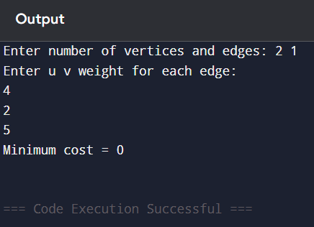

Q26. Write a program that generates n random integers and stores them in All.txt, then copies odd numbers to Odd.txt and even numbers to Even.txt and displays all three files.

Solution:

#include <stdio.h>
#include <stdlib.h>
#include <time.h>
void display(char name[]){
FILE *fp=fopen(name,"r");
int x;
printf("%s: ",name);
if(!fp){printf("Cannot open file\n");return;}
while(fscanf(fp,"%d",&x)!=EOF)printf("%d ",x);
printf("\n");
fclose(fp);
}
int main(){
FILE *all,*odd,*even;
int n,i,x;
srand(time(0));
printf("Enter n: ");
scanf("%d",&n);
all=fopen("All.txt","w");
for(i=0;i<n;i++){
x=rand()%100;
fprintf(all,"%d ",x);
}
fclose(all);
all=fopen("All.txt","r");
odd=fopen("Odd.txt","w");
even=fopen("Even.txt","w");
while(fscanf(all,"%d",&x)!=EOF){
if(x%2)fprintf(odd,"%d ",x);
else fprintf(even,"%d ",x);
}
fclose(all);fclose(odd);fclose(even);
display("All.txt");
display("Odd.txt");
display("Even.txt");
return 0;
}

Q27. Write a program to implement 20 integers with duplicate integers in a hash table with separate chaining for collision resolution.

Solution:

#include <stdio.h>
#include <stdlib.h>
#define SIZE 10
struct node{int data;struct node*next;};
struct node*table[SIZE];
void insert(int x){
int h=x%SIZE;
struct node*t=malloc(sizeof(struct node));
t->data=x;t->next=table[h];table[h]=t;
}
void display(){
int i;struct node*p;
for(i=0;i<SIZE;i++){
printf("%d: ",i);
p=table[i];
while(p){printf("%d -> ",p->data);p=p->next;}
printf("NULL\n");
}
}
int main(){
int i,x;
printf("Enter 20 integers:\n");
for(i=0;i<20;i++){scanf("%d",&x);insert(x);}
display();
return 0;
}

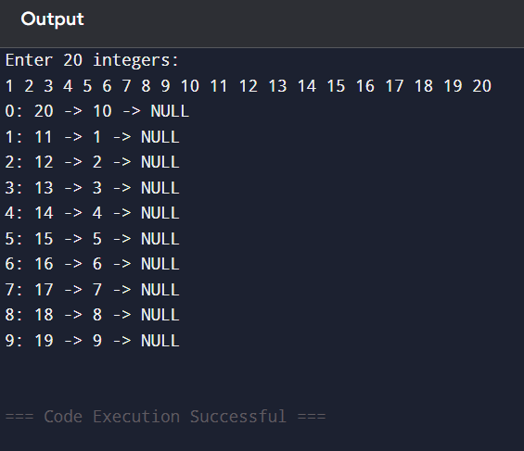

I N D E X
(Advance programs)

Week No. | Lab. Assign. No. | Detailed Statement of the Lab. Assignment | Date of Completion | Student’s Signature | Teacher’s Signature
 | 1. | Write a program which receives a matrix x[n][n] (represented by a two-dimensional array) of integers and perform the following operations on the received matrix: a) Transpose the matrix  b) Determine the row-wise sum c) Determine the column-wise sum d) Determine the sum of off-diagnoal elements e) Display the upper triangular matrix f) Display the lower triangular  matrix
 | 2. | Write a program to implement doubly linked list of integers, copy the odd integers in one list and the even integers  in another list.
 | 3. | Write a program to implement the following operations in a linear linked list: a) Remove all occurance of a given element b) Remove all duplicate elements c) Sort the elements in  ascending order d) Reverse the list
 | 4. | Write a menu-driven program which implements a stack (using linear linked list) with following operations: a) Push (Insert an element) b) Pop (Delete an element) c) Display (Print all elements of  stack)
 | 5. | Write a program that accepts a number in decimal and converts it to its equivalent binary number. The program should make use of appropriate  operations of stack.
 | 6. | Write a menu-driven program which implements a linear queue (using linear linked list) with following operations: a) Enqueue (Insert an element) b) Dequeue (Delete an element) c) Display (Print all  elements of queue)
 | 7. | Write a menu-driven program which implements a double ended queue (using one-dimensional array) with all possible insertion and deletion  operations.
 | 8. | Write a menu-driven program that implements a binary search tree with following operations: a) Total number of nodes in the tree b) Total number of leaf nodes in the tree c) Total number of non-leaf nodes in the tree d) Smallest node of the tree e) Largest node of the tree f) Search a node in the tree g) Sum of all nodes of the tree h) Display the nodes in  ascending order
 | 9. | Write a program to implement a binary tree and perform preorder, inorder and postorder traversal without performing  recursive operations
 | 10. | Write a menu-driven program which implements a graph (using adjacency list) with following operations: a) Insertion of a vertex b) Insertion of an edge c) Deletion of a vertex d) Deletion of an edge e) Calculation of degree of  each vertex.
 | 11. | Consider the list (file) of books maintained in a library system. When a user wants to check whether a particular book is available, a search operation is called for. If the book is available and is issued to the user, a delete operation can be performed to remove this book from the set of available books. When the user returns the book, it can be inserted back into the set of available books. Write a C program to solve the problem by using appropriate data structures. It is essential that the above mentioned operations should be performed efficiently as possible since these operations are performed  frequently.

AQ1. Write a program which receives a matrix x[n][n] and perform transpose, row-wise sum, column-wise sum, sum of off-diagonal elements, upper triangular matrix and lower triangular matrix.

Solution:

#include <stdio.h>
int main(){
int n,i,j,sum;
printf("Enter order of square matrix: ");
scanf("%d",&n);
int x[n][n];
printf("Enter matrix:\n");
for(i=0;i<n;i++) for(j=0;j<n;j++) scanf("%d",&x[i][j]);
printf("Transpose:\n");
for(i=0;i<n;i++){
for(j=0;j<n;j++) printf("%d ",x[j][i]);
printf("\n");
}
printf("Row-wise sum:\n");
for(i=0;i<n;i++){
sum=0;
for(j=0;j<n;j++) sum+=x[i][j];
printf("Row %d = %d\n",i+1,sum);
}
printf("Column-wise sum:\n");
for(j=0;j<n;j++){
sum=0;
for(i=0;i<n;i++) sum+=x[i][j];
printf("Column %d = %d\n",j+1,sum);
}
sum=0;
for(i=0;i<n;i++) for(j=0;j<n;j++) if(i!=j && i+j!=n-1) sum+=x[i][j];
printf("Sum of off-diagonal elements = %d\n",sum);
printf("Upper triangular matrix:\n");
for(i=0;i<n;i++){
for(j=0;j<n;j++) printf("%d ",j>=i?x[i][j]:0);
printf("\n");
}
printf("Lower triangular matrix:\n");
for(i=0;i<n;i++){
for(j=0;j<n;j++) printf("%d ",j<=i?x[i][j]:0);
printf("\n");
}
printf("Diagonal elements only:\n");
for(i=0;i<n;i++){
for(j=0;j<n;j++) printf("%d ",(i==j || i+j==n-1)?x[i][j]:0);
printf("\n");
}
return 0;
}

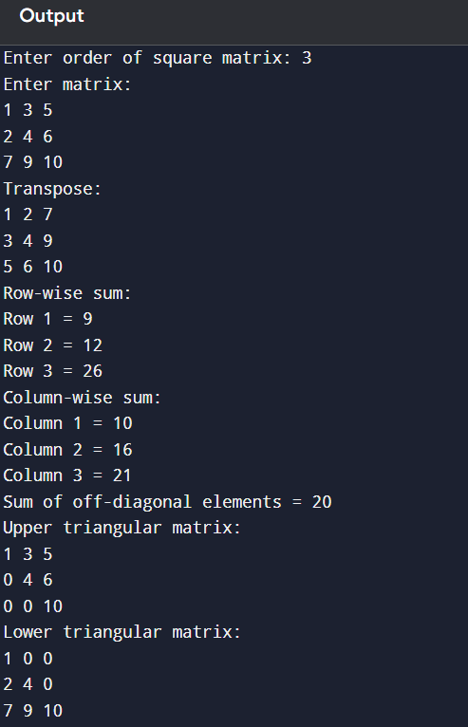
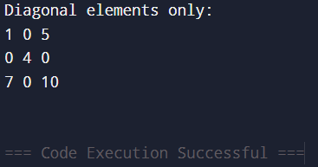

AQ2. Write a program to implement doubly linked list of integers, copy the odd integers in one list and the even integers in another list.

Solution:

#include <stdio.h>
#include <stdlib.h>
struct node{int data;struct node*prev,*next;};
struct node*newnode(int x){
struct node*t=malloc(sizeof(struct node));
t->data=x; t->prev=t->next=NULL; return t;
}
void insertEnd(struct node**h,int x){
struct node*t=newnode(x),*p=*h;
if(!*h){*h=t;return;}
while(p->next)p=p->next;
p->next=t; t->prev=p;
}
void display(struct node*h){
while(h){printf("%d ",h->data);h=h->next;}
printf("\n");
}
int main(){
struct node*main=NULL,*odd=NULL,*even=NULL,*p;
int n,i,x;
printf("Enter n: ");
scanf("%d",&n);
for(i=0;i<n;i++){scanf("%d",&x);insertEnd(&main,x);}
p=main;
while(p){
if(p->data%2) insertEnd(&odd,p->data);
else insertEnd(&even,p->data);
p=p->next;
}
printf("Original: "); display(main);
printf("Odd: "); display(odd);
printf("Even: "); display(even);
return 0;
}
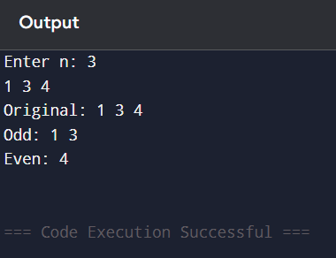

AQ3. Write a program to implement operations in linear linked list: remove all occurrence of given element, remove duplicate elements, sort ascending and reverse the list.

Solution:

#include <stdio.h>
#include <stdlib.h>
struct node{int data;struct node*next;};
struct node*head=NULL;
struct node*newnode(int x){struct node*t=malloc(sizeof(struct node));t->data=x;t->next=NULL;return t;}
void insertEnd(int x){
struct node*t=newnode(x),*p=head;
if(!head){head=t;return;}
while(p->next)p=p->next;
p->next=t;
}
void display(){
struct node*p=head;
while(p){printf("%d ",p->data);p=p->next;}
printf("\n");
}
void removeAll(int x){
struct node*p=head,*q=NULL,*t;
while(p){
if(p->data==x){
t=p;
if(q) q->next=p->next; else head=p->next;
p=p->next; free(t);
}else{q=p;p=p->next;}
}
}
void removeDuplicates(){
struct node*p=head,*q,*r;
while(p){
q=p; r=p->next;
while(r){
if(r->data==p->data){
q->next=r->next; free(r); r=q->next;
}else{q=r;r=r->next;}
}
p=p->next;
}
}
void sortList(){
struct node*i,*j; int t;
for(i=head;i;i=i->next) for(j=i->next;j;j=j->next) if(i->data>j->data){
t=i->data;i->data=j->data;j->data=t;
}
}
void reverse(){
struct node*prev=NULL,*cur=head,*next=NULL;
while(cur){
next=cur->next;
cur->next=prev;
prev=cur;
cur=next;
}
head=prev;
}
int main(){
int ch,x,n,i;
while(1){
printf("\n1.Create 2.Remove all occurrence 3.Remove duplicates 4.Sort 5.Reverse 6.Display 7.Exit\n");
scanf("%d",&ch);
if(ch==1){printf("Enter n: ");scanf("%d",&n);head=NULL;for(i=0;i<n;i++){scanf("%d",&x);insertEnd(x);}}
else if(ch==2){scanf("%d",&x);removeAll(x);}
else if(ch==3)removeDuplicates();
else if(ch==4)sortList();
else if(ch==5)reverse();
else if(ch==6)display();
else if(ch==7)break;
else printf("Invalid\n");
}
return 0;
}

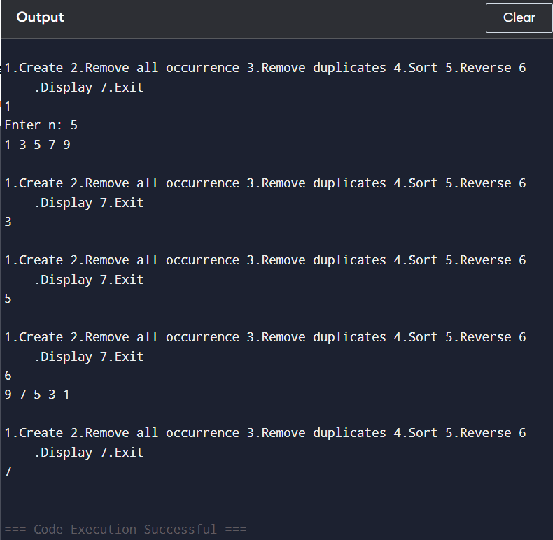

AQ4. Write a menu-driven program which implements stack using linear linked list with Push, Pop and Display.

Solution:

#include <stdio.h>
#include <stdlib.h>
struct node{int data;struct node*next;};
struct node*top=NULL;
void push(int x){
struct node*t=malloc(sizeof(struct node));
t->data=x; t->next=top; top=t;
}
void pop(){
if(!top)printf("Underflow\n");
else{struct node*t=top;printf("Popped %d\n",top->data);top=top->next;free(t);}
}
void display(){
struct node*p=top;
if(!p)printf("Empty\n");
while(p){printf("%d ",p->data);p=p->next;}
printf("\n");
}
int main(){
int ch,x;
while(1){
printf("\n1.Push 2.Pop 3.Display 4.Exit\n");
scanf("%d",&ch);
if(ch==1){scanf("%d",&x);push(x);}
else if(ch==2)pop();
else if(ch==3)display();
else if(ch==4)break;
else printf("Invalid\n");
}
return 0;
}
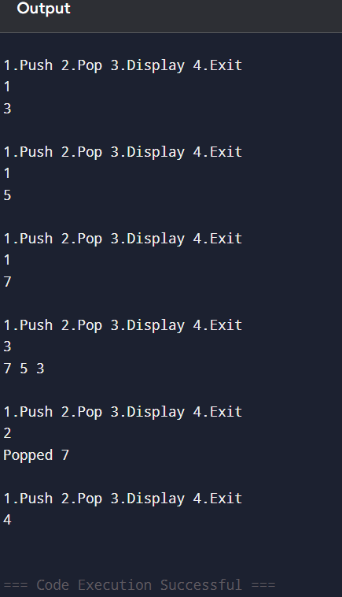

AQ5. Write a program that accepts a decimal number and converts it to binary using stack.

Solution:

#include <stdio.h>
#define MAX 100
int s[MAX],top=-1;
void push(int x){s[++top]=x;}
int pop(){return s[top--];}
int main(){
int n;
printf("Enter decimal number: ");
scanf("%d",&n);
if(n==0){printf("0");return 0;}
while(n>0){push(n%2);n/=2;}
printf("Binary: ");
while(top!=-1) printf("%d",pop());
return 0;
}
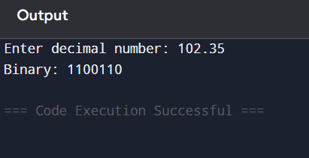
-

AQ6. Write a menu-driven program which implements linear queue using linked list with Enqueue, Dequeue and Display.

Solution:

#include <stdio.h>
#include <stdlib.h>
struct node{int data;struct node*next;};
struct node*front=NULL,*rear=NULL;
void enqueue(int x){
struct node*t=malloc(sizeof(struct node));
t->data=x; t->next=NULL;
if(!rear)front=rear=t;
else{rear->next=t;rear=t;}
}
void dequeue(){
if(!front)printf("Underflow\n");
else{
struct node*t=front;
printf("Deleted %d\n",front->data);
front=front->next;
if(!front)rear=NULL;
free(t);
}
}
void display(){
struct node*p=front;
if(!p)printf("Empty\n");
while(p){printf("%d ",p->data);p=p->next;}
printf("\n");
}
int main(){
int ch,x;
while(1){
printf("\n1.Enqueue 2.Dequeue 3.Display 4.Exit\n");
scanf("%d",&ch);
if(ch==1){scanf("%d",&x);enqueue(x);}
else if(ch==2)dequeue();
else if(ch==3)display();
else if(ch==4)break;
else printf("Invalid\n");
}
return 0;
}

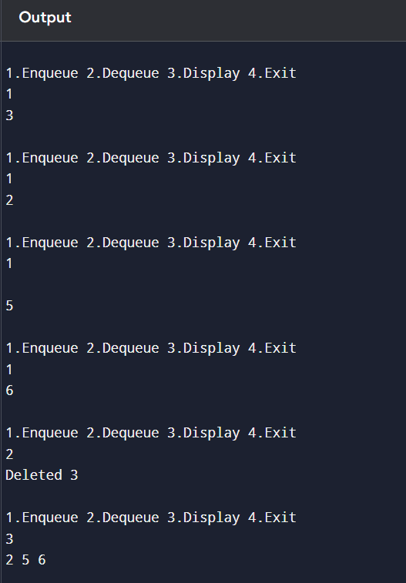

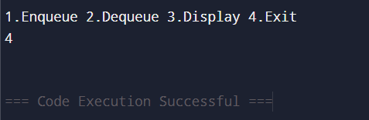

AQ7. Write a menu-driven program which implements double ended queue using one-dimensional array with all insertion and deletion operations.

Solution:

#include <stdio.h>
#define MAX 100
int dq[MAX],front=-1,rear=-1;
int full(){return (front==0&&rear==MAX-1)||front==rear+1;}
int empty(){return front==-1;}
void insertFront(int x){
if(full())printf("Overflow\n");
else{
if(empty())front=rear=0;
else if(front==0)front=MAX-1;
else front--;
dq[front]=x;
}
}
void insertRear(int x){
if(full())printf("Overflow\n");
else{
if(empty())front=rear=0;
else if(rear==MAX-1)rear=0;
else rear++;
dq[rear]=x;
}
}
void deleteFront(){
if(empty())printf("Underflow\n");
else{
printf("Deleted %d\n",dq[front]);
if(front==rear)front=rear=-1;
else if(front==MAX-1)front=0;
else front++;
}
}
void deleteRear(){
if(empty())printf("Underflow\n");
else{
printf("Deleted %d\n",dq[rear]);
if(front==rear)front=rear=-1;
else if(rear==0)rear=MAX-1;
else rear--;
}
}
void display(){
int i;
if(empty()){printf("Empty\n");return;}
i=front;
while(1){
printf("%d ",dq[i]);
if(i==rear)break;
i=(i+1)%MAX;
}
printf("\n");
}
int main(){
int ch,x;
while(1){
printf("\n1.Insert front 2.Insert rear 3.Delete front 4.Delete rear 5.Display 6.Exit\n");
scanf("%d",&ch);
if(ch==1){scanf("%d",&x);insertFront(x);}
else if(ch==2){scanf("%d",&x);insertRear(x);}
else if(ch==3)deleteFront();
else if(ch==4)deleteRear();
else if(ch==5)display();
else if(ch==6)break;
else printf("Invalid\n");
}
return 0;
}

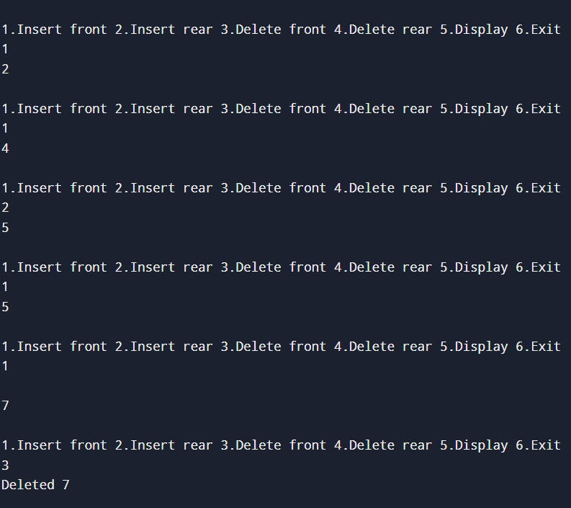

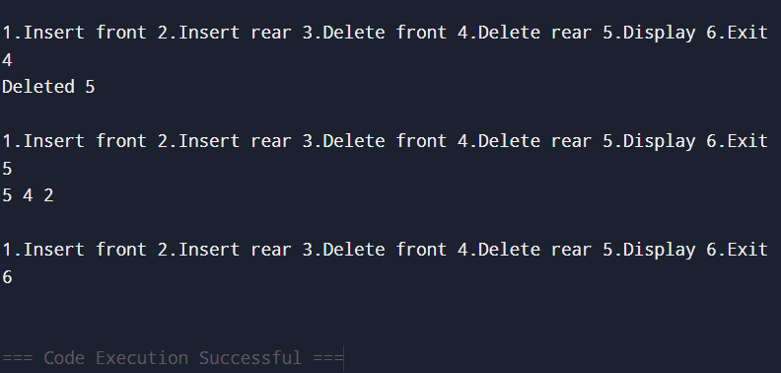

AQ8. Write a menu-driven program that implements BST with total nodes, leaf nodes, non-leaf nodes, smallest, largest, search, sum and ascending display.

Solution:

#include <stdio.h>
#include <stdlib.h>
struct node{int data;struct node*left,*right;};
struct node*root=NULL;
struct node*newnode(int x){struct node*t=malloc(sizeof(struct node));t->data=x;t->left=t->right=NULL;return t;}
struct node*insert(struct node*r,int x){if(!r)return newnode(x);if(x<r->data)r->left=insert(r->left,x);else if(x>r->data)r->right=insert(r->right,x);return r;}
int count(struct node*r){return r?1+count(r->left)+count(r->right):0;}
int leaves(struct node*r){if(!r)return 0;if(!r->left&&!r->right)return 1;return leaves(r->left)+leaves(r->right);}
int sum(struct node*r){return r?r->data+sum(r->left)+sum(r->right):0;}
struct node*search(struct node*r,int x){if(!r||r->data==x)return r;if(x<r->data)return search(r->left,x);return search(r->right,x);}
void inorder(struct node*r){if(r){inorder(r->left);printf("%d ",r->data);inorder(r->right);}}
int smallest(struct node*r){while(r->left)r=r->left;return r->data;}
int largest(struct node*r){while(r->right)r=r->right;return r->data;}
int main(){
int ch,x;
while(1){
printf("\n1.Insert 2.Total nodes 3.Leaf nodes 4.Non-leaf nodes 5.Smallest 6.Largest 7.Search 8.Sum 9.Ascending 10.Exit\n");
scanf("%d",&ch);
if(ch==1){scanf("%d",&x);root=insert(root,x);}
else if(ch==2)printf("%d\n",count(root));
else if(ch==3)printf("%d\n",leaves(root));
else if(ch==4)printf("%d\n",count(root)-leaves(root));
else if(ch==5){if(root)printf("%d\n",smallest(root));else printf("Empty\n");}
else if(ch==6){if(root)printf("%d\n",largest(root));else printf("Empty\n");}
else if(ch==7){scanf("%d",&x);printf(search(root,x)?"Found\n":"Not found\n");}
else if(ch==8)printf("%d\n",sum(root));
else if(ch==9){inorder(root);printf("\n");}
else if(ch==10)break;
else printf("Invalid\n");
}
return 0;
}

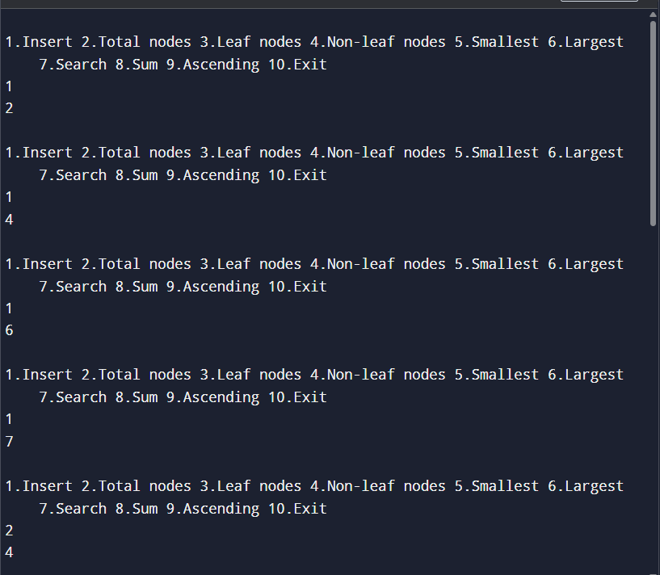

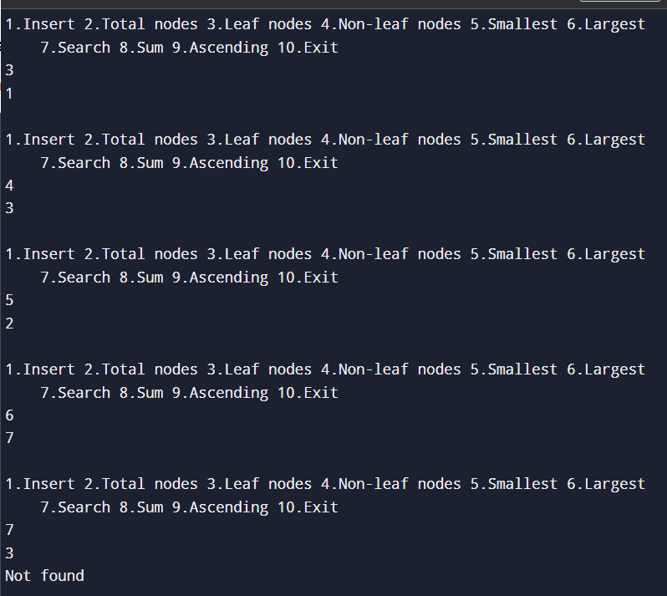

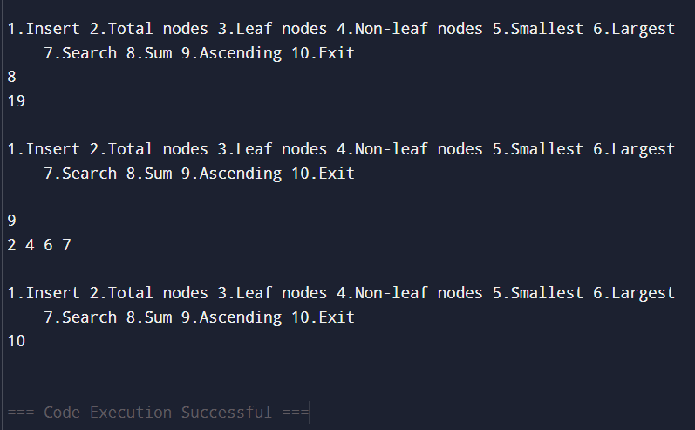

AQ9. Write a program to implement a binary tree and perform preorder, inorder and postorder traversal without recursion.

Solution:

#include <stdio.h>
#include <stdlib.h>
#define MAX 100
struct node{int data;struct node*left,*right;};
struct node*root=NULL;
struct node*newnode(int x){struct node*t=malloc(sizeof(struct node));t->data=x;t->left=t->right=NULL;return t;}
struct node*insert(struct node*r,int x){if(!r)return newnode(x);if(x<r->data)r->left=insert(r->left,x);else if(x>r->data)r->right=insert(r->right,x);return r;}
void preorder(struct node*r){
struct node*s[MAX];int top=-1;
if(r)s[++top]=r;
while(top!=-1){
r=s[top--];printf("%d ",r->data);
if(r->right)s[++top]=r->right;
if(r->left)s[++top]=r->left;
}
}
void inorder(struct node*r){
struct node*s[MAX];int top=-1;
while(r||top!=-1){
while(r){s[++top]=r;r=r->left;}
r=s[top--];printf("%d ",r->data);r=r->right;
}
}
void postorder(struct node*r){
struct node*s1[MAX],*s2[MAX];int t1=-1,t2=-1;
if(r)s1[++t1]=r;
while(t1!=-1){
r=s1[t1--];s2[++t2]=r;
if(r->left)s1[++t1]=r->left;
if(r->right)s1[++t1]=r->right;
}
while(t2!=-1)printf("%d ",s2[t2--]->data);
}
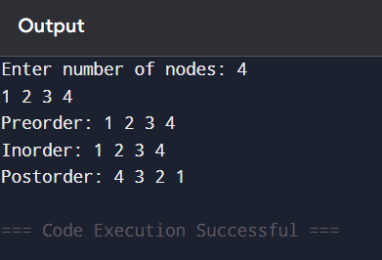
int main(){
int n,i,x;
printf("Enter number of nodes: ");
scanf("%d",&n);
for(i=0;i<n;i++){scanf("%d",&x);root=insert(root,x);}
printf("Preorder: ");preorder(root);
printf("\nInorder: ");inorder(root);
printf("\nPostorder: ");postorder(root);
return 0;
}

AQ10. Write a menu-driven program which implements graph using adjacency list with insertion/deletion of vertex/edge and degree calculation.

Solution:

#include <stdio.h>
#include <stdlib.h>
#define MAX 20
struct node{int v;struct node*next;};
struct node*adj[MAX];
int n=0;
struct node*newnode(int v){struct node*t=malloc(sizeof(struct node));t->v=v;t->next=NULL;return t;}
void insertVertex(){if(n==MAX)printf("Full\n");else adj[n++]=NULL;}
void addOne(int u,int v){struct node*t=newnode(v);t->next=adj[u];adj[u]=t;}
void insertEdge(int u,int v){if(u<n&&v<n){addOne(u,v);addOne(v,u);}else printf("Invalid\n");}
void removeOne(int u,int v){
struct node*p=adj[u],*q=NULL;
while(p){
if(p->v==v){
if(q)q->next=p->next;else adj[u]=p->next;
free(p);return;
}
q=p;p=p->next;
}
}
void deleteEdge(int u,int v){if(u<n&&v<n){removeOne(u,v);removeOne(v,u);}else printf("Invalid\n");}
void deleteVertex(int v){
int i;
struct node*p,*q;
if(v>=n){printf("Invalid\n");return;}
for(i=0;i<n;i++)removeOne(i,v);
p=adj[v];
while(p){q=p;p=p->next;free(q);}
for(i=v;i<n-1;i++)adj[i]=adj[i+1];
n--;
for(i=0;i<n;i++){
p=adj[i];
while(p){if(p->v>v)p->v--;p=p->next;}
}
}
void degree(){
int i,d;struct node*p;
for(i=0;i<n;i++){
d=0;p=adj[i];
while(p){d++;p=p->next;}
printf("Degree of %d = %d\n",i,d);
}
}
void display(){
int i;struct node*p;
for(i=0;i<n;i++){
printf("%d: ",i);
p=adj[i];
while(p){printf("%d ",p->v);p=p->next;}
printf("\n");
}
}
int main(){
int ch,u,v;
while(1){
printf("\n1.Insert vertex 2.Insert edge 3.Delete vertex 4.Delete edge 5.Degree 6.Display 7.Exit\n");
scanf("%d",&ch);
if(ch==1)insertVertex();
else if(ch==2){scanf("%d%d",&u,&v);insertEdge(u,v);}
else if(ch==3){scanf("%d",&u);deleteVertex(u);}
else if(ch==4){scanf("%d%d",&u,&v);deleteEdge(u,v);}
else if(ch==5)degree();
else if(ch==6)display();
else if(ch==7)break;
else printf("Invalid\n");
}
return 0;
}

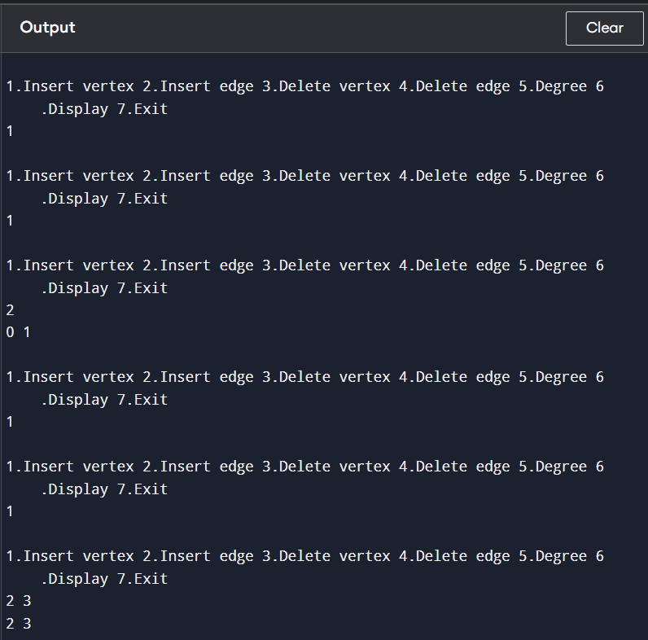

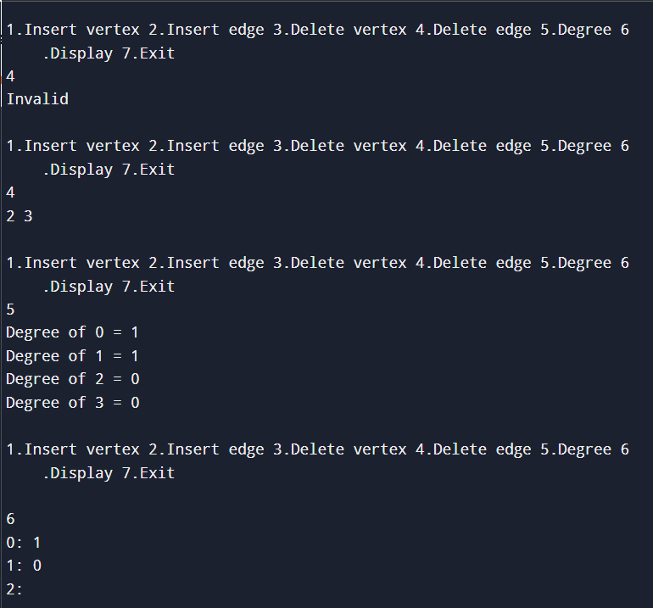

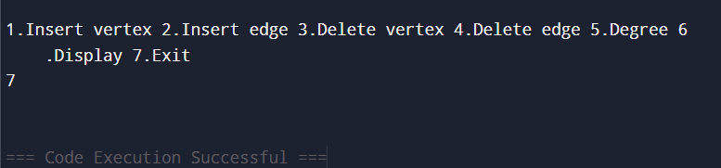

AQ11. Consider the list of books maintained in a library system. Search available books, delete issued book and insert returned book efficiently using appropriate data structures.

Solution:

#include <stdio.h>
#include <stdlib.h>
#include <string.h>
#define SIZE 20
struct book{int id;char title[100];struct book*next;};
struct book*table[SIZE];
int hash(int id){return id%SIZE;}
void insert(int id,char title[]){
int h=hash(id);
struct book*t=malloc(sizeof(struct book));
t->id=id;strcpy(t->title,title);t->next=table[h];table[h]=t;
}
struct book*search(int id){
struct book*p=table[hash(id)];
while(p){if(p->id==id)return p;p=p->next;}
return NULL;
}
void deleteBook(int id){
int h=hash(id);
struct book*p=table[h],*q=NULL;
while(p){
if(p->id==id){
if(q)q->next=p->next;else table[h]=p->next;
free(p);
printf("Book issued and removed from available list\n");
return;
}
q=p;p=p->next;
}
printf("Book not available\n");
}
void display(){
int i;struct book*p;
for(i=0;i<SIZE;i++){
p=table[i];
while(p){printf("Id=%d Title=%s\n",p->id,p->title);p=p->next;}
}
}
int main(){
int ch,id;
char title[100];
struct book*b;
while(1){
printf("\n1.Insert returned book 2.Search book 3.Issue book 4.Display 5.Exit\n");
scanf("%d",&ch);
if(ch==1){
printf("Enter id and title: ");
scanf("%d",&id);
scanf(" %[^\n]",title);
insert(id,title);
}else if(ch==2){
scanf("%d",&id);
b=search(id);
if(b)printf("Available: %s\n",b->title);
else printf("Not available\n");
}else if(ch==3){
scanf("%d",&id);
deleteBook(id);
}else if(ch==4)display();
else if(ch==5)break;
else printf("Invalid\n");
}
return 0;
}
