===========Next model type============

==========Starting for h = 1==========

Total params: 18,853

Trainable params: 18,659

Non-trainable params: 194

_________________________________________________________________

Final metrics for this model

Average of the final training set accuracy over all folds = 0.9463218092918396

Average of the final training set loss over all folds = 0.04349955916404724

Average of the final validation set accuracy over all folds = 0.8998135328292847

Average of the final validation set loss over all folds = 0.07938444167375565

Average of the ROC AUC over all folds = 0.9112642944449085

Genes with both pathogenic and benign mutations:

{'Accuracy': 0.8968937048503612, 'patho_ct': 40312, 'total': 193800, 'genes_with_both': 2613}

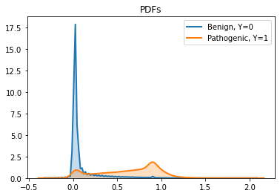

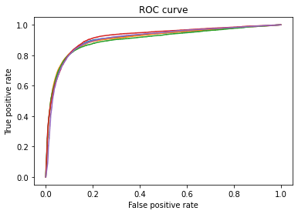

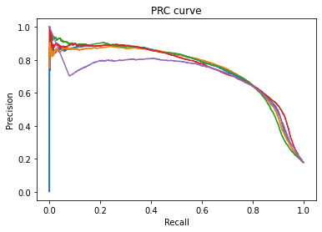

Time taken for this model 1174.3671402931213

===============Finished===============

==========Starting for h = 2==========

Total params: 39,653

Trainable params: 39,331

Non-trainable params: 322

_________________________________________________________________

Final metrics for this model

Average of the final training set accuracy over all folds = 0.9551997303962707

Average of the final training set loss over all folds = 0.038618600368499754

Average of the final validation set accuracy over all folds = 0.9010727643966675

Average of the final validation set loss over all folds = 0.0849546104669571

Average of the ROC AUC over all folds = 0.8931265526269048

Genes with both pathogenic and benign mutations:

{'Accuracy': 0.8937409700722394, 'patho_ct': 40312, 'total': 193800, 'genes_with_both': 2613}

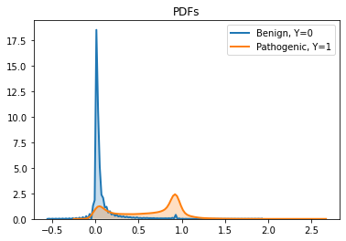

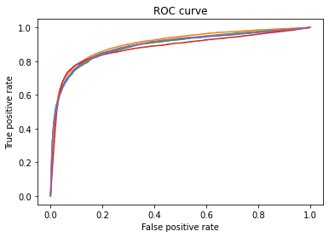

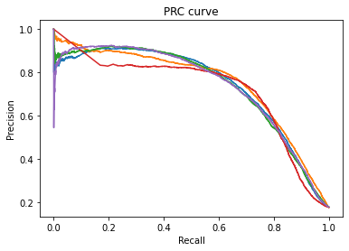

Time taken for this model 1121.1891701221466

===============Finished===============

==========Starting for h = 4==========

Total params: 81,253

Trainable params: 80,675

Non-trainable params: 578

_________________________________________________________________

Final metrics for this model

Average of the final training set accuracy over all folds = 0.9787660002708435

Average of the final training set loss over all folds = 0.020075043849647044

Average of the final validation set accuracy over all folds = 0.907517158985138

Average of the final validation set loss over all folds = 0.08404145985841752

Average of the ROC AUC over all folds = 0.8873012433426251

Genes with both pathogenic and benign mutations:

{'Accuracy': 0.9033333333333333, 'patho_ct': 40312, 'total': 193800, 'genes_with_both': 2613}

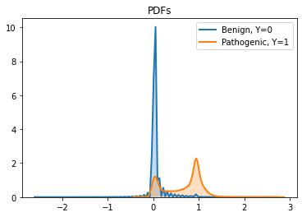

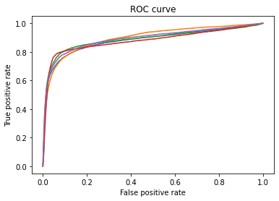

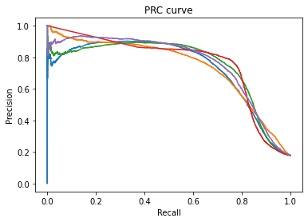

Time taken for this model 1712.8406193256378

===============Finished===============

===========Next model type============

==========Starting for h = 1==========

Total params: 28,325

Trainable params: 28,131

Non-trainable params: 194

_________________________________________________________________

Final metrics for this model

Average of the final training set accuracy over all folds = 0.9477193832397461

Average of the final training set loss over all folds = 0.043579386174678804

Average of the final validation set accuracy over all folds = 0.8975782036781311

Average of the final validation set loss over all folds = 0.0909331664443016

Average of the ROC AUC over all folds = 0.8946488435630409

Genes with both pathogenic and benign mutations:

{'Accuracy': 0.8935294117647059, 'patho_ct': 40312, 'total': 193800, 'genes_with_both': 2613}

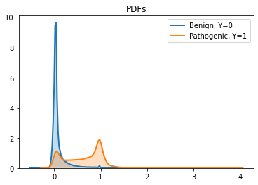

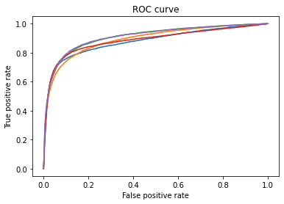

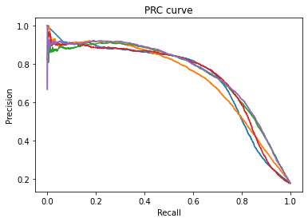

Time taken for this model 1219.835956811905

===============Finished===============

==========Starting for h = 2==========

Total params: 57,317

Trainable params: 56,995

Non-trainable params: 322

_________________________________________________________________

Final metrics for this model

Average of the final training set accuracy over all folds = 0.9695928692817688

Average of the final training set loss over all folds = 0.028735904023051262

Average of the final validation set accuracy over all folds = 0.9070509195327758

Average of the final validation set loss over all folds = 0.08138405978679657

Average of the ROC AUC over all folds = 0.8987659839998983

Genes with both pathogenic and benign mutations:

{'Accuracy': 0.9003405572755417, 'patho_ct': 40312, 'total': 193800, 'genes_with_both': 2613}

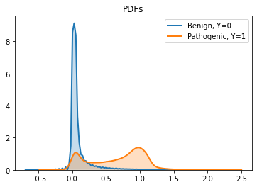

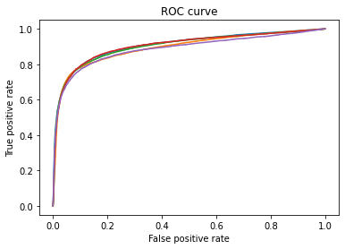

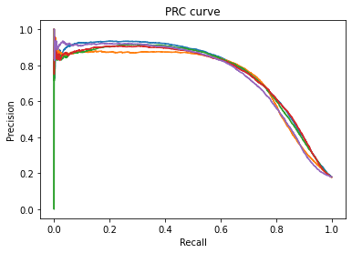

Time taken for this model 1158.397076845169

===============Finished===============

==========Starting for h = 4==========

Total params: 115,301

Trainable params: 114,723

Non-trainable params: 578

_________________________________________________________________

Final metrics for this model

Average of the final training set accuracy over all folds = 0.9926286101341247

Average of the final training set loss over all folds = 0.007530153822153806

Average of the final validation set accuracy over all folds = 0.9116739630699158

Average of the final validation set loss over all folds = 0.07546611353754998

Average of the ROC AUC over all folds = 0.924898686977747

Genes with both pathogenic and benign mutations:

{'Accuracy': 0.9310371517027863, 'patho_ct': 40312, 'total': 193800, 'genes_with_both': 2613}

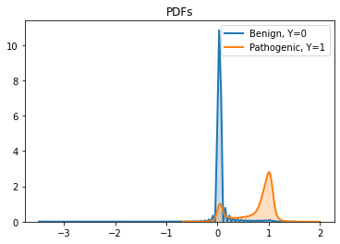

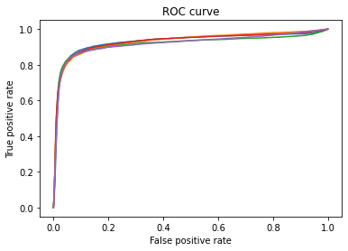

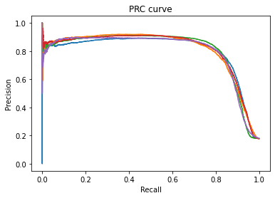

Time taken for this model 1550.0252892971039

===============Finished===============

Total time taken 7936.6570744514465

The h value for the best auc is 4 in the complex model and the corresponding auc is 0.924898686977747