

BHARATI VIDYAPEETH’S
INSTITUTE OF COMPUTER APPLICATIONS & MANAGEMENT
(Affiliated to Guru Gobind Singh Indraprastha University, Approved by AICTE, New Delhi)

Object Oriented Software Engineering Lab

(MCA-164)
Practical File

Submitted To: Submitted By:
Dr. Ritika Wason Piyush Goel(09311604425)
(Deputy Director & Associate Professor) MCA 2nd SEM

INDEX

S.no. | Problem Description | Date of Execution | Sign
WEEK 1
P1. | Create a Use Case Diagram for a Digital Sound Recorder with the following main features:  - The recorder stores up to 10 messages  - Each message is max. 2 minutes long  - The user can record message  - Recording of a message ends after 2 minutes or when the user stops recording  - Recording destroys the original message at chosen slot  - Sufficient level of battery is checked before recording message  - Message of a given slot can be replayed  - Sufficient level of battery is checked before replaying message  - Messages can be locked/unlocked  - Locked messages cannot be deleted or over-written by recording to the same slot  User uses LCD display and buttons to interact with recorder
P2. | Formulate use case descriptions for 5 major use cases identified in the digital sound recorder.
P3. | As the head of Information Technology at Acme Airlines, you are tasked with building a new booking system to replace the existing system. Acme needs a new system to allow employees to book ticket electronically and check the status of the booked tickets.  The new system will be state of the art and will have a Windows-based desktop interface to allow employees to enter booking details and view employee details. The system will run on individual employee desktops throughout the entire company. For reasons of security and auditing, employees can access only their data. The employees would only be able to view their information, and for any changes they would have to send an E- Mail to the administrator. Administrator would only have the right to make any changes in the records.  For the cost being a factor Acme wants to use their old server with the existing database. The system will retain information on all employees in the company. The administrator maintains employee information. He is responsible for adding new employees, deleting employees and changing all employee information such as name, address, and paycheck generation, as well as running administrative reports

P4. | Consider the following use-case of a travel agency. Use-Case Name: Ticket Purchasing  Description:  - The use-case begins when the customer calls the travel agency to ask it to issue a ticket that (s)he has booked.  - The travel agency operator asks the customer to give his/her booking number.  - The customer gives the booking number.  - The operator types in the booking number and the flight reservation system displays the details of the reservation made.  - The operator asks the customer to confirm the details of the reservation made.  - The customer confirms the reservation made.  - The operator asks the customer for a credit card number.  - The customer gives his/her credit card number.  - The operator types in the customer's credit card number and when the system  confirms that the credit card transaction has been authorised (s)he asks the system to print the tickets, the details of the flights, and an invoice.  - When the system confirms that the requested items have been printed, the operator informs the customer that the tickets have been issued.  Think of at least two alternative courses of events for this use-case. Describe the alternative courses as separate use-cases. Modify the description of the original use-case to make evident where exactly these alternative use-cases may be called  and under which conditions. Create a use-case diagram to illustrate the  relationships between the alternative use-cases and the use-case given.

AP1 Create a Use Case Diagram for a Digital Sound Recorder with the following main features:
- The recorder stores up to 10 messages
- Each message is max. 2 minutes long
- The user can record message
- Recording of a message ends after 2 minutes or when the user stops recording
- Recording destroys the original message at chosen slot
- Sufficient level of battery is checked before recording message
- Message of a given slot can be replayed
- Sufficient level of battery is checked before replaying message
- Messages can be locked/unlocked
- Locked messages cannot be deleted or over-written by recording to the same slot • User uses LCD display and buttons to interact with recorder

Diagram:
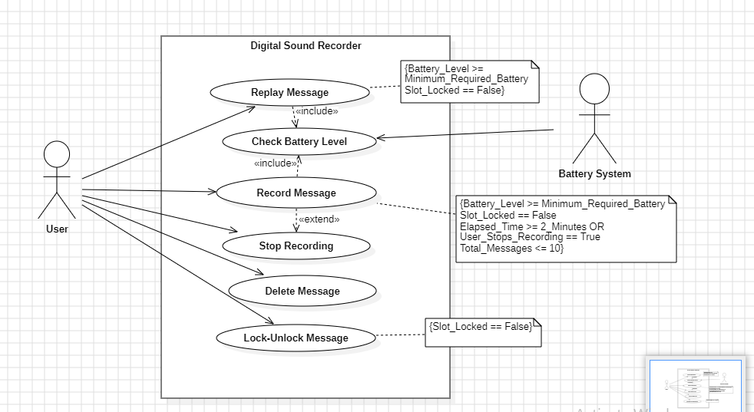
AP2. Formulate use case descriptions for 5 major use cases identified in the digital sound recorder.
USE CASES | DESCRIPTION
Record Message | The user can record a message to a specific slot in the recorder, with a maximum duration of 2 minutes. The recording stops automatically after 2 minutes or when manually stopped by the user. Preconditions include having sufficient battery and the target slot being unlocked. Postconditions include storing the message in the selected slot and overwriting the previous message in the slot if it was unlocked.
Replay Message | The user can replay a stored message from a specified slot. Preconditions include having sufficient battery and the selected slot containing a message. Postconditions include playing the selected message through the recorder.
Lock/Unlock Message | The user can lock or unlock a message in a specified slot to prevent accidental deletion or overwriting. Preconditions require selecting a valid slot. Postconditions include marking the slot as locked or unlocked based on the user's action. Locked slots cannot be overwritten or deleted.
Check Battery Level | The system checks the battery level to ensure there is enough power to perform operations like recording or replaying a message. There are no specific preconditions as this is implicitly checked before recording or replaying. If the battery level is sufficient, the operation proceeds; otherwise, an error or warning is displayed.
Delete Message | The user can delete a message from a specific slot, but locked messages cannot be deleted. Preconditions require that the slot is not locked and contains a message. Postconditions include the removal of the message from the specified slot.

AP3. As the head of Information Technology at Acme Airlines, you are tasked with building a new booking system to replace the existing system. Acme needs a new system to allow employees to book ticket electronically and check the status of the booked tickets.

The new system will be state of the art and will have a Windows-based desktop interface to allow employees to enter booking details and view employee details. The system will run on individual employee desktops throughout the entire company. For reasons of security and auditing, employees can access only their data. The employees would only be able to view their information, and for any changes they would have to send an
E-Mail to the administrator. Administrator would only have the right to make any changes in the records. For the cost being a factor Acme wants to use their old server with the existing database. The system will retain information on all employees in the company.
The administrator maintains employee information. He is responsible for adding new employees, deleting employees and changing all employee information such as name, address, and paycheck generation, as well as running administrative reports

Diagram:

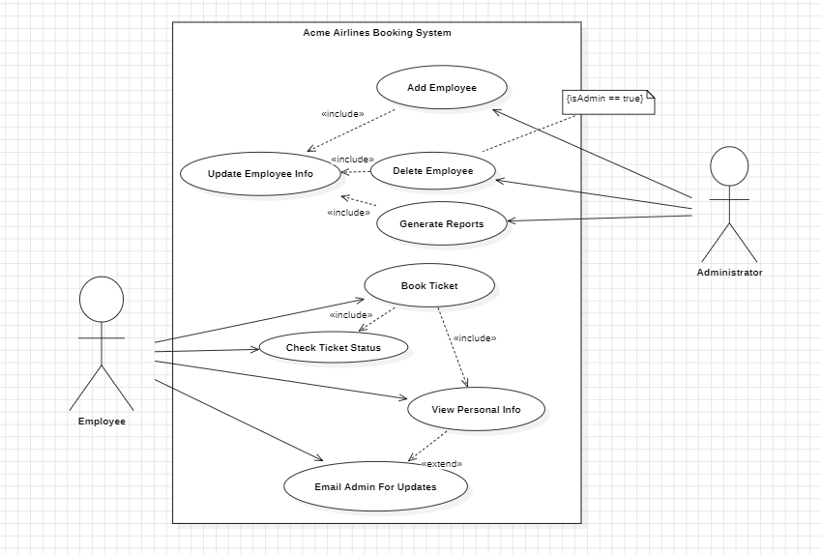
AP4. Consider the following use-case of a travel agency. Use-Case Name: Ticket Purchasing Description:
- The use-case begins when the customer calls the travel agency to ask it to issue a ticket that (s)he has booked.
- The travel agency operator asks the customer to give his/her booking number.
- The customer gives the booking number.
- The operator types in the booking number and the flight reservation system displays the details of the reservation made.
- The operator asks the customer to confirm the details of the reservation made.
- The customer confirms the reservation made.
- The operator asks the customer for a credit card number.
- The customer gives his/her credit card number.
- The operator types in the customer's credit card number and when the system confirms that the credit card transaction has been authorised (s)he asks the system to print the tickets, the details of the flights, and an invoice.
- When the system confirms that the requested items have been printed, the operator informs the customer that the tickets have been issued.

Diagram:

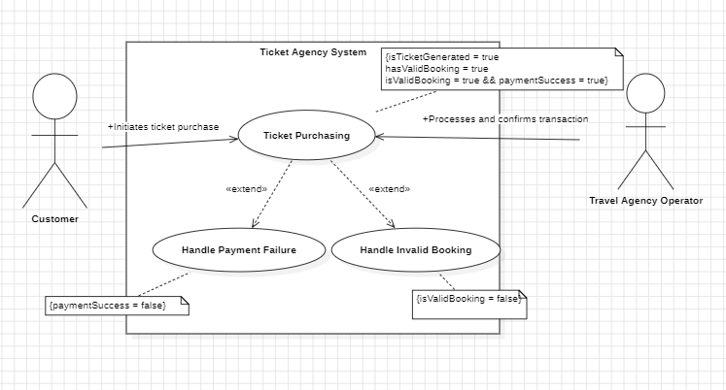

Q5
Create a Class Diagram for a Digital Sound Recorder with the following main features:
1. The recorder stores up to 10 messages
2. Each message is max. 2 minutes long
3. The user can record message
4. Recording of a message end after 2 minutes or when the user stops recording
5. Recording destroys the original message at chosen slot
6. Sufficient level of battery is checked before recording message
7. Message of a given slot can be replayed
8. Sufficient level of battery is checked before replaying message
9. Messages can be locked/unlocked
10. Locked messages cannot be deleted or over-written by recording to the same slot
User uses LCD display and buttons to interact with recorder

Diagram:

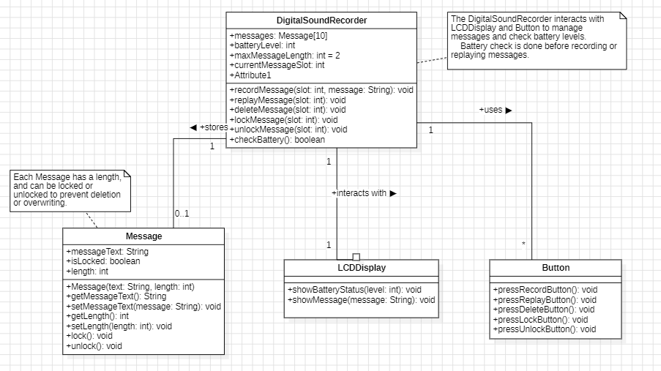

AQ4 A reactive real-time object (e.g.: any embedded real time system) wants to communicate an event to an interactive non-real time object (e.g.: user-interface or system monitoring or data logging)?
e.g., an embedded system sending sensor data to a monitoring UI

Diagram:

