
BHARATI VIDYAPEETH’S
INSTITUTE OF COMPUTER APPLICATION & MANAGEMENT
(Affilitated to Guru Gobind Singh Indraprastha University,
Approved by AICTE, New Delhi)

Python Programming
Lab
(MCA- 166)
Practical File

Submitted To: | Submitted By:
Dr. Saumya Bansal  (Assistant Professor) | Bharat Bhusan (07211604425)  MCA 2nd Sem, Sec B
INDEX
S.No. | Problem Description | Date | Sign.
P1 | Implement Python Script to generate first N natural numbers.
P2 | By considering the terms in the Fibonacci sequence whose values do not exceed 1000, find the sum of the even-valued terms.
P3 | Write a program which makes use of function to display all such numbers which are divisible by 7 but are not a multiple of 5, between 1000 and 2000.
P4 | Write a function cumulative_product to compute cumulative product of a list of numbers.
P5 | Write a function reverse to reverse a list. Without using the reverse function.
P6 | Write a function that finds the sum of first n terms of following series: 1 – x2 / 2! + x4 / 4! – x6 / 6! + …… xn / n!
P7 | With a given tuple (1, 2, 3, 4, 5, 6, 7, 8, 9, 10), write a program to print the first half values in one line and the last half values in one line
P8 | Implement a python script to check the element is in the list or not by using Linear search & Binary search.
P9 | Write a program to count the numbers of characters in the string and store them in a dictionary data structure.
P10 | Every time a vote is cast the name of the candidate is appended to the data structure. Print the names of candidates who received maximum vote in lexicographical order and if there is a tie print lexicographically smaller name.
P11 | Remove spaces from a string using recursion.
P12 | Write a Python class to reverse a string word by word : Input string : 'hello Python' Expected Output : 'Python hello'
P13 | Write a Python class which has two methods get_String and print_String.  get_String accept a string from the user and print_String print the string in upper case.
P14 | Write a Python class named Circle constructed by a radius and two methods which will compute the area and the perimeter of a circle.
P15 | Implement a python script to arrange the elements in sorted order using Bubble, Selection, Insertion and Merge sorting techniques.
P16 | Create a menu driven program to perform various matrices operations.
P17 | Write a program to compare two files and display total number of lines in a file.
P18 | Write a program to compare two files and display total number of words in a file.
P19 | Draw different graphs and plots in Python using Matplotlib Library.
P20 | Write a python code for simple GUI calculator using Tk
P21 | Write a python program to perform various database operations (create, insert, delete, update)

P1. Implement Python Script to generate first N natural numbers.
Solution:-

def generate_natural_numbers(n):
if n < 1:
print("Please enter a positive integer greater than 0.")
return []
natural_numbers = [i for i in range(1, n + 1)]
return natural_numbers

N = int(input("Enter the value of N: "))
numbers = generate_natural_numbers(N)
print("First", N, "natural numbers:", numbers)

Output:-

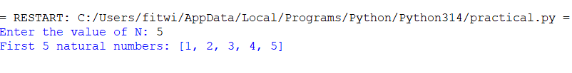

P2. By considering the terms in the Fibonacci sequence whose values do not exceed 1000, find the sum of the even-valued terms.
Solution:-

def even_fibonacci_sum(limit):
a, b = 0, 1
even_sum = 0
while a <= limit:
if a % 2 == 0:
even_sum += a
a, b = b, a + b
return even_sum

limit = 1000
result = even_fibonacci_sum(limit)
print("Sum of even Fibonacci numbers up to", limit, "is:", result)

Output:-

P3. Write a program which makes use of function to display all such numbers which are divisible by 7 but are not a multiple of 5, between 1000 and 2000.
Solution:-

def divisible_by_7_not_5(start, end):
result = []
for number in range(start, end + 1):
if number % 7 == 0 and number % 5 != 0:
result.append(number)
return result

start = 1000
end = 2000

numbers = divisible_by_7_not_5(start, end)
print("Numbers divisible by 7 but not by 5 between", start, "and", end, "are: \n", numbers)

Output:-

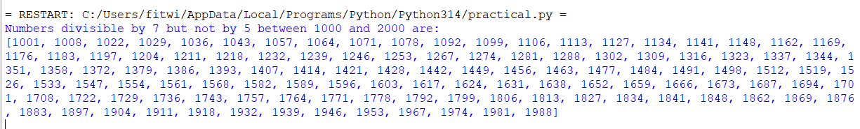

P4. Write a function cumulative_product to compute cumulative product of a list of numbers.
Solution:-

def cumulative_product(numbers):
result = []
product = 1
for num in numbers:
product *= num
result.append(product)
return result

nums = [2, 3, 4, 5]
print("Original list:", nums)
print("Cumulative product:", cumulative_product(nums))

Output:-

P5. Define a function which generates Fibonacci series up to n numbers using RECURSION.
Solution:-

def fibonacci(n):
if n <= 0:
return []
elif n == 1:
return [0]
elif n == 2:
return [0, 1]
else:
seq = fibonacci(n - 1)
seq.append(seq[-1] + seq[-2])
return seq

n = 10
print(fibonacci(n))

Output:-

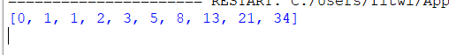

P6. Write a function that finds the sum of first n terms of following series: 1 – x2 / 2! + x4 / 4! – x6 / 6! + …… xn / n!
Solution:-

import math

def series_sum(x, n):
result = 0
sign = 1
for i in range(0, n + 1, 2):
term = sign * (x ** i) / math.factorial(i)
result += term
sign *= -1
return result

x = 2
n = 10
print(f"sum of first {n} terms with x = {x} : ",series_sum(x, n))

P7. With a given tuple (1, 2, 3, 4, 5, 6, 7, 8, 9, 10), write a program to print the first half values in one line and the last half values in one line.
Solution:-

t = (1, 2, 3, 4, 5, 6, 7, 8, 9, 10)
mid = len(t) // 2
print(t[:mid])
print(t[mid:])

Output:-

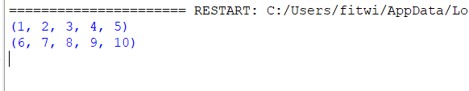

P8. Implement a python script to check the element is in the list or not by using Linear search & Binary search.
Solution:-

def linear_search(list, target):
for i in range(len(list)):
if list[i] == target:
return True
return False

def binary_search(list, target):
low = 0
high = len(list) - 1
while low <= high:
mid = (low + high) // 2
if list[mid] == target:
return True
elif list[mid] < target:
low = mid + 1
else:
high = mid - 1
return False

list = [3, 1, 4, 5, 9, 2]
target = 5
print("List : ", list)
print(f"Linear Search to find target {target}:", linear_search(list, target))
list.sort()
print("\nList : ", list)
print(f"Binary Search to find target {target}:", binary_search(list, target))
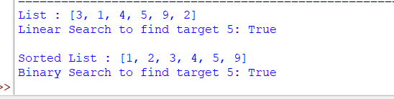

P9. Write a program to count the numbers of characters in the string and store them in a dictionary data structure.
Solution:-

def count_characters(s):
d = {}
for char in s:
d[char] = d.get(char, 0) + 1
return d

s = "hello world"
print(count_characters(s))

Output:-

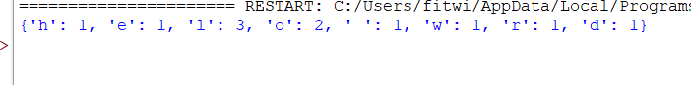

P10. Every time a vote is cast the name of the candidate is appended to the data structure. Print the names of candidates who received maximum vote in lexicographical order and if there is a tie print lexicographically smaller name.
Solution:
from collections import Counter

def find_winner(votes):
vote_count = Counter(votes)
max_votes = max(vote_count.values())
winners = [name for name, count in vote_count.items() if count == max_votes]
return sorted(winners)[0]

votes = ['Alice', 'Bob', 'Alice', 'Eve', 'Bob', 'Eve', 'Eve']
print("votes :", votes)
print("Winner : ",find_winner(votes))

P11. Remove spaces from a string using recursion.
Solution:-

def remove_spaces(s):
if not s:
return ""
if s[0] == " ":
return remove_spaces(s[1:])
else:
return s[0] + remove_spaces(s[1:])

s = "re cu rs iv e sp ac es"
print("String with space : ", s)
print("String without space : ", remove_spaces(s))

Output:-

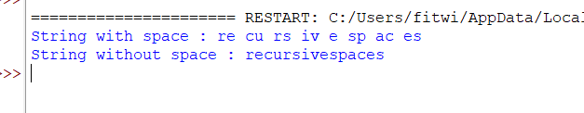

P12. Write a Python class to reverse a string word by word : Input string : 'hello Python' Expected Output : 'Python hello'
Solution:-

class ReverseWords:
def __init__(self, text):
self.text = text

def reverse(self):
return ' '.join(self.text.split()[::-1])

s = ReverseWords('hello Python')
print("String : ", s.text)
print("Reverse String : ",s.reverse())

Output:-
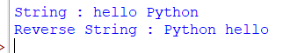
P13. Write a Python class which has two methods get_String and print_String.
get_String accept a string from the user and print_String print the string in upper case.
Solution:-

class StringManipulation:
def __init__(self):
self.user_string = ""

def get_String(self):
self.user_string = input("Enter a string: ")

def print_String(self):
print(self.user_string.upper())

obj = StringManipulation()
obj.get_String()
obj.print_String()
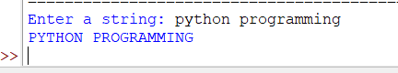
P14. Write a Python class named Circle constructed by a radius and two methods which will compute the area and the perimeter of a circle.
Solution:-

import math

class Circle:
def __init__(self, radius):
self.radius = radius

def area(self):
return math.pi * self.radius ** 2

def perimeter(self):
return 2 * math.pi * self.radius

c = Circle(5)
print("Area of circle : ",c.area())
print("Perimeter of circle : ",c.perimeter())

Output:-
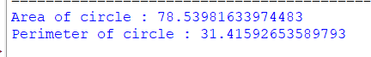
P15.Implement a python script to arrange the elements in sorted order using Bubble, Selection, Insertion and Merge sorting techniques.
Solution:
# Bubble Sort
def bubble_sort(arr):
a = arr.copy()
n = len(a)
for i in range(n):
for j in range(0, n-i-1):
if a[j] > a[j+1]:
a[j], a[j+1] = a[j+1], a[j]
return a
# Selection Sort
def selection_sort(arr):
a = arr.copy()
n = len(a)
for i in range(n):
min_idx = i
for j in range(i+1, n):
if a[j] < a[min_idx]:
min_idx = j
a[i], a[min_idx] = a[min_idx], a[i]
return a
# Insertion Sort
def insertion_sort(arr):
a = arr.copy()
for i in range(1, len(a)):
key = a[i]
j = i - 1
while j >= 0 and key < a[j]:
a[j+1] = a[j]
j -= 1
a[j+1] = key
return a
# Merge Sort
def merge_sort(arr):
if len(arr) <= 1:
return arr
mid = len(arr) // 2
left = merge_sort(arr[:mid])
right = merge_sort(arr[mid:])

return merge(left, right)
def merge(left, right):
result = []
i = j = 0
while i < len(left) and j < len(right):
if left[i] < right[j]:
result.append(left[i])
i += 1
else:
result.append(right[j])
j += 1
result.extend(left[i:])
result.extend(right[j:])
return result
# main
arr = [64, 34, 25, 12, 22, 11, 90]

print("Original list:", arr)
print("Bubble Sort:", bubble_sort(arr))
print("Selection Sort:", selection_sort(arr))
print("Insertion Sort:", insertion_sort(arr))
print("Merge Sort:", merge_sort(arr))
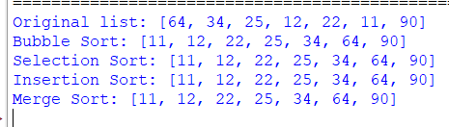
P16. Create a menu driven program to perform various matrices operations.
Solution:-
def add_matrix(A, B):
result = []
for i in range(len(A)):
row = []
for j in range(len(A[0])):
row.append(A[i][j] + B[i][j])
result.append(row)
return result
def subtract_matrix(A, B):
result = []
for i in range(len(A)):
row = []
for j in range(len(A[0])):
row.append(A[i][j] - B[i][j])
result.append(row)
return result
def multiply_matrix(A, B):
result = [[0 for _ in range(len(B[0]))] for _ in range(len(A))]

for i in range(len(A)):
for j in range(len(B[0])):
for k in range(len(B)):
result[i][j] += A[i][k] * B[k][j]
return result
def transpose_matrix(A):
result = []
for j in range(len(A[0])):
row = []
for i in range(len(A)):
row.append(A[i][j])
result.append(row)
return result
def print_matrix(M):
for row in M:
print(row)
# input matrix
def input_matrix(rows, cols):
matrix = []
for i in range(rows):
row = list(map(int, input().split()))
matrix.append(row)
return matrix

while True:
print("\nMatrix Operations Menu")
print("1. Addition")
print("2. Subtraction")
print("3. Multiplication")
print("4. Transpose")
print("5. Exit")

choice = int(input("Enter choice: "))

if choice == 1:
r, c = map(int, input("Enter rows and cols: ").split())
print("Enter matrix A:")
A = input_matrix(r, c)
print("Enter matrix B:")
B = input_matrix(r, c)

print("Result:")
print_matrix(add_matrix(A, B))

elif choice == 2:
r, c = map(int, input("Enter rows and cols: ").split())
print("Enter matrix A:")
A = input_matrix(r, c)
print("Enter matrix B:")
B = input_matrix(r, c)

print("Result:")
print_matrix(subtract_matrix(A, B))

elif choice == 3:
r1, c1 = map(int, input("Enter rows and cols of A: ").split())
print("Enter matrix A:")
A = input_matrix(r1, c1)

r2, c2 = map(int, input("Enter rows and cols of B: ").split())
print("Enter matrix B:")
B = input_matrix(r2, c2)

if c1 != r2:
print("Multiplication not possible")
else:
print("Result:")
print_matrix(multiply_matrix(A, B))

elif choice == 4:
r, c = map(int, input("Enter rows and cols: ").split())
print("Enter matrix:")
A = input_matrix(r, c)

print("Transpose:")
print_matrix(transpose_matrix(A))

elif choice == 5:
break

else:
print("Invalid choice")

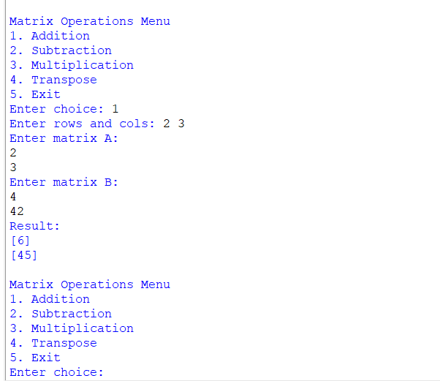
P17. Write a program to compute the number of characters, words and lines in a file.
Solution:-

# create sample file
with open("sample.txt", "w") as f:
f.write("Hello world\n")
f.write("Python is easy\n")
f.write("File handling example")

# program to count
def count_file(filename):
with open(filename, "r") as f:
text = f.read()

lines = text.split("\n")
words = text.split()
characters = len(text)

print("Number of lines:", len(lines))
print("Number of words:", len(words))
print("Number of characters:", characters)

count_file("sample.txt")
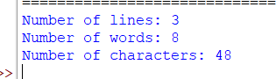

P18. Write a program to compare two files and display total number of lines in a file.
Solution:-

def compare_files(file1, file2):
with open(file1, "r") as f1, open(file2, "r") as f2:
lines1 = f1.readlines()
lines2 = f2.readlines()

print("Contents of", file1)
print("".join(lines1))

print("Contents of", file2)
print("".join(lines2))

print("Total lines in", file1, ":", len(lines1))
print("Total lines in", file2, ":", len(lines2))

if lines1 == lines2:
print("Files are identical")
else:
print("Files are different")

compare_files("file1.txt", "file2.txt")

Output:-
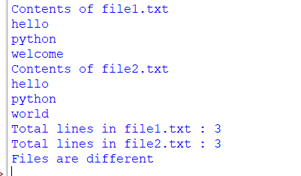

P19. Draw different graphs and plots in Python using Matplotlib Library.
Solution:-

import matplotlib.pyplot as plt
import numpy as np

x = np.linspace(0, 10, 100)
y = np.sin(x)
z = np.cos(x)

plt.figure(figsize=(12, 10))

plt.subplot(2, 2, 1)
plt.plot(x, y, label='sin(x)', color='blue')
plt.title('Line Plot')
plt.xlabel('x')
plt.ylabel('sin(x)')
plt.legend()

plt.subplot(2, 2, 2)
plt.scatter(x, y, color='red')
plt.title('Scatter Plot')
plt.xlabel('x')
plt.ylabel('sin(x)')

plt.subplot(2, 2, 3)
bars = ['A', 'B', 'C', 'D']
heights = [4, 7, 2, 6]
plt.bar(bars, heights, color='green')
plt.title('Bar Chart')

plt.subplot(2, 2, 4)
data = [30, 25, 20, 25]
labels = ['Python', 'Java', 'C++', 'JavaScript']
plt.pie(data, labels=labels, autopct='%1.1f%%')
plt.title('Pie Chart')

plt.tight_layout()
plt.show()

Output:-

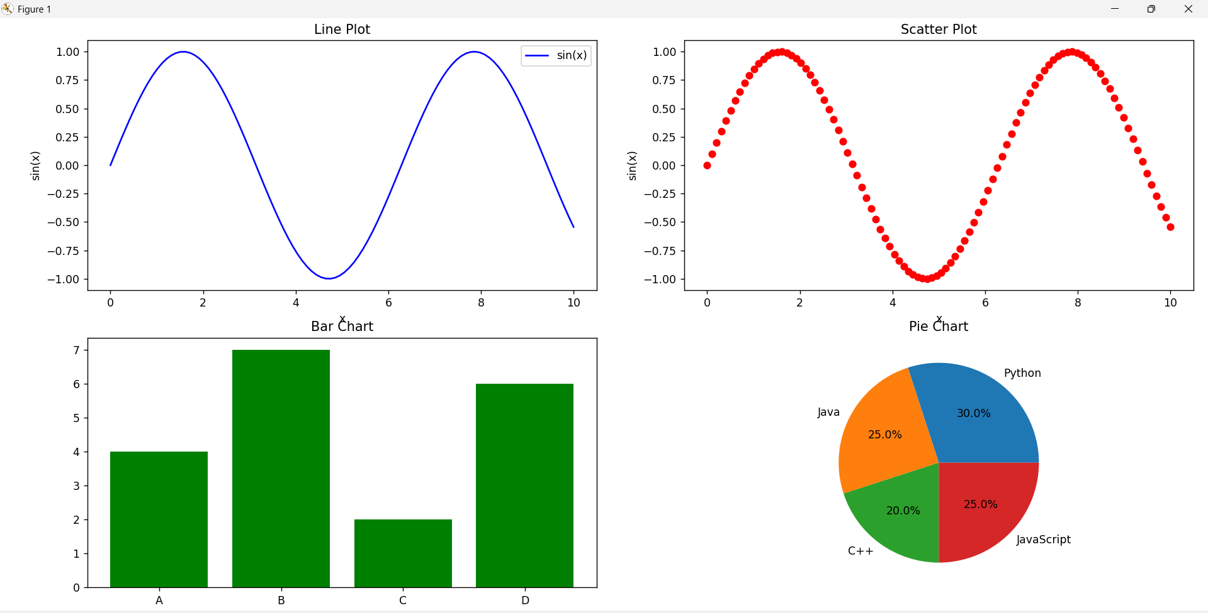

P20. Write a python code for simple GUI calculator using Tk
Solution:
import tkinter as tk

# function to handle button click
def click(event):
current = entry.get()
entry.delete(0, tk.END)
entry.insert(0, current + str(event.widget["text"]))

# clear screen
def clear():
entry.delete(0, tk.END)

# evaluate expression
def equal():
try:
result = eval(entry.get())
entry.delete(0, tk.END)
entry.insert(0, str(result))
except:
entry.delete(0, tk.END)
entry.insert(0, "Error")

# main window
root = tk.Tk()
root.title("Calculator")
root.geometry("300x350")

# entry box
entry = tk.Entry(root, font="Arial 18", justify="right")
entry.pack(fill="both", ipadx=8, pady=10, padx=10)

# buttons
buttons = [
'7','8','9','/',
'4','5','6','*',
'1','2','3','-',
'0','.','=','+'
]

frame = tk.Frame(root)
frame.pack()

row = 0
col = 0

for button in buttons:
b = tk.Button(frame, text=button, font="Arial 14", width=5, height=2)
b.grid(row=row, column=col, padx=5, pady=5)

if button == "=":
b.configure(command=equal)
else:
b.bind("<Button-1>", click)

col += 1
if col > 3:
col = 0
row += 1

# clear button
clear_btn = tk.Button(root, text="Clear", font="Arial 14", command=clear)
clear_btn.pack(fill="both", padx=10, pady=5)

root.mainloop()
Output:
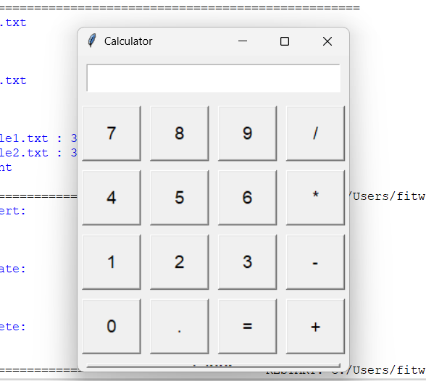
P21. Write a python program to perform various database operations (create, insert, delete, update)
Solution:-

import sqlite3

# connect to database (creates if not exists)
conn = sqlite3.connect("student.db")
cursor = conn.cursor()

# CREATE table
cursor.execute("""
CREATE TABLE IF NOT EXISTS students(
id INTEGER PRIMARY KEY,
name TEXT,
age INTEGER
)
""")

# INSERT data
cursor.execute("INSERT INTO students (name, age) VALUES (?, ?)", ("Alice", 21))
cursor.execute("INSERT INTO students (name, age) VALUES (?, ?)", ("Bob", 22))

conn.commit()

# DISPLAY data
print("Records after insert:")
cursor.execute("SELECT * FROM students")
for row in cursor.fetchall():
print(row)

# UPDATE data
cursor.execute("UPDATE students SET age = 23 WHERE name = 'Alice'")
conn.commit()

print("\nRecords after update:")
cursor.execute("SELECT * FROM students")
for row in cursor.fetchall():
print(row)

# DELETE data
cursor.execute("DELETE FROM students WHERE name = 'Bob'")
conn.commit()

print("\nRecords after delete:")
cursor.execute("SELECT * FROM students")
for row in cursor.fetchall():
print(row)

# close connection
conn.close()
Output:-

