

BHARATI VIDYAPEETH’S

INSTITUTE OF COMPUTER APPLICATIONS & MANAGEMENT
(Affiliated to Guru Gobind Singh Indraprastha University, Approved by AICTE, New Delhi)

Database Management System (DBMS)
(MCA-165)
Practical File

Submitted To: Submitted By:
Dr. Sania Kukkar Piyush Goel
(Assistant Professor) (09311604425) MCA 1st Sem, Sec B

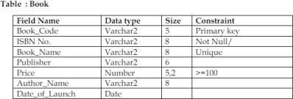
INDEX

S. No. | Problem Description | Date of Executi on | Sign.
P1 | Consider the following table: Write queries to perform the following:  - Insert few records in it.  - Increase the size of the Book_Name field to 10 characters.  - Display the total price of all the books of “TMH’ publishing house.  - Display the details of all the books of author “Yashwant Kanetkar” and “Robert Lafore”.  - Delete all the books belonging to “PHI” publisher.  - Update the price of books by 5% which belong to ‘BPB’ publishers.  - Create a new table “Author” with author details such as author id (primary key), Name of the author, subject, contact details, research area etc.  - Insert records in it and display the records of those authors who have ‘Web mining’ as their research area.  - Add a new column “Author_Id” in “Book” table and make it a foreign key on “author id” of “Author” table.  - Update all the previous records of Book table to add information of author id (newly added column)  - Display the records of the books where book name starts with ‘C’ or ‘G’ or ‘K’.  - Create a view for the user to access the Book Code, Name  and Price of books which are published by ‘Pearson Education’
P2 | Consider the following table:  - Insert few records except total marks.  - Create a view on the table to access roll no, name and total marks of those students who belong to ‘Delhi’.  - Calculate total marks of each student and save it.

- Display the name of the student who has got the highest marks.
- Display the records of those students who have got marks more than the marks of ‘Kiran’.
- Display the percentage of all the students with their names. Laboratory Manual for MCA-165; Database Management Systems Lab. © Bharati Vidyapeeth’s Institute of Computer Applications and Management (BVICAM), New Delhi | Page 14 of 18
- Display the names of those students who have got maximum marks in sub1 and more than 50 in sub2 and sub3.
- Update the marks of all those students who are fail, with grace marks 5. (fail means less than 40)
- Delete the record of student who got minimum marks.
- Display record of student who got second highest marks.
- Display the average total marks of all the student's city wise excluding the students of ‘Gurgaon’.
- Get the names of students with Roll_no less than 30 and whose total marks is more than the total marks of at least one student with Roll_no greater than or equal to 30.

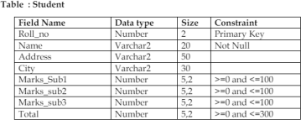

P3 | Consider the following three relations: Primary Keys are indicated by # Foreign Keys are underlined. Employee (Eid#, EName, Address, DateOfJoining, Department) Project (Pid#, PName, StartDate, TerminationDate) AssignedTo (Eid, Pid) Now write queries for the following in relational algebra as well as in SQL:  - Find the employees working on ‘Banking’ project.  - Find the projects assigned to the employees of D01 or D02.  - Find the employees who belong to Delhi and work on either ‘University’project or ‘ShareMarket’ project  - Find the employees who do not work on ‘University’ project.  - Find the employees who work on all projects.  - List the employees who have not been assigned any project.  - Find the employees who joined the department after the

commencement of ‘Bank’ project.
8. Display the start and termination date of projects which are allotted to ‘Jai Prakash’
P4 | Consider the following relations: Primary Keys are indicated by # Foriegn Keys are underlined. Student (Roll#, SName, City, Age, Gender) Course (Cid#, CName, Semester, Credits, Fee) Enrollment (Roll, Cid, DateOfReg) Now write SQL queries for the following:  - Find the details of students registered in MCA course.  - Display the total number of students enrolled in MBA.  - Display the names of students who are enrolled in the course n which “Anita” is registered.  - Display the names of all the students with their date of enrollment in the courses.  - Display the name of the course in which “Kunal” is registered.  - Display the names of boys-students enrolled in MCA.  - Display the number of students registered in MCA course who live outside Delhi.
P5 | Consider any table of your choice and execute following functions on numeric, character and date type fields :  - sqrt( ) • power( ) • ceil( ) • max( ) • min( ) • avg( ) • count( ) • exp( ) • mod( ) • sum ( ) • floor( ) • abs( ) • greatest ( ) • round( ) • to_date( ) • months_between( ) • last_day( ) • add_months( ) • next_day( ) • sysdate • round( ) • to_char( ) length( ) • substr( ) • lower( ) • initcap( ) • instr( ) • concat( ) • lpad( ) • rpad( ) • ltrim(  ) • rtrim( ) • replace( )
P6 | Write a program that demonstrates dynamic binding by creating an array of  `Person`  references, storing both `Patient` and `Doctor` objects, and calling  `displayDetails()`..
P7 | Write a PL/SQL code that will reverse a given number like 12345 to 54321.
P8 | Write a PL/SQL code to accept emp_id from user and display his  / her record. Table: Employee (EmpId, EName, DOJ, DOB, Salary, Address)
P9 | The bank manager of Delhi branch decides to mark the status of all those accounts as ‘Inactive’ on which there are no transactions performed in last 6 months. Whenever any such update takes place the corresponding record is inserted in another table ‘InactiveAccounts’ with the name and account no of the account holder and his balance. Table: Account (AccNo, Name, Address,  PANNo, Mobile, Status)

P10 | Write a Cursor(PL/SQL code) to display the Employee_name, DateofBirth, and Designation whose basic salary is greater than 15000, if not found then show the proper error message. (Use Exception handing) Table : Employee(EmpId, EName, DOJ,  DOB, Salary, Address)
P11 | Create a function that accepts emp id from the calling procedure and returns his salary. Table: Employee (EmpId, EName, DOJ, DOB, Salary, Address) Create a function that accepts emp id from the calling procedure and returns his salary. Table: Employee (EmpId,  EName, DOJ, DOB, Salary, Address)
P12 | Write a PL/SQL function ODDEVEN to return value  TRUE if the number passed to it is EVEN else will return FALSE

P1 Consider the following table:
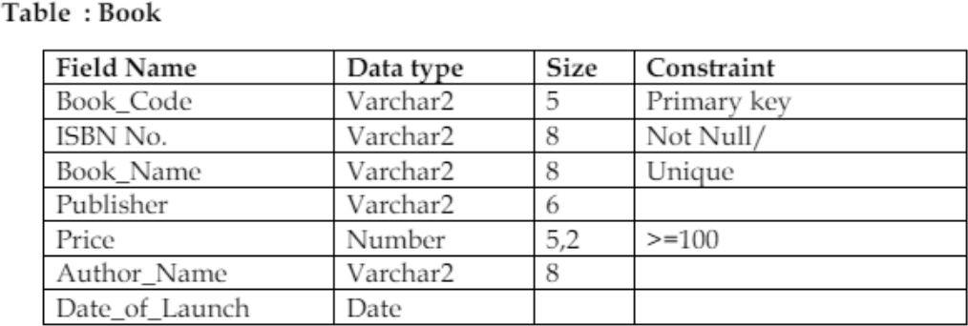

Write queries to perform the following:
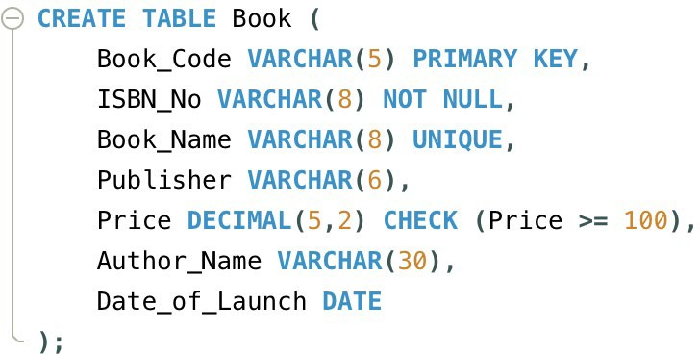
- Insert few records in it.
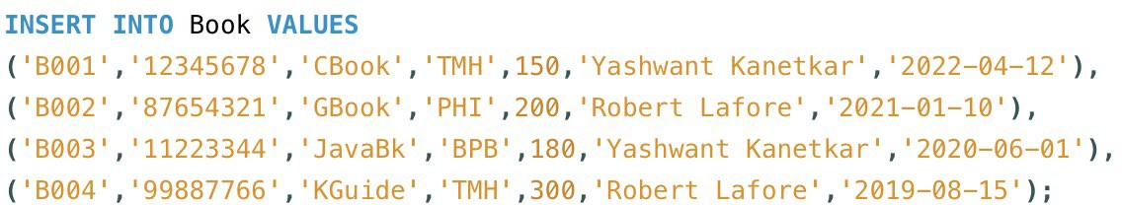
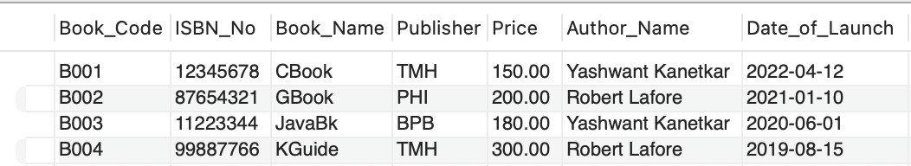

- Increase the size of the Book_Name field to 10 characters.

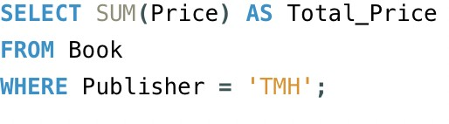
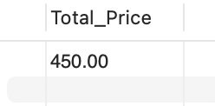
- Display the total price of all the books of “TMH’ publishing house.

- Display the details of all the books of author “Yashwant Kanetkar” and “Robert Lafore”.
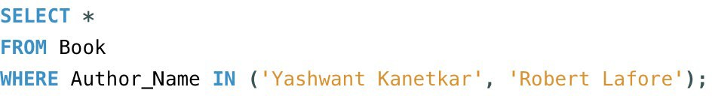
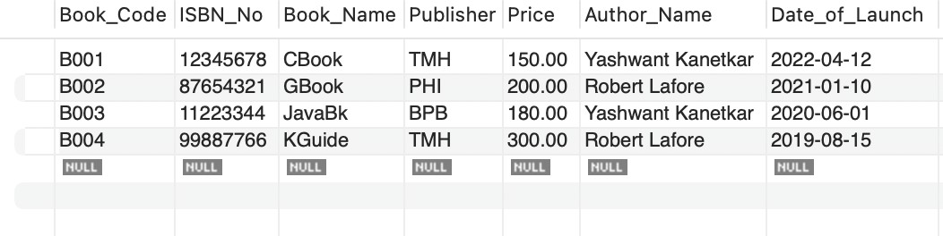
- Delete all the books belonging to “PHI” publisher.

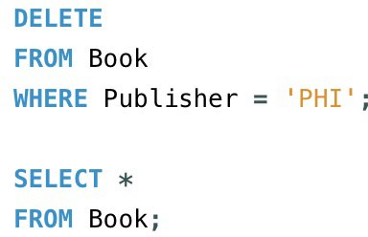
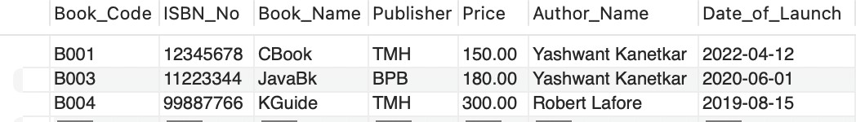

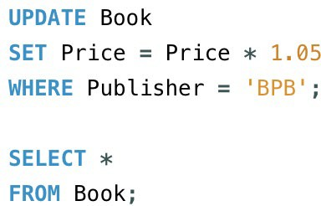
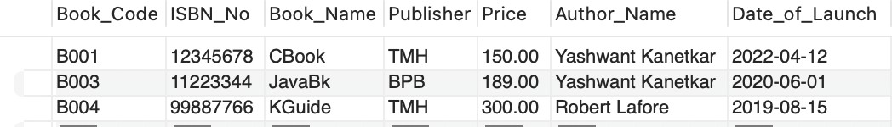
- Update the price of books by 5% which belong to ‘BPB’ publishers.

- Create a new table “Author” with author details such as author id (primary key), Name of the author, subject, contact details, research area etc.

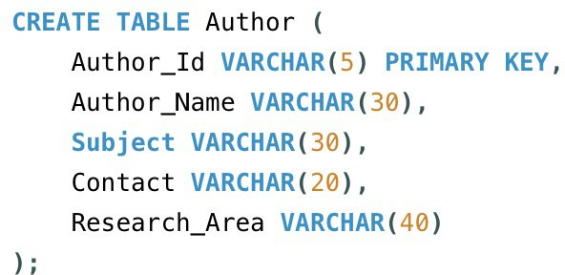

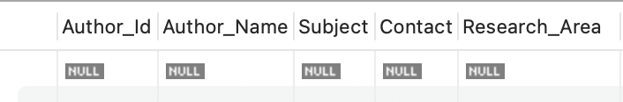

- Insert records in it and display the records of those authors who have ‘Web mining’ as their research area.
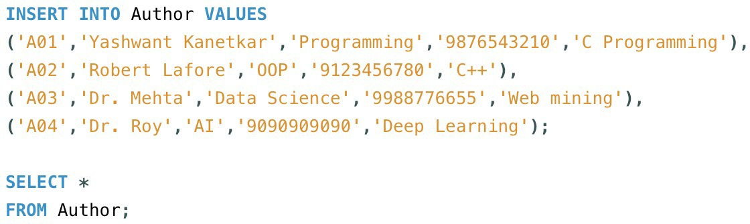
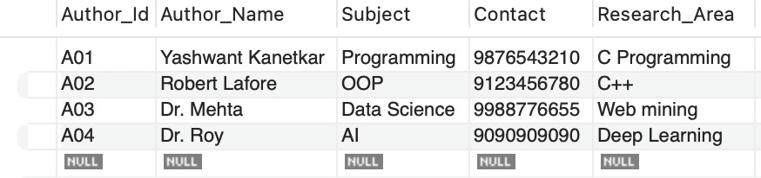

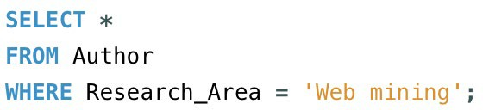
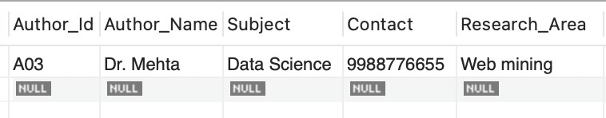

- Add a new column “Author_Id” in “Book” table and make it a foreign key on “author id” of “Author” table.
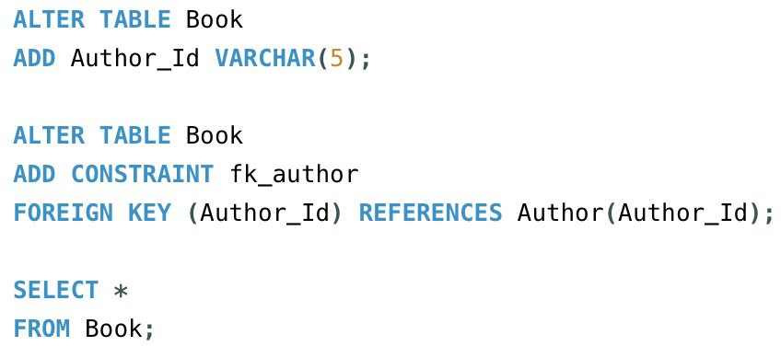
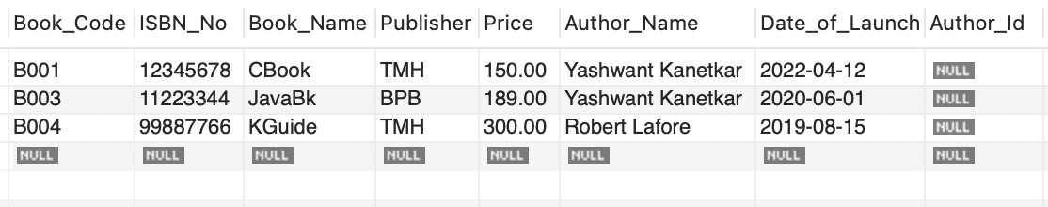

- Update all the previous records of Book table to add information of author id (newly added column)

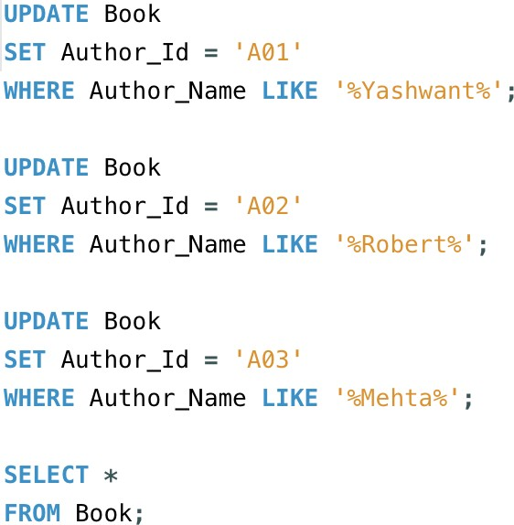
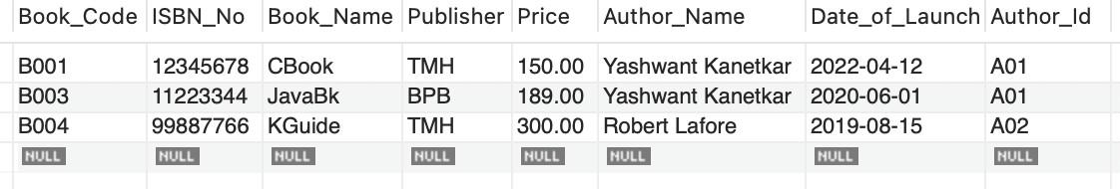

- Display the records of the books where book name starts with ‘C’ or ‘G’ or ‘K’.
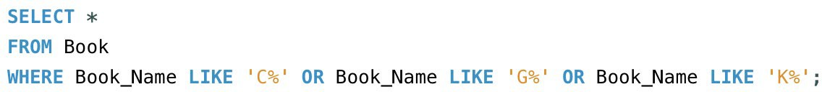

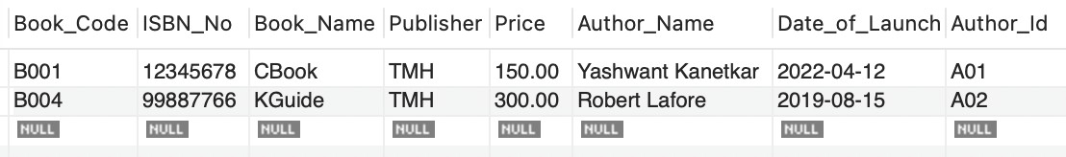

- Create a view for the user to access the Book Code, Name and Price of books which are published by ‘Pearson Education’.
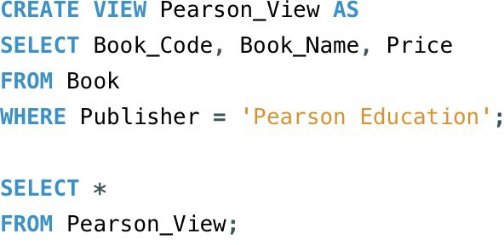


P2 Consider the following table:
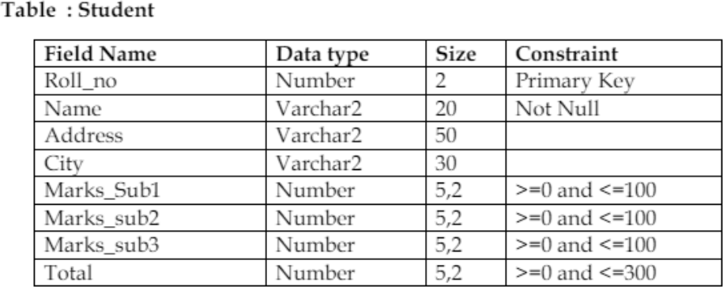
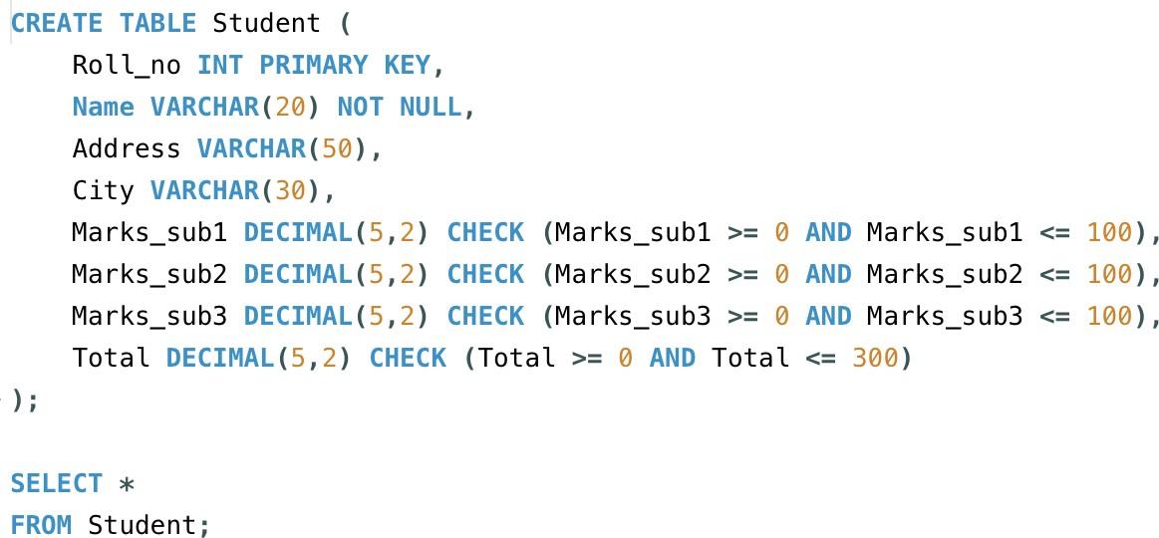

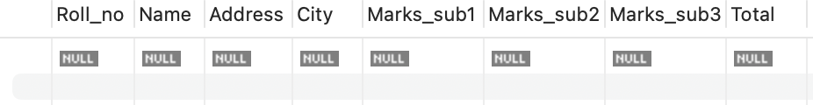

- Insert few records except total marks.
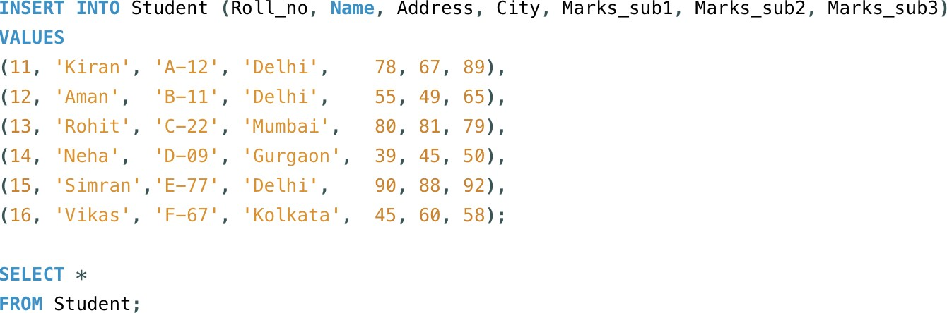

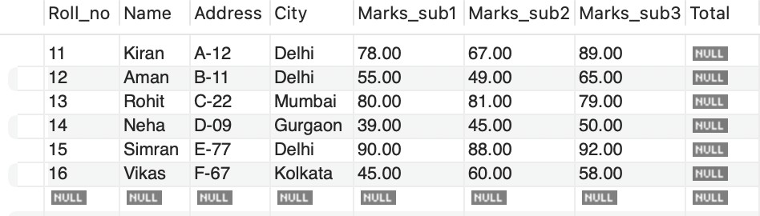

- Create a view on the table to access roll no, name and total marks of those students who belong to ‘Delhi’.
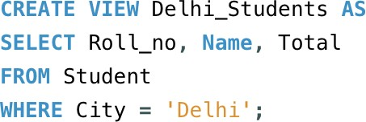

- Calculate total marks of each student and save it.
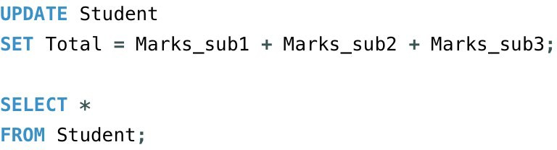
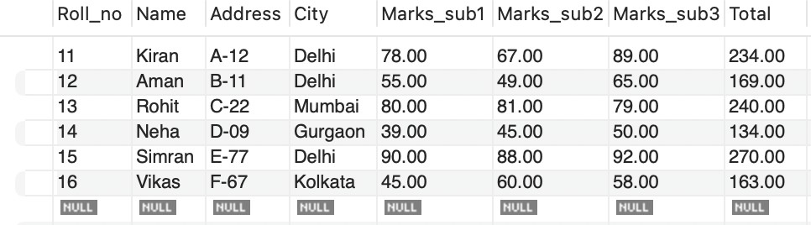

- Display the name of the student who has got the highest marks.

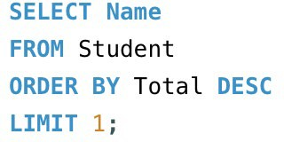

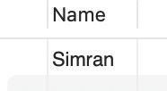

- Display the records of those students who have got marks more than the marks of ‘Kiran’.
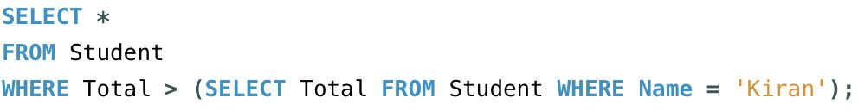
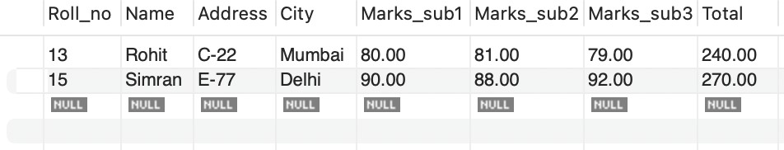


- Display the percentage of all the students with their names.

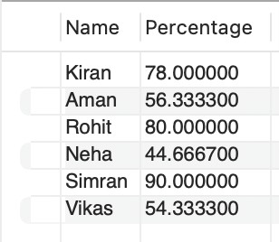

- Display the names of those students who have got maximum marks in sub1 and more than 50 in sub2 and sub3.
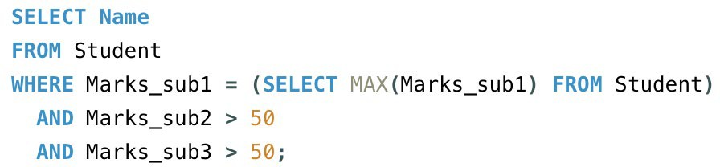
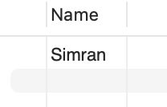

- Update the marks of all those students who are fail, with grace marks 5. (fail means less than 40)

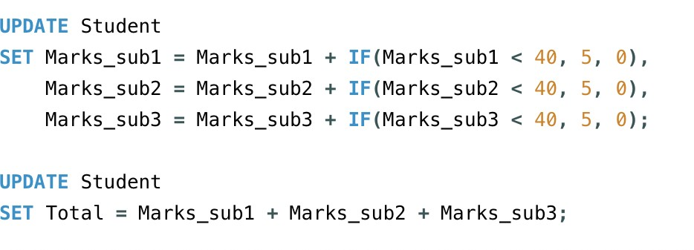

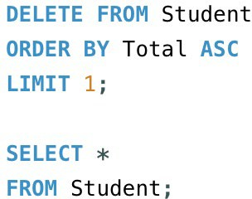
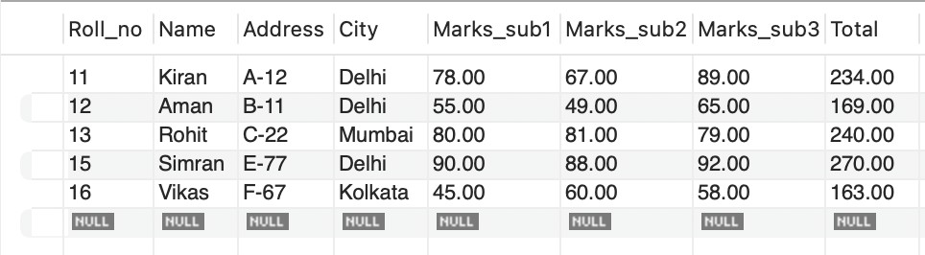
- Delete the record of student who got minimum marks.

- Display record of student who got second highest marks.
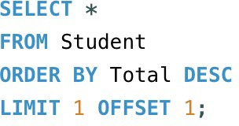

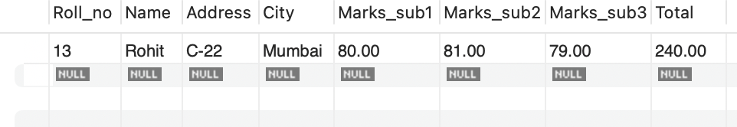

- Display the average total marks of all the student's city wise excluding the students of ‘Gurgaon’.
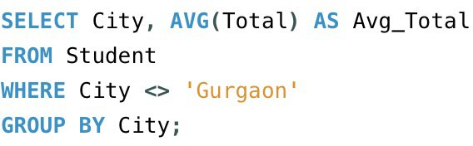
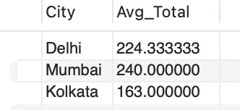

- Get the names of students with Roll_no less than 30 and whose total marks is more than the total marks of at least one student with Roll_no greater than or equal to 30.

SELECT*
FROM Students
WHERE s.Roll no< 30
AND s.Total > (
S LECT MIN(Total)
FROM Student
WH R Roll no>= 30
);
Roll_no Name Address City Marks_sub1 Marks_sub2 Marks_sub3 Total

lmml lmml lmml lmml lmml lmml lmml lmml

P3 Consider the following three relations:
Primary Keys are indicated by # Foreign Keys are underlined.
Employee (Eid#, EName, Address, DateOfJoining, Department) Project (Pid#, PName, StartDate, TerminationDate) AssignedTo (Eid, Pid)
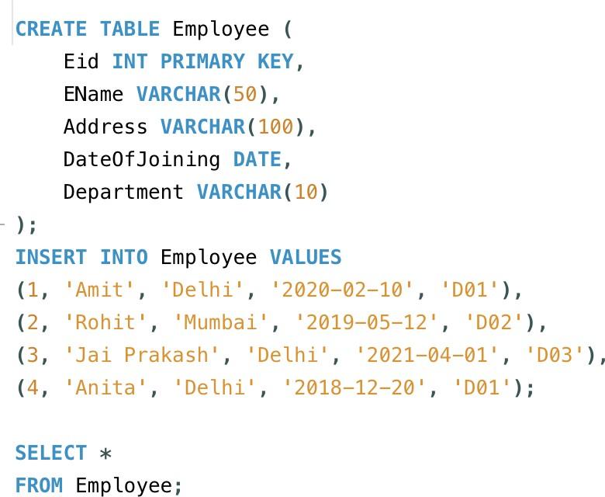

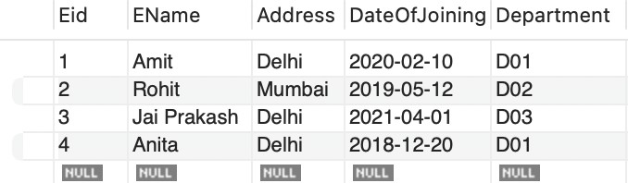

I CREATE TABLE Project (

Pid INT PRIMARY KEY,
PName VARCHAR(50),
StartDate DATE,
TerminationDate DATE
. ) ;
INSERT INTO Project VALUES
( 101, 1 Ban king• , 1 2020-01-011 , 1 2023-12-311 ) ,
( 102, 1 University 1, 12019-03-101, 1 2022-05-011),
(103, 1ShareMarket1, 12018-11-051, 12023-10-101),
(104, 1 Bank 1 , 1 2020-02-011 , 1 2024-10-01 ) ;

SELECT*
FROM Project;

Pid | PName | StartDate | TerminationDate
101 | Banking | 2020-01-01 | 2023-12-31
102 | University | 2019-03-10 | 2022-05-01
103 | ShareMarket | 2018-11-05 | 2023-10-10
104 | Bank | 2020-02-01 | 2024-10-01
IImDI | IImDI | IImDI | IImDI

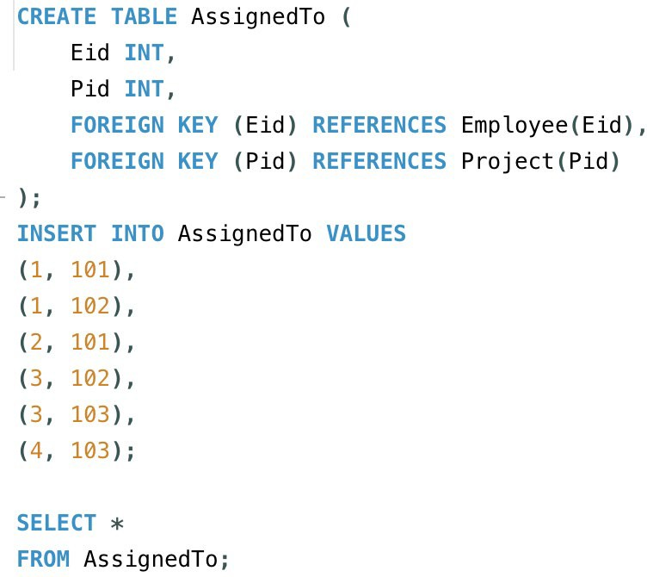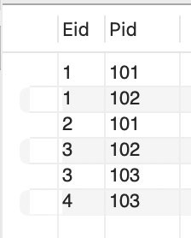
Now write queries for the following in relational algebra as well as in SQL:
- Find the employees working on ‘Banking’ project.

BANK ← σ(PName = 'Banking')(Project) EMP_PRO J ←BAN K ⨝ AssignedT o ⨝ Employee π(Eid, EName)(EMP_PROJ)

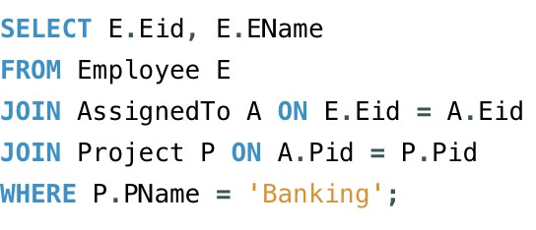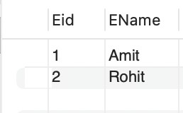
- Find the projects assigned to the employees of D01 or D02.

EMP ← σ(Department = 'D01' OR Department = 'D02')(Employee)
RESULT ← π(Pid, PName)((EMP ⨝ AssignedT o ⨝ Project))

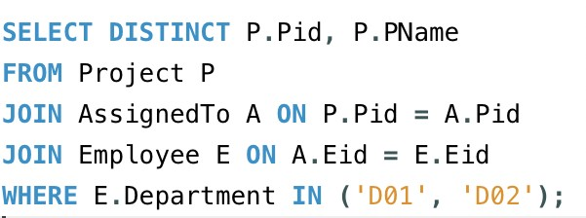

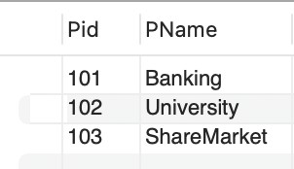
- Find the employees who belong to Delhi and work on either ‘University’project or ‘ShareMarket’ project

P ← σ(PName = 'University' OR PName = 'ShareMarket')(Project) EMP ← σ(Address = 'Delhi')(Employee)
RESULT ← π(Eid, EName)(EMP ⨝ AssignedT o ⨝ P)

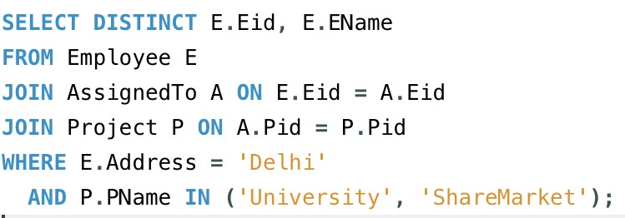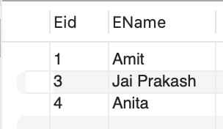
- Find the employees who do not work on ‘University’ project.

UN IV ←π (Eid)(AssignedT o ⨝ σ(PN ame='University')(Project))
RESULT ← π(Eid, EName)(Employee) – UNIV

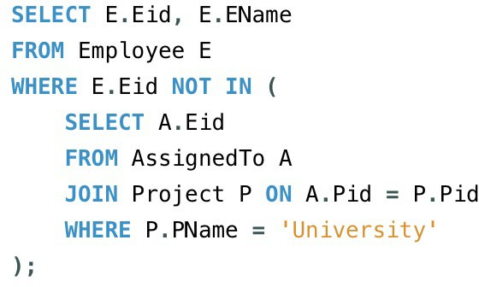
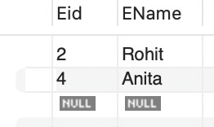
- Find the employees who work on all projects.

RESULT ← π(Eid)(AssignedTo ÷ Project)

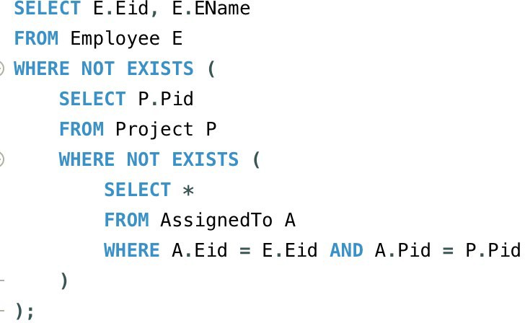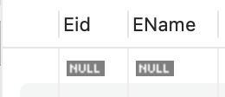

- List the employees who have not been assigned any project.

ASSIGNED ← π(Eid)(AssignedTo)
RESULT ← π(Eid, EName)(Employee) – ASSIGNED

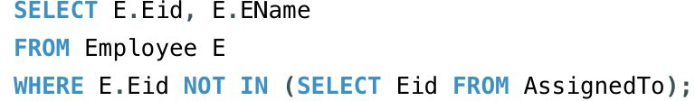

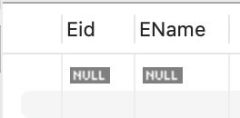
- Find the employees who joined the department after the commencement of ‘Bank’ project.

BANK ← σ(PName='Bank')(Project)
RESULT ← σ(DateOfJoining > BANK.StartDate)(Employee)

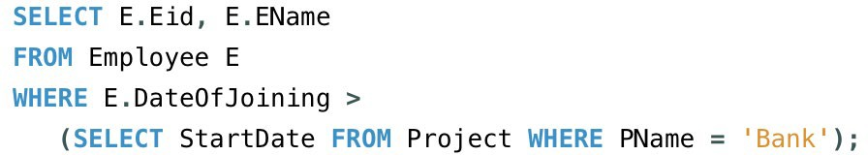
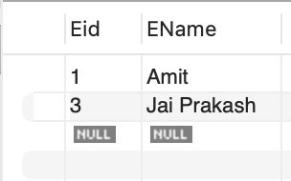

- Display the start and termination date of projects which are allotted to ‘Jai Prakash’

JP ← σ(EName='Jai Prakash')(Employee)
RESULT ← π(StartDate,TerminationDate)(JP ⨝ AssignedT o ⨝ Project)

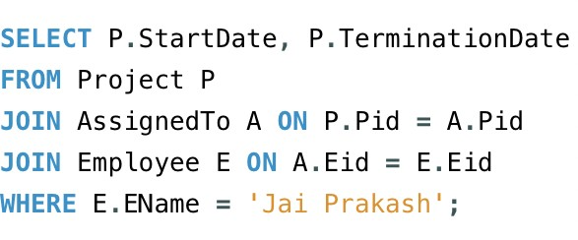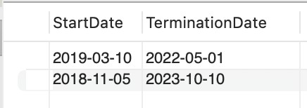

P4 Consider the following relations: Primary Keys are indicated by # Foriegn Keys are underlined.
Student (Roll#, SName, City, Age, Gender) Course (Cid#, CName, Semester, Credits, Fee) Enrollment (Roll, Cid, DateOfReg)
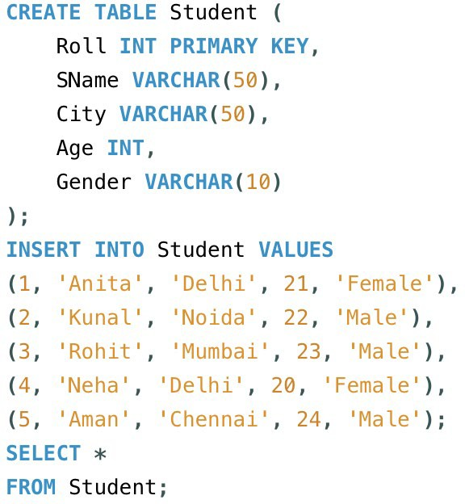

Rolrn SName City Age | Gender
1 Anita Delhi 21 | Female
2 Kunal Nloida 2:2 | Male
3 Rohit Mumbai .23 | Male
4 Nleha Delhi .20 | Female
5 Aman Chennai 24 | Male
Hl!l!I Hl!l!I 01!1!1 Hl!l!I | Hl!l!I
I CREATE TABLE Course (
Cid INT RIMARY KEY,
(Name VARCHAR(S0),
Semester INT,

. ) ;
Credits INT,,
Fee DECIMAL(10,2)

INSERT INTO Course VALUES

(101, | 1MCA 1  , | 4, | 24,, | 60000),
(102, | 1MBA 1  , | 3, | 20, | 75000),
(103, 1 CA 1, 1, 18, 45000);
S LECT *
FROM Course;

Cid | CName | Semester | Credits | Fee
101 | MCA | 4 | .24 | 6:0000.00
102 | MBA | 3 | 20 | 75000.00
103 BCA |  | 1 | 18 45000.00
Hlm!I Hlm!I |  | Hlm!I | Hlm!I Hlm!I

CREATE TABLE Enrollment ( Roll INT,
Cid INT,
DateOfReg DATE,
FOREIGN KEY (Roll) REFERENCES Student(Roll),
FOREIGN KEY (Cid) REFERENCES Course(Cid)
);
INSERT INTO Enrollment VALUES

(1, | 101, | 12023-01-101),
(2J | 101, | I 2023-02-12 I) I
(3, | 102, | 12023-03-15 I) I
(4, | 103, | 12023-04-181),
( 5J | 102I | I 2023-05-20 J ) ;
SELECT*
FROM Enrollment;

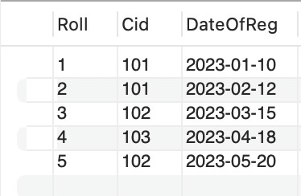
Now write SQL queries for the following:
- 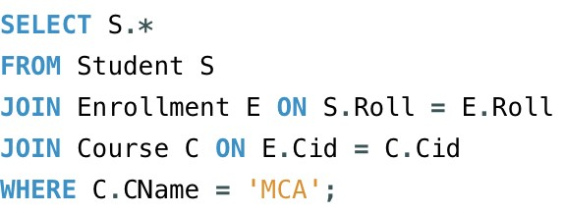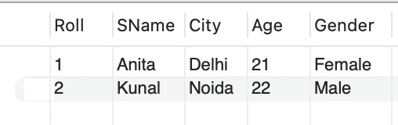Find the details of students registered in MCA course.
- Display the total number of students enrolled in MBA.
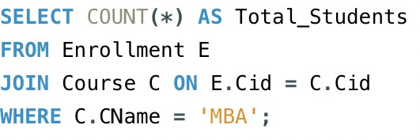

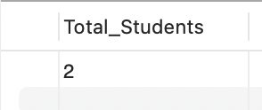
- Display the names of students who are enrolled in the course in which “Anita” is registered.
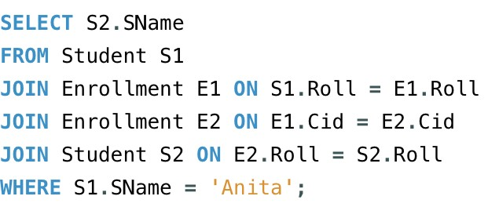
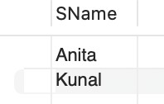
- Display the names of all the students with their date of enrollment in the courses.
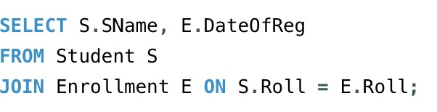

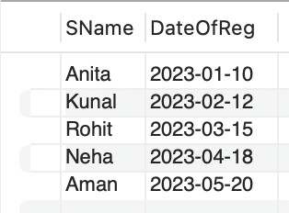
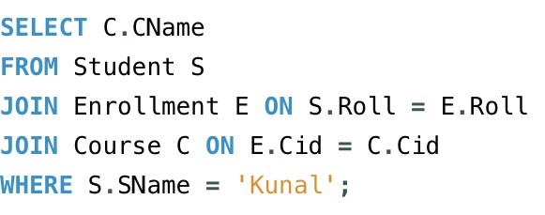
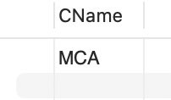
- Display the name of the course in which “Kunal” is registered.

- Display the names of boys-students enrolled in MCA.
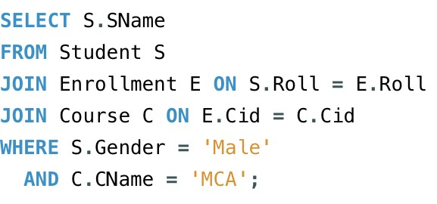

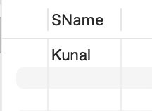
- 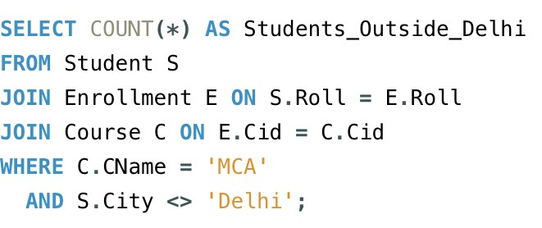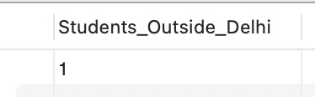Display the number of students registered in MCA course who live outside Delhi.

P5 Consider any table of your choice and execute following functions on numeric, character and date type fields :
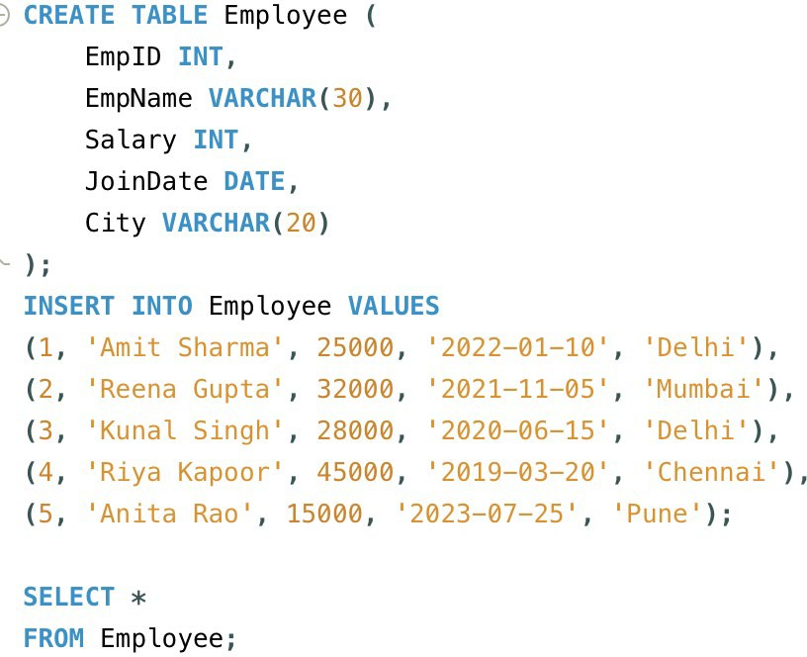

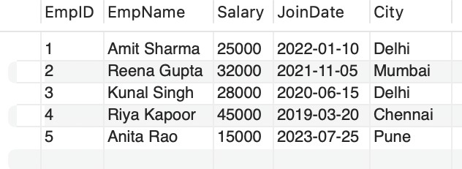


- sqrt( )

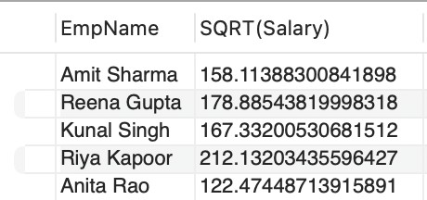

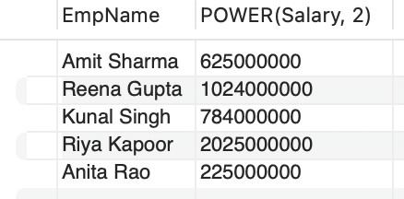
- power( )


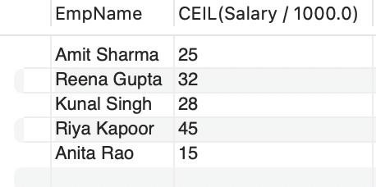
- ceil( )

- max( ) • min( ) • avg( ) • count( ) • sum ( )

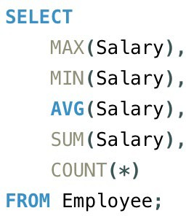

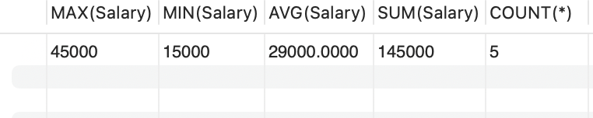

- exp( )

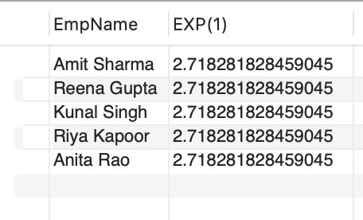

- mod()

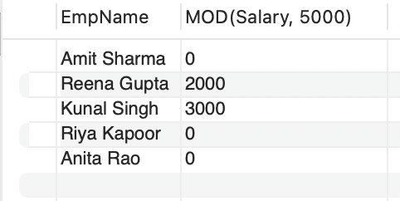
- 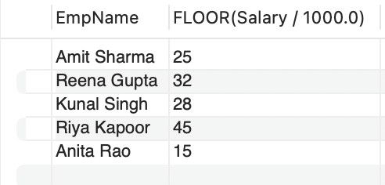floor( )
- abs( )

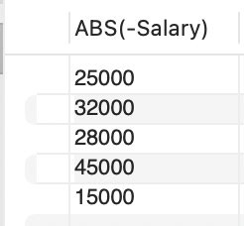
- greatest ( )

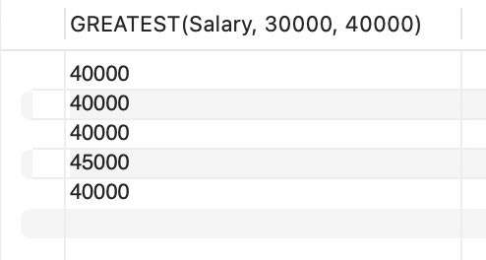
- round( )

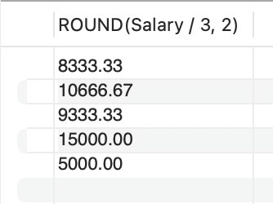

- to_date( )

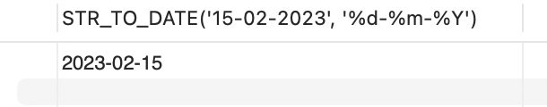

- months_between( )
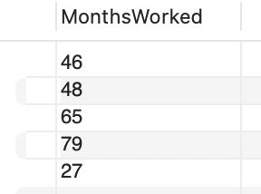

- last_day( )
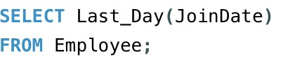
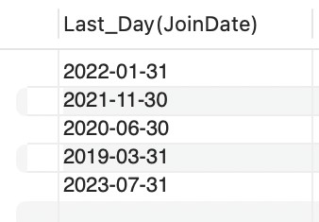

- add_months( )


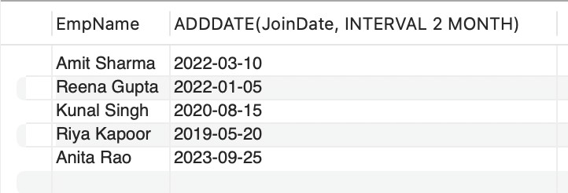
- next_day( )
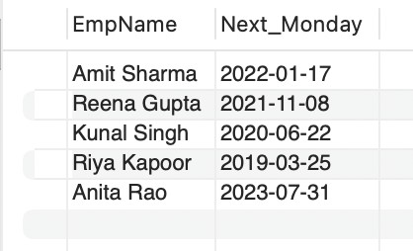


- sysdate

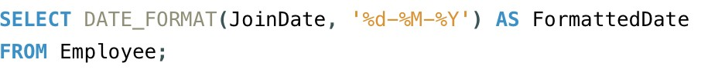
- to_char( )

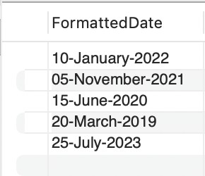

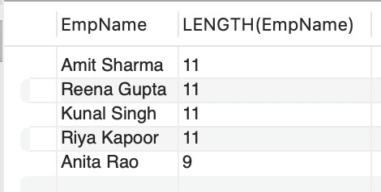length( )
- substr( )
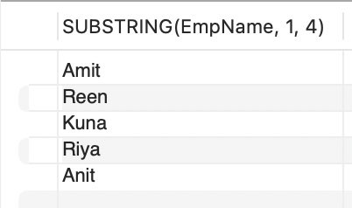

- 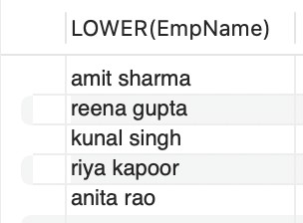lower( )

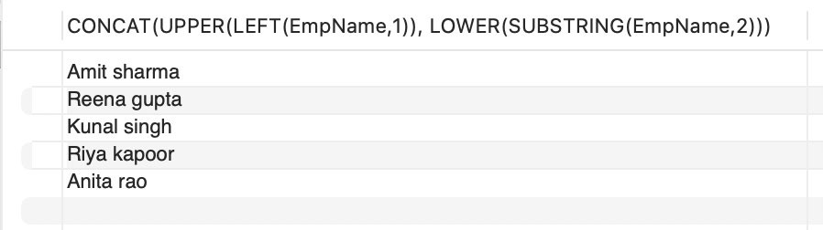
- initcap( )

- instr( )
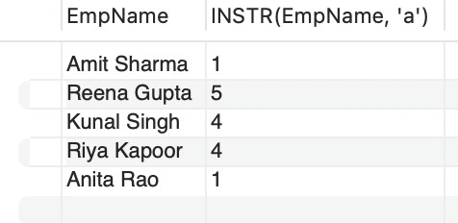

- concat( )
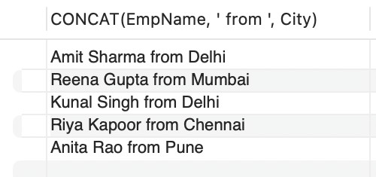

- lpad( )

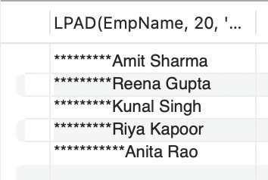
- rpad( )

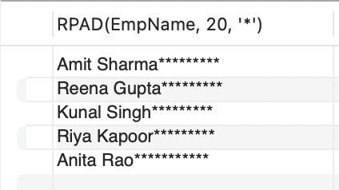
- ltrim( )
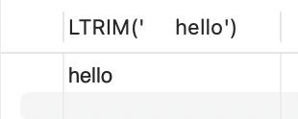

- rtrim( )
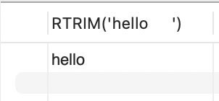

- replace( )

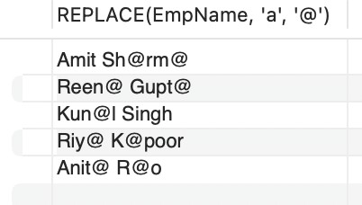

P6 Write a PL/SQL code that will reverse a given number like 12345 to 54321.
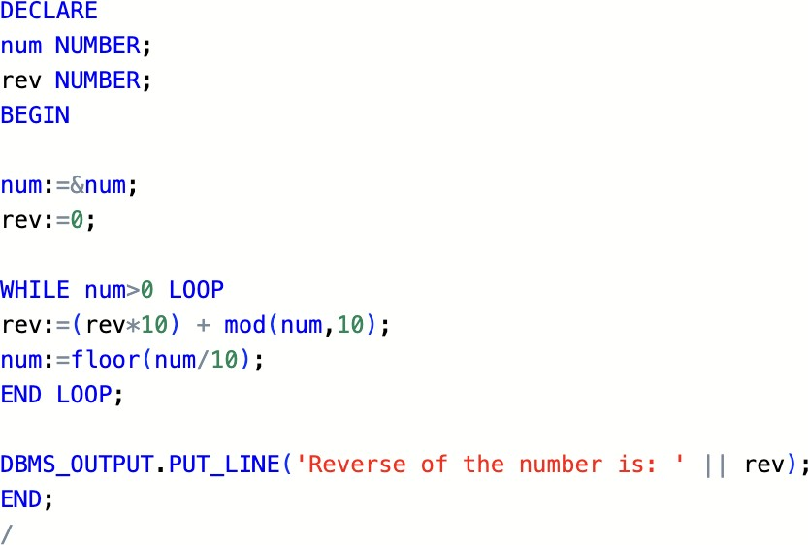
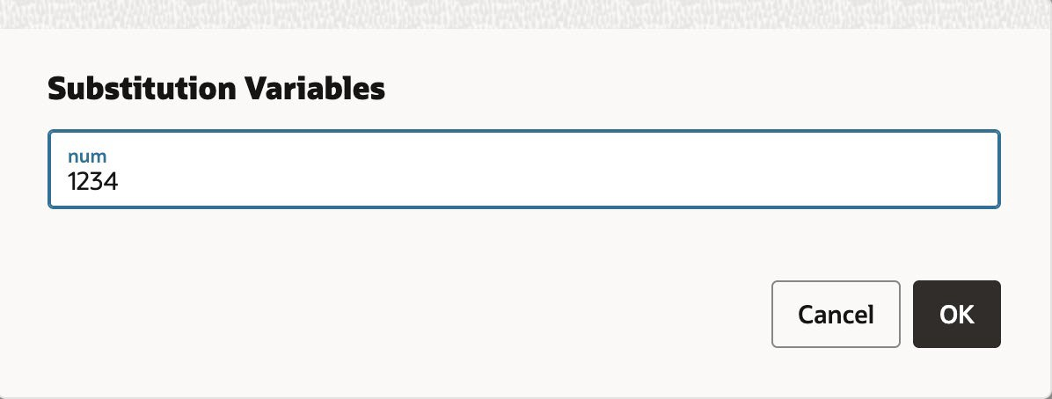

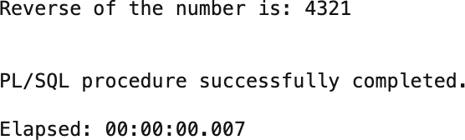

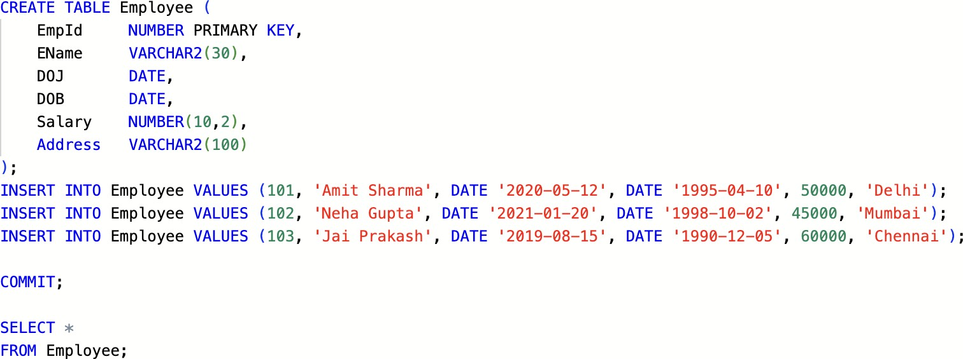
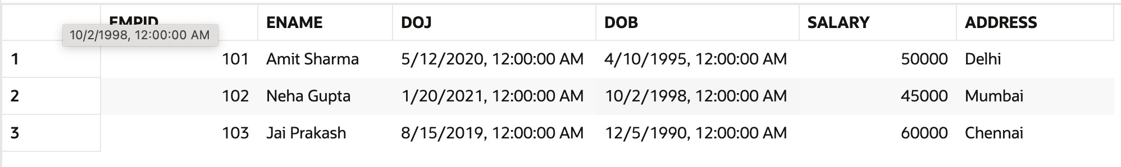
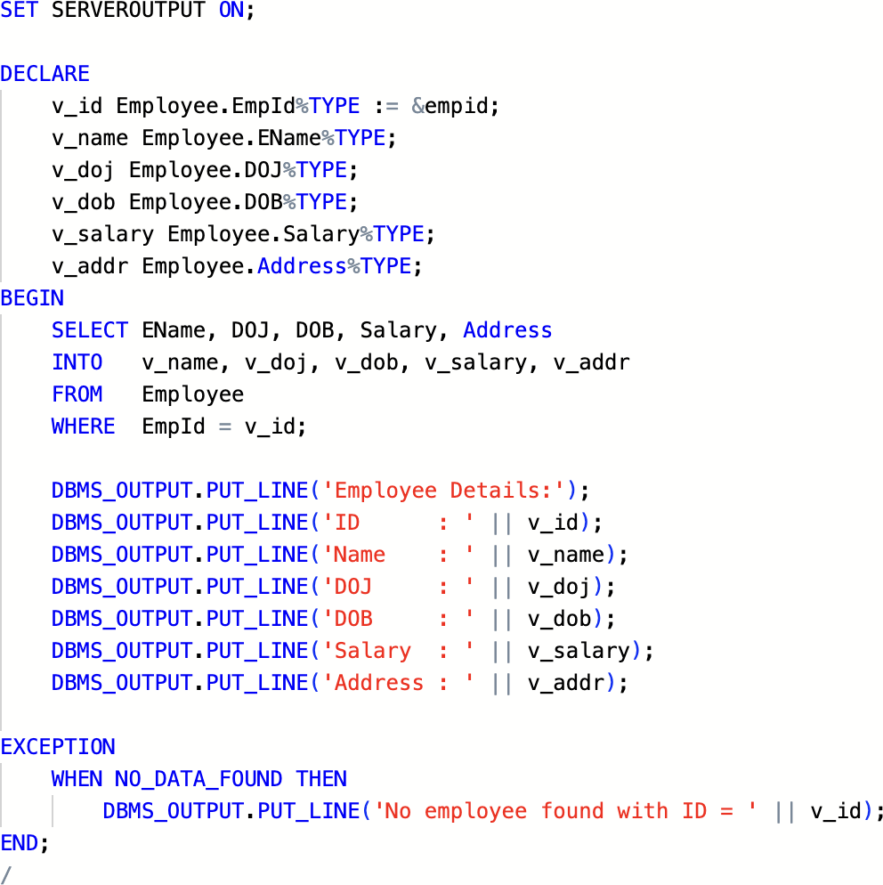
P7 Write a PL/SQL code to accept emp_id from user and display his / her record. Table: Employee (EmpId, EName, DOJ, DOB, Salary, Address)

Substitution Variables
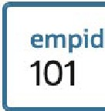

Employee Details:
ID : 101
BIi

Name DOJ DOB

Salary
: Amit Sharma
: 12...JMAY-20,
: 10-APR-95
: 50000,

Address : Delhi

PL/SQL procedure successfully completed.

P8 Write a PL/SQL code that calculates factorial of first five even numbers and stores the same in the given table. Table : Factorial (No, Fact)
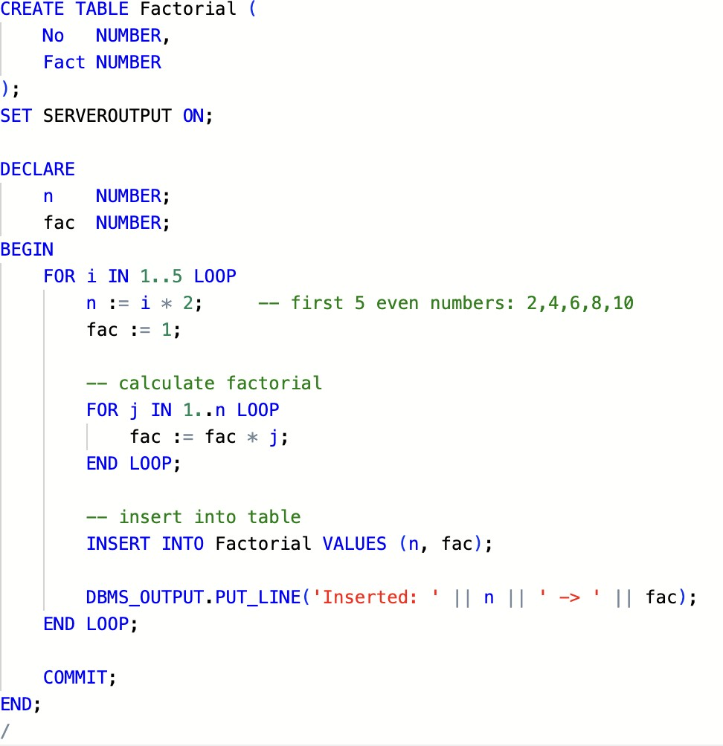

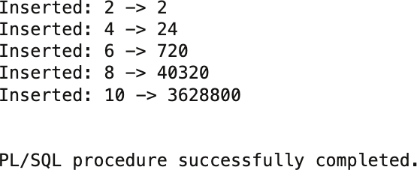

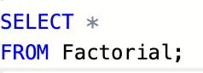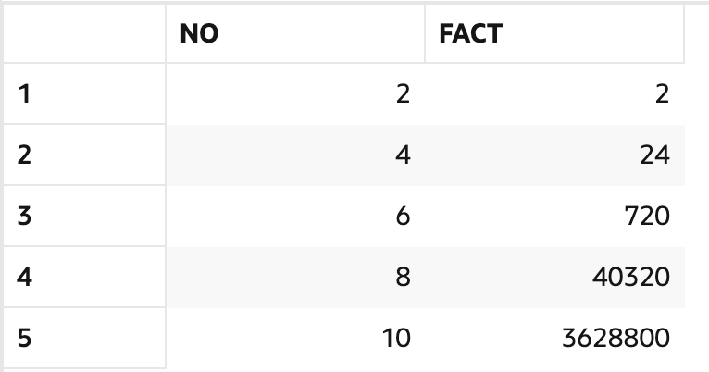

P9 The bank manager of Delhi branch decides to mark the status of all those accounts as ‘Inactive’ on which there are no transactions performed in last 6 months. Whenever any such update takes place the corresponding record is inserted in another table ‘InactiveAccounts’ with the name and account no of the account holder and his balance. Table: Account (AccNo, Name, Address, PANNo, Mobile, Status)
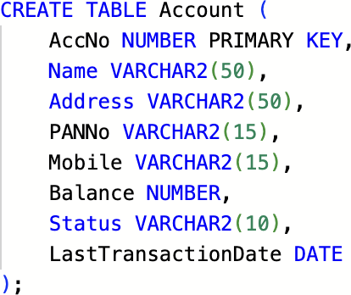

INSERT INTO Account VALUES (101, 'Amit Sharma', 'Delhi', 'ABCDE1234F', '9876543210', 25000, 'Active', DATE '2024-10-10'); INSERT INTO Account VALUES (102, 'Neha Gupta', 'Delhi', 'PQRSX6789L', '9876501020', 50000, 'Active', DATE '2024-05-15'); INSERT INTO Account VALUES ( 103, 'Ravi Singh', 'Mumbai', 'FHGTY5674Q', '9823456789', 30000, 'Active', DATE '2023-12-20'); INSERT INTO Account VALUES (104, 'Kiran Verma', 'Delhi', 'TYUOP0987L', '9988223344', 45000, 'Active', DATE '2024-02-10'); INSERT INTO Account VALUES ( 105, 'Pooja Mehta', 'Kolkata', 'LSHDY4532R', '9988112233', 60000, 'Active', DATE '2024-11-01');

SELECT*
FROM Acc. o. u. nt.I ,

 | ACCNO | NAME | ADDRESS | PANNO | MOBILE | BALANCE | STATUS | LASTTRANSACTIONDATE
 | 101 | Amit Sharma | Delhi | ABCDE1234F | 9876543210 |  | 25000 Active | 10/10/2024, 12:00:00 AM
 | 102 | Neha Gupta | Delhi | POR5X6789L | 9876501020 |  | 50000 Active | 5/15/2024, 12:00:00 AM
 | 103 | Ravi Singh | Mumbai | FHGTY5674Q | 9823456789 |  | 30000 Active | 12/20/2023, 12:00:00 AM
4 | 104 | Kiran Verma | Delhi | TYUOP0987L | 9988223344 |  | 45000 Active | 2/10/2024, 12:00:00AM
 | 105 | Pooja Mehta | Kolkata | L5HDY4532R | 9988112233 |  | 60000 Active | 11/1/2024, 12:00:00AM
CREATE TABLE Ina1ctiveAccounts (
AccNo NUMBER, Name VARCHAR2(50),
Balance NUMBER,
InactiveDate DATE
);

Table INACTIVEACCOUNTS created.

UPDATE Account

SET Staitus

WHERE Address
1Inactive1
1Delhi1

AND
LastTransactionDate < ADD_MONTHS ( SYSDATE., -6);

3 rows updated.

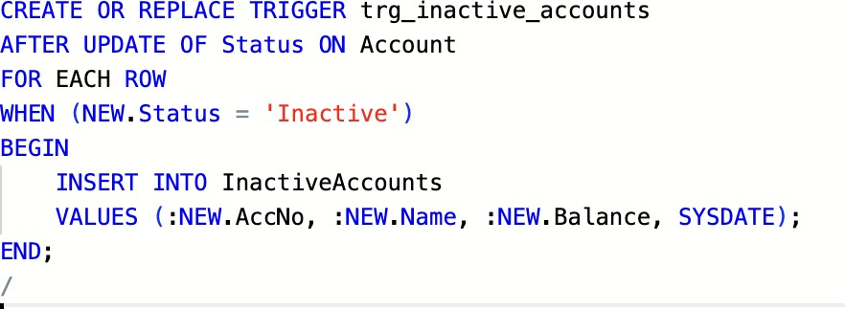

P10 Write a Cursor(PL/SQL code) to display the Employee_name, DateofBirth, and Designation whose basic salary is greater than 15000, if not found then show the proper error message. (Use Exception handing) Table : Employee(EmpId, EName, DOJ, DOB, Salary, Address)
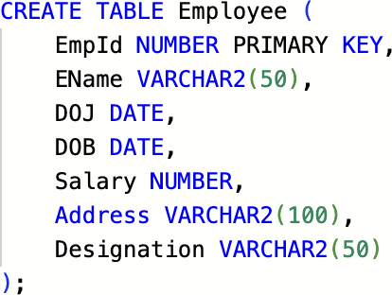
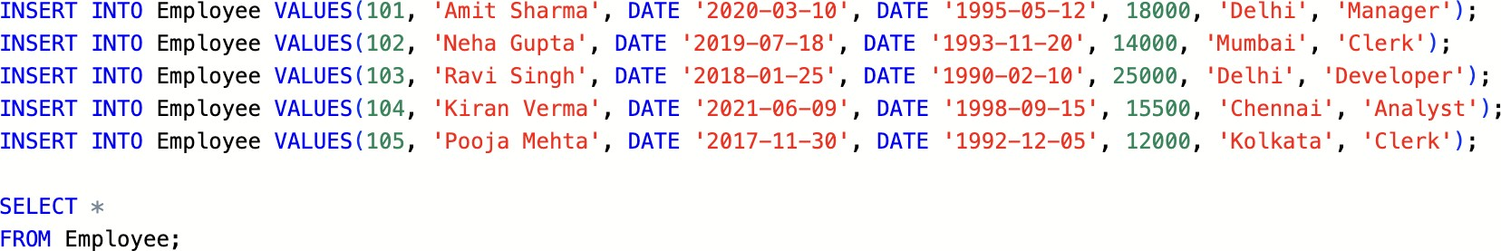

 | EMPID | ENAME | DOJ | DOB | SALARY | ADDRESS | DESIGNATION
 |  | 101 Amit Sharma | 3/10/2020, 12:00:00 AM | 5/12/1995, 12:00:00AM | 18000 | Delhi | Manager
 |  | 102 Neha Gupta | 7/18/2019, 12:00:00AM | 11/20/1993, 12:00:00 AM | 14000 | Mumbai | Clerk
 |  | 103 Ravi Singh | 1/25/2018, 12:00:00 AM | 2/10/1990, 12:00:00AM | 25000 | Delhi | Developer
4 |  | 104 KiranVerma | 6/9/2021, 12:00:00AM | 9/15/1998, 12:00:00AM | 15500 | Chennai | Analyst
 |  | 105 Pooja Mehta | 11/30/2017, 12:00:00AM | 12/5/1992, 12:00:00AM | 12000 | Kolkata | Clerk

DECLARE
-- Cursor for employees with salary> 15000 CURSOR emp_cur IS
SELECT EName, DOB, Address AS Designation FROM Employee
WHERE Salary> 15000;

v_EName Employee.EName%TYPE; v_DOB Employee.DOB%TYPE; v_Desig Employee.Address%TYPE;

no_data EXCEPTION; record_found BOOLEAN .- FALSE;

BEGIN
OPEN emp_cur;
LOOP
FETCH emp_cur INTO v_EName, v_DOB, v_Desig; EXIT WHEN emp_cur%NOTFOUND;
record_found := TRUE; DBMS_OUTPUT.PUT_LINE(
'Name: ' 11 v_EName 11
DOB: ' I I TO_CHAR(v_DOB, 'DD-MON-YYYY') I I
Designation: ' I I v_Desig
) ;
END LOOP;

IF NOT record_found THEN RAISE no_data;
END IF;

CLOSE emp_cur;

EXCEPTION
WHEN no_data THEN
DBMS_OUTPUT.PUT_LINE('No employee has salary greater than 15000.'); WHEN OTHERS THEN
DBMS_OUTPUT.PUT_LINE('Unexpected Error: ' I I SQLERRM);
END;
I

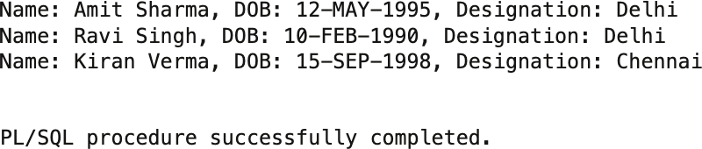

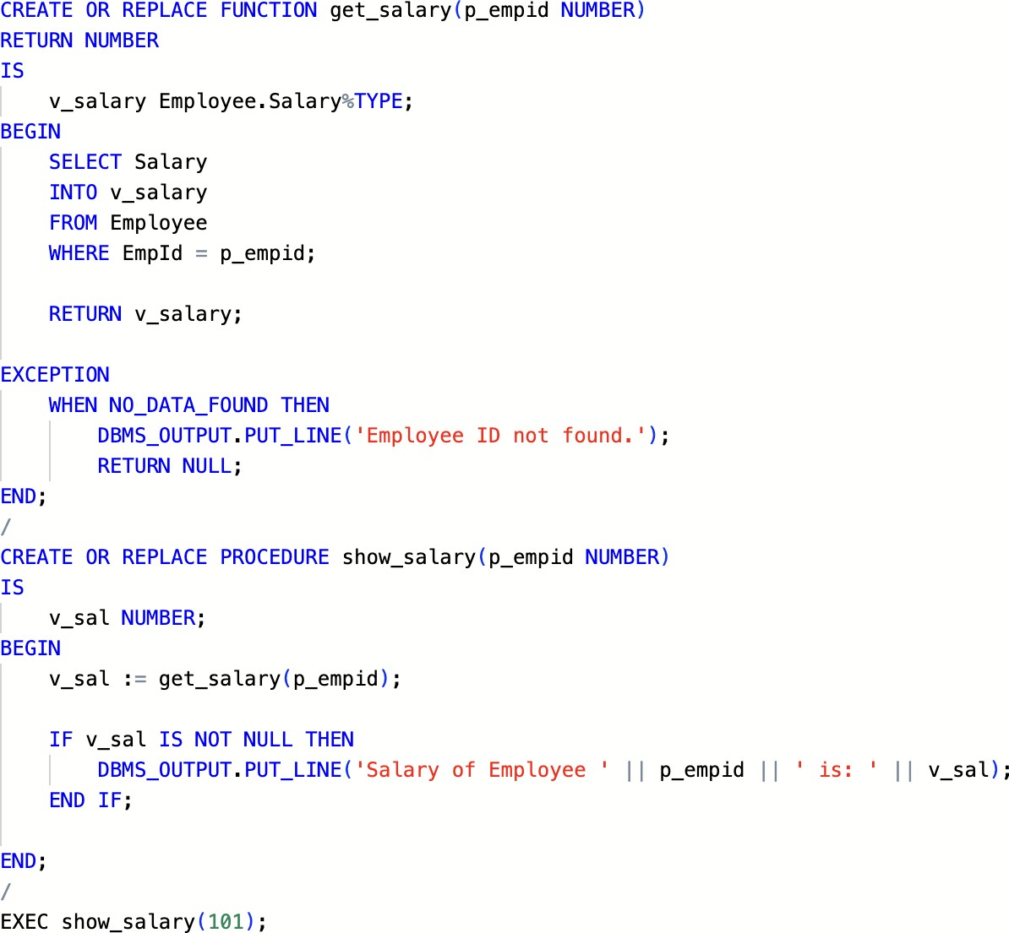
P11 Create a function that accepts emp id from the calling procedure and returns his salary. Table: Employee (EmpId, EName, DOJ, DOB, Salary, Address)

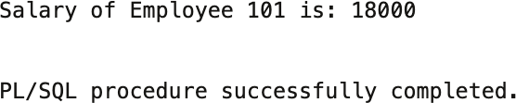

P12 Write a PL/SQL function ODDEVEN to return value TRUE if the number passed to it is EVEN else will return FALSE
