OPERATING SYSTEM WITH LINUX

(MCA-163)

Practical File

Submitted To: Submitted By:
Dr.Sunil Pratap Singh Piyush Goel (09311604425)
(Associate Professor) MCA 1stSem, Sec B

INDEX

S.  No. | ProblemDescription | Date | Sign.
P1 | Install Virtual Box and then configure Linux(Ubantu) in VirtualBox.
P2 | Run and note the PID of your shell.Log out and login again and run ps again. What do you observe?
P3 | Enter the following commands, and note your observations:  whoandtty (ii) tputclear (iii) id (iv) psandecho$$.
P4 | Run the following commands and then invokels.What do you conclude?  echo > README [Enter] echo > readme [Enter]
P5 | Create a directory and change to that directory next create another directory in the new directory and then change to that directory too. Now run $ cd without any arguments followed by pwd. What do you conclude?
P6 | Create a file mca containing the words“Hello MCA Class!”.Now create a directory bvicam, and then run mv mca bvicam. What do you observe when you run both ls and ls bar?
P7 | Run $ who am i and then interpret the output.
P8 | Find out whether the following commands are internal or external: echo, date, pwd, and ls.
P9 | Display the current date in the form dd/mm/yyyy.
P10 | Both of the following commands try to open the file mca but the error messages are a little different. What could be the reason?  $cat mca cat:mca:No such file or directory$cat<mcabash: mca: No such file or directory.
P11 | Run the following commands and discuss their output? (a)$uname (b)$passwd (c)$echo$SHELL (d)$man man  (e) $ which echo (f) $ type echo (g) $ whereisls (h) $ cd  (i) $ cd $HOME (j) $ cd ~
P12 | Framels command to (i) mark directories and executables separately and (ii) also display hidden files.
P13 | Find out the result of following:  $ cat mca
P14 | Run the following and determine which commands will work? Explain with reasons.  (a)$ mkdir a/b/ (b) $ mkdir a a/b (c) $ rmdir a/b/c (d) $ rmdir a a/b  (e) $ mkdir/bin/mca
P15 | How does the command mv mca1,mca2 behave where both mca1 and mca2 are directories, when (i) mca2 exists (ii) mca2 doesn’t exist?
P16 | Assuming that you are positione din the directory/home/bvicam, what are these commands presumed to do, and explain whether they will

work at all: (CO2) (a) $ cd ../.. (b) $ mkdir ../bin (c) $ rmdir .. (d) $
ls..

P17 | Apply Peterson algorithm for solving the critical section problem with C/Java multi-threaded programming. Assume appropriate code snippet for critical section.
P18 | Apply Bakery algorithm for synchronization of processes/threads in a C/Java program.Assume appropriate code snippet for critical section.
P19 | Write C/Java program to simulate and solve the Producer- Consumer problem.
P20 | Implement Semaphore(s)in a C/Java-multithreaded program to simulate the working and solution of Reader-Writer problem.Assume multiple reader sand writers.
P21 | Create a zombie process and an orphan processing C program with appropriate system calls.
P22 | Write a C program which creates an ew process and allows both, child and parent, to report their identification numbers (ids). The parent process should wait for the termination of  The child process.
P23 | Write two „C‟ programs (A.c and B.c) where one program (A.c) creates a child process and then that child process executes the code of other program(B.c).The logic of program  „B.c‟is to generate all the prime numbers within the specified limit.
P24 | Write an appropriate C program which implements the concept of dynamic memory allocation (use of malloc(), calloc(), realloc(), and free() system call).
P25 | Create a text file, named as „courses.txt‟ that contains the following four lines: Java Programming Operating System Structure Write a C program that forks three other processes. After forking, the parent process goes into wait state and waits for the children to finish their execution each child process reads a line from the course txt file (Child 1 Reads Line 1, Child 2 Reads Line 2, and Child 3 Reads Line  3)and each prints the respective line the lines can be printed in any order.
P26 | Write a C‟ program (using appropriate system calls of Linux) that generate and integers and stores the min a text file named a All txt then retrieve the stored integers from this file and copy to “Odd.txt” and Even.txt‟ based upon the type of number,  i.e if the retrieved integer if odd number then store in„Odd.txt‟ file or if the retrieved integer is even then store in „Even.txt‟ file. Finally, display the contents of all three files on the screen.

P27 | Write a program in „C‟ which accepts the file or directory name and permission (access rights) from the user and then changes the access rights accordingly.Use appropriate system call(s) of Linux.

P28 | Write a C program(using appropriate system calls of Linux) which generates and stores the characters from a‟ to „z‟.  Then display the stored characters in alternative manner like: a, c, e, g,…, etc.
P29 | Write a C program(using appropriate system calls of Linux) which receives roll number and names of n students, from the user one-by-one and then stores them in a text file, named as Student txt after inserting all and roll number sand names, display the contents of file. Also, display the access rights of the file Student.txt.
P30 | Demonstrate the use of following system calls by writing an appropriate „C‟ program.  (a)lseek()(b)chmod()(c)umask()(d)access()(e)utime()

P1.Install Virtual Box and then configure Linux(Ubantu) in VirtualBox
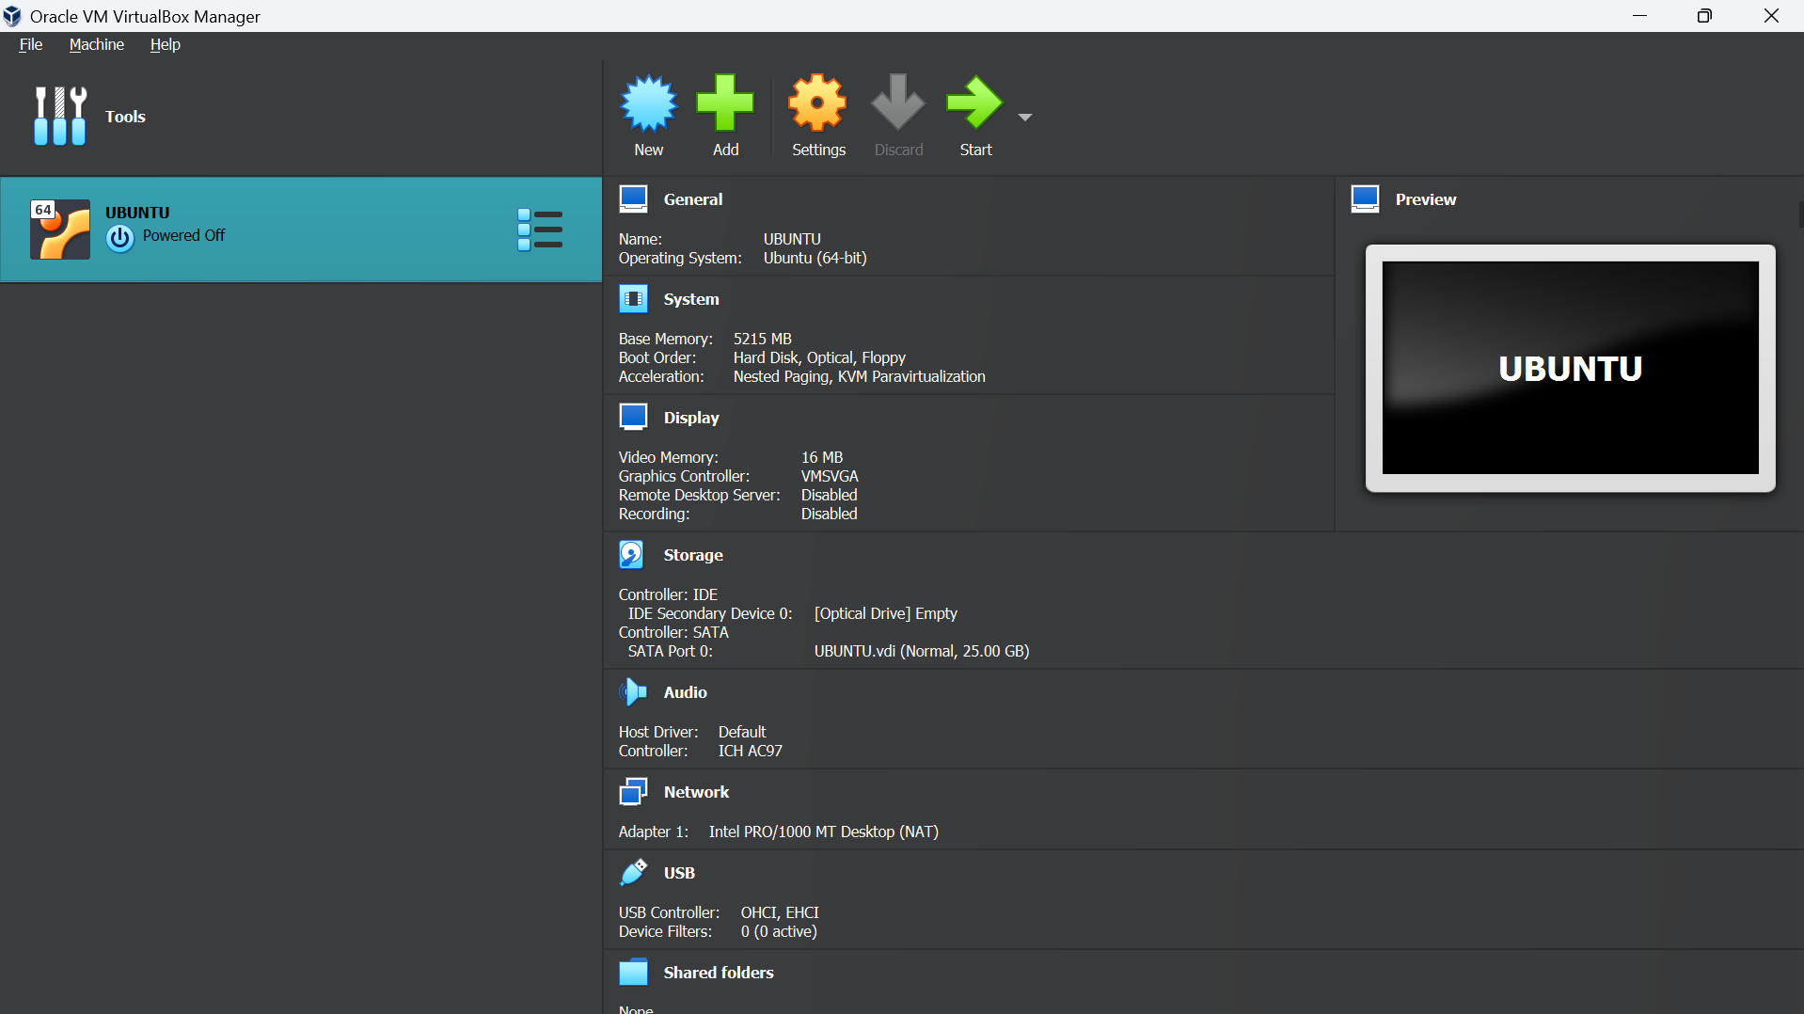
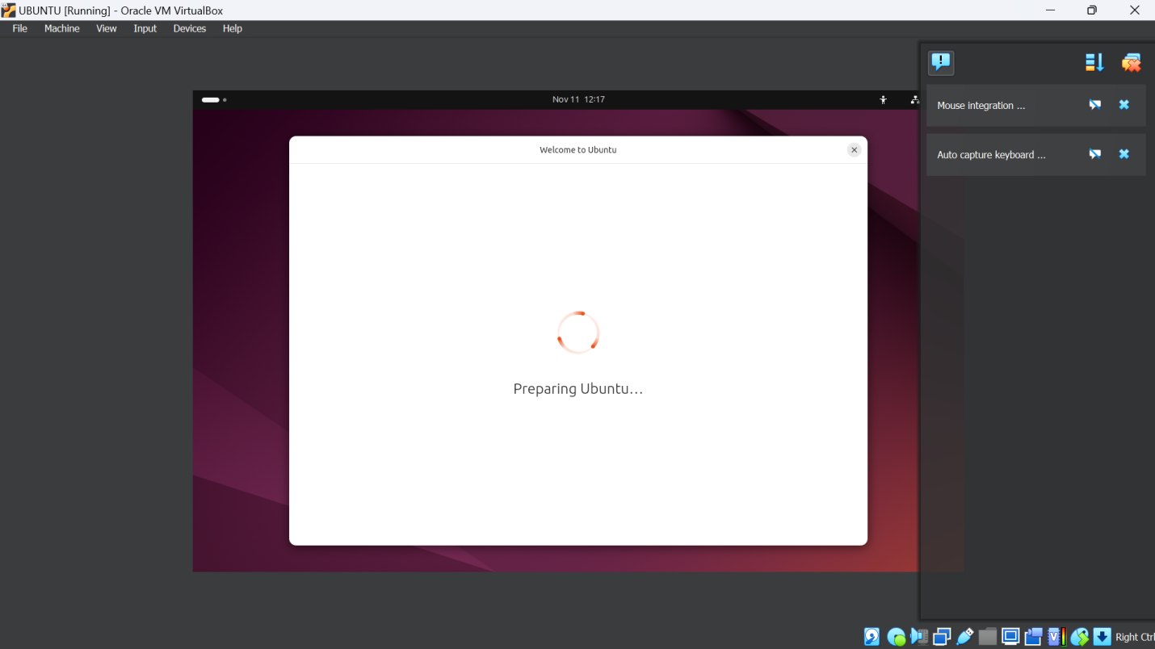



P2.Run and note the PID of your shell.Log out and login again and run ps again. What do you observe?

Ps
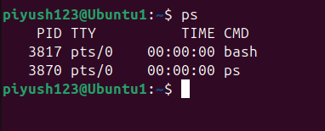

P3.Enter the following commands, and note your observations:
whoandtty (ii) tputclear (iii) id (iv) psandecho$$.

Ans)
Who (Shows a list of users currently logged into the system.)
tty (Displays the terminal (teletype) device filename that is connected to the user's session.)

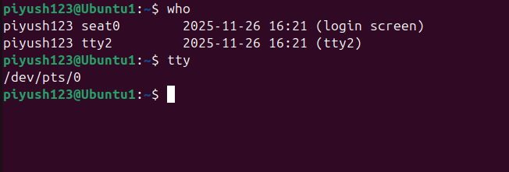

tput clear (Clears the terminal screen)
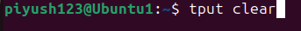

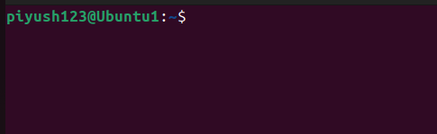

id (Prints user and group information for the current user, including user ID (UID), group ID (GID), and other groups.)

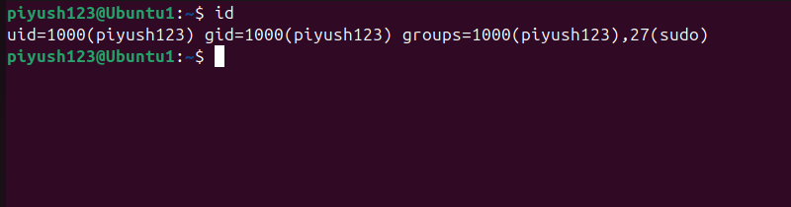

ps (Lists active processes associated with the current terminal session.)
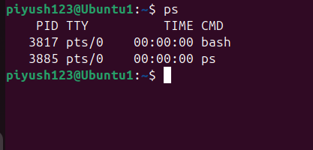

echo $$ (Displays the process ID (PID) of the current shell.)
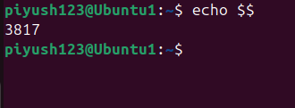

P4.Run the following commands and then invokels.What do you conclude?
echo > README [Enter] echo > readme [Enter]

echo > README
echo > readme
ls
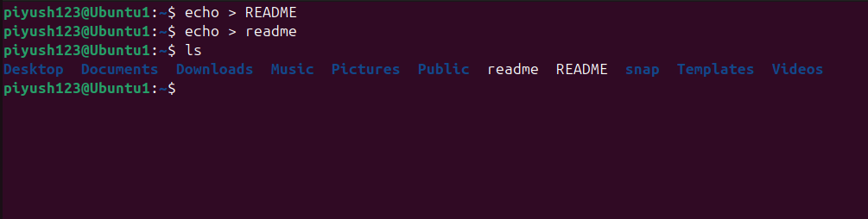

P5.Create a directory and change to that directory next create another directory in the new directory and then change to that directory too. Now run $ cd without any arguments followed by pwd. What do you conclude?

mkdir mydir
cd mydir
mkdir innerdir
cd innerdir
pwd
cd

cd (with no arguments): Changes the directory to the user's home directory.

pwd: Displays the current working directory's full path.

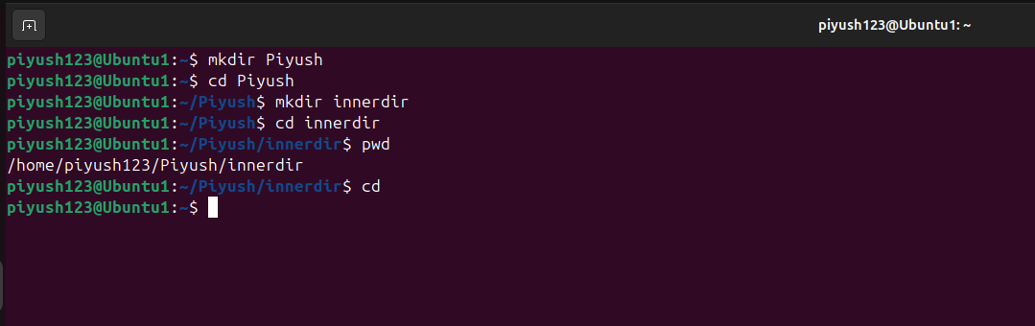

P6.Create a file mca containing the words“Hello MCA Class!”.Now create a directory bvicam, and then run mv mca bvicam. What do you observe when you run both ls and ls bar?

echo "Hello MCA Class!" > mca
mkdir bvicam
mv mca bvicam
ls
ls bvicam

The mv command in Linux is used to move or rename files and directories.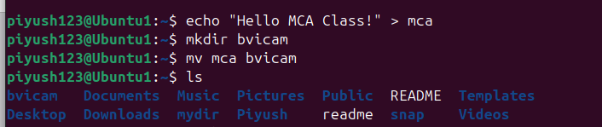

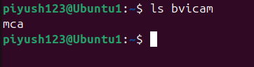

P7.Run $ who am i and then interpret the output.

whoami

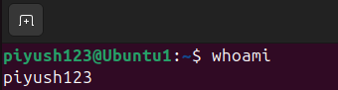

P8.Find out whether the following commands are internal or external: echo, date, pwd, and ls.

type echo
type date
type pwd
type ls

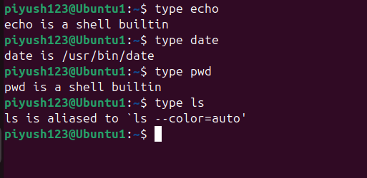

P9.Display the current date in the form dd/mm/yyyy.
date +"%d/%m/%Y"
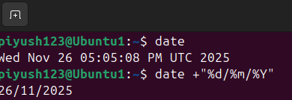

P10.Both of the following commands try to open the file mca but the error messages are a little different. What could be the reason?
$cat mca cat:mca:No such file or directory$cat<mcabash: mca: No such file or directory.

cat mca
cat < mca
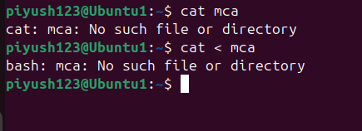

the difference is:
- cat mca: Tries to open and read the file mca directly; it shows "No such file or directory" if mca doesn’t exist.
- cat < mca: Redirects input from mca, but since the shell handles the redirection, it outputs "bash: mca: No such file or directory" if mca doesn’t exist.
The main difference is in where the error message originates—cat vs. the shell.
P11.Run the following commands and discuss their output? (a)$uname (b)$passwd (c)$echo$SHELL (d)$man man
(e) $ which echo (f) $ type echo (g) $ whereisls (h) $ cd
(i) $ cd $HOME (j) $ cd ~
uname
passwd
echo $SHELL
man man
which echo
type echo
whereis ls
cd
cd $HOME
cd ~

brief explanation of each command used in P11:
- uname: Shows system information (e.g., operating system name). Use uname -a for full details.
- passwd: Changes the user’s password. Prompts for the old and new password.
- echo $SHELL: Displays the path of the current shell in use (e.g., /bin/bash).
- man man: Opens the manual page for the man command itself, explaining how to use the manual.
- which echo: Shows the path to the echo command executable, indicating whether it’s built-in or an external command.
- type echo: Displays whether echo is a shell built-in or an external command, with details.
- whereis ls: Locates the binary, source, and manual files for ls.
- cd: Changes to the user's home directory when no path is specified.
- cd $HOME: Changes the directory to the user’s home directory explicitly.
- cd ~: Also changes to the user’s home directory (~ is a shortcut for the home directory).
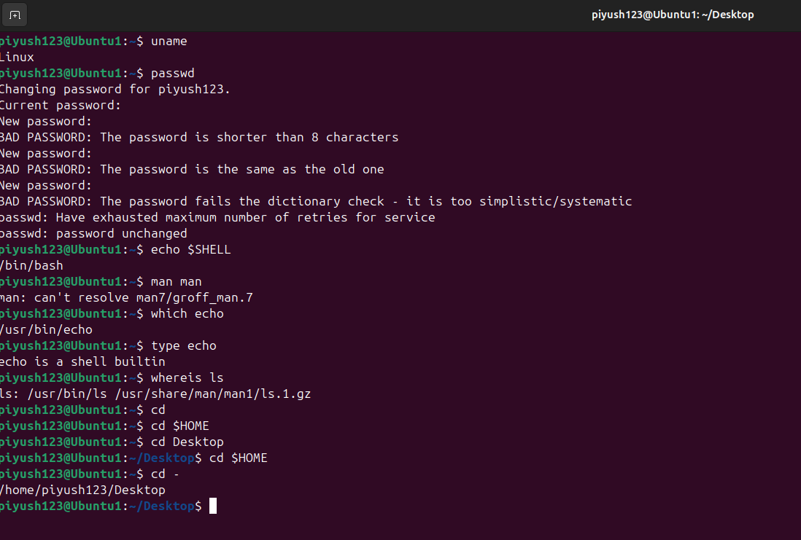
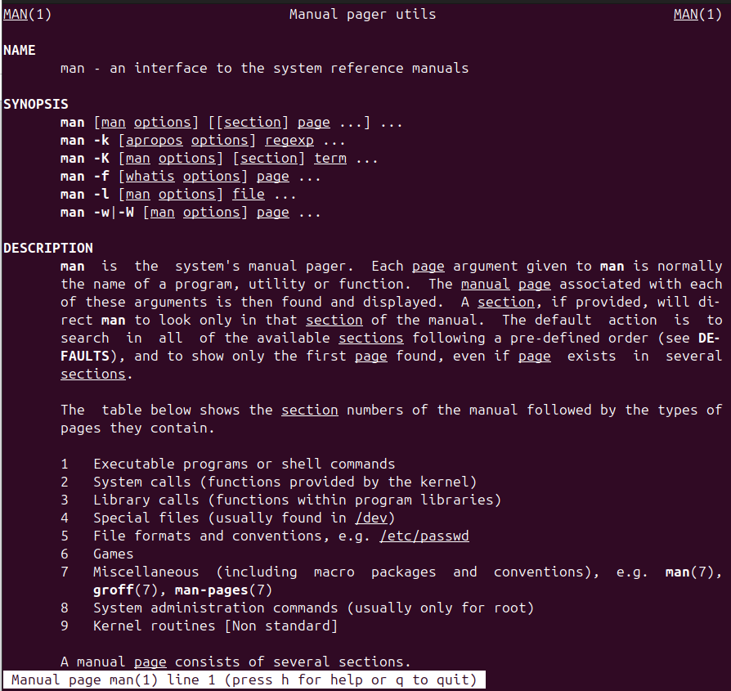

P12.Framels command to (i) mark directories and executables separately and (ii) also display hidden files.
ls -F
ls –a
ls –af

• ls -F: Marks directories (/) and executables (*).
• ls -a: Shows all files, including hidden ones.
• ls -aF: Combines both to show hidden files with type indicators.
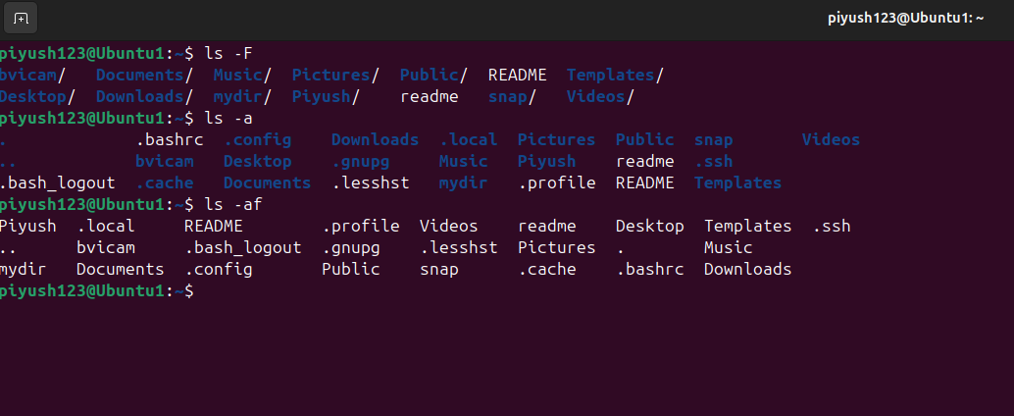

P13.Find out the result of following:
$ cat mca

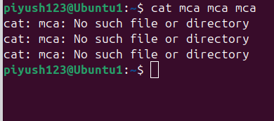

P14.Run the following and determine which commands will work? Explain with reasons.
(a)$ mkdir a/b/ (b) $ mkdir a a/b (c) $ rmdir a/b/c (d) $ rmdir a a/b
(e) $ mkdir/bin/mca

mkdir -p a/b
mkdir a a/b
rmdir a/b/c
rmdir a a/b
mkdir /bin/mca # (This will fail due to permissions)
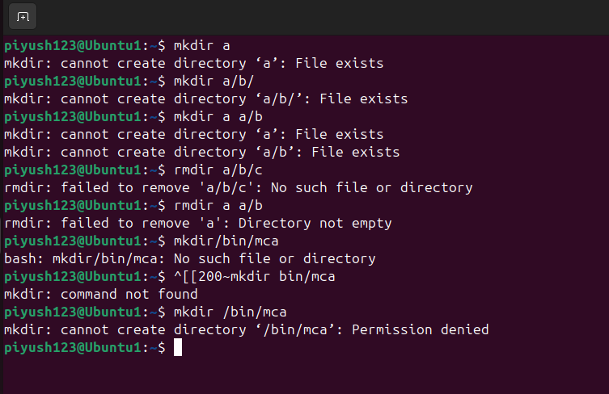
(a) $ mkdir a/b/
Outcome: This command will fail if the directory a does not already exist.
Reason: The mkdir command will only create the specified directory structure if the parent
directories exist. To create a/b/ in one command without errors, you should use mkdir -p a/b/
to ensure that any necessary parent directories are created.
(b) $ mkdir a a/b
Outcome: This command will work.
Reason: The command first creates the directory a and then a/b inside a. If a already exists,
the command will still proceed without error and create a/b inside it.
(c) $ rmdir a/b/c
Outcome: This command will fail if c does not exist or if c is not empty.
Reason: The rmdir command only removes empty directories. If a/b/c is not an existing
empty directory, this command will not work.
(d) $ rmdir a a/b
Outcome: This command will fail if either a or a/b is not empty.
Reason: The rmdir command can remove multiple directories in one command but only if
they are all empty. If a or a/b contains any files or subdirectories, the command will not work.
(e) $ mkdir /bin/mca
Outcome: This command will fail for most users.
Reason: The /bin directory is part of the system’s essential directories, and normal users do
not have write permissions to create directories within it. To run this command successfully,
superuser privileges (using sudo) are required: sudo mkdir /bin/mca. However, it is not
recommended to create user directories within /bin as it is reserved for essential system
binaries.

P15.How does the command mv mca1,mca2 behave where both mca1 and mca2 are directories, when (i) mca2 exists (ii) mca2 doesn’t exist?
mv mca1 mca2

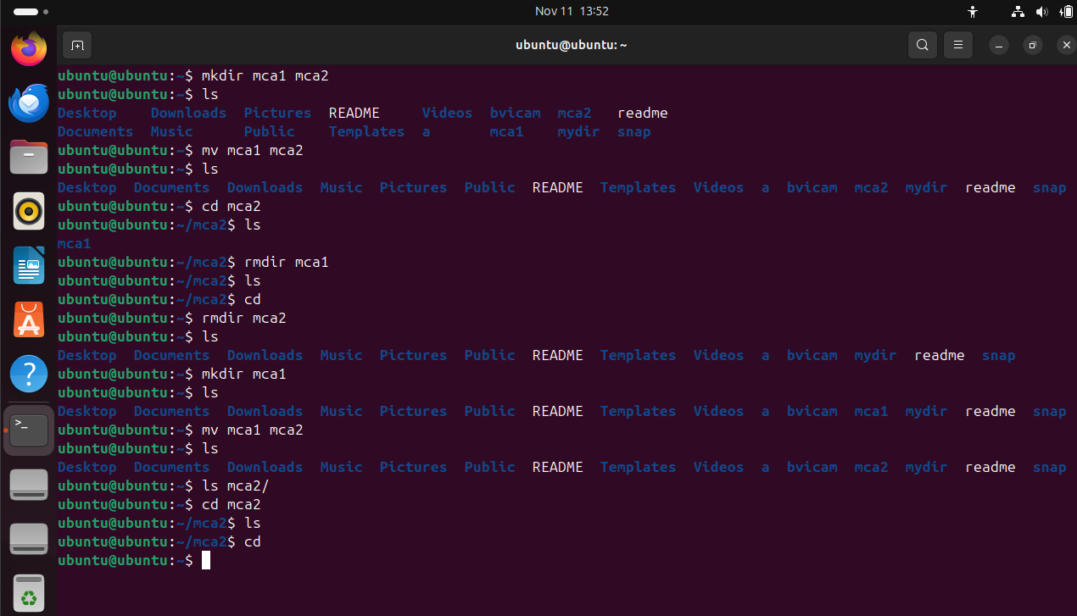

(i) mca2 exists
Outcome: The command mv mca1 mca2 will move the directory mca1 into mca2 as a
subdirectory.
Explanation: When mca2 already exists and is a directory, the mv command will move mca1
(along with its contents) inside mca2, resulting in mca2/mca1.
(ii) mca2 doesn’t exist
Outcome: The command mv mca1 mca2 will rename the directory mca1 to mca2.
Explanation: If mca2 does not exist, mv simply renames mca1 to mca2. The original
directory mca1 will no longer exist, and mca2 will take its place with all the contents intact.

P16.
- cd ../..: Moves up two directories from the current directory.
- mkdir ../bin: Attempts to create a bin directory one level up from the current directory.
- rmdir ..: Tries to remove the parent directory, which will fail because you can’t remove a directory while inside it.
- ls ..: Lists the contents of the parent directory.

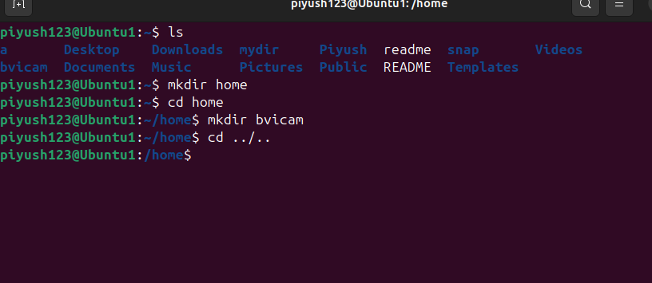

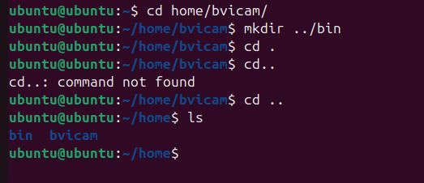

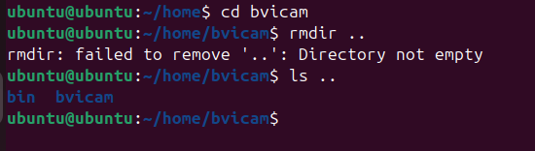

P17.Apply Peterson algorithm for solving the critical section problem with C/Java multi-threaded programming. Assume appropriate code snippet for critical section

#include <pthread.h>
#include <stdio.h>
#include <stdbool.h>

bool flag[2] = {false, false};
int turn = 0;
int shared_var = 0;

void *process0() {
flag[0] = true;
turn = 1;
while (flag[1] && turn == 1);
// Critical section
shared_var++;
printf("Process 0 in critical section: shared_var = %d\n", shared_var);
flag[0] = false;
return NULL;
}

void *process1() {
flag[1] = true;
turn = 0;
while (flag[0] && turn == 0);
// Critical section
shared_var++;
printf("Process 1 in critical section: shared_var = %d\n", shared_var);
flag[1] = false;
return NULL;
}

int main() {
pthread_t t1, t2;
pthread_create(&t1, NULL, process0, NULL);
pthread_create(&t2, NULL, process1, NULL);
pthread_join(t1, NULL);
pthread_join(t2, NULL);
printf("Final value of shared_var = %d\n", shared_var);
return 0;
}
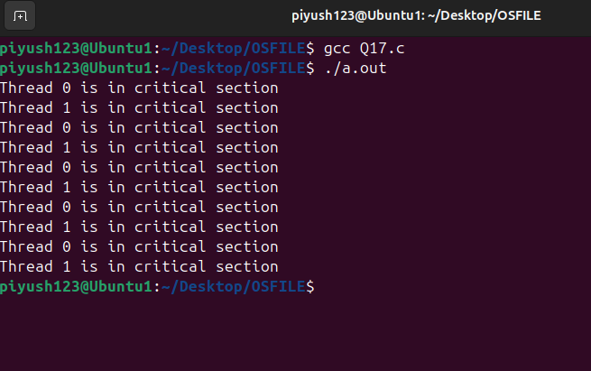

P18.Apply Bakery algorithm for synchronization of processes/threads in a C/Java program.Assume appropriate code snippet for critical section.

#include <pthread.h>
#include <stdio.h>
#include <stdbool.h>
#include <unistd.h>

#define N 2
bool choosing[N] = {false, false};
int ticket[N] = {0, 0};
int shared_var = 0;

int max_ticket() {
int max = 0;
for (int i = 0; i < N; i++) {
if (ticket[i] > max) max = ticket[i];
}
return max;
}

void lock(int i) {
choosing[i] = true;
ticket[i] = max_ticket() + 1;
choosing[i] = false;
for (int j = 0; j < N; j++) {
while (choosing[j]);
while (ticket[j] != 0 && (ticket[j] < ticket[i] || (ticket[j] == ticket[i] && j < i)));
}
}

void unlock(int i) {
ticket[i] = 0;
}

void *process(void *arg) {
int id = *((int *)arg);
lock(id);
// Critical section
shared_var++;
printf("Process %d in critical section: shared_var = %d\n", id, shared_var);
unlock(id);
return NULL;
}

int main() {
pthread_t t1, t2;
int id0 = 0, id1 = 1;
pthread_create(&t1, NULL, process, &id0);
pthread_create(&t2, NULL, process, &id1);
pthread_join(t1, NULL);
pthread_join(t2, NULL);
printf("Final value of shared_var = %d\n", shared_var);
return 0;
}

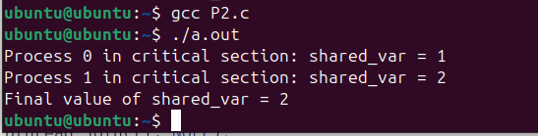

P19.Write C/Java program to simulate and solve the Producer- Consumer problem.

#include <pthread.h>
#include <semaphore.h>
#include <stdio.h>
#include <unistd.h>

#define BUFFER_SIZE 5
int buffer[BUFFER_SIZE];
int in = 0, out = 0;

sem_t empty, full;
pthread_mutex_t mutex;

void *producer(void *arg) {
for (int i = 0; i < 10; i++) {
sem_wait(&empty);
pthread_mutex_lock(&mutex);
buffer[in] = i;
printf("Produced: %d\n", i);
in = (in + 1) % BUFFER_SIZE;
pthread_mutex_unlock(&mutex);
sem_post(&full);
sleep(1);
}
return NULL;
}

void *consumer(void *arg) {
for (int i = 0; i < 10; i++) {
sem_wait(&full);
pthread_mutex_lock(&mutex);
int item = buffer[out];
printf("Consumed: %d\n", item);
out = (out + 1) % BUFFER_SIZE;
pthread_mutex_unlock(&mutex);
sem_post(&empty);
sleep(1);
}
return NULL;
}

int main() {
pthread_t prod, cons;
sem_init(&empty, 0, BUFFER_SIZE);
sem_init(&full, 0, 0);
pthread_mutex_init(&mutex, NULL);
pthread_create(&prod, NULL, producer, NULL);
pthread_create(&cons, NULL, consumer, NULL);
pthread_join(prod, NULL);
pthread_join(cons, NULL);
pthread_mutex_destroy(&mutex);
sem_destroy(&empty);
sem_destroy(&full);
return 0;
}

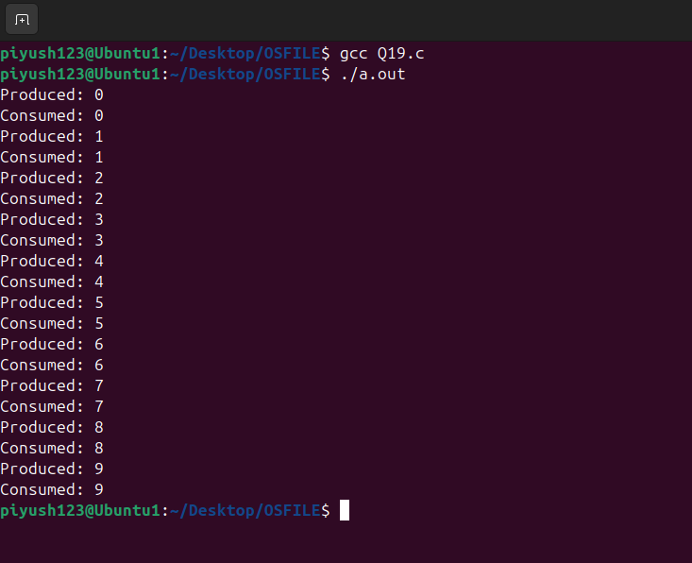

P20.Implement Semaphore(s)in a C/Java-multithreaded program to simulate the working and solution of Reader-Writer problem.Assume multiple reader sand writers.

#include <pthread.h>
#include <semaphore.h>
#include <stdio.h>
#include <unistd.h>

sem_t mutex, db;
int reader_count = 0;

void *writer(void *arg) {
sem_wait(&db);
printf("Writer is writing\n");
sem_post(&db);
return NULL;
}

void *reader(void *arg) {
sem_wait(&mutex);
reader_count++;
if (reader_count == 1) sem_wait(&db);
sem_post(&mutex);

printf("Reader is reading\n");

sem_wait(&mutex);
reader_count--;
if (reader_count == 0) sem_post(&db);
sem_post(&mutex);
return NULL;
}

int main() {
pthread_t r1, r2, w1;
sem_init(&mutex, 0, 1);
sem_init(&db, 0, 1);
pthread_create(&r1, NULL, reader, NULL);
pthread_create(&r2, NULL, reader, NULL);
pthread_create(&w1, NULL, writer, NULL);
pthread_join(r1, NULL);
pthread_join(r2, NULL);
pthread_join(w1, NULL);
sem_destroy(&mutex);
sem_destroy(&db);
return 0;
}

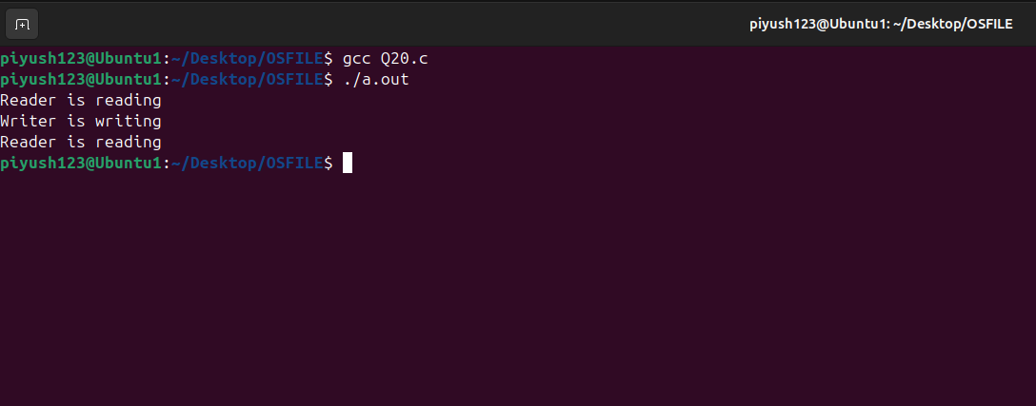

P21.Create a zombie process and an orphan processing C program with appropriate system calls.

#include <stdio.h>
#include <stdlib.h>
#include <unistd.h>

void create_zombie() {
if (fork() == 0) {
printf("Child process with PID: %d\n", getpid());
exit(0); // child exits, becoming a zombie until parent reaps it
} else {
sleep(5); // allow the child to become a zombie
printf("Parent process reaping zombie\n");
}
}

void create_orphan() {
if (fork() == 0) {
printf("Child (orphan) process with PID: %d\n", getpid());
sleep(10); // orphaned when parent exits
} else {
printf("Parent process exiting, leaving child orphan\n");
exit(0);
}
}

int main() {
create_zombie();
create_orphan();
return 0;
}

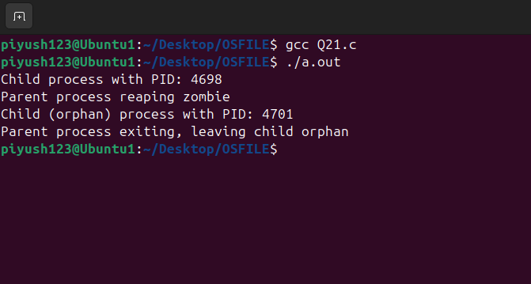

P22.Write a C program which creates an ew process and allows both, child and parent, to report their identification numbers (ids). The parent process should wait for the termination of
The child process.

#include <stdio.h>
#include <unistd.h>
#include <sys/wait.h>

int main() {
pid_t pid = fork();
if (pid > 0) {
wait(NULL); // Parent waits for child
printf("Parent PID: %d\n", getpid());
} else if (pid == 0) {
printf("Child PID: %d\n", getpid());
}
return 0;
}
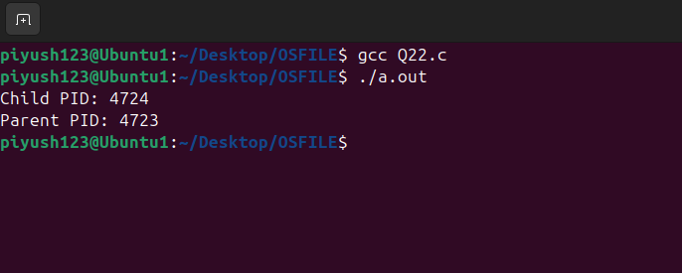

P23.Write two „C‟ programs (A.c and B.c) where one program (A.c) creates a child process and then that child process executes the code of other program(B.c).The logic of program
„B.c‟is to generate all the prime numbers within the specified limit.

A.c

#include <stdio.h>
#include <unistd.h>

int main() {
if (fork() == 0) {
execl("./B", "./B", NULL); // Execute B program
}
return 0;
}

B.c

#include <stdio.h>
#include <stdlib.h>

void generate_primes(int limit) {
for (int i = 2; i <= limit; i++) {
int is_prime = 1;
for (int j = 2; j * j <= i; j++) {
if (i % j == 0) {
is_prime = 0;
break;
}
}
if (is_prime) {
printf("%d ", i);
}
}
printf("\n");
}

int main() {
int limit = 50;
printf("Prime numbers up to %d: ", limit);
generate_primes(limit);
return 0;
}

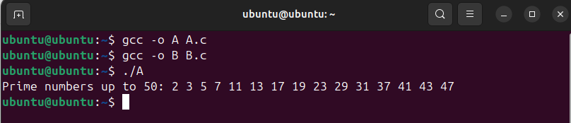

P24.Write an appropriate C program which implements the concept of dynamic memory allocation (use of malloc(), calloc(), realloc(), and free() system call).

#include <stdio.h>
#include <stdlib.h>

int main() {
int *arr = (int*) malloc(5 * sizeof(int));
for (int i = 0; i < 5; i++) arr[i] = i * i;

arr = realloc(arr, 10 * sizeof(int));
for (int i = 5; i < 10; i++) arr[i] = i * i;

for (int i = 0; i < 10; i++) printf("%d ", arr[i]);
free(arr);
return 0;
}
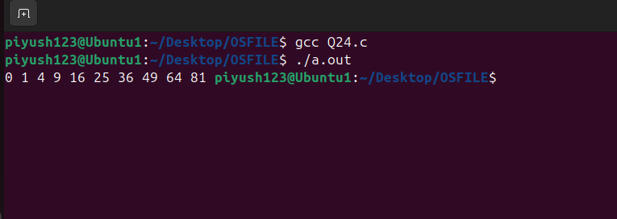

P25.Create a text file, named as „courses.txt‟ that contains the following four lines: Java Programming Operating System Structure Write a C program that forks three other processes. After forking, the parent process goes into wait state and waits for the children to finish their execution each child process reads a line from the course txt file (Child 1 Reads Line 1, Child 2 Reads Line 2, and Child 3 Reads Line
3)and each prints the respective line the lines can be printed in any order.

#include <stdio.h>
#include <unistd.h>
#include <stdlib.h>
#include <sys/wait.h>

int main() {
FILE *file = fopen("courses.txt", "r");
if (!file) {
perror("Error opening file");
return 1;
}

char line[100];

// Fork 3 child processes
for (int i = 0; i < 3; i++) {
if (fork() == 0) { // In child process
// Each child reads the corresponding line from the file
for (int j = 0; j <= i; j++) {
fgets(line, sizeof(line), file); // Read one line at a time
}
printf("Child %d read: %s", i + 1, line); // Print the line read by the child
fclose(file); // Close file in child process
exit(0); // Exit child process
}
}

// Parent waits for all children to finish
fclose(file); // Close the file in the parent process
for (int i = 0; i < 3; i++) {
wait(NULL); // Wait for any child to finish
}

return 0;
}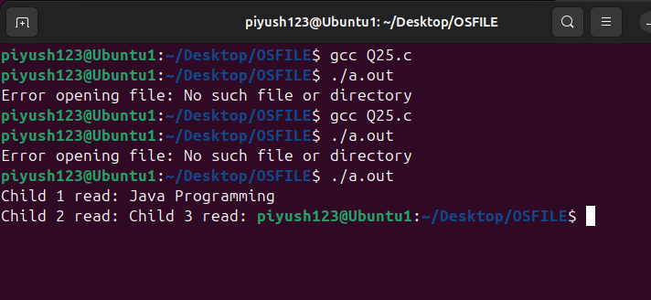

P26.Write a C‟ program (using appropriate system calls of Linux) that generate and integers and stores the min a text file named a All txt then retrieve the stored integers from this file and copy to “Odd.txt” and Even.txt‟ based upon the type of number,
i.e if the retrieved integer if odd number then store in„Odd.txt‟ file or if the retrieved integer is even then store in „Even.txt‟ file. Finally, display the contents of all three files on the screen

#include <stdio.h>
#include <stdlib.h>

int main() {
FILE *all = fopen("All.txt", "w");
for (int i = 1; i <= 10; i++) fprintf(all, "%d\n", i);
fclose(all);

FILE *odd = fopen("Odd.txt", "w"), *even = fopen("Even.txt", "w");
all = fopen("All.txt", "r");

int num;
while (fscanf(all, "%d", &num) != EOF) {
if (num % 2 == 0) fprintf(even, "%d\n", num);
else fprintf(odd, "%d\n", num);
}
fclose(all);
fclose(odd);
fclose(even);
return 0;
}
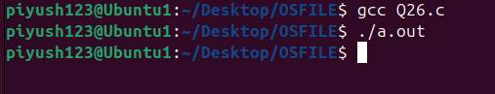
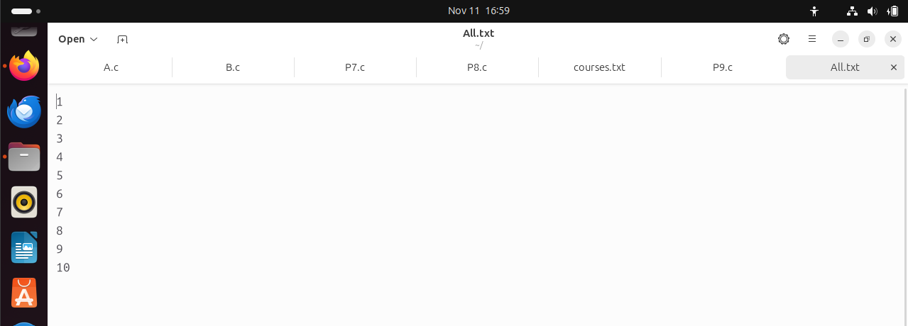

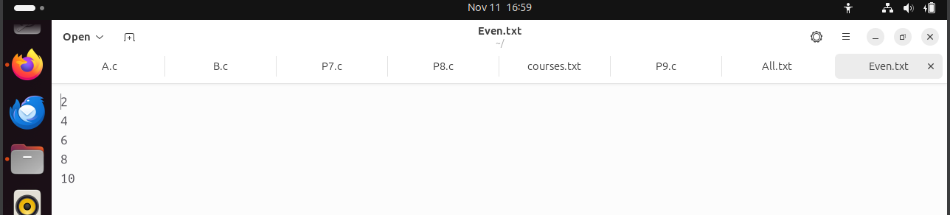

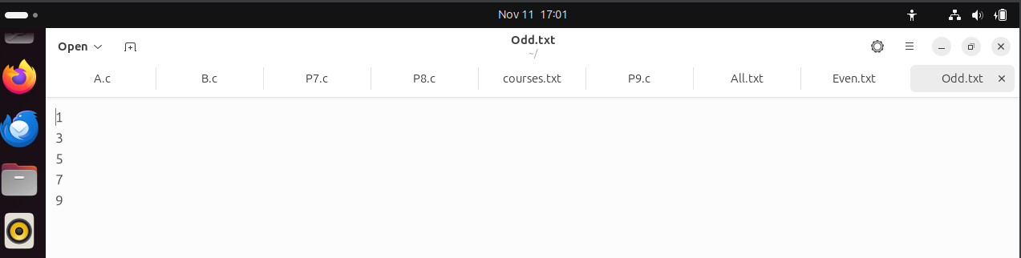

P27.Write a program in „C‟ which accepts the file or directory name and permission (access rights) from the user and then changes the access rights accordingly.Use appropriate system call(s) of Linux.

#include <stdio.h>
#include <sys/stat.h>

int main() {
char filename[256];
int permissions;

// Get file/directory name and new permissions
printf("Enter file or directory name: ");
scanf("%s", filename);
printf("Enter permissions (e.g., 755): ");
scanf("%o", &permissions);

// Change permissions
if (chmod(filename, permissions) == 0) {
printf("Permissions changed successfully.\n");
} else {
perror("Error");
}

return 0;
}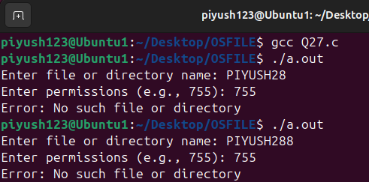

P28.Write a C program(using appropriate system calls of Linux) which generates and stores the characters from a‟ to „z‟.
Then display the stored characters in alternative manner like: a, c, e, g,…, etc.

#include <stdio.h>
#include <unistd.h>
#include <fcntl.h>

int main() {
FILE *file = fopen("alphabet.txt", "w");
for (char c = 'a'; c <= 'z'; c++) fputc(c, file);
fclose(file);

file = fopen("alphabet.txt", "r");
for (int i = 0; i <= 25; i += 2) {
fseek(file, i, SEEK_SET);
printf("%c ", fgetc(file));
}
fclose(file);
return 0;
}
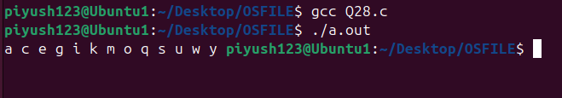

P29.Write a C program(using appropriate system calls of Linux) which receives roll number and names of n students, from the user one-by-one and then stores them in a text file, named as Student txt after inserting all and roll number sand names, display the contents of file. Also, display the access rights of the file Student.txt.

#include <stdio.h>
#include <sys/stat.h>

int main() {
FILE *file = fopen("Student.txt", "w");
int n;
printf("Enter number of students: ");
scanf("%d", &n);
for (int i = 0; i < n; i++) {
int roll;
char name[20];
printf("Enter roll and name: ");
scanf("%d %s", &roll, name);
fprintf(file, "%d %s\n", roll, name);
}
fclose(file);

struct stat st;
stat("Student.txt", &st);
printf("File permissions: %o\n", st.st_mode & 0777);
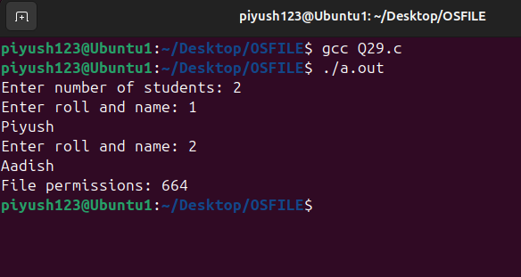
return 0;
}

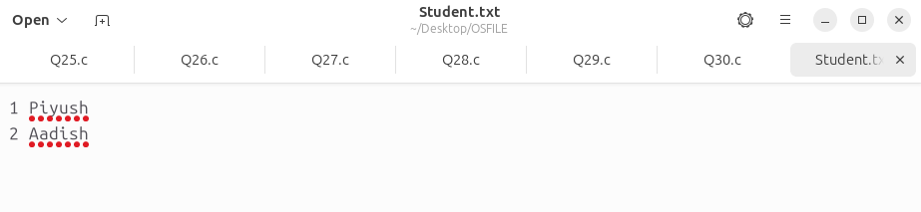
P30.Demonstrate the use of following system calls by writing an appropriate „C‟ program.
(a)lseek()(b)chmod()(c)umask()(d)access()(e)utime()

#include <stdio.h>
#include <fcntl.h>
#include <unistd.h>
#include <sys/types.h>
#include <sys/stat.h>
#include <sys/time.h>
#include <stdlib.h>
#include <time.h> // Include time.h for time() function
#include <utime.h> // Include utime.h for utime() and utimbuf struct

int main() {
// 1. Demonstrating lseek()
int fd = open("testfile.txt", O_RDWR | O_CREAT, S_IRUSR | S_IWUSR);
if (fd == -1) {
perror("Error opening file");
return 1;
}

// Seek to the 10th byte
off_t offset = lseek(fd, 10, SEEK_SET);
if (offset == -1) {
perror("Error seeking in file");
close(fd);
return 1;
}
printf("lseek() set the file offset to: %ld\n", (long) offset);

// Write something at the new offset
write(fd, "Hello, World!", 13);

// 2. Demonstrating chmod()
if (chmod("testfile.txt", S_IRUSR | S_IWUSR | S_IRGRP) == -1) {
perror("Error changing file permissions");
close(fd);
return 1;
}
printf("chmod() has changed file permissions.\n");

// 3. Demonstrating umask()
umask(S_IWGRP); // This will restrict group write permissions by default
printf("umask() has set the file mode creation mask.\n");

// 4. Demonstrating access()
if (access("testfile.txt", R_OK) == 0) {
printf("access() confirms that file is readable.\n");
} else {
perror("access() failed");
}

// 5. Demonstrating utime()
struct utimbuf new_times;
new_times.actime = time(NULL); // Current time as access time
new_times.modtime = time(NULL); // Current time as modification time

if (utime("testfile.txt", &new_times) == -1) {
perror("Error setting file times");
close(fd);
return 1;
}
printf("utime() has updated the file's access and modification times.\n");

// Closing the file descriptor
close(fd);
return 0;
}
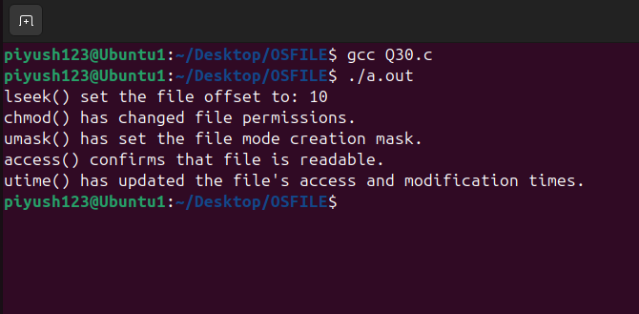

Explanation of Each System Call
- lseek():
  - Moves the file pointer to a specific location.
  - In this program, we use lseek(fd, 0, SEEK_SET) to move the pointer to the beginning of the file before reading.
- chmod():
  - Changes the permissions of a file.
  - Here, we change the permissions of example.txt to 0755 (read, write, execute for owner; read and execute for others).
- umask():
  - Sets the file mode creation mask, which affects the default permissions of newly created files.
  - We change the umask to 0022, which results in new files having at most 0644 permissions.
- access():
  - Checks the accessibility of a file (e.g., whether it exists or if it’s readable/writable).
  - We use access() to check if example.txt exists and if it has read and write permissions.
- utime():
  - Updates the access and modification times of a file.
  - Here, we set the access time to one day ago and the modification time to the current time for example.txt.

