NATIONAL REMOTE SENSING CENTRE MSA/TEOG

{{Date}}

FROM
The Head SPID,

TEOG
TO
- The Admin. Officer, VDLS
- Head, AS&CID


Through: GH (TEOG)

Sub: Request for ACS-Biometric & VM Login credentials for Project Students -Reg.,
Please find the enclosed list of Students for providing ACS Bio-Metric registration & VM Login credentials (for Jeedimetla campus only) to work at NRSC, Campus. It is requested to do the needful at the earliest.
List of Students:

Sl No. | Salute | Student Name | From | To | Location
1. | Mr | Arhan Ashraf | 05-Feb-26 | 05-Aug-2s | Jeedimetla
2. | Ms | Riddhi Pruthviraj Yadav | 09-Feb-26 | 25-Mar-26 | Balanagar
3. | Ms | Janvi Jaivir Singh | 09-Feb-26 | 25-Mar-26 | Balanagar
4. | Mr | Swetabh Ashok Hanjagi | 09-Feb-26 | 09-May-26 | Jeedimetla
5. | Ms | V Harshitha | 09-Feb-26 | 30-May-26 | Jeedimetla
6. | Ms | Sreya Theresa | 09-Feb-26 | 31-Jul-26 | Jeedimetla
7. | Ms | Vaishnavi P | 09-Feb-26 | 31-Jul-26 | Jeedimetla
8. | Mr | Nandi Venkat Vishwa Pratap Rao | 10-Feb-26 | 10-May-202s | Jeedimetla

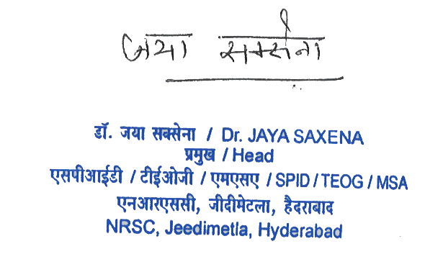

(Jaya Saxena) Head, SPID
