राष्ट्रीय सुदूर संवेदन केंद्र National Remote Sensing Centre
प्रबंधन प्रणाली क्षेत्र Management Systems Area (MSA)
प्रशिक्षण, शिक्षण एवं जनसम्पर्क समूह Training, Education & Outreach group
छात्र परियोजना इंटरफ़ेस विभाग Student Project Interface Division
Date: {{Guide_AllotmentLetter_IssuedDate}}
From
डॉ जया सक्सेना Dr Jaya Saxena
प्रमुख Head,
छात्र परियोजना इंटरफ़ेस विभाग Student Project Interface Division,
प्रशिक्षण, शिक्षण एवं जनसम्पर्क समूह Training, Education & Outreach
NRSC: ORF: 2026/Month/Sl. No.

To
{{Name_College}} Dean/HOD
{{Name_College}}
District

महोदय/ महोदया Dear Sir/Madam

विषय: एनआरएससी में विद्यार्थी प्रोजैक्ट / इंटर्नशिप Sub: Student Project/ Internship at NRSC. …
With reference to your above letter, this is to inform you that Salute {{Name_Student}}, student of Course is permitted to undertake project work/Internship at NRSC. Duration of the project/Internship is from {{From_Date}} to {{To_Date}}.

{{Name_Guide}}, {{Guide_Area}} has been identified as his/her/their Guide. The above student/students are advised to work in offline mode with him/her to carry out the project.
छात्रों के लिए आवश्यकता The students are required to:

- Be regular in work during the project period.
- On completion of the project, submit a project report in soft copy to the Guide and to the undersigned.
- Obtain prior written permission from NRSC for publication of the Project work/ results and share authorship with NRSC project guide for publications/presentations.
- Guide is responsible for the confidentiality of the data to be published in the Project Report.
- Project completion certificate will be issued by TEOG upon submission of Soft & Hard copies of Project Document along with the Project Closeout Presentation.
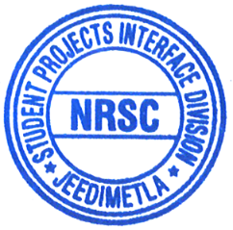
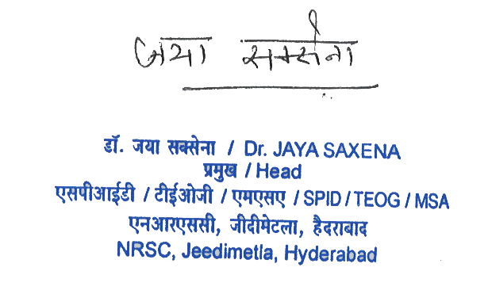
Yours sincerely

(डॉ जया सक्सेना Dr Jaya Saxena)
Copy to:
- {{Salute}} {{Name_Student}}
- {{Name_College}} Dean/HOD
- GH, TEOG
- GD, PPEG
- Project Guide – Name_Guide - Kindly ensure that the student completes the assigned work.
- {{Guide Reporting Officer}}
- {{DD}}

