

Energy Saving Trust
Project

Testing Strategy

Author :
Date :
Version : 1.0
Status :
Filename :

DOCUMENT HISTORY
Date | Author | Version | Change reference
25/02/10 | Yogendra Mishra | 1.0 | Initiated Document
15/03/10 | Priya Rastogi | 1.1 | Modified

APPROVERS AND REVIEWERS

Date | Name/Role

REFERENCES
Document Name | Date | Version | Author
QA Approach document - EST

Table of Contents
1 Management Summary 4
2 Introduction 6
2.1 Introduction To Project 6
2.2 Objective of the document 6
2.3 Audience 6
2.4 References for the required documents 6
3 Key Project Team Members 7
3.1 Key Project Team Members 7
4 Key Milestones and Deliverables 8
4.1 Key Milestones and Deliverables by Testing Phases 8
5 Testing Overview 9
5.1 Approach for Testing 9
5.2 Testing Principles 9
5.3 Types of Testing 10
5.3.1 Unit Testing 10
5.3.2 QA Testing 10
5.3.3 Integration Testing 11
5.3.4 Sanity Testing/Build Verification Testing (BVT) 12
5.3.5 System Testing 12
5.3.6 Browser Testing 14
5.3.7 Regression Testing 14
5.3.8 User Acceptance Test 14
5.4 Out of Testing Scope 15
5.5 General Test Data Approach 15
6 Tools and processes 16
6.1 Result Space 16
6.1.1 Defect Life Cycle 16
6.1.2 Categorization 18
6.2 SVN 19
7 Test deliverables 22
8 Environment details/needs 23
9 Communication plan/approach for uat 24
10 Quality Plan and Processes 25
10.1 Quality Gates 25
10.2 Defect Triaging Process 25
10.3 Test Case Prioritization 25
10.3.1 Business impact 25
10.3.2 Testing impact 25
10.3.3 Technical impact 25
10.4 Quality Metrics 25
11 Roles and responsibilities 27
12 Assumptions 28
13 Risks and Mitigation plan 29
14 Glossary 30

- Management Summary

This paper defines the testing strategy to be followed within EST being developed and contribute in achieving the objective:
“to ensure that the UK responds effectively to a pandemic, employing a range of measures in advance of and during a pandemic to mitigate its impact on health and social care services”. The main goal of the testing strategy is to define the quality gates and guidelines to ensure the end-to-end delivery of all the sites under EST.

- Trace Blog
- Community Customer Pathway
- Publication
- GID Admin
- so on….

Purpose of Testing
The purpose of the different testing phases is to ensure that the System meets all requirements (functional and non-functional) as defined in their respective requirements documents.
Specifically:
- Fulfilment of Scope (Requirements)
- Fulfilment of Functional Specifications
- Fulfilment of Acceptance Criteria
- Functionally correct, robust and secure

Sign-off & Formal Acceptance

Business Benefits
- System will function accurately from a business perspective.
- The Business will be, protected against data theft and loss.
- Early defect detection, debugging and fixing even at the implementation stage (reduces project overall costs and timescales).
- System works as per specifications across multiple platforms, browsers and technologies.
- Guaranteed security and quality of the product
- Mitigation of business functional and integration errors and their root causes.
- New enhancements do not affect any of the existing functionality and support the desired requirement.
- The functionality of the system will meet the release requirements.
- Flawless and technical error-free functioning of the system
- Able to predict and take measures in case of a load increase resulting in system resources expansion
- System will run smoothly, fast, error- and collapse-free.
- Faultless work of website functionality will strengthen and streamline the business process.

Importance of Testing
- Provide confidence in the system.
- Identify areas of weakness.
- Establish the degree of quality.
- Establish the extent that the requirements have been met i.e. what the business requires.
- To prove it is both usable and operable
- To provide sufficient information to allow an objective decision on whether the system can be promoted to later stages of the development lifecycle including production
- System is scalable and responds with the set time frame

- Introduction
  - Introduction To Project
EST is looking for a Partner to help design their existing website with new features which would be more users friendly and easy to use. These new features will add the new web site to improve their business.
The purpose of this document is to outline a testing strategy to ensure that the core technical components of the EST projects are developed, tested and released into operation following business acceptance in a coordinated and coherent manner. It will set the principles and framework in which the testing of the EST Projects are conducted .

  - Objective of the document
This document describes the testing approach for the EST website. Well structured testing will ensure that the software system meets the business requirements defined by EST. Inputs to EST Site Redesign testing include the scope matrix and wireframes.
Testing will occur continuously during implementation and will conclude with formal “Acceptance Testing” of the website by EST team members. EST will receive a final deliverable following the acceptance and verification of the criteria agreed upon by EST and Sapient.
  - Audience
The target audience for this document is EST Stakeholders, Sapient Test & Development Team and Sapient stakeholders
  - References for the required documents

SNo | Document | Location in SVN
1. | Scope Matrix
2. | Wireframes
3. | Technical Design Document

- Key Project Team Members
  - Key Project Team Members
Name | Role | Email ID
Yogita Sood
Shashi Shekhar
Yogendra Mishra
Priya Rastogi
Kavita Mandal
Vineet Goel
Ankur Aulakh
Harinder Kaur

- Key Milestones and Deliverables
  - Key Milestones and Deliverables by Testing Phases
Phase | Deliverable
Test Initiation Phase (Analysis and Design Phase) | - Test Strategy Document  - Test Plan  - Requirements Traceability Matrix (RTM).  - Test Case Templates, High Level and Low Level Cases  - Peer Review Process  - Defect Management Process  - Defect Guidelines and Triaging Process
Test Planning Phase | - High Level Cases (HLC) and Low Level Cases (LLC)  - Test / Staging Environment.  - Test Data
Test Execution Phase | - Test Execution Summary.  - Defect Summary
Test Reporting Phase | - QA Dashboard

- Testing Overview
  - Approach for Testing

Each iteration is planned for <xxx> weeks. Following is the approach that Sapient QA will follow:
- Sapient QA should be ready with their Test Cases ready for review by EST before end of <xxx> week before actually starting with the testing.
- QA would continue with their planned test case execution till mid of last week.
- By the mid of last week focus would be on closing all P1, P2 defects (zero P1, P2’s).
- EST will be doing functional sanity testing at their end for two days after the completion of each iteration. All critical defects found during these two days would be tracked in RS3. All P1 and P2 defects found during this period would be fixed in next iteration on priority.
- All the developers (Sapient as well as EST) will be maintaining their code at Sapient SVN. QA would be testing on EST CMS box. Once UAT phase begins, all the code will be promoted to EST SVN.
- A detailed report with the execution status as well as defect status would be generated and shared with all the stakeholders at the end of every iteration.

The application will be tested for the Functional and Non-Functional requirements.

The Functional testing would include following

- Unit Testing
- Integration Testing
- Sanity testing/Build verification Testing (BVT)
- System Testing
- Browser Testing
- Regression Testing

  - Testing Principles
These principles will underpin the way that testing is carried out across all the projects in EST i.e. these represent general rules that can be used to guide actions in situations where a judgement call is needed.

- Testing must focus on risk and business objectives to ensure that the most effective testing is carried out in the time available. The philosophy of this Test Strategy is based around early and rigorous testing to minimise the cost of rework, whilst avoiding unnecessary duplication of testing effort. It is usually impractical to test every eventuality, and it is unlikely to be cost-effective to do so.

- Test Reporting must be able to show what has not been tested as well as what has been tested, in order to support informed decision making by the Antiviral Strategy Project Board.

- Testing must be repeatable to allow for re-testing of fixes and regression testing.

- Techniques required to support Quality Gateway processes will be agreed, e.g. evidence gathering, entry/exit criteria and agreed deliverables, so that approval to move between stages will be based on informed decisions.

- In order to reduce duplication of effort and achieve effective testing, a collaborative approach will be encouraged. Evidence of testing carried out at one stage can be shared with those responsible for testing at another stage to reduce the need to repeat similar tests.

  - Types of Testing
    - Unit Testing
The objective of Unit Testing is to test the internal functionality of developed code with positive and negative scenarios. However, there will be an automated test script engine to unit test module. In addition, a high level test based upon the QA test scripts would also be carried out by the development team.
Unit testing is usually associated at a high level with the project development phase.

Entry Criteria
- The coding for the module is completed and all the objects associated with the module are available such as database objects etc.

Exit Criteria
- The unit testing results have no deviation from the expected results for positive and negative scenarios.

Environment
- Development Environment

Roles and Responsibilities
- Development Team Member: Unit test their respective modules.
- Team Lead: Sniff tests the build after integrating build to check if the build is testable.
- QA: Performs the build verification test and accepts the build for further testing else rejects the build.

    - QA Testing
To ensure that all functional modules technically function individually, and cover system scope as defined in the scope matrix and business use cases. This process would involve creating test scripts defined in the Test Coverage document, and executing these test cases for the modules. Where relevant, dependencies on other modules are also tested during this phase. This stage will also include Business Validation Testing - which is intensive testing of the new front end fields and screens.

Entry Criteria
- Source code for requisite functionality is checked in.
- Build is complete and is deployed on the QA environment.
- Unit testing cycle has been completed.
- Sniff testing cycle has been completed.
- N-Unit coverage
- FX Cop Warnings
- N-Unit passes

Exit Criteria
- All P1 and P2 (Major) bugs fixed.
- All P3 and P4 bugs to be scheduled for subsequent releases.
- All defects marked for this Patch / Build Fixed.
- All planned components/stories of iteration are completed.
- All defects have been logged into Defect Management tool.
- Verified results are compliant with WS-I guidelines.
- Signoff from the Pandemic Influenza Preparedness Programme Design Authority (Technical Architect).

Environment
- QA Environment.

Roles and Responsibilities

Tasks for Tester
- Complete testing as per test scripts.
- Prepare/update test records. Test records will be maintained in Defect tool.
- Any bugs found should be logged and tracked in the Defect Management tool.
- Execute the next cycle to verify that the bugs found in the first cycle are fixed.

    - Integration Testing

An end-to-end Integration Test will then be carried out on the entire delivered system (i.e. all modules as a single integrated system). After any problems have been resolved and tested, a final run of the integration test should demonstrate to the user or business representative an acceptable delivered total system. Integration testing is primarily functional testing of the system when it is integrated with all other external/related systems. An end-to-end Integration Test will then be carried out on the entire delivered system (i.e. all modules as a single integrated system).
Integration testing is usually associated at a high level with the project system testing phase.

Entry Criteria
- Approved unit and functional verification script records.
- Checked in and labelled source code.
- Complete build deployed on the Integration environment and the integration interfaces like flu line, Collection points and logistics are available for testing integrated with AVSMS.

Exit Criteria
- Closure of all P1 defects.
- Closure of P2 defects (any P2 defects remaining will be agreed upon with DH, with schedule for fix).
- All integration defects are fixed with no critical and major defects exists in the system and stable to enter system test cycle.

Environment
- System Test Environment

Roles and Responsibilities

- Developed application is integration tested by individual workstream and logs the defects identified.
- The development team will fix defects found, a new build will be, deployed for further testing, and this process will continue until the functionality is stabilised with no critical showstoppers.
- Design authority accepts and signoffs, once the technical specification related to integration phase is met
- Entry/Exit Criteria are met and the final signoff received from the AV Strategy Manager to release the code in the system phase.

Tasks for tester
- Understand functionality to be tested.
- Execute steps of testing.
- Log defects as found.

Execute the next cycle to verify that the bugs found in the first cycle are fixed

    - Sanity Testing/Build Verification Testing (BVT)
Sanity testing/Build Verification Testing (BVT) is the shallow level testing of the application, to validate if the application can be tested further. Sanity test shall ensure that the application build is stable for the full regression testing cycle to commence.

    - System Testing
Who | QA Team
What | Sanity Testing
Where | India QA Environment, UK Integration Environment
Entry Criteria | Build Completion Notification
Exit Criteria | Sanity Testing done with a coverage of 20%  Zero P1’s & P2’s
This phase of testing will involve running test cases spanning across the length and breadth of the application to verify that all modules when integrated together works as per the requirement. This will also verify that all the components of the application including the third party systems have been linked together correctly and the application as a whole works as per the agreed design.
All possible End to End business scenarios will be identified and documented by the QA team. End To End testing will be carried out by sapient QA team on Sapient test environment.

Entry Criteria
- Unit tested, functionally verified & integrated code
- Checked in and labelled code.
- Complete build deployed on the System Test environment,.
- Test scenarios created out of functional test scripts, which will simulate end-to-end business scenarios.

Exit Criteria
- Closure of all P1 defects.
- Closure of P2 defects (any P2 defects remaining will be agreed upon with DH, with schedule for fix).
- System is stable to perform the accessibility testing.

Environment
- System Test Environment

Roles and Responsibilities

Tasks for tester
- Understand functionality to be tested and perform the end-to-end system testing.
- Log defects as found
- Execute the next cycle to verify that the bugs found in the first cycle are fixed

    - Browser Testing
This is to demonstrate that web pages are rendered correctly for various supported browsers: IE 6+, Firefox 3+, Windows Safari and Chrome. Browser Testing is done to ensure that the website is functional without any P1 or P2 Defects.

No new test case will be written to conduct browser testing. Functional and Regression Test Cases will be scheduled to run for all the browser compatibility testing.
    - Regression Testing
Regression Testing is testing different parts of application on a continuous basis, to ensure that addition of new functionality in the application did not break the old components. The regression testing would ensure that none of the functionality is breaking due to bug fix or integration with other modules.

The regression testing will involve testing the functionality of the application around the changes fixed in the last cycle.

Who | QA Team
What | Functional Test  End to End Scenario  Regression Test
Where | India QA Environment
Entry Criteria | Successful conclusion of sanity test i.e., no P1’s or P2’s
Exit Criteria | No outstanding P1’s or P2’s  80% test coverage
    - User Acceptance Test

This process should be used throughout the UAT phase of the life cycle. The identified end users/customer who will be responsible to provide the final signoff on the system would own this testing
User acceptance testing is usually associated at a high level with the project user acceptance testing phase

Entry Criteria
- Complete system tested code.
- Checked in and labelled code.
- Complete build deployed on the UAT environment without any issues.

Exit Criteria
- Closure of all P1 and P2 defects
- A set of P3 and P4 defects, with a high-level plan for fixing within a decided period of time
- User acceptance criteria are met with successful completion of UAT following a formal signoff from the senior users

Environment
- UAT Environment

Roles and Responsibilities
Tasks for users
- Understand functionality to be tested.
- Execute steps of testing as documented in the UAT.
- Log defects as found.
- User to leverage upon the system test cases created for execution and the DH testing team will provide support.
- Execute the next cycle to verify that the bugs found in the first cycle are fixed.

Before actually moving onto the UAT phase sign-off for the following would be required from EST:
- Code Reviews sign-off
- Functionality sign-off

Sapient role during UAT:
- Sapient will provide QA Test Cases at the end of each iteration. However EST will own refining and updating the cases for UAT.
- Sapient Test Lead will provide support to EST Test Lead but will not own conducting UAT.
- Sapient will work with the EST team to review and define mutually agreed upon priorities for issues that have been discovered in UAT.
- All the UAT defects that are being fixed by developers would be first tested and updated by Sapient QA before being released back to UAT retest.

  - Out of Testing Scope
Listed below are types of testing that are either not in scope of the project or not in scope for Sapient.
- Performance Testing
- Security Testing
- Failover Testing
- Usability Testing
- Availability Testing

  - General Test Data Approach
In general test data required for that particular module is captured on the script while creating the script and then later captured in a single sheet per module; later on create test data in the system capture the actual test data in the Single repository sheet while executing that particular module. Test data capturing details will be decided later.

- Tools and processes
This section details various tools and processes that will be used during the testing lifecycle
  - Result Space
Sapient Result Space 3 will be used for all Test management activities like Defect Management, Test traceability and Risks/Issues management. All the defects identified during functional, integration and regression testing will be logged in the defects tracker in RS3.
    - Defect Life Cycle
The Sapient QA Team will be responsible for categorizing, prioritizing and assigning an owner to each new defect. Categorization of EST opened defects will be performed as part of defect reviews in which both Sapient and EST participate.
Defect Management will be managed as follows for this project:
- Resultspace is the standard defect tracking tool at Sapient
- The Test Lead will provide guidance to project team as required
- Assignment of Defects – Defects are managed through Resultspace, assigning to appropriate teams depending on the stage of the defect
- Defect status of ‘New’, ‘Open’, ‘Fixed’, ‘Retest’, ‘Reopen’, ‘Client Retest’, ‘Duplicate’, ‘Cannot Reproduce’ ,’Rejected ‘and ‘Closed’ will be used.
- Defect Attributes: The following attributes are required and will be updated for every defect: Title, Description, Status, Category, Priority, Raised by, Assigned To, Project Name, Drop, Failed Scripts, Blocked Scripts, Date, Screen shots/doc and Comments

Dev needs more info – assign to QA
New
Open
In Progress
Fixed
Y
N
Closed
Retest
Invalid Defect
Valid Defect
Not fixed
Fixed
Dev Fixing in progress
Valid
More info
Invalid Defect
Re-Open
Rejected

    - Categorization
      - Defect Status
The following is a list of status to which a defect may be assigned:
- New – This status will be assigned when a defect is first opened
- Open – The defect has been reviewed by the ‘Assigned To’ party
- Fixed – Once the defect is resolved, the developer (or ‘Assigned To’ party) will change the status to Fixed
- Retest – Once the Developer (or ‘Assigned To’ party) delivers the fix for a defect in the build to QA, the developer will change the status to ‘Retest’.
- Reopen – If the fix for a defect is not working as expected, QA will change the status from ‘Retest’ to ‘Reopen’.
- Closed – Once the defect has been tested and no longer considered a defect, the QA will change the status of the defect from ‘Retest’ to ‘Closed’. This status can also be updated if the bug is not reproducible or will not be fixed in general.
- Duplicate – If already a similar defect exists for a newly logged defect, Developer will change the status of this newly logged defect as ‘Duplicate’.
- Cannot Reproduce – A defect that is not appearing anymore on the QA environment, following the steps as mentioned in the defect description, Developer will change the status to ‘Cannot Reproduce’.
- Rejected – A defect which developer when replicates thinks that it’s not against the exact requirement, it has been logged just due to some misinterpretation or if it is not a bug, he will reject the defect with valid reasons
- More Info – A defect where developer wants more information to replicate it or the defects is not clear enough to fix the defect , Developer will change the status to ‘More Info'.
- In Progress – A defect, developer is working on, Developer will change the status to ‘In Progress'.

      - Defect Priorities
The defect priority Levels are as follows:
Priority | Label | Description | Example
P1 | Showstopper | - An issue that prevents execution of major functionality  - Has no workaround  - A P1 will delay a release | - Tester when enters URL for homepage gets an error message – ‘Page not found’.
P2 | Critical | - An issue that prevents execution of major functionality but has a workaround  - A major usability issue may also be classified as a P2  - P2s will delay a release | - Clicking on links does not display the expected page
P3 | Moderate | - A moderate usability issue that prevents execution of sporadically used or minor functionality  - Would never delay a release | - Any screen copy related issues – Grammatical errors  - Missing ‘*’ on mandatory fields
P4 | Cosmetic | - Lowest priority and lowest return on fix  - Would never delay a release | - Cosmetic issues (e.g. full stop in the wrong place, poor spacing on layout)

Note: Depending on the requirements by EST IT and EST business clients, bugs may be given a higher priority.
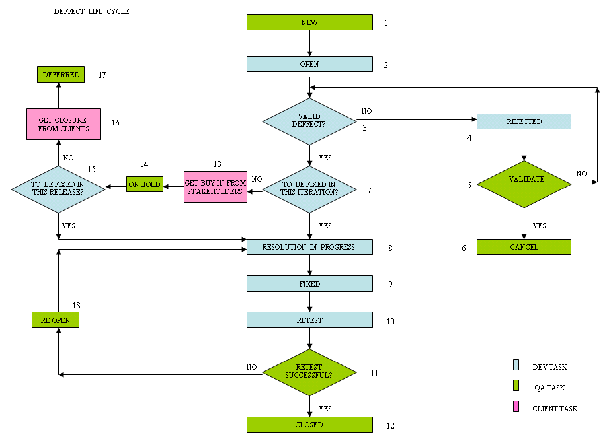

  - SVN
SVN is the configuration management tool, used to create/manage/maintain multiple versions of documentation. This tool is used for all Test Cases maintenance and all Test Management documentation like QA test plans, test cases, test execution reports etc. SVN is also used for maintaining all status reporting provided to internal and external, both on a daily / weekly level. All the test cases created will be checked in SVN and below is the test case creation process.

Test Case Creation and Review Process
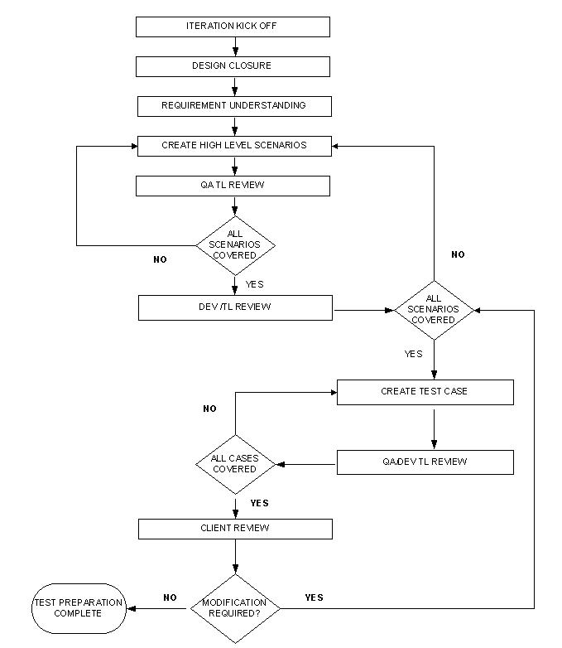
- Test deliverables
This section lists out the various deliverables that QA team will prepare and publish during various project execution stages. The typical testing deliverables are as follows:

S.No. | Document | Description | Recipient | Owner
1. | EST QA Strategy and Plan | Testing Plan and strategy document for the agreed scope. | EST Sapient QA team, Sapient Development Team, Sapient Leadership team | Test Lead
2. | Test Cases | High level Test Scenarios and Low level test cases for all the projects in Scope | EST Sapient QA team, Sapient Development Team, Sapient Leadership team | Test Lead
4. | EST Testing Status Report/QA Dashboard | Weekly report/Daily Report | EST Sapient QA team, Sapient Development Team, Sapient Leadership team | Test Lead
5 | Release Notes | Release Notes document before EST starts with UAT | EST Test Team, Sapient QA team, Sapient Development Team, Sapient Leadership team | Test Lead

- Environment details/needs
Sapient India Dev/QA Environment (India Dev/Test Stack): This environment will be used for development of all modules and unit testing them. The integration testing for all the stories will also be conducted on this environment on the QA branch.
EST Dev/QA Environment (Dev/ Test Stack): This environment will be used for End to End testing of the application including all third party integrations. This environment will also be used by the EST test team to carry out some of the UAT activities. This environment has real-time instances of all third party systems and the integration testing with all third parties will be carried out here.
EST Staging & Production Environment: The Content UAT will be carried out on this environment and this environment is where the final production code will be deployed.

Physical architecture diagram

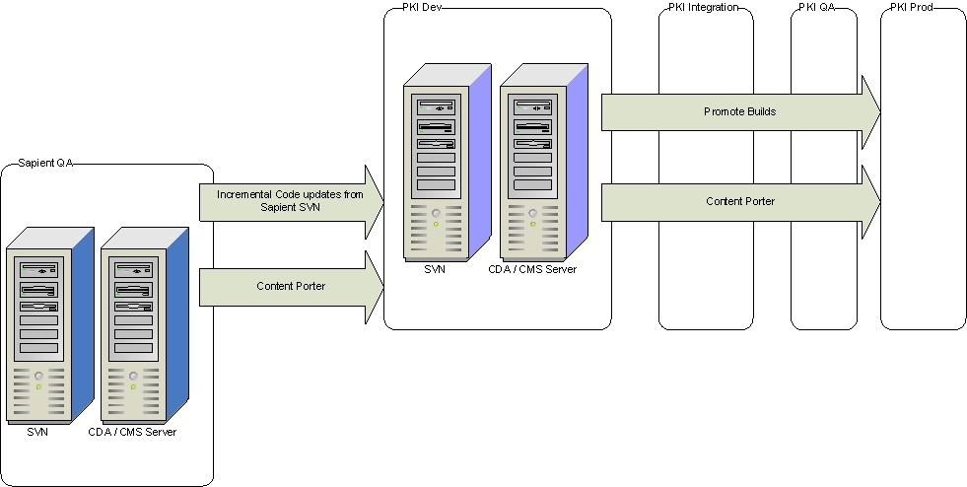

- Communication plan/approach for uat
We will setup a weekly checkpoint for triaging defects logged during UAT.

This weekly forum will be used to:
- Review the validity of a defect.
- Assign a priority (P1, P2, etc.) to the newly logged defects.
- Close fixed defects.
- Return defects that require rework.
- Review the priority for open defects.

For the defects detected during the UAT phase, EST team will include the following attendees:
Yogendra Mishra
Shashi Shekhar
Priya Rastogi

All the defects categorised as enhancements would go through the change request process and corresponding items will be tracked in RS2/3.

At the end of UAT, all the UAT defects will be imported into Sapient’s RS2/3 tool.

- Quality Plan and Processes
  - Quality Gates
Promoting from Iteration 1 to Iteration 2
- All P1 and P2 defects must be closed and 100% of targeted test cases executed during iteration 1. The iteration 1 will not be complete until the criteria are met.
- Should there be an exception; approval is required from LT of project and client as well.
This would be followed for all the subsequent iterations.
  - Defect Triaging Process
The purpose of defect triaging is to analyse, understand and categorize a defect as per its impact to application.
  - Test Case Prioritization
The goal of the testing team is to complete all required testing, and for all test cases to pass before the application is certified for go-live. However, test cases can be prioritized so that the most important functionalities are tested earliest in the testing cycle. Following are some key factors that must be kept in mind while prioritizing order in which test cases must be executed:
    - Business impact
Different functionalities in an application have different business impact for the EST client. For example - Testing against a particular type of module or template (most frequently used in an application) might be more important compared to other users. It is therefore important to test those functionalities with maximum business impact first.
    - Testing impact
If a number of test cases are dependent on a particular page from which other pages are linked, then failure of that page will severely impact testing schedule. It is therefore critical to test those pages or functionalities earlier, on which other test cases down the line will be dependent. These must also be acted upon at a priority by the development team.
    - Technical impact
Test cases which require interfacing with third parties, or which require the most commonly used browser/OS combinations, or those that are most complex to implement technically must be executed earlier in the lifecycle. This minimizes the risk to engagement moving forward

Based on above factors, every test case is assigned a priority (high, medium or low). This is the sequence in which test cases must be planned for execution.

  - Quality Metrics
The following items will be captured and monitored:

Goal | Monitored Item | Planned Monitoring Strategy | Control Strategy
Improve Quality of test cases | Number of revisions to test cases document | - Number of times the test cases document has undergone revision, subsequent to sign-off from Sapient Testing team. | - At the end, Root cause analysis to be done to find reasons for changes.
Improve Quality of Testing | Number of defects found during UAT and regression testing | - Number of defects found which are directly related to Release specific modules | - At the end, Root cause analysis to be done to find reasons for defects found.

- Roles and responsibilities
Sapient Test Lead
Create QA strategy and plan
Coordinate with the dev team to ensure stories are delivered as scheduled
Review test cases
Overall ownership of all the test deliverables including the test cases
Report status
Support EST test team during UAT
Facilitate and drive all QA activities and ensure completion
Defect management and tracking

Sapient Tester
Create test cases for the assigned stories
Create test data required for test execution
Execute test cases as per the execution plan
Report defects and retest once fixed

EST Test Lead
Review QA strategy and plan
Create UAT strategy and plan
Drive UAT execution
UAT status reporting
Secure UAT signoff after successful completion of UAT
Report UAT defects and coordinate resolution
- Assumptions
- Code must be delivered as per schedule to the environment. Any delay in development team’s schedule directly impacts the QA team’s schedule.

- A P1 defect must be resolved within 1 day, and P2 defects must be resolved within 2 days of being logged. Over and above hot fixes for P1 defects, there must be at least one build cycle for development to deploy code fixes for all outstanding bugs.

- Risks and Mitigation plan
Severity | Risk Description | Mitigation Plan
High | Environmental unavailability can impact the release schedule. | Work with Dev Team to ensure that the test environments are stable for testing. Environment stability testing planned prior to start of testing
Significant | Last minute changes in requirements can impact the testing schedule and may have an impact on the launch date | Work with Development PM/Lead to minimize the changes in scope

- Glossary

Name | Description
BVT | Build Verification Testing
FVT | Functional Verification Testing
IE | Internet Explorer
UAT | User Acceptance Testing
P1 | Priority 1
P2 | Priority 2
P3 | Priority 3
P4 | Priority 4
LOE | Level of Effort
TAR | Technical Assistance Request
ENV | Environment
NFR | Non functional requirement
UI | User Interface
ACP | Antiviral Collection Points

