Libraries Used:
Importing essential libraries for data analysis, visualization, preprocessing, modeling, and hyperparameter tuning.
Libraries include Pandas, NumPy, Seaborn, Matplotlib, Scikit-learn (for ML models and evaluation), and XGBoost.
Warnings are suppressed for cleaner output and Google Drive is mounted for dataset access Dataset:

- Dataset Name: Traffic Forecasting Flow Using Machine Learning Algorithms.
- Dataset link: https://github.com/Boobur/Forecast-traffic-flow.git

Dataset description: The dataset records hourly traffic flow at the Bogishamol Street intersection in Tashkent, focusing on vehicles moving west to east. It contains 17,373 entries from January 2023, with each record including datetime, vehicles, day, week, month, year, and hour. Key trends show peak traffic at 8–10 a.m. and 5–6 p.m. on weekdays, with lower, stable traffic on weekends. This dataset is used to train and evaluate machine learning models for traffic flow forecasting.

Data preprocessing:
- Datetime converted to structured features: Hour, Day, Week, Month, Year
- Missing values checked and handled
- Feature selection: Choose time-based features as inputs.
- Target variable: Vehicles (traffic volume).
- Train-test split: Data divided (80/20) for model training and evaluation.
- Correlation analysis: Identified most predictive features.

Exploratory Data Analysis (EDA)

Vehicles Count by Day: Change format of date and plot a graph that visualizes these trends in a line chart to identify vehicle count by day.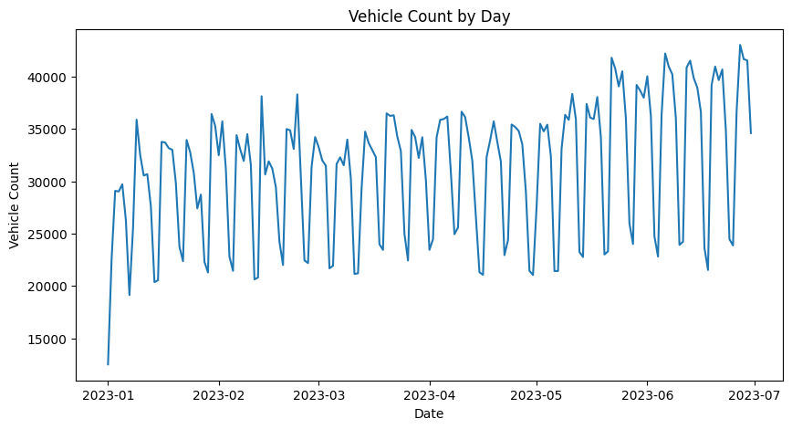

Vehicles Count by Months: Group all the vehicle counts by each month and sum them up, so you can see how traffic varies month by month.
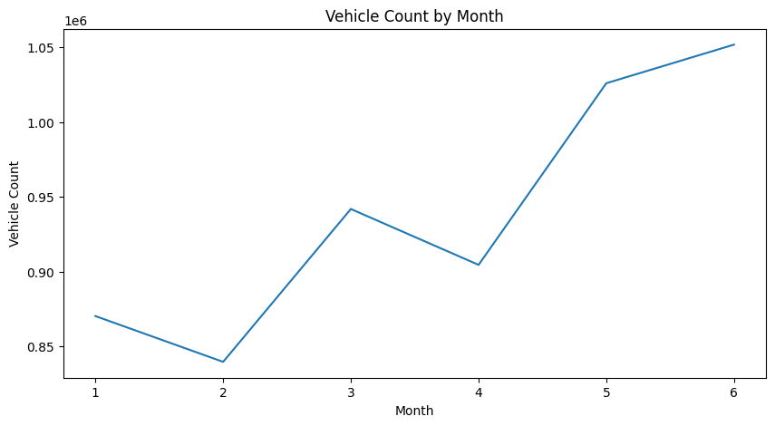

Traffic Flow Distribution: Traffic Flow Distribution describes how vehicle traffic is spread across time or categories (e.g., hours, days, months, or directions).

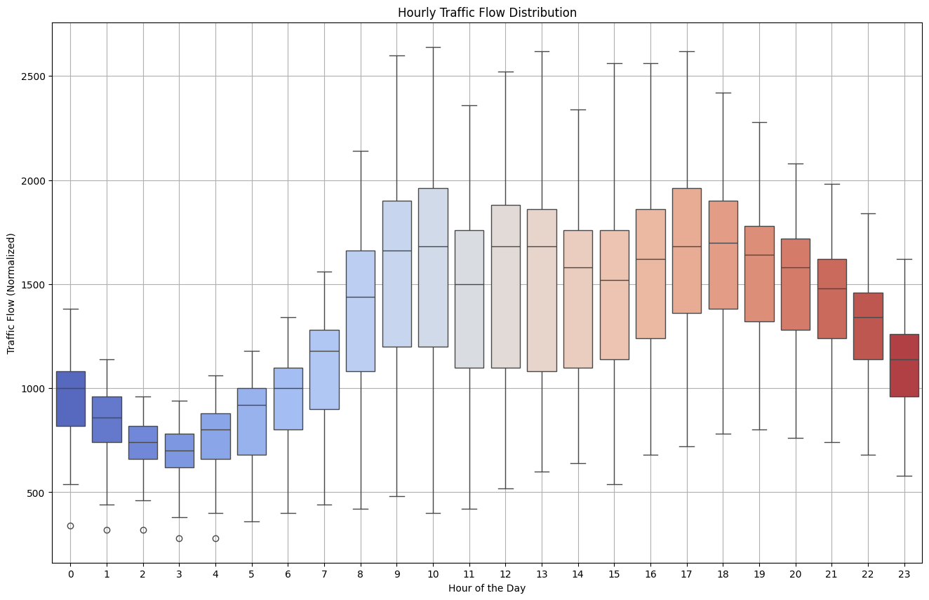

Average Vehicles by Hour:
- Identifies rush hour.
- Helps in traffic signal optimization.
- Useful for predictive modeling and pattern recognition.
- Compares traffic flow behavior over a typical day.

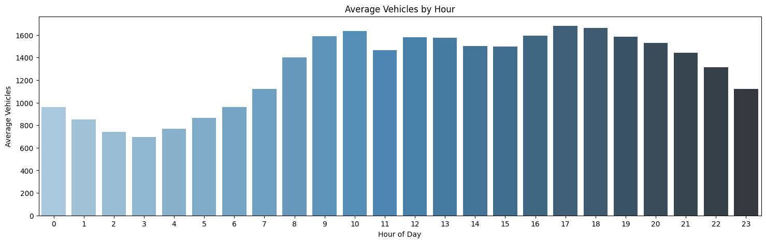

Vehicles by Day of Week:
- Total vehicles by day of week — sum all vehicle counts for each weekday.
- Average vehicles per day of week — average vehicle count for each weekday.

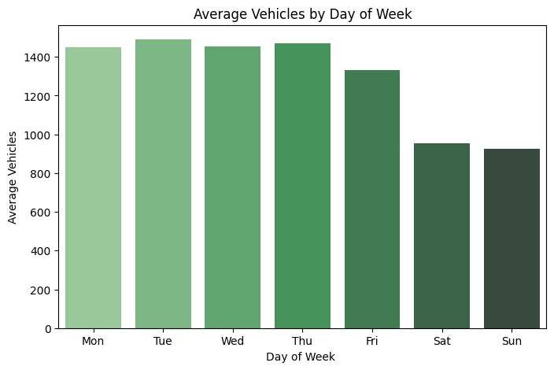

Average Vehicles by Months:
- Group your data by month (e.g., January, February, etc.).
- Calculate the average vehicle count for each month.
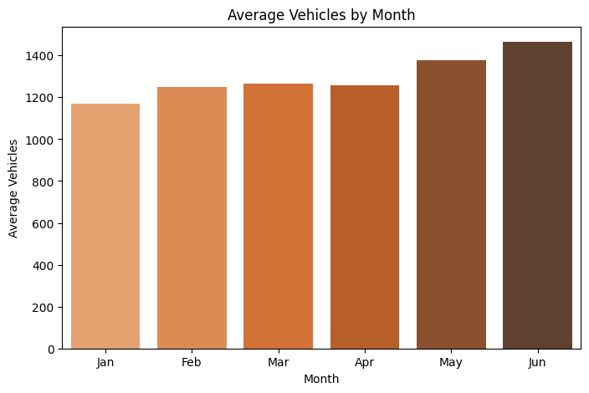

Plot Heatmap: Drops irrelevant columns. Computes and plots a correlation matrix to reveal how strongly features like hour, day, and month relate to Vehicles (target variable).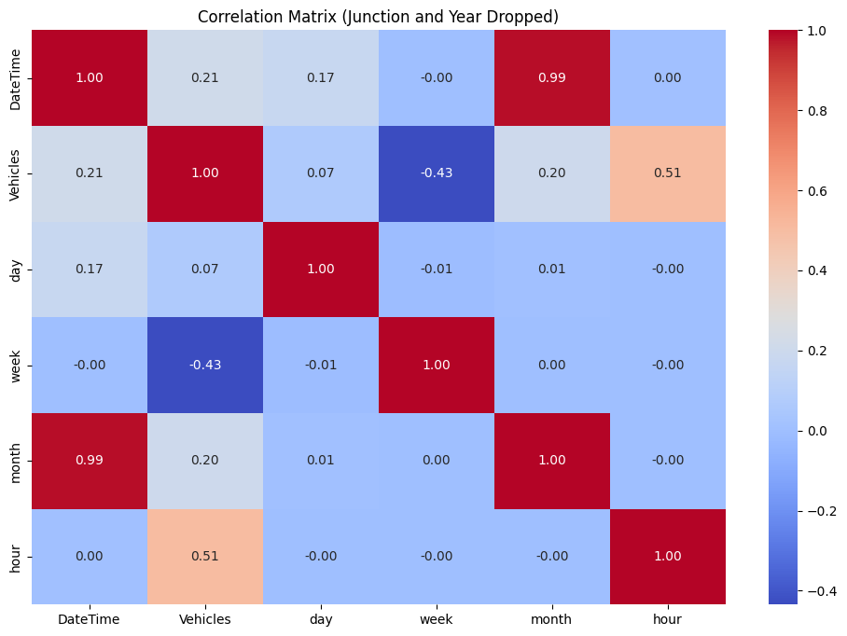

Feature Scalar:
- Algorithms like K-Nearest Neighbors, SVM often need it.
- Tree-based models (like Random Forests) usually don’t require scaling.
- When features have different units or vastly different ranges.

Define Features and Target:
- Defines X (features) and y (target) for machine learning.
- These will be used to train the prediction models.

Data Splitting for Model Training:
- Split the dataset into features (X) and target (y), followed by an 80-20 train-test split.
Model implementation

KNN Regressor Model:
Defines several Knn Regressor model with different max_depths and hyperparameters.
Trains each model, predicts on train/test data, and evaluates using:
- MAE (Mean Absolute Error)
- RMSE (Root Mean Squared Error)
- R² (Coefficient of Determination)
Results are stored and displayed in a summary DataFrame.

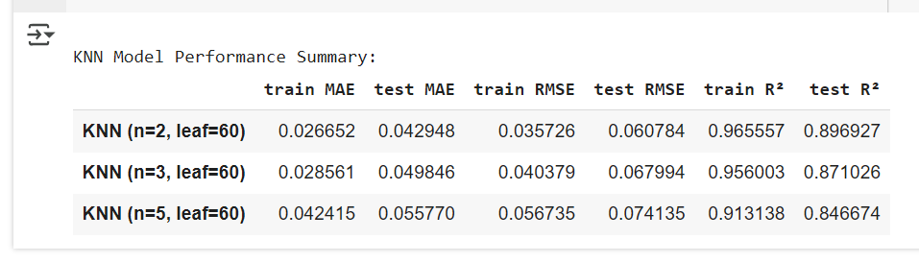

Plot Comparision Graphs:
- To visually compare predicted vs. actual traffic flow across Knn regressor model.
- To check how closely model predictions match real data.
- To reveal underfitting, overfitting, or good generalization.

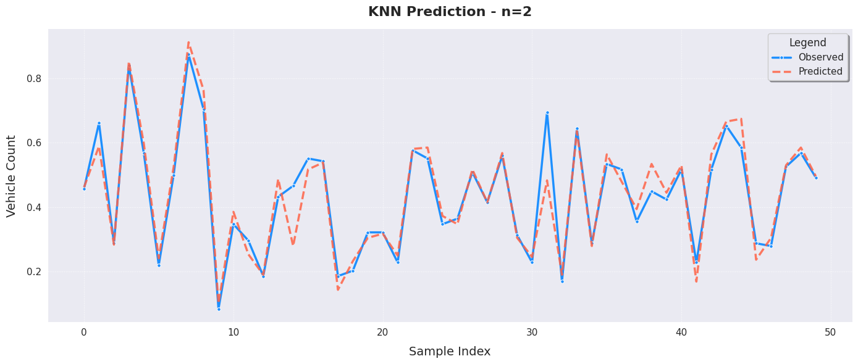
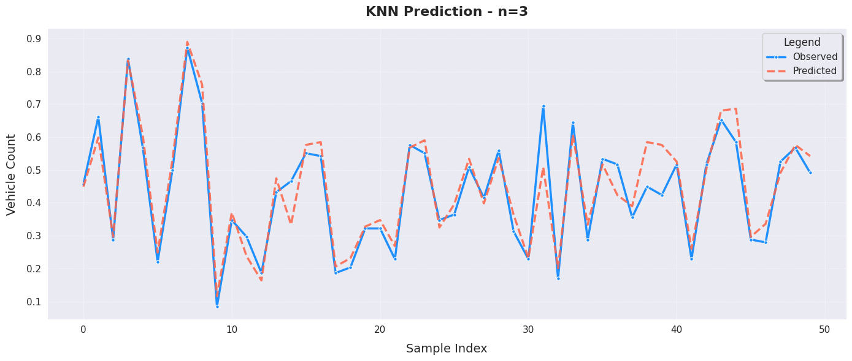
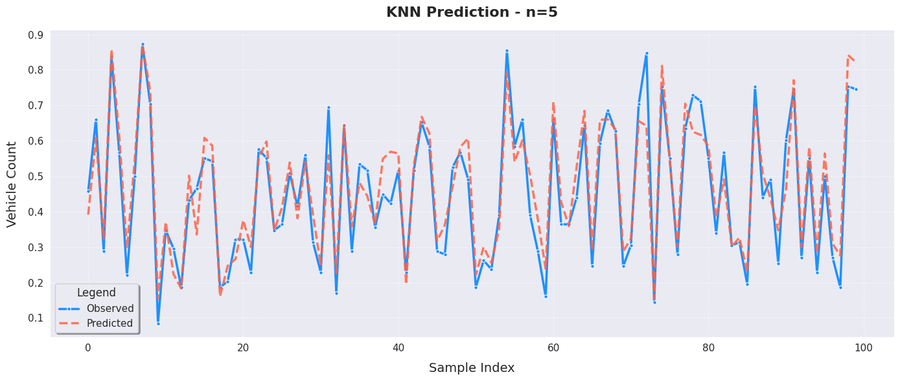

Support Vector Regression Model:
Epsilon-insensitive tube: Errors within this margin (epsilon) are ignored.
Kernel trick: Can model nonlinear relationships using kernels like RBF.
Regularization (C): Controls the trade-off between flatness and tolerance to errors.

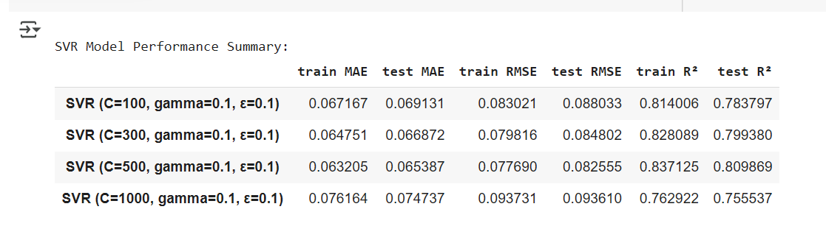

Plot Comparision Graphs:
- To visually compare predicted vs. actual traffic flow across SVR Model.
- To check how closely model predictions match real data.
- To reveal underfitting, overfitting, or good generalization.

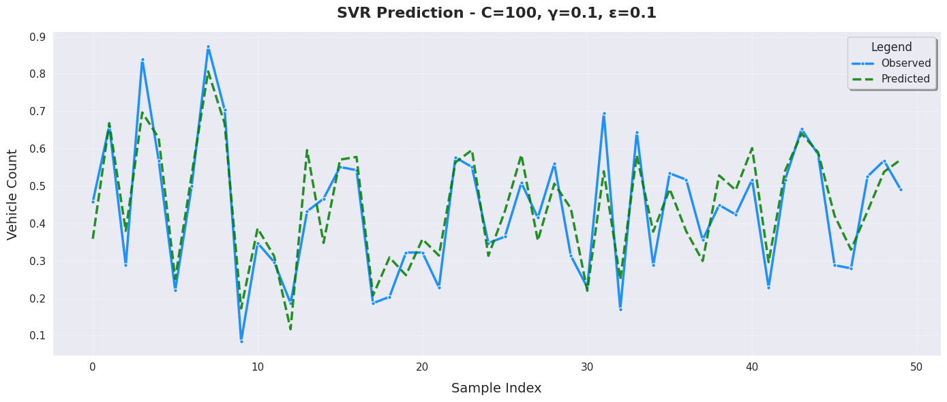
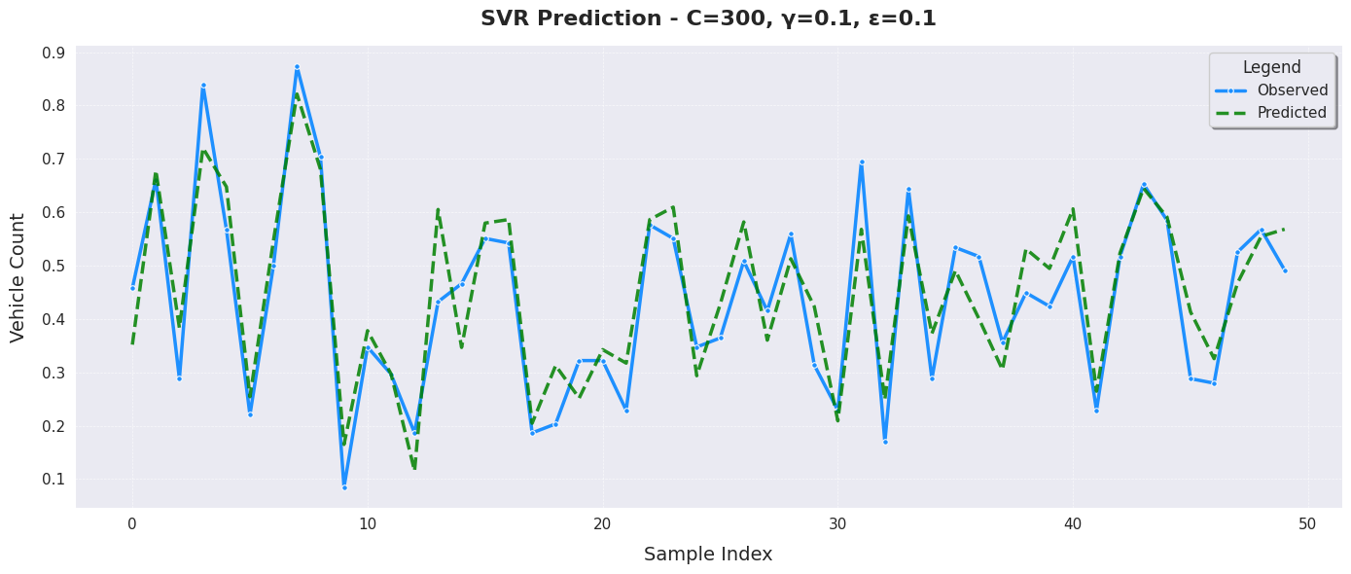
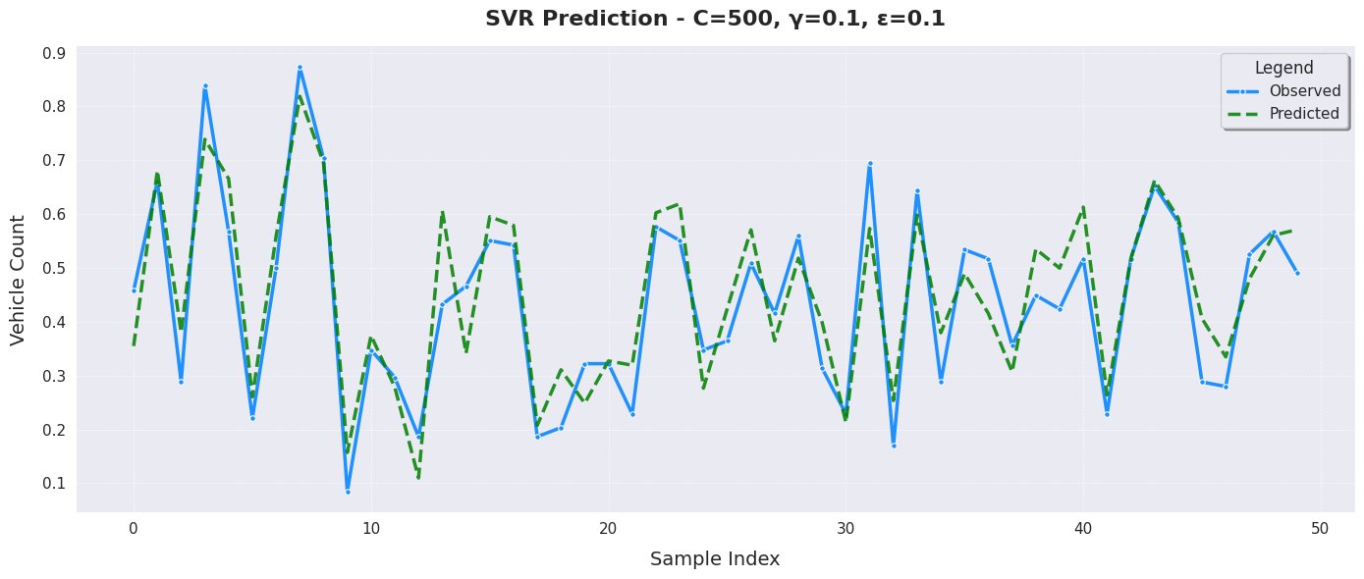
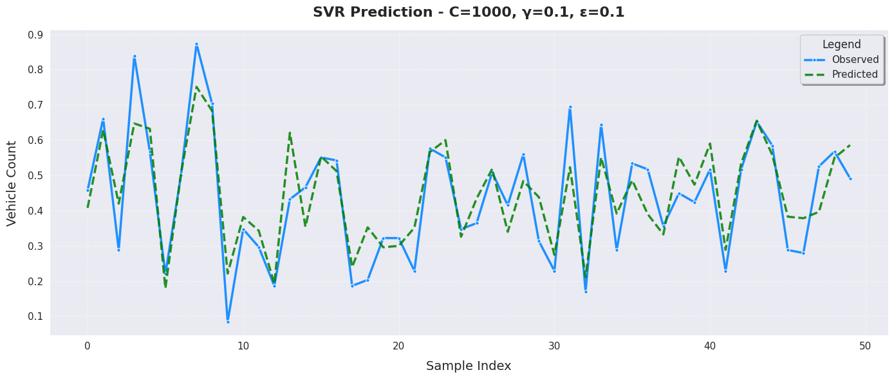

XGBRegressor Model:

Handles nonlinear relationships well.

Robust to multicollinearity and missing data.

Often delivers state-of-the-art results on tabular data.
Fast and scalable.

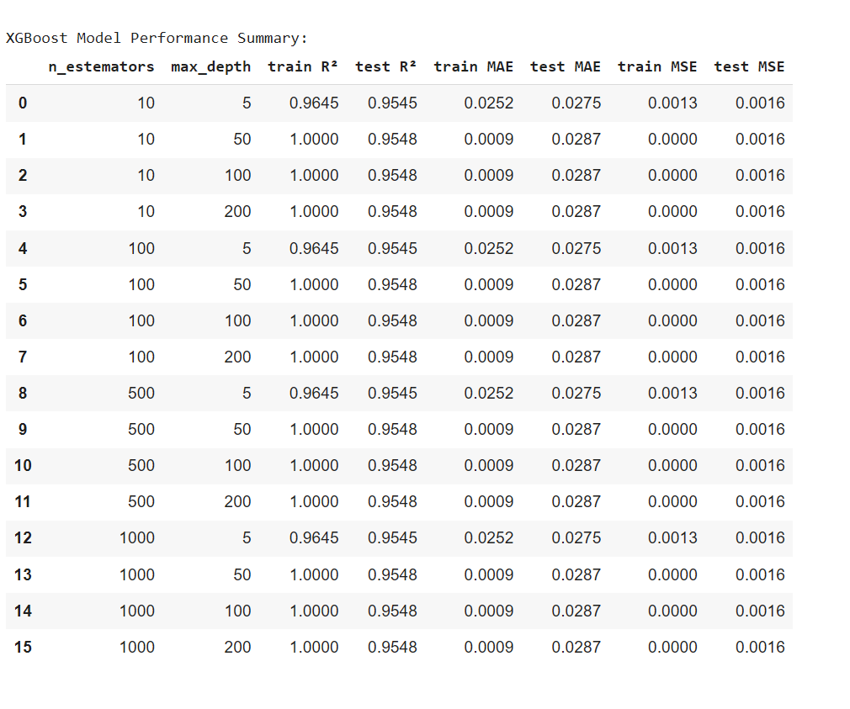

Plot Comparision Graphs:
- To visually compare predicted vs. actual traffic flow across XGBRegressor.
- To check how closely model predictions match real data.
- To reveal underfitting, overfitting, or good generalization.

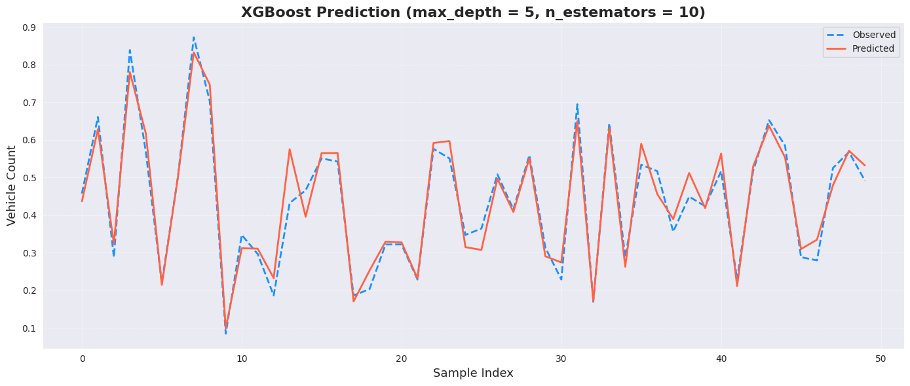
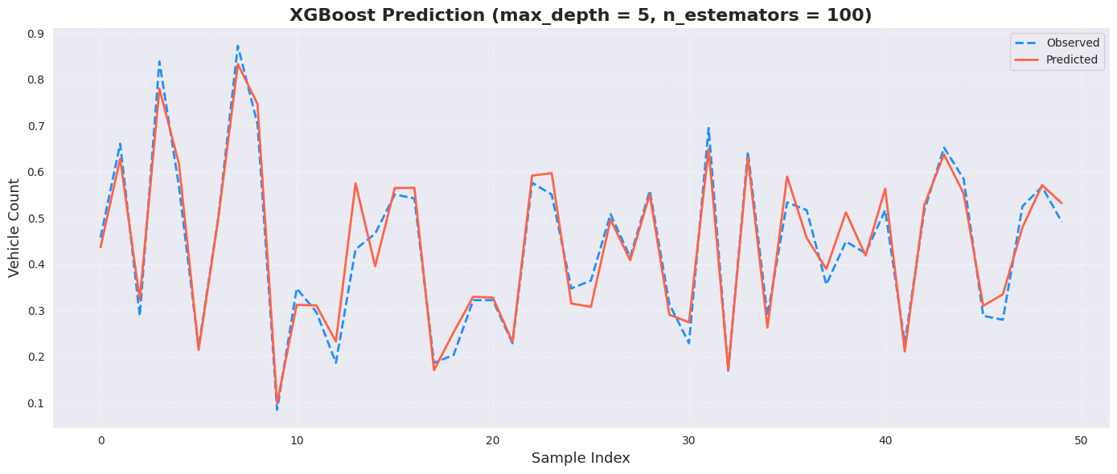
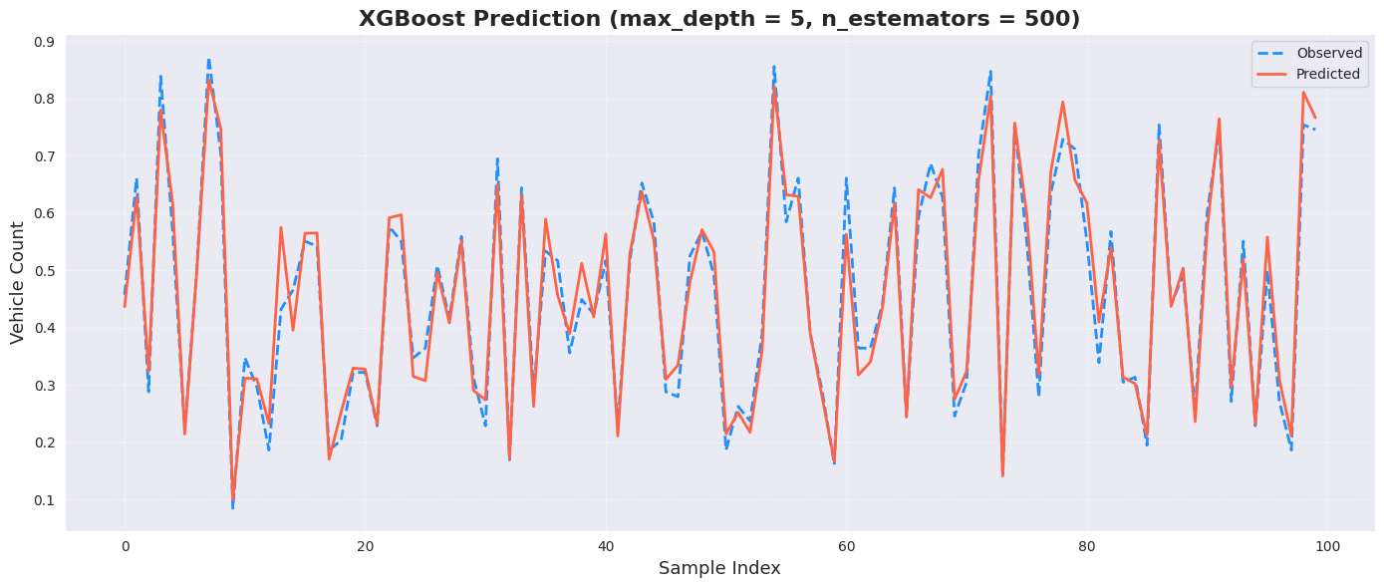
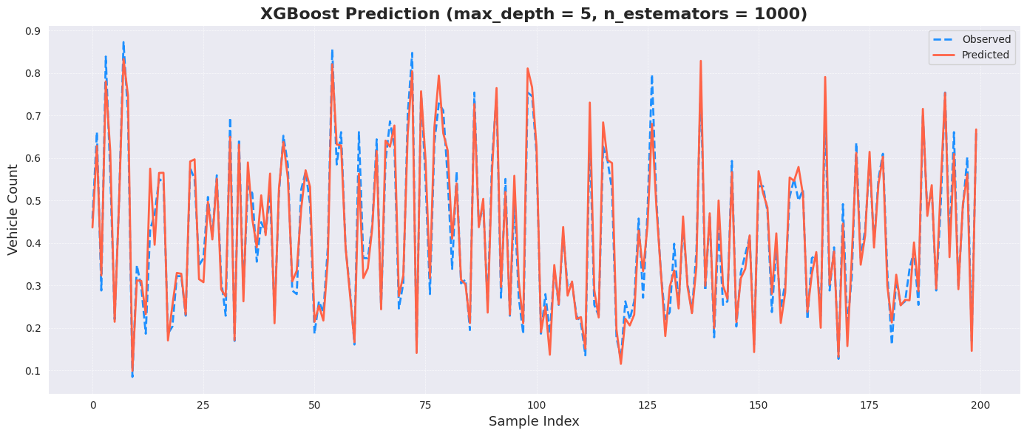

Model Performance Comparison Graph:
- comparison
  - KNN model (with n=5, leaf_size=60)
  - SVR model (with C=1000, gamma=0.1, epsilon=0.1)
  - XGBoost model (with 1000 trees)
- MSE measures average squared difference between predicted and actual values. Lower is beter.
- RMSE is the square root of MSE. It's in the same unit as the target variable, so it's more interpretable.
- R² measures the proportion of variance explained by the model. Closer to 1 is better.
