Overview
This post is in six parts; they are:
- The Complexity of NER Systems
- The Evolution of NER Technology
- BERT’s Revolutionary Approach to NER
- Using DistilBERT with Hugging Face’s Pipeline
- Using DistilBERT Explicitly with AutoModelForTokenClassification
- Best Practices for NER Implementation

The Complexity of NER Systems
The challenge of Named Entity Recognition extends far beyond simple pattern matching or dictionary lookups. Several key factors contribute to its complexity.
One of the most significant challenges is context dependency—understanding how words change meaning based on surrounding text. The same word can represent different entity types depending on its context. Consider these examples:
- “Apple announced new products.” (Apple is an organization.)
- “I ate an apple for lunch.” (Apple is a common noun, not a named entity.)
- “Apple Street is closed.” (Apple is a location.)
Named entities often consist of multiple words, making boundary detection another challenge. Entity names can be complex, such as:
- Corporate entities: “Bank of America Corporation”
- Product names: “iPhone 14 Pro Max”
- Person names: “Martin Luther King Jr.”
Additionally, language is dynamic and continuously evolving. Instead of memorizing what qualifies as an entity, models must deduce it from context. Language evolution introduces new entities, such as emerging companies, new products, and newly coined terms.
Now, let’s explore how state-of-the-art NER models address these challenges.

The Evolution of NER Technology
The evolution of NER technology reflects the broader advancement of natural language processing. Early approaches relied on rule-based systems and pattern matching—defining grammatical patterns, identifying capitalization, and using contextual markers (e.g., “the” before a proper noun). However, these rules were often numerous, inconsistent, and difficult to scale.
To improve accuracy, researchers introduced statistical approaches, leveraging probability-based models such as Hidden Markov Models (HMMs) and Conditional Random Fields (CRFs) to identify named entities.
With the rise of deep learning, neural networks became the preferred method for NER. Initially, bidirectional LSTM networks showed promise. However, the introduction of attention mechanisms and transformer-based models proved to be even more effective.

BERT’s Revolutionary Approach to NER
BERT (Bidirectional Encoder Representations from Transformers) has fundamentally transformed NER with several key innovations:

Contextual Understanding
Unlike traditional models that process text in one direction, BERT’s bidirectional nature allows it to consider both preceding and following text. This enables it to capture long-range dependencies, understand subtle contextual nuances, and handle ambiguous cases more effectively.

Tokenization and Subword Units
While not exclusive to BERT, its subword tokenization strategy allows it to handle unknown words while preserving morphological information. This reduces vocabulary size and makes the model adaptable across different languages and domains.

The IOB Tagging Mechanism
NER results can be represented in various ways, but BERT uses the Inside-Outside-Beginning (IOB) tagging scheme:
- B marks the beginning of an entity.
- I indicates the continuation of an entity.
- O signifies non-entities.
This method enables BERT to handle multi-word entities, nested entities, and overlapping entities effectively.

Using DistilBERT with Hugging Face’s Pipeline
The easiest way to perform NER is by using Hugging Face’s pipeline API, which abstracts away much of the complexity while still delivering powerful results. Here’s an example:
1  2  3  4  5  6  7  8  9  10  11  12  13  14  15  16  17  18  19 | from transformers import pipeline  # Initialize the NER pipeline  ner_pipeline = pipeline("ner",  model="dbmdz/bert-large-cased-finetuned-conll03-english",  aggregation_strategy="simple")  # Text example  text = "Apple CEO Tim Cook announced new iPhone models in California yesterday."  # Perform NER  entities = ner_pipeline(text)  # Print the results  for entity in entities:  print(f"Entity: {entity['word']}")  print(f"Type: {entity['entity_group']}")  print(f"Confidence: {entity['score']:.4f}")  print("-" * 30)
Now, let’s break down this code in detail. First, you initialize the pipeline:
1  2  3 | ner_pipeline = pipeline("ner",  model="dbmdz/bert-large-cased-finetuned-conll03-english",  aggregation_strategy="simple")
The pipeline() function creates a ready-to-use NER pipeline. This is essential because, while BERT is a machine learning model, text must be preprocessed before it can be processed by the model. Additionally, the model’s output needs to be converted into a usable format. A pipeline handles these steps automatically.
The argument "ner" specifies you want Named Entity Recognition and model="dbmdz/bert-large-cased-finetuned-conll03-english" loads a pre-trained model fine-tuned specifically for NER. The final argument, aggregation_strategy="simple", ensures that subwords are merged into complete words, making the output more readable.
The pipeline above returns a list of dictionaries, where each dictionary contains:
- word: The detected entity text
- entity_group: The type of entity (e.g., PER for person, ORG for organization)
- score: Confidence score between 0 and 1
- start and end: Character positions in the original text
This code will output the following:
1  2  3  4  5  6  7  8  9  10  11  12 | Entity: Apple  Type: ORG  Confidence: 0.9987  ------------------------------  Entity: Tim Cook  Type: PER  Confidence: 0.9956  ------------------------------  Entity: California  Type: LOC  Confidence: 0.9934  ------------------------------

Using DistilBERT Explicitly with AutoModelForTokenClassification
For greater control over the NER process, you can bypass the pipeline and work directly with the model and tokenizer. This approach provides more flexibility and insight into the process. Here’s an example:
1  2  3  4  5  6  7  8  9  10  11  12  13  14  15  16  17  18  19  20  21  22  23  24  25  26  27  28  29  30  31  32  33  34  35  36  37  38  39  40  41  42  43  44  45  46  47 | from transformers import AutoTokenizer, AutoModelForTokenClassification  import torch  # Load model and tokenizer  model_name = "dbmdz/bert-large-cased-finetuned-conll03-english"  tokenizer = AutoTokenizer.from_pretrained(model_name)  model = AutoModelForTokenClassification.from_pretrained(model_name)  # Text example  text = "Google and Microsoft are competing in the AI space while Elon Musk founded SpaceX."  # Tokenize the text  inputs = tokenizer(text, return_tensors="pt", add_special_tokens=True)  # Get predictions  with torch.no_grad():  outputs = model(**inputs)  predictions = torch.argmax(outputs.logits, dim=2)  # Convert predictions to labels  label_list = model.config.id2label  tokens = tokenizer.convert_ids_to_tokens(inputs["input_ids"][0])  predictions = predictions[0].tolist()  # Process results  current_entity = []  current_entity_type = None  for token, prediction in zip(tokens, predictions):  if token.startswith("##"):  if current_entity:  current_entity.append(token[2:])  else:  if current_entity:  print(f"Entity: {''.join(current_entity)}")  print(f"Type: {current_entity_type}")  print("-" * 30)  current_entity = []  if label_list[prediction] != "O":  current_entity = [token]  current_entity_type = label_list[prediction]  # Print final entity if exists  if current_entity:  print(f"Entity: {''.join(current_entity)}")  print(f"Type: {current_entity_type}")
This implementation is more detailed. Let’s walk through it step by step. First, you load the model and tokenizer:
1  2  3 | model_name = "dbmdz/bert-large-cased-finetuned-conll03-english"  tokenizer = AutoTokenizer.from_pretrained(model_name)  model = AutoModelForTokenClassification.from_pretrained(model_name)
The AutoTokenizer class automatically selects the appropriate tokenizer based on the model card, ensuring compatibility. Tokenizers are responsible for transforming input text into tokens. AutoModelForTokenClassification loads a model fine-tuned for token classification tasks, including both the model architecture and pre-trained weights.
Next, you preprocess the input text:
1 | inputs = tokenizer(text, return_tensors="pt", add_special_tokens=True)
This step converts the text into token IDs that the model can process. A token is typically a word but can also be a subword. For example, “sub-” and “-word” may be recognized separately even though they appear as a single word. The return_tensors="pt" argument returns the sequence as PyTorch tensors, while add_special_tokens=True ensures the inclusion of [CLS] and [SEP] tokens to the beginning and the end of the output, which are required by BERT.
Then, you run the model on the input tensor:
1  2  3 | with torch.no_grad():  outputs = model(**inputs)  predictions = torch.argmax(outputs.logits, dim=2)
Using torch.no_grad() disables gradient calculation during inference, saving both time and memory. The function torch.argmax(outputs.logits, dim=2) selects the most likely label for each token. The tensor predictions is a tensor of integers.
To convert the model’s output into human-readable text, we prepare a mapping between prediction indices and actual entity labels:
1  2  3 | label_list = model.config.id2label  tokens = tokenizer.convert_ids_to_tokens(inputs["input_ids"][0])  predictions = predictions[0].tolist()
Dictionary model.config.id2label is a mapping of prediction indices to actual entity labels. The function convert_ids_to_tokens converts integer token IDs back to readable text. Since you run the model with a single line of input text, only a sequence of output is expected. We convert the predictions to a Python list for easier processing.
Finally, you reconstruct the entity predictions using a loop. Since BERT’s tokenizer sometimes splits words into subwords (indicated by "##"), you merge them back into complete words. The entity type is determined using the label_list dictionary.

Best Practices for NER Implementation
Performing Named Entity Recognition (NER) is as simple as shown above. However, you are not required to use the exact code provided. Specifically, you can switch between different models (along with the corresponding tokenizer). If you need faster processing, consider using a DistilBERT model. If accuracy is a priority, opt for a larger BERT or RoBERTa model. Additionally, if your input requires domain-specific knowledge, you may benefit from using a domain-adapted model.
If you need to process a large volume of text for NER, you can improve efficiency by processing inputs in batches. Other techniques, such as using a GPU for acceleration or caching results for frequently accessed texts, can further enhance performance.
In a production system, proper error-handling logic should also be implemented. This includes validating input, handling edge cases such as empty strings and special characters, and addressing other potential issues.
Here’s a complete example incorporating these best practices:
1  2  3  4  5  6  7  8  9  10  11  12  13  14  15  16  17  18  19  20  21  22  23  24  25  26  27  28  29  30  31  32  33  34  35  36  37  38  39  40  41  42  43  44  45  46  47  48  49  50  51  52  53  54  55  56  57  58  59  60  61 | from transformers import pipeline  import torch  import logging  from typing import List, Dict  class NERProcessor:  def __init__(self,  model_name: str = "dbmdz/bert-large-cased-finetuned-conll03-english",  confidence_threshold: float = 0.8):  self.confidence_threshold = confidence_threshold  try:  self.device = "cuda" if torch.cuda.is_available() else "cpu"  self.ner_pipeline = pipeline("ner",  model=model_name,  aggregation_strategy="simple",  device=self.device)  except Exception as e:  logging.error(f"Failed to initialize NER pipeline: {str(e)}")  raise  def process_text(self, text: str) -> List[Dict]:  if not text or not isinstance(text, str):  logging.warning("Invalid input text")  return []  try:  # Get predictions  entities = self.ner_pipeline(text)  # Post-process results  filtered_entities = [  entity for entity in entities  if entity['score'] >= self.confidence_threshold  ]  return filtered_entities  except Exception as e:  logging.error(f"Error processing text: {str(e)}")  return []  if __name__ == "__main__":  # Initialize processor  processor = NERProcessor()  # Text example  text = """  Apple Inc. CEO Tim Cook announced new partnerships with Microsoft  and Google during a conference in New York City. The event was also  attended by Sundar Pichai and Satya Nadella.  """  # Process text  results = processor.process_text(text)  # Print results  for entity in results:  print(f"Entity: {entity['word']}")  print(f"Type: {entity['entity_group']}")  print(f"Confidence: {entity['score']:.4f}")  print("-" * 30)

Summary
Named Entity Recognition with BERT models provides a powerful way to extract structured information from text. The Hugging Face Transformers library makes it easy to implement NER with state-of-the-art models, whether you need a simple pipeline approach or more detailed control over the process.
In this tutorial, you learned about NER with BERT. In particular, you learned how to:
- Use the pipeline API for quick prototypes and simple applications
- Use explicit model handling for more control and custom processing
- Consider performance optimization for production applications
- Always handle edge cases and implement proper error handling
With these tools and techniques, you can build robust NER systems for various applications, from information extraction to document processing and more.

Custom Named Entity Recognition with BERT

How to use PyTorch and Hugging Face to classify named entities in a text

Named-entity recognition (NER)
is a subtask of information extraction that seeks to locate and classify named entities mentioned in unstructured text into pre-defined categories such as person names, organizations, locations, medical codes, time expressions, quantities, monetary values, percentages, etc.
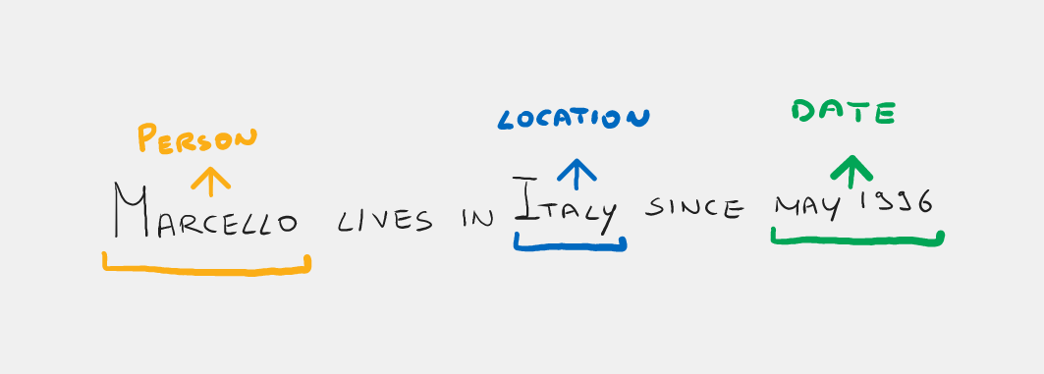
Image By Author

Background:
In this article we will use some concepts that I have already introduced in my previous article.
BERT is a language model based heavily on the Transformer encoder. If you are unfamiliar with Transformers I recommend reading this amazing article.

The Illustrated Transformer

Discussions: Hacker News (65 points, 4 comments), Reddit r/MachineLearning (29 points, 3 comments) Translations…
jalammar.github.io

BERT in a nutshell :
- It takes as input the embedding tokens of one or more sentences.
- The first token is always a special token called [CLS].
- The sentences are separated by another special token called [SEP].
- For each token BERT outputs an embedding called hidden state.
- Bert was trained on the masked language model and next sentence prediction tasks.
In the masked language model (MLM), an input word (or token) is masked and BERT has to try to figure out what the masked word is. For the next sentence prediction (NSP) task, two sentences are given in input to BERT, and he has to figure out whether the second sentence follows semantically from the first one.
If you think about it, solving the named entity recognition task means classifying each token with a label (person, location,..). So the most intuitive way to approach this task is to take the corresponding hidden state of each token and feed it through a classification layer. The final classifiers share the weights, so in practice we have a single classifier, but for demonstration pourposes, I think that it’s easier to visualize it as if there were more classifiers.
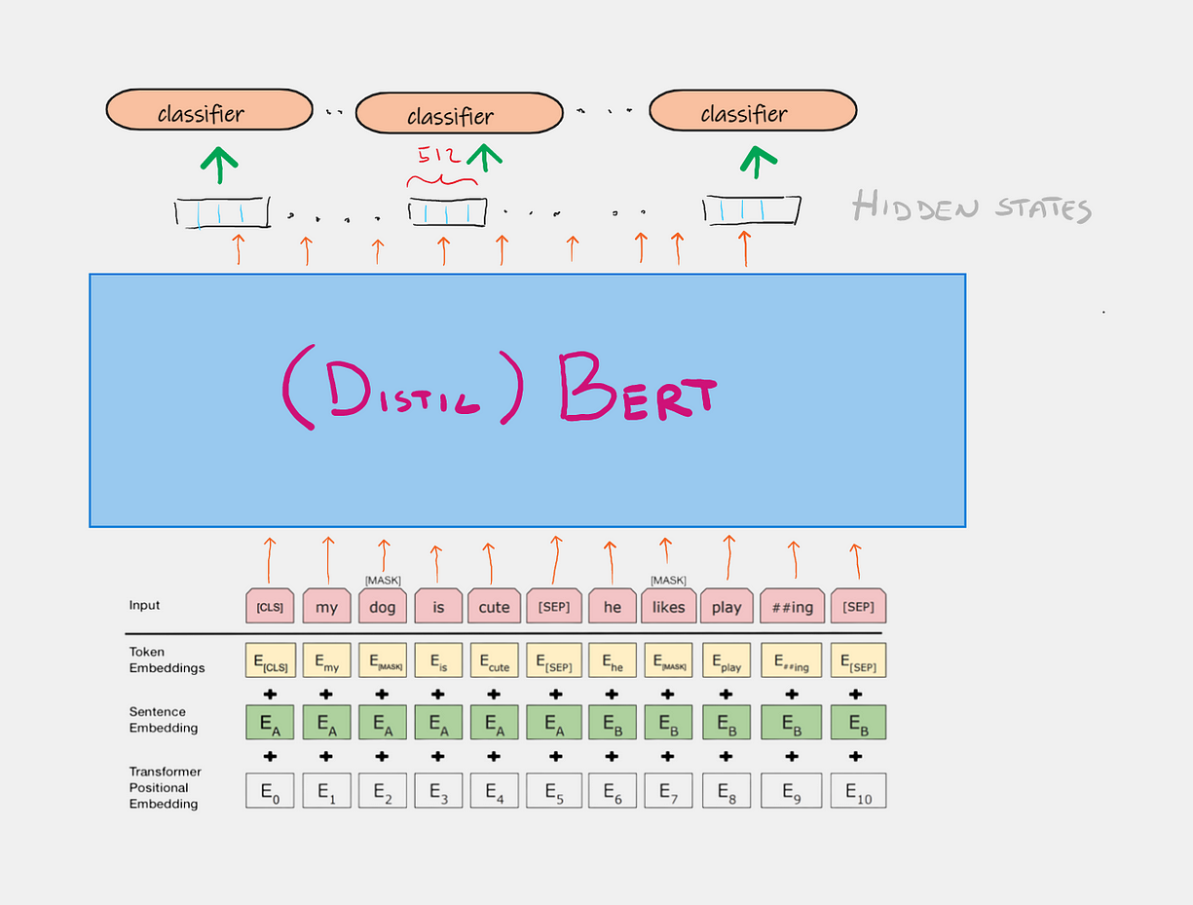
Image By Author
From the image above you can see that we will be using a lighter version of BERT called DistilBERT. This distilled model is 40% smaller than the original but still maintains about 97% performance on the various NLP tasks.
Another thing you can notice, is that BERT’s input is not the original words but the tokens. BERT has associated a tokenizer that preprocesses the text so that it is appealing for the model. The tokenizer often splits words into subwords and in addition special tokens are added : [CLS] to indicate the beginning of the sentence, [SEP] to separate multiple sentences, and [PAD] to make each sentence have the same number of tokens.
In addition, each token embedding is summed with a sentence embedding, which is a vector that somehow adds the information whether the token refers to the first or second sentence given as input to BERT.
Since the computation in transformers models is parallel unlike recurrent neural networks, we lose the temporal dimension, i.e., the ability to tell which is the first word of a sentence which is the second, etc.
Therefore, each token is also summed to a positional embedding that takes into account the position of the token in the sequence
If you want to learn more about BERT or his wordpiece tokenizer check out these resources:

The Illustrated BERT, ELMo, and co. (How NLP Cracked Transfer Learning)

Discussions: Hacker News (98 points, 19 comments), Reddit r/MachineLearning (164 points, 20 comments) Translations…
jalammar.github.io

BERT 101 — State Of The Art NLP Model Explained

BERT, short for Bidirectional Encoder Representations from Transformers, is a Machine Learning (ML) model for natural…
huggingface.co

WordPiece: Subword-based tokenization algorithm

Understand subword-based tokenization algorithm used by state-of-the-art NLP models — WordPiece
towardsdatascience.com

Summary of the tokenizers

On this page, we will have a closer look at tokenization. As we saw in the preprocessing tutorial, tokenizing a text is…
huggingface.co

Let’s code!

Dataset
The dataset we are going to use is called is CoNLL-2003 which you can find on Kaggle (with an open license).
Download the Kaggle dataset directly from Colab (remember to upload your personal Kaggle key).

Imports
imports

Split Dataset
Let’s load the first N rows of our dataframe and change the column names. Then split the dataframe into train, dev and test sets.
split data

Custom Classes
I am now going to define three classes that will be needed for this project. The first class defines our DistilBert Model. There’s no need to build the classifiers manually on top of the pretrained language model because HuggingFace already provides us with a built-in model that contains the classifier as the last layer. This model is called DistilBertForTokenClassification.

DistilbertNer Class
The init method takes into input the dimensions of the classification, so the number of tokens that we can predict, and instantiate the pretrained model.
The forward computation simply takes the inputs_ids (the tokens) and the attention_mask (array of 0/1 that tells us if the token is a PAD or not) and returns in output a dictionary : {loss, logits}
Model class

NerDataset Class
The second class it’s an extension of the module nn.Dataset, which enables us to create our custom dataset.
Given in input a dataframe this method will tokenize the text and match the additional generated tokens with the correct tag (as we described in the previous article). Now you can index the dataset which will return a batch of texts and labels.
Custom dataset

MetricsTracking Class
Sometimes it’s annoying to compute all the metrics inside the train loop, that’s why this class helps us do that. You only need to instantiate a new object and call the update method every time you make predictions over a batch.

Custom Methods
- tags_2_labels : Method that takes a list of tags and a dictionary mapping tags to labels, and returns a list of labels associated to the original tags.
Tags to labels
- tags_mapping : takes in input the tags column of a dataframe and returns : (1) a dictionary mapping tags to indexes (label) (2) dictionary mapping indexes to tags (3) the label corresponding to tag O (4) a set of unique tags encountered in the train data which will define the classifier dimension.
Tags mapping
- match_tokens_labels : from the tokenized text and the original tags (which are associated with words not token) it outputs an array of tags for every single token. It associates a token with the tag of its original word.
- freeze_model : freezes last num_layers of a model to prevent catastrophic forgetting.
- train_loop : usual train loop.

Main
Now let’s use everything in the main scope.
Create mapping tags-labels
Tokenize text
Train model
Now you should get results similar to these ones
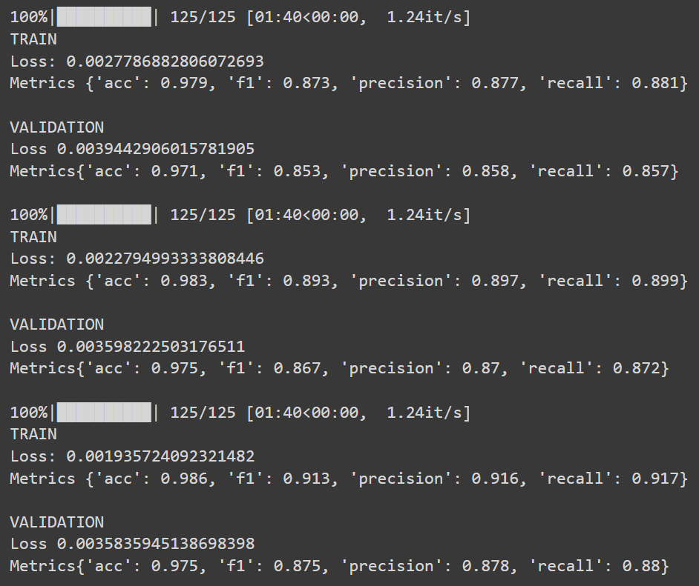
Results
Congratulations, you built your named entity recognition model based on a pre-trained language model!

Final Thoughts
In this hands-on article we saw how we can take advantage of the capabilities of a pretrained model to create a simple model to solve the named entity recognition challenge in very little time. Keep in mind that when you train the whole model on the new data you are likely to change the original DistilBert weights too much and thus deteriorate the performance of the model. For this you can decide to freeze all but the last layer, the classification layer, and prevent this problem called catastophic forgetting. In the model selection phase you can try various models by going to freeze the last k layers.

