**COURSE BROCHURE:**

|  |  |  |  |
| --- | --- | --- | --- |
|  |  |  |  |
|  | **Testing Concepts** | **Duration** |  |
|  | Application infra understanding | **20** |  |
|  | What is testing ? |  |
|  | Why to test the application ? |  |
|  | SDLC – Software Development Life Cycle |  |
|  |  |  |
|  | Water fall model |  |
|  | V & V model |  |
|  | Agile Model |  |
|  | Comparison between various models. |  |
|  | Types of testing |  |
|  | Smoke Testing |  |
|  | Regression Testing |  |
|  | Sanity Testing |  |
|  | UAT |  |
|  |  |  |
|  | Requirement Template |  |
|  | Test Plan Template |  |
|  | Test Case Template |  |
|  | Defect Template |  |
|  | Review Templates |  |
|  |  |  |
|  | STLC Phase |  |
|  | Test Requirement Analysis |  |
|  | Test Planning |  |
|  | Test Bed Setting |  |
|  | Test Design |  |
|  | Test Automation |  |
|  | Test Execution |  |
|  | Defect Tracking |  |
|  | Maintenance |  |
|  |  |  |
|  | Test Design Phase |  |
|  | Template – Test case design template |  |
|  |  |  |
|  | Test Execution |  |
|  | Test Automation |  |
|  | Templates : |  |
|  | Test case template , Test review template |  |
|  |  |  |
|  | Difference between Bug , Defect , Error |  |
|  | Defect life cycle |  |
|  | Defect priorities |  |
|  | Defect severities |  |
|  | Steps to reproduce the defect |  |
|  | Other major components |  |
|  | Defect Tracking Tools |  |
|  | Defect Report |  |
|  |  |  |
|  | Configure jira |  |
|  | Configure Zephyr Squad |  |
|  | Write a and execute the test cases in Zephyr Squad |  |
|  | Log the defect |  |
|  |  |  |
|  | Assessment - Case study manual testing |  |
|  |  |  |  |
|  | **Core Java** | **Duration** |  |
|  | Installation setup | **25** |  |
|  | First Code |  |
|  | Keywords |  |
|  | variable types |  |
|  | Scanner |  |
|  | Operators |  |
|  | Control structures |  |
|  |  |  |
|  | Object class |  |
|  | Method / Function |  |
|  | Types of method |  |
|  | Array |  |
|  | Scenarios based on array |  |
|  | Arrays |  |
|  | For each |  |
|  |  |  |
|  | Constructor |  |
|  | Types of constructor |  |
|  | this |  |
|  | Constructor Overloading |  |
|  |  |  |
|  | Oops concepts |  |
|  | class & object |  |
|  | Inheritance |  |
|  | super |  |
|  | Constructor with super |  |
|  |  |  |
|  | final |  |
|  | Polymerphism [Static and Dynamic Polymerphism] |  |
|  | Aggregation concepts [ IS-A and HAS-A] |  |
|  |  |  |
|  | Exception |  |
|  | Types of exceptions |  |
|  | catch |  |
|  | throws |  |
|  | finally |  |
|  | Checked Exception |  |
|  | UncheckedException |  |
|  | throws |  |
|  | Working with custom exception using throw |  |
|  | Exception , RunTimeException Classes |  |
|  |  |  |
|  | throws |  |
|  | Working with custom exception using throw |  |
|  | Exception , RunTimeException Classes |  |
|  | Object as a variable |  |
|  |  |  |
|  | Interface |  |
|  | Abstraction - Abstract Class |  |
|  |  |  |
|  | Encapsulation |  |
|  | getter & setter |  |
|  | getter & constructor |  |
|  |  |  |
|  | String |  |
|  | StringBuffer |  |
|  | Enum Type |  |
|  |  |  |
|  | StringBuilder |  |
|  | StringTokenizer |  |
|  |  |  |
|  | Date & Time |  |
|  | Regullar expression |  |
|  |  |  |
|  | Collections |  |
|  | ArrayList |  |
|  | Vector |  |
|  |  |  |
|  | JDBC |  |
|  |  |  |
|  | Collection |  |
|  | Set |  |
|  | Map |  |
|  |  |  |
|  | File |  |
|  | File Read & Write |  |
|  | properties files |  |
|  | Loggers |  |
|  |  |  |
|  | File Parsing |  |
|  | XML Parsing |  |
|  |  |  |
|  | File Parsing |  |
|  | Json Parsing |  |
|  |  |  |
|  | JSON Parsing |  |
|  | XML Parsing |  |
|  |  |  |
|  | MySQL Basics |  |
|  | Installation |  |
|  | Create table |  |
|  | Insert records |  |
|  | Select Quesries |  |
|  |  |  |
|  | JDBC with MySQL |  |
|  | Retrive data |  |
|  |  |  |  |
|  | **Selenium** | **Duration** |  |
|  | Introduction to automation | **45** |  |
|  | Tools available in market for functional automation |  |
|  | Why to automate the application |  |
|  | Overview of a automation testing framework (Customized) |  |
|  |  |  |
|  | WebDriver architecture |  |
|  | Understanding DOM |  |
|  | What is Locator |  |
|  | Locators id , name , xpath , cssSector , TagName |  |
|  |  |  |
|  | Download Selenium – Java 4 api |  |
|  | Configure the same with Java project |  |
|  | Write the first automation script to invoke “google.com” from firefox browser |  |
|  | Configure Selenium-Java in maven project |  |
|  | Write the first automation script to invoke “google.com” from firefox browser |  |
|  | Types of Xpath |  |
|  | Writing own relative Xpath |  |
|  | Dynamic Xpath |  |
|  | Navigation commands - Browsers |  |
|  |  |  |
|  | Working with input boxes |  |
|  | Enter the test data at the time of execution |  |
|  | Clearing the entered test data |  |
|  | Simple test case automation for login scenario |  |
|  | SendKeys - Hardcoded value |  |
|  | SendKeys - Keyboard input |  |
|  |  |  |
|  | Working with different webdriver methods |  |
|  | getText method |  |
|  | How to validate the step using getText method |  |
|  | isDisplayed method |  |
|  | How to validate the step using isDisplayed method |  |
|  | getTitle method |  |
|  | How to validate the page using getTitle method |  |
|  | getCurrentUrl method |  |
|  | How to use getCurrentUrl method to validate the page url correctness |  |
|  | WebElement |  |
|  |  |  |
|  | Working with Select class to automate drop down list |  |
|  | What is webtable |  |
|  | How to automate a web table |  |
|  | How to automate frame |  |
|  | Dynamic Select [Dev tag] |  |
|  |  |  |
|  | How to automate scroll down |  |
|  | How to automate key press |  |
|  | How to automate drag and drop |  |
|  | How to automate mouse hovering |  |
|  | Drag & Drop |  |
|  | Keypress |  |
|  | File upload |  |
|  | File Download |  |
|  |  |  |
|  | How to read and validate the pop up message |  |
|  | How to automate the pop up window and continue execution |  |
|  | How to automate child windows getWindowHandle , GetWindowHandles |  |
|  | How to automate slide bar |  |
|  | Allert |  |
|  |  |  |
|  | What is JavaScriptExecutor |  |
|  | How to automate a login scenario using javaScriptExecutor |  |
|  | What is WebElement |  |
|  | Use WebElement to store the locator and automate a simple test case. |  |
|  | What is method library , hoe to create a method library and use same . |  |
|  |  |  |
|  | Implicit wait |  |
|  | Explicit wait |  |
|  | Fluent wait |  |
|  |  |  |
|  | Read the data from text file |  |
|  | Read the data from properties file |  |
|  | Store the test data in external data source and use the same in script. |  |
|  | XML Parsing |  |
|  |  |  |
|  | Apache POI |  |
|  | Read data from excel |  |
|  | Write data to excel |  |
|  | Json parsing |  |
|  |  |  |
|  | What is framework |  |
|  | Different components of framework |  |
|  | Benefits of using framework |  |
|  | What is TestNG |  |
|  | How to install TestNG |  |
|  | Write the first script in TestNG |  |
|  | Different TestNG annotations |  |
|  |  |  |
|  | TestNG reports – testout.xml , emailable report , testNG.xml |  |
|  | Putting asserts in TestNG using Assert |  |
|  | Creating the test suite in TestNG |  |
|  |  |  |
|  | Parallel Testing |  |
|  | TestNG liesteners |  |
|  |  |  |
|  | Priorities in testNG |  |
|  | How to disable an annotation in TestNG |  |
|  | TestNG parameterization |  |
|  | Data providers annotation |  |
|  | Reports in TestNG |  |
|  |  |  |
|  | What is PageObjectModel |  |
|  | What is the benefit of using POM |  |
|  | How to design a Page class |  |
|  | Components of page class |  |
|  | Creating page class for a test case with different pages |  |
|  |  |  |
|  | Integrating POM with TestNG and executing TestNG script |  |
|  |  |  |
|  | Automate screen shots |  |
|  | Create the logfile using Log4J |  |
|  | Loggers |  |
|  | Jherkins [Optional] |  |
|  |  |  |
|  | ExtentReports - HTML Report |  |
|  |  |  |
|  | BDD Frame work |  |
|  | Cucumber BDD |  |
|  | Cucumber + Junit |  |
|  |  |  |
|  | Selenium Grid |  |
|  | Parallel Testing |  |
|  | TestNG liesteners |  |
|  |  |  |
|  | Creating customized framework from scratch – Sample case study automation |  |
|  |  |  |
|  | Creating customized framework from scratch – Sample case study automation |  |
|  | Sharing case study |  |
|  |  |  |
|  | Assessment - Selenium Case study automation |  |
|  |  |  |  |

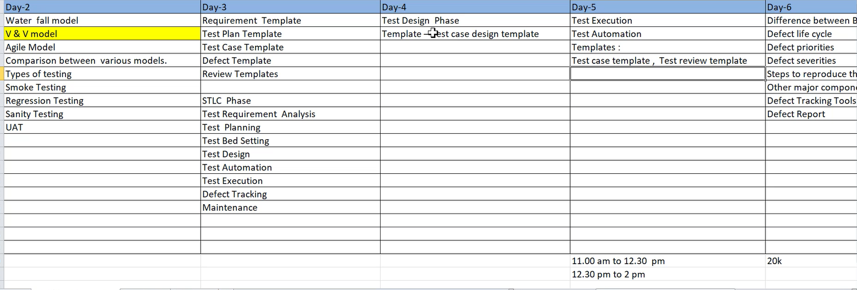

|  |
| --- |
| Application infra understanding |
| What is testing ? |
| Why to test the application ? |
| SDLC – Software Development  Life Cycle |

<https://app.vwo.com/>  
<https://awesomeqa.com/ui>  
[https://awesomeqa.com](https://awesomeqa.com/)  
<https://www.bstackdemo.com/>  
<http://www.tutorialsninja.com/demo/>  
<https://katalon-demo-cura.herokuapp.com/>  
<http://adactinhotelapp.com/>  
[http://bmw.in](http://bmw.in/)

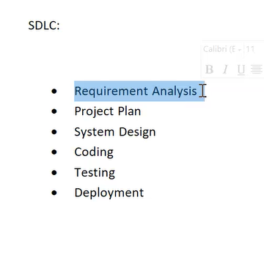

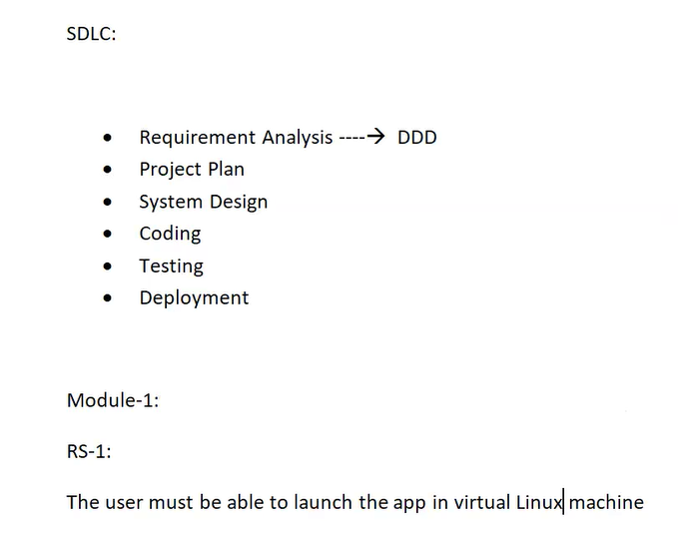

DDD - Detail Design Document

RS - Requirement study

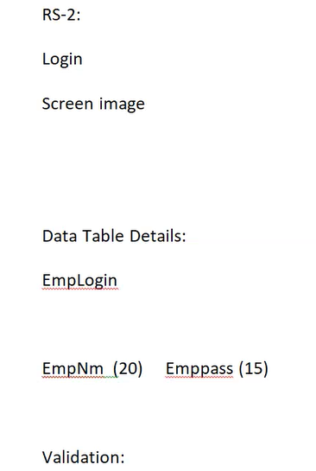

2. Project plan:

Developer plan the project on a document i.e. Project Plan

3. System Design:

a.HLD(Hign level design),b.LLD(Low level design)

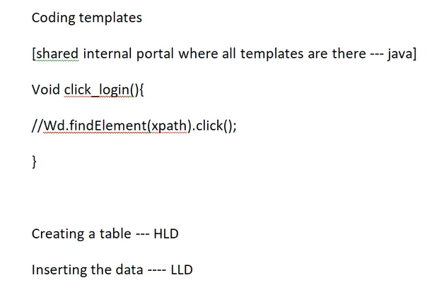

Different Models on SDLC:

V-Model:

Verification & validation model

Tester & developer both can work

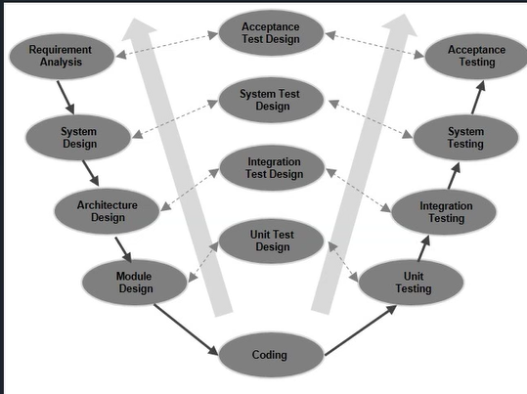

2. Waterfall Model:

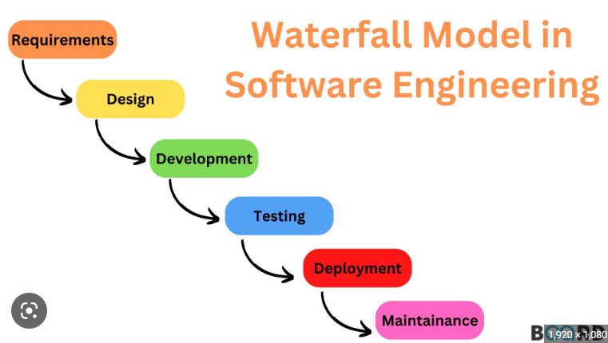

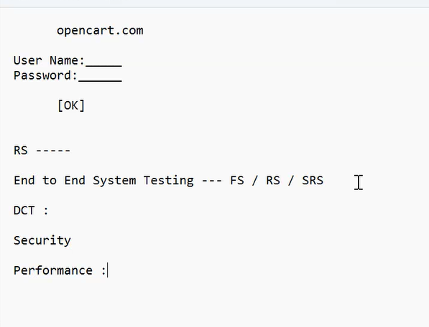

{End to End System Testing --- FS / RS / SRS} +   
Testing concepts + Java+ Selenium + Framework Inplementation

DCT : [Informatica + tera data + sql ]

Security: [Manual test cases]

Performance :[Load runner , Jmeter]

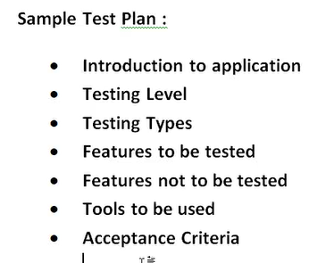

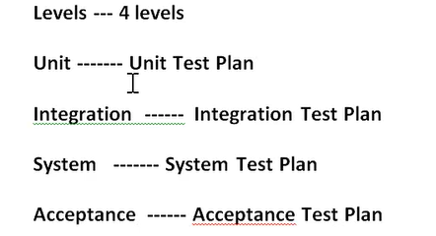

**As per our training we will focus on SYSTEM LEVEL**

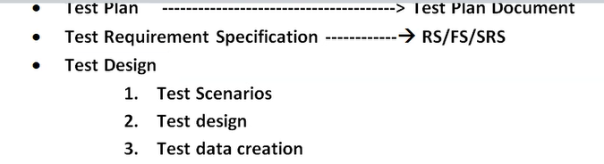

* **Test Plan    ---------------------------------------> Test Plan Document**
* **Test Requirement Specification ------------à RS/FS/SRS**
* **Test Design**

1. **Test Scenarios**
2. **Test design**
3. **Test data creation**
4. **Testing Env setup**

* **Test Automation**

1. **To covert the designed test cases to test script**
2. **Test case to java code using selenium**

* **Test Execution**

1. **Execute each test cases manually**
2. **Execute the test script inside a framework**

* **Defect Tracking**

1. **Log defect in excel template – defect report**
2. **Jira // Log the issue**

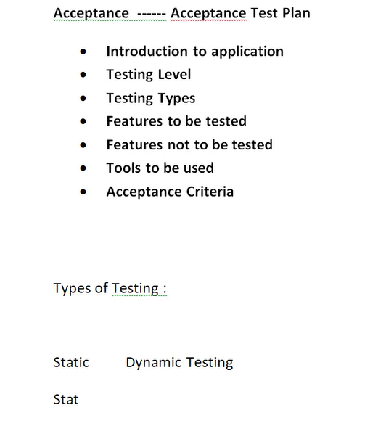

**STATIC TESTING:**

**Until test execution step**

**DYNAMIC TESTING**

**After test execution**

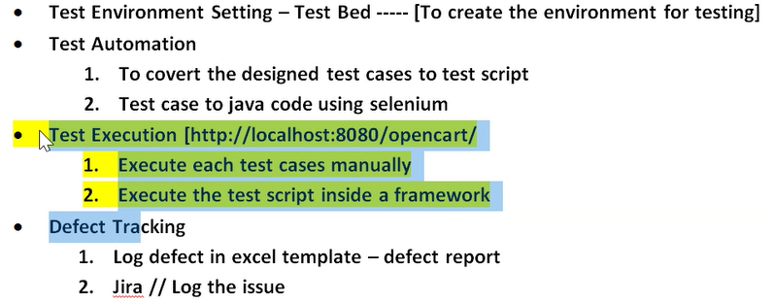

**BBT(Black box testing) vs WBT(White box testing)**

**BBT:** 

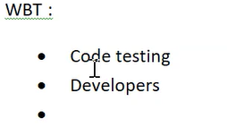

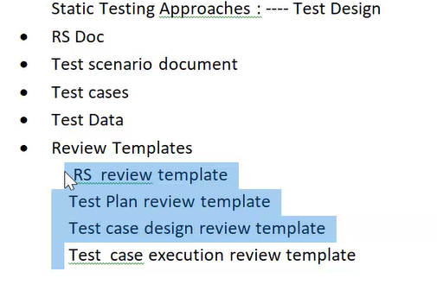

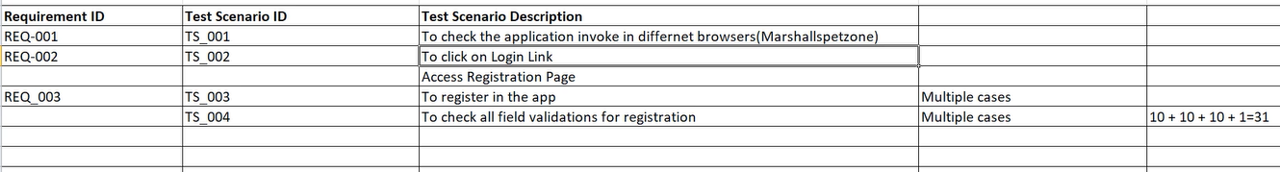

|  |
| --- |
| Types of testing |
| Smoke Testing |
| Regression Testing |
| Sanity Testing |
| UAT |

Test case template understanding

Designing the test cases

How to work on test coverage